Assignment – 6
Introduction: Excel has various functions that can be used to perform logical operations
Objective: Utilise such functions in Excel.
- Import the E-Commerce Order Ledger dataset provided into a new Microsoft Excel worksheet.
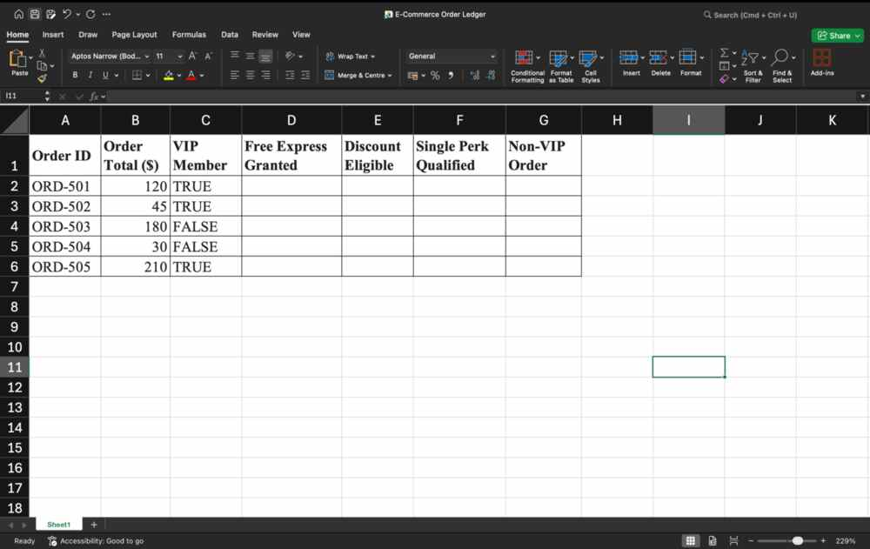
- In the Free Express Granted column, use a logical function to return TRUE only if the Order Total is at least $100 and the customer is a VIP Member.
Utilise function AND to create a formula AND(C2,B2>100) and smart fill
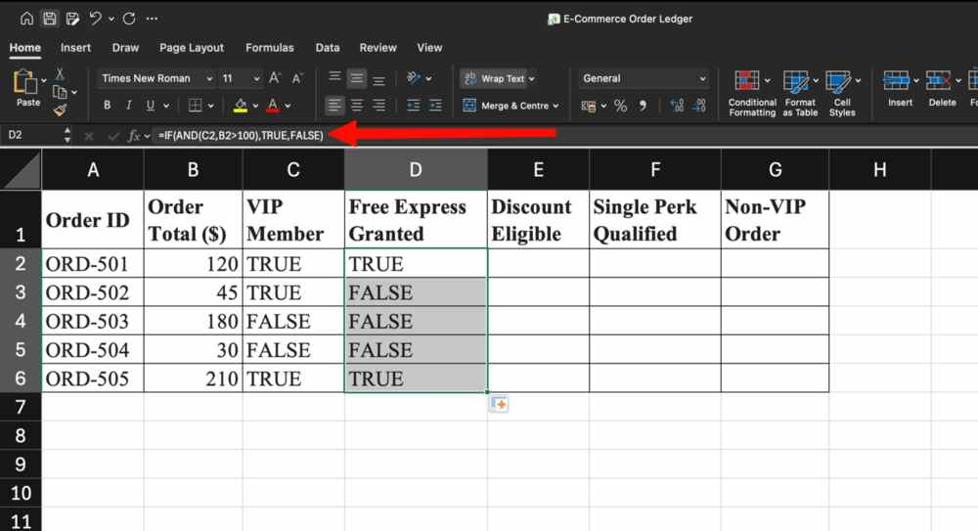
- In the Discount Eligible column, check if either the Order Total is over $150 or the customer is a VIP Member.
Utilise function OR to create a formula = OR(C2,B2>150) and smart fill
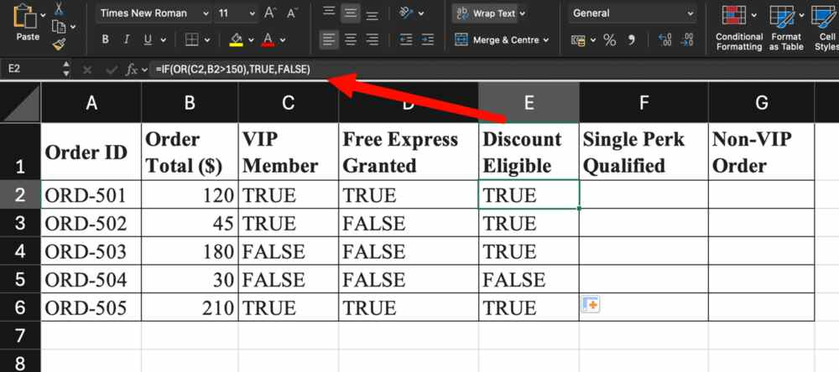
- In the Single Perk Qualified column, use any logical function to flag orders that meet exactly one condition (either Order Total OR VIP Member = TRUE, but not both).
Use XOR with the two conditions
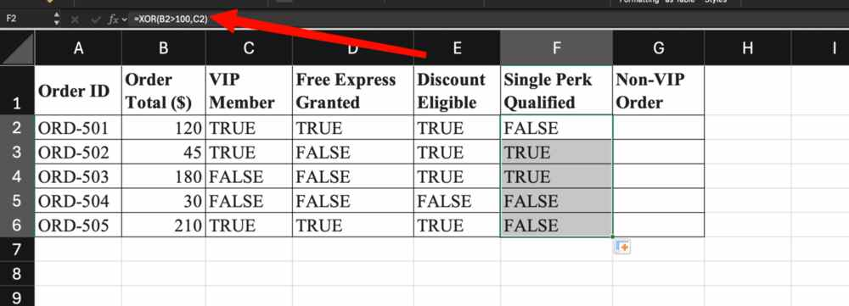
- In the Non-VIP Order column, evaluate if the customer is not a VIP Member.
Use NOT function with the VIP Member Cell
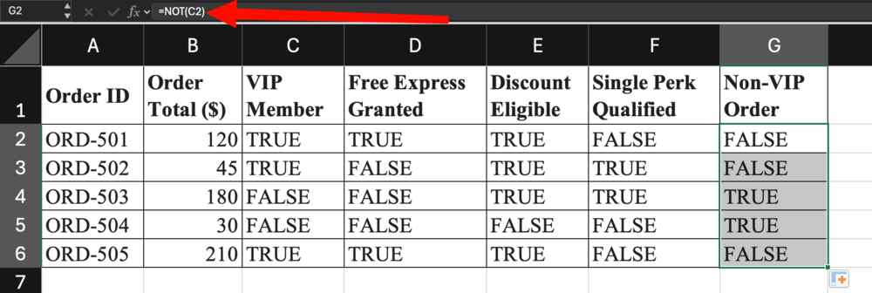
- Import the Loan Applicant Audit Dataset provided into a second worksheet.
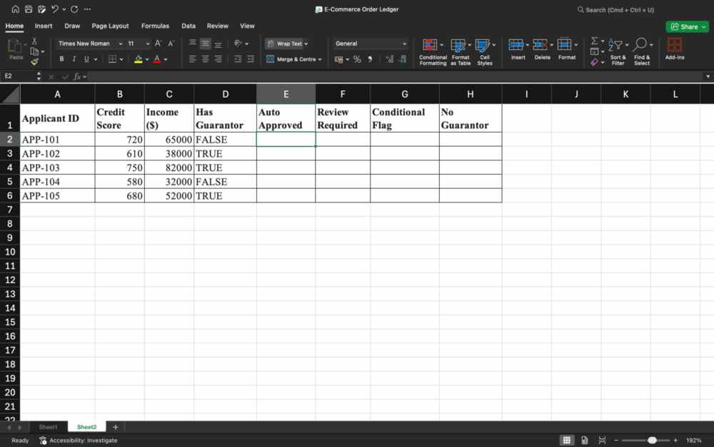
- In the Auto Approved column, use a logical function to approve (TRUE) only if Credit Score is at least 700 and Income is at least $50,000.
Use formula =AND(C3>=50000,B3>700)
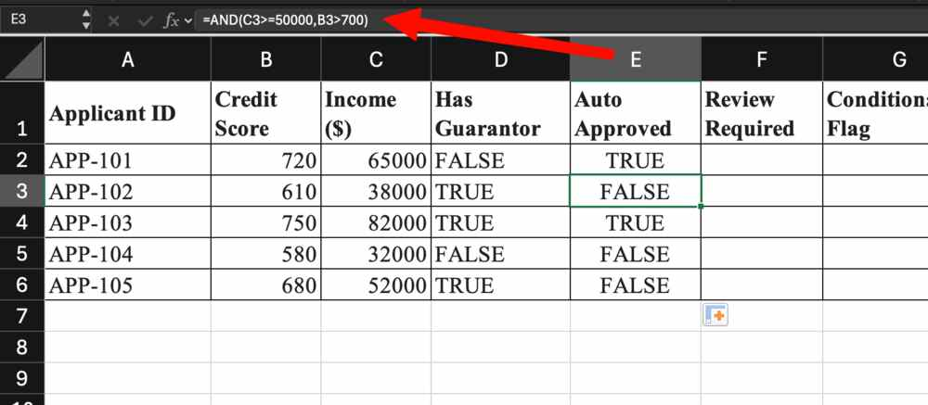
- In the Review Required column, check if Income is below $40,000 or Credit Score is below 650.
=OR(C2<40000,B2<650)
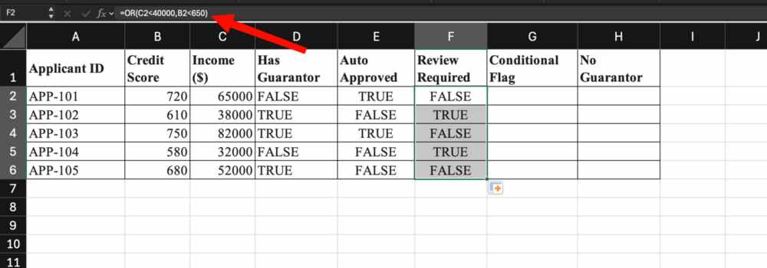
- In the Conditional Flag column, identify applicants who met exactly one requirement between Credit Score and Has Guarantor = TRUE.
Use XOR with the two conditions
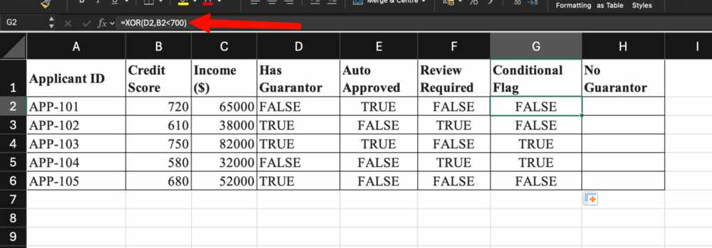
- In the No Guarantor column, use a logical function to reverse the Has Guarantor status.
Use Not function with Has Guarantor, =NOT(D2)


