Assignment – 8
Introduction: Excel has various functions that can be used to perform logical operations
Objective: Utilise such functions in Excel.
- Import the Sales Operations Ledger dataset provided into a new Microsoft Excel worksheet.
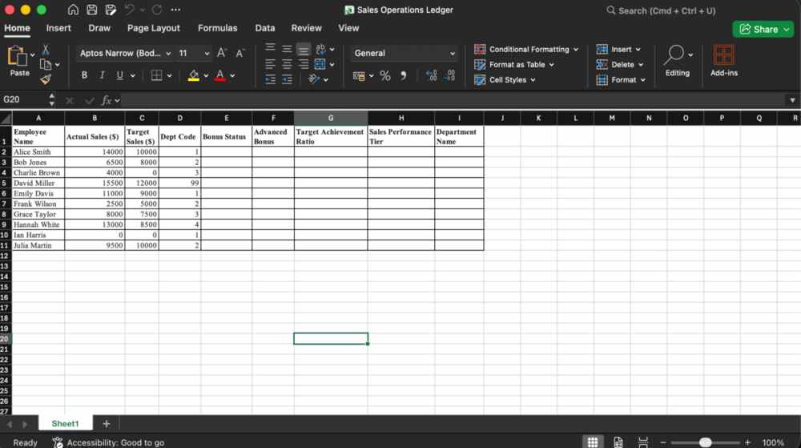
- In the Bonus Status column, use a function to return “Bonus Qualified” if Actual Sales is greater than or equal to Target Sales, and “No Bonus” otherwise.
Use formula… =IF(B2>=C2,"Bonus Qualified", "No Sales") and flash-fill
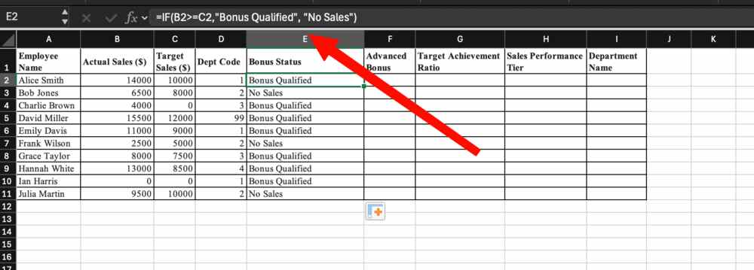
- In the Advanced Bonus column, use the IF function combined with AND to return “High Performer Bonus” only if Actual Sales is greater than $10,000 and Target Sales is greater than $8,000; otherwise return “Standard Rate”.
Use formula… =IF(AND(B2>10000, C2>8000), "High Performer Bonus", "Standard Rate") and flashfill
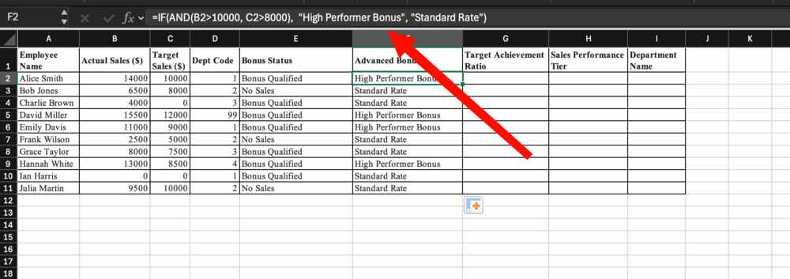
- In the Target Achievement Ratio column, divide Actual Sales by Target Sales (Sales / Target) using the IFERROR function to display “No Target Set” if a division error occurs (e.g., when Target Sales is 0).
Use formula =IFERROR(B2/C2,"No Target Set")
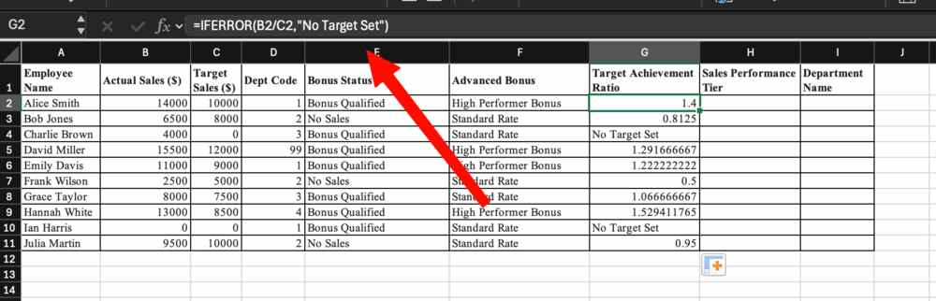
- In the Sales Performance Tier column, use the IFS function to categorize performance:
  - Return “Tier 1 (Top)” if Sales > 10k
  - Return “Tier 2 (Mid)” if Sales > 7.5k < 10k
  - Return “Tier 3 (Low)” if Sales < 7.5k
Use formula: =IFS(B3>10000, "Tier 1 (Top)", B3>7500, "Tier 2 (Mid)", B3<7500, "Tier 3 (low)")
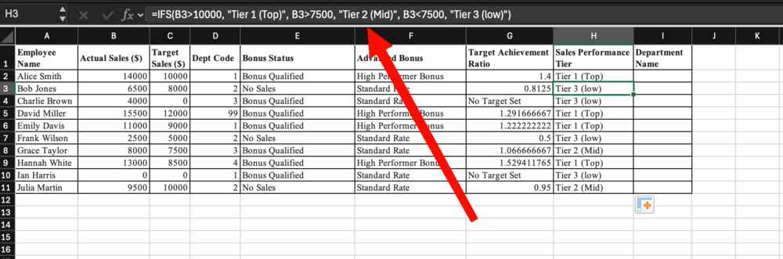
- In the Department Name column, use the SWITCH function to map Department Code 1 to “Sales”, 2 to “Marketing”, and 3 to “Finance”. Return “Unknown Dept” as the default value for any other code.
Use formula =SWITCH(D2, 1, "Sales", 2, "Marketing", 3, "Finance", "Unknown Department")
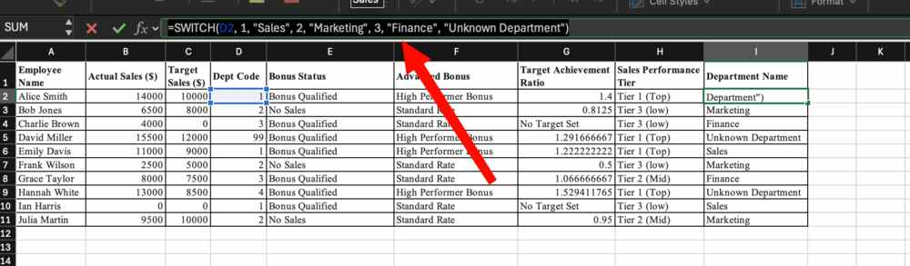
RESULT:

