Assignment – 9
Introduction: Excel has various functions that can be used to manipulate dates
Objective: Utilise such functions in Excel.
- Import the Project Timeline & HR Audit Ledger dataset provided into a new Microsoft Excel worksheet.
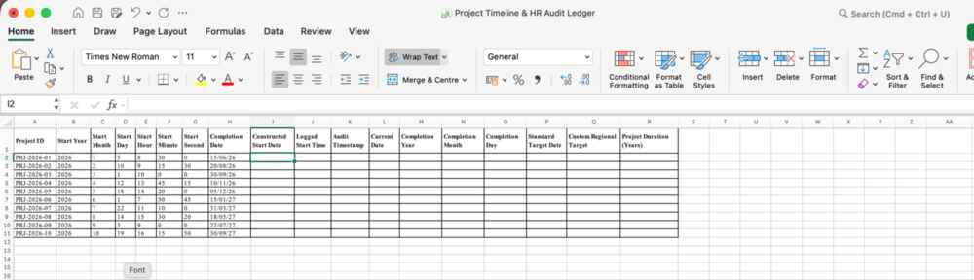
- In the Constructed Start Date column, use the DATE function to combine the Start Year, Start Month, and Start Day columns into a single valid date value.
Use formula: =DATE(B2,C2,D2) and flash-fill
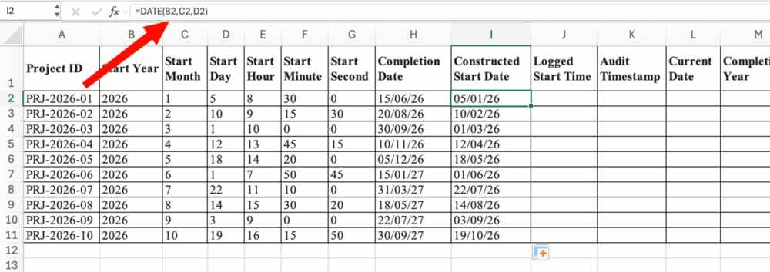
- In the Logged Start Time column, use a function to combine Start Hour, Start Minute, and Start Second into a standard time value.
Use formula: =TIME(E2,F2,G2) and flash fill
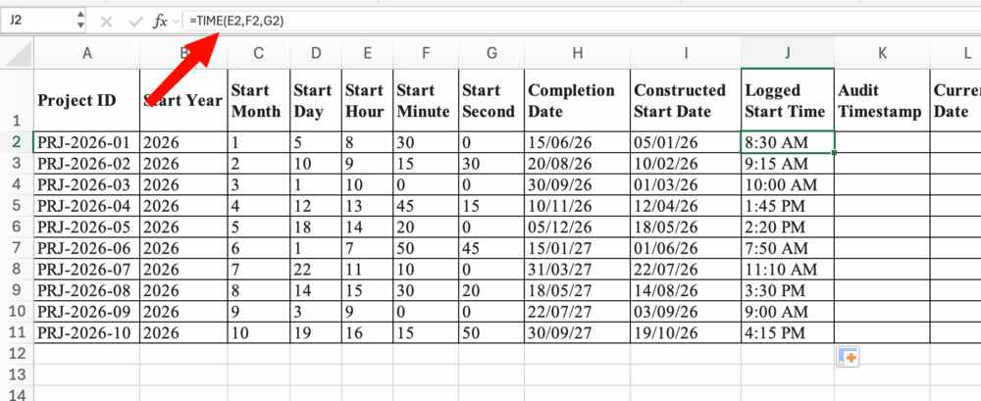
- In the Audit Timestamp column, use a function to dynamically populate the current system date and time.
Use function NOW() and flash fill
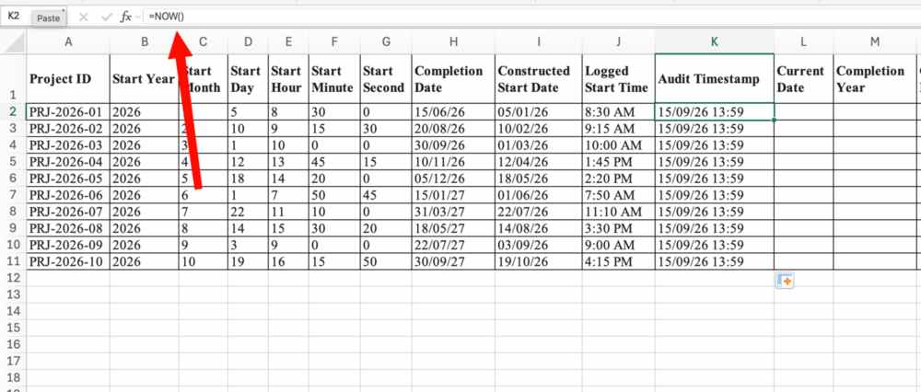
- In the Current Date column, use a function to dynamically display today’s date.
Use function TODAY() and flash fill
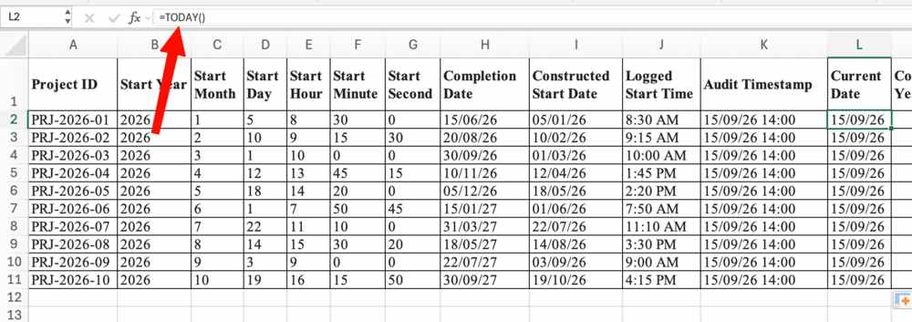
- In the Completion Year, Completion Month, and Completion Day columns, use the YEAR, MONTH, and DAY functions respectively to extract the individual date components from the Completion Date column.
Use formula: =YEAR(H2) and flash fill
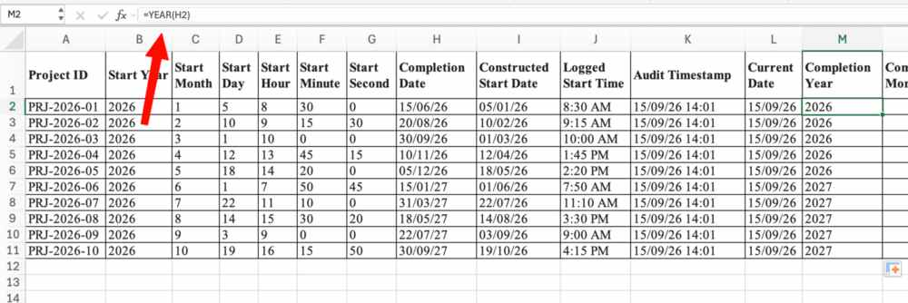

Repeat with MONTH and DAY function
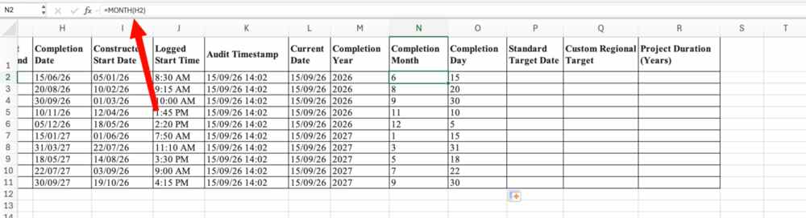
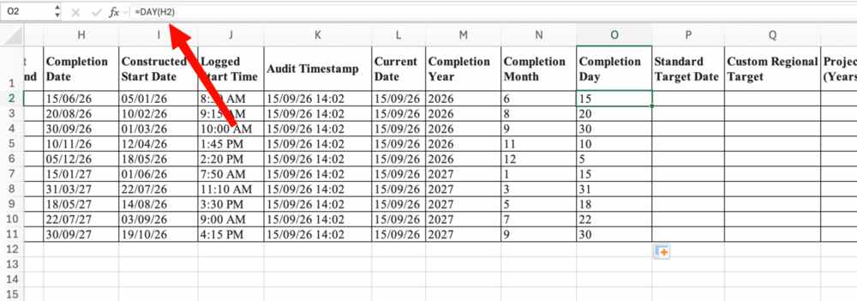
- In the Standard Target Date column, use a function to calculate the date exactly 10 working days after the Constructed Start Date (automatically excluding standard Saturday/Sunday weekends).
Use formula =WORKDAY(I2,10) and flash fill
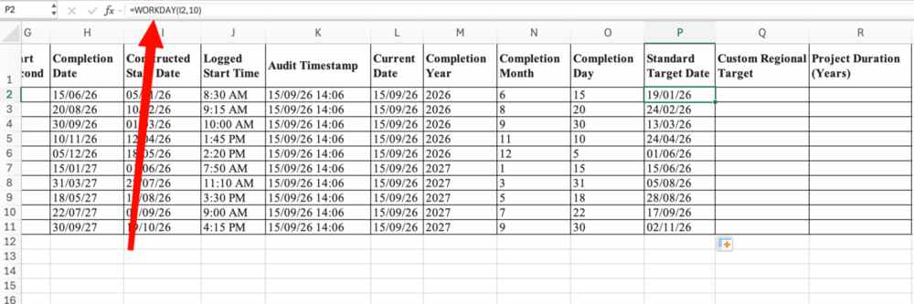
- In the Custom Regional Target column, use a function to calculate the date 10 working days after the Constructed Start Date, applying a custom weekend code where Sunday is the only day off.
Use formula =WORKDAY.INTL(I2, 10, "0000001") and flash fill
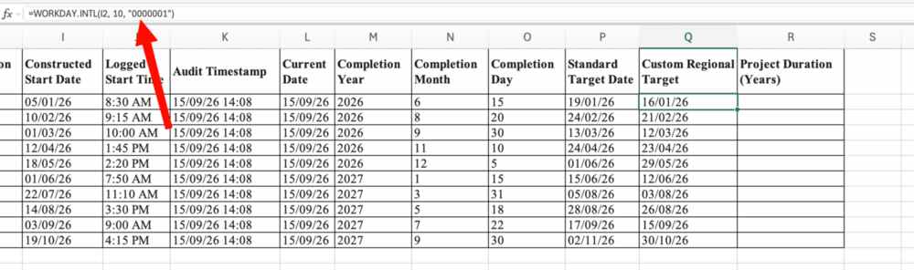
- In the Project Duration (Years) column, use a function to calculate the exact fractional proportion of a year between the Constructed Start Date and Completion Date.
Use formula: =YEARFRAC(I2,H2)
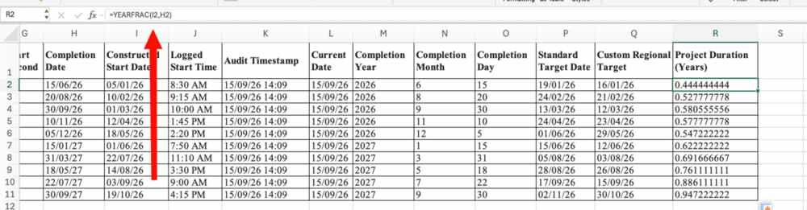

RESULT

