MAHATMA EDUCATION SOCIETY’S

PILLAI COLLEGE OF ARTS, COMMERCE & SCIENCE (Autonomous)

NEW PANVEL

PROJECT REPORT ON

“MOBILE RECHARGE MANAGEMENT SYSTEM “

IN PARTIAL FULFILLMENT OF
BACHELOR OF SCIENCE COMPUTER SCIENCE
SEMESTER 1– 2025-26

UNDER THE GUIDANCE OF
PROFESSOR. ASHWINI MATE

SUBMITTED BY: KRISHNA KAMLESH SINGH
ROLL NO: 1400
INDEX

CERTIFICATE
INTRODUCTION
OBJECTIVES
EXPLANATION
ER MODEL
DATABASE DESIGN
SQL CODE AND OUTPUT
SWOT
CONCLUSION


INTRODUCTION
The Mobile Recharge Management System is a database application designed to streamline and manage the process of mobile recharges for customers and service providers. In the digital age, where prepaid mobile connections are ubiquitous, this system serves as a backend model for an online recharge portal or a telecom company's internal system. It efficiently stores and manages critical information about service providers (like Jio, Airtel), the recharge plans they offer, customer details, and the transaction history of all recharges performed.
The system is built using a Relational Database Management System (RDBMS) like Oracle SQL, which ensures data integrity, eliminates redundancy, and allows for efficient querying to generate useful reports. This project demonstrates core database concepts including table creation, defining relationships through primary and foreign keys, inserting data, and performing complex queries to extract meaningful information.

OBJECTIVES
The primary objectives of this project are:
- To Model Real-World Entities: Create a structured database schema that accurately represents the key entities in the mobile recharge ecosystem: Customers, Service Providers, Recharge Plans, and Transactions.
- To Ensure Data Integrity: Implement relational constraints (Primary Keys, Foreign Keys) to maintain the accuracy and consistency of data (e.g., preventing a transaction for a non-existent customer).
- To Facilitate Data Management: Provide a robust structure for performing essential CRUD operations (Create, Read, Update, Delete) on all entities.
- To Enable Data Analysis and Reporting: Allow the generation of insightful reports, such as:
  - Listing all plans from a specific provider.
  - Viewing the successful recharge history of a customer.
  - Generating a detailed transaction summary report with formatted output.
- To Showcase SQL Proficiency: Demonstrate the use of advanced SQL features like table joins, date formatting (TO_DATE, TO_CHAR), and column formatting for display.

EXPLANATIONS
The system is built around four core tables:
- ServiceProvider1400: This table is a catalog of all telecom companies. It stores a unique Provider_ID, the company's name (Provider_Name), and a Contact_Number for customer service.
- Customer1400: This table acts as a customer directory. It stores a unique Customer_ID, the customer's Name, Mobile_Number, Email, and City. This information is crucial for user accounts and analytics.
- RechargePlan1400: This table contains all the recharge plans offered by the different service providers. Each plan has a unique Plan_ID and is linked to a provider via the Provider_ID foreign key. It details the Plan_Name, its Validity (e.g., 28 Days), Price, and the Data_Offer (e.g., 1.5GB/day).
- RechargeTransaction1400: This is the fact table that records every recharge event. Each Transaction_ID is unique. It links a Customer_ID to a Plan_ID, capturing the Recharge_Date, the Payment_Mode (e.g., UPI, Card), and the Status (Success, Failed, Pending) of the transaction. This table connects all other tables and is the core of the system's operational data.
Key Relationships:
- A Service Provider offers many Recharge Plans (One-to-Many).
- A Recharge Plan is used in many Transactions (One-to-Many).
- A Customer performs many Transactions (One-to-Many).

ER MODEL
Entities (Rectangles): These are the four main objects in the system:
CUSTOMER: Anyone who performs a recharge.
SERVICE_PROVIDER: A company like Jio or Airtel that offers mobile services.
RECHARGE_PLAN: A specific plan (e.g., "Jio 1.5GB/day") offered by a provider.
RECHARGE_TRANSACTION: A record of a single recharge event performed by a customer.

Attributes (Ovals): These are the properties that describe each entity. The primary key for each entity is underlined and marked with PK. It uniquely identifies each record (e.g., each customer_id is unique).

Relationships (Diamonds): These show how the entities interact:
offers: A one-to-many relationship. One Service Provider offers many Recharge Plans, but one Recharge Plan is offered by only one Service Provider. This is shown by the crow's foot ({) on the RECHARGE_PLAN side.
is chosen in: A one-to-many relationship. One Recharge Plan can be chosen in many Transactions, but a single Transaction is for one specific plan.
performs: A one-to-many relationship. One Customer performs many Transactions, but a single Transaction is performed by one specific customer.

Foreign Keys (FK): These are attributes that create the link between tables. For example: The provider_id in the RECHARGE_PLAN table is a foreign key that points to the provider_id (primary key) in the SERVICE_PROVIDER table. The plan_id and customer_id in the RECHARGE_TRANSACTION table are foreign keys linking to the RECHARGE_PLAN and CUSTOMER tables, respectively. This is how the relationship is enforced in the database.

DATABASE DESIGN
- The database design is normalized to the Third Normal Form (3NF) to minimize redundancy and dependency. Below is the schema detail:
Table: ServiceProvider1400
Column Name | Data Type | Constraints | Description
Provider_ID | NUMBER | PRIMARY KEY | Unique ID for the provider.
Provider_Name | VARCHAR(50) | NOT NULL, UNIQUE | Name of the service provider. Must be unique and cannot be missing.
Contact_Number | VARCHAR(15) | NOT NULL | Customer care contact number. Cannot be missing.
Table: Customer1400
Column Name | Data Type | Constraints | Description
Customer_ID | NUMBER | PRIMARY KEY | Unique ID for the customer.
Name | VARCHAR(50) | NOT NULL | Full name of the customer. Cannot be missing.
Mobile_Number | VARCHAR(15) | NOT NULL, UNIQUE | Customer's mobile number. Must be unique and cannot be missing.
Email | VARCHAR(50) | NOT NULL, UNIQUE | Customer's email address. Must be unique and cannot be missing. (A CHECK constraint for email format like %%@%.% would be even better).
City | VARCHAR(30) | NOT NULL | City of residence. Cannot be missing.
Table: RechargePlan1400
Column Name | Data Type | Constraints | Description
Plan_ID | NUMBER | PRIMARY KEY | Unique ID for the recharge plan.
Provider_ID | NUMBER | FOREIGN KEY REFERENCES ServiceProvider1400(Provider_ID), NOT NULL | Links the plan to its provider. Cannot be missing.
Plan_Name | VARCHAR(50) | NOT NULL | Marketing name of the plan. Cannot be missing.
Validity | VARCHAR(20) | NOT NULL | How long the plan is active (e.g., 28 Days). Cannot be missing.
Price | NUMBER(10,2) | NOT NULL, CHECK (Price > 0) | Cost of the recharge plan. Cannot be missing and must be a positive value.
Data_Offer | VARCHAR(50) | NOT NULL | Data benefits of the plan (e.g., 1.5GB/day). Cannot be missing.
Table: RechargeTransaction1400
Column Name | Data Type | Constraints | Description
Transaction_ID | NUMBER | PRIMARY KEY | Unique ID for the transaction.
Customer_ID | NUMBER | FOREIGN KEY REFERENCES Customer1400(Customer_ID), NOT NULL | Links the transaction to a customer. Cannot be missing.
Plan_ID | NUMBER | FOREIGN KEY REFERENCES RechargePlan1400(Plan_ID), NOT NULL | Links the transaction to a plan. Cannot be missing.
Recharge_Date | DATE | NOT NULL, DEFAULT SYSDATE | The date the recharge was performed. Cannot be missing. Defaults to the current date.
Payment_Mode | VARCHAR(20) | NOT NULL, CHECK (Payment_Mode IN ('UPI', 'Card', 'NetBanking', 'Wallet', 'Cash')) | Method of payment. Cannot be missing and must be from a predefined list.

SQL CODE AND OUTPUT:
CODE:
CREATE TABLE ServiceProvider1400 (
Provider_ID NUMBER PRIMARY KEY,
Provider_Name VARCHAR(20),
Contact_Number VARCHAR(20)
);

CREATE TABLE Customer1400 (
Customer_ID NUMBER PRIMARY KEY,
Name VARCHAR(20),
Mobile_Number VARCHAR(20),
Email VARCHAR(20),
City VARCHAR(20)
);

CREATE TABLE RechargePlan1400 (
Plan_ID NUMBER PRIMARY KEY,
Provider_ID NUMBER,
Plan_Name VARCHAR(20),
Validity VARCHAR(20),
Price NUMBER(10,2),
Data_Offer VARCHAR(20),
FOREIGN KEY (Provider_ID) REFERENCES ServiceProvider1400(Provider_ID)
);

CREATE TABLE RechargeTransaction1400 (
Transaction_ID NUMBER PRIMARY KEY,
Customer_ID NUMBER,
Plan_ID NUMBER,
Recharge_Date DATE,
Payment_Mode VARCHAR(20),
Status VARCHAR(20),
FOREIGN KEY (Customer_ID) REFERENCES Customer1400(Customer_ID),
FOREIGN KEY (Plan_ID) REFERENCES RechargePlan1400(Plan_ID)
);

INSERT INTO ServiceProvider1400 VALUES (1, 'Jio', '1800100100');
INSERT INTO ServiceProvider1400 VALUES (2, 'Airtel', '1800100200');

INSERT INTO Customer1400 VALUES (1, 'Rahul Sharma', '9876543210', 'rahul@gmail.com', 'Delhi');
INSERT INTO Customer1400 VALUES (2, 'Priya Verma', '9876500001', 'priya@gmail.com', 'Mumbai');
INSERT INTO Customer1400 VALUES (3, 'Amit Kumar', '9876500002', 'amitk@gmail.com', 'Kolkata');
INSERT INTO Customer1400 VALUES (4, 'Sneha Gupta', '9876500003', 'sneha@gmail.com', 'Bangalore');
INSERT INTO Customer1400 VALUES (5, 'Rohit Mehta', '9876500004', 'rohit@gmail.com', 'Hyderabad');
INSERT INTO Customer1400 VALUES (6, 'Anita Singh', '9876500005', 'anita@gmail.com', 'Chennai');

INSERT INTO RechargePlan1400 VALUES (101, 1, 'Jio 1.5GB/day', '28 Days', 249.00, '1.5GB/day');
INSERT INTO RechargePlan1400 VALUES (102, 2, 'Airtel 2GB/day', '28 Days', 299.00, '2GB/day');

INSERT INTO RechargeTransaction1400 VALUES (1001, 1, 101, TO_DATE('2025-08-01', 'YYYY-MM-DD'), 'UPI', 'Success');
INSERT INTO RechargeTransaction1400 VALUES (1002, 2, 102, TO_DATE('2025-08-02', 'YYYY-MM-DD'), 'Card', 'Pending');
INSERT INTO RechargeTransaction1400 VALUES (1003, 3, 101, TO_DATE('2025-08-03', 'YYYY-MM-DD'), 'NetBanking', 'Success');
INSERT INTO RechargeTransaction1400 VALUES (1004, 4, 102, TO_DATE('2025-08-04', 'YYYY-MM-DD'), 'Wallet', 'Failed');
INSERT INTO RechargeTransaction1400 VALUES (1005, 5, 101, TO_DATE('2025-08-05', 'YYYY-MM-DD'), 'Cash', 'Success');
INSERT INTO RechargeTransaction1400 VALUES (1006, 6, 102, TO_DATE('2025-08-06', 'YYYY-MM-DD'), 'UPI', 'Success');

SELECT Plan_Name, Price, Validity, Data_Offer
FROM RechargePlan1400 RP
JOIN ServiceProvider1400 SP ON RP.Provider_ID = SP.Provider_ID
WHERE SP.Provider_Name = 'Jio';

SELECT T.Transaction_ID, P.Plan_Name, T.Recharge_Date, T.Payment_Mode
FROM RechargeTransaction1400 T
JOIN RechargePlan1400 P ON T.Plan_ID = P.Plan_ID
WHERE T.Customer_ID = 1 AND T.Status = 'Success';

SET LINESIZE 200
SET PAGESIZE 50

COLUMN Transaction_ID HEADING 'Txn_ID' FORMAT 9999
COLUMN Customer_Name HEADING 'Customer' FORMAT A20
COLUMN Mobile_Number HEADING 'Mobile' FORMAT A12
COLUMN Provider_Name HEADING 'Provider' FORMAT A15
COLUMN Plan_Name HEADING 'Plan' FORMAT A20
COLUMN Price HEADING 'Price' FORMAT A12
COLUMN Validity HEADING 'Validity' FORMAT A12
COLUMN Recharge_Date HEADING 'Recharge Date' FORMAT A12
COLUMN Payment_Mode HEADING 'Payment' FORMAT A12
COLUMN Status HEADING 'Status' FORMAT A10

SELECT T.Transaction_ID AS Txn_ID,
C.Name AS Customer,
C.Mobile_Number AS Mobile,
SP.Provider_Name AS Provider,
P.Plan_Name AS Plan,
'₹' || TO_CHAR(P.Price, '9990.00') AS Price,
P.Validity AS Validity,
TO_CHAR(T.Recharge_Date, 'DD-MON-YY') AS "Recharge Date",
T.Payment_Mode AS Payment,
T.Status AS Status
FROM RechargeTransaction1400 T
JOIN Customer1400 C ON T.Customer_ID = C.Customer_ID
JOIN RechargePlan1400 P ON T.Plan_ID = P.Plan_ID
JOIN ServiceProvider1400 SP ON P.Provider_ID = SP.Provider_ID
ORDER BY T.Recharge_Date DESC;

OUTPUT:
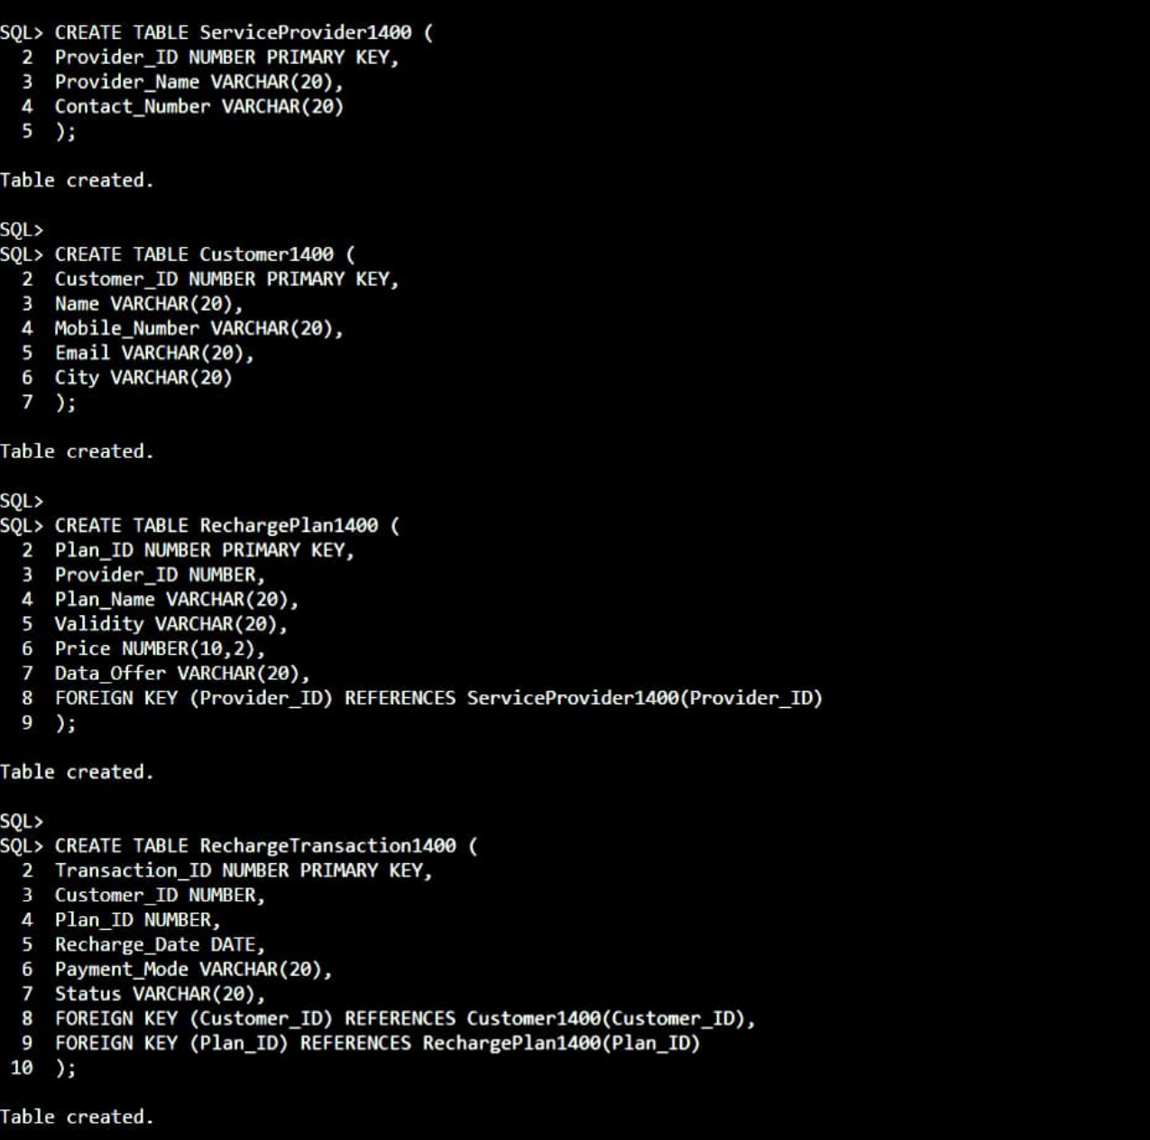

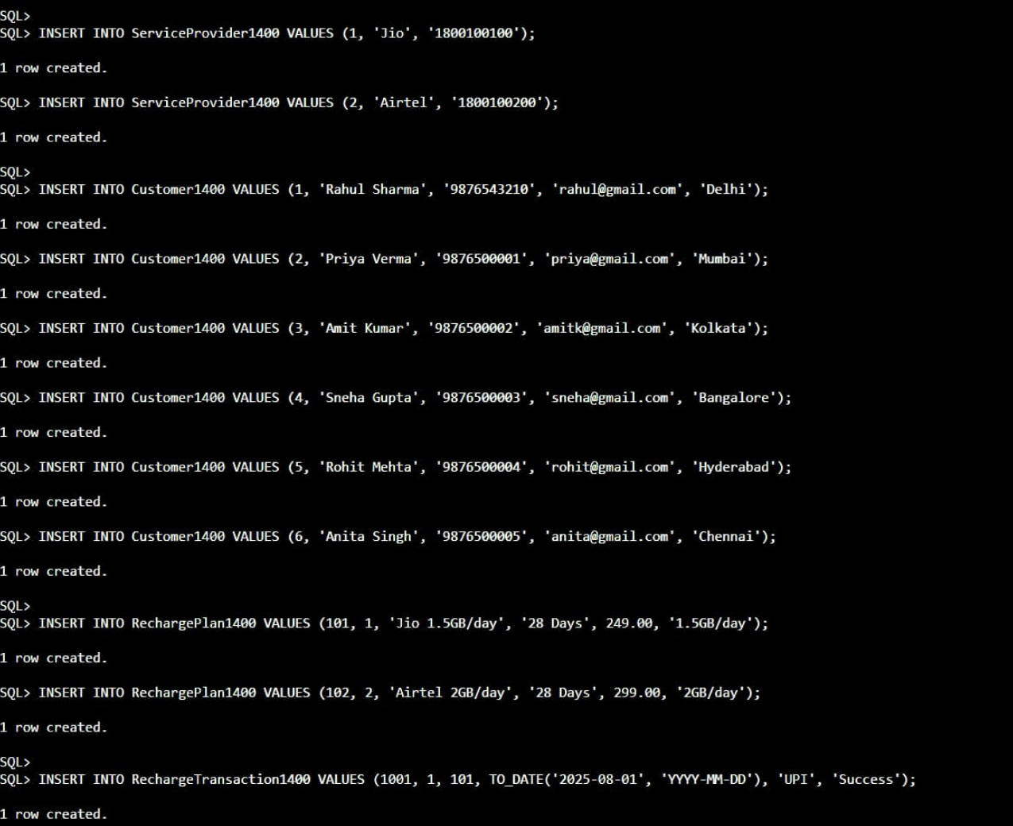

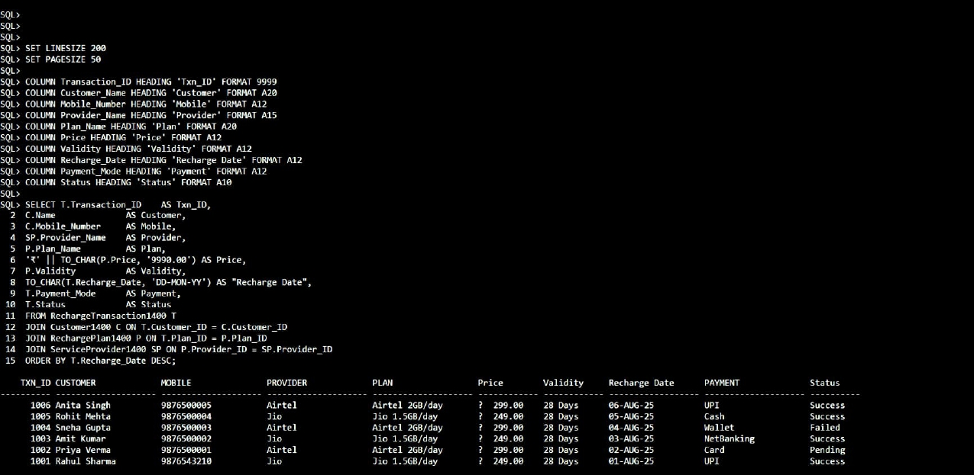
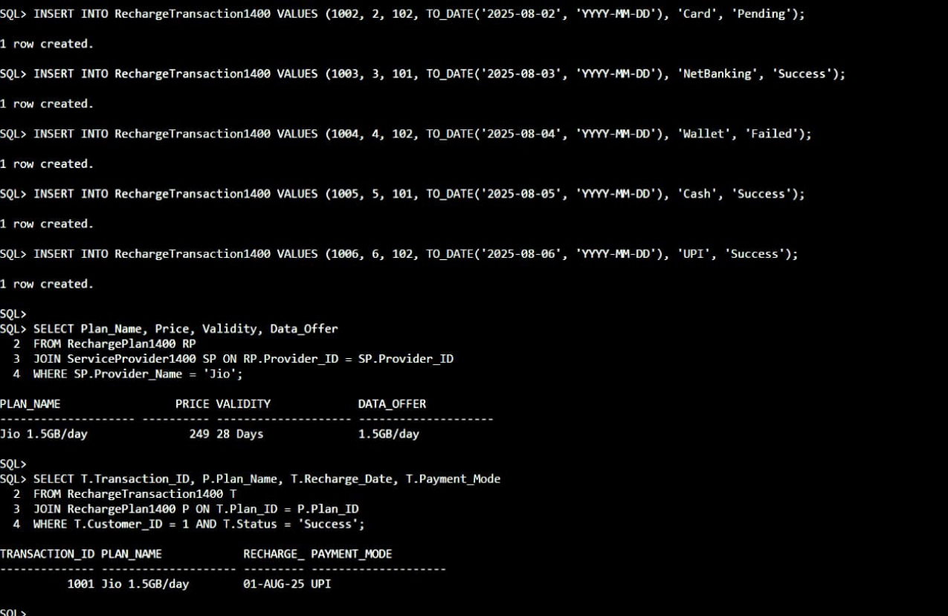
SWOT ANALYSIS: MOBILE RECHARGE MANAGEMENT SYSTEM
A SWOT analysis examines the Strengths, Weaknesses, Opportunities, and Threats of a project. This analysis is based on the database schema and queries you have developed.
S - Strengths (Internal, Positive Factors)
These are the advantages and successful features of your current system.
- Strong Data Integrity: The use of Primary Keys and Foreign Keys ensures relational integrity. This prevents orphan records (e.g., a transaction for a customer that doesn't exist) and maintains accuracy.
- Well-Defined Relationships: The database schema correctly models the real-world relationships between entities (Customer, Provider, Plan, Transaction). This is a solid foundation for a functional application.
- Effective Data Retrieval: Your SQL queries demonstrate the system's ability to generate meaningful reports, such as listing plans by provider (WHERE SP.Provider_Name = 'Jio') and retrieving customer transaction history (WHERE T.Customer_ID = 1).
- User-Friendly Output: The use of COLUMN formatting commands (SET LINESIZE, COLUMN Price FORMAT A12) shows attention to detail in presenting data in a clean, readable format for end-users.
W - Weaknesses (Internal, Negative Factors)
These are the limitations and areas for improvement in the current system's design.
- Limited Data Field Sizes: Using VARCHAR(20) for fields like Email, City, and Plan_Name is restrictive. Real-world data (e.g., longer email addresses, city names, or detailed plan descriptions) would easily exceed this limit, causing errors.
- Basic Payment Status Handling: The Status field is a simple string ('Success', 'Failed', 'Pending'). A more robust system would likely log reasons for failure, transaction IDs from payment gateways, and timestamps for status changes.
- No Data Validation: The schema lacks NOT NULL constraints on critical fields like Customer.Name, Provider_Name, or Plan.Price. This could lead to incomplete data being inserted into the database.
- Scalability Concerns: The design assumes a simple structure. For a large-scale system, features like price history for plans, customer login credentials, or user roles (Admin, Customer) would be necessary.
O - Opportunities (External, Positive Factors)
These are potential features or directions you could take the project in the future.
- Advanced Analytics: You could create more complex SQL queries for business intelligence, such as:
  - Finding the most popular recharge plan.
  - Calculating total revenue generated per provider.
  - Identifying cities with the most number of customers.
- Integration with a Front-End: This database is a perfect backend for a website or a mobile app. You could develop a UI where customers can log in, view plans, and recharge directly.
- Enhanced Features: New tables could be added for:
  - Wallet System: A Customer_Wallet table to store money for faster checkouts.
  - Offer & Discounts: An Offers table to apply coupons on recharges.
  - Customer Support: A Tickets table to log customer complaints or queries.
- Improved Reporting: Develop standardized reports (daily sales, failure rate of payments) that can be automatically generated.
T - Threats (External, Negative Factors)
These are potential external challenges the system might face.
- Security Risks: The current schema does not handle security. In a real-world scenario, storing customer data (mobile numbers, emails) requires encryption. Passwords for user login are entirely absent in this model.
- Competition: There are many established recharge apps (Paytm, PhonePe, provider apps). A new system would need a unique selling proposition (USP) like better offers, lower fees, or a superior user experience to compete.
- Dependency on Service Providers: The system's plan data must be manually updated to reflect changes made by Jio, Airtel, etc. An automated API-based system to sync plans would be complex to build and maintain.
- Regulatory Compliance: Depending on the region, storing personal user data (especially payment info, which isn't even stored here) subjects the system to regulations like GDPR or India's PDP Bill, which require strict data handling practices.

CONCLUSION:
Your Mobile Recharge Management System has a very strong core foundation with a well-structured, normalized database. Its main strengths are its integrity and clarity. The primary weaknesses are related to scalability and real-world practicality.
The project has significant opportunity to evolve into a full-fledged application by adding a user interface, advanced features, and sophisticated reporting. However, it must also address potential threats related to security and competition to be viable in a real-world scenario. This SWOT analysis shows that you have successfully built an excellent academic project that demonstrates key DBMS principles

