**FIREFOX**

1. Klik page setup

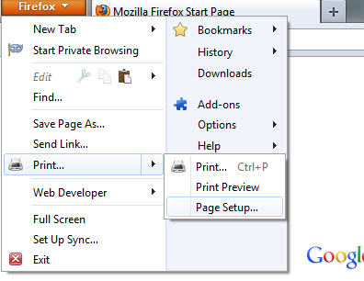

1. Tick background n color

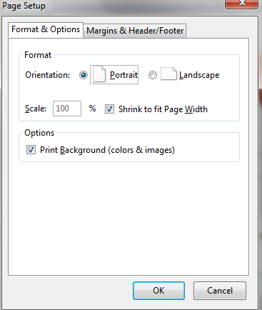

1. Set header and footer all blank

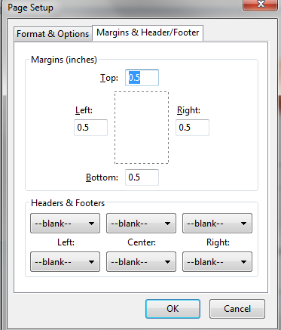

**INTERNET EXPLORER**

1 Klik page setup

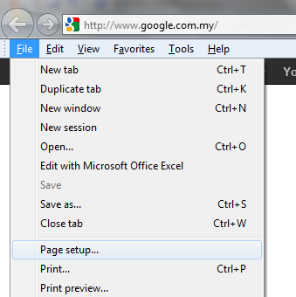

2. tick print background n set header footer all emty

