PROPOSED ACTIVITY FOR
SEA TRIAL OF AUTONOMOUS UNDERWATER VEHICLE AUV-150 IN INDIAN OCEAN
(JULY 2011)

Introduction
An Autonomous Underwater Vehicle, AUV-150 has been developed in collaboration with IIT Kharagpur, under the sponsorship of Ministry of Earth Sciences (MoES), GOI for the purpose of operating to a depth of 150 meters in an autonomous mode underwater and perform sea-bed mapping along-with collection of oceanographic data like temperature, salinity and conductivity. The system has been successfully tested for Lake Trials consecutively two times in 2009 and 2010 at Idukki Lake, Cochin with an active support extended by NPOL.
Subsequently, it is proposed to conduct sea water trial in Central Indian Ocean Basin to verify the sea-worthiness of the system including its design and entire set of functionalities. Following are the details of mission activities for the sea-testing of AUV-150.

Testing Objectives
The various objectives behind the sea-testing of AUV-150 may be summarized as follows targeted towards qualifying the AUV-150 as follows:
- Dry tests for integrity and conformity onboard Sagar Nidhi
- Soak tests and other functional tests at first position having a depth of 30~40 meters
- Performing a dive for up to 150 meters of depth in progressive phases
- Performing sea-bed mapping at various depths of the sea
- Collection of oceanographic data like salinity, temperature and conductivity at various pressure/depth levels
- Exhibiting autonomous navigation and guidance control
- Emergency handling capabilities with acoustic communication and tracking with USBL technology
System Details

Vessel
Sea-trials with work class AUV-150 shall be carried out with Technology Demonstration Vessel Sagar Nidhi owned by NIOT (MoES).

Autonomous Underwater Vehicle AUV-150 (Depth Rating 150m)
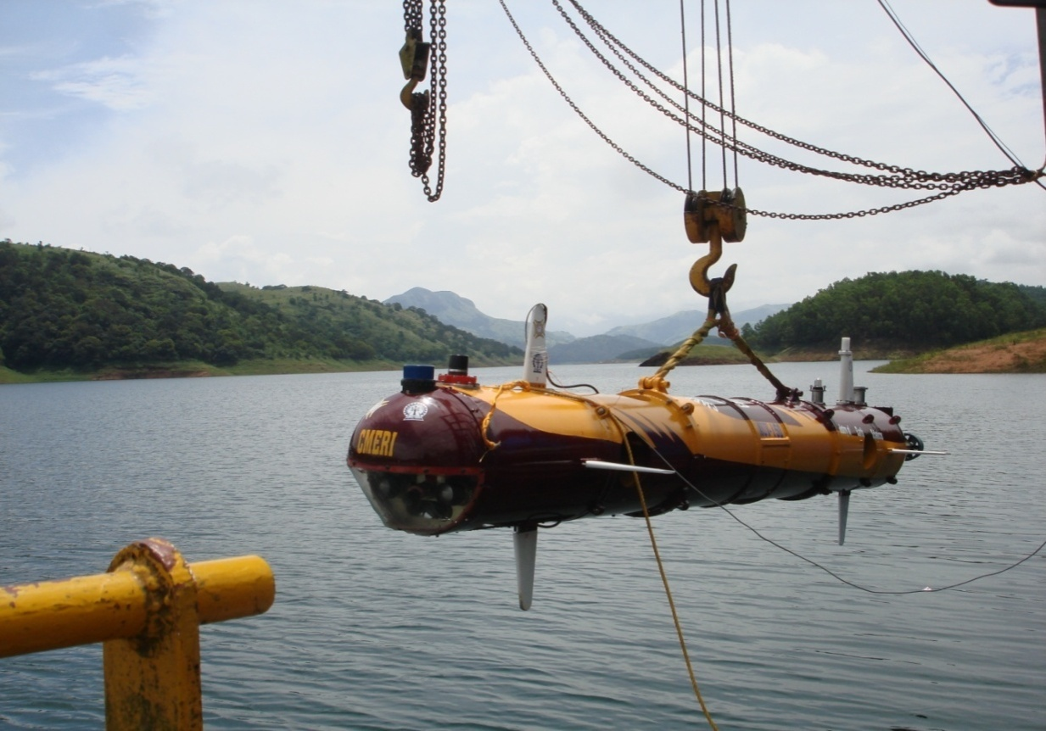
The AUV-150 is cylindrical in shape with streamlined fairing to reduce hydrodynamic drag and has own power, propulsion, navigation and control systems. The propulsion system is consisting of thrusters mounted at suitable locations. A pressure hull is deployed to contain electronics and energy system. The vehicle is programmed with a set of instructions that enable it to carry out an underwater mission without assistance from an operator on the surface. For autonomous free movement under water, the AUV determines its own geographical position with the help of navigational sensors and with navigational algorithms avoid collision with obstacles after their detection through forward looking sonar. The onboard software (preprogrammed) makes the vehicle smart. The onboard intelligence helps it to take its own decisions and re-plans the mission accordingly.

Figure.1. AUV-150 being launched during Lake Trials
at Idukki Lake, Cochin
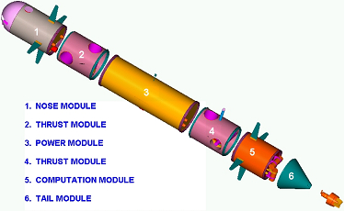
The AUV-150 as shown in figure 2 has six modules from nose to tail. Thrusters are used to propel and maneuver the AUV. Five (5) thrusters are mounted on the AUV for generating motion in different directions i.e to control surge, sway, heave, pitch and yaw. Rolling is strictly prevented. Lithium polymer battery has been used as power source considering its higher energy density, light weight, higher life and safety. For autonomous operation AUV is interfaced with obstacle avoidance sonar. The AUV is equipped with a number of navigational (Inertial Navigation System, Depth Sensor, Altimeter, Doppler Velocity Log, Forward Looking Sonar, Global Positioning System, APOS) and payload sensors (Side Scan Sonar, camera, CTD) for execution of its operation successfully.

Figure.2. Exploded View of AUV

The approximate weight of the AUV final prototype including all its onboard subsystems is 490 kgf. The AUV has slight positive buoyancy (around 3 kgf) including its payload to facilitate its retrieval in case of a power failure. Two arrays of fixed cross-fins at the two ends provide additional roll stabilizing moment.
The onboard intelligence based on advanced control methodology provided through software (preprogrammed) helps AUV to take its own decision autonomously. Hybrid communication (Radio Frequency & Acoustic) has been incorporated to communicate with the AUV for any intervention.
The overall specifications of AUV-150 have been summarized in Table 1.
Table 1. Overall Specifications for AUV-150
Depth of operation | 100m-150m
Material of construction | Al alloy body (Special Grade)
Speed | 2-4 knots
Configuration | Cylindrical, Modular
Degrees of Freedom | 5 , Stable against Roll
Energy system | Lithium Polymer Battery
Mission Time | 4-6 Hrs
Navigational Sensors | Inertial Navigation System, DVL, load GPS, Acoustic Tracking System, Forward looking Sonar, Altimeter and Pressure Sensor
Payload Sensors | Underwater camera, Side Scan Sonar, CTD
Control | Network Based Distributed Control
Communication | Acoustic & RF
Decision Making  Software | - Overall Mission Management including intelligent trajectory management, obstacle avoidance, autonomous navigation and control.  - Diagnostic tests during pre-launching and post-retrieval periods

Testing Site Details
Sea trials for AUV-150 shall be carried out in Indian Ocean waters at the following geographical locations:

Position 1  depth 30 - 40 m | Position 2  depth 150 - 200 m | Position 3  depth 500 - 600 m
13 13 45 N  080 25 00 E  13 21 00 N  080 25 00 E | 13 11 40 N  080 33 20 E  13 21 00 N  080 33 20 E | 13 11 40 N  080 42 20 E  13 21 00 N  080 39 30 E

System deployment sequence before operation
The Autonomous Underwater Vehicle AUV-150 remains docked on the ship deck. The AUV-150 while on surface is connected over WLAN with the Surface Operator’s Console installed within the Control Container resting on the deck. The underwater acoustic positioning systems as well as communication devices are checked for their proper functioning.

- Pre-operational Check on Deck (dry test)
- Pre-operational Check on Water Surface (wet test)

Phases of Operation
Mission Phases | Estimated Duration (in hours)
Surface Initialization | 0.5
Dive to target depth | 0.3
Trajectory Following on X-Y Plane | 0.5~4
Ascent | 0.3

Navigation & Guidance
• Heave speed : 1 knot
• Surge speed : 0 to 3 knots (max 4 knots)
• Underwater Positioning : 0.2 meter / 0.25⁰ (with USBL)
• Inertial Positioning: 0.5~3 meter(s) / 0.05⁰ (Yaw) / 0.01⁰ (Roll/Pitch)
• Collision Prevention: SONAR based collision detection
Range of Looking: 30 meters
Triggering Range: 6 meters
Scan Window: +/- 5 degrees about surge axis
• Communication : Acoustic integrated with Tracklink USBL
Pre-dive preparation
The preparation for the mission starts with the trajectory plan and briefing of all the personnel involved. The mother vessel reaches the location and captain gives clearance after consulting weather reports and prediction for the next 72 hours. Pre-dive checks of all mechanical, electrical and electronic equipment are carried out as per the dive test document attached. After clearance from the mission head, the vehicle is launched using the dedicated LARS. System initialization is carried out while AUV-150 stays on water surface. All the necessary surface commands are executed and response from the AUV-150 verified. After successful verification, finally the mission is initiated by giving “START” command from the Surface Operator’s Console.

Types of Mission to be planned
- Surface Mission at shallow regions of the sea
AUV-150 shall be given surface operations of the following types shall be given at shallow regions of the sea having depths of about 50 meters:
- Straight course keeping operations at arbitrary headings and distances of 30~500 meters in a to and fro mode.
- Lawn Mower operations over areas of 0.01~0.25 sq-km particularly for underwater terrain mapping.
- Subsea Mission
Subsea operations shall be given for the following depths:
- Depth of 20~30 meters
Lawn Mower operations shall be given over areas of 0.01~0.04 sq-km particularly for underwater terrain mapping.
- Depth of 80~90 meters
Lawn Mower operations shall be given over areas of 0.01~0.04 sq-km particularly for underwater terrain mapping.
- Depth of 120~150 meters
  - Straight course keeping operations shall be given at arbitrary headings and distances of 30~100 meters in a to and fro mode for sea-bed mapping.
  - Station keeping shall be performed at the specified depth of 150 meters for collection of various oceanographic data.
Communication & Positioning
During surface operations, communication shall be maintained over RF link. Data as well as mission status shall be requested for through the Surface Console. System specific data shall be transmitted by AUV-150 in a polling mode. Since GPS shall stay functional therefore the position of the vehicle can be tracked on the Surface Console from the GPS coordinates.
During subsea operations, communication shall be maintained over the acoustic link as provided by the Tracklink USBL/Modem. The USBL Transceiver shall be connected to a fairly accurate GPS at the surface end. The Transponder connected to AUV-150 at the bottom shall transmit all the necessary system information along-with an acoustic ping to the Transceiver. Position information as estimated by the Transceiver shall be used in tracking the vehicle during sub-sea operations.

Trajectory plan
Particular Lawn-mower trajectories (LMTs) shall be prepared for the AUV-150 in order to perform sea-bed mapping effectively. Figure 3 reflects a typical LMT for AUV-150.
100 meters

100 meters

N
W
E
S

Start

Figure.3. AUV-150 performing a Lawn Mower Trajectory

Recovery
Data recorded during the cruise is copied on to the storage media for further processing, analysis and archiving. As par procedure post dive check will be performed and washed completely with fresh water.

Emergency Recovery
The AUV-150 shall be continuously transmitting mission specific as well as health related data to the surface over the acoustic communication channel during subsea operations. If any discrepancy in depth, attitude correction as well as health (e.g. low battery status and presence of leak) is observed at the Surface Console, “ABORT” command shall be sent over the acoustic link. AUV-150 on receiving such command shall abandon the mission and pump back to the surface.
After this is done, AUV-150 shall be hoisted back to the deck as usually.
Detailed Plan of Operations
Day 1
- Integrating and safely mounting the AUV-150 alongwith necessary accessories on the deck, followed by dry testing of the system for verifying module conncetivity and functional integrity.
Day 2
- Perform necessary checks for the system on deck
- After successful dry testing, launch AUV-150 into waters
- Perform necessary checks and pre-operative activities on water surface

Day 3
- Perform necessary checks for the system on deck
- After successful dry testing, launch AUV-150 into waters
- Perform necessary checks and pre-operative activities on water surface
- After successful wet testing, download mission maximum duration (0.5 hour) and reference depth (as 0)
- Prepare the “mission file” for straight course-keeping operations on the sea-surface
- Download the “mission file” onto the working directory of AUV-150 control program
- Issue “Start” command to initiate the operation
- Operation shall be executed within the stipulated mission duration
- Perform necessary post-operative activities
- Prepare the “mission file” for Lawn-mower operations on the sea-surface
- Download the “mission file” onto the working directory of AUV-150 control program
- Download mission maximum duration (0.5~1 hour) and reference depth (as 0)
- Issue “Start” command to initiate the operation
- Operation shall be executed within the stipulated mission duration
- Perform necessary post-operative activities
- Prepare the “mission file” for Lawn-mower operations under water
- Download the “mission file” onto the working directory of AUV-150 control program
- Download mission maximum duration (1~2 hour(s)) and reference depth (30~40 meters)
- Issue “Start” command to initiate the operation
- Operation shall be executed within the stipulated mission duration
- Perform necessary post-operative activities
- Carry out retrieval process and place AUV-150 on deck
- Perform necessary post-operative dry checks and associated activities
Day 5
- Perform necessary pre-operative dry checks on deck
- After successful dry testing, launch AUV-150 into waters
- Perform necessary checks and pre-operative activities on water surface
- After successful wet testing, download mission maximum duration (1~3 hour(s)) and reference depth (80~90 meters)
- Prepare the “mission file” for Lawn-mower operations under water
- Download the “mission file” onto the working directory of AUV-150 control program
- Issue “Start” command to initiate the operation
- Operation shall be executed within the stipulated mission duration
- Perform necessary post-operative activities
- Carry out retrieval process and place AUV-150 on deck
- Perform necessary post-operative dry checks and associated activities
Day 3
- Perform necessary pre-operative dry checks on deck
- After successful dry testing, launch AUV-150 into waters
- Perform necessary checks and pre-operative activities on water surface
- After successful wet testing, download mission maximum duration (1~4 hour(s)) and reference depth (120~150 meters)
- Prepare the “mission file” for Lawn-mower operations under water
- Download the “mission file” onto the working directory of AUV-150 control program
- Issue “Start” command to initiate the operation
- Operation shall be executed within the stipulated mission duration
- Perform necessary post-operative activities
- Carry out retrieval process and place AUV-150 on deck
- Perform necessary post-operative dry checks and associated activities

