Testing Site : Chennai Coast of Indian Ocean
Date : From 09/07/11 to 20/07/11
Vessel : Sagar Nidhi
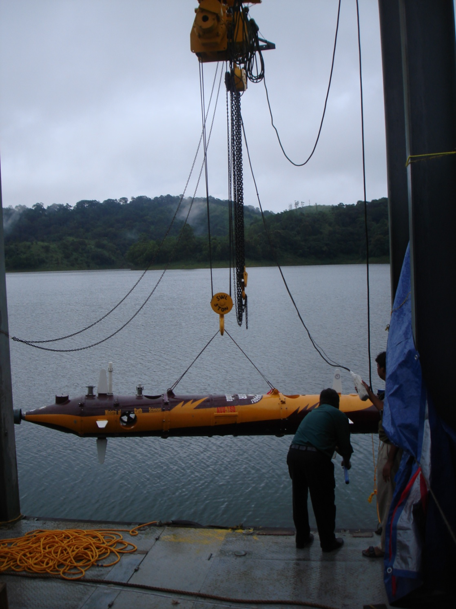

Robotics & Automation Group
CSIR-Central Mechanical Engineering Research Institute, Durgapur
(Autonomous body under Ministry of Science & Technology, GOI, New Delhi)

Table of Contents

1. Introduction 4
2. Physical Verification for deck mounting and cable interfaces 5
2.1. Secured Mounting of Major Ship based sub systems 5
2.2. AUV-150____________________________________________________________________5
3. Pre Dive (Dry) 7
3.1. Breakers 7
3.2. Control Console______________________________________________________________7
3.3. Sub-system Power and Signal Interfaces__________________________________________7
3.4. AUV-150___________________________________________________________________8
4. Pre Operational Dive Test (wet test) 10
4.1 AUV-150__________________________________________________________________10
5. Post Dive (Dry) 11
5.1. AUV-150__________________________________________________________________11
6. Summary 13
Signatures 13

Surface Vessel / Facility: Dive No:

Test Objectives:

Weather Details

Wind speed and Direction

Surface Current Speed and Direction

GPS Positions Date:

Introduction

The main objective of this test procedure is to check the safety, connectivity and functionality aspects of all the subsystems and components and as whole the readiness of the overall integrated AUV-150 for the planned missions.

Following are the details of filling the checklists:

- Physical verification and recording the remarks as ‘pre dive’ requisite before powering up the subsystems for test sequence
- After powering the system, performance check has to be made as “pre-dive-test (dry test)” requisite before deployment in water for system operation
- After deployment in water critical monitoring parameter are to be checked and recorded as ‘pre operational dive test (wet test)’ for integrated system healthiness to proceed dive operation
- After completion of “pre operational test”, system will be tested for its operation as an “Operational test plan”
- After completion of dive operation checks are to be made as “post-dive” requisite to know the status of individual system after retrieval on the deck

Physical Verification for Deck Mounting and Cable Interfaces

Secured Mounting of Major Ship based sub systems

CHECKS | STATUS | REMARKS
Control Console container
AUV-150
RF Antenna Mounting Framework
USBL Mounting Framework
Wi-Fi Camera for On-Deck Photography
Checked By: | Verified By :

AUV-150

CHECKS | STATUS |  | REMARKS
AUV-150 frame Structure:
- No visible damage
- All mounting bolts Secured
DVL:
- Securely Mounted
- Cable secured
- Bulkhead properly connected
Main Thruster
- Securely Mounted
- Bulkhead connector properly connected
Camera
- Securely Mounted
- Bulkhead connector properly connected
Lamps
- Securely Mounted
- Bulkhead connector properly connected
Forward looking SONAR (FLS)
- Securely Mounted
- Bulkhead connector properly connected
Side Scan SONARS
- Securely Mounted
- Bulkhead connector properly connected
Acoustic Transponder
- Securely Mounted
- Bulkhead connector properly connected
Checked By: |  | Verified By :

Pre Dive (Dry)

POWER-UP CHECKS

Caution
Electrical Voltages are present that can seriously cause personal injury as well as damage components. Ensure that the required personnel are in place before power up the systems.

Breakers

CHECKS | STATUS | VALUE | REMARKS
    - Ship supply status (record the value)
    - Control Console Input from Ship supply
Checked By: |  | Verified By :

Control Console
CHECKS | STATUS | REMARKS
UPS Battery rack Mounting
Air Conditioning and Lighting
Mount LCD Monitors (five numbers)
Fix Console Computers (three numbers)
Fix DVS
Fix NPort Media Converter
Fix AWK Access Point
Fix Ethernet Switch
Fix Laptops
Fix Regulated Power Supply
Electrical readiness: Battery charging, soldering, power supply, Lead Acid battery charging
Mouses & keyboards of all 4 stations
Operator Seating of all 4 stations
Power Connector Outside Console
GPS antenna mountings over the container
Checked By: | Verified By :

Subsystem Power & Signal Interfaces
CHECKS | PRE | REMARKS | POST | REMARKS
Ship power supply to Control container input
Power Connection to all computers inside the control containers
Switch ON console computers
Mount RF Antenna on the mounting frame
Connect Antenna Cable with AWK main port
Connect all console computers in LAN with the Ethernet switch
Power ON AWK wireless access point
Power ON NPort media converter
Submerge USBL Transceiver into waters from mounting frame
Connect power and signal cables from Transceiver with power supply and console computer
Power ON Transceiver
Power ON Wi-Fi Camera mounted outside the container
Console Computer & Wi-Fi Camera (both communication & display)
Checked By: |  | Verified By :

AUV-150
CHECKS |  | STATUS |  |  | VALUE |  |  | REMARKS
AUV-150 Connectivity from Console Computer |  |  |  |  | NA
Battery Voltage as observed with Multi-meter
- B1
- B2
- B3
- B4
- B5
- B6
- B1~B4
- B5~B6
Camera Operation from Console Computer |  |  |  |  | NA
Lamps Operation from Console Computer |  |  |  |  | NA
Sensors Functionality
- PHINS |  |  |  | NA
- DVL |  |  |  | NA
- Depth sensor |  |  |  | NA
- GPS |  |  |  | NA
- Altimeter |  |  |  | NA
- CTD Profiler |  |  |  | NA
Radio Beacon and Flasher  - Communication betn. Receiver & Flasher |  |  |  |  | NA
DVS Powered ON |  |  |  |  | NA
SONAR functionality
- Forward Looking SONAR |  |  |  |  | NA
- Side Scan SONAR |  |  |  |  | NA
Thruster maneuvering from Console Computer
Nose Horizontal Clockwise  Nose Horizontal Anti-Clockwise |  |  |  |  | NA
Tail Horizontal Clockwise  Tail Horizontal Anti-Clockwise |  |  |  |  | NA
Nose Vertical Clockwise  Nose Vertical Anti-Clockwise |  |  |  |  | NA
Tail Vertical Clockwise  Tail Vertical Anti-Clockwise |  |  |  |  | NA
Main Thruster Clockwise  Main Thruster Anti-Clockwise |  |  |  |  | NA
Underwater RF antenna sealing:  - O-Ring condition |  |  |  |  | NA
Checked By: |  |  |  |  | Verified By :

Pre Operational Dive Test (wet test)

CHECKS | STATUS |  |  | VALUE |  | REMARKS
AUV-150
Lamps switched ON from Console Computer |  |  |  | NA
Camera Recording Initiated |  |  |  | NA
SSS Data logging started |  |  |  | NA
CTD Data Logging Initiated |  |  |  | NA
Sensor Initialization
- PHINS |  |  |  | NA
- DVL |  |  |  | NA
- Depth sensor |  |  |  | NA
- GPS |  |  |  | NA
- Altimeter |  |  |  | NA
“Request Data” sent from Surface Console
- Latitude
- Longitude
- UTM Northing
- UTM Easting
- Altimetry
- Roll
- Pitch
Battery Status as observed from Surface Console
- B1 |  |  | NA |  | A: Alarming (<25 Volts)  C: Critical (25~<27 Volts)  S: Safe (27~29 Volts)
- B2 |  |  | NA
- B3 |  |  | NA
- B4 |  |  | NA
- B5 |  |  | NA
- B6 |  |  | NA
- B1~B4 |  |  | NA
- B5~B6 |  |  | NA
“Request Status” sent from Surface Console
Checked By : |  |  |  | Verified By :

Post Dive (Dry)

AUV-150
CHECKS |  | STATUS |  | VALUE | REMARKS
AUV-150 Connectivity from Surface Console |  |  |  | NA
FLS LEDs blinking |  |  |  | NA
Visual Inspection
- Main Thruster Mounting |  |  |  | NA
- Any physical damage to the Hull |  |  |  | NA
- Any Physical Damage to the
following devices:
 | - DVL |  |  | NA
 | - Camera |  |  | NA
 | - Lamps |  |  | NA
 | - Transponder |  |  | NA
 | - Side Scan SONAR |  |  | NA
 | - Forward Looking SONAR |  |  | NA
“Request Status” sent from Surface Console |  | Response:
Log on to DVS |  |  |  | NA
Camera Logging Status |  |  |  | NA
Side Scan SONAR logging Status |  |  |  | NA
CTD Data Logging Status
Lamps switched OFF |  |  |  | NA
Thruster maneuvering from Console Computer
Nose Horizontal Clockwise  Nose Horizontal Anti-Clockwise |  |  |  | NA
Tail Horizontal Clockwise  Tail Horizontal Anti-Clockwise |  |  |  | NA
Nose Vertical Clockwise  Nose Vertical Anti-Clockwise |  |  |  | NA
Tail Vertical Clockwise  Tail Vertical Anti-Clockwise |  |  |  | NA
Main Thruster Clockwise  Main Thruster Anti-Clockwise |  |  |  | NA
Sensors Functionality
- PHINS |  |  |  | NA
- DVL |  |  |  | NA
- Depth sensor |  |  |  | NA
- GPS |  |  |  | NA
- Altimeter |  |  |  | NA
- CTD Profiler |  |  |  | NA
Tracking by Radio Beacon Receiver |  |  |  | NA
Battery Voltage as observed with Multi-meter
- B1
- B2
- B3
- B4
- B5
- B6
- B1~B4
- B5~B6
System Powered OFF |  |  | NA
Checked By: |  |  | Verified By :

Summary

Performance summary:

Maintenance Required:

Other Comments:

Signatures

- S. Nandy _____________________
- S. R. K. Vadali
- D. Pal _____________________
- S. K. Das _____________________

Test Director
(S. N. Shome)

