Data Mining PCA and Factor Analysis

*#install.packages("psych")*

*#install.packages("GPArotation") #install.packages("readxl")*

**library**(psych) **library**(GPArotation) **library**(readxl) **setwd**("C:/Users/pc/Desktop/Spring2019/DM/hw2") *#View(USJudgeRatings)*

**TASK2**

**Problem 1**

1. Determining number of components to extract Removing the CONT variable

**fa.parallel**(USJudgeRatings[,**-**1],fa="pc",n.iter=100,show.legend = FALSE,

main="Scree plot with parallel analysis")

**Scree plot with parallel analysis**

2

4

6

8

10

0

2

4

6

8

10

eigen values of principal components

Component Number

## Parallel analysis suggests that the number of factors = NA and the number of components = 1

*#?fa.parallel()*

1. Extracting components

pc<- **principal**(USJudgeRatings[,**-**1],nfactors=1) pc

## Principal Components Analysis

## Call: principal(r = USJudgeRatings[, -1], nfactors = 1)

## Standardized loadings (pattern matrix) based upon correlation matrix

## PC1 h2 u2 com

## INTG 0.92 0.84 0.1565 1

## DMNR 0.91 0.83 0.1663 1

## DILG 0.97 0.94 0.0613 1

## CFMG 0.96 0.93 0.0720 1

## DECI 0.96 0.92 0.0763 1

## PREP 0.98 0.97 0.0299 1

## ORAL 1.00 0.99 0.0091 1## WRIT 0.99 0.98 0.0196 1

## PHYS 0.89 0.80 0.2013 1## RTEN 0.99 0.97 0.0275 1

#### PC1## SS loadings 10 13

## FAMI 0.98 0.95 0.0469 1

## Proportion Var 0.92

##

## Mean item complexity = 1

## Test of the hypothesis that 1 component is sufficient.

##

## The root mean square of the residuals (RMSR) is 0.04

## with the empirical chi square 6.21 with prob < 1

##

## Fit based upon off diagonal values = 1

c) Rotating components

|  |
| --- |
| rc<-**principal**(USJudgeRatings[,**-**1], nfactors = 1,rotate="varimax")  *#?principal()* rc |

## Principal Components Analysis

## Call: principal(r = USJudgeRatings[, -1], nfactors = 1, rotate = "varimax")

## Standardized loadings (pattern matrix) based upon correlation matrix

## PC1 h2 u2 com

## INTG 0.92 0.84 0.1565 1

## DMNR 0.91 0.83 0.1663 1

## DILG 0.97 0.94 0.0613 1

## CFMG 0.96 0.93 0.0720 1

# ## DECI 0.96 0.92 0.0763 1

# ## PREP 0.98 0.97 0.0299 1

## FAMI 0.98 0.95 0.0469 1

# ## ORAL 1.00 0.99 0.0091 1

## WRIT 0.99 0.98 0.0196 1

# ## PHYS 0.89 0.80 0.2013 1

## RTEN 0.99 0.97 0.0275 1

# ##

## PC1

## SS loadings 10.13

## Proportion Var 0.92

##

## Mean item complexity = 1

## Test of the hypothesis that 1 component is sufficient.

##

## The root mean square of the residuals (RMSR) is 0.04

## with the empirical chi square 6.21 with prob < 1

##

## Fit based upon off diagonal values = 1

1. Computing Component scores

pc<-**principal**(USJudgeRatings[,**-**1], nfactors = 1,scores=TRUE,rotate="varimax") **head**(pc**$**scores)

## PC1

## AARONSON,L.H. -0.1857981

## ALEXANDER,J.M. 0.7469865

## ARMENTANO,A.J. 0.0704772

## BERDON,R.I. 1.1358765

## BRACKEN,J.J. -2.1586211

## BURNS,E.B. 0.7669406

1. Graphing an orthogonal solution

*#?factor.plot()*

**factor.plot**(rc, labels = **rownames**(rc**$**loadings))

**Principal Component Analysis**

2

4

6

8

10

0.90

0.92

0.94

0.96

0.98

load

INTG

DMNR

DILG

CFMG

DECI

PREP

FAMI

ORAL

WRIT

PHYS

RTEN

Index

1. Interpretation

This dataset has has several attributes like demeanor,diligence, integrity, preparation to rate a US Judge. The dataset has 43 instances and has 12 attributes out of which we remove CONT , narrowing it down to 112 attributes. Running the fa.parallel function we find out that there is 1 principal component detected in the dataset and building a factor plot on it gives us the above correlation matrix diagram, which gives the domain expert a deep insight on how the components are classified and what varaibles are grouped together, this will further help us better understand how a Judge is rated.

Through this exercise we reduce a lot of correlated parameters into a few unrelated significant ones and conduct PCA in a very efficient manner.

**Problem 2**

1. Computing number of components to extract Removing ID variable and Class Variable

|  |
| --- |
| data2 <- **read_excel**("C:/Users/pc/Desktop/Spring2019/DM/hw2/Glass_Identification_Data.xlsx"  data2<-data2[**-**11] **fa.parallel**(data2[,**-**1],fa="pc",n.iter=100,show.legend = FALSE,  main="Scree plot with parallel analysis") |

)

**Scree plot with parallel analysis**

2

4

6

8

0.0

0.5

1.0

1.5

2.0

2.5

eigen values of principal components

Component Number

## Parallel analysis suggests that the number of factors = NA and the number of components = 4

*#?fa.parallel()*

1. Extracting components

pc2<- **principal**(data2[,**-**1],nfactors=4) pc2

## Principal Components Analysis

## Call: principal(r = data2[, -1], nfactors = 4)

## Standardized loadings (pattern matrix) based upon correlation matrix

## RC1 RC2 RC3 RC4 h2 u2 com

## RI 0.84 -0.07 0.15 0.47 0.95 0.051 1.7

## Na -0.06 0.22 -0.86 0.09 0.80 0.195 1.2

## Mg -0.35 -0.86 0.04 0.21 0.92 0.081 1.5

## Al -0.42 0.80 0.03 0.01 0.81 0.186 1.5

## Si -0.13 0.00 -0.02 -0.98 0.97 0.031 1.0

## K -0.62 0.22 0.51 0.30 0.79 0.212 2.7

## CA 0.91 0.12 0.30 0.06 0.94 0.058 1.3

## Ba -0.01 0.72 -0.33 0.17 0.67 0.333 1.5

## Fe 0.12 -0.04 0.50 0.07 0.27 0.730 1.2

##

## RC1 RC2 RC3 RC4

## SS loadings 2.26 2.03 1.48 1.36

## Proportion Var 0.25 0.23 0.16 0.15

## Cumulative Var 0.25 0.48 0.64 0.79

## Proportion Explained 0.32 0.28 0.21 0.19

## Cumulative Proportion 0.32 0.60 0.81 1.00

##

## Mean item complexity = 1.5

## Test of the hypothesis that 4 components are sufficient.

##

## The root mean square of the residuals (RMSR) is 0.08

## with the empirical chi square 102.53 with prob < 7.4e-20

##

## Fit based upon off diagonal values = 0.92

c) Rotating components

|  |
| --- |
| rc2<-**principal**(data2[,**-**1], nfactors = 4,rotate="varimax")  *#?principal()* rc2 |

## Principal Components Analysis

## Call: principal(r = data2[, -1], nfactors = 4, rotate = "varimax")

## Standardized loadings (pattern matrix) based upon correlation matrix

## RC1 RC2 RC3 RC4 h2 u2 com

## RI 0.84 -0.07 0.15 0.47 0.95 0.051 1.7

## Na -0.06 0.22 -0.86 0.09 0.80 0.195 1.2

## Mg -0.35 -0.86 0.04 0.21 0.92 0.081 1.5

## Al -0.42 0.80 0.03 0.01 0.81 0.186 1.5

## Si -0.13 0.00 -0.02 -0.98 0.97 0.031 1.0

## K -0.62 0.22 0.51 0.30 0.79 0.212 2.7

## CA 0.91 0.12 0.30 0.06 0.94 0.058 1.3

## Ba -0.01 0.72 -0.33 0.17 0.67 0.333 1.5

## Fe 0.12 -0.04 0.50 0.07 0.27 0.730 1.2

##

## RC1 RC2 RC3 RC4

## SS loadings 2.26 2.03 1.48 1.36

## Proportion Var 0.25 0.23 0.16 0.15

## Cumulative Var 0.25 0.48 0.64 0.79

## Proportion Explained 0.32 0.28 0.21 0.19

## Cumulative Proportion 0.32 0.60 0.81 1.00

##

## Mean item complexity = 1.5

## Test of the hypothesis that 4 components are sufficient.

##

## The root mean square of the residuals (RMSR) is 0.08

## with the empirical chi square 102.53 with prob < 7.4e-20

##

## Fit based upon off diagonal values = 0.92

d)Computing Component scores

pc2<-**principal**(data2[,**-**1], nfactors = 4,scores=TRUE,rotate="varimax") **head**(pc2**$**scores)

## RC1 RC2 RC3 RC4

## [1,] 0.2516834 -1.1257154 -0.8331376 1.14203433

## [2,] -0.5120556 -0.5823124 -0.7217195 0.07184681

## [3,] -0.6811108 -0.4417522 -0.4610237 -0.39146231

## [4,] -0.4363986 -0.6266048 -0.1520952 0.09532063

## [5,] -0.4446499 -0.6485935 -0.1947898 -0.37616223 ## [6,] -0.7149524 -0.2237372 1.1926990 -0.41874608

e)Graphing orthogonal solution

*#?factor.plot()*

**factor.plot**(rc2, labels = **rownames**(rc2**$**loadings))

**Principal Component Analysis**

−0.5 0.0 0.5 −1.0 −0.5 0.0 0.5

|  |  |  |  |  |
| --- | --- | --- | --- | --- |
| |  | | --- | | RC1 | | RI  Na  Mg  ~~A~~  l  Si  K  CA  Ba  Fe | RI  Na  g  M  Al  Si  K  CA  Ba  Fe  RI  Na  Mg  ~~A~~  l  Si  K  CA  Ba  F  e | −0.5  0.5  RI  Na  Mg  ~~A~~  l  Si  K  CA  Ba  Fe  R  I  Na  Mg  ~~A~~  l  Si  K  CA  Ba  Fe  −0.8  0.0  RI  Na  Mg  ~~A~~  l  Si  K  CA  Ba  Fe |
| −0.5  0.5  RI  Na  Mg  ~~A~~  l  Si  K  A  C  Ba  Fe  RI  Na  Mg  ~~l~~  ~~A~~  Si  K  CA  Ba  Fe  −1.0  0.0  RI  Na  Mg  l  ~~A~~  Si  K  CA  Ba  Fe  RC2  RI  Na  Mg  l  ~~A~~  Si  K  CA  Ba  Fe  RI  Na  Mg  Al  Si  K  CA  a  B  Fe | |
| |  | | --- | | RC3 | |
| RI  Na  Mg  ~~A~~  l  Si  K  CA  Ba  Fe |
| |  | | --- | | RC4 | |

−0.5 0.0 0.5 −0.8 −0.4 0.0 0.4

f) Interpretations This dataset studies the classification of types of glass and was motivated by criminological investigation. At the scene of the crime, the glass left can be used as evidence if it is correctly identified. The dataset has 214 instances and has 10 attributes out of which we remove ID and class , narrowing it down to 8 attributes. Running the fa.parallel function we find out that there 4 principal components detected in the dataset and building a factor plot on it gives us the above correlation matrix diagram, which gives the domain expert a deep insight on how the components are classified and what variables are grouped together, this will further help the criminology investigators in finding an insight on their evidence.

**Problem3**

**Performing Factor Analysis**

a)Determining number of components to extract

**fa.parallel**(Harman23.cor**$**cov, n.obs=Harman23.cor**$**n.obs, fa="fa", n.iter=100, main="scree plot with factor analysis")

**scree plot with factor analysis**

1

2

3

4

5

6

7

8

0

1

2

3

4

eigen values of principal factors

FA Actual Data

FA Simulated Data

Factor Number

## Parallel analysis suggests that the number of factors = 2 and the number of components = NA b) extract the components

fa <- **fa**(Harman23.cor**$**cov, nfactors= 2, rotate = "none") fa

## Factor Analysis using method = minres

## Call: fa(r = Harman23.cor$cov, nfactors = 2, rotate = "none")

## Standardized loadings (pattern matrix) based upon correlation matrix

## MR1 MR2 h2 u2 com

## height 0.86 -0.32 0.84 0.16 1.3

## arm.span 0.85 -0.41 0.89 0.11 1.4

## forearm 0.81 -0.41 0.82 0.18 1.5

## lower.leg 0.83 -0.34 0.81 0.19 1.3

## weight 0.75 0.57 0.89 0.11 1.9

## bitro.diameter 0.63 0.49 0.64 0.36 1.9

## chest.girth 0.57 0.51 0.58 0.42 2.0

## chest.width 0.61 0.35 0.49 0.51 1.6

##

## MR1 MR2

## SS loadings 4.45 1.51

## Proportion Var 0.56 0.19

## Cumulative Var 0.56 0.74

## Proportion Explained 0.75 0.25

## Cumulative Proportion 0.75 1.00

##

## Mean item complexity = 1.6

## Test of the hypothesis that 2 factors are sufficient.

##

## The degrees of freedom for the null model are 28 and the objective function was 6.94

## The degrees of freedom for the model are 13 and the objective function was 0.26

##

## The root mean square of the residuals (RMSR) is 0.02

## The df corrected root mean square of the residuals is 0.03

##

## Fit based upon off diagonal values = 1

## Measures of factor score adequacy

## MR1 MR2

## Correlation of (regression) scores with factors 0.98 0.94

## Multiple R square of scores with factors 0.96 0.89

## Minimum correlation of possible factor scores 0.93 0.78

C) Factor extraction with orthogonal and oblique rotation

fa.varimax <- **fa**(Harman23.cor**$**cov, nfactors=2, rotate="varimax") fa.varimax

## Factor Analysis using method = minres

## Call: fa(r = Harman23.cor$cov, nfactors = 2, rotate = "varimax")

## Standardized loadings (pattern matrix) based upon correlation matrix

|  |  |
| --- | --- |
| ## | MR1 MR2 h2 u2 com |
| ## height | 0.87 0.29 0.84 0.16 1.2 |
| ## arm.span | 0.92 0.21 0.89 0.11 1.1 |
| ## forearm | 0.89 0.19 0.82 0.18 1.1 |
| ## lower.leg | 0.86 0.26 0.81 0.19 1.2 |

## weight 0.23 0.92 0.89 0.11 1.1

## bitro.diameter 0.18 0.78 0.64 0.36 1.1

## chest.girth 0.12 0.75 0.58 0.42 1.1

## chest.width 0.25 0.65 0.49 0.51 1.3

|  |  |
| --- | --- |
| ## |  |
| ## | MR1 MR2 |
| ## SS loadings | 3.29 2.67 |
| ## Proportion Var | 0.41 0.33 |
| ## Cumulative Var | 0.41 0.74 |

## Proportion Explained 0.55 0.45

## Cumulative Proportion 0.55 1.00

##

## Mean item complexity = 1.1

## Test of the hypothesis that 2 factors are sufficient.

##

## The degrees of freedom for the null model are 28 and the objective function was 6.94

## The degrees of freedom for the model are 13 and the objective function was 0.26

##

## The root mean square of the residuals (RMSR) is 0.02

## The df corrected root mean square of the residuals is 0.03

##

## Fit based upon off diagonal values = 1

## Measures of factor score adequacy

## MR1 MR2

## Correlation of (regression) scores with factors 0.97 0.95

## Multiple R square of scores with factors 0.94 0.91 ## Minimum correlation of possible factor scores 0.88 0.82

fa.promax <- **fa**(Harman23.cor**$**cov, nfactors=2, rotate="promax") fa.promax

## Factor Analysis using method = minres

## Call: fa(r = Harman23.cor$cov, nfactors = 2, rotate = "promax")

## Standardized loadings (pattern matrix) based upon correlation matrix

|  |  |
| --- | --- |
| ## MR1 MR2 h2 u2 com | |
| ## height 0.88 0.06 0.84 0.16 | 1 |
| ## arm.span 0.96 -0.03 0.89 0.11 | 1 |
| ## forearm 0.93 -0.05 0.82 0.18 | 1 |
| ## lower.leg 0.88 0.03 0.81 0.19 | 1 |
| ## weight 0.00 0.94 0.89 0.11 | 1 |
| ## bitro.diameter -0.01 0.81 0.64 0.36 | 1 |
| ## chest.girth -0.07 0.79 0.58 0.42 | 1 |
| ## chest.width 0.10 0.65 0.49 0.51  ##  ## MR1 MR2  ## SS loadings 3.36 2.60  ## Proportion Var 0.42 0.33  ## Cumulative Var 0.42 0.74  ## Proportion Explained 0.56 0.44  ## Cumulative Proportion 0.56 1.00  ##  ## With factor correlations of  ## MR1 MR2  ## MR1 1.00 0.48 | 1 |

## MR2 0.48 1.00

##

## Mean item complexity = 1

## Test of the hypothesis that 2 factors are sufficient.

##

## The degrees of freedom for the null model are 28 and the objective function was 6.94

## The degrees of freedom for the model are 13 and the objective function was 0.26

##

## The root mean square of the residuals (RMSR) is 0.02

## The df corrected root mean square of the residuals is 0.03

##

## Fit based upon off diagonal values = 1

## Measures of factor score adequacy

## MR1 MR2

## Correlation of (regression) scores with factors 0.98 0.96

## Multiple R square of scores with factors 0.96 0.93

## Minimum correlation of possible factor scores 0.92 0.85

d) Factor scores

fa <- **fa**(Harman23.cor**$**cov, nfactors= 2, rotate = "varimax",score=TRUE) (fa**$**weights)

|  |  |
| --- | --- |
| ## | MR1 MR2 |
| ## height | 0.26978933 -0.08743310 |
| ## arm.span | 0.40153276 0.01394996 |
| ## forearm | 0.23385047 -0.11827354 |
| ## lower.leg | 0.21770758 -0.03983803 |
| ## weight | -0.15331340 0.71035858 |

## bitro.diameter -0.04193297 0.17190329

## chest.girth -0.04161745 0.13432201

## chest.width -0.03442273 0.11896061

e)Orthogonal solution

**factor.plot**(fa.varimax, labels = **rownames**(fa.varimax**$**loadings))

**Factor Analysis**

0.2

0.4

0.6

0.8

0.2

0.4

0.6

0.8

MR2

height

arm.spa

forearm

lower.leg

weight

bitro.diameter

est.girth

chest.width

MR1

1. Oblique Solutions

**fa.diagram**(fa.promax, labels = **rownames**(fa.promax**$**loadings))

**Factor Analysis**

arm.span

forearm

height

lower.leg

weight

bitro.diameter

chest.girth

chest.width

MR1

1

0.9

0.9

0.9

MR2

0.9

0.8

0.8

0.6

0.5

1. Interpretations

In this problem we explain the correlations among the given variables in the dataset by uncovering a smaller set of completely unrelated variables. Thus we find factors and then try to explain the correlations amongst all the variables given the dataset. In this problem we first find the factors i.e a smaller set of unrelated variables, rotate the variables and then compute their scores and then plot the results.

**Problem 4**

a) Determine the number of components to extract

**fa.parallel**(Harman74.cor**$**cov, n.obs=Harman74.cor**$**n.obs, fa="fa", n.iter=100, main="scree plot with facto

**scree plot with factor analysis**

5

10

15

20

0

2

4

6

8

eigen values of principal factors

FA Actual Data

FA Simulated Data

Factor Number

## Parallel analysis suggests that the number of factors = 4 and the number of components = NA b) Extract the components

fa <- **fa**(Harman74.cor**$**cov, nfactors= 4, rotate = "none") fa

## Factor Analysis using method = minres

## Call: fa(r = Harman74.cor$cov, nfactors = 4, rotate = "none")

## Standardized loadings (pattern matrix) based upon correlation matrix

|  |  |
| --- | --- |
| ## | MR1 MR2 MR3 MR4 h2 u2 com |
| ## VisualPerception | 0.60 0.03 0.38 -0.22 0.55 0.45 2.0 |
| ## Cubes | 0.37 -0.03 0.26 -0.15 0.23 0.77 2.2 |
| ## PaperFormBoard | 0.42 -0.12 0.36 -0.13 0.34 0.66 2.3 |
| ## Flags | 0.48 -0.11 0.26 -0.19 0.35 0.65 2.0 |
| ## GeneralInformation | 0.69 -0.30 -0.27 -0.04 0.64 0.36 1.7 |

## PargraphComprehension 0.69 -0.40 -0.20 0.08 0.68 0.32 1.8

|  |  |
| --- | --- |
| ## SentenceCompletion | 0.68 -0.41 -0.30 -0.08 0.73 0.27 2.1 |
| ## WordClassification | 0.67 -0.19 -0.09 -0.11 0.51 0.49 1.3 |
| ## WordMeaning | 0.70 -0.45 -0.23 0.08 0.74 0.26 2.0 |
| ## Addition | 0.47 0.53 -0.48 -0.10 0.74 0.26 3.1 |
| ## Code | 0.56 0.36 -0.16 0.09 0.47 0.53 2.0 |
| ## CountingDots | 0.47 0.50 -0.14 -0.24 0.55 0.45 2.6 |

## StraightCurvedCapitals 0.60 0.26 0.01 -0.29 0.51 0.49 1.9

## WordRecognition 0.43 0.06 0.01 0.42 0.36 0.64 2.0

|  |  |
| --- | --- |
| ## NumberRecognition | 0.39 0.10 0.09 0.37 0.31 0.69 2.2 |
| ## FigureRecognition | 0.51 0.09 0.35 0.25 0.45 0.55 2.3 |
| ## ObjectNumber | 0.47 0.21 -0.01 0.39 0.41 0.59 2.4 |
| ## NumberFigure | 0.52 0.32 0.16 0.14 0.41 0.59 2.1 |
| ## FigureWord | 0.44 0.10 0.10 0.13 0.23 0.77 1.4 |
| ## Deduction | 0.62 -0.13 0.14 0.04 0.42 0.58 1.2 |
| ## NumericalPuzzles | 0.59 0.21 0.07 -0.14 0.42 0.58 1.4 |
| ## ProblemReasoning | 0.61 -0.10 0.12 0.03 0.40 0.60 1.1 |
| ## SeriesCompletion | 0.69 -0.06 0.15 -0.10 0.51 0.49 1.2 |
| ## ArithmeticProblems  ## | 0.65 0.17 -0.19 0.00 0.49 0.51 1.3 |
| ## | MR1 MR2 MR3 MR4 |
| ## SS loadings | 7.65 1.69 1.22 0.92 |
| ## Proportion Var | 0.32 0.07 0.05 0.04 |
| ## Cumulative Var | 0.32 0.39 0.44 0.48 |

## Proportion Explained 0.67 0.15 0.11 0.08

## Cumulative Proportion 0.67 0.81 0.92 1.00

##

## Mean item complexity = 1.9

## Test of the hypothesis that 4 factors are sufficient.

##

## The degrees of freedom for the null model are 276 and the objective function was 11.44

## The degrees of freedom for the model are 186 and the objective function was 1.72

##

## The root mean square of the residuals (RMSR) is 0.04

## The df corrected root mean square of the residuals is 0.05

##

## Fit based upon off diagonal values = 0.98

## Measures of factor score adequacy

## MR1 MR2 MR3 MR4

## Correlation of (regression) scores with factors 0.97 0.91 0.87 0.79

## Multiple R square of scores with factors 0.94 0.82 0.75 0.62 ## Minimum correlation of possible factor scores 0.89 0.65 0.50 0.24

fa**$**factors

## [1] 4

c) Factor extraction with orthogonal rotation

fa.varimax <- **fa**(Harman74.cor**$**cov, nfactors=4, rotate="varimax") fa.varimax

## Factor Analysis using method = minres

## Call: fa(r = Harman74.cor$cov, nfactors = 4, rotate = "varimax")

## Standardized loadings (pattern matrix) based upon correlation matrix

|  |  |
| --- | --- |
| ## | MR1 MR3 MR2 MR4 h2 u2 com |
| ## VisualPerception | 0.15 0.68 0.20 0.15 0.55 0.45 1.4 |
| ## Cubes | 0.11 0.45 0.08 0.08 0.23 0.77 1.3 |
| ## PaperFormBoard | 0.15 0.55 -0.01 0.11 0.34 0.66 1.2 |
| ## Flags | 0.23 0.53 0.09 0.07 0.35 0.65 1.5 |
| ## GeneralInformation | 0.73 0.19 0.22 0.14 0.64 0.36 1.4 |

## PargraphComprehension 0.76 0.21 0.07 0.23 0.68 0.32 1.4

## SentenceCompletion 0.81 0.19 0.15 0.07 0.73 0.27 1.2

## WordClassification 0.57 0.34 0.23 0.14 0.51 0.49 2.2

## WordMeaning 0.81 0.20 0.05 0.22 0.74 0.26 1.3

## Addition 0.17 -0.11 0.82 0.16 0.74 0.26 1.2

## Code 0.18 0.11 0.54 0.37 0.47 0.53 2.1

## CountingDots 0.02 0.20 0.71 0.09 0.55 0.45 1.2

## StraightCurvedCapitals 0.18 0.42 0.54 0.08 0.51 0.49 2.2

## WordRecognition 0.21 0.05 0.08 0.56 0.36 0.64 1.3

## NumberRecognition 0.12 0.12 0.08 0.52 0.31 0.69 1.3

## FigureRecognition 0.07 0.42 0.06 0.52 0.45 0.55 2.0

## ObjectNumber 0.14 0.06 0.22 0.58 0.41 0.59 1.4

## NumberFigure 0.02 0.31 0.34 0.45 0.41 0.59 2.7

## FigureWord 0.15 0.25 0.18 0.35 0.23 0.77 2.8

## Deduction 0.38 0.42 0.10 0.29 0.42 0.58 2.9

## NumericalPuzzles 0.18 0.40 0.43 0.21 0.42 0.58 2.8

## ProblemReasoning 0.37 0.41 0.13 0.29 0.40 0.60 3.0

## SeriesCompletion 0.37 0.52 0.23 0.22 0.51 0.49 2.7

## ArithmeticProblems 0.36 0.19 0.49 0.29 0.49 0.51 2.9

##

## MR1 MR3 MR2 MR4

## SS loadings 3.64 2.93 2.67 2.23

## Proportion Var 0.15 0.12 0.11 0.09

## Cumulative Var 0.15 0.27 0.38 0.48

## Proportion Explained 0.32 0.26 0.23 0.19

## Cumulative Proportion 0.32 0.57 0.81 1.00

##

## Mean item complexity = 1.9

## Test of the hypothesis that 4 factors are sufficient.

##

## The degrees of freedom for the null model are 276 and the objective function was 11.44

## The degrees of freedom for the model are 186 and the objective function was 1.72

##

## The root mean square of the residuals (RMSR) is 0.04

## The df corrected root mean square of the residuals is 0.05

##

## Fit based upon off diagonal values = 0.98

## Measures of factor score adequacy

## MR1 MR3 MR2 MR4

## Correlation of (regression) scores with factors 0.93 0.87 0.91 0.82

## Multiple R square of scores with factors 0.87 0.76 0.83 0.68

## Minimum correlation of possible factor scores 0.74 0.52 0.65 0.36

c) Factor extraction with oblique rotation

fa.promax <- **fa**(Harman74.cor**$**cov, nfactors=4, rotate="promax") fa.promax

## Factor Analysis using method = minres

## Call: fa(r = Harman74.cor$cov, nfactors = 4, rotate = "promax")

## Standardized loadings (pattern matrix) based upon correlation matrix

## MR1 MR3 MR2 MR4 h2 u2 com

## VisualPerception -0.08 0.78 0.06 -0.05 0.55 0.45 1.0

## Cubes -0.02 0.53 -0.02 -0.05 0.23 0.77 1.0

## PaperFormBoard 0.00 0.66 -0.16 -0.01 0.34 0.66 1.1

## Flags 0.10 0.60 -0.03 -0.10 0.35 0.65 1.1

## GeneralInformation 0.79 -0.02 0.10 -0.05 0.64 0.36 1.0

## PargraphComprehension 0.82 0.00 -0.11 0.09 0.68 0.32 1.1

## SentenceCompletion 0.91 -0.02 0.03 -0.14 0.73 0.27 1.0

## WordClassification 0.54 0.22 0.11 -0.06 0.51 0.49 1.4

## WordMeaning 0.89 -0.02 -0.13 0.08 0.74 0.26 1.1

## Addition 0.09 -0.39 0.97 -0.01 0.74 0.26 1.3

## Code 0.03 -0.11 0.53 0.29 0.47 0.53 1.7

## CountingDots -0.15 0.09 0.81 -0.11 0.55 0.45 1.1

## StraightCurvedCapitals 0.00 0.38 0.55 -0.17 0.51 0.49 2.0

## WordRecognition 0.11 -0.15 -0.07 0.65 0.36 0.64 1.2

## NumberRecognition -0.01 -0.03 -0.07 0.61 0.31 0.69 1.0

## FigureRecognition -0.15 0.39 -0.14 0.54 0.45 0.55 2.2

## ObjectNumber 0.00 -0.15 0.11 0.66 0.41 0.59 1.2

## NumberFigure -0.21 0.21 0.25 0.42 0.41 0.59 2.8

## FigureWord 0.01 0.16 0.07 0.32 0.23 0.77 1.6

## Deduction 0.27 0.35 -0.07 0.18 0.42 0.58 2.5

## NumericalPuzzles 0.00 0.34 0.38 0.03 0.42 0.58 2.0

## ProblemReasoning 0.26 0.33 -0.03 0.17 0.40 0.60 2.5

## SeriesCompletion 0.23 0.48 0.09 0.04 0.51 0.49 1.5

## ArithmeticProblems 0.27 -0.03 0.45 0.14 0.49 0.51 1.9

##

## MR1 MR3 MR2 MR4

## SS loadings 3.70 2.95 2.72 2.11

## Proportion Var 0.15 0.12 0.11 0.09

## Cumulative Var 0.15 0.28 0.39 0.48

## Proportion Explained 0.32 0.26 0.24 0.18

## Cumulative Proportion 0.32 0.58 0.82 1.00

##

## With factor correlations of

## MR1 MR3 MR2 MR4

## MR1 1.00 0.59 0.47 0.53

## MR3 0.59 1.00 0.53 0.59

## MR2 0.47 0.53 1.00 0.56

## MR4 0.53 0.59 0.56 1.00

##

## Mean item complexity = 1.5

## Test of the hypothesis that 4 factors are sufficient.

##

## The degrees of freedom for the null model are 276 and the objective function was 11.44

## The degrees of freedom for the model are 186 and the objective function was 1.72

##

## The root mean square of the residuals (RMSR) is 0.04

## The df corrected root mean square of the residuals is 0.05

##

## Fit based upon off diagonal values = 0.98

## Measures of factor score adequacy

## MR1 MR3 MR2 MR4

## Correlation of (regression) scores with factors 0.96 0.93 0.94 0.90

## Multiple R square of scores with factors 0.92 0.86 0.89 0.81

## Minimum correlation of possible factor scores 0.85 0.72 0.77 0.61 d) Factor scores

|  |  |
| --- | --- |
| fa <- **fa**(Harman23  (fa**$**weights) | .cor**$**cov, nfactors= 4, rotate = "varimax",score=TRUE) |
| ## | MR1 MR2 MR3 MR4 |
| ## height | 0.23701306 -0.04718955 -0.30362841 -0.86839273 |
| ## arm.span | 0.53104780 -0.03203649 0.08060363 1.88120723 |
| ## forearm | 0.07687461 -0.04815310 -0.14880920 -0.32781027 |
| ## lower.leg | 0.28041097 -0.09769697 0.41254826 -0.71603977 |
| ## weight | -0.06563465 0.50476234 -0.05708746 -0.05267651 |
| ## bitro.diameter -0.06881327 0.30603323 -0.55022623 0.04470304  ## chest.girth -0.09440238 0.23278948 0.71214110 0.04015009  ## chest.width -0.05685604 0.11868808 -0.03555216 0.04466266 e) Orthogonal solution | |
| **factor.plot**(fa.varimax) | |

**Factor Analysis**

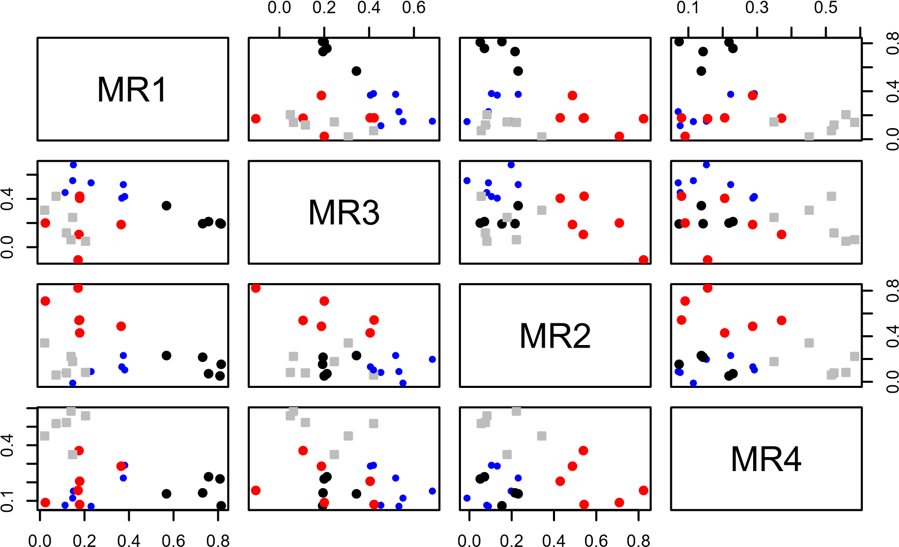

1. Oblique Solutions

**fa.diagram**(fa.promax, labels = **rownames**(fa.promax**$**loadings))

**Factor Analysis**

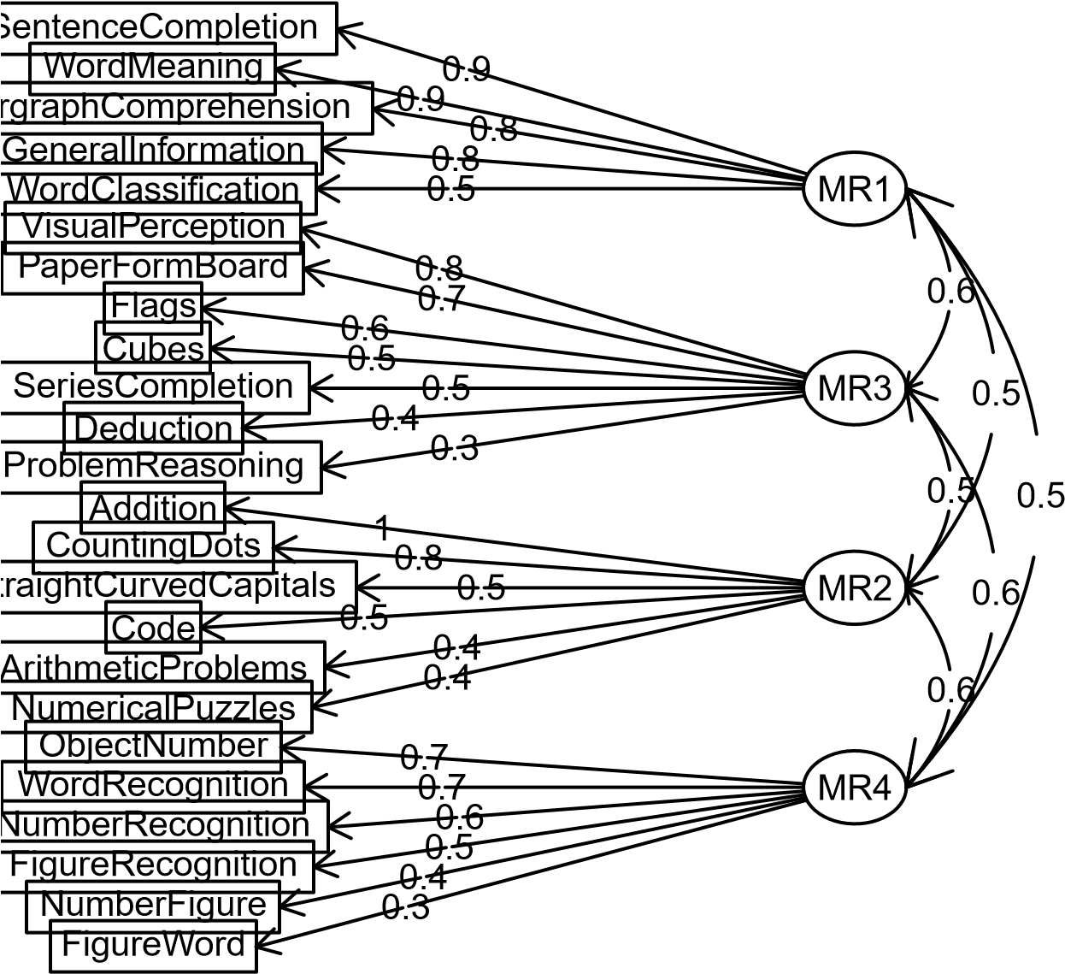

1. Interpretations

According to the Scree test with factor analysis we were able to analyze 4 factor that were to be extracted. In this problem we basically explain the correlations among the given variables in the dataset by uncovering a smaller set of completely unrelated variables. Thus we find factors and then try to explain the correlations amongst all the variables given the dataset.

In this problem we first find the factors i.e a smaller set of unrelated variables, rotate the variables and then compute their scores and then plot the results.

**problem 5**

Dropping Class variable a) Determining number of components to extract

verteb <- **read_excel**("C:/Users/pc/Desktop/Spring2019/DM/hw2/Vertebral_Column_Data.xlsx") **fa.parallel**(verteb[1**:**6], fa="both", n.iter = 100, main = "Scree plots to determine number of components

1

2

3

4

5

6

0.0

1.0

2.0

3.0

**Scree plots to determine number of components to be extracted**

Factor/Component Number

eigenvalues of principal components and factor analysis

PC Actual Data

PC Simulated Data

PC Resampled Data

FA Actual Data

FA Simulated Data

FA Resampled Data

## Parallel analysis suggests that the number of factors = 3 and the number of components = 2 b) Perform Multidimensional scaling

dist<-**dist**(verteb[1**:**6], method = "euclidean", diag = FALSE, upper = FALSE, p=2) cmd <- **cmdscale**(dist,k=2)

1. Orthogonal Solution

**factor.plot**(cmd, title = "Multidimensional Scaling", label="")

**Multidimensional Scaling**

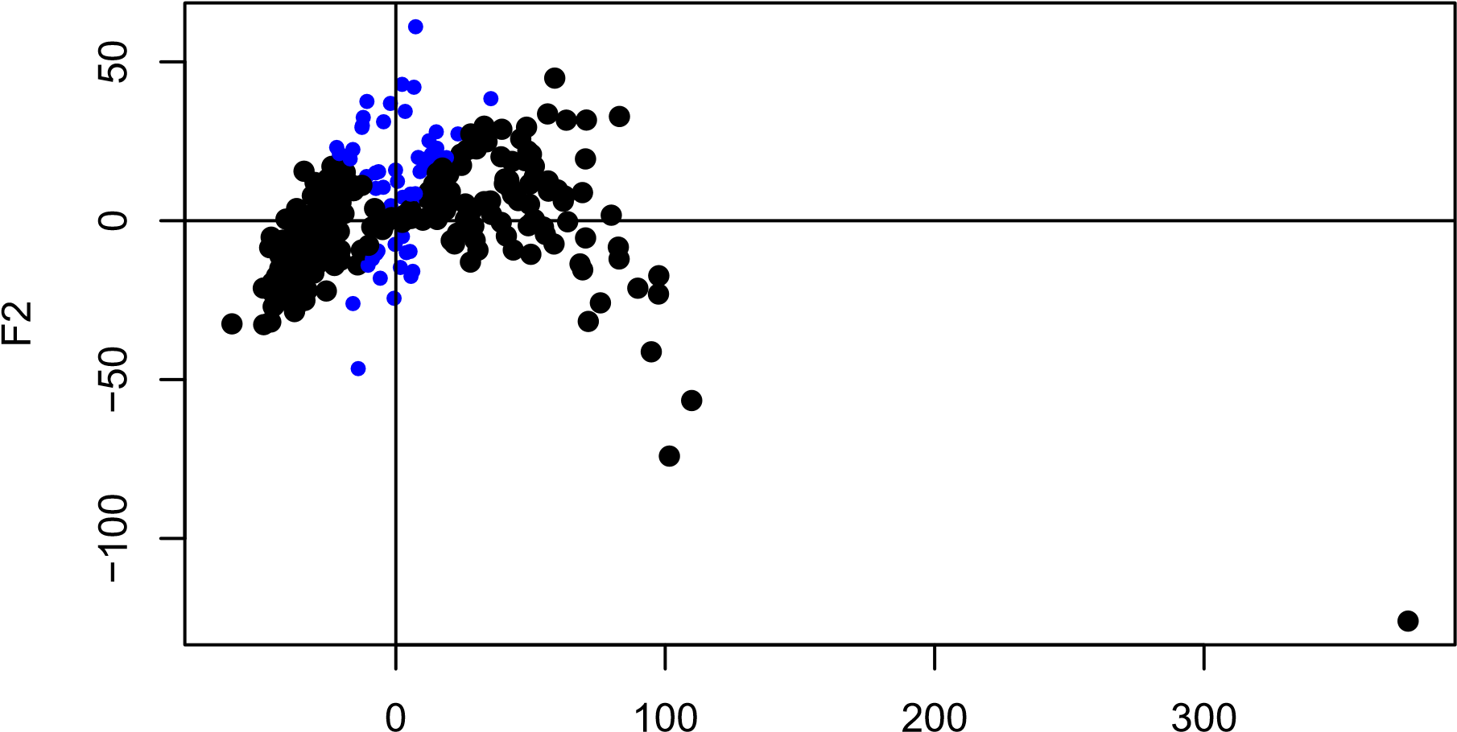

F1

1. Interpretations

The vertebral dataset contains 6 variables and a class variable containing 3 sub-classes and a total of 310 instances. After deleting the class column we run the data through fa.parallel function, in fa argument we gave the argument as “both” which gives analysis of both factor analysis and parallel analysis. Factor analysis suggest us the number of component as 4 and parallel analysis as 3. Then we use cmdscale() function which does classical multidimensional scaling. Multidimensional scaling is one of several multivariate techniques that aim to reveal the structure of data set by plotting points in one or two dimesnions. We then develop a factor plot to the multidimensional scaled data.