# **Customer User Guide**

* Customer can browse their needed products through search bar in the home page.



* Customer can login by clicking login.

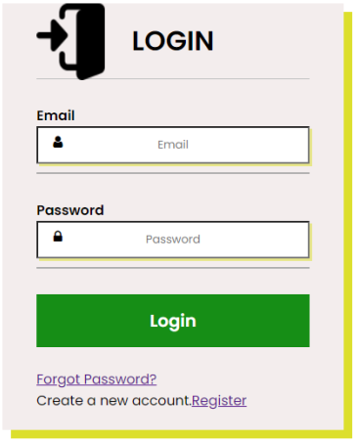

* If they are new customer, they can register by clicking in join/register.

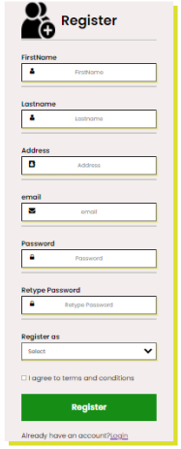

* After logged in customer can click on their profile.



* Customer can edit their profile after clicking their name in homepage.

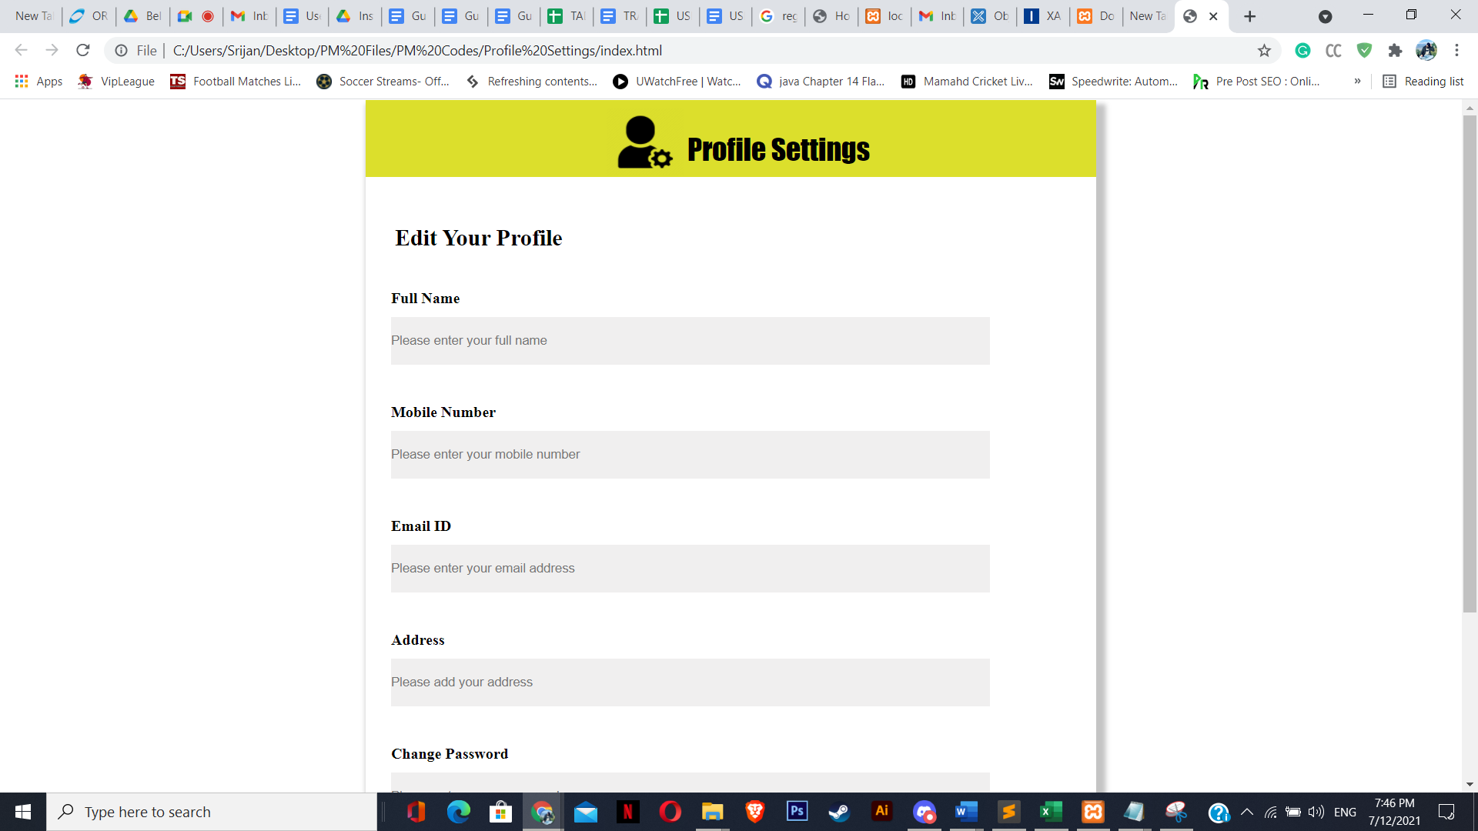

* Customer can also search their products by sorting the categories.

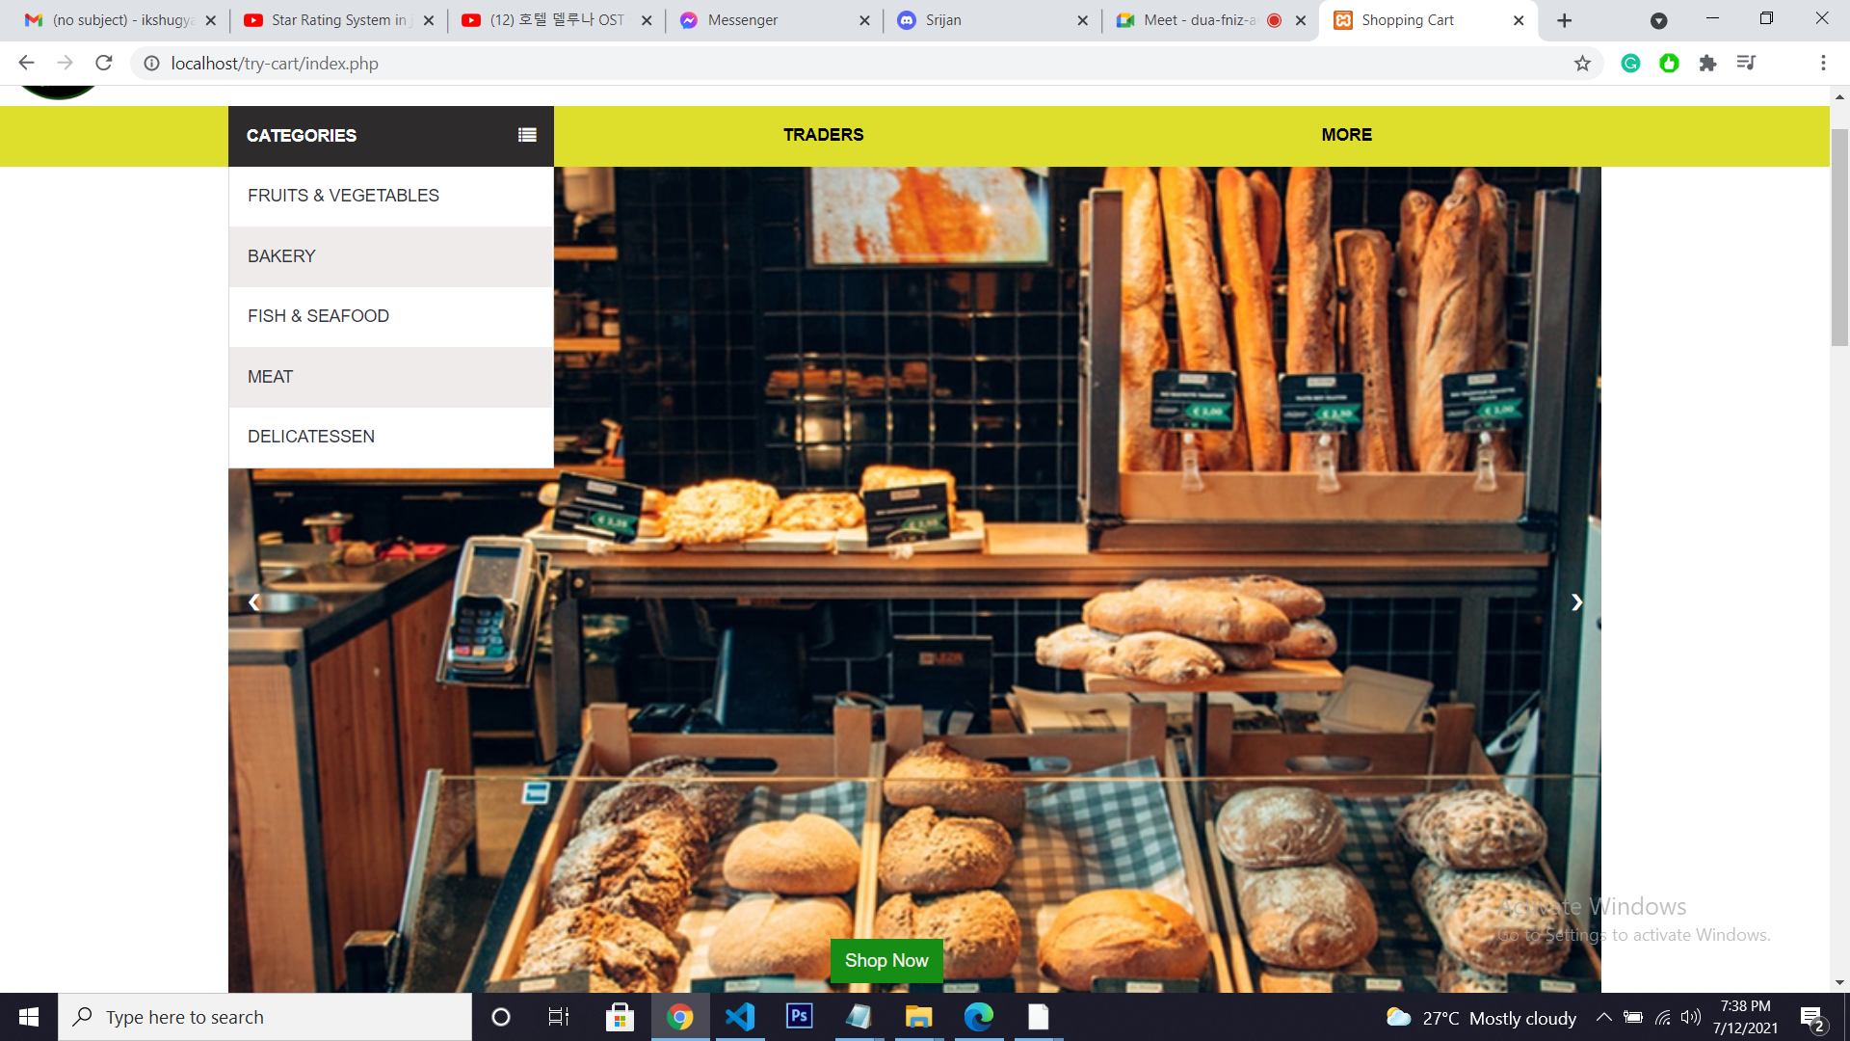

* Customers can add/remove their products in the cart page.

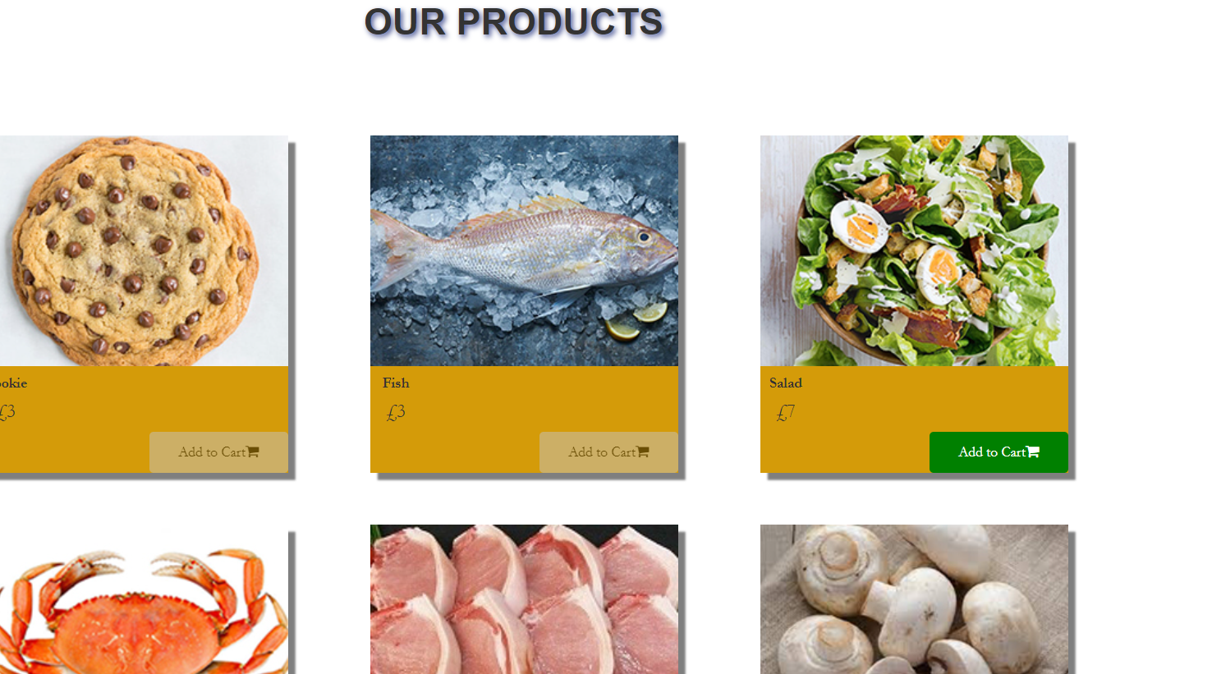

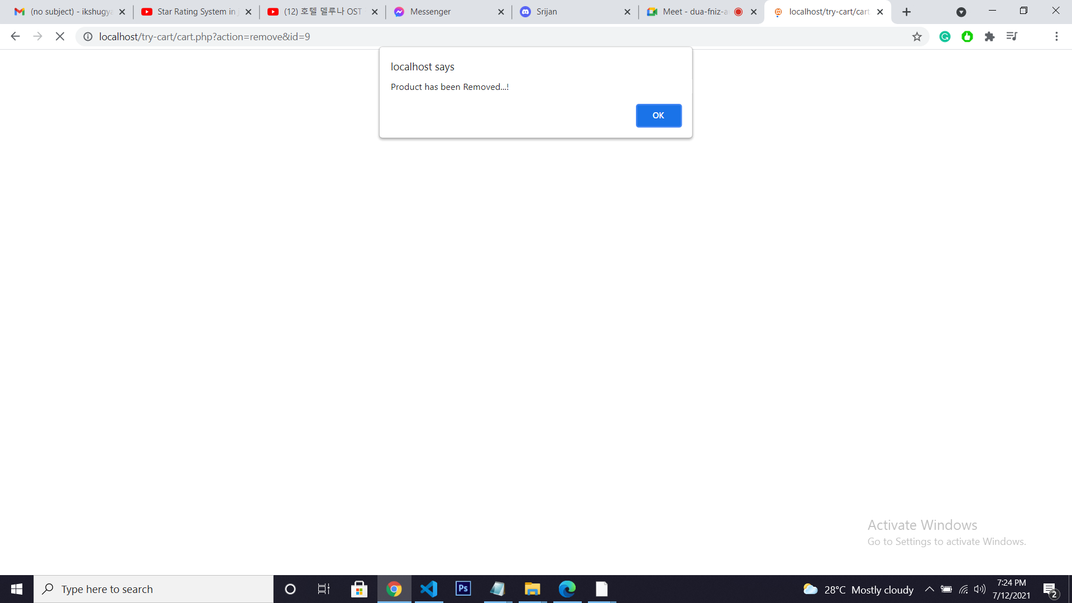

* After adding products customer can buy by clicking buy now button.

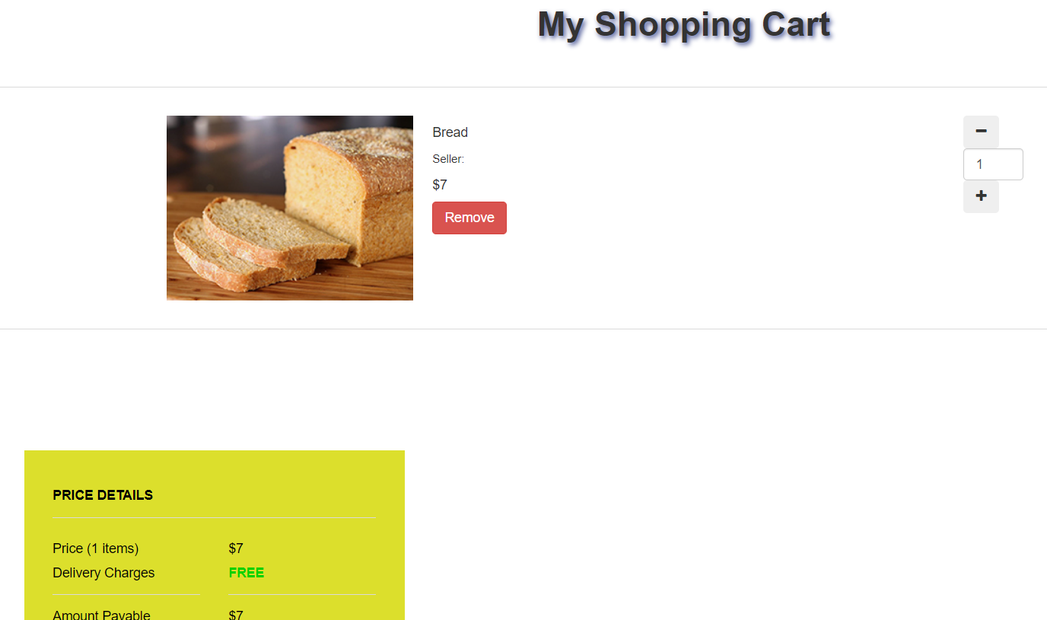



* The customer is redirected to the paypal page.

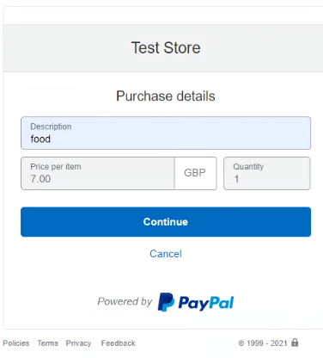

* Customer will have to log in to paypal.

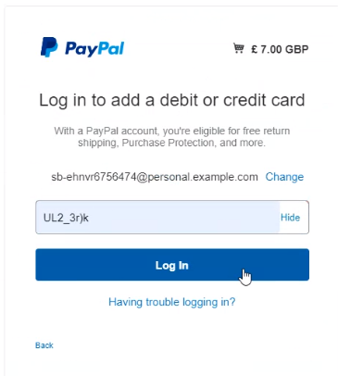

* Now customer can purchase their product.

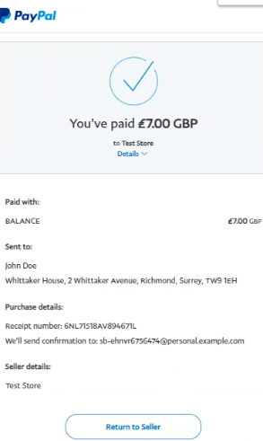

* Finally, customer can logout by clicking log out in the top nav.



* Now they will be redirected to login page.

