# Trader User Guide

* Trader can login through the login button in the navigation bar.



* If the trader is registered he can enter his account details from the following login page.

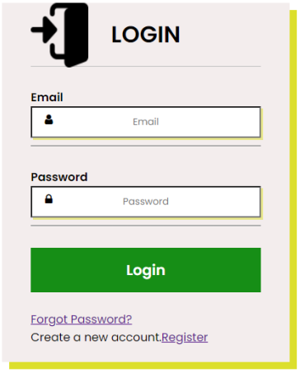

* If you are a new member to the site then you can register in the navigation bar or from the login page.

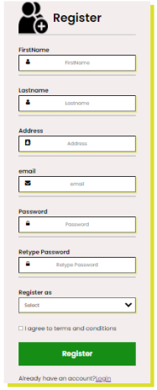

* Email verification is sent to admin about the new registration after the description about the shop is provided by the new trader.

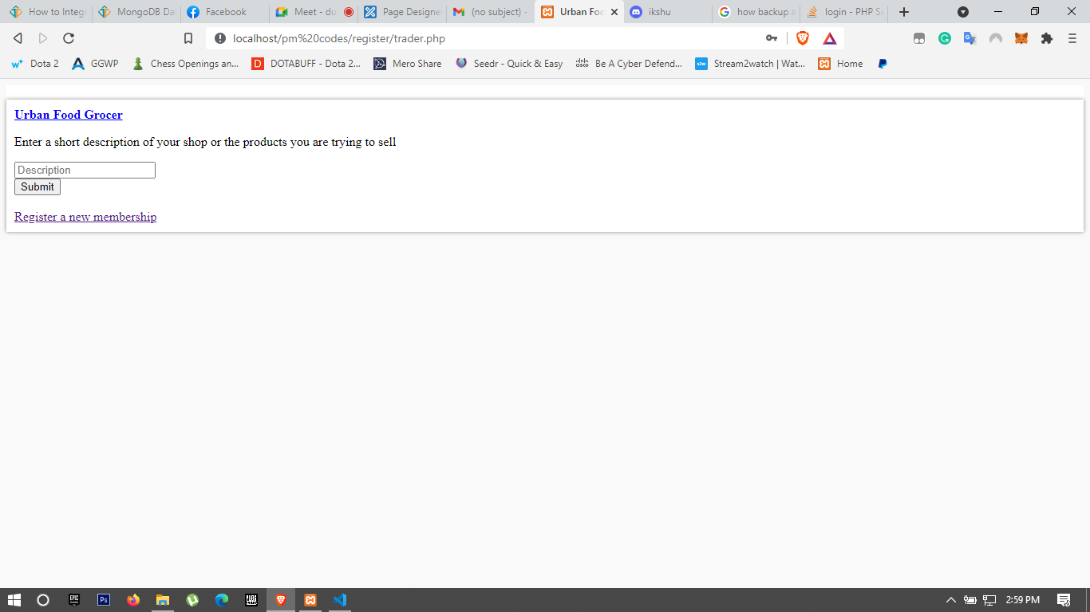

* The trader can add new products, update and delete as well through navigation.

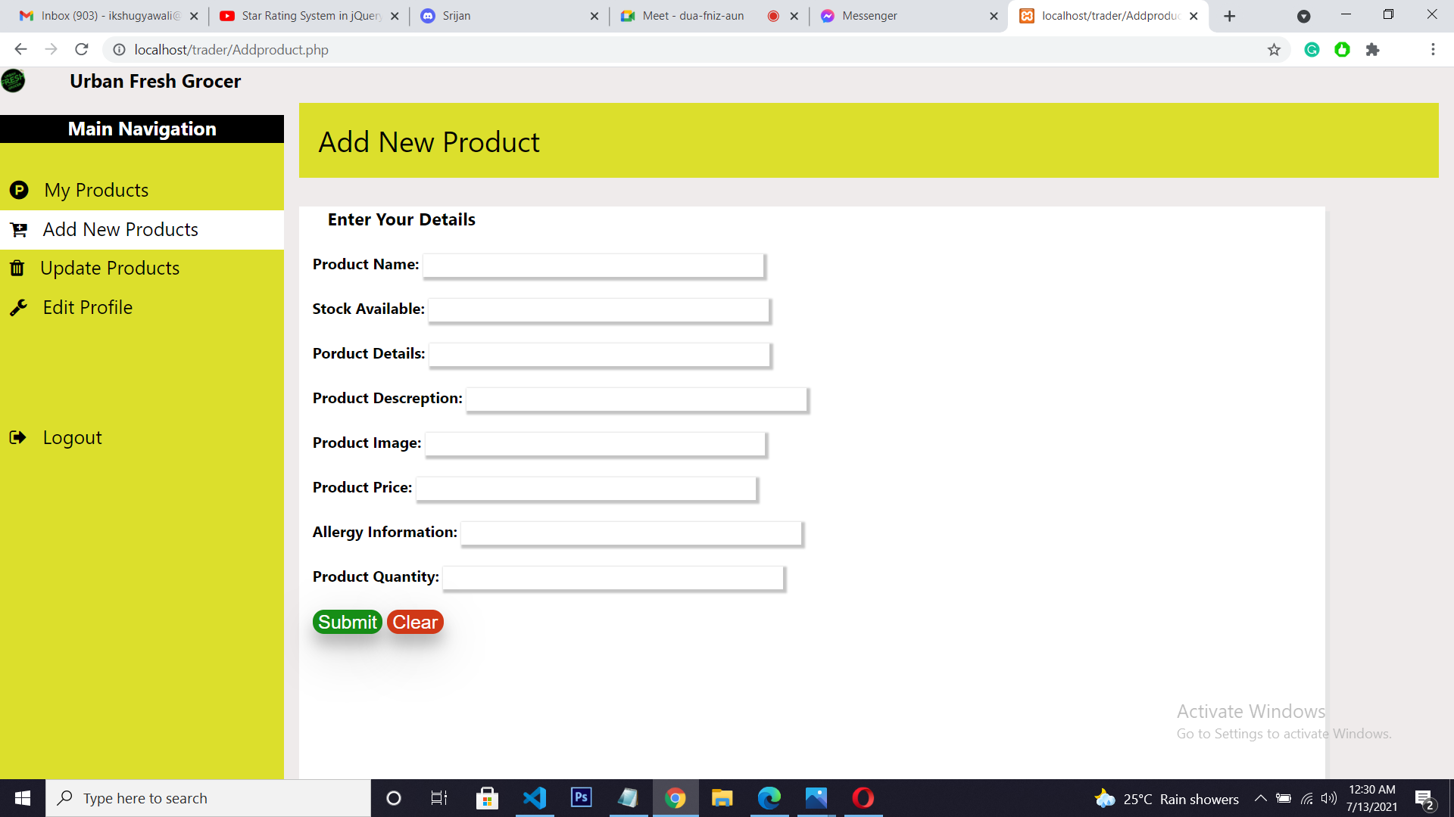

* Trader can logout through the logout tab in the dashboard ad will be redirected to the login page.

