一 | 答案 | 1---5、CBDCA 6---10、CBCAA
二 | 答案 | 1) View Level 2) 3  3) (100,98) 4) Revoke  5) Transaction
三 | 答案 | 1) Answer  Only values occurring in the primary key attribute of the referenced relation may occur in the foreign key attribute of the referencing relation  2) Answer  A candidate key is a set of attributes in a table that satisfies: (1) No two distinct records have the same values for it. (2) There is not a proper subset of a candidate key that satisfies (1).  A superkey is a set of attributes where no two distinct records have the same values for it.  3) Answer  Should be divided.  Loan_numbe→amount, and loan_number is not superkey in the combined relation.  4) Answer  ACID Stands for atomicity, consistency, isolation, durability. Atomicity: Either all operations of the transaction are properly reflected in the database or none are. Consistency: Execution of a transaction in isolation preserves the consistency of the database. Isolation: Although multiple transactions may execute concurrently, each transaction must be unaware of other concurrently executing transactions. Durability: After a transaction completes successfully, the changes it has made to the database persist, even if there are system failures.
四 | 答案 | 1）Answer：  2）Answer：  3）Answer：  4) Answer
  B | C | 200
  6 | 7 | 200
  2 | 3 | 200
  4 | 5 | 200
  7 | 9 | 200
  A | B | C
  a1 | 6 | 7
  a4 | 4 | 5
  a2 | 6 | 7
  a3 | 7 | 9
  A | B | C
  a1 | 6 | 7
  a2 | 2 | 3
  a1 | 2 | 3
  a2 | 6 | 7
  A | B
  a1 | 8
  a2 | 8
  a3 | 7
  a4 | 4
五 | 答案 | - Answer  Create table Class(  cname char(30),  meets at char(30),  room char(30),  fid char(30),  primary key(cname),  foreign key(fid) references faculty)  - Answer  Insert into students  Values(‘111’,’Kobe Bryant’,’CS’,’senior’,22);  Insert into Enrolled  Values(‘111’,’CS411’)  - Answer  Delete from class  Where class.fid in  (select fid from faculty where fname=’Joe Smith’)  - Answer  Create view busyfaculty as  (select fid, fname  From faculty natural join class  Group by fid, fname  Having count(cname)>3)  - Answer  (select class.snum from student natural join class natural join enrolled where room=’R128’) union  (select snum form students natural join enrolled where cname in (select cname from class natual join entrolled group by cname having count(snum)>=5)
六 | 答案 | a) Answer：  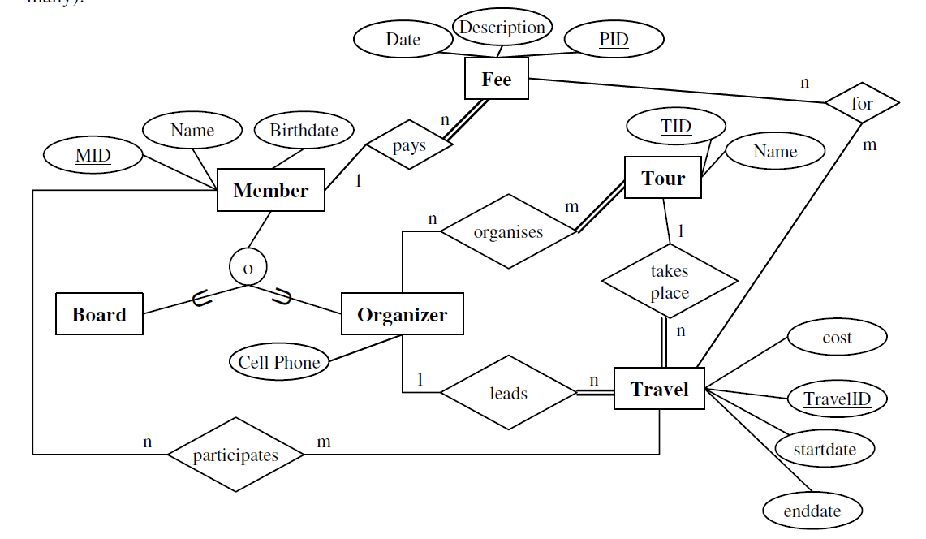  b) Answer：  Member（MID，Name, Birthdate）  Fee(Date, Description, PID, MID)  Board (MID)  Organizer(MID, CellPhone)  Tour(TID,Name)  Travel(TravelID, TID, MID, Cost, Startdate, Enddate  FeeforTravel(PID, TravelID)  Orgnize(MID,TID)  Participate(MID, TravelID)
七 | 答案 | a) Answer:  Candidate key: AB, BD  b) D in AB→CD.  c) Not in 3NF.Fc={AB→C,A→D,D→AE,E→F}.  Rcan be decomposed into {A,B,C},{A,D,E},{E,F}

