**Enoch Ikunda**

**COS350**

**PROG3: mysubmit.c**

**Prof: Bob Boothe**

**Note: You allowed me a little extension due to my poor internet**

[could not print using a2ps]

**mkdir cos101** make a new empty directory for testing

**mkdir cos101/submit** make the submit subdirectory

**mysubmit** run your program and submit to cos101 the three

files: mysubmit.c mysubmit Makefile

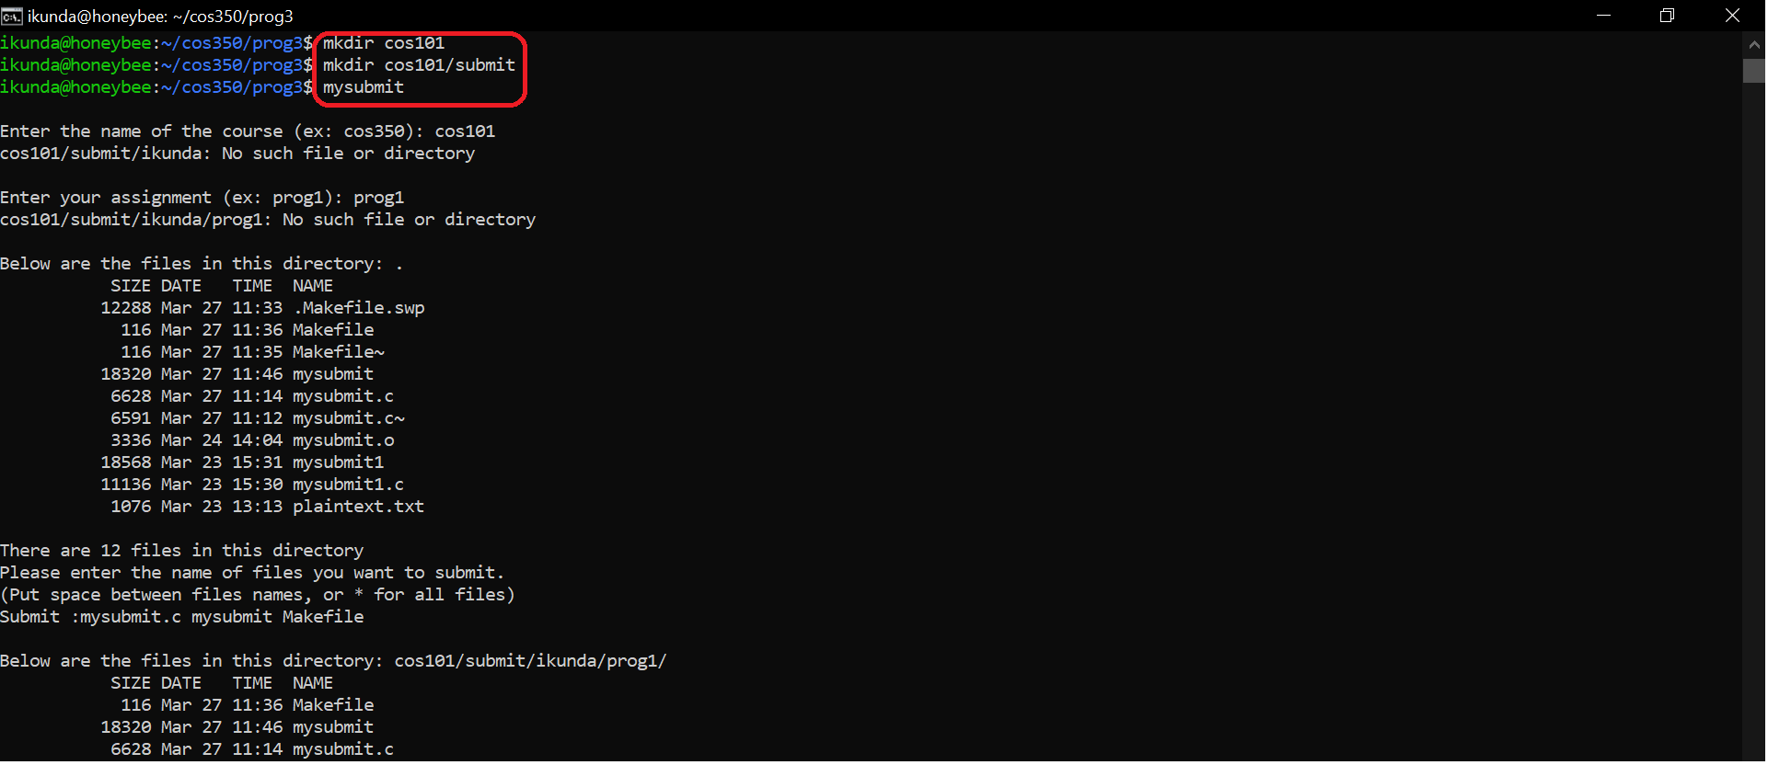

**ls –lR cos101** recursive listing to verify everything worked

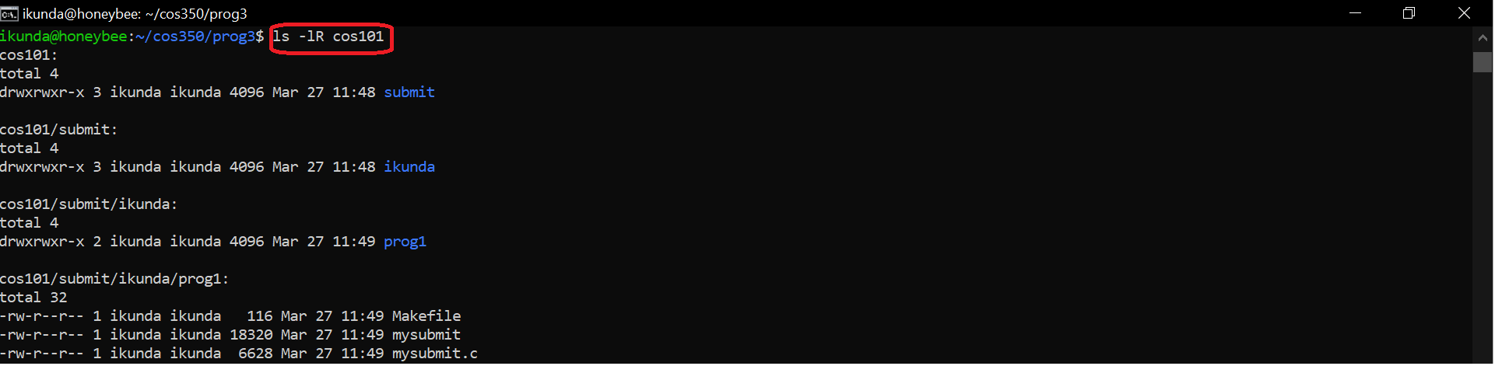

**mkdir cos102** make a new empty directory for testing

**mkdir cos102/submit** make the submit subdirectory

**mysubmit** run your program and submit to cos102,

but this time just use * to

submit everything

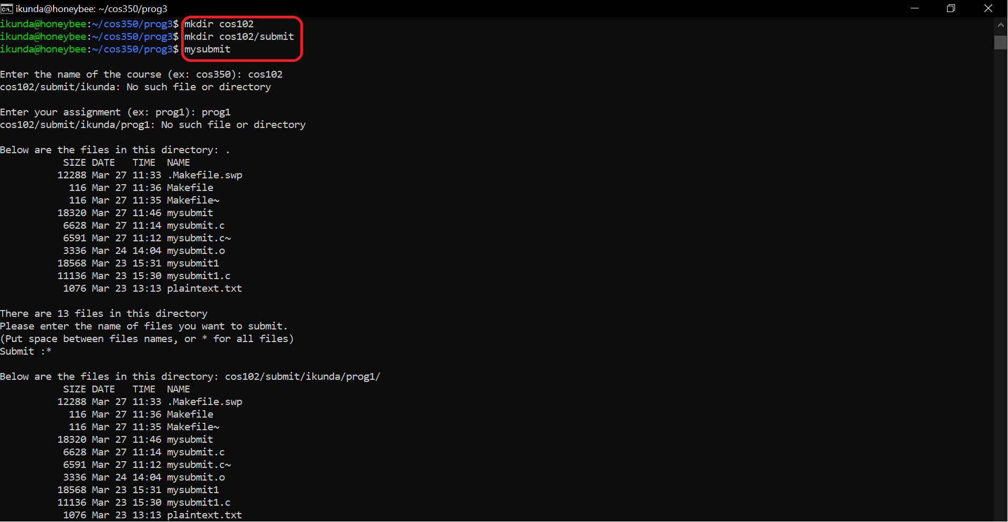

**ls –lR cos102** recursive listing to verify everything worked

**mysubmit** run it again but this time use a non-existent course directory cos103 to test error handling

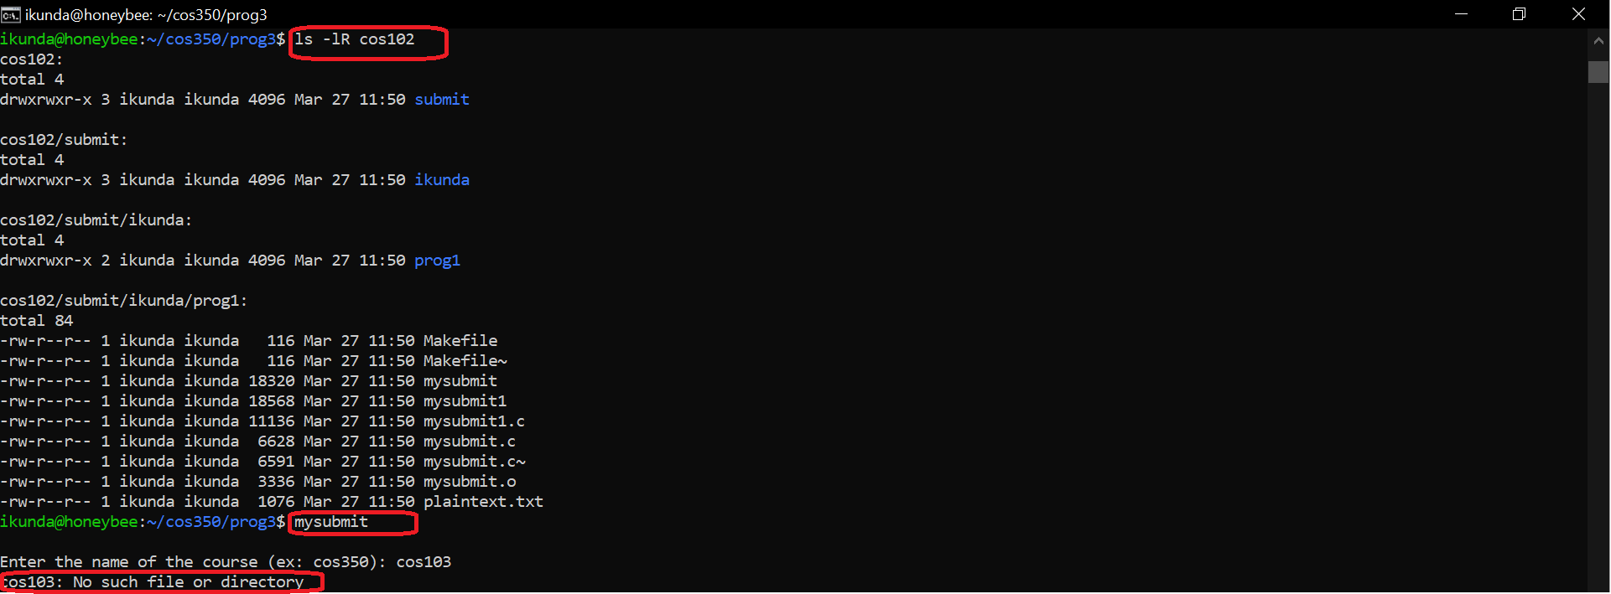

/*Prog3 by Enoch Ikunda

* Prof: Bob Boothe

* Purpose : list & transfer filest to a desired (but specific) folder

* Action: no argument needed just fill in the prompts

* note: The progrma can either take selected files or all the files from desired directory

* Bug: only works in current directory

*/

#include <unistd.h>

#include <stdio.h>

#include <stdlib.h>

#include <string.h>

#include <sys/stat.h>

#include <sys/types.h>

#include <time.h>

#include <dirent.h>

#include <pwd.h>

#include <fcntl.h>

#define INPUTBUF 512

#define BUFFERSIZE 4096

#define COPYMODE 0644

char coursepointer [INPUTBUF];

char course [INPUTBUF];

char projectpath [INPUTBUF];

uid_t id;

char *user;

int verfydirexist (char *dirname);

char *get_user(uid_t uid);

int verifyfiles (char *currentdir);

int displayfiles ();

void dostat(char *);

void show_file_info(char *, struct stat *);

void transferfiles( char *files, char *path);

void pathupdated (char *updatepath, char *path, char *submited);

void dotransfer (char *newpath, char *filesub);

void oops (char *s1, char *s2);

int main()

{

printf("\nEnter the name of the course (ex: cos350): ");

if(fgets(coursepointer,INPUTBUF,stdin))

{

coursepointer[strcspn(coursepointer,"\n")] = 0;

}

strcpy(course, coursepointer);

//1)****the course and verify that directory exists****

if(verfydirexist(course) == -1)

{

perror (course);

exit(0);

}

//2)****Verify that it contains a submit directory****

strcat(course,"/submit");

if(verfydirexist(course) == -1)

{

perror (course);

exit(0);

}

//3 & 4)*******Get the user's name from the system &

//If this user does not yet have a subdirectory within

//the submit directory, create one*****

strcat(course,"/");

id = getuid();

user = get_user(id);

strcat(course,user);

if(verfydirexist(course) == -1)

{

perror (course);

mkdir(course, 0777);

}

//5)******Ask the user for the name of the assignment

//ans create this subdirectory if it does not already

//exits

char assignment [INPUTBUF];

printf("\nEnter your assignment (ex: prog1): ");

if(fgets(assignment,INPUTBUF,stdin))

{

assignment[strcspn(assignment,"\n")] = 0;

}

strcat(course,"/");

strcat(course,assignment);

if(verfydirexist(course) == -1)

{

perror (course);

mkdir(course, 0777);

}

strcat(projectpath, course);

//6)Show the user a list of the files in their current

//directory*****

int filesnumb = verifyfiles(".");

printf("\nThere are %d files in this directory", filesnumb);

if (filesnumb < 0 )

{

printf ("could not load files in this directory");

exit(0);

}

//7)Ask the user for the names of the files to submit.

//Allow * for everything

printf("\nPlease enter the name of files you want to submit."

"\n(Put space between files names, or * for all files)"

"\nSubmit :");

strcat(projectpath,"/");

//check if the files submitted are not null

char submitfiles [INPUTBUF];

if(fgets(submitfiles,INPUTBUF,stdin))

{

submitfiles[strcspn(submitfiles,"\n")] = 0;

}

transferfiles(submitfiles, projectpath);

exit(0);

}

//This function verifies if a directory exists.

int verfydirexist (char *dirname)

{

struct stat dirstat;

char currentdir [64];

strcpy(currentdir, "./");

strcat(currentdir, dirname);

return stat(currentdir, &dirstat);

}

/*

* returns pointer to username associated with uid,

* uses getpwuid()

*/

char *get_user( uid_t uid )

{

struct passwd *pw_ptr;

static char numstr[10];

if (( pw_ptr = getpwuid(uid)) == NULL )

{

sprintf(numstr,"%d", uid);

return numstr;

}

else

return pw_ptr->pw_name ;

}

/*displays files in current directory*/

int verifyfiles (char *currentdir)

{

int i, numbfiles;

struct dirent **list;

printf("\nBelow are the files in this directory: %s", currentdir);

numbfiles = scandir(currentdir, &list, NULL, alphasort);

if ( numbfiles == -1)

{

perror (currentdir);

}

printf("\n%15s %s %s %3s", "SIZE", "DATE", "TIME", "NAME\n");

for (i = 0; i<numbfiles; i++)

{

dostat( list[i]->d_name);

}

//after scanning you clear the data in name_list

for (i = 0; i < numbfiles; i++)

{

free(list[i]);

}

free (list);

return numbfiles - 2; //because we have to substract the hiddenfiles

}

void dostat ( char *filename)

{

struct stat info;

if (stat(filename, &info) ==-1)

{

perror(filename);

}

else

{

show_file_info (filename, &info);

}

}

/*

*This function does the display info formatting

*/

void show_file_info (char *filename, struct stat *info_p)

{

if ( S_ISDIR (info_p-> st_mode))

{

return;

}

printf("%15ld", (long) info_p->st_size);

printf(" %-13.12s", 4+ctime(&info_p->st_mtime));

printf("%s\n", filename);

}

/*

*This function submits files from src directory to dest directory

*/

void transferfiles( char *files, char *path)

{

int i,j;

i = 0;

char *submited [512];

//int in_fd, out_fd, n_chars;

char updatepath [512];

//char buf [BUFFERSIZE];

if (strchr(files, ' ') != NULL)

{

submited[i] = strtok(files, " ");

while (submited[i] != NULL)

{

i++;

submited [i] = strtok(NULL, " ");

}

for(j=0; j<i;j++)

{

pathupdated (updatepath,path,submited[j]);

dotransfer (updatepath, submited[j]);

}

verifyfiles(path);

}else if (strchr(files, '*') != NULL)

{

DIR *dir_ptr;

struct dirent *direntp;

dir_ptr = opendir(".");

while ((direntp = readdir(dir_ptr)) != NULL)

{

if(direntp->d_type !=4)

{

submited[i] = direntp->d_name;

i++;

}

}

for (j=0; j<i; j++)

{

pathupdated (updatepath,path,submited[j]);

dotransfer (updatepath, submited[j]);

}

verifyfiles(path);

}

}

void pathupdated (char *updatepath, char *path, char *submited)

{

strcpy (updatepath, path);

strcat (updatepath, submited);

}

void dotransfer (char *newpath, char *filesub)

{

int in_fd, out_fd, n_chars;

char buf [BUFFERSIZE];

if((in_fd = open (filesub, O_RDONLY)) == -1)

{

verifyfiles(newpath);

oops("Cannot open ", filesub);

}

if((out_fd = creat (newpath, COPYMODE)) == -1)

oops("cannot creat", newpath);

while (( n_chars = read (in_fd,buf, BUFFERSIZE)) > 0)

{

if (write( out_fd, buf, n_chars) != n_chars)

oops("Write error to ",newpath);

}

if (n_chars == -1)

{

oops("read error from", filesub);

}

if (close (in_fd) == -1 || close (out_fd) == -1)

{

oops("Error closing files", "");

}

}

void oops(char *s1, char *s2)

{

fprintf(stderr,"error: %s ", s1);

perror(s2);

exit(1);

}

COS 350 Program 3 Testing - please fill out and turn in this testing sheet with your written submission. Name(s): Enoch Ikunda

|  |  |  |  |  |  |  |
| --- | --- | --- | --- | --- | --- | --- |
|  | Pts | Works | Mostly  Works (explain) | Occasionally  Works (explain) | Not implemented | Explanation |
| 1. Ask Course Name & Verify | 5 | yes |  |  |  |  |
| 2. Verify the submit dir exists | 5 | yes |  |  |  |  |
| 3. Get the user’s name | 5 | yes |  |  |  |  |
| 4. Check for and create the user  dir. | 5 | yes |  |  |  |  |
| 5. Ask & create  the assignment dir. | 5 | yes |  |  |  |  |
| 6. Show the user the list of files to  submit. | 25 | yes |  |  |  |  |
| 7. Ask for files to submit. | 5 | yes |  |  |  |  |
| 8.a. Copy the list of files. | 15 | yes |  |  |  |  |
| 8.b. Copy * | 10 | yes |  |  |  |  |
| 9. Show the final  contents of the submission dir | 5 | yes |  |  |  |  |
| 10. Makefile | 5 | yes |  |  |  |  |
| error handling | 10 | yes |  |  |  | What errors? |