A Cheap Chess AI

Purpose
If you’ve been reading my other app plans, you know that I have an Idea for a new clicker game. Clicker games generally start off from the bottom, with the player eventually working their way up to bigger, better, more grandiose, and wackier objects.
This leads a little bit of a problem for my clicker game: What is something that is:
- Plausibly AI-ish,
- Requires dirt-cheap hardware
- Is easy enough to implement
- Doesn’t have any linear algebra or probability theory or any of that nonsense (Those are later upgrades)
- Can plausibly be called “Not useless”.
I took a look at the Wikipedia article for AI history. Deep Blue, the Computer that was beat by Bobby Fischer, was one of the first entries on this list. Bingo! Deep Blue (A) ran in the 1980s, when al hardware was bad (B). Many people play chess online (E). All that’s left is proving that making an “AI” for chess doesn’t translate into requiring the clicker game player to get carpal tunnel syndrome. That, and not requiring anything I learnt in college: Those are upgrades. You will learn those later, after you get off the ground floor.

Kill/Death Ratio
How does this Chess AI Work?
I know a few things about chess. I know the relative piece values:
Pawn: 1, Bishop & Knight: 3, Rook: 5, and Queen: 8.
This can be the basis for our Chess “AI”. I remember, back when I was bad yet improving at chess (As opposed to now, mediocre but degenerating), I could go through the motions well enough by attempting to get favorable K/D odds. That was my strategy, and it can be the AI’s as well.

Points: The basis of this Chess AI

The wisdom of my father’s father.
Once my grandfather was trying to teach me (an elementary schooler) the basics of chess. In addition to the point values of the relative pieces, he also told me that the most important squares are the center 4. This is the centre of the battlefield, the place where all the action takes place.
Thus, we add extra points the closer a piece moves to the center. Pawns, which have promotion potential, are immune from this after capturing a piece.
This serves as a tiebreaker, in case no other pieces have good moves

Virgins? That can be sacrificed
There are a couple of “Cool Moves” in chess, most of which require virginity. These are En Passant, Castling, and the “Pawn starts with the double move”
I’ll start off with En Passant and Castling. The reason I’m writing this “AI” is to prove a chess AI can be written quickly, and the quicker the better. Thus the AI will neither castle nor En Passant, in order to save on Dev time.

The eight Virgins you can’t sacrifice
Pawn’s double moves, however? My laziness would be made too manifest if the AI was unaware that pawns could move twice on their opening turn

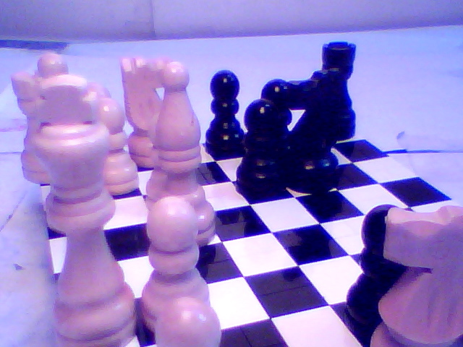

Language:
Front End: Typescript
Back End: Java

