**LAPORAN PRAKTIKUM**

**MODUL 4**

**“Single Linked List Bagian 1”**

**Disusun Oleh:**

Rizky Ageng Nugroho

21104045

Dosen Pengampu:

Yudha Islami Sulistya, S.Kom, M.Cs.

**PROGRAM STUDI S1 REKAYASA PERANGKAT LUNAK**

**FAKULTAS INFORMATIKA**

**TELKOM UNIVERSITY PURWOKERTO**

**2024/2025**

**Tugas Pendahuluan**

1. Jawban soal tugas pendahuluan (Soal 1-3)

(source code di github)

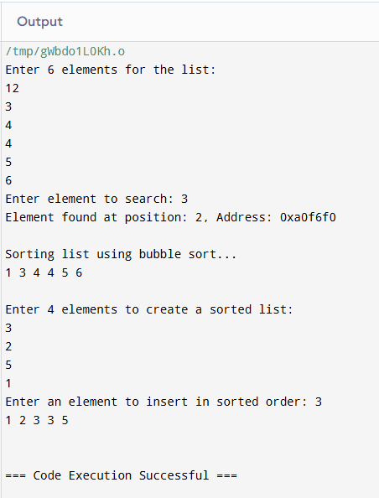

Tugas Unguided

1. Jawaban soal unguided

(source code di github)

