**IE3081 – Modeling and Discrete Simulation Course**

**Project Report**

**Ceyhun Erdönmez 150120851**

**Introduction:**

The bank will have 4 drive-thru servers. These servers will be lined up side by side in 2 pairs. So we will have two queue. When two vehicles come to the left queue at the same time, the one that comes first will be processed on the server that front second car will be processed on the server that rear. Even if the operation of the vehicle in front is finished, the ordinary vehicle on the left will not be able to access the server. Because the vehicle operating on the back server is there and there is no space to pass by. Therefore, the vehicle processing on the back server will be expected to leave.

**System Components:**

* **Main:** The purpose of main is to combine all components, inputs, outputs, variables, source, queue, servers and elements such as sink.
  + **Variables:**
    - numberOfCustomer: Holds total number of customer in the system.
    - AverageTimeSpentPerCustomer: Holds average time spent per customer in the system.
    - AverageTimeSpendFirstQueuePerCustomer: Holds average time of customers waiting in the first queue in the system.
    - AverageTimeSpendSecondQueuePerCustomer: Holds average time of customers waiting in the second queue in the system.
  + **Distributions:**
    - sourceDistribution: Determines what time interval customers will arrive.
    - ATM1Distribution: Determines how long the processing time of customers coming to first ATM will be.
    - ATM2Distribution: Determines how long the processing time of customers coming to second ATM will be.
    - ATM3Distribution: Determines how long the processing time of customers coming to third ATM will be.
    - ATM4Distribution: Determines how long the processing time of customers coming to fourthATM will be.
  + **Dataset:**
    - dataset: Keeps customers arrival data by time.
  + **Source:** Thanks to the source, customers log in to the system at the time interval we set.
  + **SelectOutput:** We can direct the customers logging into our system to the queue order via selectoutput.
  + **Queue:** If our servers are full, our customers will wait here.
  + **Hold:** While transferring customers from queue to server, we wait for a while with hold so that we don't get any errors.
  + **ATM’s:** Customers handle their transactions in ATMs (servers).
  + **Sink:** Through sink, customers leave the system.

**Relation between system components:**

It directs customers to selectoutput via the source connector. Selectoutput sends customers to the top or bottom queue with 50% probability. If there are customers at ATMs, component of hold tells to queue customers to wait. If ATMs are available, the next customer is sent to the selectoutput. Selectoutput decides which server the client will go to. The customer leaves the system via sink after processing the transaction according to the processing time of the ATM from the customdistribution.

**Generation of random variates:**

Through selectoutputs, it is determined which path the customers will follow randomly.

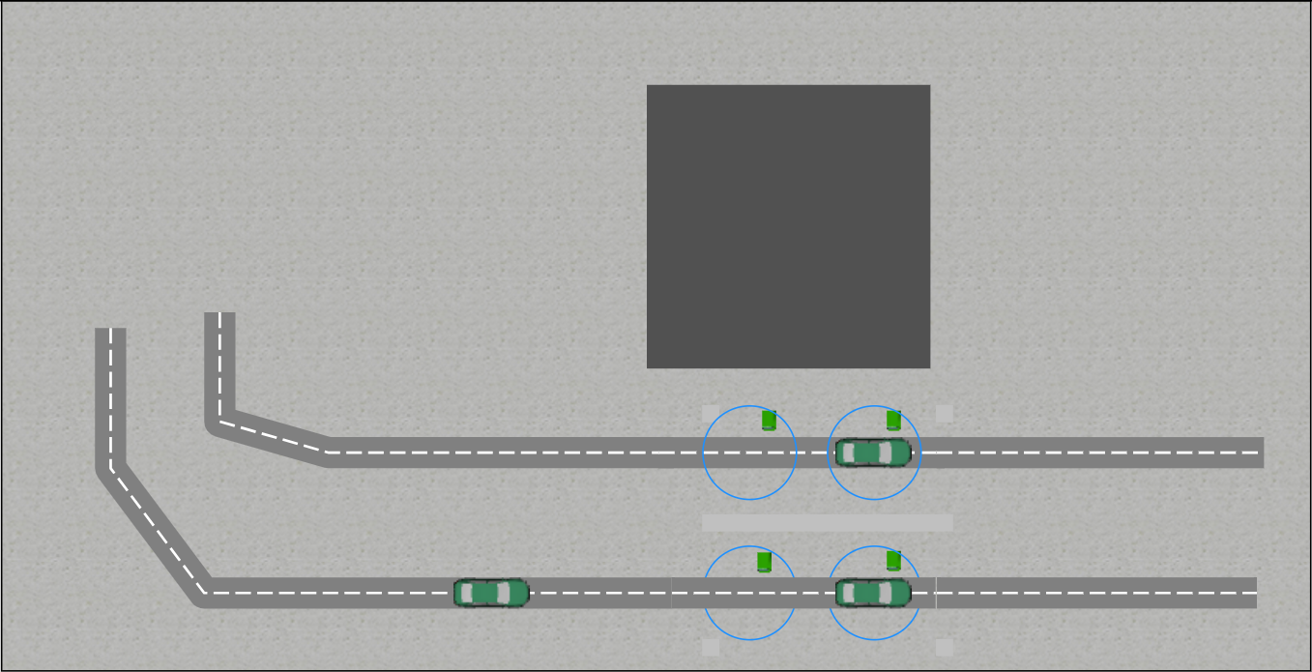**2D view of the model**:

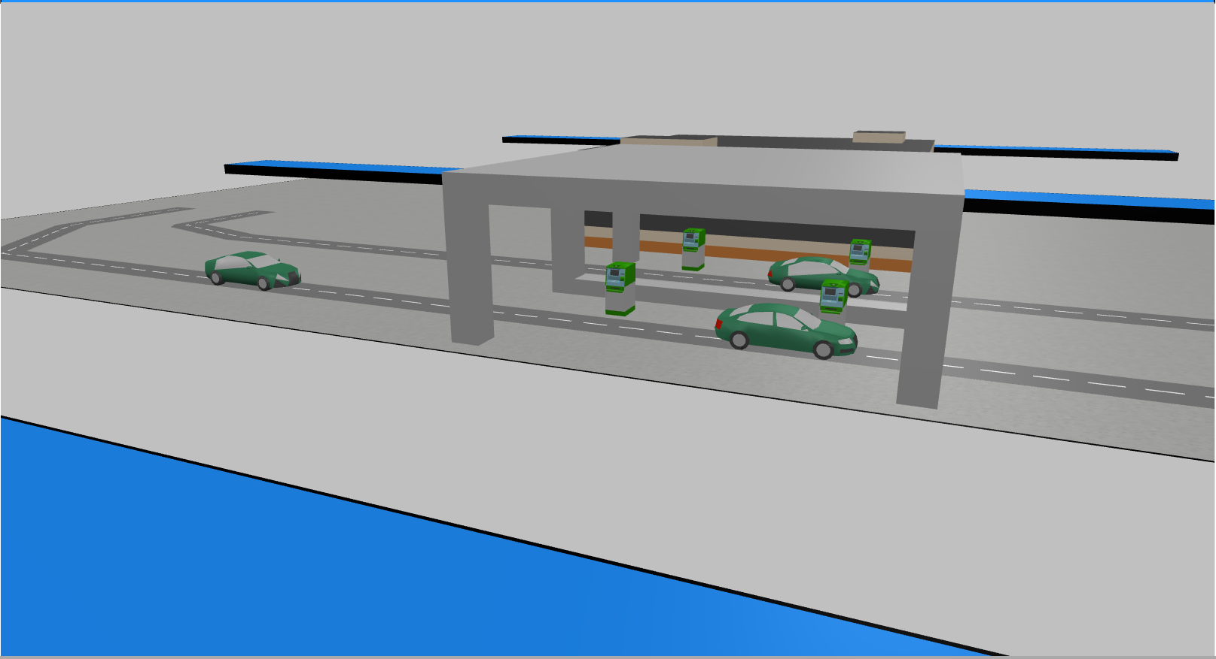**3D view of the model:**

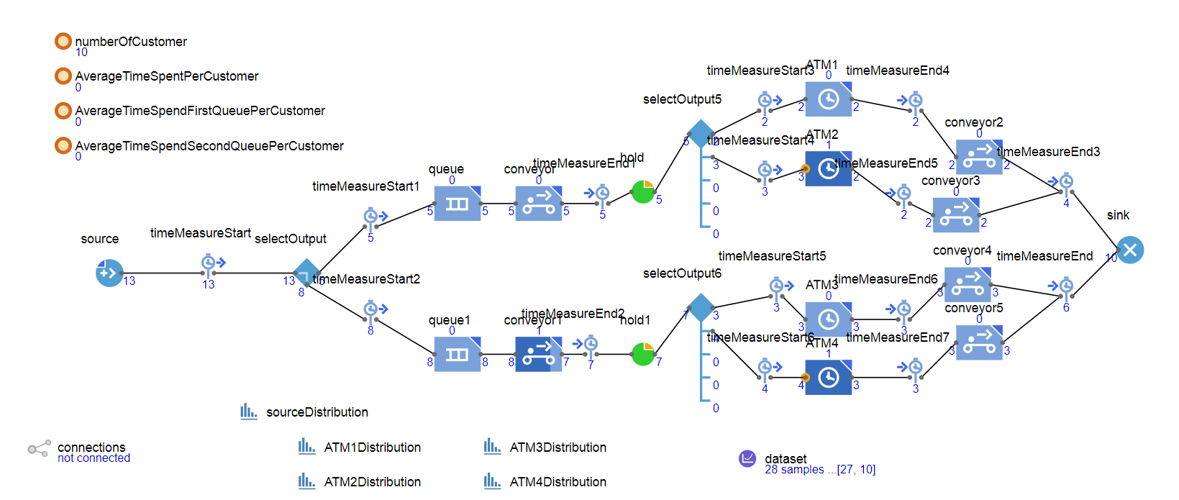**Logic of the model:**

**Input variables:**

**Uncontrollable input variables:**

* selectOutput: float
* selectOutput5: float
* selectOutput6: float

**Controllable input variables:**

* sourceDistribution: float
* ATM1Distribution: float
* ATM2Distribution: float
* ATM3Distribution: float
* ATM4Distribution: float
* ATM1 Capacity: int
* ATM2 Capacity: int
* ATM3 Capacity: int
* ATM4 Capacity: int

**Outputs:**

**Situation 1:**

* sourceDistribution:
  + interval: 1 number of observations: 0.4
  + interval: 2 number of observations: 0.2
  + interval: 3 number of observations: 0.2
  + interval: 4 number of observations: 0.1
  + interval: 5 number of observations: 0.1
* ATM1Distribution:
  + interval: 1 number of observations: 0.2
  + interval: 2 number of observations: 0.2
  + interval: 3 number of observations: 0.2
  + interval: 4 number of observations: 0.2
  + interval: 5-6 number of observations: 0.2
* ATM2Distribution:
  + interval: 1 number of observations: 0.4
  + interval: 2 number of observations: 0.2
  + interval: 3 number of observations: 0.2
  + interval: 4 number of observations: 0.1
  + interval: 5 number of observations: 0.1
* ATM3Distribution:
  + interval: 1 number of observations: 0.4
  + interval: 2 number of observations: 0.2
  + interval: 3 number of observations: 0.2
  + interval: 4 number of observations: 0.1
  + interval: 5 number of observations: 0.1
* ATM4Distribution:
  + interval: 1 number of observations: 0.4
  + interval: 2 number of observations: 0.2
  + interval: 3 number of observations: 0.2
  + interval: 4 number of observations: 0.1
  + interval: 5 number of observations: 0.1

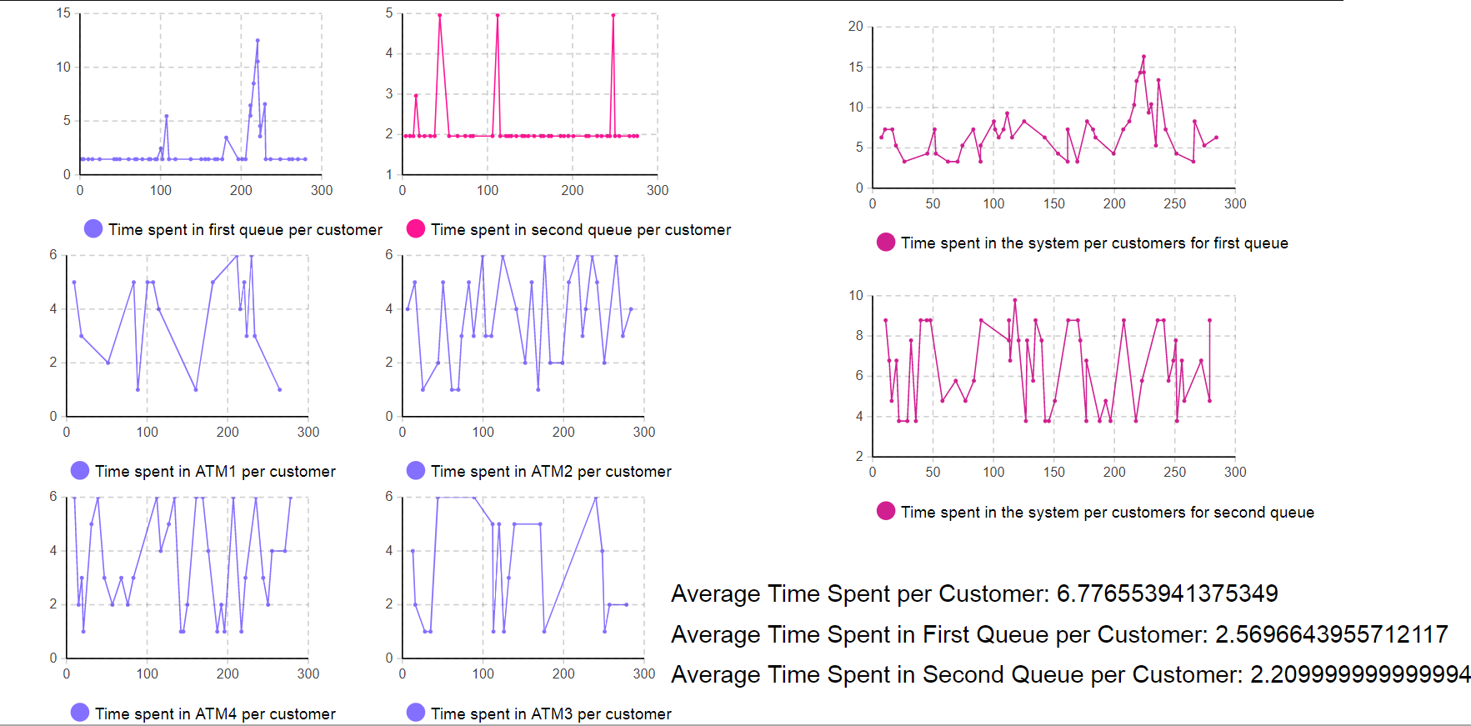**Replication 1.1**:

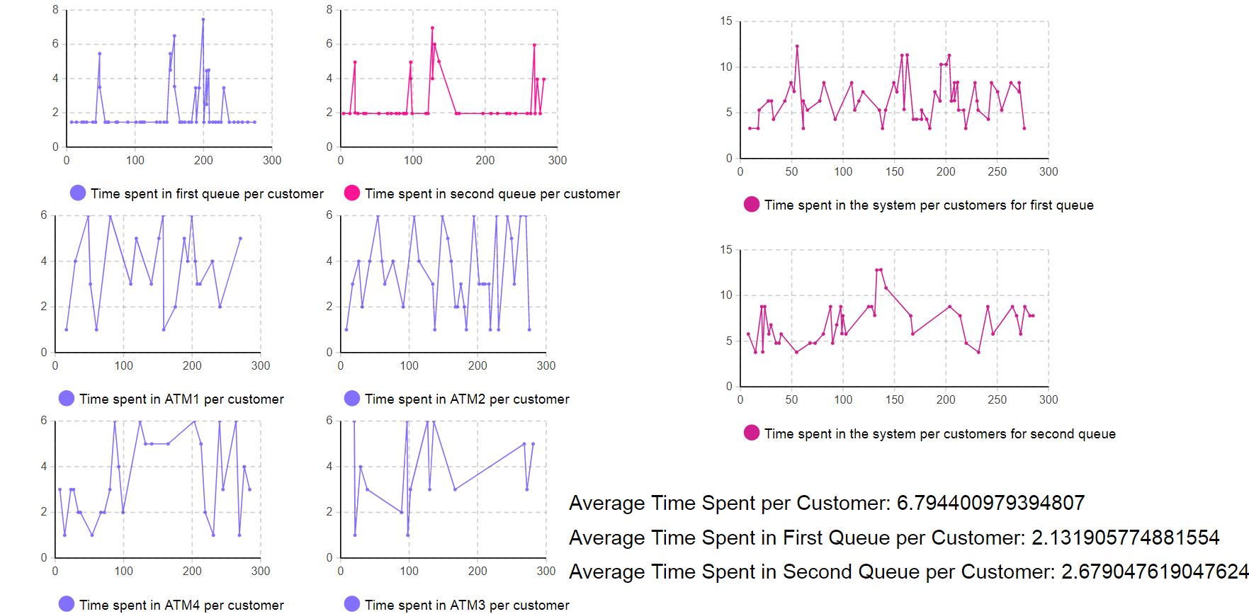**Replication 1.2**:

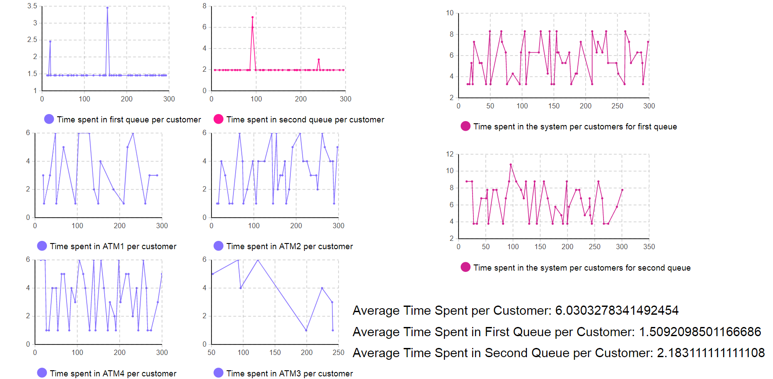**Replication 1.3**:

**Situation 2(Changed System):**

* sourceDistribution:
  + interval: 1 number of observations: 0.4
  + interval: 2 number of observations: 0.4
  + interval: 3 number of observations: 0.1
  + interval: 4 number of observations: 0.2
* ATM1Distribution:
  + interval: 1 number of observations: 0.2
  + interval: 2-3 number of observations: 0.4
  + interval: 4 number of observations: 0.1
  + interval: 5-6 number of observations: 0.3
* ATM2Distribution:
  + interval: 2 number of observations: 0.1
  + interval: 3 number of observations: 0.5
  + interval: 4 number of observations: 0.3
  + interval: 5-6 number of observations: 0.1
* ATM3Distribution:
  + interval: 1 number of observations: 0.2
  + interval: 2-3 number of observations: 0.6
  + interval: 4 number of observations: 0.2
* ATM4Distribution:
  + interval: 3 number of observations: 0.35
  + interval: 4 number of observations: 0.25
  + interval: 5-6 number of observations: 0.4

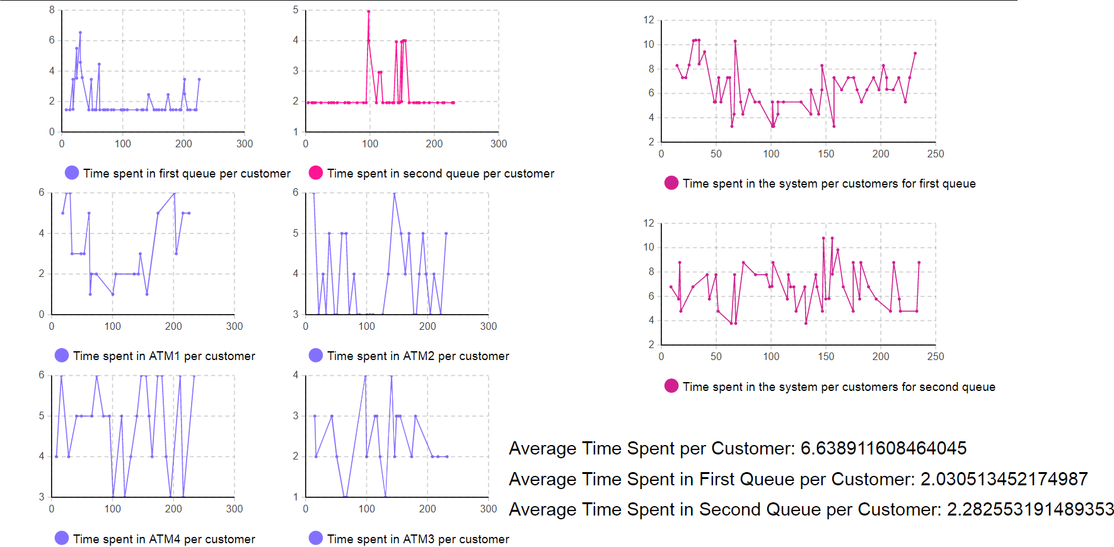**Replication 2.1:**

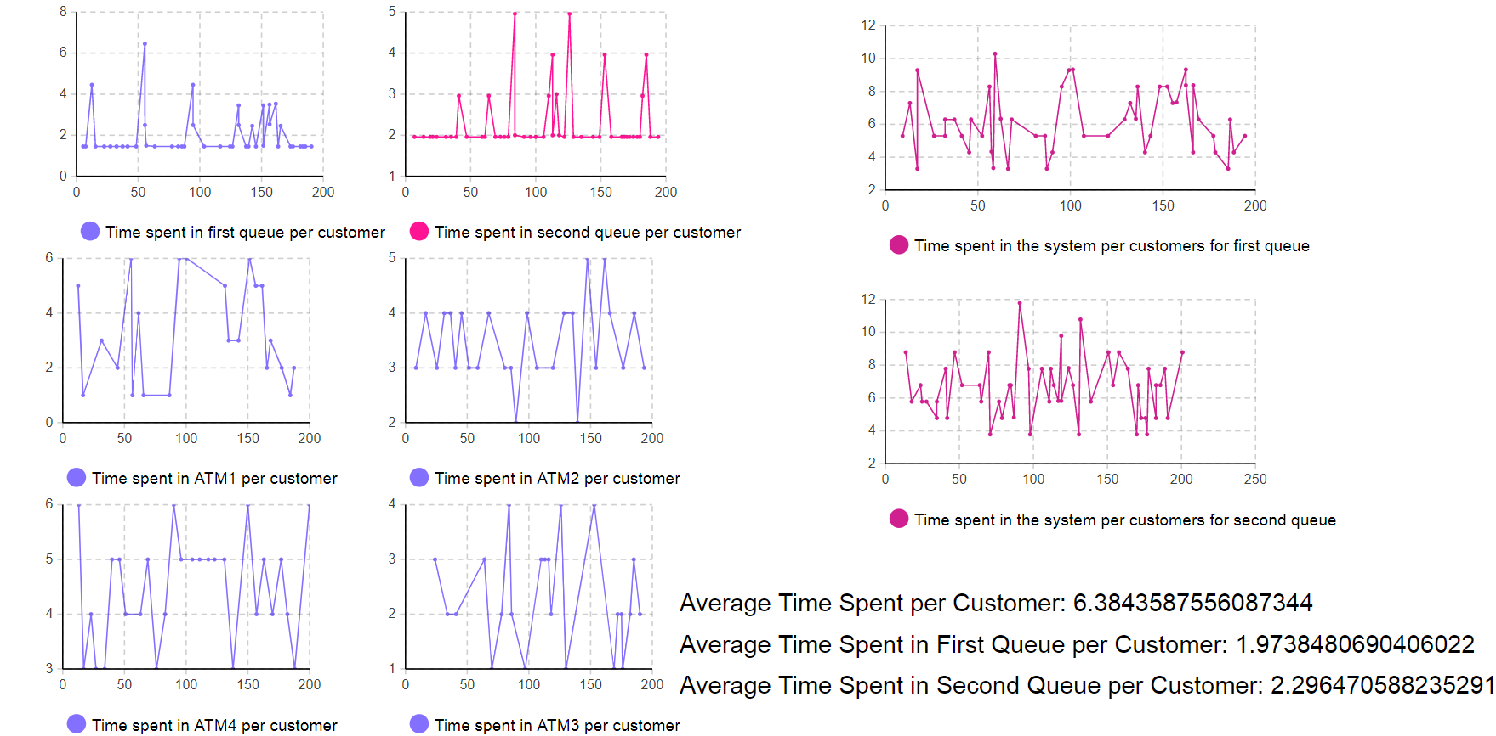**Replication 2.2:**

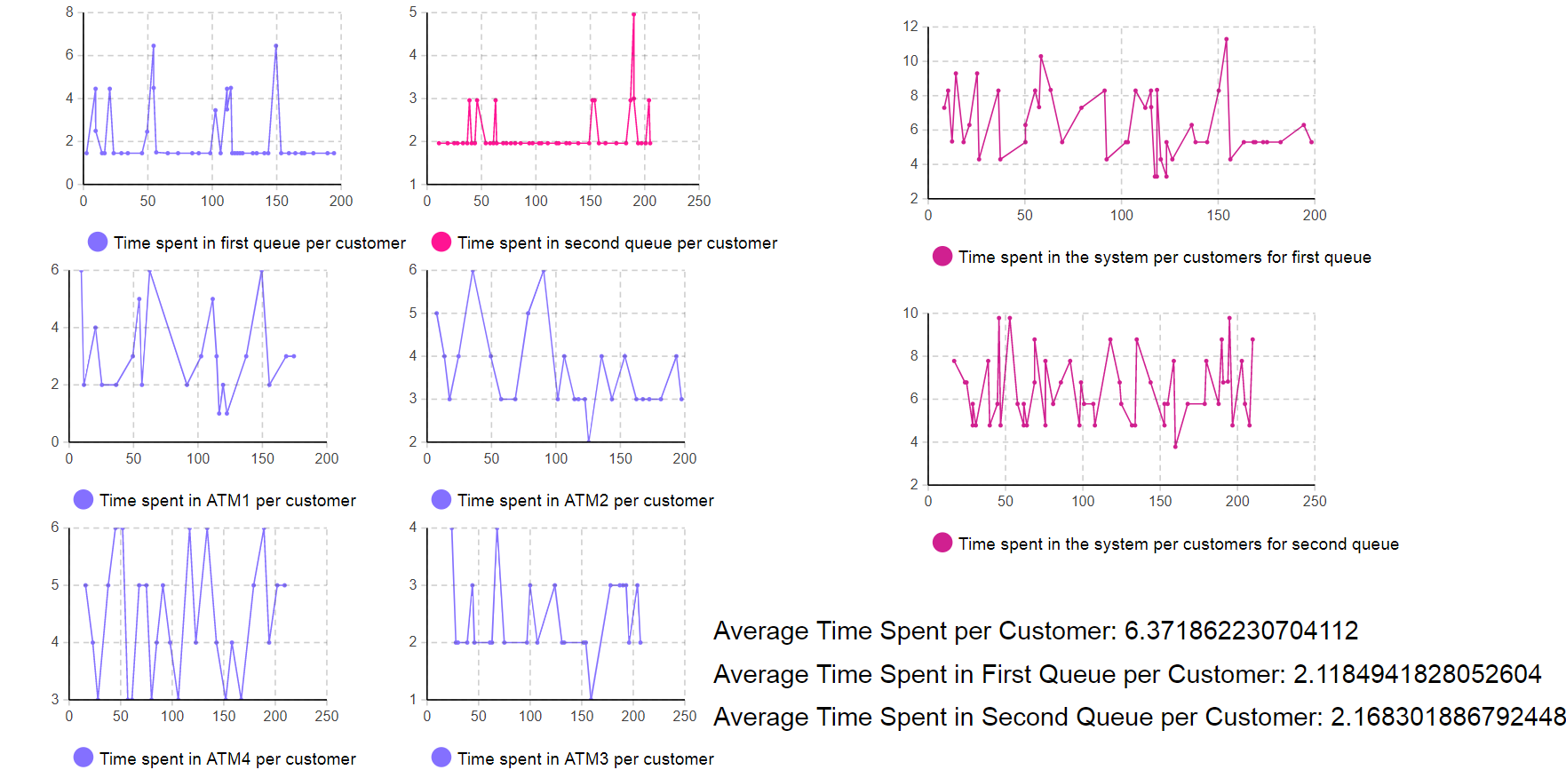**Replication 2.3:**

**Situation 1:**

**Mean for average time spent per customer:**

(6.77+6.79+6.03)/3 **= 6.53**

Standard deviation:

√ (((6.53-6.77)^2+(6.53-6.79)^2+(6.53-6.03)^2)/2)

√(0.0576+0.0676+0.25 / 2) = 0.433

**Confidence Interval (%95):**

CI =X̄ ± Z×σ/√n

=6.53 ± 1.9600×0.433/√300

**=6.53 ± 0.0490**

**Total Number of Replications:**

Upper Limit:

6.53+3*0.433 = 7.829

Lower Limit:

6.53-3*0.433 = 5.231

(6.79-6.03)*0.9 = 0.684

0.684 = 2*1.96*0.433 / √n

**N = 0.402**

**95% prediction intervals**

6.53-1.96*0.433*√(1+1/3) < μ < 6.53+1.96*0.433*√(1+1/3)

**= 5.55 < μ < 7.50**

**Situation 2(Changed System):**

**Mean for average time spent per customer:**

(6.63+6.38+6.37)/3 **= 6.46**

Standard deviation:

√ (((6.46-6.63)^2+(6.46-6.38)^2+(6.46-6.37)^2)/2)

√(0.0289+0.0064+0.0081 / 2) = 0.147

**Confidence Interval (%95):**

CI =X̄ ± Z×σ/√n

=6.46 ± 1.9600×0.147/√300

**=6.46 ± 0.0166**

**Total Number of Replications:**

Upper Limit:

6.46+3*0.147 = 6.901

Lower Limit:

6.46-3*0. 147 = 6.019

(6.63-6.37)*0.9 = 0.234

0.234= 2*1.96*0.147/ √n

**N = 0.164**

**95% prediction intervals:**

6.46-1.96*0.147*√(1+1/3) < μ < 6.46+1.96*0.147*√(1+1/3)

**= 6.12 < μ < 6.79**