EE180DA Lab Report

Introduction:

During development of our IR Blaster / Raspberry PI Synchronization method, we may want to be able to debug where everyone is located. Currently, I have implemented a google sheets implementation where any user can enter their location, and our “Control Pi” will be able to read the google sheets, look at the most recent position / location update for each user (indicated by what we call in the code as roll_id), and creates a pandas dataframe.

Completed Action Items:

This week, the following was accomplished:

1. Google Forms created / filled out, and relevant google sheets API_key and service account was created in order to use python to access this google sheet that we can access with anyone.
2. Relevant admin account for this specific project ([EE180DAproject@gmail.com](mailto:EE180DAproject@gmail.com)) hosts this google sheet, and linked the google sheet to the service account for access for the control pi
3. Tested that my implementation works. For instance, calling my script runs the following:

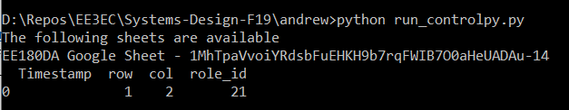

Where timestamp is automatically created by the google form, row and column are the positions indicated by the google form, and role_id is the specific unit number of the raspberry pi. (Essentially, a unique identifier).

The goal is to then use this controlpi to integrate the various subsystems that the other teammembers are working on. So far this code only serves as a baseline, but on integration will be responsible for:

* BLE Communication and Communication of what image to display
* An (optional and not necessary) web interface that would allow anyone participating to see their location in a grid, and remove themselves if necessary
  + Will be done using Flask/Python as well as flask-bootstrap, a port of bootstrap

The code consists of the following:

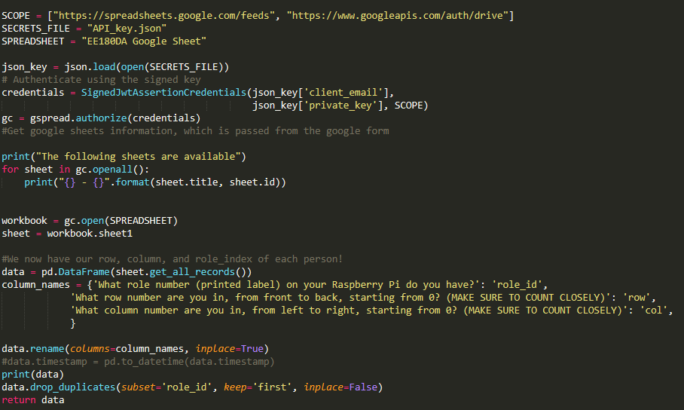

Action items for myself for next week are:

* Look into the BLE subsytem and integrate it into this code.
* Create flask template for grid of people, and the ability to remove one’s location.