This week, the following was accomplished:

Action Items and Updates from Last Week:

* WebUI (Flask and Bootstrap): Originally meant for debugging, may turn into an admin toolkit.

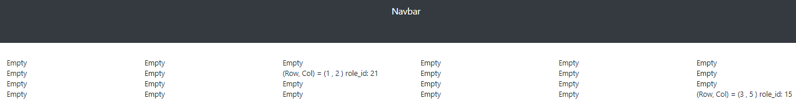

* + This is responsible for loading the google sheet and displaying the currently registered grid.
  + HTML is dynamically generated to produce this row / column / each individual raspberry pi (with their own role_id). This is done using Flask, and a lot of the CSS from Bootstrap is leveraged.
* Interface with BLE: Each raspberry pi is already programmed with their own role_id. So all we do is send over a BLE announcement: role_id: you’re at (row, col).
  + Each (row , col) will display something to make a larger image. The overall image, however, has to be preprogrammed on each individual rbpi.
  + TODO: Determine how my BLE code will interface with each individual rbpi, and make sure whatever command structure we make is *consistent.* Will be done on Friday during lab.

Action Items for Next Week:

* Create a set of images to display, and make sure how we’re going to scale it (eg, if image size doesn’t divide evenly).
* Create some way to program these images (or patch with our code in a consistent way) dynamically depending on role_id.