EE180DA Lab Report

Introduction:

During use of our system, we will need to use our control Raspberry Pi to communicate BLE with the other raspberry pi’s. In order to facilitate this, I previously wrote a simple Flask webapp to detect which role each raspberry pi has been assigned. The picture is attached below.

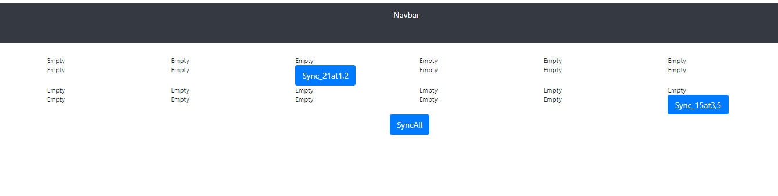

Note that each role and role’s position is determined by a google form.

For this week, the completed action items are:

1. Front-end (form) input to sync all raspberry pi’s.

2. Front-end (form) input to sync a single raspberry pi.

3. Restructuring the backend Flask server such that the backend only needs to call a function to send the BLE packets to synchronize all the PI’s. (This is being written and tested by other members currently). [In essence, I just made it so that the Sync Buttons only need 2 line changes in code on the backend, so I just prepared for integration].

The next action items for this week are:

1. Create a tool to program the SD cards.

2. Create a tool to set an arbitrary image, compress it to some arbitrary image size, and have the Flask server have a set of modes (of images) that it can select.