Action Items Done this Week:

* Made a UI App using PyQT (Linux or Windows deployable) to programmatically write the role ID’s to SD Cards, and to burn Raspberry Images. (We may remove the burning the raspberry image and instead choose to burn the raspberry images to all the sd cards first, and then have this program only write roleid’s…)

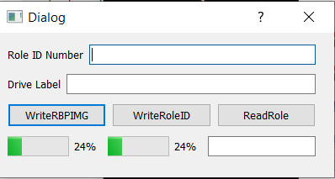

* In the backend of my WebApp for synchronization, I added the BLE code changes. So now hitting the button from the frontend will now trigger a BLE event corresponding to telling a device what color he will be displaying.

Action Items for Next Week:

* Finalize integration / testing of my webapp to listening Pi’s.