Temperature calculation program for SCS Reaction (SCSTempCal)
Version 1.0
Introduction
Temperature calculation program for SCS Reaction (SCSTempCal) is intended for theoretical estimation calculation of the maximum temperature in reactions named Solution Combustion Synthesis (SCS). Modeling reactions using different types of fuel and with obtaining of different composition of products allows a qualitative and quantitative assessment of the temperature regime of combustion processes. The assumptions used in the calculation algorithm allow calculating temperatures for combustion processes lasting up to 15–20 seconds.
Thermodynamic model The program algorithm is based on a model for calculating the temperature effect of SCS reactions in a real physical open reactor (1).
, (1)
where ΔH_{reag}(T_{ig}) – total enthalpy of reagents at ignition temperature, ΔH_{prod}(T_{max}) – total enthalpy of products at maximum temperature, T_{ig} – ignition temperature of the reaction mixture, T_{max} – maximum combustion temperature, m – the mass of the target product, M – the molar mass of the obtained target product, μ – the number of moles of exhaust gases, R – the universal gas constant, ΔT_{max} – maximum temperature effect, σ – Stefan-Boltzmann constant, S – open surface area of the reactor, t_{com} – combustion time, – total average heat capacity of all reaction products. λ – specific heat of vaporization, n – the number of remaining water molecules in crystalline hydrate (if crystalline hydrates are involved in the combustion reaction). Individual heat capacities C_{i}(T) were calculated using the Mayer-Kelly equation (2):
, (2)
where a_{i}, b_{i} и c_{i} – coefficients of the Mayer-Kelly equation from tables of heat capacities.
Equation (1) has no analytical solution. The characteristic heat balance function F(T_{max}) was introduced to solve this equation. The F(T_{max}) is the difference between the left and right sides of equation (1) and has the form (3):
(3)
The experimental parameters are ignition temperature, T_{ig}, and combustion time, t_{com}, which can be set during simulation. The initial temperature was taken to be 298 K. Then, with a step of 1 K, the values of the individual isobaric heat capacities C_{i} and C_{j} were calculated by formula (2) and the enthalpies of the reactants and products by formulas (4) and (5)
(4)
(5)
The values of heat capacities were compared with their limiting values. When exceeding C_{i}(T) calculated according to formula (2), their limit value was established. The average heat capacities of the reaction products C_{j} was calculated by the formula (6).
(6)
Then, the total enthalpies, the total average heat capacity of the products, the work on the expansion of gases, and the loss of heat due to radiation were calculated. The function F(T_{max}) is monotonically decreasing with increasing T_{max}. Transition through a zero value means a quasi-equilibrium state of the combustion reaction from solutions with a maximum temperature. It should be noted that a necessary condition for self-sustaining combustion is the positive difference of the first two terms of equation (3).
Compatible with operating systems
The program was developed under Windows XP and newer Windows versions. Linux and Mac OS compatible with python 3.4+ interpreter and python numpy, matplotlib, and python3-tk libraries are supported.
Installing the program on the Windows OS
Copy the folder with the program to your hard drive. Test the program by running the SCSTempCal.exe file.
If SCSTempCal.exe does not start, an alternative installation method is possible. It is necessary to download the python 3 interpreter from the official site https://www.python.org/downloads/. Only version 3.4 is suitable for Windows XP. Newer Windows OS versions are compatible with the latest python version. It is necessary to make sure that the option “add python.exe to PATH” is selected in the installation settings. Run the python installation. Run the command line after python installing. To do this, you can use the key combination win + r, then type cmd.exe in the opened window and click «OK». Enter the following commands in the command line:
pip install numpy
pip install matplotlib
Run the SCSTempCal.py file using the python interpreter.
Installing the program on Linux
Make sure that python 3 is installed on the computer. If necessary, install python 3. Enter the following commands in console:
sudo pip install numpy
sudo pip install matplotlib
sudo pip install python3-tk
Run the SCSTempCal.py file using the python interpreter (python3 SCSTempCal.py).
Test run of a single calculation
The launch of the program «Calculator of combustion temperature» runs the SCSTempCal.exe file, which opens the start window. The start window displays the version of the program and its authors. The “Start Work” button navigates to the working window (Fig. 1).
The program requires the following data to calculate the maximum burning temperature:
1) chemical reaction equation (highlighted in red frame 1 in figure 1);
2) information on the compounds involved in the reaction (Fig. 2);
3) reaction parameters (highlighted in red frame 2 in figure 1).
The rules and methods for entering this data are described below. We prepared a file input.txt with all needed information to carry out a first test calculation. Just click the “Load data” button to take advantage of it. This button allows you to read from the file input.txt and enter information about the chemical reaction equation and reaction parameters in the appropriate fields. After all the necessary data have been entered, the program is launched using the “Start” button. If all the required data have been entered, the maximum burning temperatures in various approximations will appear at the bottom of the window with an increase in the accuracy of the calculation from top to bottom (highlighted in red frame 3 in figure 1). The calculation results are written out to the files output.txt, out_cp.txt and out_dh.txt in a more detailed form.

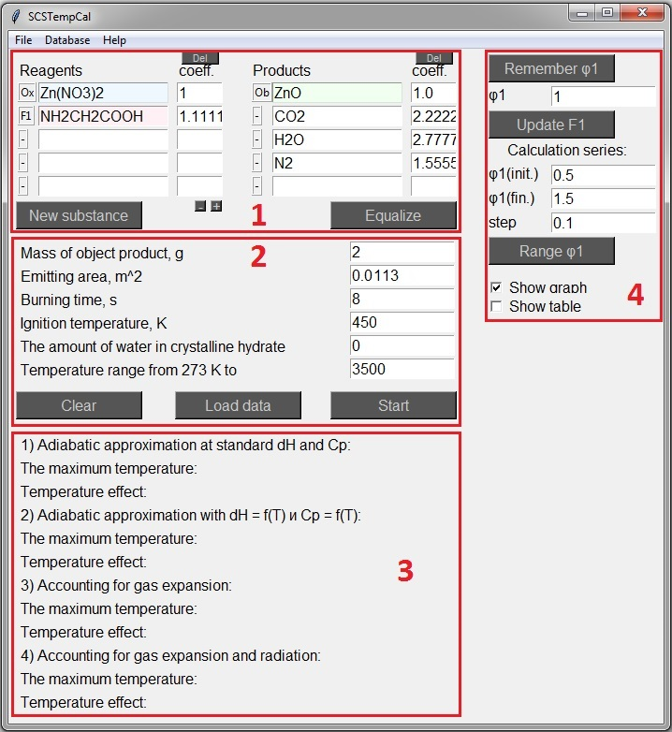
Fig. 1. The working window

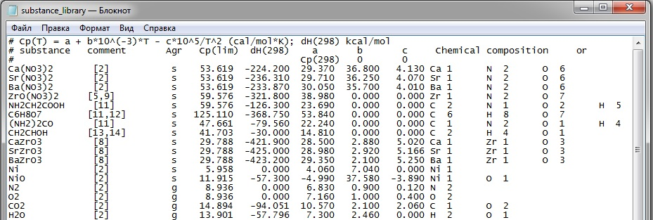
Fig. 2. Part of the database file substance_library.txt

Chemical reaction equation
In the upper part of the working window there are fields for entering chemical compounds that are involved in the reaction (highlighted in red frame 1 in figure 1). Reagents must be indicated on the left and chemical reaction products on the right. The names (chemical formulas) of the reagents and products should be written in the same format as in the substance_library.txt database (first column in figure 2). So, Ca(NO₃)₂ and CaN₂O₆ are perceived by the program as two different compounds. The corresponding chemical reaction equation coefficients should be indicated in the adjacent smaller fields. The number of input fields for reagents and products is varied using the “+” and “-” buttons. The purpose of the “-”, “Ox”, “F” and “Ob” labels to the left of the reagent names will be described below.
The button «Equalize» is designed for automatic distribution of the coefficients of the equation. The basis of this function is the solution of a system of linear equations. The solution of the system is possible only in the case when the number of introduced coefficients of the reagents and products is equal to the difference between the total number of substances involved in the reaction and the number of different types of chemical elements. If insufficient or too many coefficients are indicated, the program will display a message about the need to increase or decrease their number. If coefficients with negative values appear as a result of pressing this button, then the substances corresponding to them must be transferred from the reagents to the products or vice versa, changing the sign. The «del» buttons allow you to quickly remove the coefficients below them.
It is possible to automatically fill in the chemical reaction equation fields with previously stored data (see Saving and loading input data for more information).
Reaction parameters
The program in the calculation process uses information about the conditions of the reaction (highlighted in red frame 2 in figure 1). This includes:
1) object product mass;
2) emitting area;
3) burning time;
4) ignition temperature;
5) amount of water in crystalline hydrate.
The object product is the substance with the label «Ob». Its mass must be indicated in the column mass of the object product. This value is used so that the program determines the actual quantities of reagents and products. The user can remove the “Ob” label from the first product (replacing it with a “-” label) and set the “Ob” label next to any other product. It is possible to specify more than one target product and enter their total mass.
The area of the emitting surface is characterized by the surface area of the reactor in which combustion takes place. A larger area results in faster cooling and lower temperatures. Burning time and ignition temperature are the duration of the reaction in seconds and the temperature of its onset in K. If at the beginning of the reaction one of the reactants exists in the form of crystalline hydrate, the number of stoichiometric units of crystalline water multiplied by the coefficient of the chemical equation in front of the crystalline hydrate is indicated in the column for the amount of water in the crystalline hydrate. This value is necessary to estimate the amount of heat used to evaporate the water.
The last input field in the red frame 2 in Figure 1 contains the value of the upper boundary of the temperature range in which the maximum combustion temperature is searched. Decreasing the value of this parameter will speed up the calculations. However, insufficient value can lead to the fact that the maximum temperature is not reached. In this case, the words «undefined» will appear after starting the calculation instead of the maximum combustion temperatures. The authors of the program recommend to use a value of 3500.
Saving and loading the input data
The program provides the ability to save in a text file the data entered by the user into the working window (chemical reaction equation, reaction parameters). This feature is implemented by the menu option file > save... The location of the file and its name are arbitrarily specified by the user. An example of the structure of such a file is shown in Figure 3.

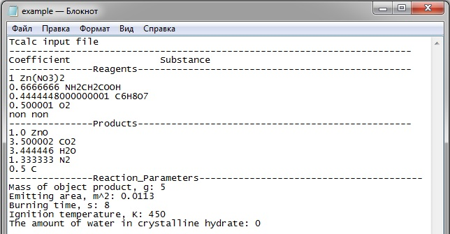
Fig 3. Example of file with saved data

The non is used to indicate that there is an empty field in the list of reagents or products.
Loading saved data is implemented in two ways. A more universal way is to use the option menu File > load... User must specify the path to the data file in this case. The “Load data” button allows faster loading from the input.txt file in the program directory. The input.txt file can be replaced with a custom one. Please note that the “-”, “Ox”, “F” and “Ob” labels are not saved to the file. When loading data from a file, it must be arranged manually.
Information on the compounds involved in the reaction
The program will start the calculation only if there is a record in the substance_library.txt database (Fig. 2) about each of the compounds involved in the reaction. Otherwise, an error like «Reagent X not found in substance_library.txt database» will appear after clicking on the «Start» button. Let's look at an example of such a record for NiO:
NiO [2] s 11.915 -57.300 -4.990 37.580 -3.890 Ni 1 O 1
Here the following information is sequentially indicated:
1) Substance name: NiO
2) Comment: [2]
3) State of aggregation: s (s – solid, g – gas)
4) Limiting value of Cp: 11.915 (Cp(lim) = 3NR for solid substances)
5) Standard enthalpy of formation: -57.300
6) The coefficient a of the equation Cp = a + b*T/1000 – c*10^5/T^2: -4.990
7) The coefficient b of the equation Cp = a + b*T/1000 – c*10^5/T^2: 37.580
8) The coefficient c of the equation Cp = a + b*T/1000 – c*10^5/T^2: -3.890
9) Elemental composition of the compound: Ni 1, O 1
The commentary column contains references from which data on the substance were obtained. If there is no comment, then by default the “-” symbol is placed in its place.
If the dependence of heat capacity at constant pressure on temperature is unknown, then 0 is indicated instead of the coefficients b and c, and standard Cp(298) is indicated instead of a. Heat capacity, limiting heat capacity and coefficients of its temperature dependence are expressed in cal/(mol*K), and enthalpy – in kcal/mol.
The program splits the line with information about the substance by spaces. The contents of each column of the substance_library.txt must not contain spaces.
Adding/editing/deleting records from the database.
The substance_library.txt file can be manually updated with information about new compounds while maintaining the specified format. In addition, the function of recording new substances from the program is provided. To do this, use the “New substance” button or the menu option Database > New substance. A window with fields for entering all the necessary information will appear (Fig 4). The «Auto recognition» button is designed to automatically determine the elemental composition according to the compound formula. The «Record» button will add a new record to the substance_library.txt file, if all the fields have been filled correctly. Otherwise, an error message and its description will appear. One of the reasons for the occurrence of an error is that the specified number of characters is exceeded. Thus, the maximum length of the compound name is 15 characters, the comment – 12, Cp(lim) and enthalpy – 9, the coefficients of temperature dependence – 7, the name of the element – 2, the number of element atoms – 6. This restriction has been introduced to maintain better readability of the substance_library.txt file. However, if the user really needs to exceed the allotted length limit, this can be done by directly editing the substance_library.txt file manually.

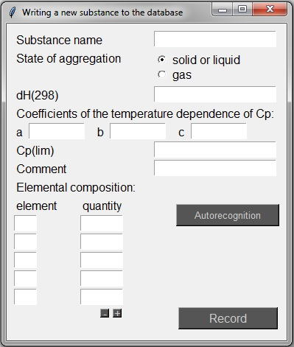
Fig. 4. Writing a new substance to the substance_library.txt database

Viewing and editing old records is possible either manually in the substance_library.txt file, or using the menu option Database > Find in Database... In the last case, a window with a field to enter the name of the desired substance will appear. The “Search” button launches a search for the entered name in the substance_library.txt file. If the corresponding record is found, information about this substance will be displayed. The “Delete” and “Overwrite” buttons allow user to delete this record from the file or overwrite its modified version.
The menu option Database > New substance does not allow you to create records with the same name. However, if for some reason there are already two records with the same name in the substance_library.txt file, only the first record will be displayed in the search result. Similarly, when starting the calculation, only the first record data will be used.
Calculation results
The results of a single calculation are stored in the files output.txt, out_cp.txt and out_dh.txt. The files out_cp.txt and out_dh.txt contain the calculated values of the heat capacities and enthalpies of the substances involved in the reaction at temperatures from 298 to 3500 K. The file output.txt (Fig 5) contains the results of calculating the maximum burning temperature. The input calculation data is listed at the beginning of this file. Behind this data there is a table with the following columns:
1) temperature (K),
2) total heat capacity of reagents,
3) total heat capacity of products,
4) total enthalpy of reagents,
5) total enthalpy of products,
6) enthalpy difference,
7) average heat capacity of products * temperature difference,
8) gas work,
9) difference of three preceding columns,
10) the previous column * the amount of the substance of the product,
11) spent on radiation energy
12) the result is the difference between the two previous columns.

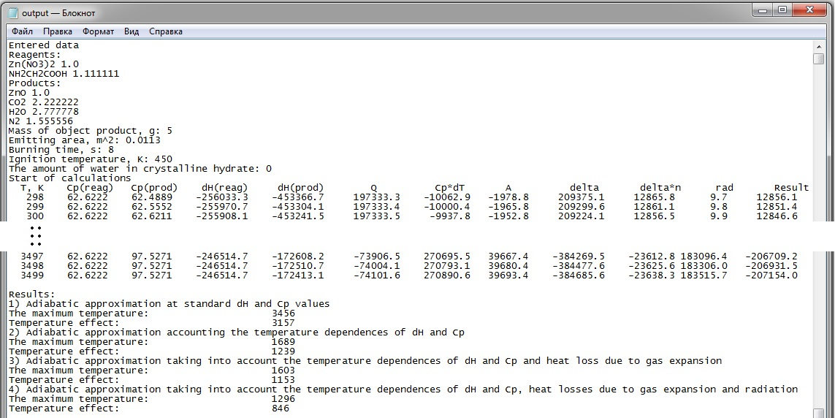
Fig. 5. Results of calculations: file output.txt

Calories are used as the unit of energy measurement. The temperature at which the total value of the column takes the value 0 corresponds to the maximum combustion temperature in the approximation that takes into account the temperature dependences of dH and Cp, heat loss due to expansion of gases and radiation. The calculated maximum temperatures and temperature effects (difference of the maximum temperature and ignition temperature) are given in various approximations with a gradual increase in accuracy at the end of the file.
Restarting the calculations erases the results recorded in the files output.txt, out_cp.txt and out_dh.txt. User should copy these files to another folder or rename to save the results before the next run.
Using the φ variable
The φ value characterizes the fuel/oxidizer ratio. φ = 1 if there is no O₂ in the reaction equation. φ > 1 when O₂ is on the reagent list and φ < 1 when O₂ is on the product list. Reagent labels must be specified in order to use φ. The «F» label must be placed opposite the fuel in the list of reagents, and the «Ox» label must be set opposite the oxidizing precursor. If oxygen is present in the list of reagents, then the «-» mark should be opposite it. In total, user can specify up to 4 «F» labels. Each label will be assigned a corresponding serial number i, taking values from 1 to 4. Interface elements similar to the highlighted in red frame 4 in Figure 1 will appear for each specified fuel.
The «Remember φi» button allows the program to remember the fuel coefficient value with the label «Fi», where i is a serial number from 1 to 4. Using this button, the user must independently verify that the reaction equation corresponds to φ = 1, and the value 1 is indicated in the field under this button. If this value is different from 1, the program will record the ratio of the fuel coefficient value with the label “Fi” to the existing value in the field under the “Remember φi” button. Further, user can automatically recalculate the coefficients of the reaction equation varying the value of φ in the field under the button «Remember φi» and using the “Update Fi” button. Oxygen will be automatically added to the list of reagents or products if necessary.
Conducting serial calculations with φ
The «Range φi» button allows you to conduct a series of calculations with different values of φ. Before using φ, it is necessary to apply the «Remember φi» button and indicate the initial, final value of φ and the step with which this variable will vary in the course of calculations. The program will automatically recalculate the chemical reaction equation coefficients and start the calculation of the maximum temperature. The results of each separate calculation of the series will be saved to the file output_i_φ.txt, where φ is the numerical value of φ, and i is the serial number of φ. It will also create a file output_temp.txt, which presents the maximum temperature depending on φ. Optionally, the user can request the automatic opening of this file or plotting a graph based on it.
Examples of using the program.
1) One oxidizer and one fuel.
Consider the reaction of zinc nitrate with glycine as a simple example. The list of reagents includes Zn(NO₃)₂ and NH₂CH₂COOH. ZnO, H₂O, CO₂ and N₂ have been selected as products. The label of the object product «Ob» is located opposite ZnО, and the labels «-» are placed opposite other products. Coefficient 1 is indicated next to Zn(NO₃)₂. The «Equalize» button allows you to get the remaining coefficients of the equation (Fig. 1). Next, the user must specify the parameters of the reaction. For example, the mass of the target product (ZnO) = 5 g, the emitting area = 0.0113 m², burning time = 8 s, ignition temperature = 450 K. The amount of water in crystalline hydrate is zero, because there are no crystalline hydrates in the reagent list. Pressing the «Start» button will start the calculations. The maximum combustion temperature obtained in the most accurate approximation is 1296 K.
The current equation does not contain O₂ in the list of reagents or products, i.e. φ = 1. Now we carry out the calculation for φ other than 1. Labels «Ox» and «F1» should be placed opposite Zn(NO₃)₂ and NH₂CH₂COOH, respectively. Next, the user should click the «Remember φ1» button. We indicate the value 1.2 in the field φ1. Then we obtain new coefficients of the chemical reaction equation by clicking on the «Update F1» button and start the calculation by clicking on the «Start» button. The maximum temperature is 1361 K. It is also now possible to carry out serial calculations with varying values of φ1.
Please note that incomplete combustion of substances is possible. This leads to other reaction products and a change in maximum temperature. Suppose that carbon is also formed in addition to carbon dioxide in the reaction of zinc nitrate with glycine: Zn(NO₃)₂ + NH₂CH₂COOH → ZnO + H₂O + CO₂ + C + N₂. Now the user needs to set 2 coefficients for autofill of coefficients. Let the coefficient Zn(NO₃)₂ be equal to 1, and the coefficient C will be equal to 0.2. Autofill will result in the following coefficients: Zn(NO₃)₂ + 1.2NH₂CH₂COOH → ZnO + 3H₂O + 2.2CO₂ + 0.2C + 1.6N₂. Starting calculations will lead to a maximum reaction temperature of 1279 K. Increasing the amount of C to 0.5 will lower the maximum reaction temperature to 1253 K.
2) One oxidizer and two fuels.
The program allows taking into account more than one fuel in the combustion reaction. We will consider the combustion reaction of zinc nitrate with glycine and citric acid as an example: Zn(NO₃)₂ + NH₂CH₂COOH + C₆H₈O₇ → ZnO + H₂O + CO₂ + N₂. ZnO will be the object product («Ob» label). Zn(NO₃)₂ is an oxidizing agent («Ox» label). NH₂CH₂COOH and C₆H₈O₇ act as fuel («F1» and «F2» labels). Autofill of the coefficients of this equation requires setting 2 coefficients, one of which sets the ratio between the amount of glycine and citric acid. Now the variables φ1 and φ2 refer to glycine and citric acid, respectively. Let it be required to calculate the maximum combustion temperature in a reaction in which φ1 = 0.7 and φ2 = 0.3. It is necessary to specify the coefficients 1 and 0 for Zn(NO₃)₂ and C₆H₈O₇, respectively, and click the «Equalize» button. The resulting equation will correspond to φ1 = 1. Next, the user needs to make sure that 1 is indicated in the field φ1, and use the «Remember φ1» button. Then the coefficients of the equation should be removed. Now it is necessary to specify the coefficients 1 and 0 for Zn(NO₃)₂ and NH₂CH₂COOH, respectively, and click the «Equalize» button again. The resulting equation will correspond to φ2 = 1. Pressing the «Remember φ2» button will save the corresponding coefficient into the program memory. The values 0.7 and 0.3 are entered into the fields φ1 and φ2, after which the «Update F1» and «Update F2» buttons are pressed. The final equation should be as follows: Zn(NO₃)₂ + 0.777NH₂CH₂COOH + 1.666C₆H₈O₇ → ZnO + 2.611H₂O + 2.555CO₂ + 1.388N₂ (Fig. 6). Now, after entering the reaction parameters, the user can perform a single calculation or a series of calculations for φ1 or φ2.

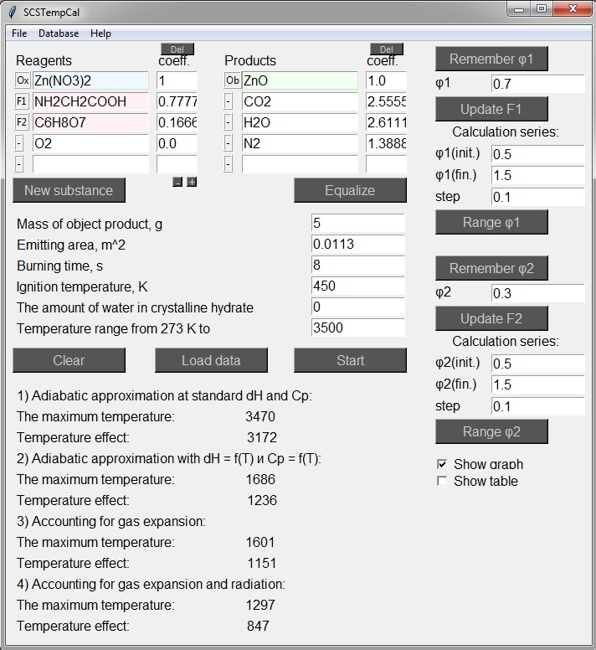
Fig. 6. The equation of reaction with one oxidizer and two fuels

3) Two oxidizers and one fuel.
Consider the combustion reaction of Ca(NO₃)₂ and ZrO(NO₃)₂ with glycine. The reaction equation after the arrangement of the coefficients will have the following form: Ca(NO₃)₂ + ZrO(NO₃)₂ + 2.222NH₂CH₂COOH → CaZrO₃ + 5.555H₂O + 4.444CO₂ + 3.111N₂. Let CaZrO₃ be the object product. We use the following parameter values: mass of the object product = 2 g, emitting area = 0.0113 m2, burning time = 2 s, ignition temperature = 450 K, the amount of water in crystalline hydrate = 0. The maximum combustion temperature of this reaction for given parameters is 1237 K.
CaZrO₃ was chosen as the product in this reaction. In addition, individual oxides can be specified as products: CaO and ZrO₂ (Fig. 7). The maximum combustion temperature at the same parameters is 1225 K. The higher combustion temperature in the first case is associated with the formation enthalpy of CaZrO₃ from CaO and ZrO₂.

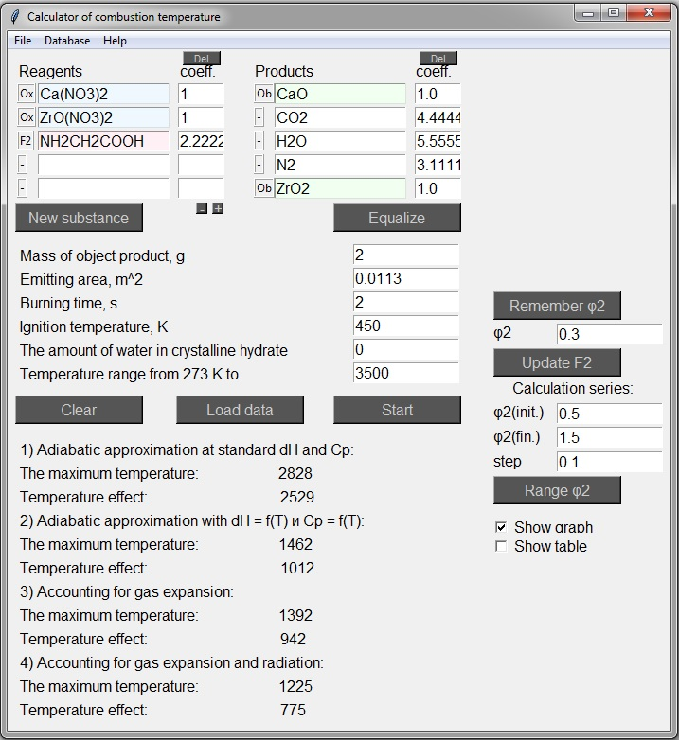
Fig. 7. The reaction equation with two oxidizers and one fuel

