Dashboards for Clicker Data
  - INFO 4100 Learning Analytics
Sydney Chin (scc273), Younghyun Jung (yj582), Arianna Hsu (ach282), Ivy Liu (il328), Amy Oduor (aao73), Sheki Okwayo(lso24)
This project is about developing a learning analytics dashboard based on clicker data. You will work as a team to learn how to make a dashboard using R Shiny (official page with several tutorials: https://shiny.rstudio.com/tutorial/).
Learning Objectives
- Understand the structure of clicker data
- Create multiple different visualizations
- Design and implement an instructor and student dashboard
- Critically evaluate your own dashboard design
You are given aggregated clicker records for a CS course taught at Cornell. There are two datasets: the experience dataset and the quiz dataset.
Scenario
You are approached by a college instructor who uses iClickers in her CS class on Business Intelligence. She would like to gain insights about her students and how they are engaging/performing in order to better help them in class. She would also like to better support students by giving them feedback at scale about where they stand and perhaps how they compare to others in the class.
You offer to build a prototype of a dashboard using her clicker data: this is a dashboard for the instructor which offers an overview of the class characteristics, engagement, and performance; and it is a dashboard for students which offers a specific student an overview of their engagement and performance (and how it compares to others).
Data
The experience dataset contains one record per student who completed the CS course between 2016-2018. There are two sources to this dataset: Faculty Center and a Skills Survey (administered via the Blackboard LMS) where students self reported their skill level for various skills the first week of class. This data has been de-identified. Name, netid, emplid, major have all been removed and replaced with a unique numeric identifier. Note that not all students completed the skills survey, they will have null values for the survey result fields.
Attribute Name | Data Type | Definition
student_key | numeric Unique key | Assigned as part of de-identification process. Uniquely identifies student records for this data set only.
year | numeric | Four digit year student was enrolled in BI Class.
prog | character Values (GRAD, UGRAD) | Indicates whether the student was a graduate or undergraduate student when they were enrolled in BI course.
database_score | numeric (0-5) | Self reported experience level with database technology prior to taking course. 0= no experience, 5= expertise
sql_score | numeric (0-5) | Self reported experience level with SQL prior to taking course. 0= no experience, 5=expertise
programing_score | numeric (0-5) | Self reported experience level with Any Programing language prior to taking course. 0=no experience, 5=expertise
stored_proc_score | numeric (0-5) | Self reported experience level with stored procedure languages prior to taking course. 0=no experience, 5=expertise
etl_score | numeric (0-5) | Self reported experience level with Extract Transform Load (ETL) development prior to taking course. 0=no experience, 5=expertise
data_vis_score | numeric (0-5) | Self reported experience level using data visualization tools prior to taking course. 0=no experience, 5=expertise
requirement_gather_score | numeric (0-5) | Self reported experience level gathering customer requirements prior to taking course. 0=no experience, 5=expertise
skill_survey_score | numeric | Sum of the self reported skill level scores.
The quiz dataset contains one record per student per class session held where iClickers were used. Sources used in the creation of this data set include: iClicker session xml files, Blackboard gradebook (for quiz scores), and the Blackboard class schedule (used to map iClicker session to related quiz scores). Note that in some cases there are multiple iClicker sessions / lectures associated with a single quiz. This dataset may be joined to the experience dataset by the student_key field.
Attribute Name | Data Type | Definition
Acad_date_key | numeric | Date key in the form of YYYYMMDD indicating the date the class session was held.
student_key | numeric | Unique identifier for students who took BI class 2016-2018. This key is the primary key for the experience_data file.
year | numeric | Four digit year class session was held.
session_number | numeric | Identifies the session number for a particular semester. Session number is assigned by iClicker.
quiz_number | numeric | There are 10 quizzes throughout the BI course. This attribute indicates which quiz is associated with the iClicker session(s).
attended | numeric (0,1) | Binary indicating whether the student attended that particular class session / lecture. 0=no, 1=yes.
total_possible_clicker | numeric | The total number of iClicker questions asked that session.
total_completed_clicker | numeric | The number of iClicker questions answered by student that session.
completed_q_clicker | numeric | The number of completed Quiz iClicker questions
correct_q_clicker | numeric | How many correct Quiz answers by student that session.
completed_t_clicker | number | How many Temperature questions answered by student that session. Temperature questions are 0-5, 0= bad, 5=great. There is no correct answer to Temperature questions, they are used to guage how students are feeling about a particular subject, assignment, etc.
avg_t_clicker | number | The average temperature answer by student for that session. An average of 1 or 2 would be generally negative, while 4 or 5 would be generally positive responses.
quiz_score | numeric | Quiz score out of 20 points possible.

Part 1: Planning / Sketching
Go through the planning / sketching process described in the reading about dashboards. While some dashboards are certainly better than others, there is not one correct solution here. However, spending enough time to make a concrete plan is essential for the success of your project. Everything you do to make the dashboards will be easier if you have a clear plan, especially because you will be splitting up the work and everyone needs to know what they should work on.
Question 1: You will make a student dashboard and a teacher dashboard. Carefully consider the implications of this for design and content. To plan, answer the following prompts once for the student dashboard and then for the teacher dashboard. The more concrete you are here the easier it will be later. Focus on the concrete ideas that you will implement in the next steps. You can iterate on this step and modify your responses as your ideas for the dashboard become clearer. You should explore the dataset in R for 5-10 minutes to get a good sense of what the dataset has to offer.
Planning for the student dashboard
- For whom? Who will use it and what is their background?
  - Students have a mix of backgrounds including both undergrad and graduate students. They will use this dashboard to know their standing compared to other students in the class.
- Why? What is the goal? What questions to answer?
  - The student’s goal is to be able to assess their understanding of the content so they know when to ask for help. Additionally, it is helpful to know their attendance rate in order to maximize their participation grade.
- What? What data to show and what is its structure?
  - [add your answer here]
  - [add your answer here]
- How? How will visualizations support the goal?
  - [add your answer here]
  - [add your answer here]
Planning for the teacher dashboard
- For whom? Who will use it and what is their background?
  - The instructor is teaching a large class, so it is hard to be able to gauge how every student is doing. The teacher would like more support in pinpointing which students need additional interventions.
- Why? What is the goal? What questions to answer?
  - The instructor would like to know which sessions students were able to understand well and which sessions were confusing. Also, it is important to know which students are struggling to understand the course content.
- What? What data to show and what is its structure?
  - [add your answer here]
  - [add your answer here]
- How? How will visualizations support the goal?
  - The skills gap visualization will help the instructor know which students have incorrectly assessed their skills (had high survey scores but low quiz scores) and which students are struggling due to their lack of prior knowledge (had low survey scores and currently have low quiz scores).
Question 2: Based on your plan above, make a sketch of what the dashboard would look like. See this week’s readings for examples. Be detailed about what kinds of data points and visualizations you want to see in different parts of the page. Consider the user experience and how you should position more general information compared to more specific information, and where you may need some additional explanation to help the viewer understand a graphic, for example. In your sketch, it is useful to give labels to different objects, because in the steps below you can split up work between team members and the labels will help you connect the UI with the data objects. Show your sketches in section to get feedback from the teaching team.
Each dashboard should contain at least 4 data visualizations. You may include any additional summary statistics (e.g. key percentages or tables).

Part 2: Dashboard Wire-frame Implementation
This is where you generate the dashboard layout. You are given a very basic wire frame example for the dashboard below. For more information on how R Shiny Dashboards work, look at https://rstudio.github.io/shinydashboard/get_started.html and https://rstudio.github.io/shinydashboard/structure.html. You can add different types of content into a fuidRow(). In the starter code, there are 2 rows of content: the first has two little info boxes; the second has two larger viz boxes. You can add more rows and change what is in them as you wish. Follow the naming convention, e.g. inst.info1 is the first info box for instructors.
Your team can split up the tasks. Some work on creating the UI (this part), while others work on pre-processing the data and creating the statistics and visualizations that will populate the UI (next part).
Question 3: Create the layout for the dashboard tabs. You can have as many “tabs” as you like. Each tab is the content displayed when the user clicks on one of the menu items (so it is the page content). Here you are just specifying the wire frame i.e. what goes where on the pages, not what goes into it.
#######################################
####### BEGIN INPUT: Question 3 #######
#######################################
# =====================
# INSTRUCTOR DASHBOARD
# =====================
instructor_dash <- tabItem(
tabName = "instructor",
h2("Instructor Dashboard"),
fluidRow(
box(
title = "Instructor Filters", width = 12, status = "primary",
column(4, selectInput("inst.year", "Select Year", choices = c("All"), selected = "All")),
column(4, sliderInput("inst.attend_cutoff", "Risk Attendance Cutoff (%)", min = 40, max = 95, value = 75, step = 5)),
column(4, sliderInput("inst.quiz_cutoff", "Risk Avg Quiz Score Cutoff", min = 8, max = 18, value = 14, step = 1))
)
),
# KPI Boxes
fluidRow(
infoBoxOutput("inst.total_students", width = 3),
infoBoxOutput("inst.avg_attendance", width = 3),
infoBoxOutput("inst.avg_score", width = 3),
infoBoxOutput("inst.avg_sentiment", width = 3)
),
# Charts
fluidRow(
box(
title = "Quiz Score Trend", width = 6,
plotOutput("inst.quiz_trend", height = 250)
),
box(
title = "Skill to Performance Gap", width = 6,
plotOutput("inst.skill_gap_plot", height = 250)
)
),
# At-Risk Analytics
fluidRow(
box(
title = "Student Intervention Map", width = 6,
plotlyOutput("inst.risk.map", height = 300)
),
box(
title = "At-Risk Students List", width = 6,
div(style = "height: 300px; overflow-y: auto;",
tableOutput("inst.risk.table")
)
)
)
)
# =====================
# STUDENT DASHBOARD
# =====================
student_dash <- tabItem(
tabName = "student",
h2("Student Dashboard"),
fluidRow(
infoBoxOutput("stu.attendance"),
infoBoxOutput("stu.avg_score"),
infoBoxOutput("stu.clicker_acc"),
infoBoxOutput("stu.sentiment")
),
fluidRow(
box(
title = "My Quiz Scores vs Class Average", width = 6,
plotOutput("stu.quiz_compare", height = 250)
),
box(
title = "My Attendance per Session", width = 6,
plotOutput("stu.attendance_plot", height = 250)
)
),
fluidRow(
box(
title = "My sentiment vs class average",
width = 6,
plotOutput("stu.sentiment_plot", height = 250)
),
box(
title = "My Skill Profile vs Class Average",
width = 6,
plotOutput("stu.plot4", height = 250)
)
)
)
#######################################
#######################################

Part 3: Data Pre-processing
Get the data ready for use in the dashboard. Before the next stage, you want to have the data ready in the right format for simple computations and plotting. To do this effectively, you need to know by now what you want to display in each dashboard. However, this is also an iterative process. Once you have completed a first iteration of the design, you can come back to this step and add further pre-processing for more visualizations you like to add. This step is also an opportunity to better understand the structure of the datasets.
The instructor dashboard should show information for all students. The student dashboard is typically focused on an individual student. You can either pick a student (at random or intentionally) and use them as the “reference student” for the student dashboard. Or, a bit more ambitious but also more rewarding to try out, you can create an interactive dashboard in which you select the student and then the dashboard updates to show the information for that student. I would recommend you start with the simpler version and get that to work before you try to make it dynamic.
Use the space below to be ready for your information visualizations in the dashboards.
#######################################
####### BEGIN INPUT #######
#######################################
######################################
####### QUIZ SCORE DATA #######
######################################
quiz_clean <- quiz %>%
mutate(
clicker_completion_rate = if_else(
TOTAL_POSSIBLE_CLICKER > 0,
TOTAL_COMPLETED_CLICKER / TOTAL_POSSIBLE_CLICKER,
NA_real_
)
)
experience_clean <- experience
inst_year_choices <- c("All", sort(unique(quiz_clean$YEAR)))
student_choices <- sort(unique(quiz_clean$STUDENT_KEY))
reference_student_key <- student_choices[1]
all_sessions <- sort(unique(quiz_clean$SESSION_NUMBER))
skill_cols <- c(
"DATABASE_SCORE", "SQL_SCORE", "PROGRAMING_SCORE",
"STORED_PROC_SCORE", "ETL_SCORE", "DATA_VIS_SCORE",
"REQUIREMENT_GATHER_SCORE"
)
class_avg <- experience_clean %>%
summarise(across(all_of(skill_cols), mean, na.rm = TRUE))
## Warning: There was 1 warning in `summarise()`.
## ℹ In argument: `across(all_of(skill_cols), mean, na.rm = TRUE)`.
## Caused by warning:
## ! The `...` argument of `across()` is deprecated as of dplyr 1.1.0.
## Supply arguments directly to `.fns` through an anonymous function instead.
##
## # Previously
## across(a:b, mean, na.rm = TRUE)
##
## # Now
## across(a:b, \(x) mean(x, na.rm = TRUE))
#######################################
#######################################

Part 4: Prepare All Data Visualizations
This is where you create the content for the wire frames you created above. Again, you can refer to the examples and documentation in https://rstudio.github.io/shinydashboard/get_started.html and https://rstudio.github.io/shinydashboard/structure.html for guidance. You can also find many examples online just by searching with Google.
Question 4: For each of the pieces of content you planned for in the wire frames above, generate the relevant content. You need to assign them all to the output variable by referencing the name of the wire frame element you chose above like this output$name.of.element.
server <- function(input, output, session) {
#######################################
####### BEGIN INPUT: Question 4 #######
#######################################
updateSelectInput(session, "inst.year", choices = inst_year_choices, selected = "All")
updateSelectInput(session, "stud.key", choices = student_choices, selected = reference_student_key)
instructor_filtered <- reactive({
req(input$inst.year)
if (input$inst.year == "All") {
quiz_clean
} else {
quiz_clean %>% filter(YEAR == as.numeric(input$inst.year))
}
})
instructor_student_rollup <- reactive({
instructor_filtered() %>%
group_by(STUDENT_KEY) %>%
summarise(
attendance_rate = mean(ATTENDED, na.rm = TRUE),
avg_quiz_score = mean(QUIZ_SCORE, na.rm = TRUE),
sessions = n(),
.groups = "drop"
)
})
at_risk_filtered <- reactive({
req(input$inst.attend_cutoff, input$inst.quiz_cutoff)
instructor_student_rollup() %>%
mutate(
risk_group = case_when(
attendance_rate < (input$inst.attend_cutoff / 100) & avg_quiz_score < input$inst.quiz_cutoff ~ "Low Attendance & Score",
attendance_rate < (input$inst.attend_cutoff / 100) ~ "Low Attendance",
avg_quiz_score < input$inst.quiz_cutoff ~ "Low Score",
TRUE ~ "On Track"
)
) %>%
filter(risk_group != "On Track") %>%
arrange(attendance_rate, avg_quiz_score)
})
student_data <- reactive({
req(input$stud.key)
quiz_clean %>%
filter(STUDENT_KEY == as.numeric(input$stud.key)) %>%
arrange(SESSION_NUMBER)
})
output$sidebar_stud_info <- renderUI({
req(input$stud.key)
student_meta <- experience_clean %>%
filter(STUDENT_KEY == as.numeric(input$stud.key)) %>%
select(PROG, YEAR) %>%
head(1)
prog_text <- ifelse(nrow(student_meta) > 0 && !is.na(student_meta$PROG), student_meta$PROG, "Unknown")
year_text <- ifelse(nrow(student_meta) > 0 && !is.na(student_meta$YEAR), student_meta$YEAR, "Unknown")
div(style = "padding: 0 15px;",
div(style = "background-color: #2c3b41; padding: 15px; border-radius: 5px; margin-top: 10px;",
p("Program", style = "margin: 0; color: #8aa4af; font-size: 12px;"),
h4(prog_text, style = "margin: 5px 0 15px 0; color: white; font-weight: bold;"),
p("Cohort year", style = "margin: 0; color: #8aa4af; font-size: 12px;"),
h4(year_text, style = "margin: 5px 0 0 0; color: white; font-weight: bold;")
)
)
})
output$inst.total_students <- renderInfoBox({
total_stu <- n_distinct(instructor_filtered()$STUDENT_KEY)
infoBox("Total students", total_stu, icon = icon("users"), color = "blue")
})
output$inst.avg_attendance <- renderInfoBox({
avg_att <- mean(instructor_filtered()$ATTENDED, na.rm = TRUE)
infoBox("Avg attendance", paste0(round(avg_att * 100), "%"), icon = icon("calendar-check"), color = "green")
})
output$inst.avg_score <- renderInfoBox({
avg_score <- mean(instructor_filtered()$QUIZ_SCORE, na.rm = TRUE)
infoBox("Avg quiz score", paste0(round(avg_score, 1), " / 20"), icon = icon("pencil-alt"), color = "yellow")
})
output$inst.avg_sentiment <- renderInfoBox({
avg_sent <- mean(instructor_filtered()$AVG_T_CLICKER, na.rm = TRUE)
infoBox("Avg sentiment", paste0(round(avg_sent, 1), " / 5"), icon = icon("smile"), color = "green")
})
output$inst.quiz_trend <- renderPlot({
quiz_trend_data <- instructor_filtered() %>%
group_by(QUIZ_NUMBER) %>%
summarise(
avg_score = mean(QUIZ_SCORE, na.rm = TRUE),
q25 = quantile(QUIZ_SCORE, 0.25, na.rm = TRUE),
q75 = quantile(QUIZ_SCORE, 0.75, na.rm = TRUE)
) %>%
filter(!is.na(QUIZ_NUMBER)) %>%
mutate(quiz_label = factor(paste0("Q", QUIZ_NUMBER), levels = paste0("Q", sort(unique(QUIZ_NUMBER)))))
ggplot(quiz_trend_data, aes(x = quiz_label, y = avg_score, group = 1)) +
geom_ribbon(aes(ymin = q25, ymax = q75), fill = "#bbdefb", alpha = 0.5) +
geom_line(color = "#1976d2", linewidth = 1.2) +
geom_point(color = "#0d47a1", size = 3) +
scale_y_continuous(limits = c(5, 20), breaks = c(10, 15, 20)) +
labs(x = "Quiz Number", y = "Average Score") +
theme_void() +
theme(
axis.text.x = element_text(color = "#444444", size = 11, margin = margin(t = 10)),
axis.text.y = element_text(color = "#444444", size = 11, margin = margin(r = 10)),
plot.margin = margin(t = 10, r = 10, b = 20, l = 10)
)
})
output$inst.risk.map <- renderPlotly({
req(input$inst.attend_cutoff, input$inst.quiz_cutoff)
map_df <- instructor_student_rollup() %>%
mutate(
risk_group = case_when(
attendance_rate < (input$inst.attend_cutoff / 100) & avg_quiz_score < input$inst.quiz_cutoff ~ "Low Attendance & Score",
attendance_rate < (input$inst.attend_cutoff / 100) ~ "Low Attendance",
avg_quiz_score < input$inst.quiz_cutoff ~ "Low Score",
TRUE ~ "On Track"
)
)
p <- ggplot(map_df, aes(
x = attendance_rate * 100,
y = avg_quiz_score,
color = risk_group,
text = paste(
"Student ID:", STUDENT_KEY,
"<br>Attendance:", paste0(round(attendance_rate * 100), "%"),
"<br>Avg Quiz Score:", round(avg_quiz_score, 1),
"<br>Status:", risk_group
)
)) +
geom_point(size = 2, alpha = 0.8) +
scale_color_manual(values = c(
"Low Attendance & Score" = "#E15759",
"Low Attendance" = "#fc9272",
"Low Score" = "#F28E2B",
"On Track" = "gray70"
)) +
geom_vline(xintercept = input$inst.attend_cutoff, linetype = "dashed", color = "gray40") +
geom_hline(yintercept = input$inst.quiz_cutoff, linetype = "dashed", color = "gray40") +
labs(x = "Attendance Rate (%)", y = "Avg Quiz Score (out of 20)", color = "Status") +
theme_classic() +
theme(legend.position = "none")
ggplotly(p, tooltip = "text")
})
output$inst.risk.table <- renderTable({
at_risk_filtered() %>%
transmute(
`Student ID` = as.integer(STUDENT_KEY),
`Attendance %` = round(100 * attendance_rate, 1),
`Avg Score` = round(avg_quiz_score, 2),
`Status` = risk_group
)
})
output$stu.attendance <- renderInfoBox({
infoBox("Attendance", paste0(round(100 * mean(student_data()$ATTENDED, na.rm = TRUE), 1), "%"), icon = icon("user-check"), color = "aqua")
})
output$stu.avg_score <- renderInfoBox({
infoBox("Avg Quiz Score", round(mean(student_data()$QUIZ_SCORE, na.rm = TRUE), 2), icon = icon("chart-line"), color = "green")
})
output$stu.clicker_acc <- renderInfoBox({
infoBox("Clicker Completion", round(mean(student_data()$TOTAL_COMPLETED_CLICKER, na.rm = TRUE), 2), icon = icon("mouse-pointer"), color = "orange")
})
output$stu.sentiment <- renderInfoBox({
infoBox("Avg Sentiment", round(mean(student_data()$AVG_T_CLICKER, na.rm = TRUE), 2), icon = icon("smile"), color = "purple")
})
output$stu.quiz_compare <- renderPlot({
student_quiz <- student_data() %>%
group_by(QUIZ_NUMBER) %>%
summarise(student_avg = mean(QUIZ_SCORE, na.rm = TRUE), .groups = "drop")
class_quiz <- quiz_clean %>%
group_by(QUIZ_NUMBER) %>%
summarise(class_avg = mean(QUIZ_SCORE, na.rm = TRUE), .groups = "drop")
compare_df <- left_join(student_quiz, class_quiz, by = "QUIZ_NUMBER") %>%
pivot_longer(cols = c(student_avg, class_avg), names_to = "group", values_to = "score")
ggplot(compare_df, aes(x = factor(QUIZ_NUMBER), y = score, fill = group)) +
geom_bar(stat = "identity", position = "dodge", width = 0.7) +
scale_fill_manual(values = c(class_avg = "#2b8cbe", student_avg = "#d95f0e"), labels = c("Class Avg", "My Score")) +
labs(x = "Quiz Number", y = "Score", fill = NULL) +
theme_classic() +
theme(legend.position = "top")
})
output$stu.attendance_plot <- renderPlot({
att_data <- student_data() %>%
mutate(
session = factor(paste0("S", SESSION_NUMBER), levels = paste0("S", all_sessions)),
status = ifelse(ATTENDED == 1, "attended", "absent"),
height = ifelse(status == "attended", 1.0, 0.5)
) %>%
select(session, status, height) %>%
complete(session, fill = list(status = "absent", height = 0.5))
ggplot(att_data, aes(x = session, y = height, fill = status)) +
geom_col(width = 0.4, show.legend = FALSE) +
scale_fill_manual(values = c("attended" = "#56ae7c", "absent" = "#b55347")) +
scale_y_continuous(limits = c(0, 1.1), expand = c(0, 0)) +
theme_void() +
theme(
axis.text.x = element_text(color = "#444444", size = 9, angle = 45, hjust = 1, vjust = 1, margin = margin(t = 10)),
plot.margin = margin(t = 10, r = 10, b = 40, l = 10)
)
})
output$stu.sentiment_plot <- renderPlot({
student_sent <- student_data() %>%
group_by(QUIZ_NUMBER) %>%
summarise(student_avg = mean(AVG_T_CLICKER, na.rm = TRUE), .groups = "drop")
class_sent <- quiz_clean %>%
group_by(QUIZ_NUMBER) %>%
summarise(class_avg = mean(AVG_T_CLICKER, na.rm = TRUE), .groups = "drop")
compare_df <- left_join(class_sent, student_sent, by = "QUIZ_NUMBER") %>%
pivot_longer(cols = c(student_avg, class_avg), names_to = "group", values_to = "score") %>%
filter(!is.na(QUIZ_NUMBER))
ggplot(compare_df, aes(x = factor(QUIZ_NUMBER), y = score, color = group, group = group, linetype = group)) +
geom_line(linewidth = 1) +
geom_point(size = 2, aes(shape = group)) +
scale_color_manual(
values = c(class_avg = "gray60", student_avg = "#e7298a"),
labels = c("Class Avg", "Me")
) +
scale_linetype_manual(
values = c(class_avg = "dashed", student_avg = "solid"),
labels = c("Class Avg", "Me")
) +
scale_shape_manual(
values = c(class_avg = 15, student_avg = 16),
labels = c("Class Avg", "Me")
) +
scale_y_continuous(limits = c(0, 5)) +
labs(x = "Quiz Number", y = "Sentiment Score (0-5)", color = NULL, linetype = NULL, shape = NULL) +
theme_classic() +
theme(
legend.position = "top",
legend.margin = margin(b = -10)
)
})
output$stu.plot4 <- renderPlot({
req(input$stud.key)
student_skills <- experience_clean %>%
filter(STUDENT_KEY == as.numeric(input$stud.key)) %>%
select(all_of(skill_cols))
if(nrow(student_skills) == 0 || all(is.na(student_skills))) {
plot.new()
text(0.5, 0.5, "Skill survey data not available for this student.", cex = 1.2, col = "red")
return()
}
radar_data <- rbind(
setNames(as.data.frame(matrix(5, nrow = 1, ncol = 7)), skill_cols), # max
setNames(as.data.frame(matrix(0, nrow = 1, ncol = 7)), skill_cols), # min
class_avg,
student_skills
)
colnames(radar_data) <- c("Database", "SQL", "Programming", "Stored Proc", "ETL", "Data Vis", "Req. Gathering")
radarchart(
radar_data, axistype = 1,
pcol = c("gray50", "#4E79A7"),
pfcol = c(rgb(0.5, 0.5, 0.5, 0.3), rgb(0.3, 0.5, 0.7, 0.3)),
plwd = 2, cglcol = "grey", cglty = 1, axislabcol = "grey40", vlcex = 0.9,
)
legend(
x = "bottomright", legend = c("Class Average", "You"),
col = c("gray50", "#4E79A7"), lty = 1, lwd = 2, bty = "n"
)
})
output$inst.skill_gap_plot <- renderPlot({
# Define skill columns
skill_cols <- c("DATABASE_SCORE", "SQL_SCORE", "PROGRAMING_SCORE",
"STORED_PROC_SCORE", "ETL_SCORE", "DATA_VIS_SCORE",
"REQUIREMENT_GATHER_SCORE")
# Calculate student baseline skills
student_skills <- experience_clean %>%
mutate(avg_survey_score = rowMeans(select(., all_of(skill_cols)), na.rm = TRUE)) %>%
select(STUDENT_KEY, avg_survey_score)
# Join with instructor rollup data
plot_data <- instructor_student_rollup() %>%
inner_join(student_skills, by = "STUDENT_KEY") %>%
mutate(
category = case_when(
avg_survey_score < 2.5 & avg_quiz_score < input$inst.quiz_cutoff ~ "Under-prepared",
avg_survey_score >= 2.5 & avg_quiz_score < input$inst.quiz_cutoff ~ "Overconfident",
avg_quiz_score >= input$inst.quiz_cutoff ~ "Performing Well",
TRUE ~ "Other At-Risk"
)
)
# Create the Scatterplot with fixed scales
ggplot(plot_data, aes(x = avg_survey_score, y = avg_quiz_score, color = category)) +
geom_point(size = 3, alpha = 0.7) +
geom_vline(xintercept = 2.5, linetype = "dotted", color = "gray50") +
geom_hline(yintercept = input$inst.quiz_cutoff, linetype = "dashed", color = "red") +
# SET SCALES HERE
scale_x_continuous(limits = c(0, 5), breaks = 0:5) +
scale_y_continuous(limits = c(0, 20), breaks = seq(0, 20, by = 5)) +
scale_color_manual(values = c(
"Under-prepared" = "#E15759",
"Overconfident" = "#F28E2B",
"Performing Well" = "#76B7B2",
"Other At-Risk" = "#BAB0AC"
)) +
labs(
x = "Average Initial Skill Score (0-5)",
y = "Average Quiz Score (0-20)",
color = "Student Profile"
) +
theme_minimal() +
theme(legend.position = "bottom")
})
#######################################
#######################################
}

Part 5: Produce Dashboard and Reflect
You should be able to simply run the code below as is to see your dashboard.
Note: Unfortunately, you cannot knit this part into a pdf. So I added eval=FALSE to let the knitting run smoothly and you can submit your PDF.
#######################################
### This code creates the dashboard ###
#######################################
# Here we set up the Header of the dashboard
dhead <- dashboardHeader(title = "Clicker Dashboard")
# Here set up the sidebar which has links to two pages
dside <- dashboardSidebar(
sidebarMenu(id = "tabs",
menuItem("Instructor View", tabName = "instructor", icon = icon("dashboard")),
menuItem("Student View", tabName = "student", icon = icon("th"))
),
conditionalPanel(
condition = "input.tabs == 'student'",
hr(style = "border-top: 1px solid #444; margin: 10px 0;"),
div(style = "padding: 10px 15px;",
h5("MY INFO", style = "color: #8aa4af; font-size: 12px; letter-spacing: 1px; margin-bottom: 10px;")
),
selectInput("stud.key", "Student ID", choices = c()),
uiOutput("sidebar_stud_info")
)
)
# Here we set up the body of the dashboard
dbody <- dashboardBody(
tags$style(HTML("
body { background-color: #f5f5f5; color: #333333; font-family: 'Inter', sans-serif; }
.attendance-card {
background-color: #ffffff;
padding: 30px;
border-radius: 20px;
width: 100%;
max-width: 800px;
margin: 50px auto;
box-shadow: 0 4px 15px rgba(0,0,0,0.05);
}
.card-title { font-size: 24px; font-weight: bold; color: #1a1a1a; margin-bottom: 5px; }
.card-subtitle { font-size: 16px; color: #666666; margin-bottom: 40px; }
")),
tabItems(
student_dash,
instructor_dash
)
)
# Combining header, sidebar, and body
ui <- dashboardPage(dhead, dside, dbody)
# Generating a local instance of your dashboard
shinyApp(ui, server)
Question 5: Add screenshots of your group’s dahsboards below using this syntax or simply add them to the Word document after knitting:
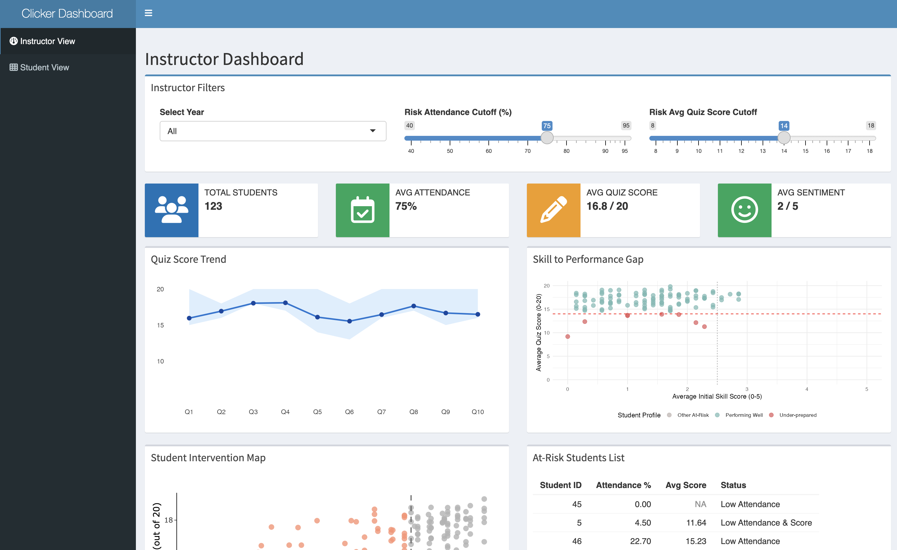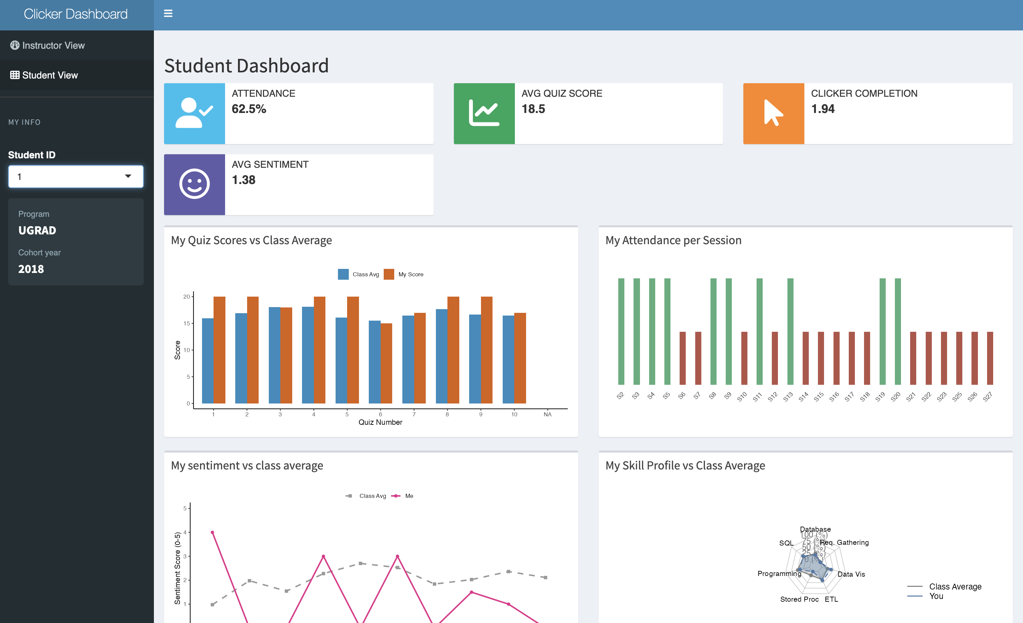
Question 6: Evaluate your group dashboard from the perspective of the instructor (teacher dashboard) and from the perspective of the student (student dashboard). What do you like about it, what would you change or add to it if you had more time?
Reflection for the student dashboard
- What do you like about it?
  - I really like the highly personalized nature of the visualizations, especially how the radar chart and sentiment trend lines allow students to instantly see their individual standing compared to class-wide benchmarks.
- What would you change or add to it if you had more time?
  - If I had more time, I would implement an “Automated Resource Recommender” that suggests specific review materials based on the quiz topics where a student’s score falls significantly below the class average.
- What was the biggest challenge you faced? How did you address it?
  - The primary challenge was ensuring the sidebar student selector seamlessly updated all four disparate plots simultaneously; I addressed this by centralizing the data filtering into a single reactive function to maintain state consistency.
Reflection for the teacher dashboard
- What do you like about it?
  - The “Skill to Performance Gap” scatter plot is excellent because it helps instructors identify “at-risk” students who may have overestimated their initial abilities or are struggling despite high prior experience.
- What would you change or add to it if you had more time?
  - I would add a direct “Action” button within the At-Risk Students list that allows the teaching team to send pre-formatted intervention emails to specific students directly from the dashboard interface.
- What was the biggest challenge you faced? How did you address it?
  - Balancing high-level class trends with granular student-level details was difficult, so we implemented a hierarchical layout using info boxes for quick KPIs and scrolling tables for deeper drill-down analysis.

Estimate time spent
We want to give students an estimate of how much time this homework will take. Please indicate how many hours you spent to complete this homework here.
- We spent 10 hours.

Generative AI usage
As stated in the course syllabus, using generative AI is allowed to help you as you complete this homework. We are interested in how it is being used and whether it is helpful for you.
- How much did you use generative AI (e.g., not at all, some, most, or all the questions) and which one did you use? => We used generative AI to most of the questions.
- If you used generative AI, how did you use it and was it helpful? => We primarily leveraged AI to write complex code structures, debug reactive data flows, and refine the UI styling # Submit Project
This is the end of the group project. Please Knit to Word (if you run into an issue, you can knit to PDF). The resulting file has to show both the R code and R output. Upload it on Canvas before the due date.

