Ian Lim Ee Khai

P21013175

4001CEM

Task 4 - Prototype UI and Usability Testing

4001CEM 2021 Assignment

# Function 1 - Advanced searchImage

Search for a book with title “Operating Systems Concepts”.

Search for books written by “Tolkien”.

Search for books published by “Penguin House”.

Search for all books published between 2005 and 2008.

Search for science fiction English books.

Search for reference books that have been posted within 1 kilometer of your address.

Sort search results by distance from you.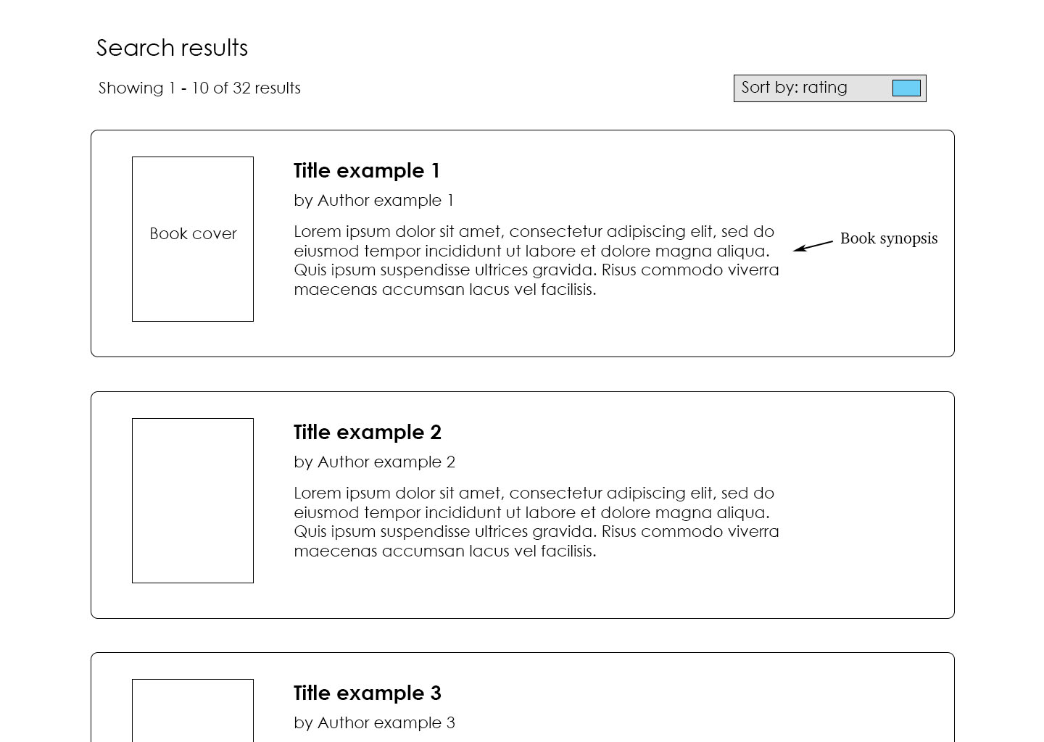

# Function 2 - Home page, account details and posting a book.Image

# Enter user details and sign-in.

Go to account page.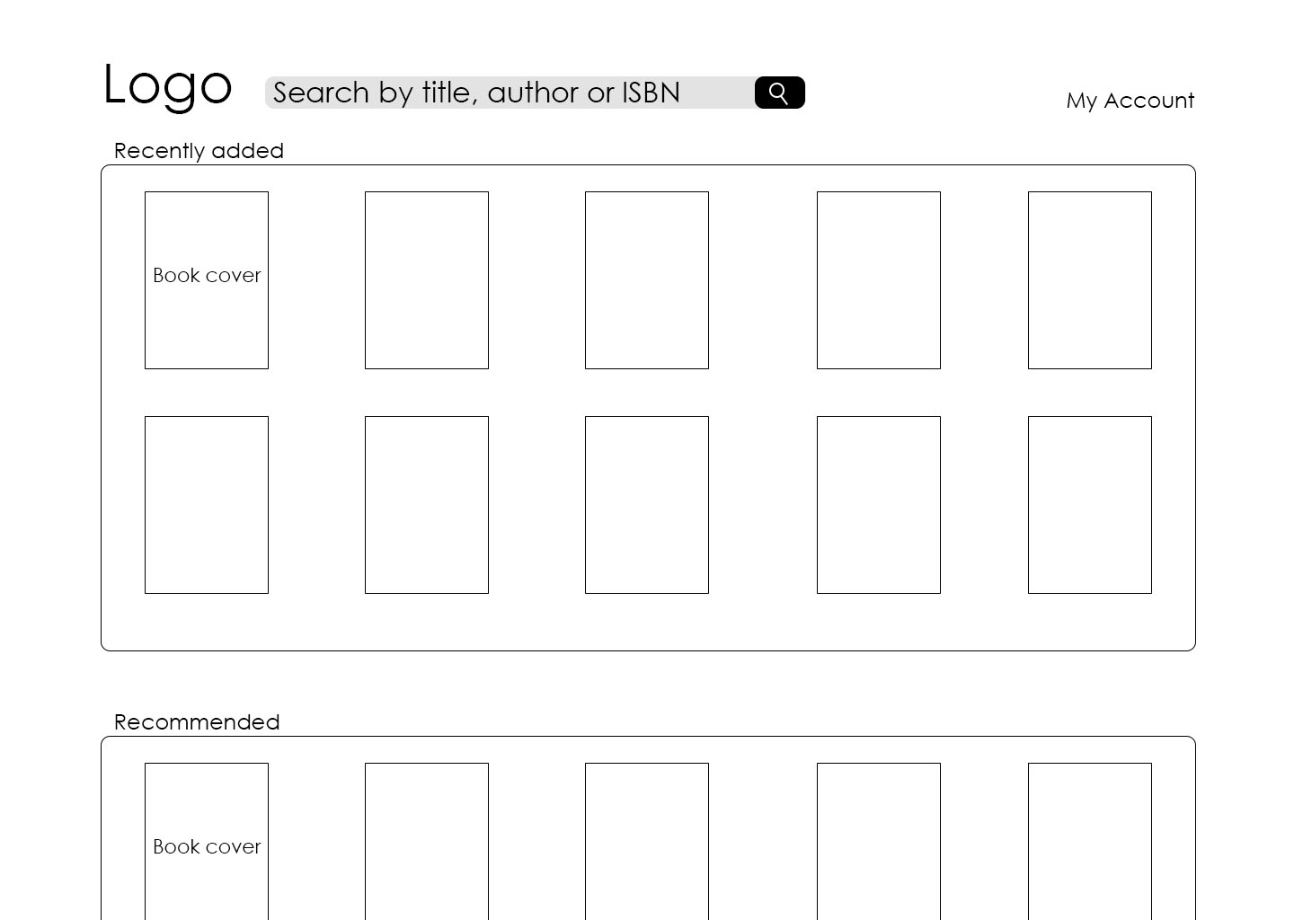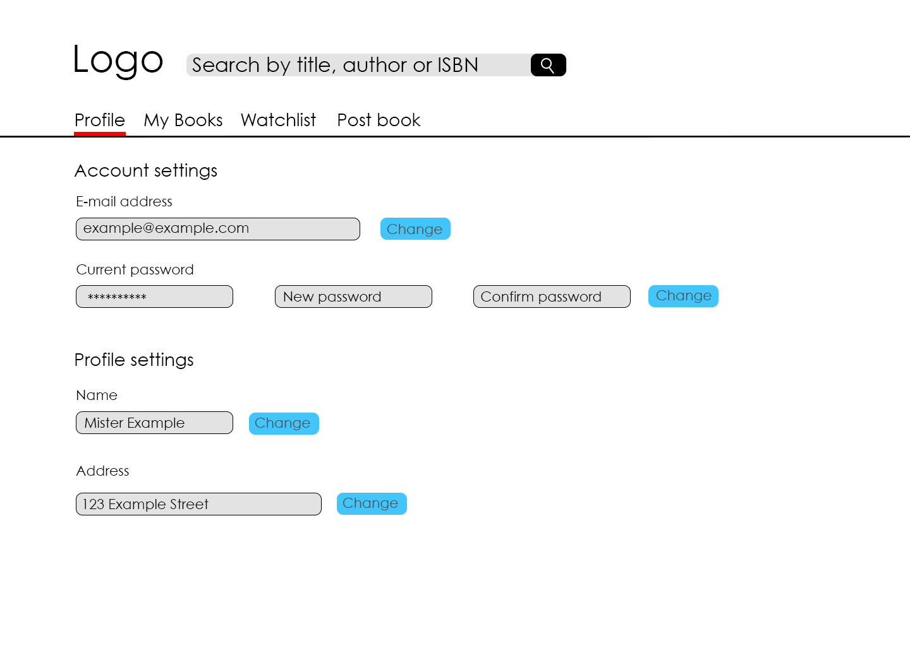

Go to your list of books up for trading.

Sort your books by date added in ascending order.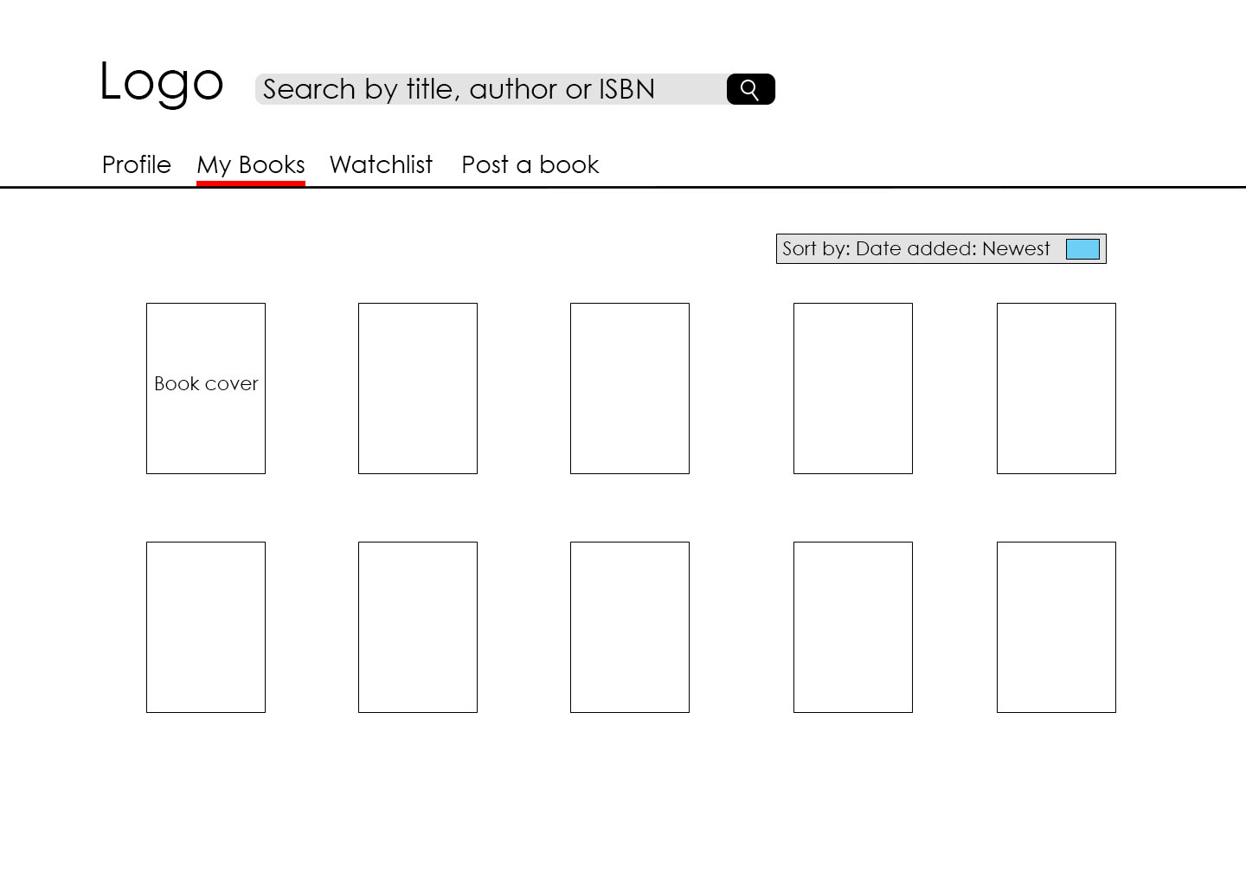

Go to your list of books that you are looking to trade for.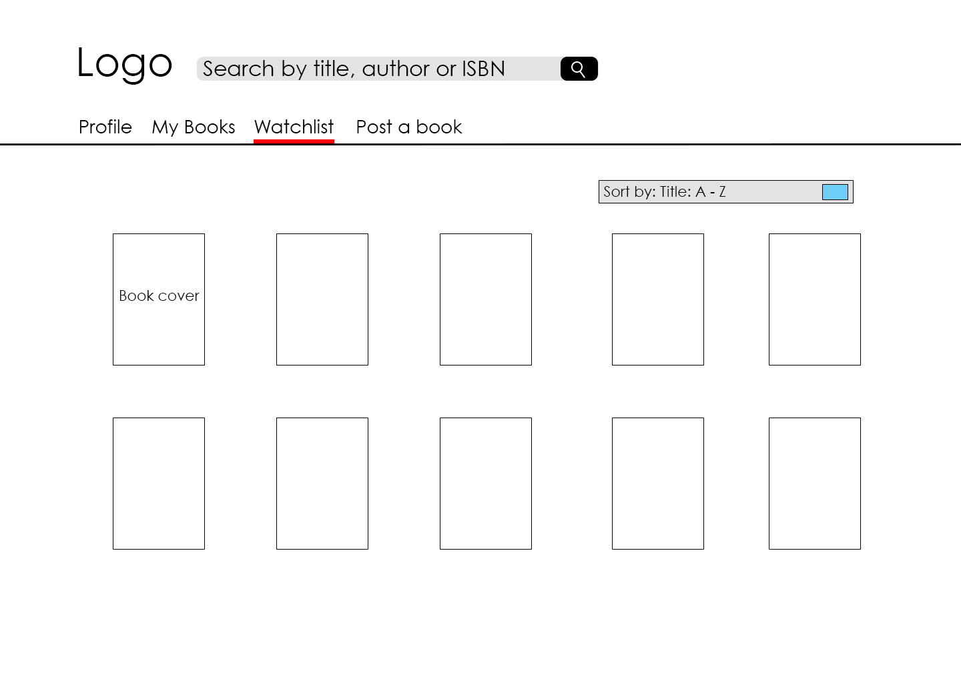

Go to the tab that let’s you post books.

Post a book with title “Lord of the Flies”, with author William Golding, with genre “Fiction”, published by “Faber and Faber” in 2004 in English, in used condition, delivering with postage or local meetup, only accepting trades, with rating of 4.