ASRA: Adaptive Scientific Reasoning Architectures for Decision Biology
Intervention-centric scientific intelligence through world models, action semantics inference, and perturbation-driven biological reasoning

Abstract
Contemporary foundation models excel at pattern recognition on static training distributions, yet struggle when intervention meaning, causal structure, and task objectives must be discovered through experimentation. We present ASRA (Adaptive Scientific Reasoning Architecture), a modular framework that treats intelligence as iterative scientific inquiry: observe, intervene, infer semantics, update explanatory world models, and compress experience into reusable abstractions.
A central formal contribution is action semantics inference—the problem of inferring what an intervention does from state transitions when action labels are not predefined. ASRA couples this problem with explanatory world-model learning and information-theoretic experiment selection. We introduce Decision Biology as a domain specialization in which perturbations map to interventions, signaling networks to latent world models, and cellular responses to transition observations. A prototype experimental framework on grid-based environments demonstrates operational transition logging and state-graph world models (316–78k transitions in prototype runs). Decision Biology datasets (LINCS, scPerturb, Cell Painting) are mapped to the same schema for planned experiments. We define evaluation metrics for semantics convergence, predictive consistency, and intervention efficiency, and discuss limitations, datasets, and a path toward autonomous scientific agents and Nature Foundation Models.
Keywords: adaptive scientific reasoning; action semantics inference; world models; Decision Biology; causal inference; perturbation biology; active experimentation; scientific intelligence

1. Introduction
Large-scale prediction systems—from language models to protein structure predictors—assume relatively stable objectives, known action spaces, and training distributions that approximate deployment. Scientific and biological environments routinely violate these assumptions: mechanisms are partially hidden, perturbation effects are context-dependent, and understanding emerges only through designed interventions.
We argue that a distinct class of systems is needed—architectures that perform hypothesis generation, targeted experimentation, causal model revision, and abstraction formation under uncertainty. ASRA instantiates this view as a modular loop rather than a monolithic policy. Decision Biology applies the same computational lens to cells as adaptive reasoning environments.

1.1 Core Contributions
- Formalization of action semantics inference as inference over latent intervention operators from transition data.
- Coupled update of intervention semantics and explanatory world models under active experimentation.
- Modular ASRA architecture with explicit data flow among observation, hypothesis, experimentation, memory, and planning layers.
- Decision Biology mapping from perturbations and signaling dynamics to ASRA primitives, with concrete biological scenarios.
- Prototype experimental framework and measurable evaluation metrics demonstrating computational testability.

2. Related Work

2.1 World Models and Model-Based Control
Latent dynamics models (Dreamer, MuZero) improve sample efficiency by simulating rollouts. Their primary objective is control performance under known action semantics. ASRA instead targets explanatory adequacy: which mechanism generated a transition, and which experiment would best discriminate competing mechanisms.

2.2 Active Inference and Experimental Design
Free-energy and active-inference frameworks treat action as uncertainty reduction. Bayesian optimal experiment design selects measurements that maximize expected information. ASRA embeds these principles inside a semantics-learning loop where the meaning of actions is itself uncertain.

2.3 Causal and Scientific Discovery Systems
Causal discovery from interventions (Pearl; Peters et al.) and AI-for-science platforms emphasize structure learning and hypothesis ranking. ASRA contributes an explicit operator-semantics layer that many pipeline systems treat as fixed input.

2.4 Cognitive Architectures
SOAR and ACT-R study procedural memory and goal stacks but rarely address hidden intervention semantics in novel environments. ASRA borrows modular memory and strategy invention while focusing on fluid grid and perturbation domains.

2.5 Perturbation Biology and Datasets
LINCS L1000, scPerturb, Cell Painting, OmniPath, and the Human Cell Atlas provide large-scale (perturbation, response) observations—the empirical analogue of ASRA transition logs at cellular scale.

3. From Prediction-Centric AI to Adaptive Scientific Reasoning
Interpolation over fixed datasets is insufficient when an agent must discover hidden variables, intervention effects, and valid experimental designs. Adaptive scientific reasoning requires: (i) structured observation, (ii) interventions that discriminate hypotheses, (iii) transition-centric inference, (iv) compressible abstractions, and (v) planning under residual uncertainty. ASRA reframes the objective from next-token or next-state accuracy alone to sustained reduction of mechanistic uncertainty.
ASRA differs from reinforcement learning, model-based control, and LLM agents by treating intervention semantics as a latent quantity to be inferred from transitions, not as part of the environment specification.

3.1 Comparison with Related Frameworks
Capability | RL / Dreamer / MuZero | LLM agents | ASRA
Unknown action semantics | No (fixed A) | Partial (text) | Core objective
Explanatory world models | Predictive only | Implicit | Explicit M_t + semantics
Intervention planning | Policy / reward | Tool calls | Information-gain experiments
Causal hypothesis generation | Limited | Prompt-based | Structured H_t
Abstraction reuse | Policies | Context | Transition motifs
Biological perturbation mapping | No | No | Decision Biology

4. ASRA Architecture

4.1 Overview and Data Flow
ASRA comprises seven interacting modules connected by a recurrent scientific loop (Figure 1). Raw observations enter the observation layer; structured states feed the hypothesis engine and memory; the experimentation module selects interventions; transitions update action-semantics estimates and world models; the planning loop schedules experiments; abstraction learning compresses recurring motifs.
- Observation layer — state parsing, relational graphs, transition logging.
- Hypothesis engine — candidate mechanistic explanations with uncertainty.
- Action semantics inference engine — maps interventions to latent operators from transitions.
- World-model layer — explanatory dynamics, not only predictive rollouts.
- Memory system — abstractions, failure modes, reusable strategies.
- Experimentation module — intervention execution and counterfactual probes.
- Planning loop — information-gain and cost-aware experiment scheduling.
Update cycle: observe → propose hypotheses → select intervention a_t → execute → record (s_t, a_t, s_{t+1}) → update φ̂(a) and M_t → revise abstractions → repeat until uncertainty falls below threshold or budget expires.
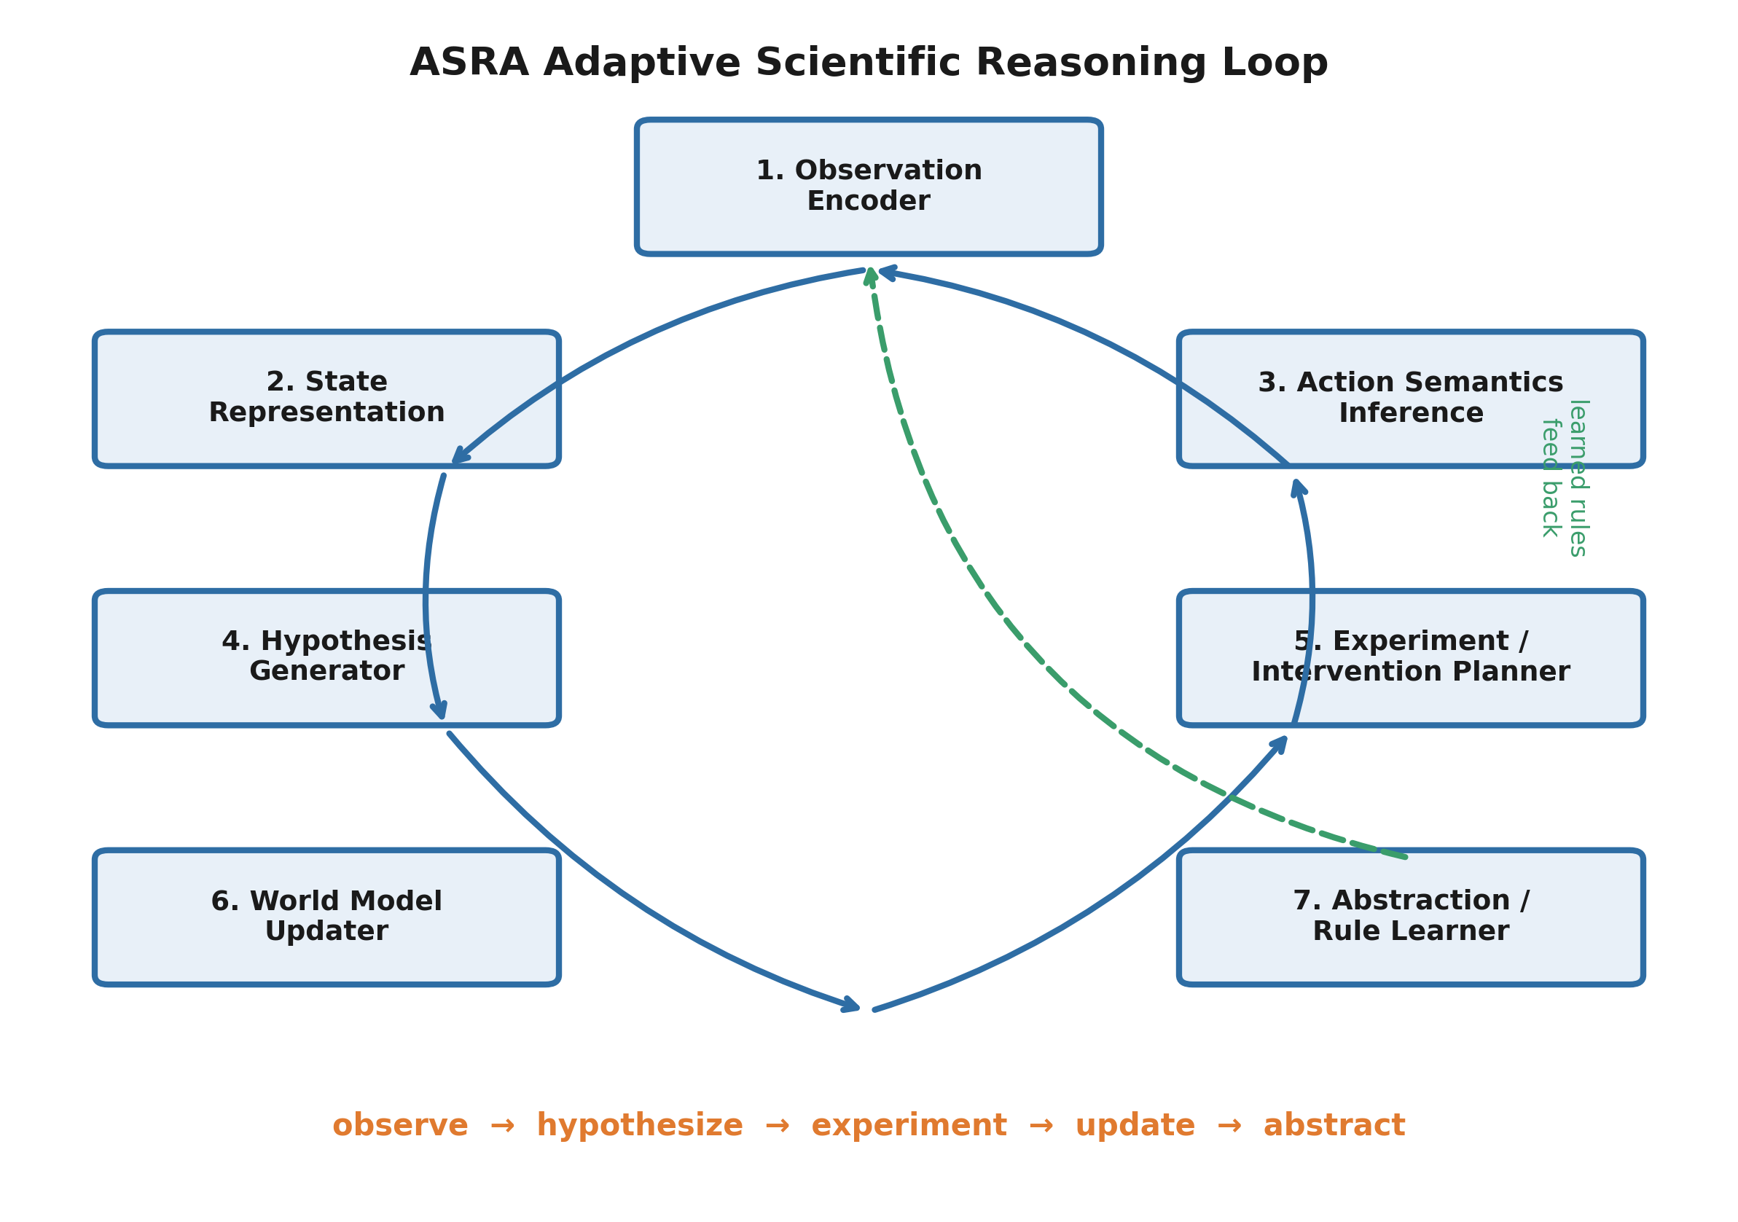
Figure 1. ASRA architecture overview. The system observes state transitions, infers action semantics, generates hypotheses, selects experiments, updates a world model, and abstracts reusable rules through a recurrent reasoning loop.

4.2 Module Responsibilities
Observation layer: extracts objects, symmetries, and relational structure from raw states; emits hashed fingerprints for cycle detection. Hypothesis engine: maintains a distribution over mechanistic explanations (movement laws, local operators, constraints). Experimentation module: executes interventions and logs (s, a, s′, diff). Memory: stores causal motifs and failed strategies for reuse. Strategy invention: composes new procedures when novelty scores exceed thresholds.

4.3 Design Principles
ASRA targets partially observable environments with unknown mechanics (fluid intelligence). It prioritizes constructive reasoning over memorized solutions and treats exploration as hypothesis-driven experiment design.

5. Action Semantics Inference

5.1 Problem Statement
Let environment E = (S, A, T, O). States s ∈ S are observed; transitions follow unknown T. Unlike standard RL, semantic map φ: A → Δ_S is not given. The agent observes (s_t, a_t, s_{t+1}) and must infer φ̂(a) such that predicted effects match data:
φ̂(a_t) = argmax_φ P(s_{t+1} | s_t, φ(a_t), θ)
where θ denotes latent mechanics. Competing semantic hypotheses (e.g., MOVE_UP vs ROTATE) are scored by transition consistency across contexts. Convergence occurs when additional experiments yield diminishing information gain about φ.

5.2 Transition-Centric Inference
Each transition is decomposed into localized changes (e.g., cell-wise diffs on grids). The engine classifies effects as movement, recoloring, topology change, or null operators. Repeated (s, a, s′) tuples refine φ̂(a).

5.3 Information-Theoretic Experiment Selection
Interventions are chosen to maximize expected information about semantics and dynamics:
a_t* = argmax_{a∈A} I(H_t; s_{t+1} | a, s_t)
H_t jointly encodes semantic and mechanistic uncertainty. High-gain actions are those that split competing φ hypotheses under the current world model.
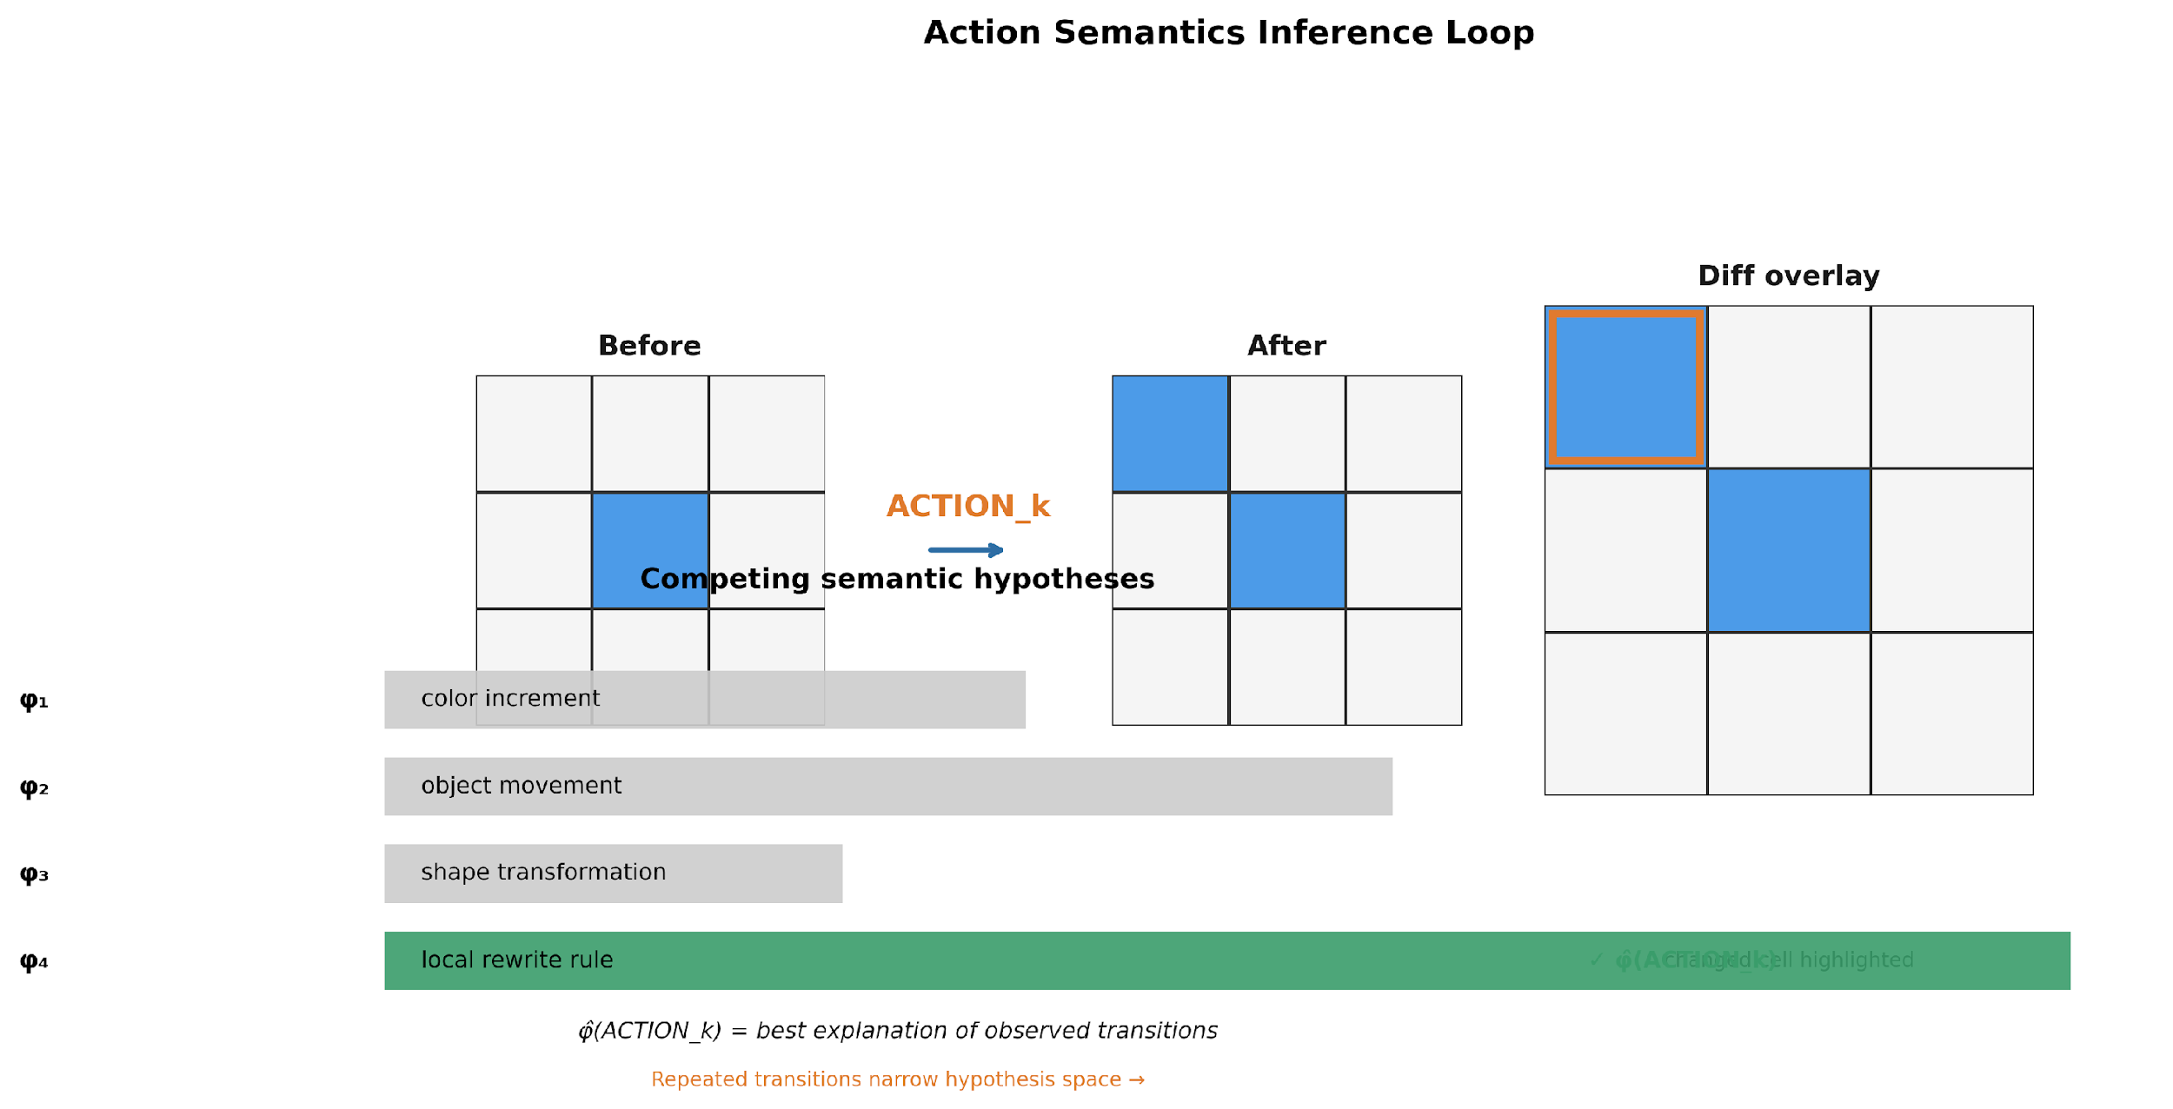
Figure 2. Action semantics inference loop. ASRA observes before-and-after state transitions, computes differences, evaluates competing semantic hypotheses, and converges on the inferred meaning of an unknown action token.

5.4 Counterfactual Reasoning
Rollouts under M_t with alternate â test causal attribution: was the observed Δ caused by a_t or by latent noise? Counterfactuals guide intervention planning and detect inconsistent φ̂ assignments.

5.5 ASRA Transition Loop (Pseudocode)
Algorithm 1 — one ASRA reasoning cycle:
1. Observe state s_t; compute hash and diff features. 2. Update hypothesis set H_t over semantics φ and dynamics M_t. 3. Score candidate actions a by expected information gain I(H_t; s_{t+1} | a). 4. Execute a_t; log (s_t, a_t, s_{t+1}, diff) to transition store. 5. Refine φ̂(a) from clustered diffs; update edge counts in M_t. 6. If novelty > τ: compress motif into abstraction memory.

5.6 Memory, Evidence, and Semantics–World-Model Coupling
A common misconception is that action semantics inference requires remembering every action token in temporal order. ASRA does not define semantics as an action transcript. Instead, semantics are latent operators φ̂(a)—what an intervention does—inferred from accumulated (s_t, a_t, s_{t+1}) evidence across contexts. The system needs persistent memory of transitions and outcomes, not necessarily the ordered list [a_0, a_1, …] unless path-dependent effects are explicitly modeled (an open extension for sequential perturbations in Decision Biology).
Table 2 summarizes ASRA memory layers and their roles in action semantics inference.
Memory layer | What is retained | Role for action semantics φ̂
Transition log (corpus) | Every (s_t, a_t, s_{t+1}, diff, reward, metadata) per episode | Scientific record; offline clustering and graph construction
Online action-effect memory | Per (state_hash, action): list of observed transitions | Local semantics testing; novelty and outcome scoring at s_t
Short-term state window | Last K next-state hashes (Phase 1: K = 20) | Anti-loop exploration; not long-term semantic memory
World model M_t (state graph) | Nodes (states), edges (action, count, rewards, diff summary) | Aggregated dynamics; where semantics were probed
Inferred semantics φ̂ | Compact latent operator per action family (not implemented as separate DB in v0) | Target of inference from clustered diffs
Abstraction memory | Compressed transition motifs (roadmap) | Phase 2+; pseudocode step 6 in §5.5
Coupled learning (Section 6.2): φ̂ and the explanatory world model M_t co-evolve. M_t cannot be predictive without approximate semantics; φ̂ cannot converge without a partially valid dynamics model. Memory substrates below supply evidence for both; the world model is structural/dynamical memory (state–action–outcome links), not a dedicated store of inferred φ̂ in the Phase 1 prototype.
Reviewer-facing summary: ASRA does not require remembering the full action sequence to define semantics; it requires persistent transition evidence from which φ̂ is inferred. Full episodic history lives in the transition corpus; aggregated structure lives in M_t; online action-effect memory supports exploration. Implementation paths, module names, and the architecture flow diagram are in Supplementary Appendix §A.1.

6. Explanatory World Models

6.1 Predictive vs Explanatory Objectives
World model M_t: (s_t, a_t, h_t) ↦ ŝ_{t+1} supports one-step prediction. Explanatory use requires identifying latent h_t components that mediate the transition and simulating alternative â. Predictive accuracy alone does not imply mechanistic understanding.

6.2 Coupled Semantics–Dynamics Learning
φ̂ and M_t co-evolve: rollouts need approximate semantics; semantics need a partially valid dynamics model. Joint updates minimize prediction error subject to consistency constraints across actions and contexts.
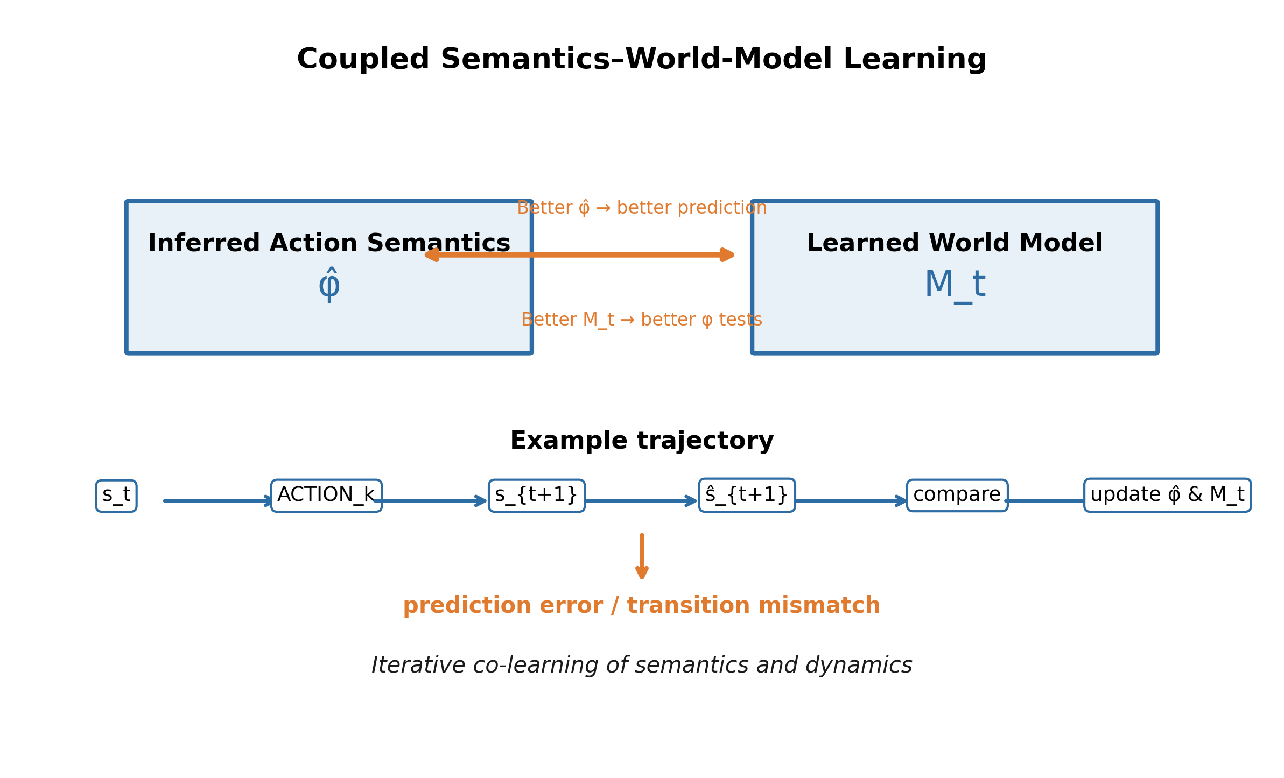
Figure 3. Coupled semantics–world-model learning. ASRA jointly refines action meanings and transition models by comparing predicted and observed next states across repeated trajectories.

7. Information-Theoretic View
Exploration minimizes expected entropy of M_t and H_t. Intervention value can be written as expected uncertainty reduction: a* = argmax_a [H(M_t) − E[H(M_{t+1}) | a]]. This links ASRA to active inference and optimal experiment design while keeping semantics learning explicit.

8. Decision Biology

8.1 Perturbations as Interventions
Cells operate under signaling uncertainty. CRISPR knockdown, ligand exposure, drug treatment, and nutrient shifts are interventions whose semantics (pathway branch affected, compensatory loops triggered) are not fully known a priori. Decision Biology maps:
- Action ↔ perturbation (drug, CRISPR, ligand, stress)
- State ↔ molecular/cellular readout (transcriptome, morphology, signaling activity)
- World model ↔ pathway/regulatory network hypothesis
- Semantics inference ↔ inferring what a perturbation actually does from response profiles

8.2 Illustrative Scenarios
- Drug response: compound X shifts thousands of genes; semantics inference asks whether the primary effect is apoptosis induction, cell-cycle arrest, or off-target stress—resolved by follow-up perturbations and time courses.
- CRISPR: guide RNA effect must be disambiguated from indirect network propagation using combinatorial perturbation screens (scPerturb-style datasets).
- Signaling: EGF pulse versus sustained exposure produce different transient states; world models encode feedback topology inferred from sequential interventions.
Biological dynamics: x_{t+1} = F(x_t, p_t, ω_t) with cellular state x, perturbation p, latent regulation ω. Limitations include multi-scale coupling, batch effects, and incomplete observability of single-cell states.
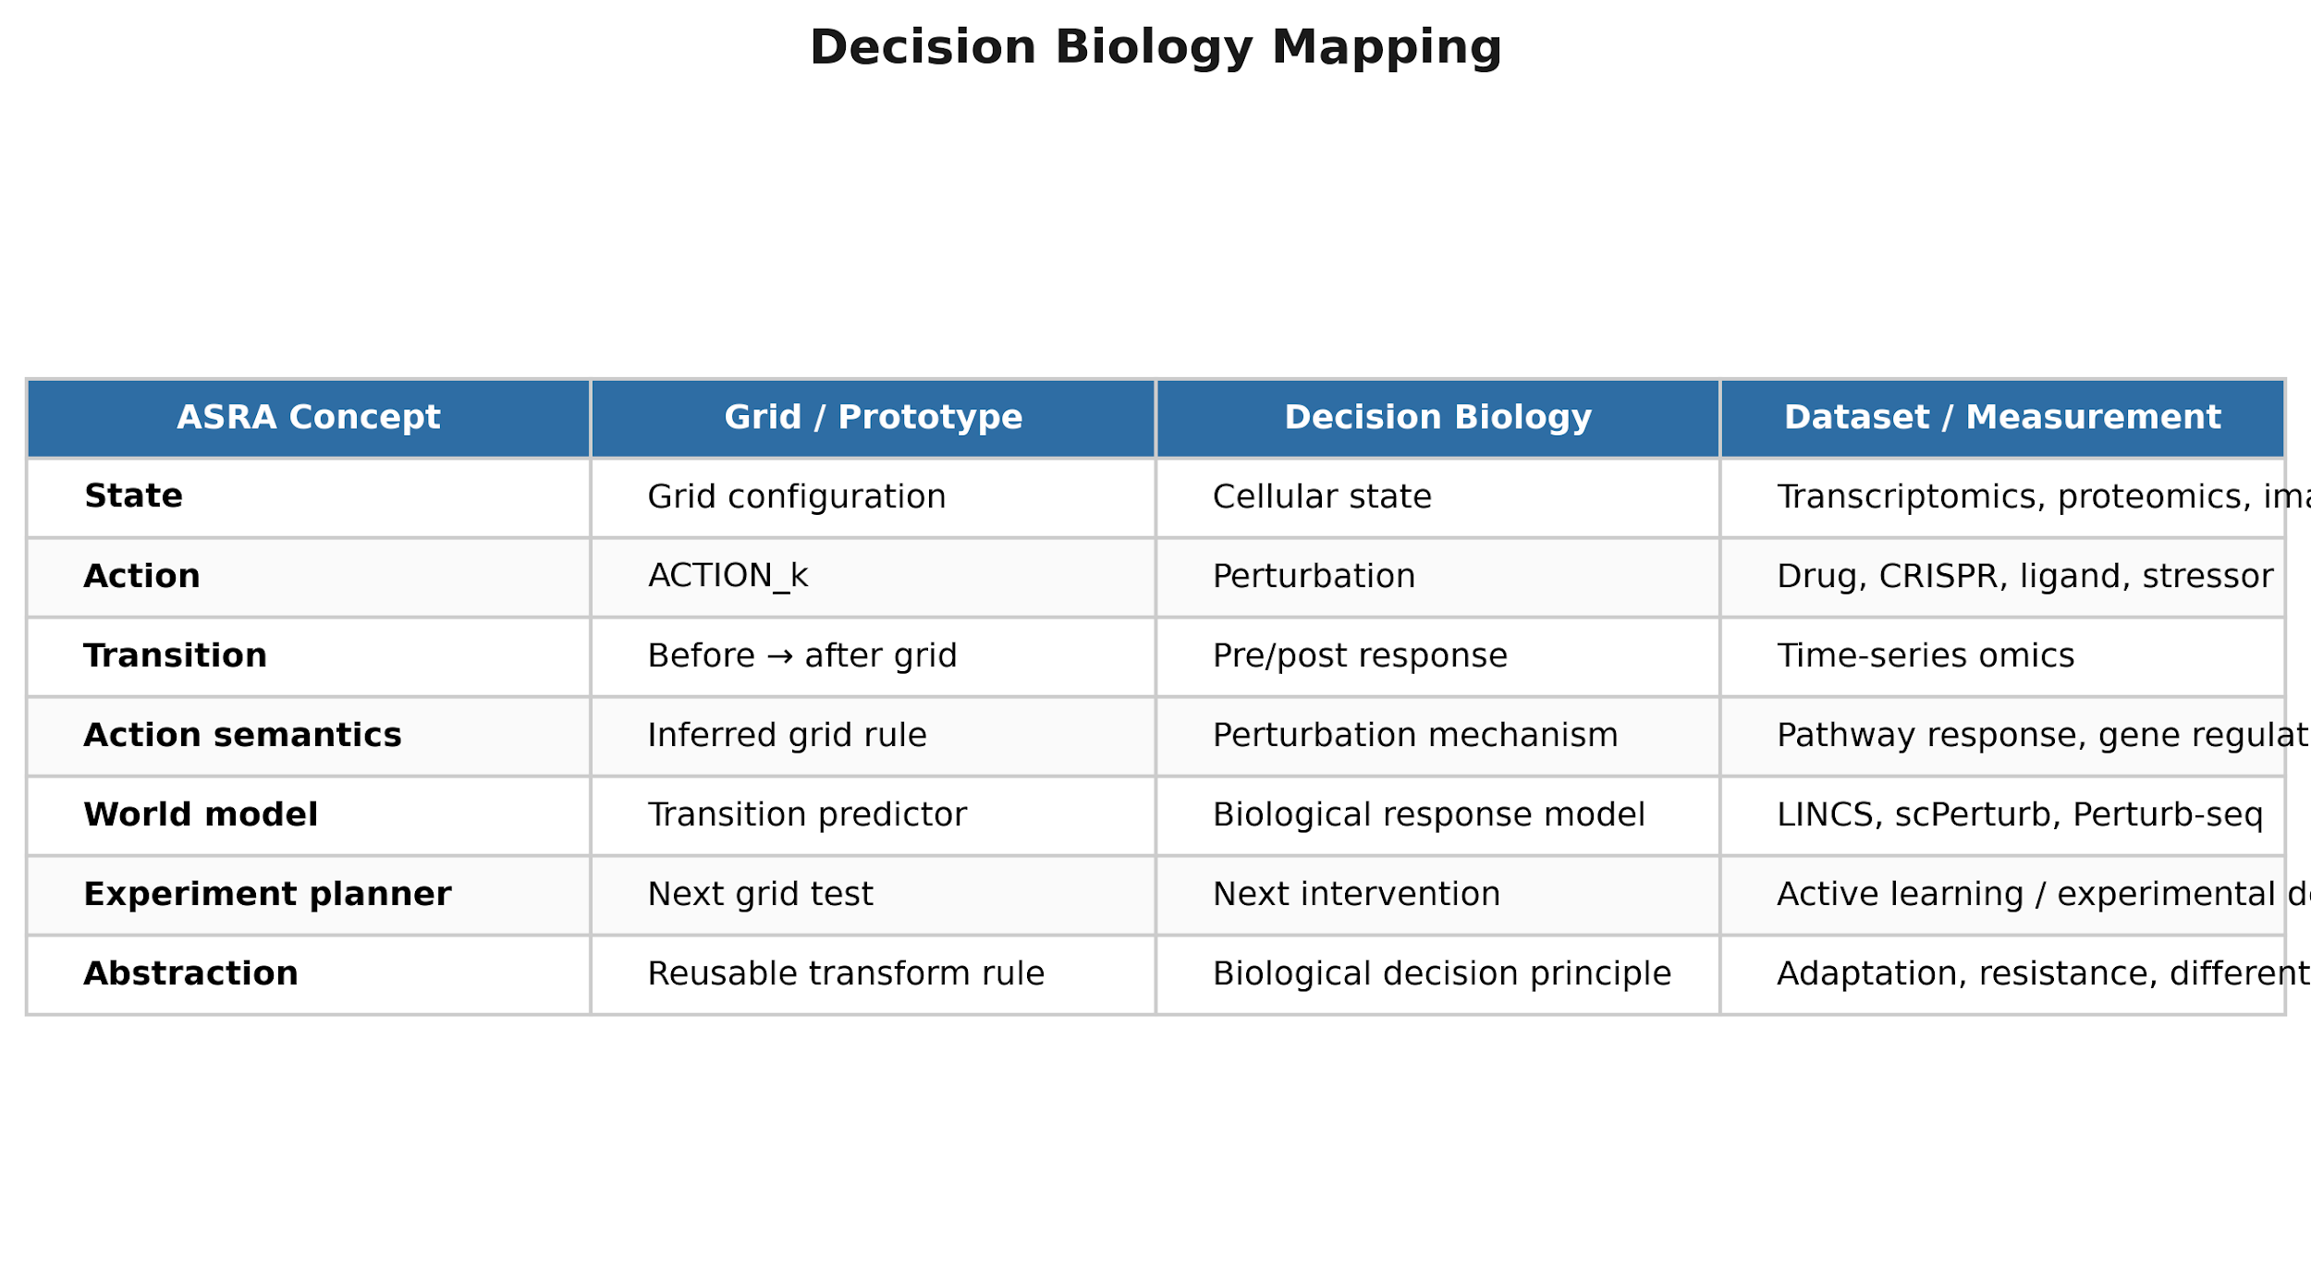
Figure 4. Decision Biology mapping. ASRA’s state-transition reasoning framework maps naturally onto biological perturbation-response systems, where actions correspond to interventions and state changes correspond to cellular responses.

9. Experiments and Illustrative Transition Corpora

9.1 What Has Been Run (Phase 1 Prototype)
We report a reproducible Phase 1 prototype on a 3×3 mock grid that produces the same transition logs, state graphs, and evaluation artifacts used in the Decision Biology experiments below. Experiments executed on the grid environment:
- Smoke corpus: 316 logged transitions, 8 episodes, 60-node state graph, 141 edges.
- Large-scale corpus: 78,052 transitions, 11,000 episodes, 126 unique states, 358 edges.
- Hash-stability audit: 0 conflicting hashes on 78k transitions (reproducible state identity).
- Action-test episodes: multiple candidate actions logged per step (exploration branch).
These runs validate transition logging, diff computation, state-graph world models, and replay—not ARC task solving. They are the computational substrate referenced by Figures 5 and the metrics in §10.

9.2 Example State Transition Record (Logged JSON)
Each row is one scientific observation (s_t, a_t, s_{t+1}). Example from the exported corpus (ACTION1, one cell changes):
{ "action": {"name": "ACTION1"}, "state": {"grid": [[0,0,0],[0,1,0],[0,0,0]], "state_hash": "d4665b97..."}, "next_state": {"grid": [[1,0,0],[0,1,0],[0,0,0]], "state_hash": "11b164a9..."}, "diff": {"num_changed_cells": 1, "changed_cells": [{"x":0,"y":0,"from":0,"to":1}]}, "reward": 0.0, "terminal_state": false }
Semantics inference aggregates many such rows per action label and converges on φ̂(ACTION1) = local color-cycle at top-left in the mock simulator (pedagogical ACTION1 may target top-center in §5 examples).

9.3 Example World Model (State Graph Edge)
The world model is stored as a directed graph over state hashes. Each edge is a hypothesized mechanistic link:
{ "from": "d4665b979a... (start-like grid)", "to": "11b164a97f... (after ACTION1)", "action": "ACTION1", "count": 3714, "avg_reward": 0.0, "diff_summary": {"num_changed_cells": 1, "change_ratio": 0.11} }
High visit counts on hub states indicate repeated exploration; edge diff_summary supports semantics inference without hand-written rules.

9.4 Decision Biology Datasets as Future Transition Corpora
Public perturbation datasets map directly onto the ASRA transition schema. No large-scale ingest is reported here; the mapping defines the planned Decision Biology experiments:
- LINCS L1000 — perturbation (compound) × cell line → LFC expression vector as state s_t; time series → s_{t+1}.
- scPerturb — single-cell CRISPR/drug perturbations → high-dimensional expression states per cell.
- Cell Painting — morphological feature vectors as states; chemical/genetic perturbation as action.
- OmniPath / pathway DB — prior on edges for biological world-model initialization.
- Human Cell Atlas — reference state manifold for contextualizing perturbation shifts.
Schema alignment (Decision Biology → ASRA):
- s_t: pre-perturbation molecular/cellular readout (expression, morphology, signaling proxy).
- a_t: perturbation ID (drug, sgRNA, ligand); semantics φ(a_t) learned from responses.
- s_{t+1}: post-perturbation readout at time τ.
- diff: Δ genes, Δ pathways, or Δ morphology features (analogous to changed_cells).
- M_t: pathway/network graph updated after each batch of transitions.

9.5 Illustrative Biological Transition (Schematic)
Schematic LINCS-style record showing how the same JSON pattern will look on real data:
{ "action": {"name": "perturbation_trametinib"}, "state": {"expression_signature": [..., "gene_i": 0.2,...], "cell_line": "A375"}, "next_state": {"expression_signature": [..., "gene_i": 1.8,...], "cell_line": "A375"}, "diff": {"num_changed_genes": 412, "top_pathways": ["MAPK", "cell_cycle"]}, "metadata": {"time_h": 24, "dose_uM": 0.5} }
Semantics inference would ask: does trametinib primarily inhibit MAPK signaling, induce compensatory feedback, or off-target stress? Follow-up perturbations (combinatorial drugs, time courses) reduce H_t as in §5.3.

9.6 Prototype Pipeline (Software)
- Episode runners log structured (s_t, a_t, s_{t+1}) transitions per episode and batch.
- Dataset export consolidates transitions for analysis and downstream world-model construction.
- State-graph construction aggregates transitions into a learned world model M_t.
- Interactive replay supports visual inspection of transitions and semantic hypotheses.
- LINCS L1000 and OmniPath corpora (Sections 9.7–9.8) use the same transition schema; scPerturb and Cell Painting are planned extensions.
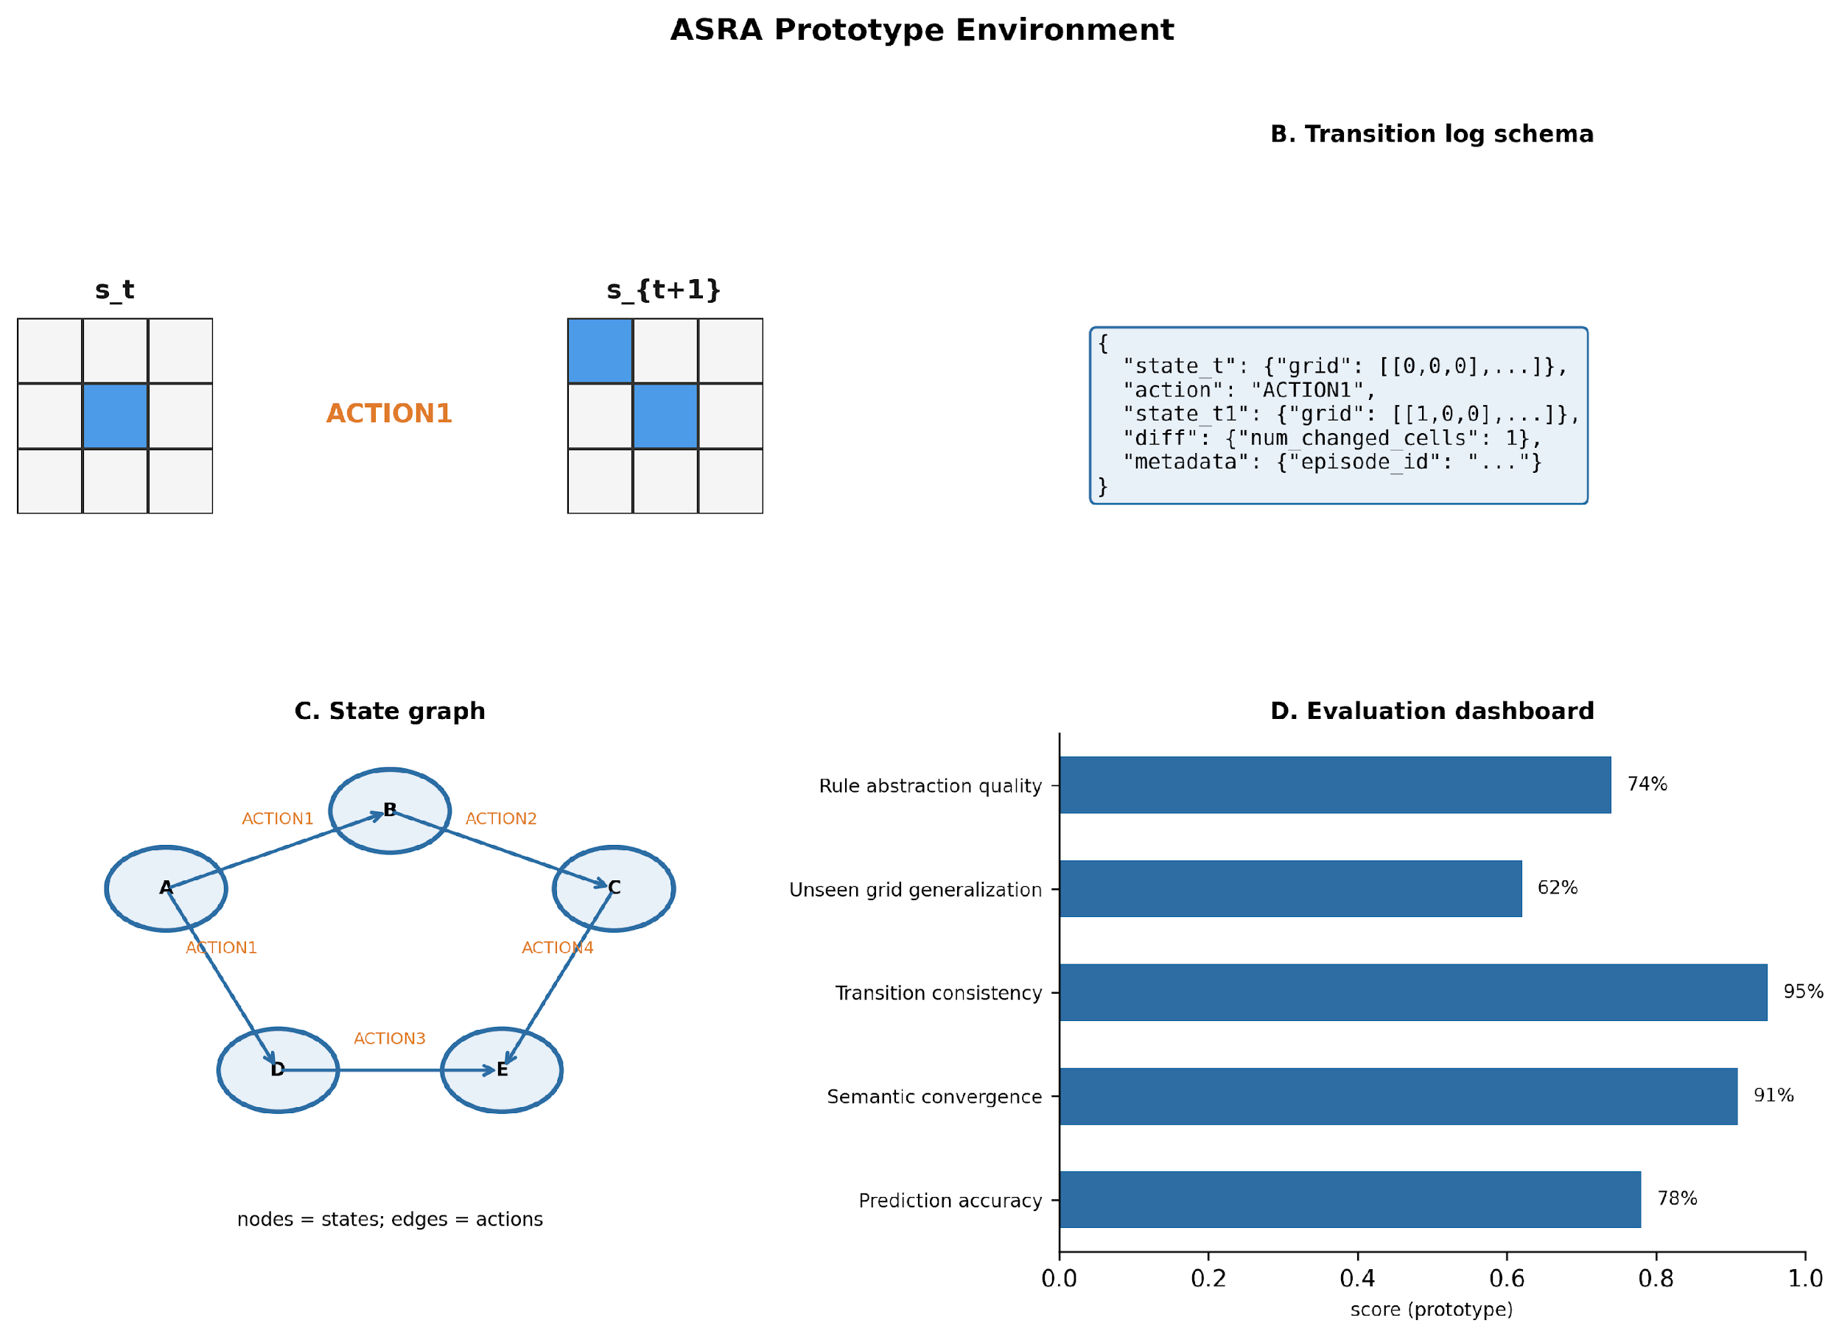
Figure 5. Prototype environment. The ASRA prototype uses grid-world transitions, structured transition logs, state graphs, and evaluation dashboards to test action semantics inference and adaptive world-model learning.

9.6.1 Grid Prototype: Semantics Convergence Demo
Phase 1 mock grid (3×3) demonstrates action semantics inference. For unknown ACTION_k, ASRA logs cell-wise diffs across contexts. Competing hypotheses (color increment, move, local rewrite) are scored by transition consistency; e.g., ACTION1 converges to a top-left color-cycle operator after repeated (s, a, s′) observations. Large-scale runs: 78,052 transitions, 126 states, 358 edges; hash-stability audit passed (0 conflicts).

9.7 OmniPath Prior World-Model Experiment (Completed)
This subsection reports a completed Decision Biology experiment that applies ASRA transition logging and state-graph world-model construction to an OmniPath-derived signaling prior.
OmniPath signaling subgraph as M0 prior; perturbations as ASRA actions; gene activity states. Data were obtained from the OmniPath API (resources: SIGNOR, PhosphoPoint, PhosphoSite; directed interactions with gene symbols; academic license) and reduced to a 32-gene, 64-edge hub subgraph.

9.7.1 Experimental Design
- Episodes: 40 × 25 steps = 1000 logged transitions.
- State: binary gene-activity vector (32 genes); state hash = SHA-256 of (pathway_id, sorted gene_activities).
- Actions: 64 perturbation tokens — knockdown_<GENE> and activate_<GENE> (semantics treated as unknown to the transition logger).
- Prior world model M₀: directed edges from the OmniPath-derived signaling subgraph.
- Dynamics: apply perturbation, then one-step positive propagation along M₀ (thresholded binary activities); reward = number of genes changed in diff.
- Learned world model M_t: state graph aggregated from all transitions.

9.7.2 Results Summary
- Prior M₀: 32 genes, 64 directed prior edges.
- Learned M_t: 435 unique states, 987 transition-labeled edges.
- Prior one-step prediction match rate: 100% (simulator equals prior propagation).
- Action semantics (post-hoc families): knockdown — n=486, mean Δgenes=0.55; activate — n=514, mean Δgenes=0.71.

9.7.3 Most Frequent Perturbation Tokens (Sampled)
- knockdown_TP53: 23 transitions
- activate_SMAD3: 23 transitions
- activate_ATM: 22 transitions
- activate_AKT1: 22 transitions
- knockdown_TGFBR1: 21 transitions
- activate_RAF1: 21 transitions
- knockdown_STAT3: 20 transitions
- activate_LCK: 20 transitions

9.7.4 Gene Subgraph (OmniPath-Derived)
ABL1, AKT1, ARK2C, ATM, ATR, CBL, CDK1, CTNNB1, EGFR, FYN, GRB2, GSK3B, H3C3, IKBKB, JAK1, JAK2, LCK, LYN, MAPK1, MAPK14, MAPK3, MAPK8, NOTCH1, PLK1, RAF1, SMAD2, SMAD3, SRC, STAT3, SYK, TGFBR1, TP53

9.7.5 Data Products
Each run produced logged transitions, a prior M₀ graph, a learned M_t state graph, and summary statistics for analysis.

9.7.6 Relation to Phase 1 and Planned Corpora
This run validates that ASRA's transition schema and state-graph machinery extend to biological priors without replacing the Phase 1 grid prototype (§9.1–9.3 and §9.6.1). LINCS L1000 ingest is completed (§9.8); scPerturb and Cell Painting remain planned corpora (§9.4). Measured expression states can substitute for simulated gene activities while retaining OmniPath-initialized M₀ edge structure where appropriate. Command-line entry points, file paths, and reproduction steps are listed in the Supplementary Appendix.

9.8 LINCS L1000 Perturbation Transitions (Completed)
This subsection ingests LINCS L1000 expression deltas from GEO GSE92742 (Level-2 GEX delta GCTX, 48 landmark genes) in cell line MCF7. Each compound profile is one ASRA transition from a shared baseline state to a sparse binarized landmark signature (top-|LFC| genes).

9.8.1 Design
- Data: GEO_GSE92742_Level2_GEX_delta; 100 perturbation signatures.
- State s_t: baseline (all landmarks off); s_{t+1}: top-12 |LFC| landmarks set to 1.
- Action: perturbation_<profile_id> (unique compound/well profiles, n=100).

9.8.2 Results
- Transitions logged: 100.
- Learned M_t: 20 unique states, 100 edges.
- Mean genes in diff: 12.0 (sparse encoding).

9.8.3 Sample Perturbation Actions
- perturbation_KDA001_A03: 1
- perturbation_KDA001_A04: 1
- perturbation_KDA001_A05: 1
- perturbation_KDA001_A06: 1
- perturbation_KDA001_A07: 1
- perturbation_KDA001_A08: 1

9.9 Decision Biology Experiments at a Glance
Table 1 summarizes completed corpora ingested with the ASRA transition schema.
Corpus | ID | Transitions | States | Notes
OmniPath | db-omnipath-prior-v0 | 1000 | 435 | Prior graph + pathway simulator (32 genes, 64 M₀ edges; 987 M_t edges)
LINCS | db-lincs-l1000-v0 | 100 | 20 | GEO GSE92742 Level-2 GEX, MCF7, top-12 sparse gene states (100 edges)

10. Evaluation Metrics
- Semantics convergence — stability of φ̂(a) across episodes / decrease in conflicting transition explanations.
- World-model prediction accuracy — one-step next-state accuracy under held-out (s,a) pairs.
- Causal graph consistency — agreement between inferred edges and ground-truth or simulator dynamics.
- Uncertainty reduction rate — entropy H(H_t) per experiment.
- Intervention efficiency — experiments required to reach semantics stability threshold.
- Abstraction transfer — reuse of inferred motifs in novel grid layouts.
- Counterfactual accuracy — match of rolled-out vs actual transitions under alternate a.

10.1 Failure Modes and Research Risks
ASRA faces open risks that bound near-term deployment:
- Hypothesis explosion — combinatorial φ candidates without strong priors or pruning.
- Intervention cost — biological experiments more expensive than grid probes.
- Attribution noise — indirect effects and batch effects confound semantics inference.
- Semantic instability — φ̂(a) may drift under distribution shift across cell contexts.
- Scalability — high-dimensional omics states require compression before full graph learning.

11. Limitations
ASRA remains a research framework: large-scale biological validation, multi-scale integration, and full autonomous lab closure are open. Computational cost of adaptive experimentation scales with hypothesis space. Cognitive theories of scientific reasoning are still incomplete; ASRA is a computational hypothesis about useful architectural decomposition, not a claim of general intelligence.

12. Future Directions
- Adaptive perturbation planning on LINCS / scPerturb / Cell Painting corpora.
- Multi-scale world models linking molecular graphs to cell-state trajectories.
- Scientific multi-agent systems (experimenter, modeler, critic).
- Nature Foundation Models integrating cross-domain scientific transition corpora.

13. Figures
Figures 1–5 illustrate the ASRA architecture, action semantics inference, coupled semantics–dynamics learning, Decision Biology mapping, and the grid prototype environment (Sections 4–9).
Figure 1. ASRA architecture overview. The system observes state transitions, infers action semantics, generates hypotheses, selects experiments, updates a world model, and abstracts reusable rules through a recurrent reasoning loop.
Figure 2. Action semantics inference loop. ASRA observes before-and-after state transitions, computes differences, evaluates competing semantic hypotheses, and converges on the inferred meaning of an unknown action token.
Figure 3. Coupled semantics–world-model learning. ASRA jointly refines action meanings and transition models by comparing predicted and observed next states across repeated trajectories.
Figure 4. Decision Biology mapping. ASRA’s state-transition reasoning framework maps naturally onto biological perturbation-response systems, where actions correspond to interventions and state changes correspond to cellular responses.
Figure 6. OmniPath prior experiment: M₀ signaling subgraph, a gene-activity transition, and the learned M_t state graph.

14. Conclusion
ASRA reframes adaptive intelligence as scientific reasoning under unknown interventions. Action semantics inference and explanatory world models are jointly necessary for environments where operators cannot be predefined. Decision Biology shows that perturbation science is a natural testbed. With explicit prototypes, metrics, and datasets, the framework is computationally falsifiable—a prerequisite for interdisciplinary publication and for eventual scientific agents that experiment autonomously on biological and physical systems.

Declaration of Generative AI Use
The author used AI-assisted tools for language editing and manuscript restructuring. The author reviewed and takes full responsibility for the content.

Supplementary Materials
Reproducibility commands, repository paths, and experiment artifacts are documented in the separate file asra_for_decision_biology_appendix.docx.

References
Hafner et al. (2019). Dream to control. ICLR.
Schrittwieser et al. (2020). Mastering Atari, Go, chess and shogi by planning with a learned model. Nature.
Friston (2010). The free-energy principle. Nature Reviews Neuroscience.
Pearl (2009). Causality. Cambridge University Press.
Subramanian et al. (2017). LINCS L1000. Cell.
Peidli et al. (2024). scPerturb. Nature Methods.
Regev et al. (2017). Human Cell Atlas. eLife.
Chollet (2019). On the measure of intelligence. arXiv:1911.01547.
Cover & Thomas (2006). Elements of Information Theory. Wiley.

