**TIC-TAC-TOE**

**Class: __**20BEC____ **Group No.: ___**A**_______**

**Group Members Details**

|  |  |  |
| --- | --- | --- |
| **S. No.** | **Name** | **UID** |
| 1. | Lakshay Chawla | 20BEC1002 |
| 2. | Shagun | 20BEC1014 |

**Problem Statement**

*I built a tic-tac-toe game*

**Key Features/Benefits**

* *Easy to play*
* *Multiplayer (2 only)*
* *Good way to pass our time*

**List of Software Used**

* *Python 3.9 (Anaconda)*
* *VS code*
* *Jupyter notebook (works perfectly in jupyter notebook)*

**Deliverables**

* ***Git hub:***[*https://github.com/ilakshaychawla/Tic-tac-toe.git*](https://github.com/ilakshaychawla/Tic-tac-toe.git)
* ***Google Drive:***[*https://drive.google.com/file/d/1cO7kEd-SeAOkUy4CkGHzmU74kbtWbYSU/view?usp=sharing*](https://drive.google.com/file/d/1cO7kEd-SeAOkUy4CkGHzmU74kbtWbYSU/view?usp=sharing)

**Workflow**

**Step – 1:** *To place our marker we have to choose the desired position and just use our keyboard numpad key corresponding to the position.*

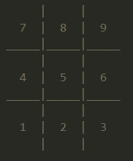 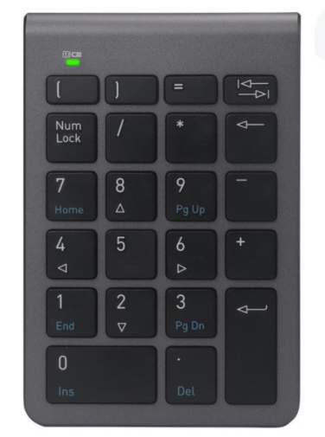

BOARD NUMPAD

**Step – 2:** We have to choose our marker X or O.

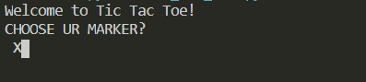

**Step – 3:** *Ready??*

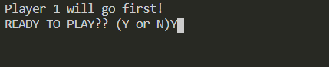

**Step – 4:** *Now, program displays the board and we are ready to go, just decide the position and press the key as told in step 1.*

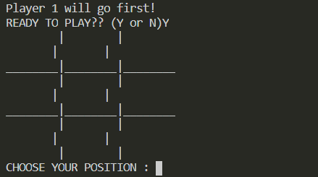

**Step – 5:**  *After player 1, player 2 will go*

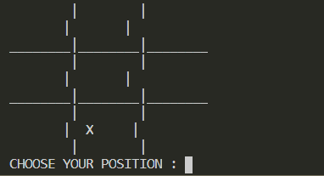

**Step – 6:** *Now player with O marker i.e. player 2 has won the game, and displays, player 2 has won.*

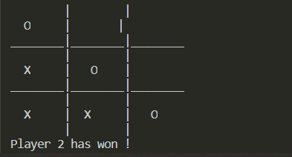

**Step – 7:** *When the game is completed it asks us again, if we want to play again or not.*



***Add as many steps as required to cover the full functionality of the presented solution.***