StreamOn

**Project Name:** “StreamOn”

**Project Description:** This project application is a search engine that will display available streaming applications for a specific movie.

**User Story:** As a movie watcher, I want to know which streaming applications are available to watch my movies. This will reduce time spent searching for streaming applications to watch my movie.

**Wireframe or sketch of the design: (Please refer to page 2 for rough design flow)**

**API’s to be used:**

* GuideBox
* YouTube

**Rough breakdown of task:**

1. Front-End
   1. HTML Creation
      1. Create landing page (CSS: <https://materializecss.com/> )
      2. Create results page
2. Back-End
   1. Establish API connections
   2. Code JS file to HTML

Landing Page:

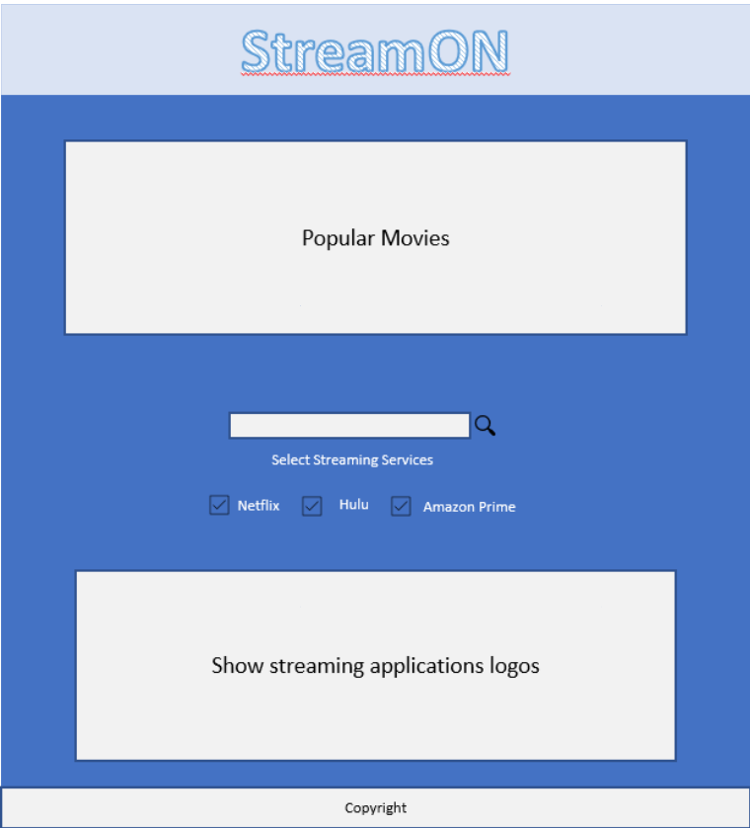

Results Pages

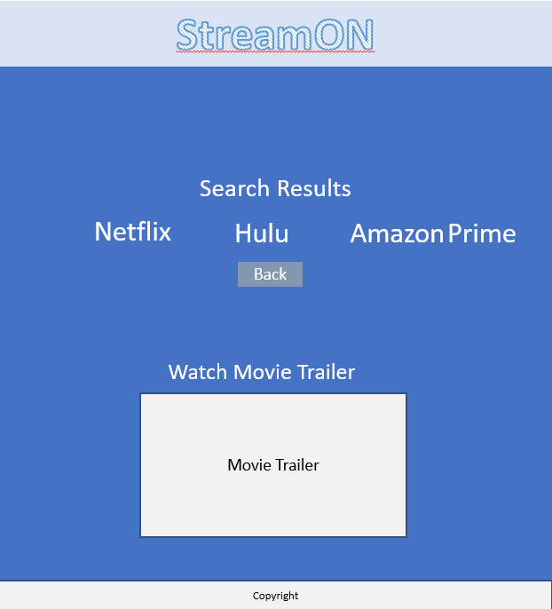l

: