**********************************************************************************

LIVEABILITY
**********************************************************************************

File name Description
BAG2025_Livability2002.csv  BAG2025_Livability2008.csv  BAG2025_Livability2012.csv  BAG2025_Livability2014.csv  BAG2025_Livability2016.csv  BAG2025_Livability2018.csv  BAG2025_Livability2020.csv  BAG2025_Livability2022.csv  BAG2025_Livability2024.csv | Liveability and dimension scores are produced on different scale levels by the Dutch Ministry of the Interior and Kingdom Relations using the ‘Leefbaarometer 1.0’ for the years 2002 and 2008, the ‘Leefbaarometer 2.0’ for the year 2012 and in the ‘Leefbaarometer 3.0’ for the years 2014, 2016, 2018, 2020, 2022 and 2024.  Liveability is defined as the extent to which the living environment is in line with the conditions and needs of residents. The liveability scores in the Leefbaarometer 3.0 are based on 45 environment characteristics (regarding population, social cohesion, public space, safety, level of resources, and housing) in 5 different dimensions with 94 variables in the underlying models. The dimension scores are only available for 2014 and from 2018 onwards.  The LBM scores are expressed as a value distributed around an average score of approximately 4,11. For a better understanding the scores are also presented in 9 liveability classes from 1 (very insufficient) to 9 (excellent). A detailed description of the development of this instrument can be found here.  Due to privacy concerns, no scores are given for PC6 areas with less than 5 inhabitants.  Liveability scores are delivered on 100x100 meter grid level, on neighborhood level, on 4 position postcode level, on district level or on municipality level.  The derived Gecco tables on address or PC6 level are based on the liveability 100x100 meter gridlevel.  The available liveability and dimension scores for 2014, 2016, 2018, 2020 and 2022 per 100x100 meter CBS grid were linked to the corresponding BAG address locations of 2025.
Field name(s) Description
postcode Postcode for 6 position postcode
huisnummer House number of BAG address location
huisletter House letter of BAG address location
huisnummertoevoeging Additional coding for BAG address location
Key Unique combination of postcode, huisnummer, huisletter and huisnummertoevoeging
jaar Year of measurement
lbm Liveability value score
afw Deviation of national average score
fys Score for the dimension physical environment
onv Score for the dimension nuisance and insecurity
soc Score for the dimension social cohesion
vrz Score for the dimension amenities
won Score for the dimension housing stock
**********************************************************************************
De uitkomsten van eerdere metingen - 2002, 2008, 2012 en 2016 - zijn zodanig getransformeerd dat ze aansluiten op de metingen van 2014, 2018, 2020 en 2022 met Leefbaarometer 3.0. (Leefbaarometer FAQ)

Appendix – explanation and classification of liveability scores

Distribution and classification of LBM scores
The Leefbaarometer model produces a score that predicts the liveability of an area. Figure 1 shows the number of residential addresses per Liveability score. The distribution is approximately symmetrical. There are approximately the same number of residential addresses to the left and right of the middle Liveability score (rounded: 4.11). In addition, the number of addresses that have been assigned a certain score decreases almost evenly. The score itself has no meaning: in an area with a 10% higher score, the quality of life is not necessarily 10% higher.”
Figure 1 Number of residential addresses per (rounded) Liveability score
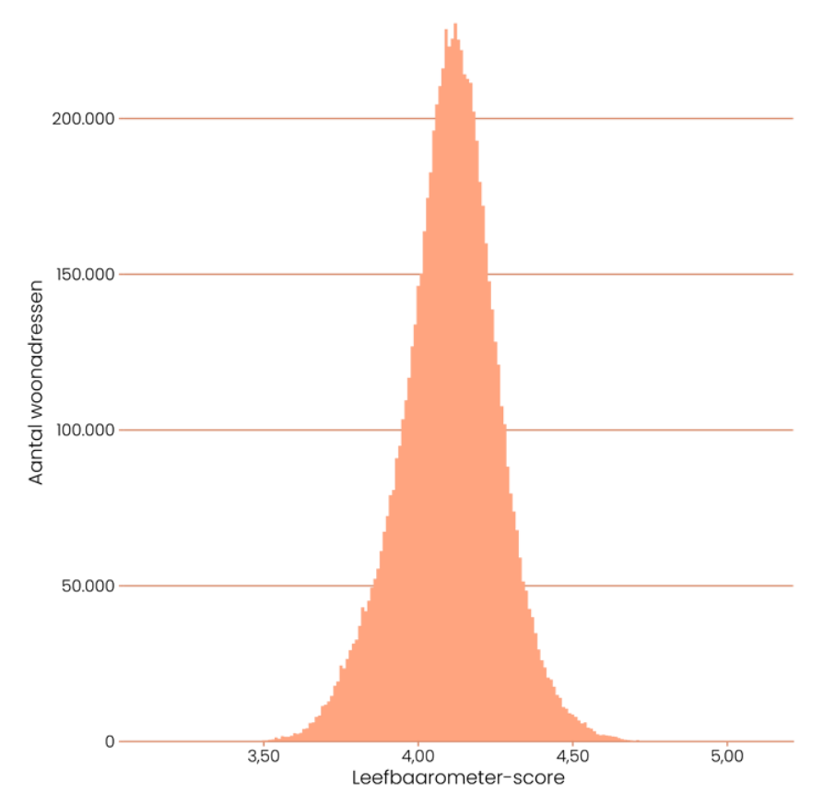
Classification based on quality of life assessments WoON 2018
To give the scores meaning, they are converted into classes. These scores are divided into nine classes (from 'Very insufficient' to 'Excellent') in a similar manner to LBM 2.0. This division into classes explains the Liveability score. To determine the LBM 3.0 class, the distribution of assessments about the quality of life according to WoON 2018 is used. The class boundaries have been chosen in such a way that the distribution of residential addresses across the classes is equal to the distribution of households across the classes in WoON. 2018. In short: 9.4% of households in WoON 2018 assess the quality of life as 'Weak' and just as many residential addresses have an LBM 3.0 score that corresponds to LBM 3.0 class 'Weak'.”
Table 1 shows which LBM 3.0 scores correspond to which LBM 3.0 classes and what share belongs to that class (the same data is shown graphically in Figure 2). This means that the classes have a simple interpretation and they fit in well with people's actual quality of life assessment of their living environment.
Tabel 1 Distribution of households across LBM 3.0 classes
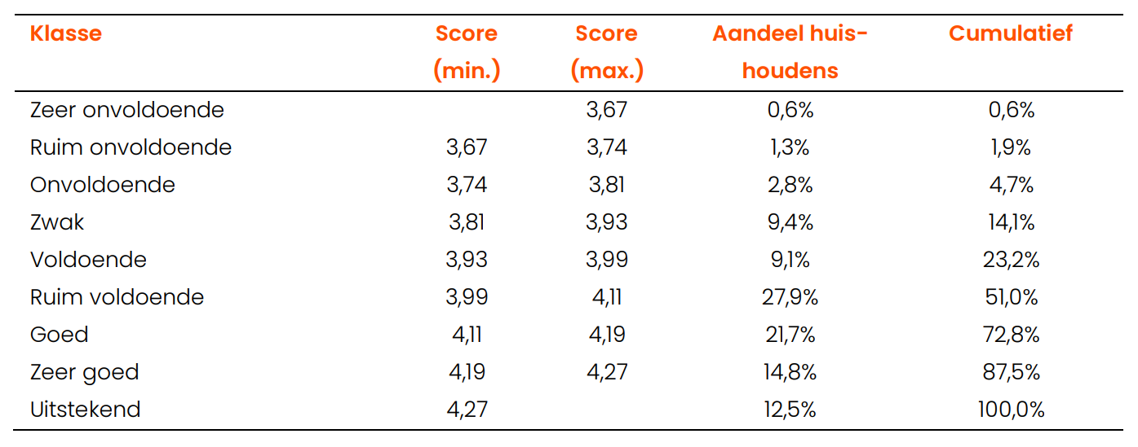
Figure 2 and Figure 3 show that the distribution of scores across the classes is not even. Nearly half of households assess the quality of life as 'More than adequate' or 'Good', and the share of households that assess the quality of life as 'More than adequate' is larger than the share that assesses the quality of life as 'Weak' or 'Adequate' . It is also striking that the middle Livability score corresponds almost exactly to the border between 'More than sufficient' and 'Good'. This means that in 2018, approximately half of households in the Netherlands assessed the quality of life as 'Good' or better and that approximately the same number of households assessed the quality of life as 'More than adequate' or worse.”

Figure 2 Distribution of households across LBM 3.0 classes
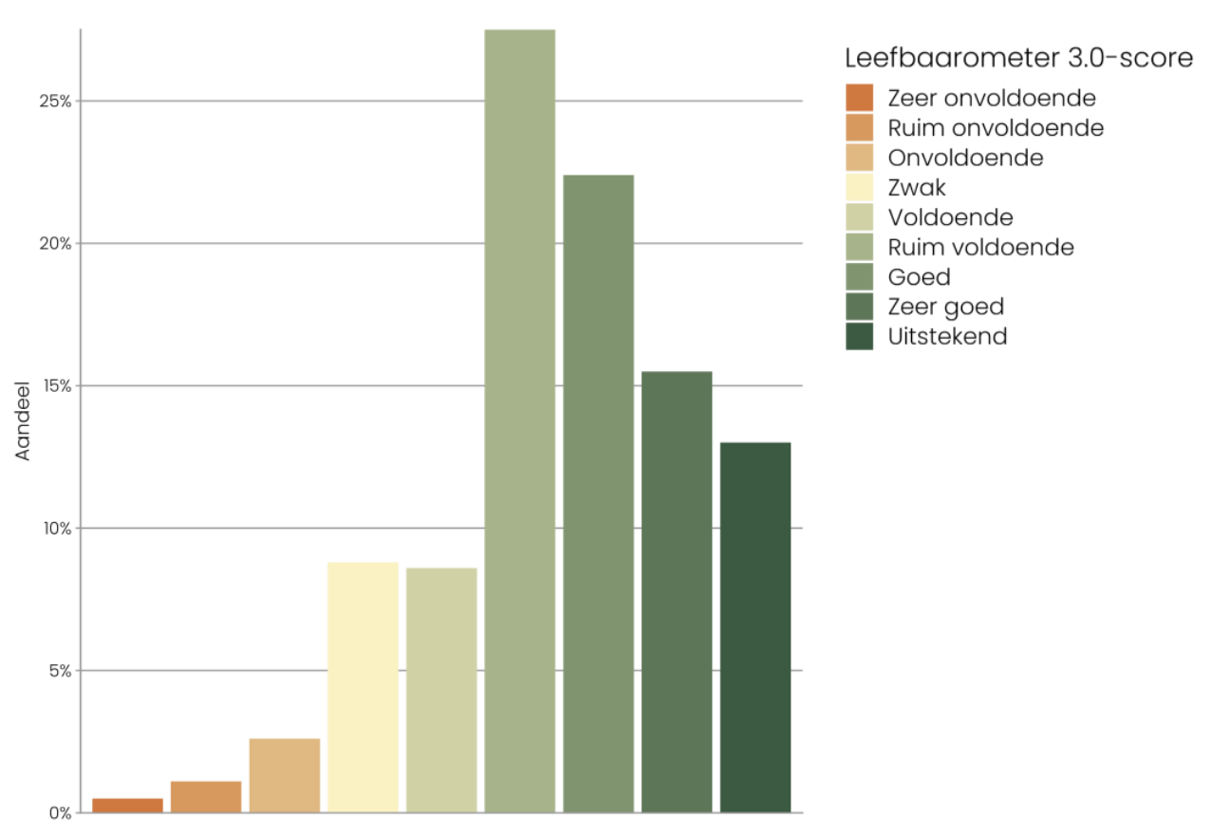
Figure 3 LBM 3.0-score and -class

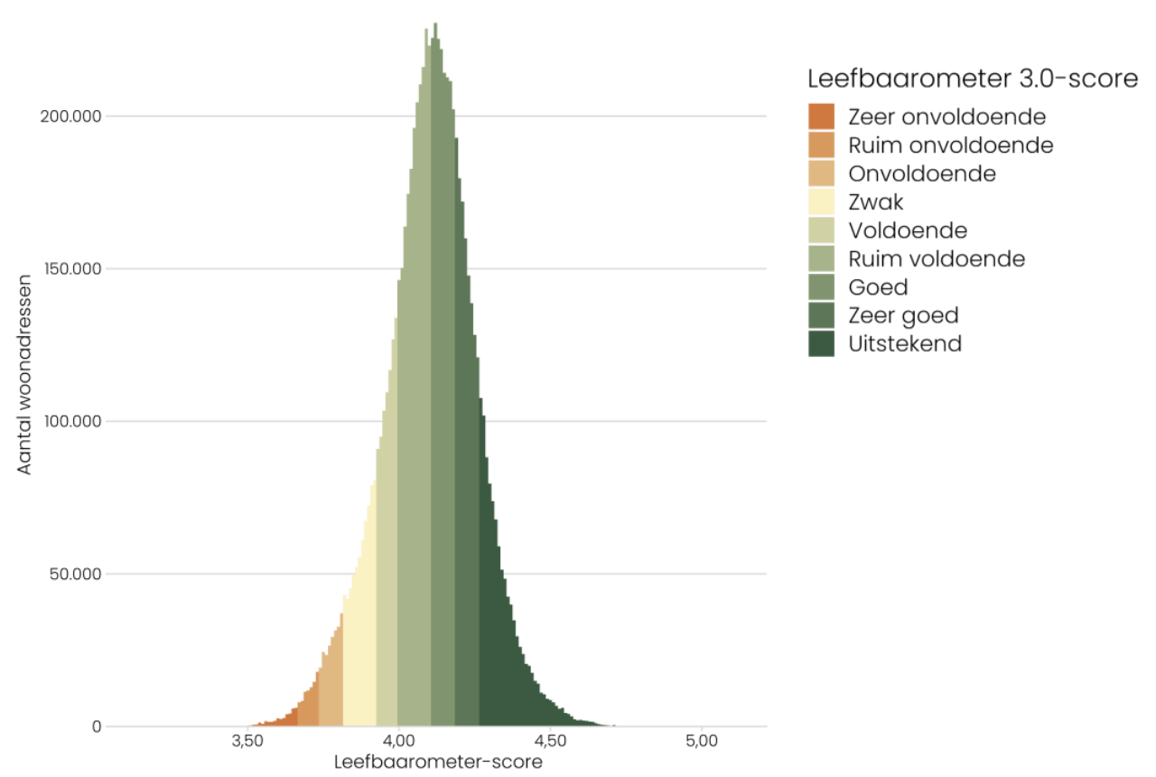

Has the quality of life been recalculated in previous years with the new model?
The new model has been used to predict the quality of life for 2014, 2018, 2020 and 2022.
The introduction of the Leefbaarometer 3.0 marks a break in the trend compared to Leefbaarometer 2.0. After all, the Liveability Meter 3.0 is partly based on other indicators than the Liveability Meter 2.0 and different weightings have been applied. This break took place in both 2014 and 2018. The 2014 and 2018 measurements as presented in the Leefbaarometer 3.0 are also the outcome of Leefbaarometer 3.0. This therefore deviates from the outcome of the 2014 and 2018 measurements that were previously reported with Leefbaarometer 2.0.
The results of previous measurements - 2002, 2008, 2012 and 2016 - have been transformed in such a way that they correspond with the measurements of 2014, 2018, 2020 and 2022 with Leefbaarometer 3.0.
To this end, the average ratio between the scores was determined at the very lowest scale level (six position postcode areas) based on Liveability Meter 2.0 and Liveability Meter 3.0. The results of previous measurements have been multiplied by this ratio. Because only 2014, 2018, 2020 and 2022 were calculated with the Leefbaarometer 3.0 model, the dimension scores can only be displayed for these years.

Source: Selections of text (in Dutch) and figures from rapport 'Leefbaarometer 3.0; instrumentontwikkeling', december 2021 https://www.leefbaarometer.nl/resources/LBM3Instrumentontwikkeling.pdf

