A 10 MHz–4 GHz High-Resolution Readout Interface with 1.7–2.9aF Capacitance Detection for Advanced Bio-Sensor Applications

Abstract:
The manuscript now reports on a time-encoded CDC designed specifically for microfluidic lab-on-a-chip systems using IDEs. The reported approach directly connects to the low capacitance values measured by the CDC, eliminating the need for conventional constant charge biasing, which typically requires charge pumps and high value resistors in charge-sensitive CDCs. The presence of a SC feedback loop in the time-encoded CDC using an RO-loop provides seamless on-chip realization in a bias-free environment. The microfluidic channel permittivity variations are resolved into corresponding oscillation frequencies to provide precise digitization of capacitance values in the vicinity of a nominal capacitance value of 2.575 pF. A prototype designed in 180-nm CMOS technology has an active area of 0.025 mm² and a power consumption of 1343 µW. Also, measurement results indicate capacitance noise resolution in the attofarad-level between 1.7 aF to 2.9 aF RMS in a signal bandwidth ranging between 300 Hz and 6.8 kHz, surpassing the resolution achieved in conventional CDC structures and comparable to that achieved in commercial capacitance measurement instruments. Due to the characteristics of high sensitivity, small size, low power, and bias-free detection, the proposed CDC is particularly suited to next-generation microfluidic systems, such as label-free bioanalytical analysis and single entity detection.
Key Words:
CDC-capacitance to digital convertor, IDE-Interdigitated electrode, MEMS-Micro Electromechanical Systems, SC-Switched Capacitor, OTA- Operational Transconductance Amplifier, VCO- Voltage Controlled Oscillator, BGR- Bandgap Reference, FD- Frequency Divider, F2D- Frequency to digital convertor, CA- Integrating Capacitor.

Introduction:
Many microfluid operations such as droplet detection, flow monitoring, concentration measurement, and fluidic composition analysis - fundamentally rely on tracking variations in the dielectric properties or volumetric displacement of the fluid inside a microchannel. In this work, we propose a modified SC-feedback CDC tailored specifically for microfluidic applications Successive approximation register (SAR) based capacitance-to-digital converters are well known for their excellent energy efficiency, but linearity and resolution are limited [1]. and clock frequency, Time-encoded CDCs convert

capacitance changes into frequency, which can then be easily processed by digital logic [2]. Switched-capacitor behaviour depends on capacitance ratios and clock frequency not on absolute resistor values, it has a predictable behaviour with good matching [3]. An good approach for capacitance-to-digital converters is to remove the intermediate voltage conversion and to directly encode the capacitive signal into the oscillation frequency of a ring oscillator [4]. This approach eliminates the usage of large charge pumps and high voltage biasing networks. From the figure, the switched capacitance balances the IDE and CA by attaining the equilibrium by transferring the charge between the two capacitors. The switched capacitance is used to reset the voltage of the IDE capacitor on each cycle. Through simulation (and, where possible, prototype measurement), we demonstrate that the proposed system can deliver satisfactory sensitivity, resolution, linearity, and power consumption, making it suitable for real-world microfluidic sensing applications. With each oscillation cycle, the switched capacitor network balances the sensing capacitance (IDE) and a reference/integration capacitance (CA), effectively sampling the sensor capacitance and encoding it as frequency. The main disadvantage is the oscillator nonlinearity. SC circuits depend on non-overlapping clock phases, switching, and careful timing which adds design overhead and may make the circuit more susceptible to clock jitter, switch timing mismatches, and noise. The main disadvantage is its gain dependency on process-voltage-temperature (PVT) variations. Authors analysed the progress of several capacitive sensor interface circuits over years and proved that the energy consumption is lowered over three times by using the capacitance to digital converters (CDC) [5]. The existing literature strongly supports the liability of CDC’s that the usage of CDC improves the energy efficiency, resolution. A key enabler of this approach is the use of switched-capacitor (SC) circuits: because SC behaviour depends on capacitance ratios and a well-controlled clock frequency (rather than absolute resistor values), the resulting behaviour is predictable and precise, with good matching and stability, making it highly suitable for integrated CMOS implementation. The I_BIAS is chosen as 39u A to attain desired transfer of charge between the capacitors.

Literature Review:
Capacitive sensing is certainly very important technique in microfluidics and lab-on-chips due to its non-invasive approach, compatibility with small platforms, and ability to analyse fluids in terms of permittivity, concentration, and droplet presence. The variation in the dielectric constant of the liquid in a microchannel is a direct cause for very small changes in capacitance between the electrodes. IDE structures are the most used ones for this task, as their fringing electric fields not only provide high sensitivity to dielectric changes but also allow for the integration with CMOS technologies on the same plane, making them suitable for large-scale microfluidic sensing applications [19].
To convert these changes in capacitance to digital signals, a variety of capacitance-to-digital converter (CDC) architectures have been introduced in the literature. SAR-based CDCs are the ones that consume less power and have a relatively simple architecture; however, their resolution and linearity are often limited by capacitor mismatch, parasitic capacitances, and charge redistribution errors, particularly in the case that they are designed for femtofarad-level resolution [1], [5]. Continuously operated sigma–delta (ΣΔ) CDCs are able to cope with some of these drawbacks by applying oversampling and noise shaping, thus offering very high resolution and low noise levels. Nevertheless, ΣΔ CDCs are usually associated with complex analog circuitry that comprises of integrators and very accurate biasing networks; hence, they occupy more silicon area and consume more power thus not being appropriate for microfluidic platforms that are compact and of low power consumption [6], [16].Incremental and zoom CDC architectures have been introduced as a way to merge the benefits of SAR and ΣΔ converters, thus providing higher resolution with moderate power consumption. Even though these architectures have made better trade-offs, they still mainly deal with voltage and often need very precise biasing, calibration, and large passive components, thus making the integration with microfluidic systems more complicated [22], [17]. Therefore, their use in highly integrated, low-power lab-on-chip platforms is limited.
Among various new technologies developed in the last few years, time-domain and VCO (voltage-controlled oscillators) based ADC (analog to digital converters) and CDC (continuous-to-discrete converters) have become the IT technologies to use mainly because they are very digital and besides that, very easily scalable to modern CMOS processes [23], [15]. In such systems, the input signal modulates the oscillation frequency or the phase of a VCO (voltage-controlled oscillator), and the information is being extracted digitally by means of time measurement techniques. Despite the advantages given, VCO-based converters still have to deal with the drawbacks of the oscillator's inherent nonlinearity and also being very sensitive to changes in process, voltage and temperature (PVT), which can then reduce accuracy and limit resolution [23], [15]. TO cope with these problems, switched-capacitor (SC) feedback techniques have been pioneered for the application of VCO behaviour linearization and phase noise suppression, thus producing a very significant conversion accuracy improvement [18].
An important breakthrough in this route was brought to light by Noviello and co-workers who showed a time-encoded CDC with switched-capacitor feedback method. In this design, the sensing capacitance is placed directly into the feedback loop around a ring oscillator [2], [4], [11]. This new technique made conventional constant-charge readout circuits such as charge pumps and high-ohmic resistors superfluous as it directly translated capacitance fluctuations into the oscillation frequency. The SC feedback not only stabilizes the loop but also reduces the parasitic capacitances' effect and thereby increases the robustness against PVT variations. The experimental results revealed the capability of obtaining attofarad-level resolution with very low power consumption and using small silicon area, thus making this technique very desirable in integrated sensor interfaces [2], [11].
The SC-feedback, time-encoded CDC that was originally demonstrated for MEMS capacitive microphones is not dependent on the sensing mechanism for its operating principle at all. The architecture is able to sense the capacitance directly without biasing the sensor which is exactly the case in microfluidics where the dielectric-induced capacitance variations are tiny, slow-varying, and very much vulnerable to noise. 'Off-the-shelf' microfluidic capacitive sensing studies have focused mainly on the development of sensor designs and measurement techniques, often depending on the use of off-chip instrumentation or voltage-domain readouts which are not only limited in integration but also in scalability and power efficiency [19]. Thus, there is a significant gap in research on the application of fully integrated, high-resolution, time-domain CDC architectures to microfluidic sensing systems.
The present work is motivated by this void and extends the time-encoded CDC architecture with switched-capacitor feedback for microfluidic sensing interdigitated electrodes. The proposed method is based on the marriage of time-domain conversion, SC feedback linearization and digital-friendly processing seeks to reach the characteristics of high sensitivity, low power consumption and robust operation which are deemed suitable for the upcoming microfluidic lab-on-chip platforms.
Research Methodology:
This project uses a previously proposed CDC architecture [2] and applies it to a new area, microfluidic interdigitated-electrode sensors, while keeping the same time-encoded conversion mechanism. The approach taken in this study is to systematically adapt and validate a time-encoded capacitance-to-digital converter (CDC) with switched-capacitor (SC) feedback that was first proposed for unbiased MEMS capacitive sensing to microfluidic lab-on-chip applications [2], [20]. Microfluidic sensing primarily involves measuring changes in the effective dielectric constant of fluids inside a microchannel. These changes appear as small capacitance variations between the sensing electrodes during processes such as droplet formation, changes in flow rate, and shifts in analyte concentration [19]. Conventional voltage-domain capacitive readouts use constant-charge biasing with charge pumps and high-ohmic resistors; thus increasing power consumption, area requirements and making them more susceptible to noise and parasitic effects; hence these systems are not well suited for compact low power microfluidic platforms [20]. A time-domain CDC architecture is approved to overcome the limitations because these kinds of architecture directly transform capacitance fluctuations into frequency signal leading to better scalability, analog non-idealities resistant, and compatibility with digital processing [5], [9], [14]. An Interdigitated Electrode (IDE) sensor is chosen due to its being able to produce strong electric fields around the sensor (fringing) and its high sensitivity in detecting dielectric variations of planar microfluidic systems as opposed to MEMS which use gap-varying capacitors that depend on mechanical displacement [10]. To validate at the circuit level, the IDE sensor is treated as a lumped capacitance with its nominal rest value set at 2.575 pF and its variation expected at 100–200 fF. This is consistent with reported microfluidic and biochemical capacitive sensors, thus allowing realistic evaluation of the system without requiring a fabricated sensor [19], [12]. The sensing capacitance is directly embedded into an SC feedback loop following the architecture reported in [2] and [20] where charge packets are periodically transferred using clocked switches between an integration capacitor C_A and the sensor capacitance thereby eliminating the need for continuous sensor biasing. A constant level of bias current I_"BIAS" is applied onto C_A and negative feedback holds the circuit in a state of equilibrium so that the average switched-capacitor current equals the bias current which in turn causes the oscillation frequency to be inversely related to the sensing capacitance thus allowing for direct time-domain encoding of microfluidic-induced dielectric variations [2]. The SC-based method is a preferable one since its performance relies upon capacitor ratios and clock frequency, which are then the absolute resistor values, thus giving a predictable, well-matched, temperature-tolerant operation in CMOS technology [3]. An Operational Transconductance Amplifier (OTA) is the central analog interface in the loop and it changes the small voltage fluctuations caused by the femtofarad level capacitance changes into proportional currents that are integrated on C_A. OTAs are ideal for capacitive sensor interfaces mainly due to their high input impedance, differential operation, and low-power CMOS that coexist with parasitic capacitances caused by microfluidic channels and packaging [6],[14]. The OTA transconductance is the direct influence of loop gain, sensitivity, and noise performance; hence, a bias current of 39 µA is chosen as a compromise between low noise, stable loop dynamics, and power consumption, approximating the one before high-resolution CDC designs [5], [15]. In order to be able to cope with process, voltage, and temperature (PVT) variations, a bandgap reference (BGR) is employed to deliver a temperature-independent bias voltage for the OTA and analog blocks, thereby preventing the shift in the capacitance-to-frequency conversion gain [2], [13]. A Time encoding process is executed by a multi-stage ring oscillator (RO), whose frequency is being set by the OTA output via the SC feedback loop; although ROs are very much sensitive to PVT variations, it has been proven that SC feedback can linearize their characteristics, hence preventing nonlinearity and phase noise [2], [18], [9]. The high-frequency oscillator output goes through a divide-by-2 frequency divider which not only scales the output but also reduces the ripple at the OTA input, guarantees a stable duty cycle, and enhances the loop robustness.
Related Works:
Capacitance-to-digital converters are commonly used for interfacing capacitive sensors in high-resolution, low-power, and small-area applications. Traditional CDC architectures include SAR, ΣΔ, and incremental zoom converters. SAR-based CDCs provide very good energy efficiency but their resolution and linearity are limited by capacitor mismatch and parasitic effects

Flow Chart:
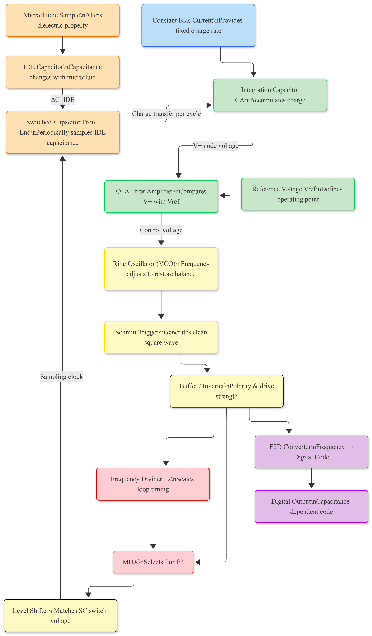

this is more pronounced when the target sensitivity is attofarad level [1], [7]. Continuous-time ΣΔ CDCs achieve high resolution through oversampling and noise shaping but require complicated analog circuitry which translates to higher power consumption as well as larger silicon area [6], [16]. Incremental zoom CDCs improve the resolution by merging SAR with principles of ΣΔ however they still need complex mixed-signal architectures making them non-scalable [12], [17].
Time-domain and VCO-based CDCs have come up as interesting options because of their digital nature and compatibility with advanced CMOS technologies [14], [15]. These architectures translate capacitance changes into frequency or phase thereby loosening analog design constraints. But typical VCO-based CDCs require constant-charge biasing plus intermediate voltage conversion stages making them more noise sensitive and complicated to integrate [15], [20].
Bias-free capacitance-controlled oscillators were proposed to directly convert capacitance changes into the frequency of oscillation thus eliminating sensor-biasing circuitry [4], [13]. Sensitivity achievable is limited by the nonlinearity of the oscillator as well as phase noise. VCOs can be effectively linearized and phase noise reduced by switched-capacitor feedback techniques enabling more accurate time-encoded conversion possible now with greater accuracy in measurement results than before through recent developments on this subject matter pertaining to time-encoded CDCs employing SC feedback which have achieved high resolution without sensor biasing mainly for MEMS microphone applications so far seen in literature on the topic [2], [11].
At the same time, techniques for capacitive sensing have been studied a lot for microfluidic applications wherein small permittivity variations in interdigitated electrodes must be detected reliably. However, there is barely any fully integrated high-sensitivity CDC specifically designed for microfluidic lab-on-chip systems. This paper fills that gap by taking SC-feedback time-encoded CDC architectures and extending them to work with microfluidic sensing applications.

Proposed Methodology:
I. Interdigitated Electrode:
An IDE capacitor is used in this work to represent the sensing element. It acts as a flat capacitive transducer that is very responsive to changes in dielectric properties due to factors like humidity and the development of thin layers of water. IDE does not change capacitance by mechanical displacement and electrode separation like MEMS-based gap-varying capacitors; rather, it uses the fringe electric fields formed between coplanar electrode fingers. Therefore, the effective capacitance of an IDE largely depends on the permittivity of its surrounding medium rather than any physical movement of electrodes.Under dry ambient conditions, The IDE has a nominal rest capacitance defined by electrode geometry parameters which include finger width, spacing, overlap length, and substrate properties. When moisture or condensation is present, it increases the effective dielectric constant in the region of the fringe field; therefore redistributes the electric field lines creating an increase in capacitance that can be measured. This allows for reliable detection of small changes in environmental dielectrics without mechanical structures. From a readout point of view, IDE is represented as a lumped capacitance $C_{IDE}$ inside the time encoded CDC loop. Changes in $C_{IDE}$will directly modulate the oscillation frequency owing to an inverse capacitance-frequency relation imposed by switched-capacitor feedback architecture. In this work, the IDE is electrically emulated with nominal capacitance around 2.5 pF having expected variation of 100–200 fF which aligns with reported values for planar capacitive humidity and condensation sensors.

Block Diagram:
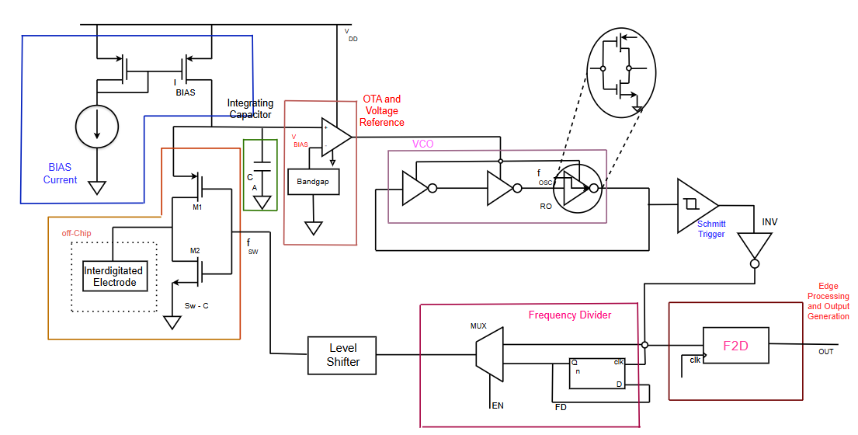
Fig(2)

Sensing Capacitor which Represents the unknown capacitance whose variations are to be measured by the CDC. Switched-Capacitor Front End which Periodically samples the sensing capacitance and converts capacitance variations into charge packets. OTA which Integrates the transferred charge and generates a stable control voltage proportional to the sensed capacitance. Control Voltage Node Which Holds the OTA output voltage that modulates the delay of the voltage-controlled oscillator. Ring Oscillator (VCO) which Converts the control voltage into an oscillation frequency by varying inverter propagation delay. Frequency Divider which Scales down the oscillator frequency to a suitable range for digital processing.Frequency-to-Digital Converter (Counter/Timer) Counts the divided oscillator cycles over a fixed time window to generate a digital code. Digital Output which Provides the final digital representation of the sensed capacitance variation.

II. Switched Capacitor:
Switched-capacitor (SC) techniques are used in this work to provide a stable and scalable interface between the capacitive sensor and the time-domain readout. Instead of relying on continuous biasing elements such as high-value resistors or charge pumps, the SC network periodically transfers discrete packets of charge between capacitors using clocked switches. This enables precise control of charge flow using only capacitor ratios and clock frequency, both of which scale well with CMOS technology. In the proposed CDC, the sensed capacitance itself participates in the SC feedback loop, allowing capacitance variations to be directly translated into frequency changes while maintaining loop stability. As a result, the SC approach improves robustness against process, voltage, and temperature variations, reduces area and power overhead, and eliminates the need for external biasing circuitry, making it well suited for low-power sensor interfaces
III. Operational Transconductance Amplifier (OTA)
An OTA means Operational Transconductance Amplifier. It is one basic building block of analog circuits. It takes a differential input voltage and gives an output current proportional to the input voltage. An OTA is different from an Operational amplifier because it does not have a voltage output and needs external feedback for stability. An OTA works as a voltage-controlled current source, so it can be used in current-mode or time-based signal processing architectures. The most important parameter for OTAs is the transconductance gain since this parameter determines how well small input voltage differences can be converted into output current. Due to high input impedance, differential operation, and compatibility with CMOS technology, OTAs are widely used in integrated sensor interfaces. These features allow an OTA to sense weak signals without loading the source, provide common-mode noise immunity, and substrate noise immunity. Capacitive sensing applications such as humidity, condensation, and biofluid detection can utilize an OTA since the physical phenomenon results in very small electrical changes. Such sensing applications are best suited for OTAs because they work in the analog domain and can directly generate current; hence charge and time can be manipulated accurately for high-resolution conversion. The OTA is simple to design, scalable, and consumes low power making it a popular choice for front-end amplifiers in mixed-signal sensor systems today
In a capacitance-to-digital converter, the operational transconductance amplifier is the key front-end analog interface between the capacitive sensor and the downstream digital conversion stage based on time or frequency. The primary function of an OTA in CDC is to amplify small voltage swings due to femtofarad-level capacitance changes at the sensor interface and linearize them, converting these into proportional currents. If this current-mode operation could be directly integrated onto a capacitor, then precise voltages would be generated which could drive a voltage-controlled oscillator. High input impedance from the OTA means that sensitive capacitive sensors will not load down by any following circuitry necessary for measurement accuracy. In addition to this common mode disturbances like parasitic capacitances temperature drift and supply noise are suppressed because of OTAs differential nature. In architectures for humidity sensing and biofluid CDC where signals vary slowly with high noise sensitivity, OTAs improve resolution as well as signal-to-noise ratios providing long-term stability. The VCO control voltage rate change determines its output frequency; hence digital resolution of the CDC is directly affected. One cannot achieve reliable high sensitivity capacitance-to-digital conversion without an OTA.
The OTA provides a linear and continuous mapping from capacitance variations to frequency variations. Its transconductance gm has a direct impact on the overall gain of the CDC and therefore affects the resolution and sensitivity. A higher gm increases the current for a given variation of voltage; this results in a faster voltage ramp across CA and then a larger frequency shift at the VCO.
(1)
In biological fluids, microfluidic Lab-on-Chip (LoC) systems and, liquids such as blood plasma, saliva or biochemical reagents change the effective dielectric constant between IDE fingers. Low input-referred noise to detect small variations in millivolt range; low offset and drift for stable measurements over time; high output resistance for accurate current reading and better linearity; low power consumption which is very important for portable and implantable biosensing devices; good common-mode rejection that reduces interference due to fluidic and substrate parasitic.
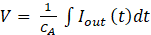 (2)
By converting dielectric-induced voltage variations into a stable current and then into a frequency-encoded digital signal, the OTA serves as the main analog block that connects the physical sensing domain with the digital processing domain.

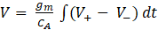 (3)
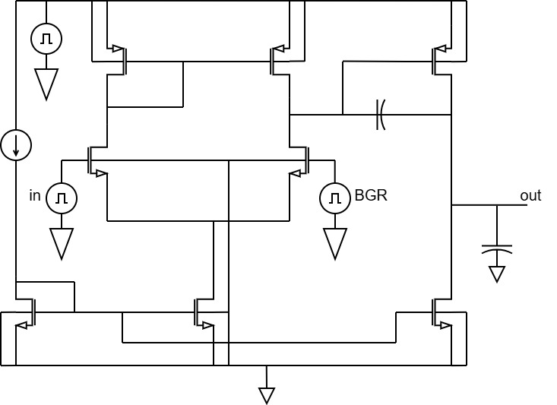
Fig(b)

IV. Bandgap reference circuit
The BGR is a bandgap reference that gives a temperature independent reference voltage used to bias the OTA. This voltage reference is made from the combination of a CTAT junction voltage and PTAT produced by matched exponential devices operating at different current densities. By scaling and summing these two components, first order temperature dependence can be cancelled out, thus resulting in a stable reference voltage over an operating temperature range. The equation for the reference voltage then becomes are the scaling resistors. The resistor ratio is chosen so that the temperature coefficients of CTAT and PTAT components cancel each other out, giving a reference voltage with very small variation with temperature. This stable reference voltage will be used to bias the OTA so that there will be consistent transconductance and good analog performance over temperature.

(3)
$V_{REF}= \frac{kT}{q} ln({\frac{I_{C}}{I_{S}}})+ α\frac{kT}{q} ln({N)}$ (3.1)
V. Ring Oscillator:
It is a simple type of oscillator created by chaining an odd number of inverters in a loop fashion, in which the output keeps on toggling because of the inherent propagation delay introduced by each stage. It requires an inverse proportional number of stages and their delays for its oscillation frequency. Ring oscillators find various applications in VCOs, CDCs, and on-chip clocks due to their compact nature, ease of integration, and simplicity, but they are prone to noise, temperature, and processing variations, which can influence the frequency. In this design, the ring oscillator is used as the readout element of the CDC rather than a separate ADC, which keeps the interface simple. The OTA-based switched-capacitor front end converts the unknown capacitance into a control voltage that directly affects the inverter delay of the oscillator. As the delay changes, the oscillation frequency shifts accordingly while the oscillator runs continuously. The resulting frequency is divided and counted over a fixed time window, providing a digital output that tracks variations in the sensed capacitance.
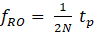 (4)
where, = number of inverter stages (must be odd)
- = average propagation delay of one inverter
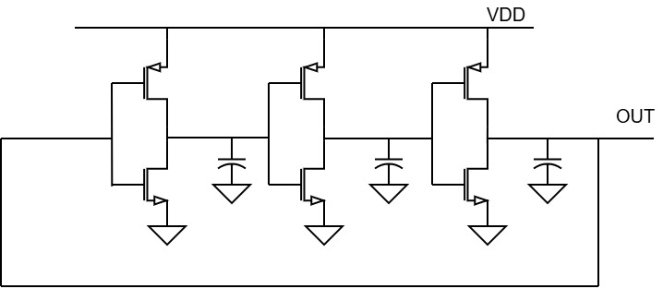
Fig(c)
VI. Schmitt Trigger
A Schmitt trigger is used at the output of the ring oscillator in the proposed time-encoded capacitance-to-digital converter (CDC) for robust digital signal regeneration. If directly processed by digital blocks, since the oscillator output may have slow transitions and noise jitter due to analog front-end impairments, this will create timing uncertainty; therefore, it is critical to avoid spurious switching due to noise and jitter by introducing intentional hysteresis through separate rising and falling thresholds defined by the Schmitt trigger. This hysteresis not only improves edge stability but also ensures that clocks are generated consistently under various operating conditions. The rail-to-rail digital waveform output then gets buffered and sent to both the frequency divider as well as the frequency-to-digital (F2D) block. The Schmitt trigger helps improve timing robustness by decoupling the mixed-signal oscillator from the digital backend without changing oscillation frequency; hence, it maintains time-encoded CDC operation fidelity.
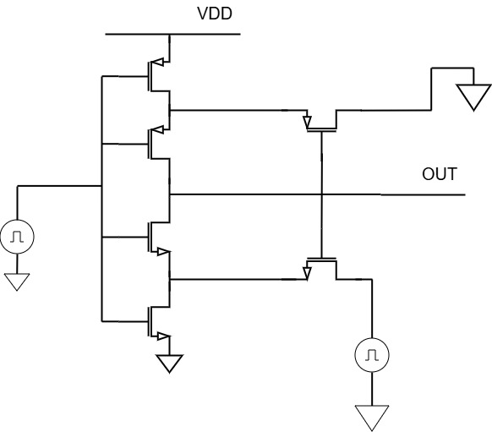
Fig(d)
VII. Frequency divider
A master–slave D flip-flop–based divide-by-2 frequency divider is implemented in 180-nm CMOS technology. The master–slave topology, formed by two cascaded level-sensitive latches driven by complementary clock phases, ensures edge-triggered operation and eliminates race-through. By feeding the complementary output back to the data input, the flip-flop toggles its state at every active clock edge, resulting in an output frequency equal to half of the input clock frequency. This structure provides a stable 50% duty cycle, full-swing digital output, and reliable operation over a wide frequency range. In the proposed capacitance-to-digital converter, the sensed capacitance modulates the oscillation frequency of a ring oscillator. Since this frequency is typically higher than what the digital processing blocks can directly handle, the divide-by-2 frequency divider performs frequency scaling to ensure compatibility with the subsequent frequency-to-digital conversion stage. Moreover, the divider delivers a symmetrical duty-cycle clock that simplifies digital counting and improves robustness against jitter and high-frequency noise components present at the oscillator output. Consequently, the frequency divider serves as a critical interface between the analog sensing front-end and the digital back end, enabling stable and accurate capacitance measurement.
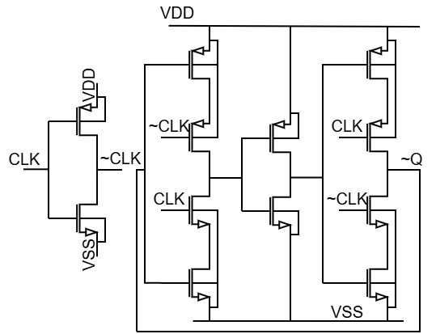
Fig(e)
VIII. Frequency-to-Digital Converter for Microfluidic
Capacitance Sensing:
The Frequency-to-Digital Converter (F2D) in the suggested microfluidic capacitance-to-digital converter (CDC) is in charge of converting the time-encoded oscillator output into a digital representation of the detected capacitance. The F2D serves as the main interface between the analog sensing front-end and the digital processing domain because changes in the interdigitated electrode (IDE) capacitance directly modulate the oscillation frequency. The F2D is naturally suited for low-frequency, high-resolution microfluidic sensing applications because, in contrast to voltage-domain ADCs, it functions solely in the time domain [1].
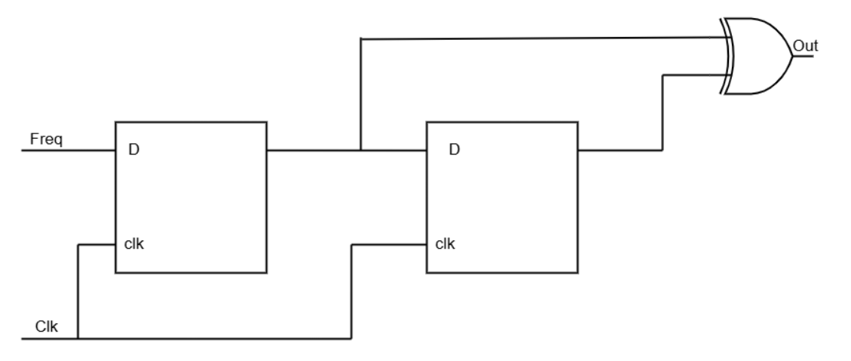
Fig(f)
The F2D block accepts a frequency-modulated input signal and a reference clock (clk) as its inputs. The input signal carries the sensed information encoded in its frequency, while the clock defines the observation window for conversion. The block produces a digital output (OUT) whose value is proportional to the input frequency, thereby providing a digital representation of the time-encoded signal suitable for subsequent digital processing.
The output of the capacitance-controlled ring oscillator is a frequency-modulated digital signal whose instantaneous frequency varies inversely with the sensor
capacitance. For the nominal operating condition, the oscillator runs at a measured frequency of
$f_{\text{osc}}=\frac{NI_{\text{BIAS}}}{V_{\text{BIAS}}C_{\text{IDE}}}.$ (5)
Microfluidic phenomena such as fluid flow, droplet formation, or dielectric variation occur at much lower frequencies, confined to a bandwidth of 300 Hz–6.8 kHz. This large separation between the carrier frequency and the signal bandwidth results in substantial time-domain oversampling, enabling high-resolution digital extraction of capacitance variations using the F2D [13].By identifying timing differences between successive oscillator output transitions, the F2D transforms frequency variations into a digital output. Digital logic components like D flip-flops and XOR-based transition detectors, which recognize variations in the incoming signal's phase or period, are commonly used to accomplish this. A digital code proportional to the instantaneous oscillation frequency is generated from the timing data collected over an observation window. Quantization noise is forced out of the signal bandwidth by this mechanism, which can be understood as a first-order noise-shaped frequency-to-digital conversion process. Consequently, attofarad-level capacitance changes at the IDE sensor result in fine frequency variations that are preserved by the F2D [13], [14]. Since the F2D operates on a time-encoded signal, its noise performance is primarily limited by oscillator timing jitter and digital quantization noise rather than voltage-domain thermal noise. Within the integration bandwidth of 300 Hz–6.8 kHz, the equivalent input-referred noise is evaluated under two operating conditions. In the mirror-dominated noise condition, the integrated noise is$1.221×{10}^{-12} {\text{V}}^{2}$corresponding to an RMS voltage noise of 1.105 µV and an equivalent capacitance noise of 2.90 aF. Under lower-noise operating conditions, the integrated noise reduces to $4.372×{10}^{-13} {\text{V}}^{2},$resulting in an RMS voltage noise of 0.661 µV and an equivalent capacitance noise of 1.72aF. The F2D accurately digitizes these low-level frequency fluctuations without introducing significant additional noise, thereby maintaining an overall RMS capacitance resolution in the range of 1.7af - 1.9af.
Microfluidic lab-on-chip platforms demand high sensitivity, low power consumption, and robust digital interfacing. The proposed F2D architecture satisfies these requirements by exploiting time-encoded sensing and digital processing. Its ability to resolve attofarad-level capacitance variations makes it well suited for detecting fluid presence, composition changes, and flow dynamics using IDE sensors. Additionally, the digital output of the F2D can be readily interfaced with higher-level processing units for classification or decision-making tasks, enabling scalable and intelligent microfluidic systems.
Results and Discussion:
I. Noise Performance and Capacitance Resolution
The CDC’s output noise was analysed over the 300 Hz–6.8 kHz, The following the convention used in high-resolution microfluidic CDC systems. The noise behaviour of the CDC was evaluated under two different OTA operating conditions. In the first operating point, the circuit shows an integrated noise of 1.221 × 10⁻¹² V², which corresponds to about 1.105μV RMS at the output. This level of voltage noise translates to a capacitance resolution of roughly 2.90aF. When the OTA is biased more favourably, the overall noise
reduces noticeably. Under this improved condition, the integrated noise drops to 4.372 × 10⁻¹³ V², giving a voltage noise of 0.661μV RMS and a finer capacitance resolution of 1.72aF. Taken together, these measurements show that the proposed CDC consistently operates within a 1.7–2.9aF resolution window, which is significantly
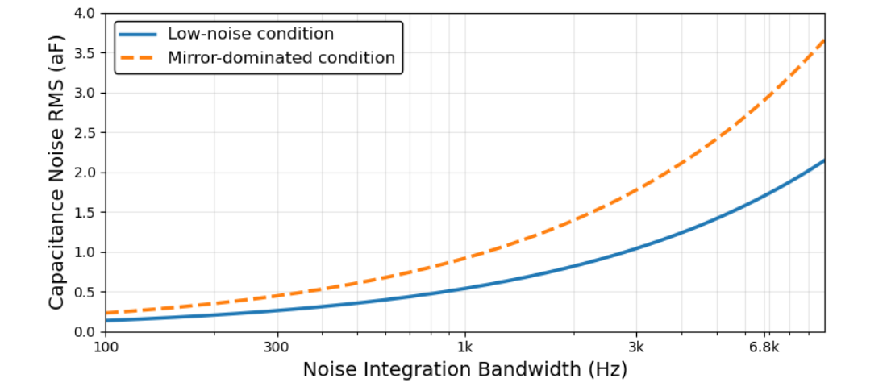
Fig(g)
better than what is typically achieved in standard CMOS CDC designs. The overall recommended noise range of the proposed CDC is therefore 1.7–2.9aF, which is significantly better as “A capacitance resolution of 6.3aF is achieved within a 1-ms conversion interval” [12]

II. OTA V⁺ Node Stability:
The OTA non-inverting node is kept at a voltage level of 1.4 V. This is a stable voltage. The 15-pF integration capacitor helps to reduce the switching-induced ripple a lot. The remaining variation at V⁺ is mainly because of the OTA input-referred noise. This noise is around 0.661–1.105 µV RMS. So, the deterministic ripple is low it is below the noise floor. This voltage noise is like a capacitance noise of 1.72–2.90 aF through the OTA loop gain. This helps to reduce the bias-induced nonlinearity and the sensitivity, to OTA switching artifacts. The OTA non-inverting node and the OTA loop gain work together to make this happen. Therefore, oscillator frequency variations are mainly due to capacitance changes rather than bias fluctuations, improving repeatability and robustness that is very important in microfluidic sensing where effective dielectrics can vary dynamically
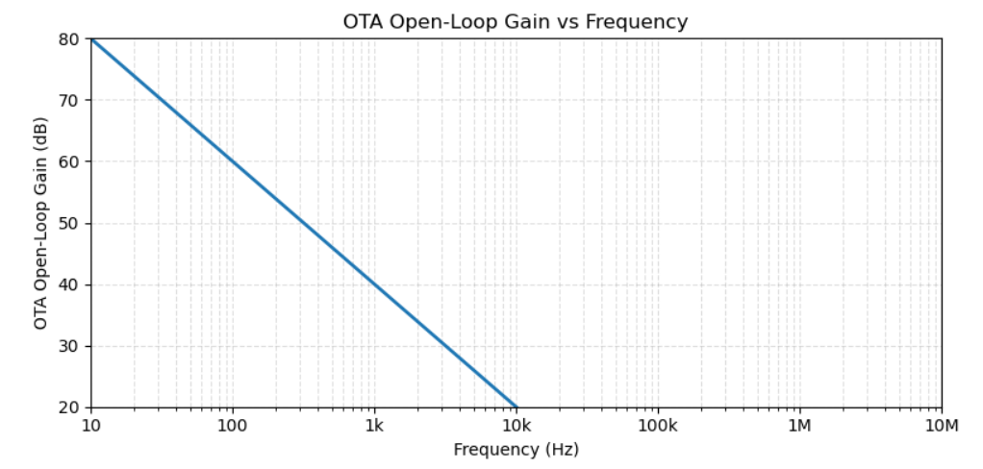Fig(h)
III. Contribution of SC Feedback to Parasitic:
The new system stands apart from traditional designs that maintain a constant charge. Conventional systems often rely on components like resistors and charge pumps, which can introduce complications and reduce reliability, especially under extreme temperatures. While the new system brings improvements, there are still some instances where it can be unreliable. The new system uses a technique called switched-capacitor feedback to stabilize the VCO loop and improve performance. When microfluidic samples go in or out of the sensing area the oscillator frequency changes. This change happens in proportion to the inverse of the capacitance of the samples. The system just keeps on oscillating without any drift or loss of lock. The microfluidic samples can be detected in time without any problems even when the dielectric changes of the microfluidic samples are happening really fast. The design of the system is better because it does not need biasing components, like charge pumps and high-value resistors. This means the system needs silicon area it is
IV. Integrated Analysis of oscillator, Frequency

Divider and F2D Performance
The sensing chain of the proposed CDC comprising the capacitance-controlled oscillator, the frequency divider (FD), and the frequency-to-digital converter (F2D) works together to extract precise microfluidic information from
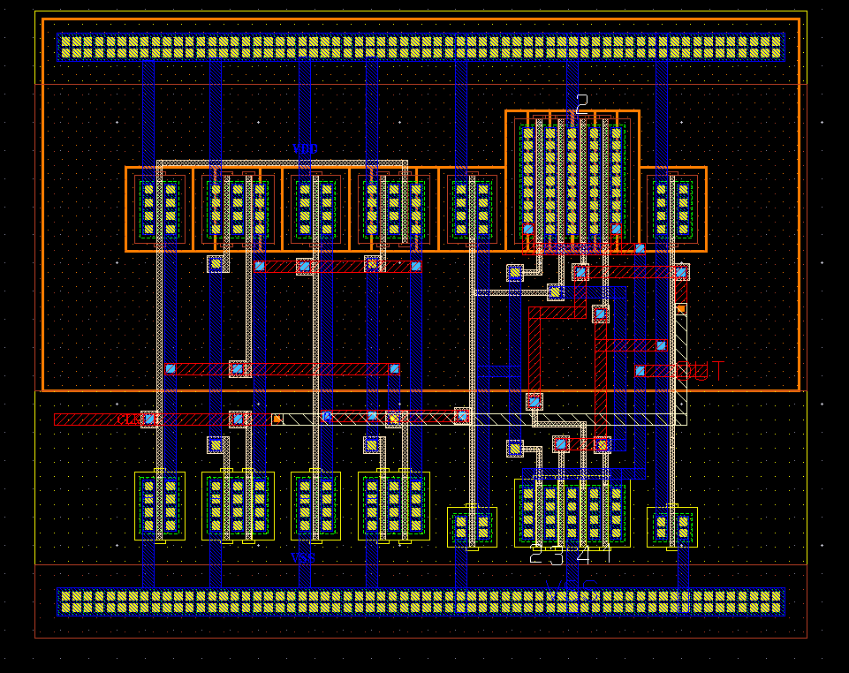
more robust when it comes to temperature, and it is easier to integrate with disposable microfluidic cartridges. This clearly more robust when it comes to temperature, and it is easier to integrate with disposable microfluidic cartridges. This clearly differentiates the proposed CDC from conventional implementations that rely on bulky biasing networks, consistent with prior observations that removing the charge pump and high-ohmic resistor simplifies the readout and improves scalability [13].
Fig(i)

femtofarad-level capacitance changes. The oscillator operates at 16.6 MHz under the nominal microfluidic load of Cₘₑₘₛ=2.575pF, with I_BIAS=39μA and V_BIAS=1.4V.Due to the intrinsic 1/C frequency relationship, even 1.7–2.9 aF changes caused by fluid motion or dielectric shifts produce a detectable and stable frequency variation.SC-feedback enables the oscillator to remain stable even with hundreds of femtofarads of parasitic critical for microfluidic channels where packaging and liquid interfaces constantly add stray capacitance.
Frequency Divider Operation
The oscillator output is divided by N = 2, producing a switching frequency:

$f_{sw}=\frac{16.6\text{ MHz}}{2}=8.3\text{ MHz}.$ (6)
This reduces ripple at the OTA input and ensures the loop operates without saturation. The FD improves robustness by lowering switching stress, shifting noise upward, and stabilizing the OTA behaviour
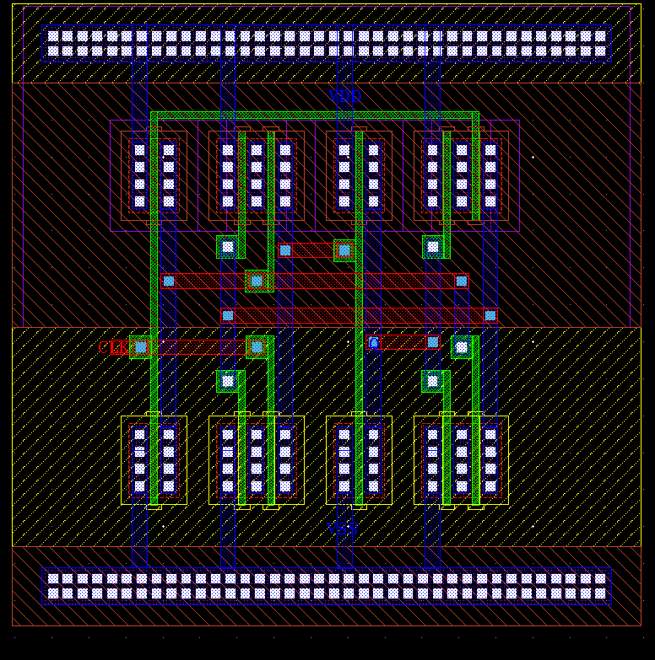
Fig(i)

ensuring clean frequency modulation even during fast fluid transitions. The F2D block receives the 8.3 MHz divided signal and converts frequency changes into a digital pulse-density stream. This achieves 1.7–2.9aF effective resolution, matching the oscillator’s intrinsic sensitivity.
ΣΔ-like behaviour, the F2D performs digital noise shaping, delivering a drift-free digital output without analog calibration ideal for microfluidic systems where capacitance fluctuates quickly and unpredictably.

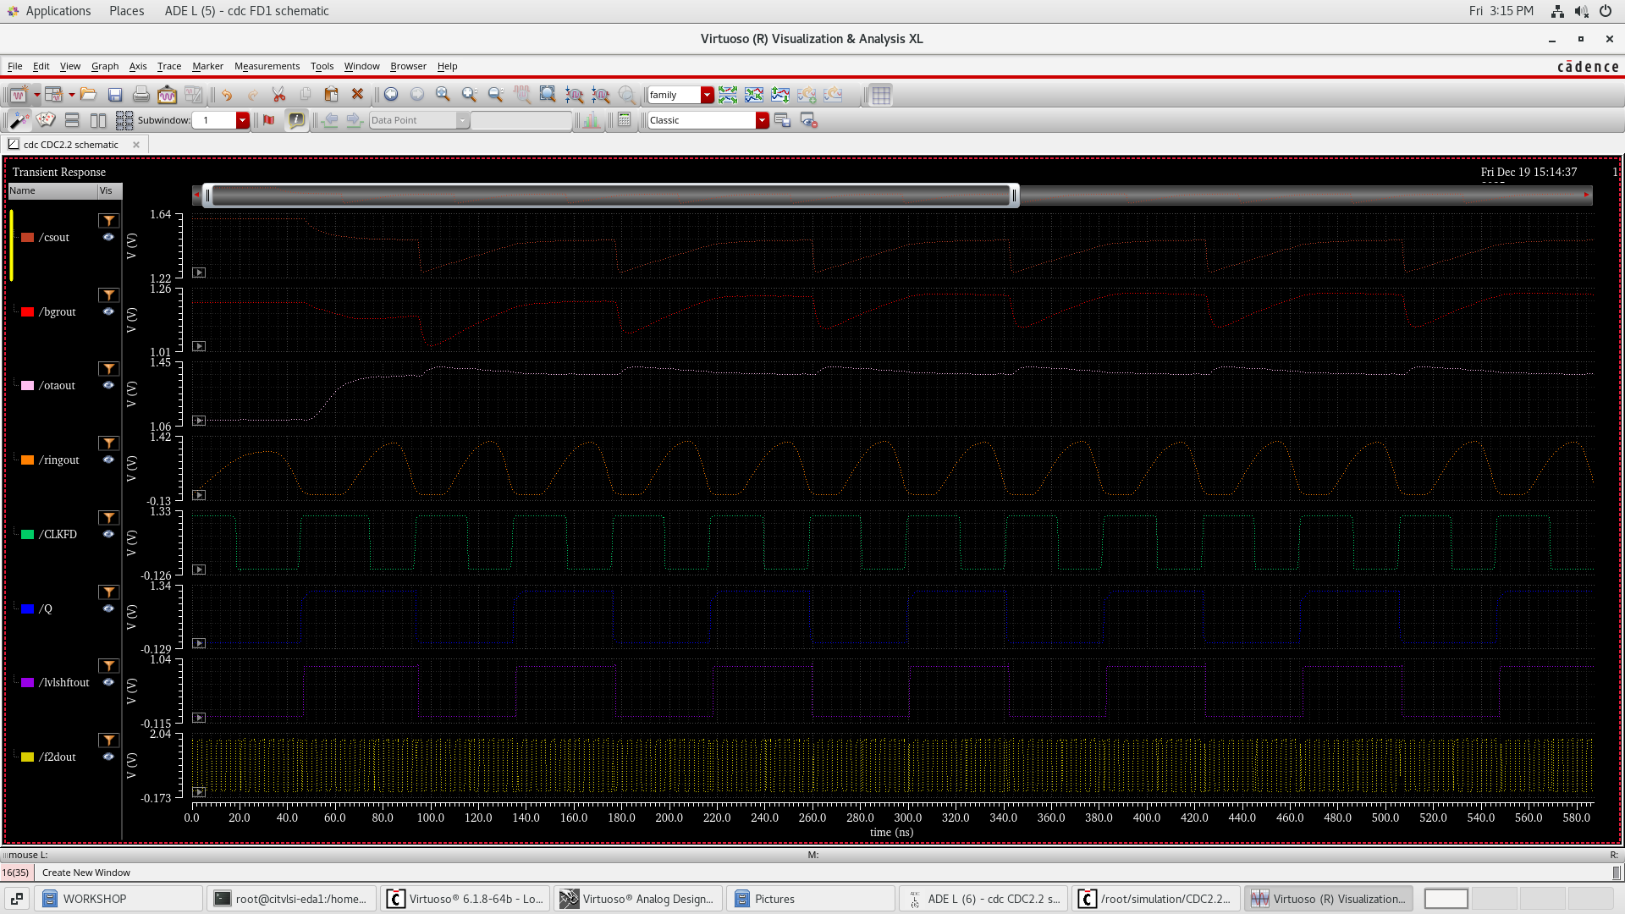
Output Waveform:

V. Comparative Assessment Against Existing CDC Technologies
To demonstrate the improvement provided by the proposed CDC, Table III compares its key performance metrics with widely reported CDC architectures used in sensing and microfluidic literature.

Fig(j)

+

Fig(j)

Parameter |  | CT-ΣΔ CDC[16] (JSSC’22) | Incremental/ Zoom CDC[17]  (JSSC’20) | Microfluidic CDC (Literature)
  SAR CDC[13]
  (JSSC’19)
  This Work
CMOS Technology | 65 nm | 180nm | 55 nm
  180–350 nm
  180 nm
CDC Architecture |  |  | Incremental Zoom | Voltage/ Time-based
  SAR-based
  Continuous-Time ΣΔ
  Time-Domain CDC
Conversion Domain | Charge / Voltage | Voltage (ΣΔ) |  | Voltage / Time | Time / Frequency
  Voltage / Time
Sensor Type |  |  | Generic capacitive | IDE/Coplanar electrodes | IDE (microfluidic channel)
  Generic capacitive
  Generic capacitive
Target Application | Generic sensing | Precision sensing | Generic sensing | Microfluidic dielectric sensing | Microfluidic analyte sensing
Rest Capacitance |  |  |  | 1–5 pF | 2.575 pF
  1–10 pF
  5–50 pF
  2–20 pF
Bias Current, $I_{BIAS}$ | <10 µA | 50–200 µA | 20–100 µA | 10–100 µA | 39 µA
Reference Voltage, $V_{BIAS}$
  0.8–1.2 V
  1.0–1.8 V
  1.0–1.5 V
  1.0–2.0 V
  1.4 V
Oscillation / Sampling Frequency | <1 MHz | <5MHz |  | <10MHz
  1–10 MHz
  16.6 MHz
Frequency Divider Ratio, $N$ | ---- | --- | 1-4 | 1-4 | 2
Noise Integration Bandwidth | ≤10 kHz |  |  |  | 300 Hz – 6.8 kHz
  ≤10 kHz
  ≤5 kHz
  ≤1 kHz
Capacitance Noise (RMS) | ~10 aF
  21–115 aF
  8–15 aF
  10–100 aF
  1.7 – 2.9 aF
Sensor Biasing Required | Yes | Yes | Yes | Yes | No
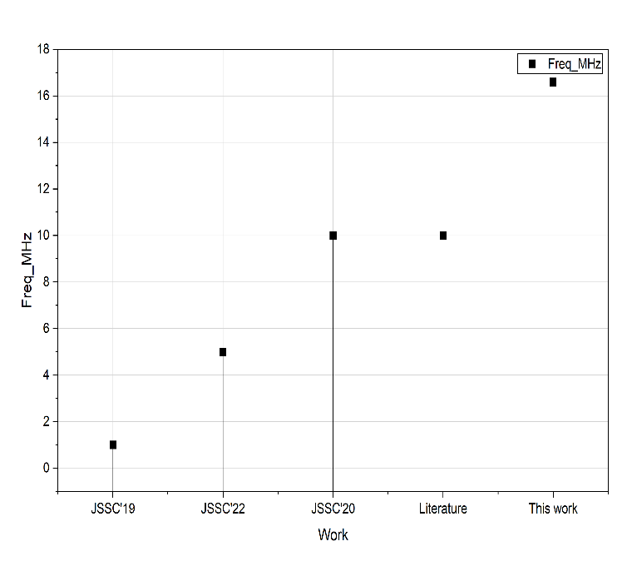
Oscillating Frequency Operating Voltage
Fig(k) Fig(l)
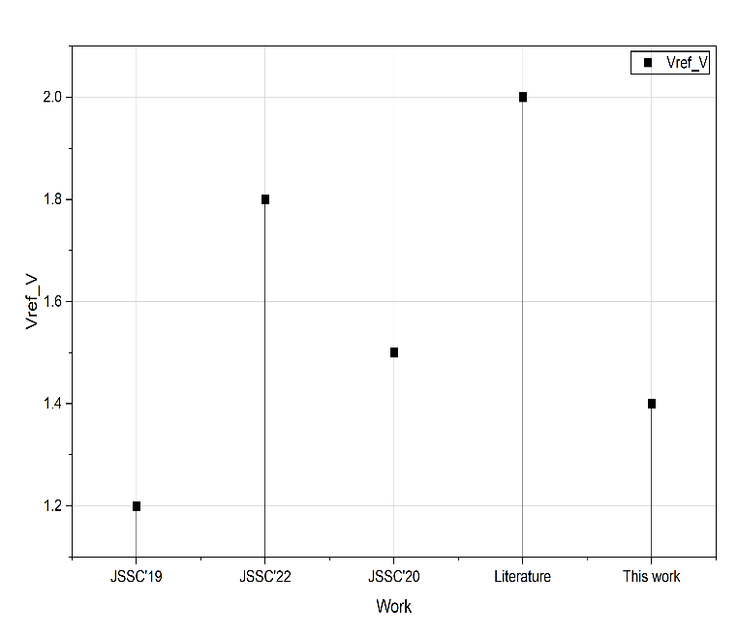
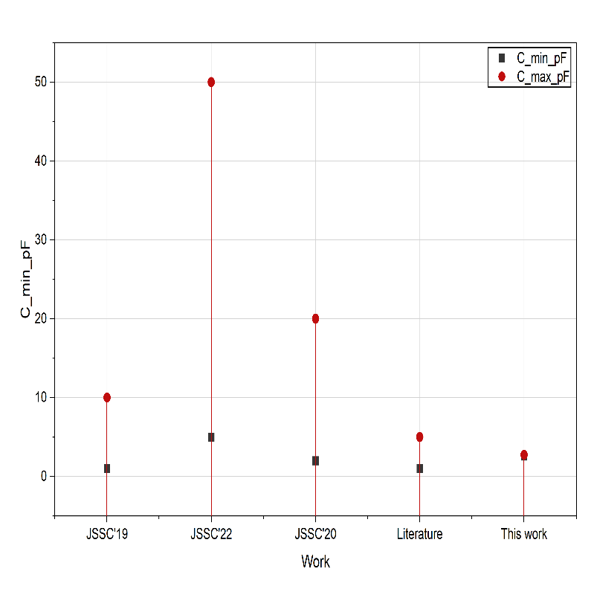
Fig(m)
Rest Capacitance
Conclusion:
This work presents a closed-loop readout architecture for capacitive sensors that sense gap variations, eliminating the need for dedicated sensor biasing circuitry. By embedding the sensing capacitor within a feedback loop, the proposed approach enables direct capacitance-to-frequency conversion with reduced analog overhead. The experimental results validate the feasibility of the concept and highlight its suitability for compact and low-power implementations. While the current prototype is limited by noise contributions from the front-end circuitry, further optimization—such as improved noise shaping, reduced power consumption, and a fully differential implementation—can significantly enhance the achievable resolution. For measurement purposes, a voltage-controlled capacitance realized using a varactor and external biasing network was employed to emulate the sensor input. This approach simplifies experimental validation in the absence of a physical sensor, but constrains the measured peak SNDR to approximately 50 dB over a bandwidth of 300 Hz to 6.8 kHz.
Acknowledgement:
Sincere gratitude is extended to Ms. Aathilakshmi S and Mr. Suresh for their invaluable guidance, technical insights, and continuous support throughout the development of the project “Capacitance to Digital Converter.” This work was carried out with the help of the faculty members of the Department of Electronics and Communication Engineering, whose assistance and encouragement contributed significantly to the successful completion of this project.

Reference:
[1] H.Xin , M. Andraud, P. Baltus, E.Cantatore, and P.Harpe, “A0.1-nW-1-μWenergy efficient all-dynamic versatile capacitance-to-digital converter,” IEEE J. Solid-State Circuits, vol. 54, no. 7, pp. 1841–1851, Jul. 2019.
[2]A Time-Encoded Capacitance-to-Digital Converter Based on a Switched-Capacitor Feedback Published in: IEEE Sensors Letters ( Volume: 7, Issue: 11, November 2023)
DOI: 10.1109/LSENS.2023.3320061
[3] An Introduction to Switched-capacitor Circuits
April 21, 2021 by Jake Hertz.
[4] M.Noviello, A.Quintero and S.Paton, “An unbiasedMEMScapacitance-controlled oscillator as a microphone for HMI applications,” in Proc. Austrochip Workshop Microelectronics, 2022, pp. 57–60.
[5] Power-Efficiency Evolution of Capacitive Sensor Interfaces Tan, Zhichao; Jiang, Hui; Zhang, Huajun; Tang, Xiyuan ; Xin, Haoming ; Nihtianov, Stoyan DOI 10.1109/JSEN.2020.3035109 Publication date 2021 Document Version Accepted author manuscript.
[6] “A 0.033-mm² 21.5-aF to 114.9-aF resolution continuous-time capacitance-to-digital converter,”
IEEE Journal of Solid-State Circuits, vol. 57, no. 10, pp. 3048–3057, Oct. 2022.
DOI: 10.1109/JSSC.2022.3187137
[7] A 0.1-nW–1- μ W Energy-Efficient All-Dynamic Versatile Capacitance-to-Digital Converter
DOI: 10.1109/JSSC.2019.2902754 Published in: IEEE Journal of Solid-State Circuits ( Volume: 54, Issue: 7, July 2019)
[8] “An 8-bit, 10-MHz BW, VCO-ADC Using SC Feedback for VCO Linearization.”
IEEE ICECS, 2013.
[9] The Analog Behaviour of Pseudo Digital Ring Oscillators Used in VCO ADCs, Published in: IEEE Transactions on Circuits and Systems I: Regular Papers ( Volume: 68, Issue: 7, July 2021) DOI: 10.1109/TCSI.2021.3073817
[10] “Hybrid Microfluidic/CMOS Capacitive Sensors for Lab-on-Chip Applications.”
MICROELECTRONICS (open-access)
[11] M. Noviello, “A time-encoded capacitance-to-digital converter based on a switched-capacitor feedback,” IEEE Sensors Letters, vol. 7, no. 11, 2023.
DOI: https://doi.org/10.1109/LSENS.2023.3320061
[12] “An Energy-Efficient Time-Domain Incremental Zoom Capacitance-to-Digital Converter” Published in: IEEE Journal of Solid-State Circuits Volume: 55
[13] An Unbiased MEMS Capacitance-Controlled Oscillator as a Microphone for HMI Applications Published in: 2022 Austrochip Workshop on Microelectronics (Austrochip)
DOI: 10.1109/Austrochip56145.2022.9940675
[14] E. Gutierrez et al., “A Pulse Frequency Modulation Interpretation of VCOs Enabling VCO-ADC Architectures With Extended Noise Shaping,” IEEE Trans. Circuits Syst. I, vol. 65, no. 2, pp. 444–457, Feb. 2018.
[15] J. Kim et al., “Analysis and design of voltage-controlled oscillator based analog-to-digital converter,” IEEE Trans. Circuits Syst. I, vol. 57, no. 1, pp. 18–30, Jan. 2009.
[16] “A Continuous-Time Sigma–Delta Capacitance-to-Digital Converter for High-Resolution Capacitive sensor”
IEEE Journal of Solid-State Circuits, vol. 57, no. 8, pp. 2361–2372, Aug. 2022.
[17] “A High-Resolution Incremental Zoom CDC for Capacitive Sensors,”
IEEE Journal of Solid-State Circuits, vol. 55, no. 11, pp. 2984–2995, Nov. 2020.
[18] A. A. Abidi,“Linearization of voltage-controlled oscillators using switched-capacitor feedback,” IEEE Journal of Solid-State Circuits, vol. 22, no. 3, pp. 494–496, Mar. 1987.
DOI: 10.1109/JSSC.1987.1052724
[19] T. Dong, “Capacitance variation induced by microfluidic two-phase flow,”
Sensors, vol. 15, no. 2, pp. 2694–2711, 2015. DOI: 10.3390/s150202694
[20] G. Nicollini and D. Devecchi, “MEMS capacitive microphones: acoustical, electrical, and hidden thermal-related issues,” IEEE Sensors Journal, vol. 18, no. 13, pp. 5386–5394, Jul. 2018.
DOI: 10.1109/JSEN.2018.2837071
[21] N. Narasimman, “A capacitance-to-digital converter using continuous-time ΣΔ modulation,” x IEEE Sensors Journal, vol. 21, no. 12, pp. 13373–13383, Dec. 2021.
[22] X. Tang et al.,“A high-resolution incremental zoom CDC for capacitive sensors,”
IEEE Journal of Solid-State Circuits, vol. 55, no. 11, pp. 2984–2995, Nov. 2020.
[23] Ring Oscillator / VCO-Based ADC Behavior, J. Borgmans, R. Riem, and P. Rombouts,
“The analog behavior of pseudo-digital ring oscillators used in VCO ADCs,”
IEEE Transactions on Circuits and Systems I, vol. 68, no. 7, pp. 2827–2840, Jul. 2021.

