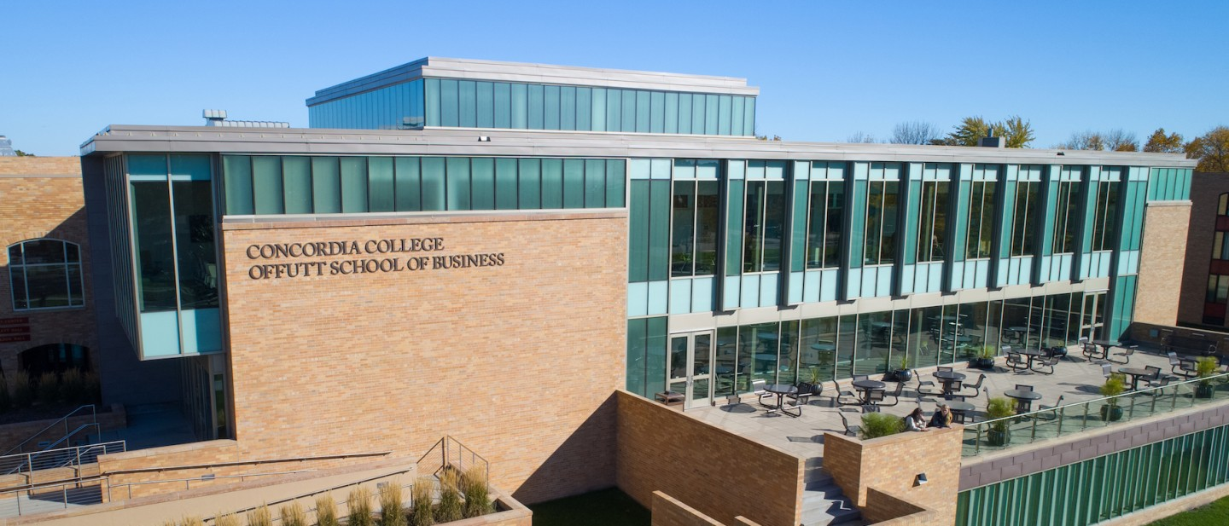

Project Plan

|  |
| --- |
| Final Project |

|  |  |
| --- | --- |
| Course | **CSC 470 – Applied Software Project** |
|  | |
| Project Name | RCCG Website |
|  |  |
| Team Members | **Iyanu Lamina** |

|  |
| --- |
| Executive Summary |
| **Your executive summary should resemble an elevator pitch: your motivation is to quickly persuade a decision maker to get involved in your project.** |
| * **What is the purpose of your project; what problem(s) does it address?** * **Why is your project important; why is it relevant?** * **Who could your project help; who is your audience or customer?** |
| **About this website**  This project involves the development of a website for clients, providing users with the ability to access information about the organization. The website will feature sections such as the About page (highlighting services), mission and vision, events, anthem, contact details, beliefs, photos, location, prayer line, and more.  Specifically, the website will include:   * **About Page:** Detailing the organization's services. * **Mission and Vision:** Outlining the purpose and goals. * **Contact Information:** Including contact details, location, and a dedicated prayer line. * **Services:** Information about days and times of operation (to be included in the footer). * **Photos:** Visual representation of events and activities. * **Anthem:** Featuring the organization's anthem. * **Admin Panel:** Providing administrators with the ability to create accounts and manage updates, edits, and deletions.   The footer will contain essential information such as contact details, location, prayer line, and services schedule. The admin panel will facilitate account creation and enable seamless updating, editing, and deletion of content."  **Purpose of the website**  It is a means of informing the community about the activities of the church and facilitating outreach efforts to invite people to attend services. The primary purpose of the website is to serve as a platform where members of the organization and other potential users can access information about the church. Additionally, it will offer updates from the organization to keep potential users informed. Moreover, the website is designed to provide new users with the necessary information and guidance on how to locate the church when needed.    **Problem it addresses**  We are aware that some individuals are unable to attend church physically, and we aim to share the word of God with them primarily through our online services, hosted on social media platforms such as Facebook. Our website serves as a portal to connect people with the church and provide regular updates. It offers valuable information for both the congregation and the public. Additionally, the website facilitates online donations. What sets it apart from other church websites is our plan to track attendance for each member. This allows us to foster a sense of community, enabling everyone to recognize each other and providing an avenue to reach out to those who couldn't attend church on a particular Sunday."  **Why is the project important; Why is it relevant:**  It facilitates keeping church members informed and up-to-date. By sharing information with the public, it contributes to the growth of our membership. Additionally, funds generated from/through the website will be used to support various church initiatives. It serves as a platform to communicate our vision to the public.  **Who could your project help; who is your audience, stakeholder, or customer:**  Our stakeholders include the congregation and potential members, as well as believers in Christ who are seeking a church but have not yet found one, and the general public. This project aims to benefit these groups of people. |

|  |  |  |
| --- | --- | --- |
| Timeline | | |
| **Milestone** | **Name** | **Due Date** |
| **Milestone 1** | **Planning and Proposal** | **Tuesday, February 6** |
| **Milestone 2** | **Design and Pitch** | **Thursday, February 29** |
| **Milestone 3** | **Major Implementation** | **Tuesday, April 9** |
| **Milestone 4** | **Final Presentation** | **Thursday, May 2** |

|  |  |  |  |  |
| --- | --- | --- | --- | --- |
| Milestone Summary | | | | |
| **Milestone 1** | **Planning and Proposal** | | | |
| **Item** | **Description** | **Estimated Hours** | **Actual Hours** | **Date Completed** |
| **Purpose** | **Determine your final project and present a high-level overview to the class** |  |  |  |
| **Summary** | Come up with a concept for your final project, determine stakeholders, create high-level UML diagrams for system architecture, requirements, and database structure (table names and relations, column names optional at this point). | 6.42 | 6.633 | 1/28/24 |
| **Planning Document/**  **Project Plan** | planning documentation is clean and well-written; includes a cover page, logical layout, and flow of information. Include project executive summary and milestone summary (include actual and estimated time with dates). | 0.50 | 0.50 | 1/28/24 |
| **Project Stakeholders** | Determine who the stakeholders are. | 0.17 | 0.083 | 1/28/24 |
| **Requirements** | Write a detailed system requirements and architecture, functional and non-functional requirements. | 0.75 | 0.5 | 1/28/24 |
| **System Architecture** | Skeleton architecture designed (primary page/screens w/relations/transition arrows) and included in planning document | 1.0 | 2 | 1/30/24 |
| **User Stories/Use-Case Scenarios** | High-level user stories and Use-case scenarios written in planning document. | 1.5 | 1.5 | 1/28/24 |
| **Data Structures** | Database structure outlined in planning document; tables defined, relational diagrams | 1.5 | 1.0 | 1/28/24 |
| **Project Timeline** | Custom project timeline w/milestones deadlines and deliverables included in planning document | 1.0 | 1.25 | 1/28/24 |
| **Milestone 2** | **Design and Pitch** | | | |
| **Item** | **Description** | **Estimated Hours** | **Actual Hours** | **Date Completed** |
| **Purpose** | **Create a general look-and-feel for your project, determine requirements details, present your project to the class** |  |  |  |
| **Summary** | Determine how you want your final project deliverables to look, including color scheme, graphics/images, and placement and layout of major components (e.g. buttons, input fields, data, instructions, etc.).  Detail the requirements (user stories, scenarios, etc.) and database structure. |  |  |  |
| **Task**  **(add more rows)** | [ TODO: create a list of tasks you need to complete for this milestone and estimate your time; use the rubric to help determine what you need to do, and add a new row to this table for each major task ] |  |  |  |
| **Milestone 3** | **Major Implementation** | | | |
| **Item** | **Description** | **Estimated Hours** | **Actual Hours** | **Date Completed** |
| **Purpose** | **Implement as much of your project’s major functionality as you can, present your project to the class** |  |  |  |
| **Summary** | At this stage of development, you should have your project’s major functionality implemented and usable, including database interactions. |  |  |  |
| **Task**  **(add more rows)** | [ TODO: create a list of tasks you need to complete for this milestone and estimate your time; use the rubric to help determine what you need to do, and add a new row to this table for each major task ] |  |  |  |
| **Milestone 4** | **Final Presentation** | | | |
| **Item** | **Description** | **Estimated Hours** | **Actual Hours** | **Date Completed** |
| **Purpose** | **Show your completed project to the class** |  |  |  |
| **Summary** | Share your hard work over the course of the semester with the class. |  |  |  |
| **Task**  **(add more rows)** | [ TODO: create a list of tasks you need to complete for this milestone and estimate your time; use the rubric to help determine what you need to do, and add a new row to this table for each major task ] |  |  |  |

|  |  |
| --- | --- |
| Resource List | |
| **Resource Name** | Damian Lampl |
| **URL** |  |
| **Date Accessed** |  |
| **Notes** |  |
| **Resource Name** | W3School |
| **URL** | [W3Schools Online Web Tutorials](https://www.w3schools.com/) |
| **Date Accessed** |  |
| **Notes** |  |
| **Resource Name** | Others |
| **URL** |  |
| **Date Accessed** |  |
| **Notes** | Still in process!!! |
| **Resource Name** |  |
| **URL** |  |
| **Date Accessed** |  |
| **Notes** |  |
| **Resource Name** |  |
| **URL** |  |
| **Date Accessed** |  |
| **Notes** |  |