Complete Modelling and Analysis of a Variable-Gain Analog Feedback Controller for a Second-Order System
Antenna azimuth position control: op-amp realisation, P / PD / error-dependent gain, simulated in LTspice, Simulink and Simscape
Control Systems Project Report
[Your name] | [Roll number] | [Course / Instructor]
October 2026

Contents
Abstract
1. Introduction and objectives
2. System description
3. Plant modelling and order reduction
4. Proportional (variable-gain) controller: theory
5. Op-amp circuit design
6. Verification of the proportional loop
7. Limits of P control and the PD controller
8. Error-dependent (nonlinear) variable gain
9. Simulink and Simscape implementation
10. Results and discussion
11. Conclusions, limitations and future work
Appendix A: LTspice netlist
Appendix B: MATLAB scripts
References

Abstract
This report designs, builds and analyses a variable-gain analog feedback controller for a real second-order servo, the antenna azimuth position-control system. The plant is first modelled mathematically, and the third-order model is reduced to a second-order one with a justified dominant-pole approximation. A proportional controller whose gain K is adjustable is then analysed in closed form: the damping ratio falls as ζ = 3.323/√K while the natural frequency rises as ω_{n} = 0.2573√K, so raising K speeds the loop up but makes it more oscillatory. The settling time is shown to stay fixed at about 4.68 s whatever K is chosen, which is the central limitation of proportional-only control.
To remove this limitation a derivative term acting on the output is added (K_{p} = 173, K_{d} = 10.99), which meets a 10 % overshoot and 2 s settling target. Finally an error-dependent (nonlinear) gain is introduced: high gain far from the target and low gain near it. The report shows that this scheduling works only when it is combined with derivative damping, that it makes the response depend on the step size, and that the loop remains globally stable. Every controller is realised with op-amp stages, with all resistor and capacitor values derived, and verified in MATLAB, Simulink and a Simscape op-amp circuit. The scheduled-PD controller reduces overshoot from about 10 % (fixed PD) to about 4 % at its design amplitude, at the cost of slightly slower settling.

1. Introduction and objectives
An antenna that must point at a target (a satellite, for example) is a position servo. A command angle is given, the controller compares it with the measured angle, and a motor drives the error to zero. How quickly and how smoothly it gets there depends mostly on the gain of the controller. A high gain moves the antenna quickly but may make it overshoot and oscillate; a low gain is smooth but slow. A variable-gain controller lets the designer, or the controller itself, choose this trade-off.
The objectives of the project are:
- Model a real second-order servo system (antenna azimuth) and derive closed-form performance equations as a function of the controller gain K.
- Design the variable-gain controller and realise it with operational amplifiers, deriving every component value.
- Verify the design by simulation (LTspice netlist, MATLAB, Simulink, Simscape).
- Identify the limits of proportional control and overcome them with derivative action.
- Extend the controller with an error-dependent nonlinear gain, analyse its stability and behaviour, and implement it in a Simscape op-amp circuit.
The work followed a theory-first order: equations and design decisions were made on paper, then turned into circuits, then checked by simulation. Table 1 summarises the stages.
Table 1: Project stages and tools
Stage | What was done | Tool
Modelling | Plant transfer function, order reduction | Hand analysis, Python/MATLAB check
P controller | Closed-loop theory, root locus, design for a spec | Hand analysis, numerical step responses
Circuit | Four op-amp stages with derived R and C values | Hand analysis, LTspice netlist
PD controller | Derivative on output, gains and circuit stage | Hand analysis, numerical check, Simscape
Nonlinear gain | Error-dependent gain, stability argument | Numerical simulation, Simulink
Hardware-level check | Nonlinear path inside the op-amp circuit | Simscape (hybrid model)

2. System description
The system is the antenna azimuth position-control system, a standard textbook example (Nise, Control Systems Engineering, configuration 1). Figure 1 shows the loop. A potentiometer on the command shaft converts the commanded angle θ_{i} into a voltage; a second potentiometer on the antenna shaft converts the actual angle θ_{o} into a voltage; their difference is the error voltage v_{e}. The preamplifier multiplies v_{e} by the variable gain K, a power amplifier supplies the motor armature, and the motor turns the antenna through a gear train.
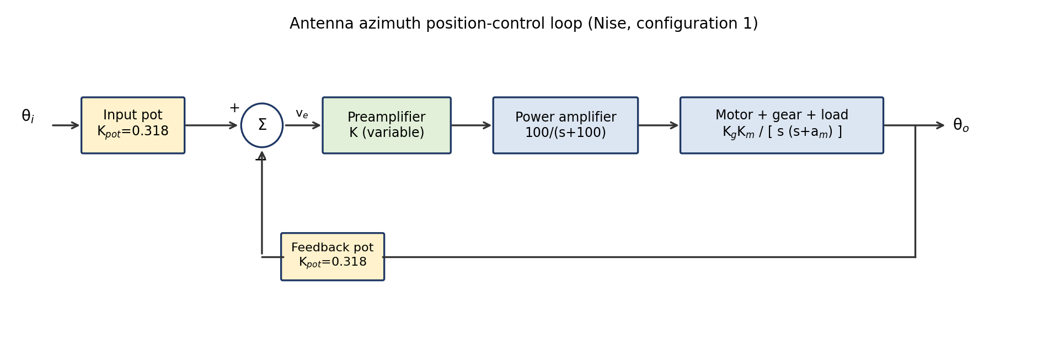
Figure 1: Block diagram of the antenna azimuth position-control loop. The preamplifier gain K is the variable-gain controller of this project.
Table 2: Parameters of the antenna azimuth system
Block | Symbol / transfer function | Value
Input and feedback potentiometers | K_{pot} | 0.318 V/rad
Preamplifier (the controller) | K | variable (design parameter)
Power amplifier | K₁/(s+a) | 100/(s+100)
Motor and load (armature to shaft) | K_{m}/[s(s+a_{m})] | 2.083/[s(s+1.71)]
Gear ratio | K_{g} | 0.1

In plain words: The loop is a position servo. The motor integrates its own speed to get position, which is why the plant contains a factor 1/s. The motor pole at 1.71 rad/s describes how quickly motor speed settles. The preamplifier gain K is the knob we will tune.

3. Plant modelling and order reduction

3.1 Full open-loop model
Multiplying the blocks of Figure 1 in the forward path gives the open-loop transfer function. The numerical coefficient is the product of the constants:
K_{pot} × K₁/a × K_{g} × K_{m} = 0.318 × 100 × 0.1 × 2.083 = 6.624
G(s) = K_{pot} · K · [100/(s+100)] · K_{g} · [2.083 / (s(s+1.71))] = 6.624 K / [ s (s+1.71)(s+100) ]
This is third order, with poles at s = 0, s = −1.71 and s = −100.

3.2 Reduction to second order
The power-amplifier pole is at −100 rad/s, so its time constant is 1/100 = 10 ms. The mechanical pole at −1.71 rad/s has a time constant of 1/1.71 = 0.585 s. The ratio is about 58, so the power amplifier settles long before the mechanical part has moved noticeably. This is the standard dominant-pole approximation: the fast block is replaced by its DC gain.
100/(s+100) at s ⇒ 0 = 100/100 = 1
The static gain happens to be exactly 1. Define the loop constant c and the plant constant c₂:
c = K_{pot} K_{g} K_{m} = 0.318 × 0.1 × 2.083 = 0.0662
c₂ = K_{g} K_{m} = 0.1 × 2.083 = 0.2083
G(s) ≈ c K / [ s (s + 1.71) ] = 0.0662 K / [ s (s + 1.71) ]
The approximation was checked by comparing the exact third-order closed loop with the second-order one (Figure 2). For K = 41.3 the overshoot is 15.0 % (reduced) against 15.6 % (full), and for K = 100 it is 33.1 % against 34.7 %. The settling times differ by less than 0.1 s. The reduced model is therefore accurate enough, and it is what the rest of the report uses.
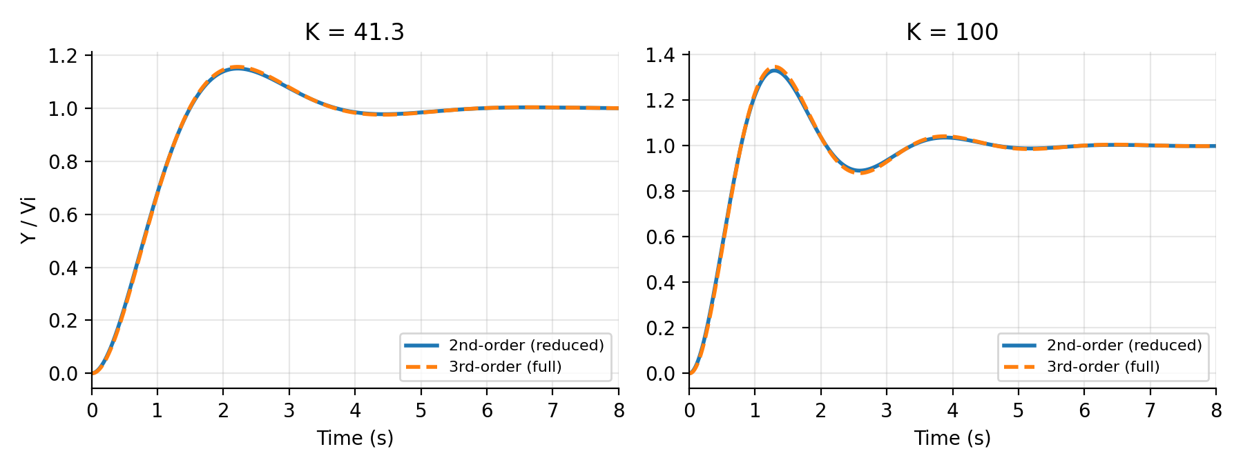
Figure 2: Third-order (full) and second-order (reduced) closed-loop step responses for K = 41.3 and K = 100. The curves nearly coincide.
In plain words: Dropping the fast power-amplifier pole changes the answer by only about 1 % in overshoot, and it turns a third-order problem into a second-order one that can be solved by hand.

4. Proportional (variable-gain) controller: theory

4.1 Closed-loop transfer function
With unity feedback (the two potentiometer gains are already folded into c), the closed loop is T(s) = G/(1+G):
T(s) = c K / [ s(s+1.71) + c K ] = 0.0662 K / ( s² + 1.71 s + 0.0662 K )
The characteristic equation is s² + 1.71 s + 0.0662 K = 0.

4.2 Natural frequency and damping ratio as functions of K
Comparing with the standard form s² + 2ζω_{n}s + ω_{n}² = 0:
ω_{n}² = 0.0662 K ⇒ ω_{n} = √(0.0662 K) = 0.2573 √K
2ζω_{n} = 1.71 ⇒ ζ = 1.71 / (2 × 0.2573 √K) = 3.323 / √K
In plain words: Raising K raises ω_{n} (a faster loop) but lowers ζ (a more oscillatory loop). One knob moves both in opposite directions.

4.3 Critical-damping gain
ζ = 1 ⇒ 3.323/√K = 1 ⇒ K = 3.323² = 11.04
For K < 11.04 the loop is over-damped (no overshoot, sluggish). For K > 11.04 it is under-damped (faster, with overshoot).

4.4 Time-domain performance
For an under-damped second-order system, with ω_{d} = ω_{n}√(1−ζ²):
Percent overshoot %OS = 100 · exp( −ζπ / √(1−ζ²) )
Peak time T_{p} = π / ( ω_{n} √(1−ζ²) )
Rise time (10 to 90 %) T_{r} ≈ 1.8 / ω_{n}
Settling time (2 %) T_{s} ≈ 4 / (ζ ω_{n})
A key observation follows from the second line of Section 4.2: the product ζω_{n} equals 1.71/2 = 0.855 for every K. Therefore:
T_{s} = 4 / 0.855 = 4.68 s (independent of K)
Table 3: Proportional control: predicted performance for several gains (OS from the formula, and from a numerical step response as a check)
K | ω_{n} (rad/s) | ζ | %OS formula | %OS simulated | T_{p} (s) | T_{s} (s) | T_{r} (s)
11.04 | 0.855 | 1.000 | 0.0 | 0.0 | - | 4.68 | 2.11
25 | 1.286 | 0.665 | 6.1 | 6.1 | 3.27 | 4.68 | 1.40
41.3 | 1.653 | 0.517 | 15.0 | 15.0 | 2.22 | 4.68 | 1.09
50 | 1.819 | 0.470 | 18.8 | 18.8 | 1.96 | 4.68 | 0.99
100 | 2.573 | 0.332 | 33.1 | 33.1 | 1.29 | 4.68 | 0.70
200 | 3.639 | 0.235 | 46.8 | 46.8 | 0.89 | 4.68 | 0.49

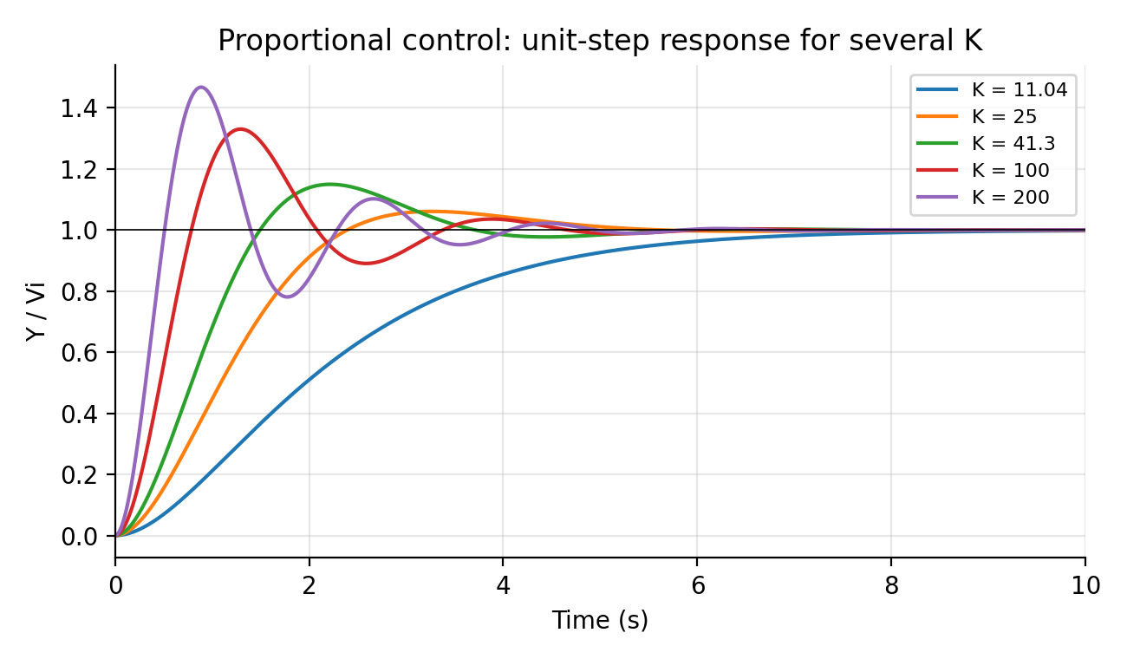
Figure 3: Unit-step response of the proportional loop for several values of K. Overshoot grows with K, while the envelope decay (settling time) does not change.

4.5 Steady-state error
The loop has one pole at the origin (type 1), so the error to a step input is zero. For a ramp input of unit slope the velocity constant is:
K_{v} = lim_{s⇒0} s G(s) = 0.0662 K / 1.71 = 0.0387 K
e_{ss,ramp} = 1 / K_{v} = 25.8 / K

4.6 Stability (Routh-Hurwitz)
Second-order model: the characteristic polynomial s² + 1.71 s + 0.0662 K has all coefficients positive for K > 0, so the loop is stable for every positive gain.
Full third-order model, characteristic equation 1 + G(s) = 0:
s(s+1.71)(s+100) + 6.624 K = s³ + 101.71 s² + 171 s + 6.624 K = 0
Routh first column: 1, 101.71, (101.71 × 171 − 6.624 K)/101.71, 6.624 K
Stability requires 101.71 × 171 > 6.624 K ⇒ K < 17392 / 6.624 = 2626
The second-order approximation therefore hides an upper stability limit of about K = 2626, which is far above the gains used in this project (K ≤ 300).

4.7 Root locus
The closed-loop poles are the roots of s² + 1.71 s + 0.0662 K = 0:
s = [ −1.71 ± √( 1.71² − 4 × 0.0662 K ) ] / 2
- K = 0: poles at the open-loop poles, s = 0 and s = −1.71.
- 0 < K < 11.04: both poles are real and move towards each other along the real axis.
- K = 11.04: they meet at s = −0.855 (breakaway point, ζ = 1).
- K > 11.04: they split into a complex pair with fixed real part −0.855 and a growing imaginary part, √(0.0662K − 0.731).
Because there are two poles and no zeros, the asymptotes are at ±90° through the centroid (0 + (−1.71))/2 = −0.855, and the locus coincides with them after the breakaway point. A fixed real part is exactly the reason the settling time cannot be changed by K.
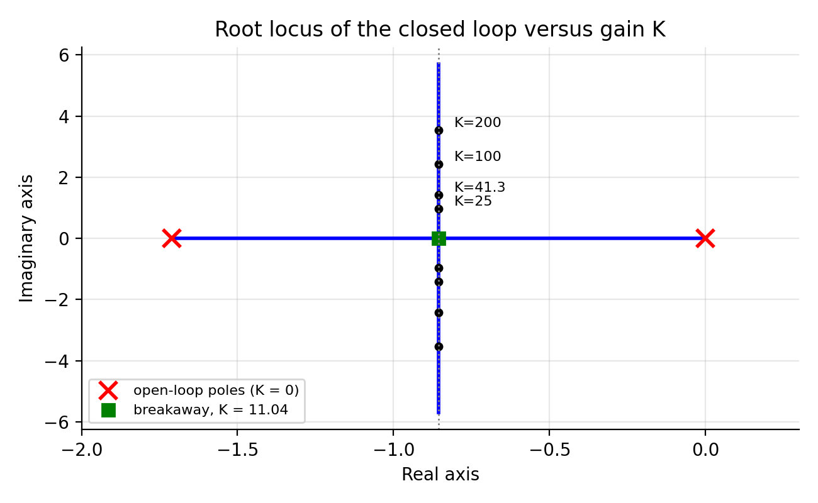
Figure 4: Root locus of the closed loop as K increases from 0 to 500. The poles leave the real axis at K = 11.04 and then move vertically at a fixed real part of −0.855.

4.8 Worked design: choosing K for a 15 % overshoot
ln(0.15) = −1.897 ⇒ ζπ / √(1−ζ²) = 1.897
ζ / √(1−ζ²) = 1.897 / π = 0.6039
ζ² = 0.6039² / (1 + 0.6039²) = 0.3647 / 1.3647 = 0.2672 ⇒ ζ = 0.517
√K = 3.323 / 0.517 = 6.427 ⇒ K = 41.3
ω_{n} = 0.2573 × 6.427 = 1.654 rad/s
T_{p} = π / (1.654 × √(1−0.517²)) = π / (1.654 × 0.856) = 2.22 s
T_{r} ≈ 1.8 / 1.654 = 1.09 s, T_{s} = 4.68 s
The design gain is K = 41.3. The settling time of 4.68 s is the same as for any other K.

5. Op-amp circuit design
Every block is built from op-amps used with negative feedback. Two rules of the ideal op-amp are used throughout: (1) no current flows into the input pins; (2) feedback forces the two input voltages to be equal (a "virtual short"). The loop uses four stages. Because the loop passes through three inverting stages, the error amplifier is wired so that the net feedback is negative; this is checked in Section 5.5.

5.1 Stage 1: error (difference) amplifier
It must output v_{e} = 0.318 (Y − V_{i}). A difference amplifier with R₁ = R₃ = 100 kΩ and R_{f1} = R₄ is used, with V_{i} on the inverting side and Y on the non-inverting side.
V₊ = Y · R₄/(R₃+R₄)
KCL at the inverting node: (V_{i} − V₋)/R₁ = (V₋ − V_{out})/R_{f1}
with V₋ = V₊ and R₄/R₃ = R_{f1}/R₁: V_{out} = (R_{f1}/R₁) (Y − V_{i})
R_{f1}/R₁ = 0.318 ⇒ R_{f1} = R₄ = 0.318 × 100 kΩ = 31.8 kΩ
The two resistor pairs must match, otherwise the output is a weighted rather than a pure difference and the loop settles at the wrong final value.

5.2 Stage 2: variable-gain controller
An inverting amplifier, V_{c} = −(R_{f}/R_{in}) v_{e} = −K v_{e}. The input resistor is fixed at 5 kΩ and the feedback resistor R_{f} is a potentiometer (the gain knob). Varying R_{f} changes only this stage; varying R_{in} would also change the load seen by Stage 1.
K = R_{f} / 5 kΩ ⇒ R_{f} = 5 kΩ × K
Table 4: Feedback resistor needed for each gain
Target K | Purpose | R_{f}
11.04 | critical damping | 55.2 kΩ
25 | well damped | 125 kΩ
41.3 | 15 % overshoot design | 206.5 kΩ
100 | fast, oscillatory | 500 kΩ
200 | very oscillatory | 1 MΩ

5.3 Stage 3: leaky integrator (motor pole)
This stage realises c₂/(s + 1.71). A capacitor C_{f} is placed in parallel with R_{f3}. The feedback impedance is:
Z_{f} = R_{f3} ‖ 1/(sC_{f}) = R_{f3} / (1 + s R_{f3} C_{f})
V_{out}/V_{in} = −Z_{f}/R_{in3} = −[ 1/(R_{in3}C_{f}) ] / [ s + 1/(R_{f3}C_{f}) ]
Matching with c₂/(s + a_{m}) and choosing C_{f} = 1 µF:
1/(R_{f3}C_{f}) = 1.71 ⇒ R_{f3} = 1/(1.71 × 10⁻⁶) = 585 kΩ (use 590 kΩ)
1/(R_{in3}C_{f}) = 0.2083 ⇒ R_{in3} = 1/(0.2083 × 10⁻⁶) = 4.80 MΩ (use 4.87 MΩ)
Because R_{in3} is very large, a JFET-input op-amp (such as the TL082) is preferred in a real build, since bipolar input bias currents would create a visible DC offset.

5.4 Stage 4: pure integrator (position)
Removing the parallel resistor leaves only the capacitor in the feedback: Z_{f} = 1/(sC₂), so Y = −V_{in}/(sR₂C₂). With R₂ = 1 MΩ and C₂ = 1 µF the product R₂C₂ = 1 s and the stage is a unity integrator, 1/s. Its output is the antenna position Y, which is fed back to Stage 1. A long run can drift because a constant offset is integrated without limit; a large resistor (about 10 MΩ) across C₂ removes this at the cost of a very slow extra pole.

5.5 Sign check and loop verification
The four stage equations, in the circuit sign convention, are:
Stage 1: v_{e} = 0.318 (Y − V_{i})
Stage 2: V_{c} = −K v_{e}
Stage 3: V_{m} = −[ 0.2083 / (s+1.71) ] V_{c}
Stage 4: Y = −(1/s) V_{m}
Substituting step by step:
Y = −(1/s)(−[0.2083/(s+1.71)])(−K)(0.318)(Y − V_{i})
Y = −[ 0.0662 K / ( s(s+1.71) ) ] (Y − V_{i})
Y [ 1 + 0.0662 K / (s(s+1.71)) ] = [ 0.0662 K / (s(s+1.71)) ] V_{i}
Y / V_{i} = 0.0662 K / ( s² + 1.71 s + 0.0662 K )
This is exactly the closed-loop transfer function of Section 4.1, so the signs are correct: three inverting stages together with Y on the non-inverting input of Stage 1 give negative feedback. Had Y been connected to the inverting input, the loop would have positive feedback and the output would run to the supply rail.
Table 5: Final component values of the proportional loop
Stage | Function | Components
1 | Difference amplifier, gain 0.318 | R₁ = R₃ = 100 kΩ; R_{f1} = R₄ = 31.8 kΩ
2 | Variable gain K | R_{in} = 5 kΩ; R_{f} = 5 kΩ × K (potentiometer)
3 | Leaky integrator (motor) | R_{in3} = 4.87 MΩ; R_{f3} = 590 kΩ; C_{f} = 1 µF
4 | Integrator (position) | R₂ = 1 MΩ; C₂ = 1 µF

To complete: Insert a screenshot of your Simscape (or LTspice) schematic of the four-stage loop here, and cite it in this section.

6. Verification of the proportional loop
The closed-loop step responses of the second-order model were computed numerically for the gains of Table 3 and compared with the formulas. The simulated overshoots (6.1 %, 15.0 %, 18.8 %, 33.1 %, 46.8 % for K = 25, 41.3, 50, 100, 200) equal the formula values to the displayed precision, and K = 11.04 gives no overshoot, as expected at critical damping. The same loop was written as an LTspice netlist with ideal op-amps (Appendix A) using the component values of Table 5; its output V(y) should reproduce the curve for K = 41.3 in Figure 3, with a peak of about 1.15 V.
In the Simscape circuit the proportional loop was compared with the PD loop for a 10 V step (Section 10.4); the proportional curve shows about 6 % overshoot, a peak time near 3.3 s and a final value equal to the input, consistent with the K = 25 row of Table 3.
To complete: If you ran the LTspice netlist, insert your V(y) screenshot here and quote the overshoot read from the .meas output.

7. Limits of P control and the PD controller

7.1 The limitation
Section 4.4 showed that ζω_{n} = a_{m}/2 is fixed, so the real part of the poles, and with it the settling time, cannot be changed by K. To move the poles horizontally we need a controller term that grows with s, that is, with the rate of change. This is derivative action.

7.2 PD acting on the error
Let the controller be C(s) = K_{p} + K_{d}s acting on the error. Repeating the closed-loop derivation:
Y / V_{i} = c (K_{p} + K_{d}s) / [ s² + (a_{m} + cK_{d}) s + cK_{p} ]
ω_{n} = √(c K_{p}), 2ζω_{n} = a_{m} + c K_{d}
Now K_{p} sets the speed ω_{n} and K_{d} independently sets the damping. The settling time becomes T_{s} = 8/(a_{m} + cK_{d}), which depends on K_{d}.

Design example: 10 % overshoot and 2 s settling
ln(0.10) = −2.3026, ζ/√(1−ζ²) = 2.3026/π = 0.7330, ζ² = 0.5373/1.5373 = 0.3495 ⇒ ζ = 0.591
T_{s} = 4/(ζω_{n}) = 2 ⇒ ζω_{n} = 2 ⇒ ω_{n} = 2/0.591 = 3.383 rad/s
K_{p} = ω_{n}² / c = 11.44 / 0.0662 ≈ 173
K_{d} = (2ζω_{n} − a_{m}) / c = (4 − 1.71) / 0.0662 = 34.6
The closed-loop numerator c(K_{p} + K_{d} s) contains a zero at s = −K_{p}/K_{d}, which the standard formulas ignore. Simulating the exact transfer function gives an overshoot of 13.9 % and a settling time of 1.53 s, not 10 % and 2 s. A zero near the dominant poles increases overshoot, so the design must be corrected (for example by a higher damping target) if PD is applied on the error.

7.3 Derivative kick and derivative on the output
When the derivative acts on the error, a sudden change in the reference is differentiated too. For an ideal step this is a very large spike (a "derivative kick") at t = 0. The standard cure is to differentiate only the measured output Y, so that the reference is never differentiated. The control signal becomes:
u = K_{p} · e − K_{d} · s · Y
Repeating the derivation (the K_{d} term enters the plant directly, without passing through the potentiometer gain):
Y / V_{i} = c K_{p} / [ s² + (a_{m} + c₂K_{d}) s + c K_{p} ]
The numerator is now a constant, so there is no zero and the standard formulas apply exactly. The same targets give:
K_{p} = 173 (unchanged)
K_{d} = (2ζω_{n} − a_{m}) / c₂ = (4 − 1.71) / 0.2083 = 10.99
A numerical check gives 10.0 % overshoot and 1.75 s settling, essentially exactly the target, with no iteration needed. K_{d} is about 3.1 times smaller than in the error-derivative design because it is no longer scaled by K_{pot} = 0.318.
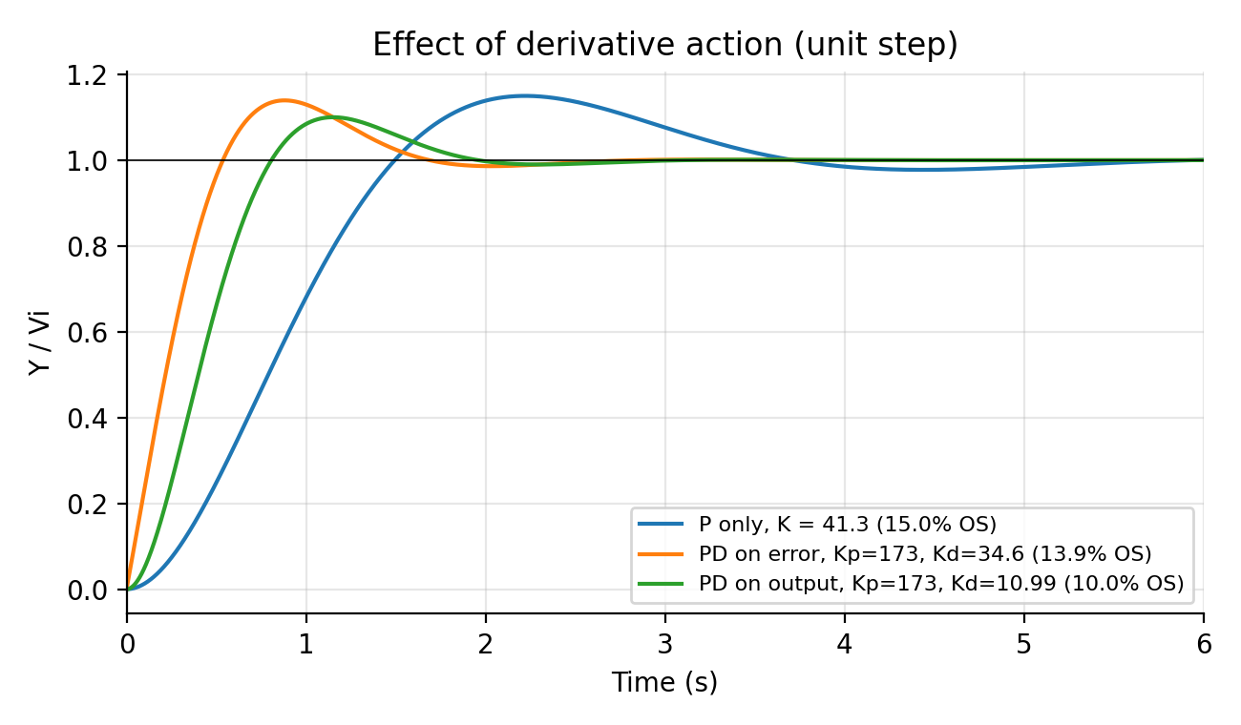
Figure 5: Proportional (K = 41.3), PD on the error (with zero) and PD on the output (no zero). Derivative action on the output meets the 10 % / 2 s target.
Table 6: Comparison of P, PD on the error and PD on the output (unit step)
Controller | Gains | Overshoot | Settling time (2 %)
P only | K = 41.3 | 15.0 % | 4.75 s
PD on the error | K_{p} = 173, K_{d} = 34.6 | 13.9 % | 1.53 s
PD on the output | K_{p} = 173, K_{d} = 10.99 | 10.0 % | 1.75 s

7.4 Circuit realisation of the derivative on the output
A plain differentiator has a gain that grows without limit with frequency, so it amplifies noise and can become unstable. A practical differentiator adds a small resistor R_{s} in series with the capacitor:
V_{d}(s) = −[ R_{d}C_{d} s / (1 + R_{s}C_{d} s) ] Y(s)
Below the corner 1/(R_{s}C_{d}) this is a true differentiator −R_{d}C_{d}s, and above it the gain levels off at R_{d}/R_{s}. The product R_{d}C_{d} must equal K_{d}:
C_{d} = 1 µF, R_{d} = K_{d}/C_{d} = 10.99 / 10⁻⁶ = 11 MΩ
Corner at 100 rad/s: R_{s} = 1/(100 × 1 µF) = 10 kΩ
The differentiator input is taken from the output node Y. Its output V_{d} is fed into the inverting-input node of Stage 3 through a resistor R_{in3b} = 4.87 MΩ, equal to R_{in3}. Stage 3 acts as a summing junction, so the proportional and derivative signals receive equal weight and then pass through Stages 3 and 4 together, which is the motor model. Stage 2 is changed to give K_{p} = 173, that is R_{f} = 173 × 5 kΩ = 865 kΩ.

7.5 Why a PI term was not adopted
A PI term (K_{i}) was also analysed. Because the plant already contains an integrator, a step command already gives zero steady-state error. Adding K_{i} turns the loop into a third-order, type-2 system. Its benefits are zero error for ramp inputs (for the PD design the ramp error is a·0.349 for a ramp of slope a) and removal of the constant-disturbance offset of 1/(K_{pot}K_{p}) = 0.018 per unit of disturbance. Its costs are a larger overshoot (about 12 % for K_{i} = 10, above 20 % for K_{i} = 50) and a slow tail. For a project centred on step response and gain variation PI is not needed, so it is documented here only as an optional extension.

8. Error-dependent (nonlinear) variable gain

8.1 Concept
Instead of a fixed K, the gain depends on the size of the error: large when the antenna is far from the target (to move fast) and smaller as it gets close (for a gentle arrival). With v_{e} the error voltage, the control action is u = K(|v_{e}|)·e with:
K(|v_{e}|) = K_{near} + (K_{far} − K_{near}) · min( |v_{e}| / V₀, 1 )
Here V₀ is the "knee": the error at which the gain reaches its far value. A design with K_{near} = 60, K_{far} = 300 and V₀ = 0.318 V is shown in Figure 6; 0.318 V is the initial error voltage of a 1 V step.
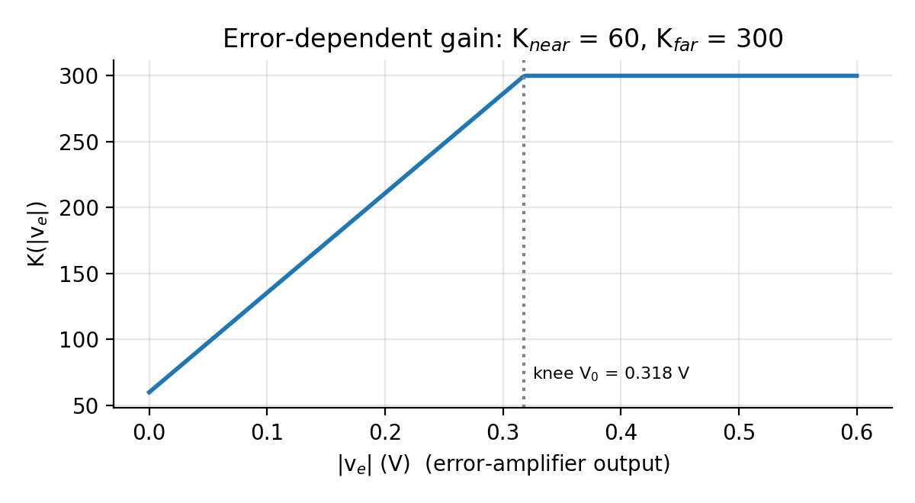
Figure 6: Error-dependent gain K(|v_{e}|) used in the design.

8.2 Scheduling alone does not help
The loop was simulated with the nonlinear gain for a 1 V step (Table 7). A scheduled proportional controller (K from 11 to 150) still overshoots by 38.5 %, almost as much as a fixed K = 150. The reason follows from Section 4.2: with proportional action only, the damping is fixed by the motor pole. Lowering the gain near the target weakens the restoring force but does not brake the motion, so the antenna coasts past the target with the speed it has gained.

8.3 Scheduling combined with derivative damping
With derivative action on the output providing damping at all error levels, the gain can be high at large error without hurting the arrival. Several candidates were simulated (1 V step):
Table 7: Fixed and scheduled controllers, 1 V step (numerical simulation)
Controller | Overshoot | Settling (2 %) | Time to 90 %
Fixed K = 41.3 | 15.0 % | 4.75 s | 1.31 s
Fixed K = 150 | 41.3 % | 4.42 s | 0.56 s
Scheduled P only, K 11 to 150 | 38.5 % | 5.48 s | 0.63 s
Fixed PD, K_{p} = 173, K_{d} = 10.99 | 10.0 % | 1.75 s | 0.69 s
Scheduled PD, K_{p} 100 to 300, K_{d} = 14 | 8.4 % | 1.97 s | 0.57 s
Scheduled PD, K_{p} 60 to 300, K_{d} = 15 | 4.4 % | 2.22 s | 0.63 s

The chosen design is K_{near} = 60, K_{far} = 300, K_{d} = 15, V₀ = 0.318 V. Compared with the fixed PD design it has less than half the overshoot (4.4 % against 10 %) and a faster rise, at the cost of a longer settling time (2.22 s against 1.75 s) because the low gain near the target makes the final approach slower.
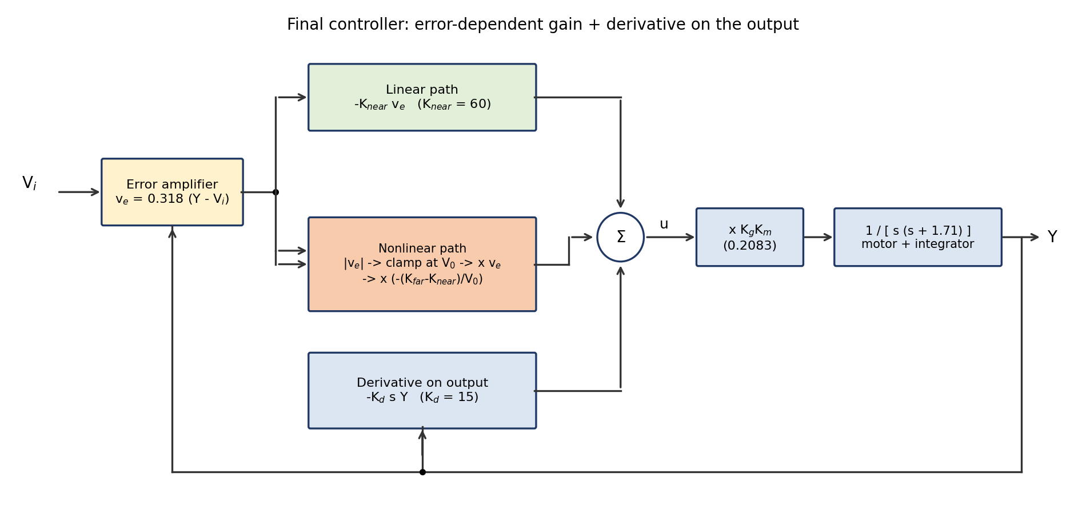
Figure 7: Structure of the final controller: error-dependent gain plus derivative on the output.

8.4 Stability
Let x = Y − V_{i} be the deviation from the target. For a constant reference the dynamics are:
ẍ + a₂ ẋ + h(x) = 0, a₂ = a_{m} + c₂K_{d} > 0, h(x) = c₂K_{pot} K(K_{pot}|x|) · x
The function h is odd, and x·h(x) > 0 for x ≠ 0 because K ≥ K_{near} > 0. Take the energy-like function:
V(x, ẋ) = ½ ẋ² + ∫₀^{x} h(s) ds ≥ 0
dV/dt = ẋ ( ẍ + h(x) ) = −a₂ ẋ² ≤ 0
V is positive definite and radially unbounded (h grows at least as c₂K_{pot}K_{near}·x), and dV/dt can vanish only at ẋ = 0, where the dynamics force x = 0 (LaSalle). The origin is therefore globally asymptotically stable: the nonlinear gain cannot destabilise the loop.

8.5 Dependence on the step size
The linear controllers give the same normalised response for every step size. The scheduled controller does not, because the step size decides which part of the gain curve is used. For a large step the error stays above the knee for most of the move, so the loop behaves like a fixed K = 300 with K_{d} = 15:
ζ = (a_{m} + c₂K_{d}) / (2√(c K)) = (1.71 + 0.2083 × 15) / (2 √(0.0662 × 300)) = 4.835 / (2 × 4.457) = 0.542
%OS = 100 exp(−0.542π/√(1−0.542²)) = 13.2 %
This is exactly the overshoot seen for large steps (about 13 %). For small steps the error is below the knee throughout and the gain stays low, so the response is over-damped and slow. Because the system is homogeneous when V₀ scales with the step, the knee must be chosen from the command amplitude expected in use: for a 10 V step, V₀ = 3.18 V reproduces the 1 V behaviour (4.4 % overshoot, 2.22 s settling by numerical simulation).

8.6 Realising the nonlinear gain with op-amps
The linear part, −K_{near}v_{e}, is the existing Stage 2 with R_{f} = 60 × 5 kΩ = 300 kΩ. The extra part is a second signal injected into the summing node of Stage 3:
v_{extra} = −[ (K_{far} − K_{near}) / V₀ ] · v_{e} · min( |v_{e}|, V₀ )
Derivation of the sign and size: the control action needed is u = K(|e|)e. Stage 2 supplies −K_{near}v_{e}, in the circuit sign convention in which v_{e} = −e. The extra gain term is (K_{far} − K_{near}) · min(|v_{e}|/V₀, 1) · e = −(K_{far} − K_{near})/V₀ · v_{e} · min(|v_{e}|, V₀), which is the expression above. Its coefficient is 240/0.318 = 754.7 for V₀ = 0.318 V.
A hardware chain for this signal is: a pre-amplifier of gain 10 on v_{e}; a precision full-wave rectifier to obtain |v_{e}|; a clamp at 3.18 V; an analog multiplier (for example AD633, output XY/10); and an inverting gain stage of 75.5. The output is fed into the Stage 3 summing node through 4.87 MΩ, as for the derivative path. In the simulations of this project the rectifier, clamp and multiplier were replaced by behavioural blocks (Section 9.2).

9. Simulink and Simscape implementation

9.1 Signal-level Simulink model
A Simulink model, built by script, implements the scheduled PD controller at signal level. The error is v_{e} = 0.318(V_{i} − Y). The gain K(|v_{e}|) is built from an Abs block, a Saturation block (0 to V₀), a Gain of (K_{far} − K_{near})/V₀, a Constant K_{near} and a Sum. A Product block multiplies this gain by v_{e}. A derivative block s/(0.01s + 1) acting on Y, scaled by K_{d}, is subtracted to form u. Then u passes through the gain 0.2083 and the transfer function 1/[s(s + 1.71)] to give Y, which is fed back. The 0.01 s filter on the derivative corresponds to the R_{s} limiter of the circuit. The model script is in Appendix B.
To complete: Insert a screenshot of the Simulink block diagram (model nl_gain_antenna) here.

9.2 Simscape op-amp circuit (hybrid model)
The nonlinear path was added to the existing Simscape op-amp circuit as a hybrid: the loop is circuit-level and the nonlinear function is behavioural. Changes and additions:
- Stage 2 feedback resistor changed to 300 kΩ (K_{near} = 60) and the differentiator feedback resistor to 15 MΩ (K_{d} = 15).
- A Voltage Sensor on the Stage 1 output (v_{e}), a PS-Simulink converter, then Abs, Saturation (0 to V₀), Product with v_{e}, and a Gain of −(K_{far} − K_{near})/V₀.
- A Simulink-PS converter and a Controlled Voltage Source, connected through a 4.87 MΩ resistor to the Stage 3 summing node.
The recommended test order is first with the nonlinear gain set to zero, which must reproduce a fixed PD loop (K_{p} = 60, K_{d} = 15), and then with the path active.
To complete: Insert a screenshot of the Simscape circuit (Azimuth_system) and a close-up of the nonlinear path here.

10. Results and discussion

10.1 Scheduled PD in Simulink, 1 V step
Figure 8 shows the response of the Simulink model for a 1 V step. The overshoot is 3.7 % and the settling time is 2.09 s. These agree with the numerical prediction (4.4 %, 2.22 s); the small difference comes from the 0.01 s derivative filter, which adds a little damping. The output settles at exactly 1 V, confirming zero steady-state error.
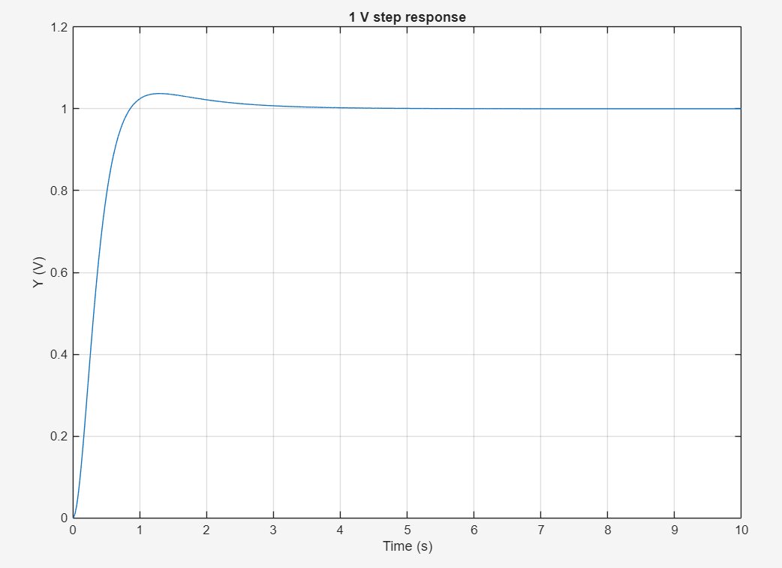
Figure 8: Simulink: 1 V step response of the scheduled PD controller (K_{near} = 60, K_{far} = 300, K_{d} = 15). Overshoot 3.7 %, settling time 2.09 s.
Figure 9 shows the effective gain during this step. It starts at the far value of about 300 and falls towards 60 as the error shrinks, with a small kink near 0.85 s where the response crosses the target and the error changes sign, and a final settling at 60.
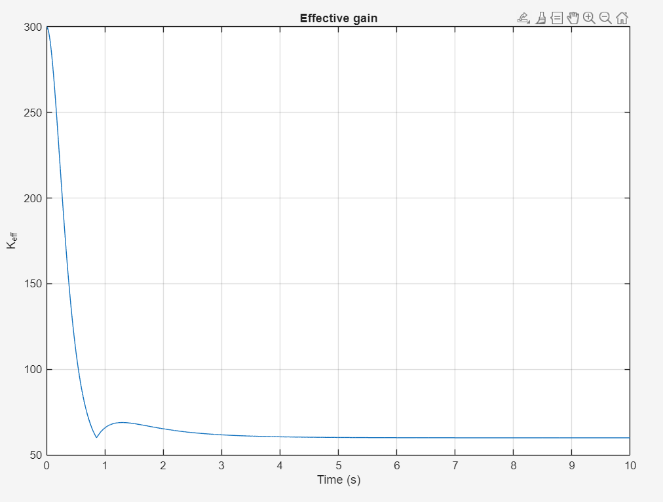
Figure 9: Simulink: effective gain K_{eff} during the 1 V step. The gain starts near 300 and settles at 60.

10.2 Comparison with fixed PD and with scheduling without derivative
Figure 10 compares three controllers for a 1 V step.
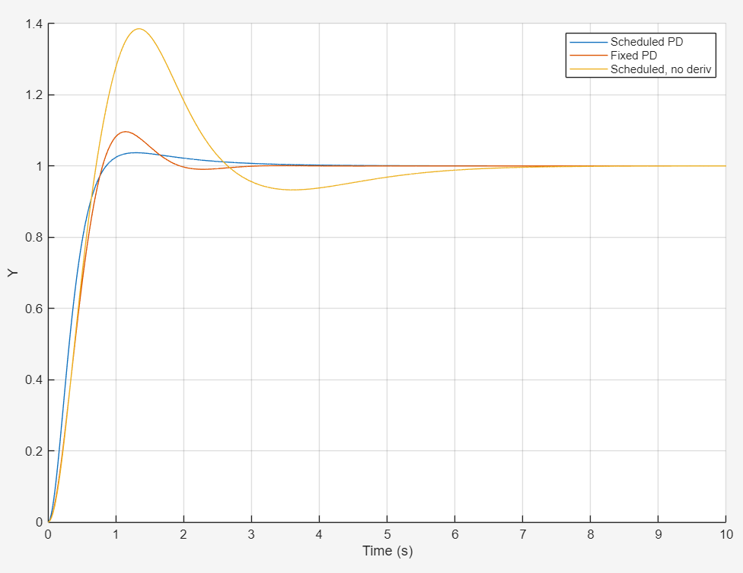
Figure 10: Simulink: scheduled PD, fixed PD and scheduled gain without derivative action (1 V step).
Table 8: Measured results from Figure 10 (Simulink)
Controller | Overshoot | Settling (2 %)
Scheduled PD (K_{p} 60 to 300, K_{d} = 15) | 3.7 % | 2.09 s
Fixed PD (K_{p} = 173, K_{d} = 10.99) | 9.6 % | 1.73 s
Scheduled without derivative (K 11 to 150) | 38.5 % | 5.48 s

The third row agrees with the independent numerical simulation of Section 8.2 (38.5 %, 5.48 s) to the displayed precision, which validates the Simulink model. The scheduled PD controller cuts the overshoot of fixed PD by about 60 % at the cost of roughly 0.36 s of settling time. Scheduling without derivative action is clearly the worst design.

10.3 Dependence on the step size
Figure 11 shows the normalised response of the Simulink model for step sizes of 0.1, 0.3, 1, 3 and 10 V. The curves fan out instead of coinciding, proving the controller is nonlinear. Figure 12 shows the same sweep from an independent MATLAB ode45 script; the two agree closely.
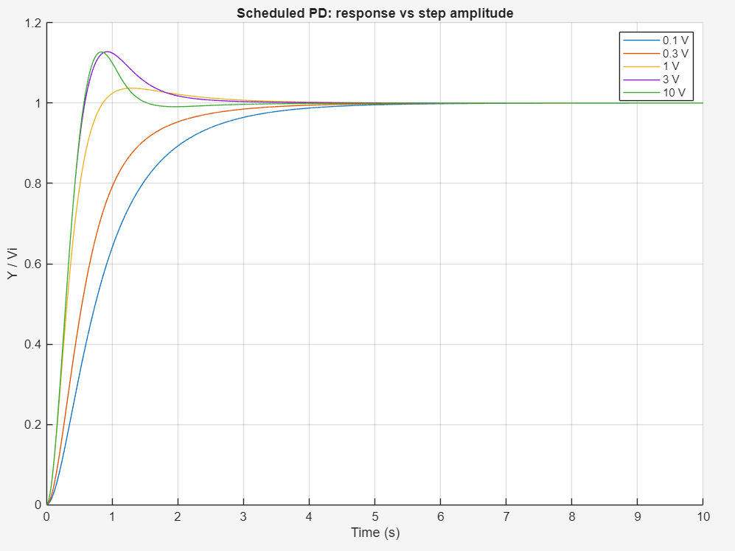
Figure 11: Simulink: response of the scheduled PD controller versus step amplitude (normalised by the step size).
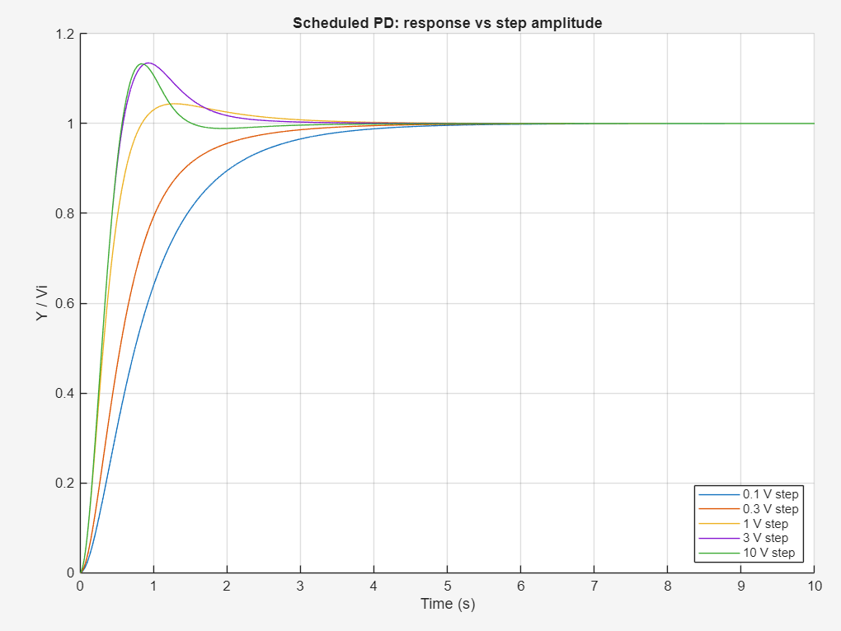
Figure 12: MATLAB ode45 script: the same amplitude sweep, as an independent check.
Table 9: Overshoot and settling time versus step size (Simulink measurement)
Step size | Overshoot | Settling (2 %)
0.1 V | 0 % | 3.54 s
0.3 V | 0 % | 2.73 s
1 V | 3.7 % | 2.09 s
3 V | 12.8 % | 1.95 s
10 V | 12.7 % | 1.33 s

Small steps give no overshoot but are slow; large steps are fast but overshoot by about 13 %, matching the ζ = 0.542 estimate of Section 8.5. Overshoot and settling time for this controller must therefore always be quoted together with the step size. Figure 13 shows the effective-gain trace from the ode45 script, which equals the Simulink result of Figure 9.
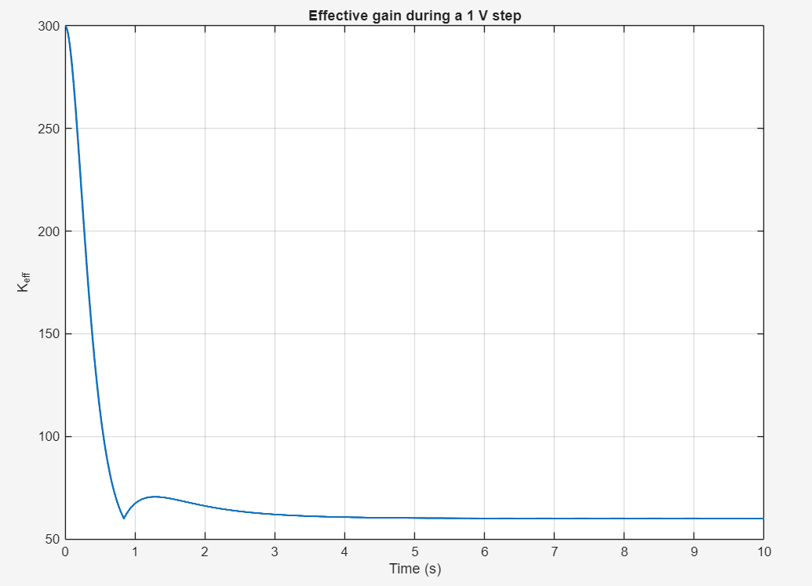
Figure 13: MATLAB ode45 script: effective gain during a 1 V step.

10.4 Simscape op-amp circuit, 10 V step
Figure 14 compares the three controllers in the Simscape op-amp circuit for a 10 V step. All three settle at 10 V, as the integrating plant requires. From the plot, the P-only loop peaks near 10.6 V at about 3.3 s (about 6 % overshoot), the fixed PD loop peaks near 11.0 V at about 1.15 s (about 10 %), and the scheduled PD loop peaks near 10.4 V (about 4 %), settling in about 2 s.
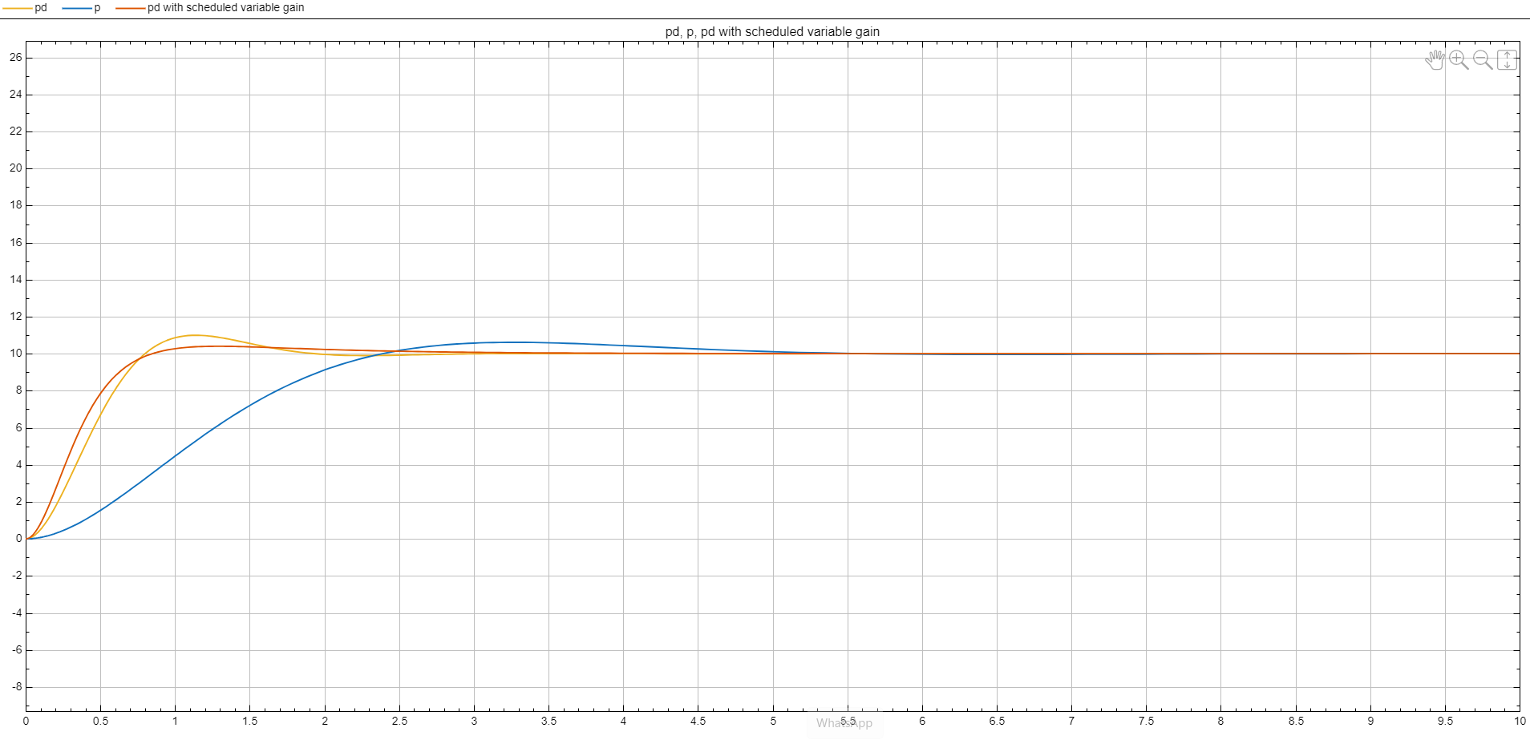
Figure 14: Simscape op-amp circuit, 10 V step: P-only (blue), fixed PD (yellow) and PD with scheduled variable gain (orange).
An important finding came from this test. With the knee left at 0.318 V, a 10 V step lies far beyond the knee, the gain stays at 300 for most of the move, and the scheduled controller overshoots more than fixed PD (about 13 % against 10 %). Moving the knee to 3.18 V, that is, scaling it to the step size, restores the intended behaviour and gives about 4 % overshoot with about 2.2 s settling (Table 10).
Table 10: Effect of the knee setting on a 10 V step (numerical prediction)
Controller | Overshoot | Settling (2 %)
Fixed PD (K_{p} = 173, K_{d} = 10.99) | 10.0 % | 1.75 s
Scheduled PD, knee 0.318 V | 13.3 % | 1.34 s
Scheduled PD, knee 3.18 V | 4.4 % | 2.22 s

To complete: Confirm which knee setting (0.318 V or 3.18 V) was used for the orange curve in Figure 14, and replace the approximate peak values read from the plot with your measured numbers. The curves in Figure 14 also contain small watermark marks; a clean screenshot would look better.

10.5 Summary of the three controllers
Table 11: Summary (1 V step unless stated)
Controller | Overshoot | Settling (2 %) | Remarks
P only (K = 41.3) | 15 % | 4.75 s | Settling time fixed by the motor pole
Fixed PD on the output | 10 % | 1.75 s | Meets the 10 % / 2 s target
Scheduled PD | 4 % | 2.1 to 2.2 s | Fast rise, low overshoot; depends on step size

11. Conclusions, limitations and future work

Conclusions
- The antenna azimuth system reduces to the second-order model G(s) = 0.0662K/[s(s+1.71)] with unity feedback; the reduction changes the overshoot by about 1 %.
- For proportional control, ω_{n} = 0.2573√K and ζ = 3.323/√K; the loop is critically damped at K = 11.04 and its settling time is fixed at 4.68 s for every K. The root locus makes this visible as a vertical line at a real part of −0.855.
- The four-stage op-amp circuit, with every component derived, reproduces the closed-loop transfer function exactly, including the sign check.
- Derivative action on the output (K_{p} = 173, K_{d} = 10.99) removes the settling-time limit and meets the 10 % / 2 s target without derivative kick.
- An error-dependent gain does not help without derivative damping (38.5 % overshoot), but with it cuts the overshoot to about 4 % with a fast rise; the loop is globally stable, but the response depends on the step size, so the knee V₀ must be matched to the expected command.

Limitations
- Ideal op-amps were used: there are no supply limits. At t = 0 the proportional stage demands about 55 V per volt of step for K_{p} = 173 and about 95 V for K_{far} = 300, which a real ±15 V op-amp would clip. Saturation would slow large moves.
- The nonlinear path is behavioural in Simscape; the rectifier, clamp and multiplier circuits are specified (Section 8.6) but not built.
- Component tolerances were not studied; resistor mismatch in the error amplifier shifts the final value, and the 4.87 MΩ resistors call for low-bias op-amps.
- The power-amplifier pole was neglected; the full model shows it is a small effect for the gains used, but it limits stability above K ≈ 2626.

Future work
- Real op-amp models with supply rails, slew-rate and bandwidth limits, and anti-windup if integral action is added.
- Frequency-domain analysis (Bode plots and phase margins) for the P and PD designs.
- Monte-Carlo tolerance and robustness study (motor pole and gain variation).
- Optional PI term for ramp tracking and disturbance rejection, as outlined in Section 7.5.
- A circuit-level realisation of the nonlinear gain with an analog multiplier.
amplifiers.

