MORAX
Labour Compliance Software
Product Requirements Document (PRD)

Document Status | Draft for Product / Engineering Build
Version | 1.0
Date | 25 September 2026
Audience | Product, Design, Engineering, QA, Compliance Operations
Primary Objective | Build a MORAX-branded labour compliance management platform based on the supplied reference product behaviour and screens.

Reference basis: This PRD translates the supplied MORAX requirements and the provided reference screenshots into functional, workflow, UI, data, and acceptance requirements. It intentionally excludes technology-stack decisions; implementation stack and deployment architecture will be specified separately.

Contents
- 1. Product Vision and Scope
- 2. Product Overview
- 3. Goals, Success Measures, and Non-Goals
- 4. Users, Roles, and Permissions
- 5. Information Architecture and Navigation
- 6. Core Data and Entity Model
- 7. Functional Requirements by Module
- 8. Detailed User Workflows
- 9. Compliance Rule and Due-Date Engine
- 10. Document, License, Notice, and Notification Management
- 11. Dashboard, Reporting, and Analytics
- 12. Search, Filters, Sorting, and Bulk Actions
- 13. Audit Trail and Governance
- 14. UX and UI Requirements Derived from Reference Screens
- 15. Validation and Business Rules
- 16. Notifications and Escalations
- 17. Reporting Requirements
- 18. Security, Privacy, and Non-Functional Requirements
- 19. MVP / Phase Plan
- 20. Acceptance Criteria and QA Checklist
- 21. Appendix A - Reference Screen Inventory
- 22. Appendix B - Sample Compliance Detail Fields

1. Product Vision and Scope
Vision. Create a single source of truth for labour-law compliance across MORAX establishments, contractors, contractor sites, statutory obligations, documents, licences, notices, and regulatory updates. The platform should make the current compliance position understandable in seconds and make the next required action obvious.
Primary scope. The product covers the complete operational compliance lifecycle: configure the organization and entities, map applicable laws and compliance requirements, generate recurring and one-time obligations, assign work to makers/checkers/admins, collect evidence, review/approve submissions, calculate status and risk, track overdue items, retain documents, manage licences and notices, and provide dashboards/reports.

1.1 Product boundary
- The product is an operational compliance management system, not a legal-advice engine. Statutory interpretations, due-date rules, penalties, forms, and regulatory content must be maintained by authorized compliance/legal administrators and versioned.
- The product must support multi-entity operations: corporate/company, units/branches/establishments, contractors, and contractor sites.
- The platform must support state-specific and central compliance applicability. The initial content can cover the stated 4 Labour Codes, 5 Central Acts, and 3 State Acts, with a data model that can expand to more jurisdictions and regulations.
- The platform must treat compliance evidence as auditable records. A user must be able to see who created, submitted, reviewed, approved, rejected, or changed an item.

2. Product Overview
MORAX Labour Compliance Software is a comprehensive cloud-based compliance management platform for planning, managing, monitoring, and evidencing labour-law compliance. It consolidates compliance obligations across organizational units and contractors, provides real-time dashboards, manages statutory documents, and creates an auditable workflow from obligation to closure.

2.1 Initial product coverage
Area | Requirement
Regulatory coverage | Initial content model supports 4 Labour Codes, 5 Central Acts, and 3 State Acts, with state/UT extensibility.
Geography | Architecture/data model should support 38 States and Union Territories and be extensible.
Statutory reference content | Digital Library for acts, rules, forms, returns, statutory registers, minimum wage, professional tax, LWF, holidays, and working-hours data.
Automation | Recurring compliance schedules, due-date calculation, reminders, escalations, and status updates.
Governance | Role-based access, approval workflow, audit history, versioned regulatory content, and document verification.
Evidence | Digital record keeping for returns, challans, registers, reports, notices, licences, and supporting documents.

2.2 Core platform capabilities
- Compliance dashboard and health view
- Recurring and one-time compliance management
- Unit / Contractor / Contractor Site master
- Company user and role management
- Audit trail and activity history
- Digital record keeping and document verification
- License management and renewal tracking
- Notice management
- Digital Library / statutory reference repository
- Government notification and regulatory update feed
- Reports and exports
- Automated in-app and email notifications / reminders

2.3 Key user outcomes
- Plan better by seeing obligations before they become overdue.
- Simplify workflows through maker/checker/admin responsibility assignment.
- Reduce manual effort with automatic recurrence, reminders, and status calculations.
- Use live progress tracking to identify due, overdue, completed, late, rejected, and pending items.
- Maintain a central, searchable evidence repository.
- Use historical reports to understand compliance performance over time.

3. Goals, Success Measures, and Non-Goals

3.1 Product goals
- Provide an organization-wide real-time view of labour compliance health.
- Make each compliance obligation actionable: owner, due date, risk, legal basis, required form, evidence, status, and next step.
- Support multiple legal entities/operating locations and contractor structures without duplicating master data.
- Enable controlled submission/review/approval while preserving a complete audit trail.
- Centralize compliance evidence and statutory reference documents.
- Reduce missed deadlines through automated reminders and escalation workflows.

3.2 Suggested success measures
Metric | Definition | Target / Direction
On-time completion rate | Completed on or before due date / total due | Increase over time
Overdue exposure | Count of open overdue compliance items | Decrease over time
Evidence completeness | Open items with required evidence missing | Decrease over time
Review turnaround | Time from submission to checker decision | Decrease over time
Notification effectiveness | Required reminders sent before due date | Increase to 100% coverage

3.3 Non-goals for this PRD
- Choosing the implementation technology stack, hosting architecture, or deployment model.
- Replacing legal/compliance professionals in interpreting ambiguous legislation.
- Guaranteeing regulatory correctness without a governed statutory-content maintenance process.
- Payroll processing, employee attendance, recruitment, or full HRMS functionality beyond information needed for compliance applicability.

4. Users, Roles, and Permissions
Role | Primary responsibility | Typical scope | Core permissions
MORAX Admin / Super Admin | Configure organization, rules, users, permissions, legal content | All entities | Full create/edit/view/configure, workflow administration, audit and reports
Unit Admin | Own unit-level compliance operations | Assigned units | View/create/update compliance, assign maker/checker, approve where permitted, reports
Unit Maker | Prepare compliance submissions and evidence | Assigned units | Create/upload/submit; view own workflow; cannot final-approve own submission
Contractor Admin | Manage contractor entity and contractor-site compliance | Assigned contractors/sites | Assign work, review status, manage contractor documentation
Contractor Maker | Prepare contractor compliance submissions | Assigned contractors/sites | Upload evidence, fill forms, submit for checking
Contractor Checker | Verify contractor submissions | Assigned contractors/sites | Review, approve, reject, request correction, add remarks
Viewer / Auditor | Read-only oversight | Configured scope | View dashboards, records, audit trail, reports; no edits
Permission rule: Roles are not sufficient by themselves; every role must also be scoped to an entity or entity hierarchy. Example: one user may be Unit Maker for Mana Dale and Contractor Checker for a selected contractor. The data model must therefore support user-to-entity assignments with role context.

5. Information Architecture and Navigation
Navigation item | Expected capability | Reference UI behaviour
Dashboard | Organization compliance overview, health, progress, reports, entity filter, PDF export | Sidebar top-level item; content is card/chart oriented
Compliances | Expandable section with Recurring Compliances and One Time Compliances | Accordion/sidebar child navigation
Users | Company user list, role, entity assignment, status, created date, edit/toggle actions | Table with search and actions
Unit / Contractor / Site | Master list and creation/edit flows for units, contractors, contractor sites | Entity tabs plus Add Entity action
Licenses | License register, renewal dates, expiry reminders, documents | Separate operational module
Govt Notifications | Regulatory update feed, affected law/state/entity, read status | Notification list / details
Support Tickets | Issue/request tracking with status and assignment | Ticket list and detail
Digital Library | Acts, rules, forms, returns, registers, statutory reference data | Expandable reference library
Document Library | Operational evidence repository with metadata and retrieval | Document-centric list and search
Notice Management | Legal / labour notices, response dates, owners, evidence and closure | Notice register
My Profile | Profile and assigned scope | Account settings
Change Password | Credential update | Simple secured form
Logout | End authenticated session | Immediate sign-out

5.1 Global header requirements
- Show MORAX branding, hamburger/sidebar toggle, page title, notification bell, signed-in user avatar, and organization context.
- Use consistent date presentation and timezone across dashboard, compliance due dates, audit timestamps, and reports.
- Provide a global search only where the module supports it; do not pretend global search returns records it cannot access.
- User/session controls must be available without leaving the current module.

6. Core Data and Entity Model

6.1 Entity hierarchy
Entity hierarchy: MORAX Company -> Unit / Branch -> Contractor (optional relationship to parent Unit) -> Contractor Site (optional relationship to Contractor + operational location). Compliance applicability is calculated at the lowest relevant operational entity while inherited attributes are available from parent records.
Entity | Key fields | Relationships | Compliance impact
Company | Name, legal identifiers, address, compliance profile | Parent of all organizational entities | Global defaults and regulatory profile
Unit / Branch | Name, entity code, type, state, city, pincode, address, workforce, GSTIN, PAN, LIN, employer/occupier/owner, applicable regulations, start dates | Belongs to Company; may have contractors | Primary establishment applicability
Contractor | Name, parent unit, contractor type, state/city inheritance, workforce, statutory IDs, applicability, dates | Belongs to Company; optionally linked to Unit | Contract labour obligations
Contractor Site | Site name, contractor, unit type, state/city, pincode/address, workforce, identifiers, applicability | Child of Contractor / operational location | Site-level obligations
User Assignment | User, role, entity, effective dates, status | Links user to one or more entities | Controls visibility and actions

6.2 Core compliance record
- Rule / Act / Section identifiers
- Compliance title and description
- Compliance category: Remittance, Return, Register, Records, Intimation/Filing, Display, Notice, Procedural, Notice/Display
- Document type and required form number
- Frequency and recurrence anchor
- Calculated due date and deadline rule
- Applicable state / UT and entity type
- Risk: Critical / High / Medium / Low
- Status: Due / Overdue / Pending for Approval / Approved / Completed Late / Rejected by Checker
- Owner / Maker / Checker / Admin
- Required evidence checklist
- Remarks / correction notes
- Activity history and audit metadata
- Effective-from/effective-to regulatory version

7. Functional Requirements by Module

7.1 Dashboard
ID | Requirement | Acceptance summary
DASH-01 | Entity filter | Allow the user to select All Entities or a specific accessible entity. Dashboards recalculate based on selection.
DASH-02 | Date context | Show selected reporting date / period and permit period selection where supported.
DASH-03 | Overview cards | Display Due, Overdue, Completed, Completed Late, Rejected by Checker, Pending for Approval, and Compliance Rate.
DASH-04 | Status visualization | Provide a donut or equivalent status chart with legend and count consistency with KPI cards.
DASH-05 | Overall progress | Display an overall compliance-progress visualization and separate Unit / Contractor completion indicators.
DASH-06 | Monthly progress | Display completion trend over the last 12 months or configured history window.
DASH-07 | Unit summary | List entities with Due, Overdue, Done, and Rate metrics; support drill-down.
DASH-08 | Download PDF | Generate a period/entity-scoped dashboard report as a PDF.
DASH-09 | Module summary | Show high-level counts for licenses, notices and other core modules.
DASH-10 | Consistency | All dashboard widgets must derive from the same filtered dataset and refresh together.

7.2 Recurring Compliances
- COMP-01 - Provide Recurring Compliances as the primary operational worklist.
- COMP-02 - Show total compliance count and category tabs with counts for Remittance, Return, Register, Records, Intimation/Filing, Display, Notice, Procedural, and Notice/Display.
- COMP-03 - Group compliance rows by governing Rule / Act with expandable/collapsible sections.
- COMP-04 - Each rule section shows rule count and summary chips such as Due, Awaiting Approval, and Overdue.
- COMP-05 - Each row shows Entity, Compliance Type, Document Type, Form No., Frequency, Due Date, Risk, Status, and Actions.
- COMP-06 - Clicking the row action opens a detailed read-only modal unless the user has edit/submit rights.
- COMP-07 - The detail view displays legal framework, section, rule description, required form, consequences, entity information, timeline, and activity history.
- COMP-08 - Support status transitions such as Due -> In Progress/Submitted -> Pending for Approval -> Approved/Completed, and Due -> Overdue where deadline passes without completion.
- COMP-09 - Support correction loop: Pending/Submitted -> Rejected by Checker -> Resubmitted.
- COMP-10 - Store every status change with actor, timestamp, action, and remark.

7.3 One Time Compliances
- OTC-01 - Use the same compliance worklist pattern as Recurring Compliances but for event-driven / one-time obligations.
- OTC-02 - Support trigger source such as establishment creation, licence event, notice, incident, registration, or manually created obligation.
- OTC-03 - Allow one-time due date, assignee, risk, evidence checklist, workflow, and closure fields.
- OTC-04 - One-time items must not silently regenerate after closure unless explicitly configured as recurring or re-triggerable.

7.4 Compliance detail modal
- Header: compliance title, risk badge, frequency badge, and current status badge.
- Entity Information: Unit, Contractor, Site, State, and applicable relationship context.
- Timeline: Period, due date, submission date, approval date, completion date and overdue duration as applicable.
- Legal Frame & Parameters: Act, section/rule, applicability statement, recurrence parameters, and legal version.
- Rule Description: human-readable obligation statement.
- Required Form: form/document identifier when applicable.
- Consequences: documented statutory consequence/penalty text.
- Activity History: action, user/system actor, timestamp, and remarks.
- Action controls: Close; and, for authorized roles, Edit/Submit/Approve/Reject/Request Correction/Upload Evidence.

7.5 Entity Master: Unit / Contractor / Contractor Site
- Provide an All / Units / Contractors / Contractor Sites tabbed master view.
- Provide Add Entity action that opens a modal/full-page form with three steps/tabs: Unit / Branch, Contractor, Contractor Site.
- Support edit, activate/deactivate, and view relationship hierarchy.
- Display relationship labels such as “Under: Mana Dale” for contractors in unit context.
- Show operational location, worker/employee count, admin/maker/checker assignments, and current status in the master list.

7.6 Add Unit / Branch form
Section | Fields / Behaviour
Identity | Branch / Unit Name*; Unit Type* (Shop/Office, Factory, Dock Work, Mines); Entity Code
Location | State*; City*; Pincode*; Address*
Employees | No. of Males*; No. of Females*; Total Employees (calculated/read-only)
Start date | Unit Start Date*
Additional details | GSTIN; PAN; LIN; Name of Employer / Occupier / Owner
Applicable regulations | BOCW; PF; ESIC (extensible checklist)
Compliance | Compliance Start Date*
Assignments | Maker; Checker; Admin; optional create-new-user workflow

7.7 Add Contractor form
- Parent Unit* select; Contractor Name*; Contractor Type* = In-house / Outsourced; Entity Code.
- Start Date and End Date.
- Pincode and Address. State/City are inherited from the selected parent Unit but should remain visible and read-only unless business rules allow override.
- Workers: No. of Males*, No. of Females*, Total Workers calculated/read-only.
- GSTIN, PAN, LIN.
- Applicable regulations: BOCW, PF, ESIC.
- Compliance Start Date*.
- Assignments: Maker, Checker, Admin. Maker may use “Create New User”; the create-user sub-form requires Name, Email, Password, and optional Mobile.
- On save, validate parent relationship, duplicate entity code/name, worker counts, dates, mandatory regulatory fields, and user assignment uniqueness.

7.8 Add Contractor Site form
- Site Name*; Contractor Name; Unit Type* (Shop/Office, Factory, Dock Work, Mines); Entity Code.
- Start Date and End Date.
- State*, City*, Pincode*, Address*.
- Workers: No. of Males*, No. of Females*, Total Workers calculated/read-only.
- GSTIN, PAN, LIN.
- Applicable regulations: BOCW, PF, ESIC.
- Compliance Start Date*.
- Maker / Checker / Admin assignments.
- Link site to contractor and preserve site-level compliance scope.

7.9 Users
- Users table: ID, Name, Email, Mobile, Role, Entities, Status, Created, Actions.
- Search by name/email/ID.
- Status toggle (active/inactive) must require confirmation for disabling users who own open work items.
- Entity chips may show multiple assignments with overflow count (e.g., +18 more).
- Edit action updates profile, roles, assignments and active status, subject to authorization.
- Prevent deletion of users with audit records; use inactive status instead.
- Support audit of password reset, role change, entity assignment, and status change.

7.10 License Management
- License master with license type, issuing authority, registration/license number, entity, issue date, expiry date, renewal date, status, responsible owner, document attachments, and remarks.
- Upcoming renewal tracker with configurable reminder offsets.
- Expiry/renewal status: Active, Due for Renewal, Expired, Suspended/Cancelled where relevant.
- License details accessible from entity page and dashboard module summary.
- License document versions and audit trail.

7.11 Document Library
- Repository for returns, challans, registers, forms, reports, certificates, notices, licences, and supporting evidence.
- Metadata: document category/type, related act/rule, entity, state, period, compliance ID, document date, upload date, uploaded by, verification status, version, tags.
- Document states: Draft/Uploaded, Pending Verification, Verified, Rejected, Archived.
- Support preview/download where permitted, document replacement with version retention, and searchable metadata.
- Do not overwrite historical evidence silently; new uploads create versions.

7.12 Notice Management
- Notice register: notice number, authority, notice type, date received, entity, subject, response due date, owner, status, severity, attachments.
- Workflow: Received -> Assigned -> Response in Progress -> Submitted -> Closed (or configurable legal workflow).
- Track response documents, correspondence, deadlines, reminders, and closure evidence.
- Link a notice to related compliance(s) when a regulatory breach or filing issue is involved.

7.13 Digital Library
- Browse central/state Acts and Rules.
- Browse applicable forms, returns, statutory registers and compliance guidance content.
- Maintain minimum wage, professional tax, LWF rates, state-wise holiday lists, and working-hours requirements as structured reference data.
- Each statutory item must have source citation metadata, jurisdiction, effective date, superseded date, version, and last-reviewed date.
- Provide search and filters by state, act, rule, form, topic, document type, and effective period.

7.14 Government Notifications
- Feed of labour-law amendments and regulatory updates.
- Notification detail: title, source authority, publication date, effective date, affected state/UT, affected act/rule, summary, source document, applicability tags.
- Unread/read state per user plus “mark as relevant” or acknowledgement where needed.
- Allow admin to convert an update into an internal action, rule change review task, or notification campaign.

8. Detailed User Workflows

8.1 Organization / entity onboarding
- Admin opens Unit / Contractor / Site -> Add Entity.
- Select entity type: Unit / Branch, Contractor, or Contractor Site.
- Enter mandatory identity, location, workforce, statutory identifiers, and applicability details.
- Configure compliance start date and applicable regulatory flags.
- Assign Maker / Checker / Admin roles to one or more users.
- Save and activate entity.
- Compliance engine evaluates applicable rules based on entity attributes, jurisdiction, type, worker profile, and effective regulatory dates.
- System creates relevant compliance instances from the first eligible due date and marks them according to the configured start date.
- Admin verifies generated obligations through the entity detail and compliance list.

8.2 Recurring compliance submission and approval
- Compliance reaches Due status before deadline.
- Maker opens compliance record.
- Maker views obligation, legal basis, due date, required form, checklist, and instructions.
- Maker uploads/fills required evidence and adds remarks.
- Maker submits. Status becomes Pending for Approval.
- Checker reviews evidence. Checker can Approve, Reject, or Request Correction.
- Approved/completed records contribute to completion rate. Late completion is captured separately when completion occurs after the due date.
- Rejected items remain visible with correction reason and return to maker workflow.
- Every step is written to activity history.

8.3 Overdue handling
- At due-date cutoff, incomplete item changes to Overdue.
- Overdue duration is displayed.
- Configured notifications/escalations are sent to maker, checker, admin, and/or business owner.
- User can still submit/complete overdue items unless the compliance rule is explicitly locked after cutoff.
- Completion after due date becomes Completed Late if business rule is enabled.
- Historical overdue state remains visible in audit and reports even after completion.

8.4 Correction / rejection loop
- Checker selects Reject / Request Correction and must enter a remark.
- Maker receives notification and sees correction reason at the top of the task.
- Maker can replace/add evidence while preserving old versions.
- Resubmission creates a new activity entry and moves status to Pending for Approval.
- Checker decision closes the loop.

9. Compliance Rule and Due-Date Engine

9.1 Rule master structure
- Rule ID (internal stable key)
- Act / Code name
- Rule / Section / Regulation reference
- State / UT / Central jurisdiction
- Compliance title
- Compliance category
- Document type
- Form number
- Frequency
- Due-date calculation method
- Applicability condition(s)
- Risk level
- Required documents/checklist
- Penalty/consequence text
- Responsible role default
- Effective from / effective to
- Version and supersession status
- Evidence retention period
- Regulatory source and last reviewed date

9.2 Applicability evaluation
- Use the entity hierarchy and jurisdiction data as inputs.
- Use entity type, contractor status, workforce count, selected regulations, and other configured conditions to determine applicability.
- Do not generate an obligation until required inputs are valid and the rule is effective for the entity period.
- Allow an administrator to mark a compliance as “Not Applicable” only with a mandatory reason and audit record, if the business permits this status.
- Rule changes should affect future eligible cycles by default; historical compliance instances must preserve the rule version that generated them.

9.3 Recurrence and due date
- Frequency options based on reference UI: Daily, Weekly, Monthly, Quarterly, Half-yearly, Annually, One-time, Event-based.
- Support configurable anchor: calendar month, month-end, fixed day, financial year, quarter-end, event date, or relative offset.
- Calculate next due date after completion according to rule recurrence, not by simply adding a fixed number of days unless the rule is configured that way.
- Use a clear timezone and holiday/weekend adjustment rule when applicable. The adjustment rule must be configurable per compliance rule because statutory provisions differ.
- Allow rule-specific grace/late windows where legally relevant; do not apply one global grace rule.

10. Document, License, Notice, and Notification Management

10.1 Document verification workflow
- Upload -> metadata capture -> checksum/version -> Pending Verification -> Verified or Rejected.
- Verifier must be able to record a reason when rejecting.
- Verified evidence becomes read-only unless a new version is uploaded.
- Document downloads/previews should respect entity and role permissions.
- Retention/archival should be configurable and should not delete required audit history.

10.2 License reminder model
- Default reminder intervals should be configurable (for example 90/60/30/7 days before expiry), not hard-coded.
- Send reminders based on owner/entity scope.
- Show days-to-expiry and status in the license tracker.
- On expiry, escalate according to configured severity and ownership.

10.3 Automated notifications
- Due-date reminder
- Overdue alert
- Pending approval reminder
- Rejected/correction notification
- License renewal reminder
- Notice response deadline alert
- Government notification / regulatory update alert
- User assignment or reassignment notification
- System-generated compliance creation / regeneration notification

11. Dashboard, Reporting, and Analytics
- Compliance rate = completed/approved compliance outcomes divided by eligible obligations for the selected scope and period, using the agreed business definition.
- Every chart/card must expose the underlying count on hover or by click where applicable.
- Dashboard filters must cascade to every widget.
- Entity-specific drill-down must open the matching compliance list with filters pre-applied.
- Reports must support selected period, entity, status, risk, frequency, and category filters.
- Export should preserve the filters used to generate the report.

11.1 Dashboard reference KPIs
KPI | Meaning | Drill-down
Due | Currently due/open obligations within selected period | Compliance list filtered to Due
Overdue | Open obligations past due date | Compliance list filtered to Overdue
Completed | Completed/approved obligations | Completed list/report
Completed Late | Completed after due date | Late completion report
Rejected by Checker | Currently/recently rejected workflow items | Rejected list with reasons
Pending for Approval | Submitted items awaiting checker/admin action | Approval queue
Compliance Rate | Configured compliance score for scope/period | Score detail/report

12. Search, Filters, Sorting, and Bulk Actions

12.1 Recurring compliance filters
Filter | Options | Behaviour
Entity Type | All, Units, Contractors, Contractor Sites | Changes the entity selector and scoped result set.
Entity | All Entities, then available entities in the selected type/scope | Hierarchical/scrollable selector; inaccessible entities are not shown.
Status | All, Due, Overdue, Pending for Approval, Approved, Completed Late, Rejected by Checker | Single-select filter; counts refresh after selection.
Risk Level | All, Critical, High, Medium, Low | Filters obligations by configured risk.
Frequency | All, Daily, Weekly, Monthly, Quarterly, Half-yearly, Annually, One-time, Event-based | Filters recurrence class.
Date Range | Current, This Month, This Quarter, This FY, Last Month, Last Quarter, Last 6 Months, Last FY, Next Month, Next Quarter, Next 6 Months, All Time, Custom Range | Defines date field and period used for result filtering.

12.2 Category tabs
- Display category tabs with counts: All, Remittance, Return, Register, Records, Intimation/Filing, Display, Notice, Procedural, Notice/Display.
- Tab counts must reflect current filters, not the global unfiltered dataset.

12.3 Search
- Search by compliance title, entity, act/rule, form number, or other configured searchable field.
- Search result count and filter state must remain visible.
- Clear Filters resets every field to default values and returns the default date range.

13. Audit Trail and Governance
- Every create, update, assignment, submission, approval, rejection, status change, document upload, document verification, rule edit, and user permission change must be audited.
- Audit record must store actor, role, entity scope, action, timestamp, object ID, previous value where appropriate, new value, IP/device metadata where approved by security policy, and remarks.
- Compliance activity history must be visible from the compliance detail screen in chronological order.
- Audit logs are append-only to application users.
- Regulatory rule versions must be immutable after activation; corrections create a new version and preserve old history.

14. UX and UI Requirements Derived from Reference Screens
- Use a left navigation rail/sidebar with clear module grouping and collapsible sections.
- Use a consistent top header with page title, notification indicator, user avatar, organization context, and application controls.
- Use blue/white primary application styling with status/risk colors used consistently: risk badges, status badges, and alert cards must be semantically consistent across modules.
- Use cards for KPIs, compact tables for operational data, and modals for read-only details where interaction does not require a full page.
- Show mandatory fields using a clear asterisk.
- Use helper banners for inheritance rules; the reference entity forms visibly explain that contractor location can inherit state/city from the parent unit.
- Use computed fields as read-only where appropriate (e.g., Total Workers / Total Employees).
- Use clear empty/loading/error states on tables and dashboards.
- Tables should support horizontal scrolling without destroying header alignment.
- Date controls should be consistently formatted and support keyboard entry plus date picker where applicable.
- Do not expose internal database IDs unless useful to administrators.

14.1 Screen-by-screen build notes
Screen | Implementation note
Dashboard | Replicate the reference pattern: entity filter + date context; six/seven high-level KPI cards; status donut; frequency distribution; unit summary table; recurring/one-time toggle; filter panel; grouped compliance list; PDF export.
Recurring Compliances | Replicate the reference pattern: filter row, category chips, rule-group accordions, column table, action/view icon, counts in group header.
Compliance Detail | Replicate the reference modal pattern: risk/frequency/status header, entity information, timeline, legal frame and parameters, rule description, required form, consequences, activity history, Close button.
Add Entity | Use three selectable entity creation modes: Unit / Branch, Contractor, Contractor Site. Preserve section headers and clear grouping of identity, location, workforce, additional details, regulations, compliance settings, and user assignments.
Company Users | Use searchable tabular listing with name, email, mobile, role, entity chips, active status, created date, and action controls.
Entity Master | Use tabs for All / Units / Contractors / Contractor Sites, relationship display (“Under: ...”), location, worker count, admin/maker/checker, status, and edit action.
Filter Menus | Use single-select dropdowns matching the reference option sets and cascading behaviour. Ensure dropdowns are not clipped by parent containers.

15. Validation and Business Rules
ID | Rule | Requirement
VAL-01 | Mandatory field enforcement | All * fields cannot be blank on save.
VAL-02 | Unique entity code | Entity code must be unique within the applicable company scope.
VAL-03 | Unique/controlled name | Duplicate entity names within the same parent should trigger warning or block according to configured policy.
VAL-04 | Date validation | End date cannot precede start date; compliance start date must be valid for the entity lifecycle.
VAL-05 | Worker counts | Male + female = total; total is calculated, not manually editable where the reference form shows read-only total.
VAL-06 | Assignment coverage | A compliance with required checker workflow must have a valid checker assignment before submission/approval workflow is activated.
VAL-07 | Self-approval restriction | A maker must not approve their own submission unless an explicit admin override policy exists; default is prohibited.
VAL-08 | Inactive user | Inactive users cannot receive new assignments. Existing open records require reassignment or remain visible with an owner warning.
VAL-09 | Historical integrity | Changing master data must not rewrite already generated historical compliance records without an explicit audited migration action.
VAL-10 | Not applicable | Optional Not Applicable status requires a reason and authorized role; the record remains auditable.
VAL-11 | Evidence | A compliance cannot transition to final completed/approved unless all required evidence items are satisfied, unless rule configuration explicitly allows waiver.
VAL-12 | Risk | Risk is determined by rule master and can be overridden only by authorized role with mandatory reason.

16. Notifications and Escalations

16.1 Reminder ladder
Trigger | Recipient | Default example | Action
Upcoming due | Maker + owner | 7 days before | Prepare/submit reminder
Near due | Maker + checker | 1 day before | High-priority reminder
Overdue | Maker + checker + admin | At/after due time | Overdue alert + escalation
Pending approval | Checker | After configured SLA | Approval reminder
Rejected | Maker + owner | Immediately | Correction request with remarks
License expiry | Owner + admin | Configurable offsets | Renewal alert
Notice response | Assigned owner + admin | Configurable offsets | Response deadline alert
Configurable policy: Reminder intervals, recipients, channels, escalation windows, and working-hour rules must be configurable by administrators. The examples above are defaults for requirement discussion, not legal deadlines.

17. Reporting Requirements
ID | Report | Content
RPT-01 | Compliance Summary | Due, Overdue, Completed, Completed Late, Rejected, Pending Approval, Compliance Rate by period/entity.
RPT-02 | Entity-wise Compliance | Unit/Contractor/Site wise obligations and completion rate.
RPT-03 | Risk Exposure | Open Critical/High/Medium/Low obligations with overdue age.
RPT-04 | Pending Approval | Checker work queue with aging.
RPT-05 | Late Completion | Completed after due date, with reason/remarks.
RPT-06 | Document Completeness | Required evidence missing / pending verification / verified.
RPT-07 | License Tracker | Upcoming renewal and expired licences.
RPT-08 | Notice Tracker | Open notices, deadlines, status, owners.
RPT-09 | Audit Report | Filterable history of user and compliance activity.
RPT-10 | Regulatory Change Impact | Notifications/updates mapped to affected rules/entities.

18. Security, Privacy, and Non-Functional Requirements
- Authentication must use secure session/token management and configurable password policy; exact technology is outside this PRD.
- Authorization must be enforced server-side for every read/write action based on role + entity assignment.
- Tenant/company data must be isolated so one customer cannot access another customer’s records.
- Sensitive documents should be access-controlled and audited.
- Password fields must never be logged or stored in plain text.
- All privileged actions must be auditable.
- Use soft-delete/deactivation for business records where legal/audit history requires retention.
- The application should support responsive desktop-first use; operational tables may require horizontal scrolling at lower widths.
- Dashboard and compliance lists should load within an agreed performance SLA under the expected data volume.
- Long-running report generation should provide progress/queued state rather than blocking the UI.
- Uploaded files must be validated for type/size and malware scanning can be integrated as a platform control.
- Backups, disaster recovery, retention, and data residency policies must be documented separately as part of the technical/operational architecture.

19. MVP / Phase Plan
Phase | Scope | Exit criteria
MVP | Authentication/RBAC; company/unit/contractor/site masters; user assignments; recurring & one-time compliance worklists; rule master; due-date engine; dashboard; compliance detail; submit/check/approve/reject; document upload; audit trail. | Core compliance workflow works end-to-end for at least one state and one configured rule set with traceable audit history.
Phase 2 | Licenses; Document Library; Notice Management; Digital Library; reports/exports; advanced notifications; PDF dashboard/reporting. | Operational records, evidence, licenses and notices can be managed in the same platform.
Phase 3 | Government notification ingestion, regulatory change impact, advanced analytics, bulk onboarding/imports, external HR/payroll integrations if required. | Regulatory updates and scale workflows reduce manual administration further.

20. Acceptance Criteria and QA Checklist
ID | Area | Acceptance criterion
AC-01 | Entity onboarding | Admin can create Unit, Contractor and Contractor Site with mandatory validations; relationships and counts are saved correctly.
AC-02 | User assignment | Users can be assigned as Maker/Checker/Admin by entity; permissions reflect assignment scope.
AC-03 | Compliance generation | Creating/activating an entity with an applicable rule generates the correct compliance instances from the configured compliance start date.
AC-04 | Dashboard consistency | Dashboard KPI counts equal the filtered compliance dataset and change when entity/date scope changes.
AC-05 | Filter correctness | Every filter option returns only matching records; reset returns default state.
AC-06 | Workflow | Maker can submit; Checker can approve/reject/request correction; unauthorized roles cannot perform restricted actions.
AC-07 | Auditability | Every state transition and master-data change appears in activity history/audit report.
AC-08 | Evidence | Required documents can be uploaded, verified/rejected, and versioned without overwriting history.
AC-09 | Overdue | Past-due open items become Overdue and display overdue duration.
AC-10 | Late completion | A completed-after-due item is identifiable as Completed Late when configured.
AC-11 | Reporting | PDF/CSV exports preserve selected period and filter context.
AC-12 | Security | A user cannot access records outside assigned entity scope, including through direct URL/API manipulation.
AC-13 | Usability | All major reference screens have matching information hierarchy, labels, actions, and visual states.
AC-14 | Regulatory versioning | Updating a rule creates a new effective version without altering historical compliance instances generated under a previous version.

20.1 QA scenarios for the reference UI
- Open Recurring Compliances and verify the dashboard + worklist load without horizontal alignment breaks.
- Select Entity Type = Contractors and verify the entity dropdown contains only contractors.
- Select Status = Overdue and verify only overdue items remain.
- Select Risk = High and verify only High risk items remain.
- Select Frequency = Monthly and verify frequency text and counts are consistent.
- Select Date Range = Custom Range and verify the custom date selector drives the worklist.
- Open a compliance action icon and verify the detail modal contains legal basis, timeline, consequences, and activity history.
- Create a Unit and verify Total Employees is calculated and the compliance engine uses the selected state/applicability.
- Create a Contractor with Parent Unit and verify inherited state/city behaviour.
- Create a Contractor Site and verify contractor relationship and site-level scope.
- Assign users from the entity form and verify the Company Users page reflects roles and entities.

21. Appendix A - Reference Screen Inventory
The following screenshots were supplied as product references. They should be treated as behaviour and information-architecture references for MORAX, not as a source of technology implementation decisions.
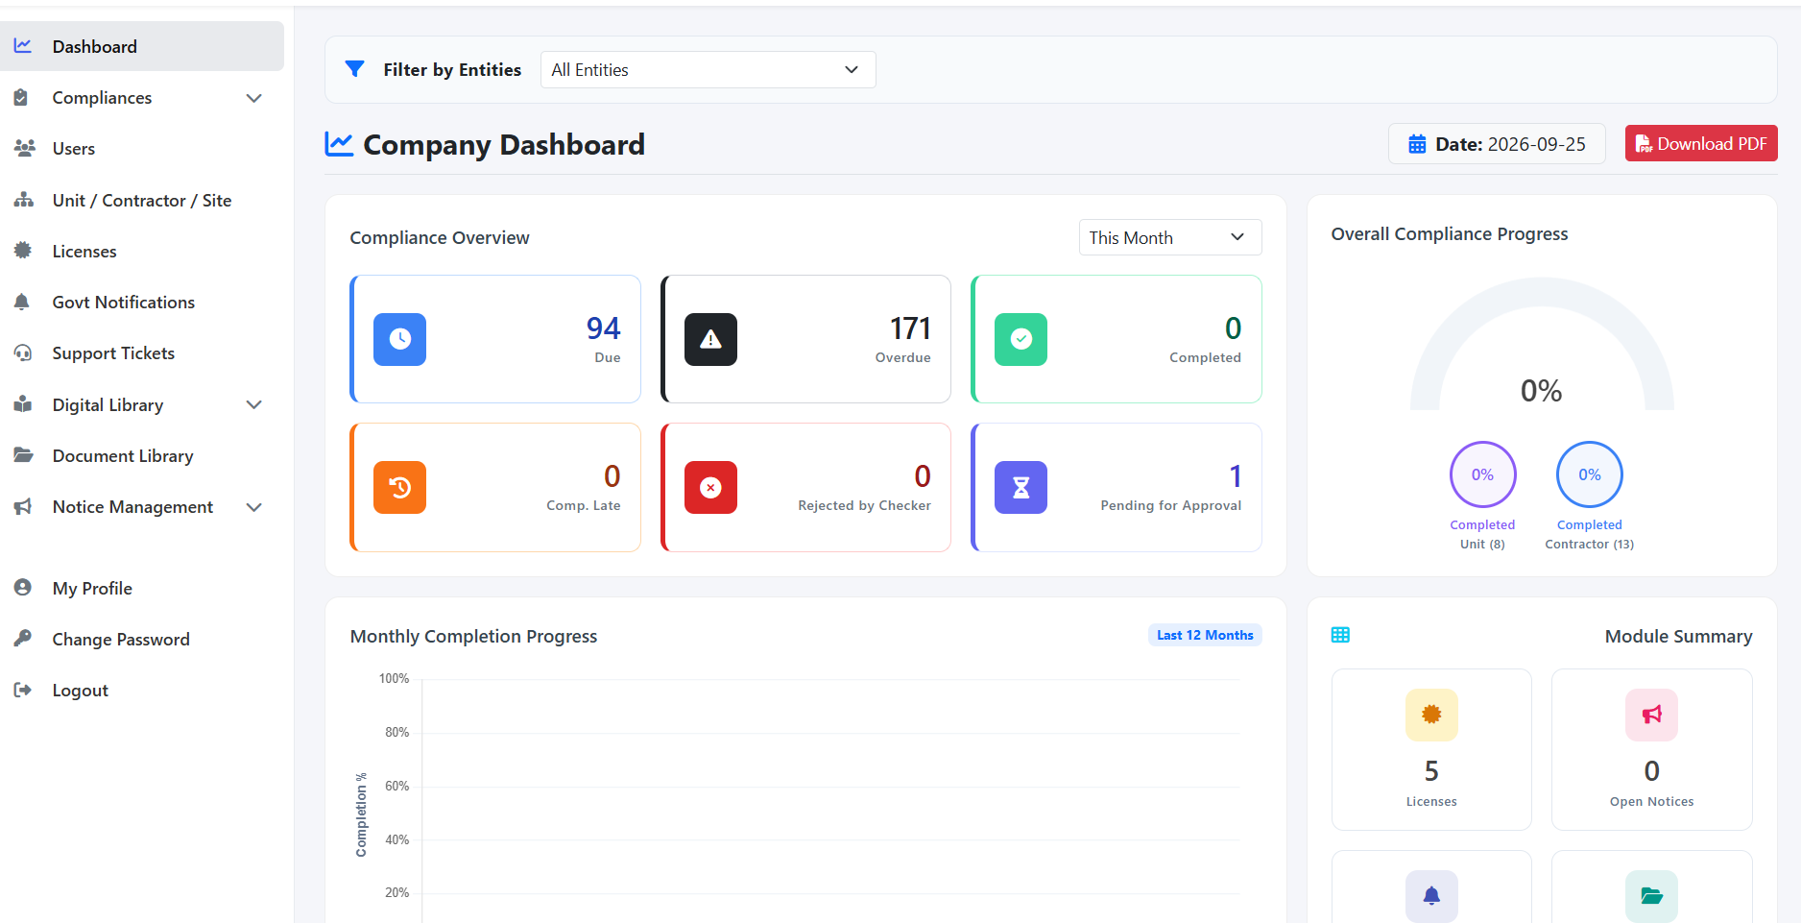
A1. Company Dashboard - overview cards, progress, entity filter, PDF export.

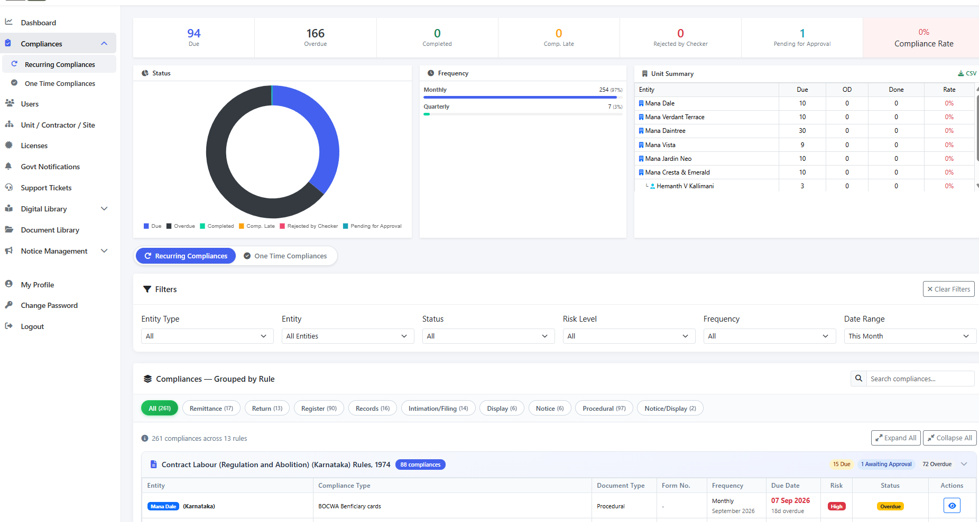
A2. Recurring Compliances - status/frequency summaries, grouped rule table, filters, category tabs.

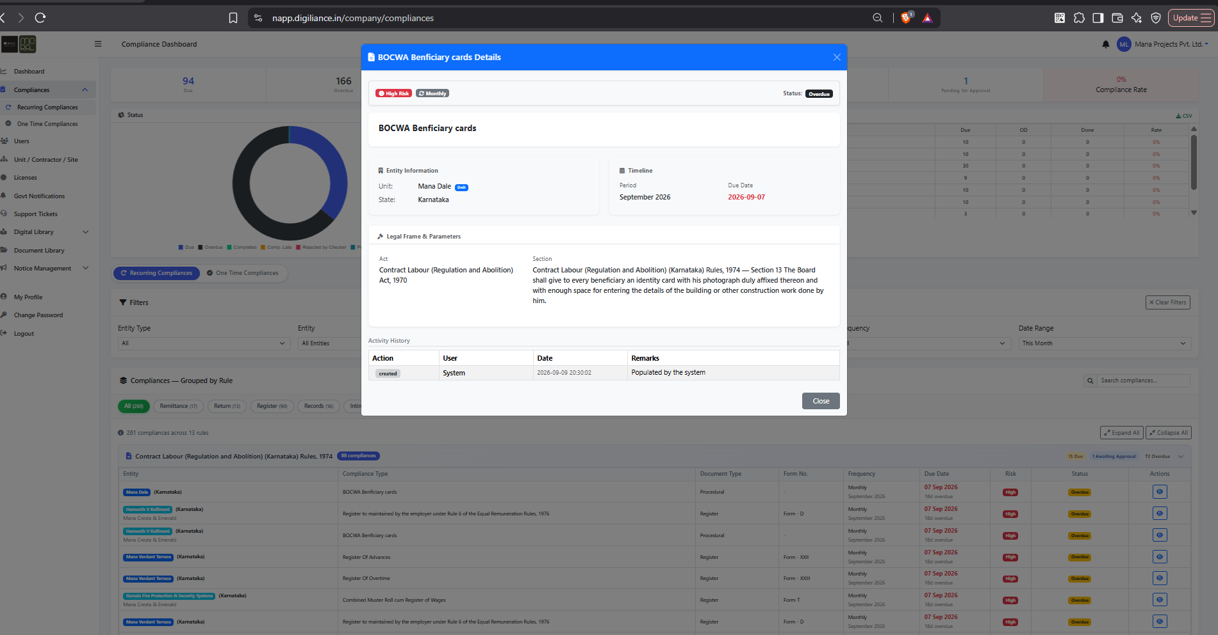
A3. Compliance detail modal - legal basis, entity information, timeline, required form, consequences, activity history.

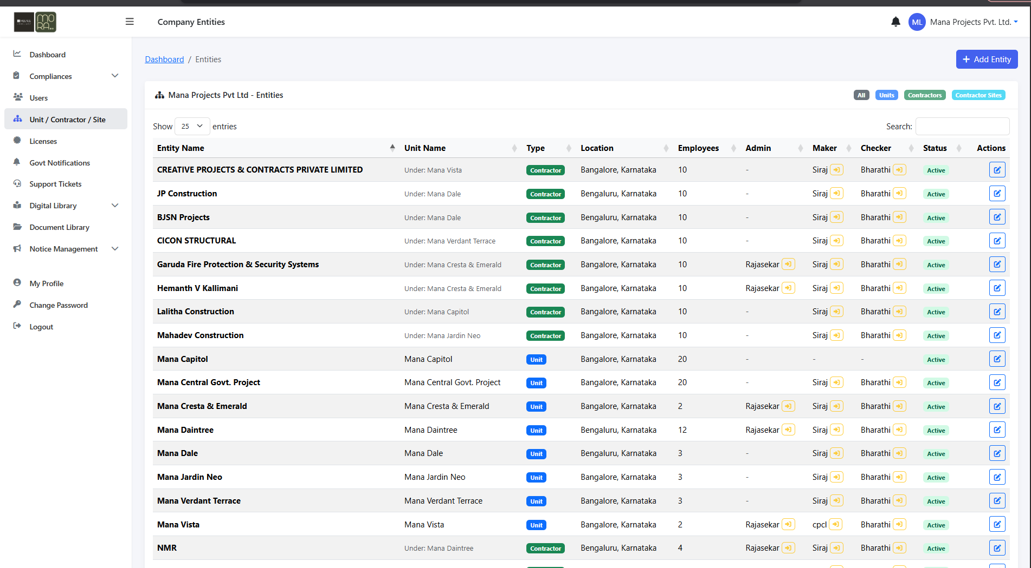
A4. Entity master - All/Units/Contractors/Contractor Sites, parent relationships, worker counts, assignments, status.

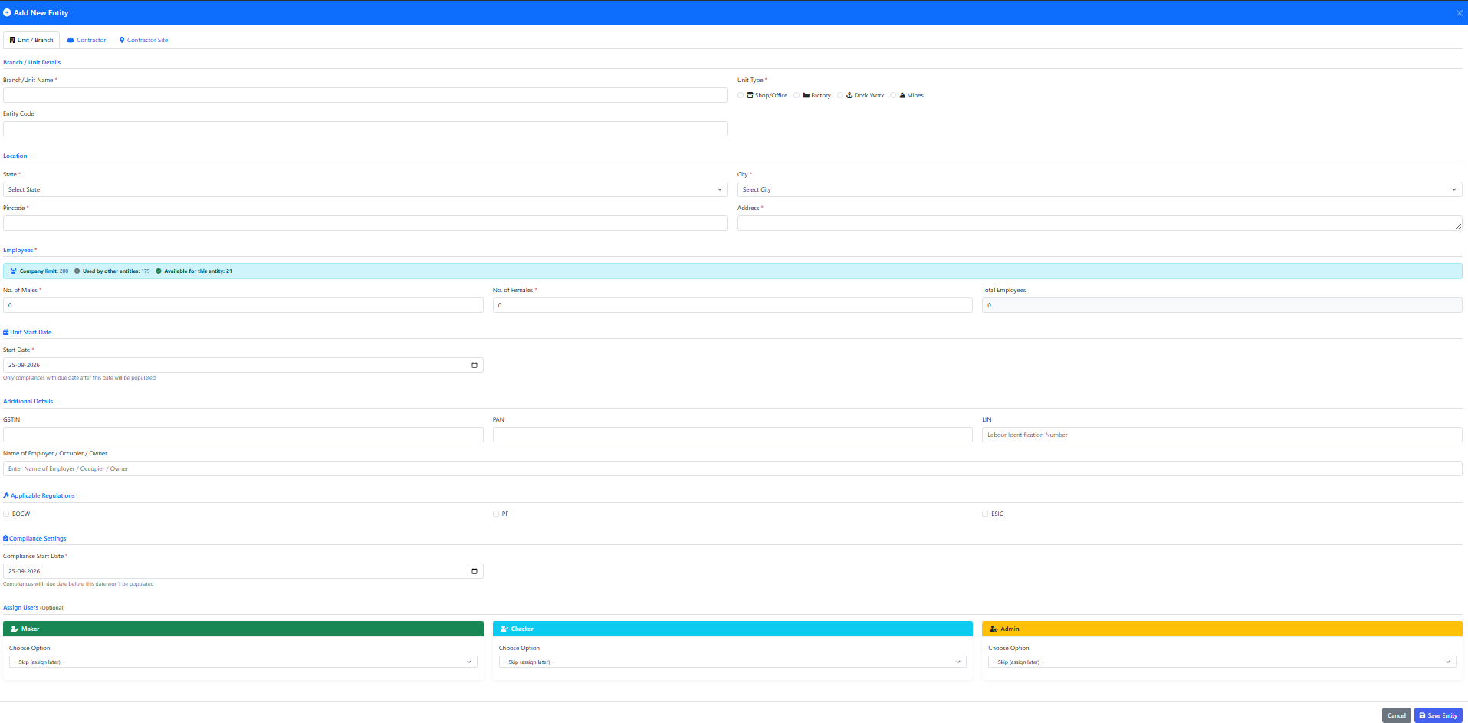
A5. Add Unit / Branch - identity, unit type, location, employee counts, identifiers, regulations, compliance date, assignments.

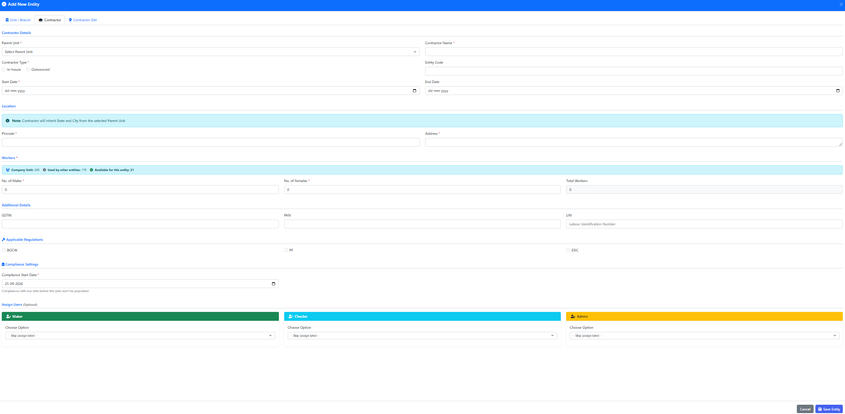
A6. Add Contractor - parent unit, contractor type, worker counts, inherited location note, regulations, assignments.

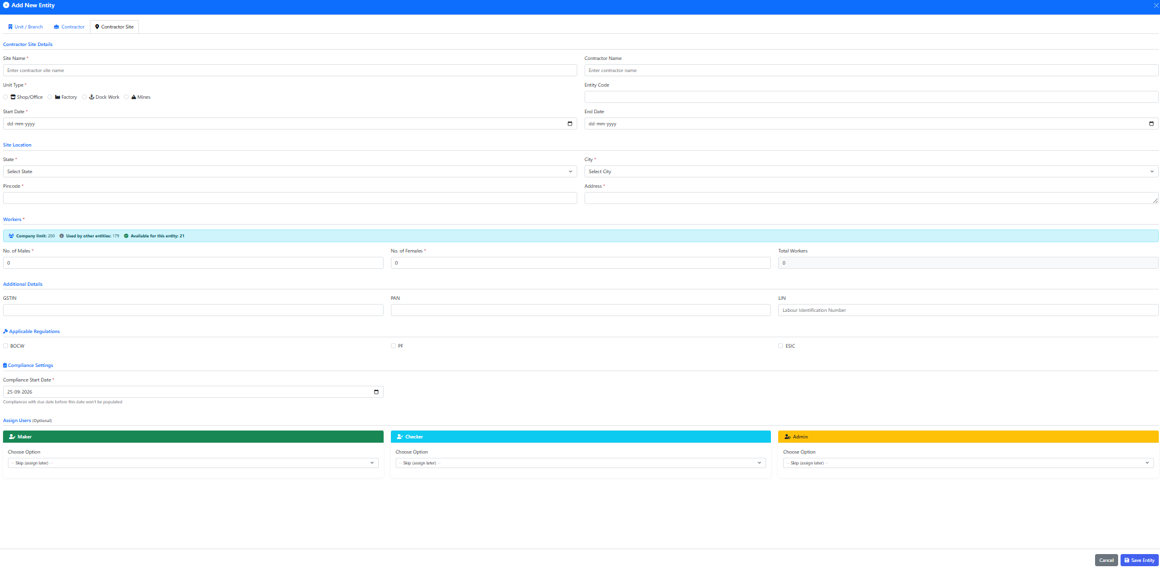
A7. Add Contractor Site - site identity, contractor, location, worker counts, regulations, assignments.

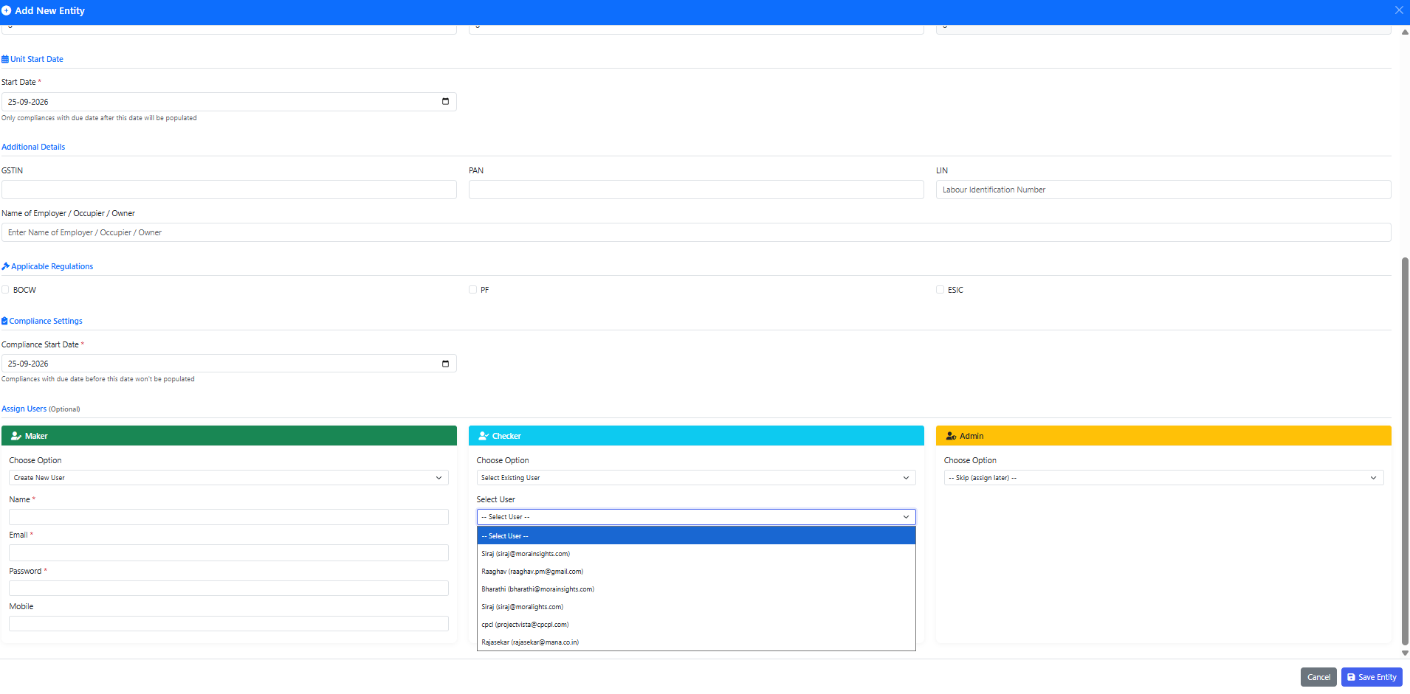
A8. Entity assignment - create new Maker user and select existing Checker/Admin users.

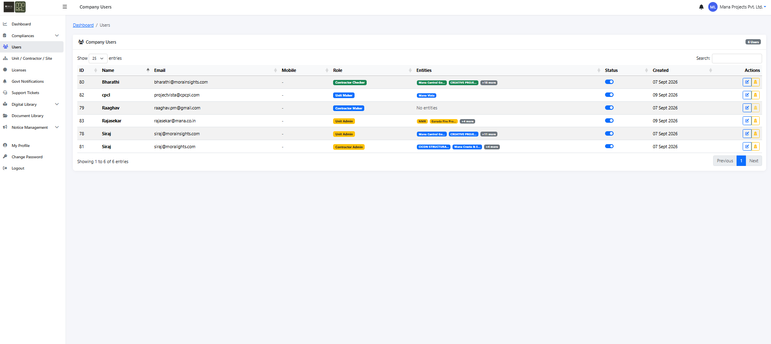
A9. Company Users - user list, role, entity chips, status, created date, actions.

21.1 Filter reference images
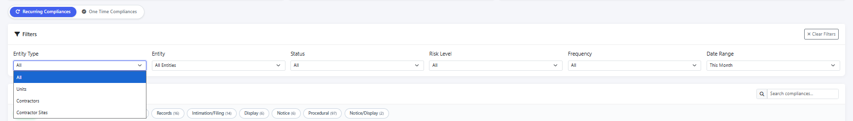
A10. Entity Type filter options - All, Units, Contractors, Contractor Sites.
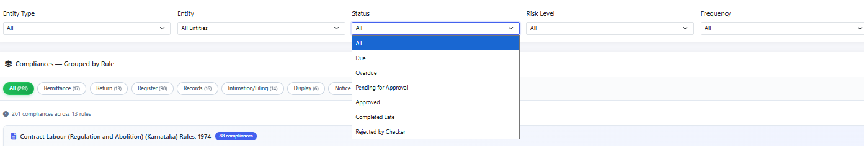
A11. Status filter options - All, Due, Overdue, Pending for Approval, Approved, Completed Late, Rejected by Checker.
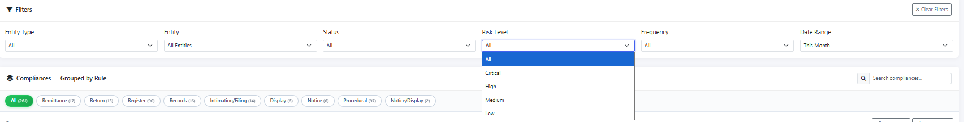
A12. Risk filter options - All, Critical, High, Medium, Low.
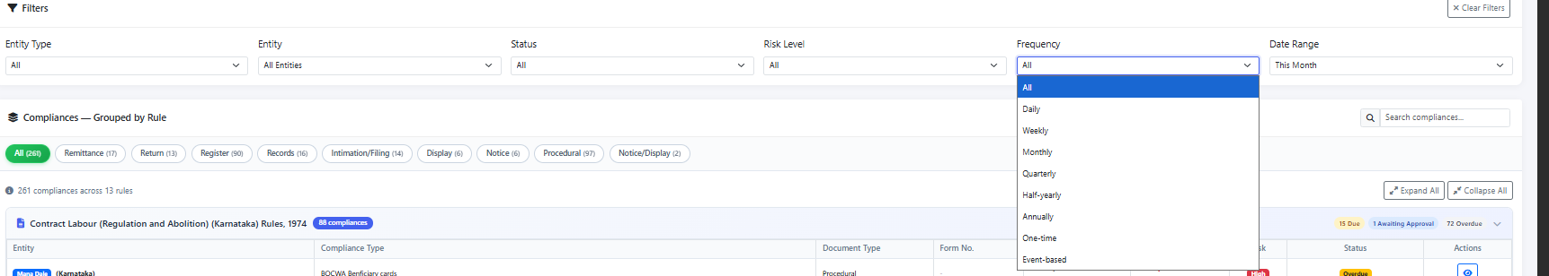
A13. Frequency filter options - All, Daily, Weekly, Monthly, Quarterly, Half-yearly, Annually, One-time, Event-based.
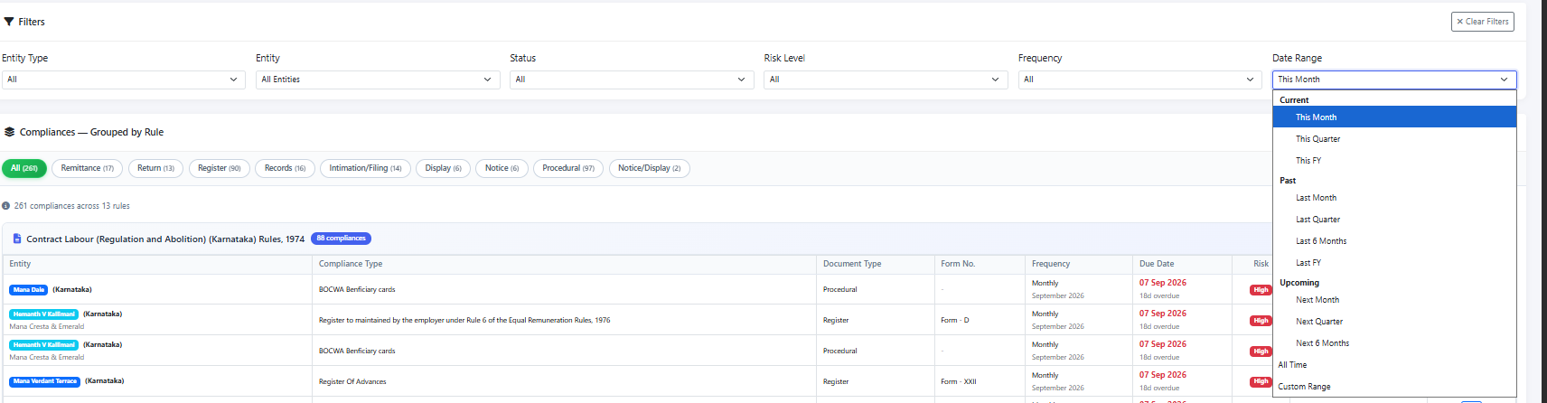
A14. Date range options - Current, month/quarter/FY and historical/future ranges, All Time, Custom Range.
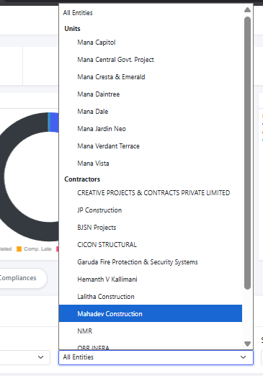
A15. Entity selector showing units followed by contractors with scrollable selection.

22. Appendix B - Sample Compliance Detail Fields
Section | Field | Requirement
Header | Compliance title | Human-readable compliance obligation title.
Header | Risk | Critical / High / Medium / Low badge.
Header | Frequency | Configured recurrence badge.
Header | Status | Current workflow status.
Entity Information | Unit | Operational unit / establishment.
Entity Information | Contractor | Contractor if applicable.
Entity Information | State | Applicable jurisdiction.
Timeline | Period | Applicable month/quarter/year/event period.
Timeline | Due date | Calculated due date.
Legal Frame | Act | Act / Labour Code name.
Legal Frame | Section | Section / Rule / clause.
Legal Frame | Rule text | Human-readable legal requirement.
Rule Description | Description | Business explanation of what must be done.
Required Form | Form | Required statutory form/document.
Consequences | Penalty / consequence | Configured consequence text.
Activity History | Action | Created / Submitted / Approved / Rejected / etc.
Activity History | User / System | Actor.
Activity History | Date | Timestamp.
Activity History | Remarks | Free text / reason / correction note.
Implementation guidance for Codex: Build from the requirements and acceptance criteria first. Treat each module as a bounded workflow with explicit entities, permissions, statuses, and audit events. Avoid hard-coding the reference company names, sample compliance names, screenshots, or regulatory counts; these are demonstration/reference values and must become configuration/master data for MORAX.

