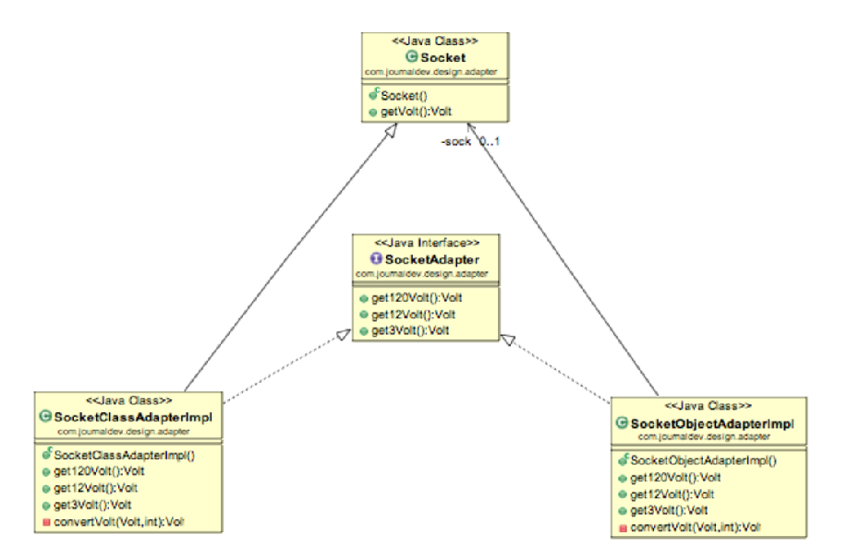

Some of the adapter design pattern example we could easily find in JDK classes are;

* java.util.Arrays#asList()
* java.io.InputStreamReader(InputStream) (returns a Reader)
* java.io.OutputStreamWriter(OutputStream) (returns a Writer)