**Cloud Native – CaseStudy project** - ilan

AzureCosmoDB API for mongodb

Execute – node index.js

Postman testing – local host

**Angular app local run - localhost**

Azure repos

Git add .

Git commit –m first

Git push -u origin master

Agent Pool-- nohup ./run.sh &

Docker daemon failed.

azureuser@LinuxVM1:~/myagent$ sudo usermod -aG docker $USER

azureuser@LinuxVM1:~/myagent$ sudo chown $USER:docker /var/run/docker.sock

azure repo CI CD NodeJS pipeline

**Docker registry – containerise app**

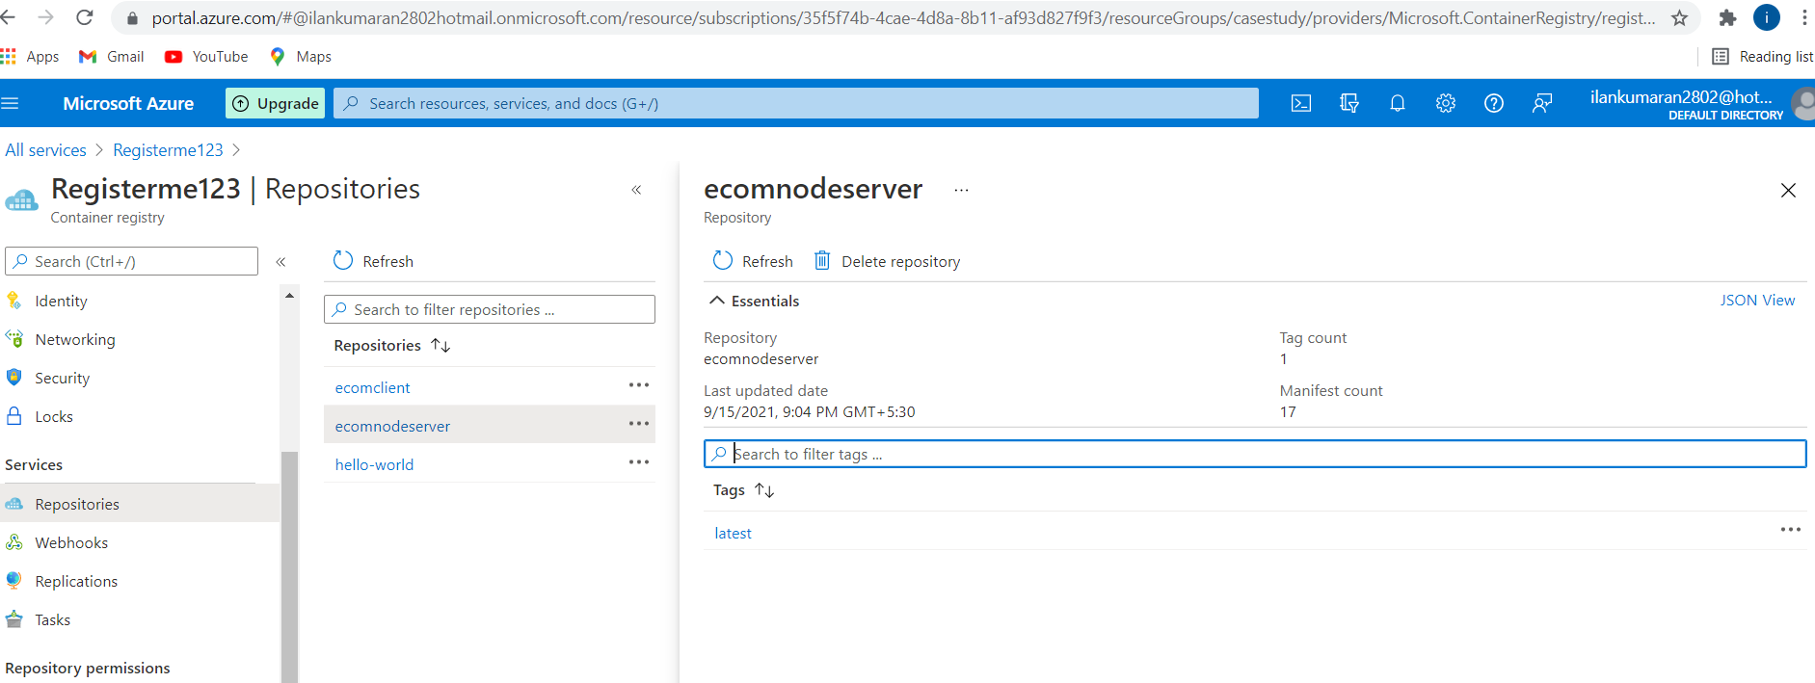

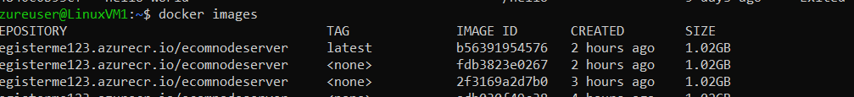

AkS services - kubernetes

Kubectl get services – external ip results

Static web app deploy

YAML to deploy in static web deploy

trigger:

- master

pool:

  name: ownpool

  vmImage: linuxagent

steps:

- task: NodeTool@0

  inputs:

    versionSpec: '14.x'

  displayName: 'Install Node.js'

- script: |

    npm install -g @angular/cli

    npm install

    ng build --prod

  displayName: 'npm install and build'

- task: AzureStaticWebApp@0

  inputs:

      app_location: "/"

      api_location: "api"

      output_location: "dist/organic-client"

  env:      azure_static_web_apps_api_token: $(deployment_token1)

AZURE BLOB STORAGE :

AZURE API MANAGEMENT

AKS service as API management – post man test

[OrganicClient (brave-dune-054c32b10.azurestaticapps.net)](https://brave-dune-054c32b10.azurestaticapps.net/login)

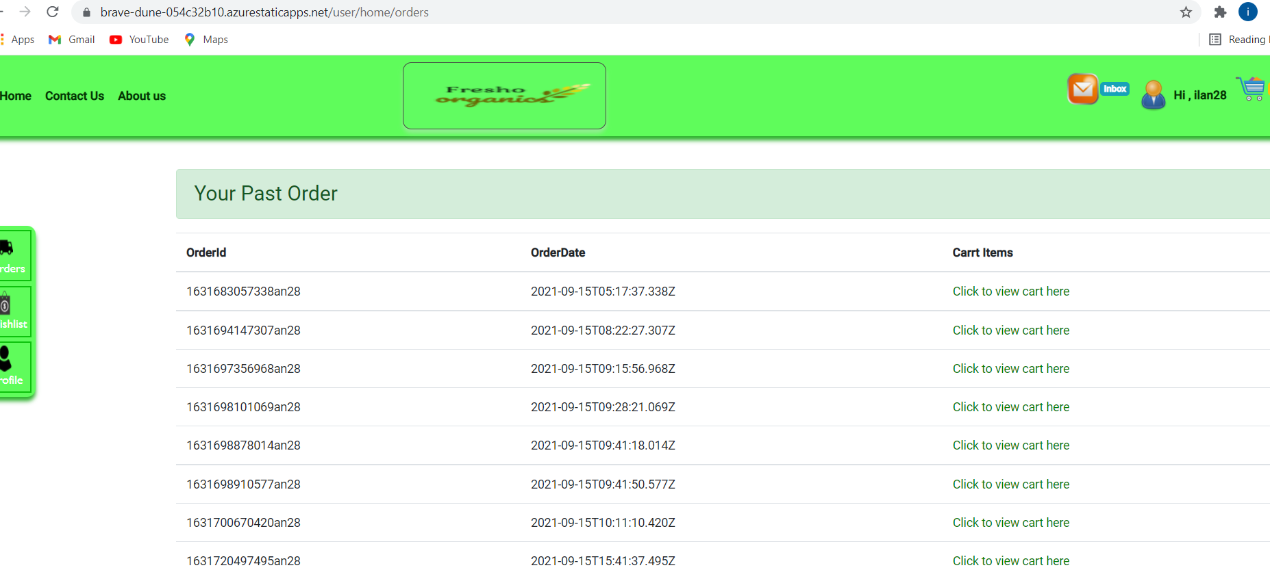

**Storage Queue trigger :**

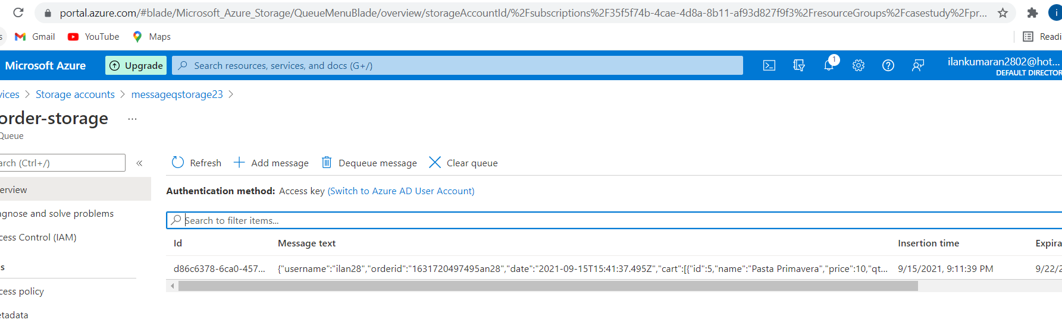

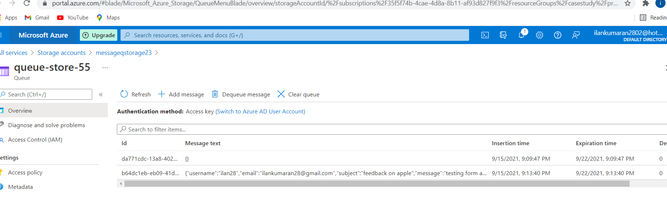

LOGIC APP – send email

