Task: given a list of directories names

Do: in case there are duplicate names, give indexes to the names as OS does it

The way I decided to do this task:

I decided to build a dict where I say per a dir name (that will appear without any index) the value is a list of available indexes

**Exp1:**

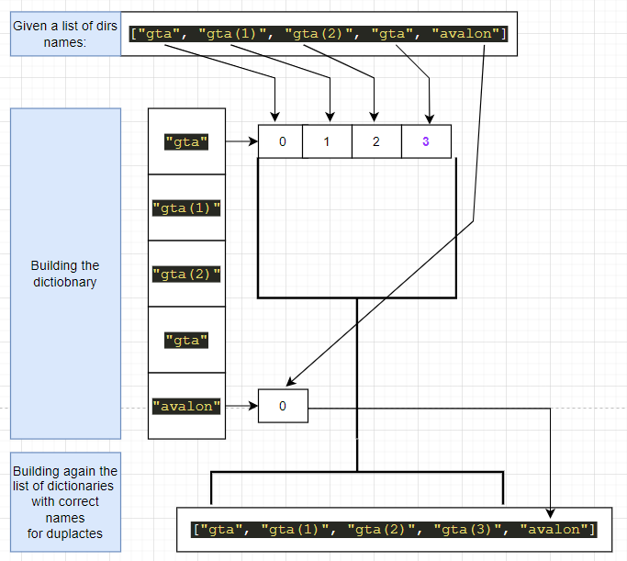

**Exp2:**

This is the list of the folder names:

**['onepiece', 'onepiece(1)', 'onepiece(2)', 'onepiece(3)', 'onepiece']**

Start arranging the dir names in the new list with appropriate names

The arranged list of directories is:

**['onepiece', 'onepiece(1)', 'onepiece(2)', 'onepiece(3)', 'onepiece(4)']**

**Exp3:**

This is the list of the folder names:

**['pes', 'fifa', 'gta', 'pes(2019)']**

Start arranging the dir names in the new list with appropriate names

The arranged list of directories is: **['pes', 'pes(2019)', 'fifa', 'gta']**

**Exp4:**

This is the list of the folder names:

**['gta']**

Start arranging the dir names in the new list with appropriate names

The arranged list of directories is: **['gta']**