Start of translation danio rerio exons 1-3:

**C A A A G g t a a c a a t c a c a g C A ATGGCGCAA**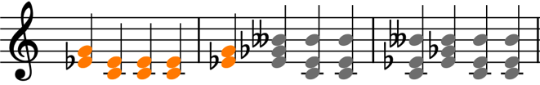

**...**

** AAC GAC AGC CAA GAG TTC GCG GAG CTC TGG GAG AAG AAT TTG** **AT(T) g t**

**(t) a a g t a a g (AT)TATTCAGCCCCCAGGT GGTGGCTCTTGC**

**...**

**TGGGACATCATT AATGATGAG g t a t t**

End of translation danio rerio:

**GACGAAGGAAGA AGCGACTCTGAT TAAG G T G A T**

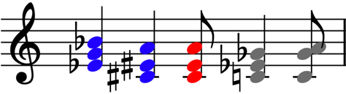 **ACTCAACA(G) g a c (CA)GCCA GAA TTA**

**...**

