תרגיל בית **3** – טכנולוגיות אינטרנט מתקדמות  
אילנית חנוכו - 208657320  
 נוי ביטון - 312238678  
 מעיין שרביט - 318301744  
 חן חנצין - 208636761

1. Our system engineer would be Noy:

|  |  |  |
| --- | --- | --- |
| **Team Member** | **Designated Tasks** | **Finished Tasks** |
| Noy+Maayan | Preparation of a use case diagram describing the use of the website. | Done |
| Ilanit+Hen | A presentation of the website's architecture | Done |
| Ilanit | Homepage functionality after the login  Preparation of a use case diagram describing the use of the website. | TBD |
| Hen | User Authentication Implementation: Develop and integrate user authentication functionality to ensure secure access to the project management tool. | TBD |
| Hen | Login page | Done |
| Noy+Maayan | Database setup | Done |
| Noy + Ilanit | Frontend-backend integration | TBD |
| Hen | Collaborative document editing feature development | Done |
| Maayan | Setting up and overseeing testing | Not Started |

1. ארכיטקטורה

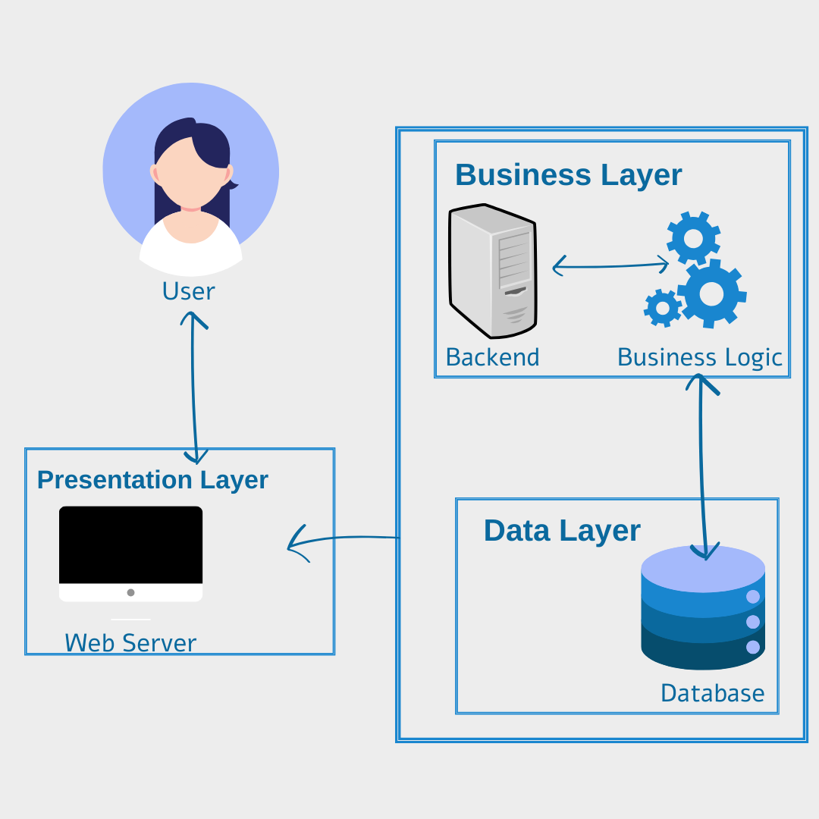  
**Presentation Layer:** This is the layer with which users directly interact. It consists of a web server and the user interface (UI). The UI is rendered in the user's browser and includes all the client-side elements they can interact with.

**Business Layer:** This layer contains the backend server and the business logic of the application. It's responsible for processing user requests from the presentation layer, executing the appropriate business rules, and handling application operations. This is where the core functionality of the app is implemented.

**Data Layer:** This is the MongoDB database where all the application data is stored. The business layer communicates with the data layer to retrieve, update, and store data based on the business logic's operations.

3. **דיאגרמת Use-Case:**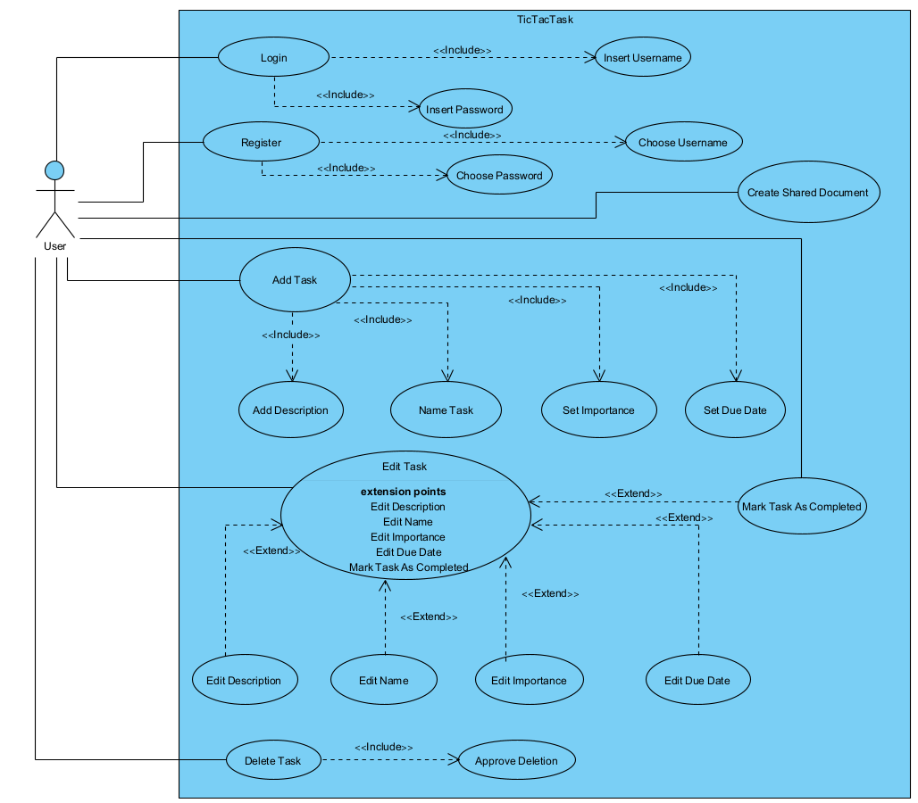

4. א.

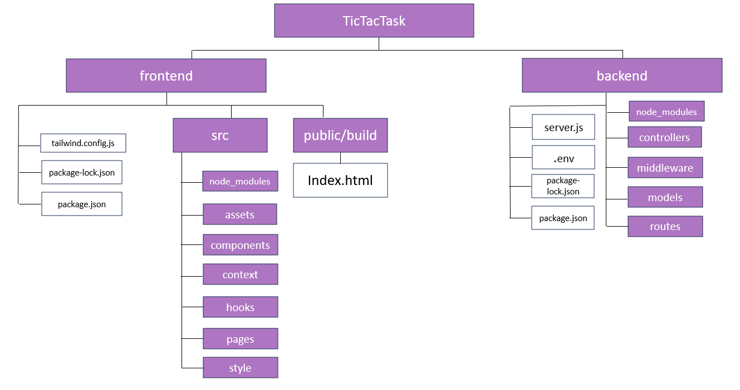

ב.

