User Guide
  - Amdocs Max Pulse
Track key accounts and stakeholders, spot buying and risk signals early, and turn external changes into next best actions.
How to use this guide: start with Getting Started to set up companies and stakeholders, then use Today’s Brief and the Intelligence Panel sections as a reference during daily work.
Table of Contents
- Why Max Pulse
- Getting Started: Company tracking; Stakeholder tracking
- Today’s Brief: Header & Navigation; Filters; Feed
- Intelligence Panel: Signal; Sources; Activity; About; Tracker
- Sales Workflows
- Signal-to-Action Matrix

Why Max Pulse
Pulse is Amdocs’ account intelligence tool — a daily view of what is happening across your accounts and stakeholders, what it means, and where to act.
Powered by Pulse, Max goes beyond a news feed. It creates a dedicated agent for each of your customers and stakeholders, continuously tracking signals like buyer engagement shifts, leadership changes, and competitive moves.
Instead of raw alerts, Pulse cuts through the noise.
It connects signals to your account context and turns them into clear, actionable insight.
It connects the dots and gives you clarity on:
what changed, why it matters, and what to do next.
Unlike generic AI tools or alerts, Max brings together Amdocs internal data, external signals, and analyst insights — so you act at the right moment, with the right context.

Getting Started (Main Signals Area)

Quick Setup: Companies you want to track
Monitor companies and stakeholders, choose the appropriate relationship type, and adjust sensitivity.
Follow these steps to set up the accounts and stakeholders you want to track.
- Open Today’s Brief. Navigate to the main Signal feed to see signals across your tracked accounts.
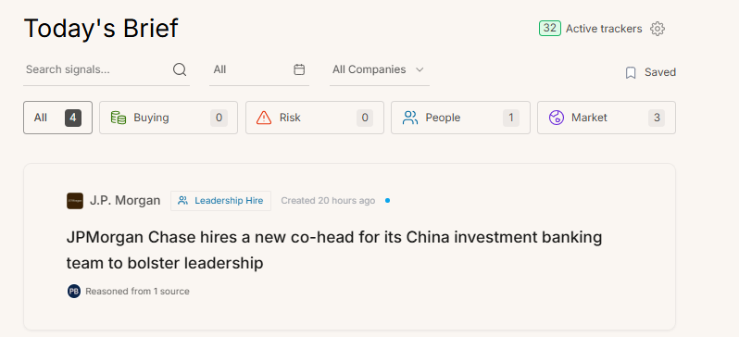
- Add your companies and stakeholders
Open Track to add a new company or person you want to follow.
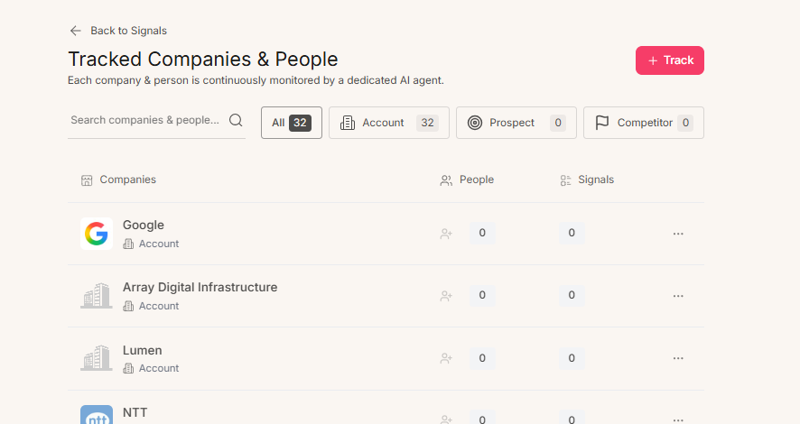
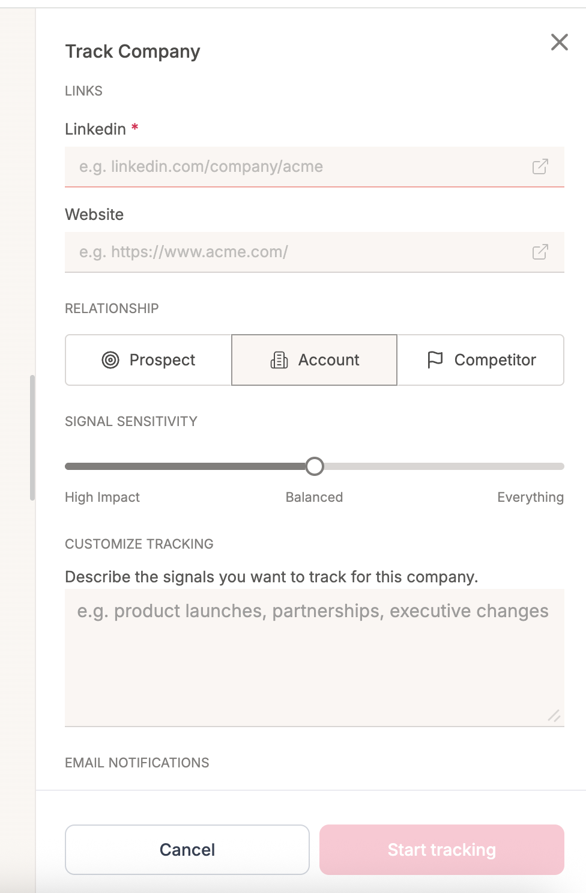
- Add companies that you want to follow
3
4
5
6
7
8
Add the LinkedIn URL or the company website to begin monitoring.

- Set the Relationship type
Choose Prospect (new logos), Account, or Competitor — this shapes how the AI interprets signals.
Prospect: Looks for buying signals and entry points — events that create a reason to engage for the first time.
Account: Looks for Risk signals and expansion opportunities — protecting and growing existing revenue.
Competitor: Looks for product strategy and weaknesses — intelligence to sharpen your competitive positioning.

- Adjust Signal Sensitivity:
Start on Balanced; switch to High Impact for quiet accounts or Everything for hot deals.
High Impact: Surfaces only critical strategic shifts — minimal noise. Best for cold or early-stage accounts.
Balanced: The recommended default for most active accounts. Filters minor events while keeping meaningful signals visible.
Everything: Surfaces every minor event for maximum visibility. Best for high-priority deals

- Customize Tracking:
Write which signals you want to track.
For example: specific domain, product launch, industry changes, executive transitions.
Natural language instruction to focus the AI on specific topics (e.g., “product launches, partnerships, executive changes”).

- Email Notifications Set
Notification frequency: High Impact, Everything, or None.
Receive a daily email summary of accounts and stakeholders signals based on their impact.
- Start tracking the company

Quick Setup: Stakeholders you want to track
Map the buying group and assign political roles to each stakeholder.
- Click Add to choose the stakeholder you want to track
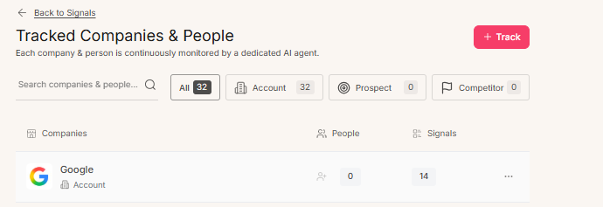
This links the person to the correct account context.

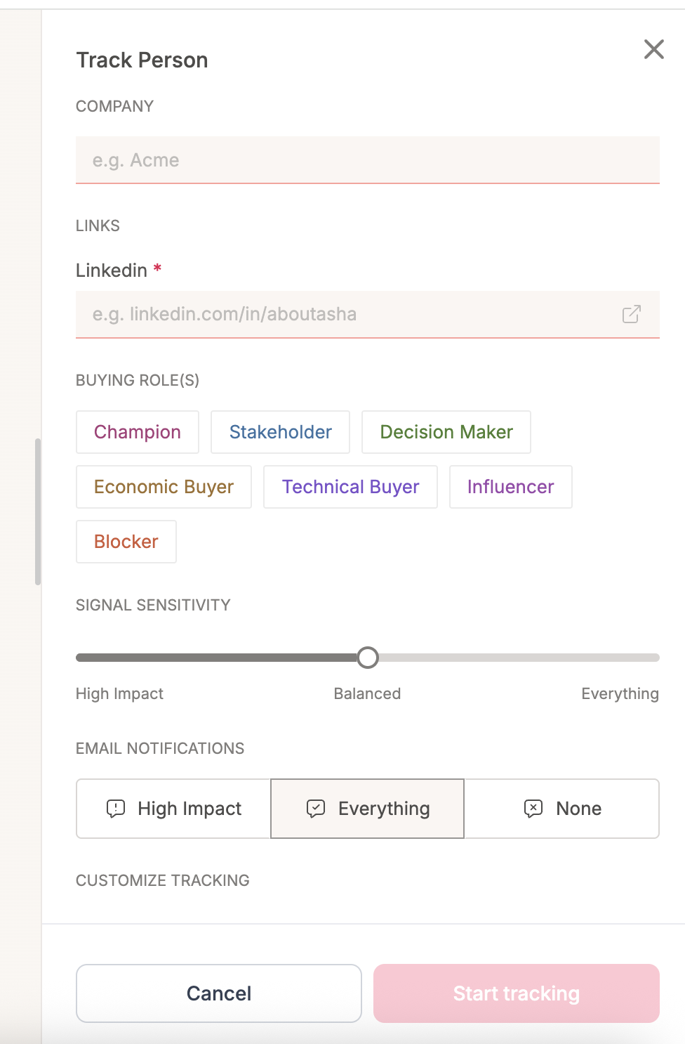
- Add Company:
Links the individual to the parent account context so their signals are surfaced in the correct company feed.
- Stakeholder Link (LinkedIn): T
Add the LinkedIn profile URL the AI agent uses to monitor this person’s activity, posts, and career movements.
- Buying Role(s):
Champion Stakeholder Decision Maker Economic Buyer Technical Buyer Influencer Blocker
Assign a political role to each person to help the AI understand the buying group dynamics.
This shapes how signals about this individual are interpreted and prioritized in the feed.
- Signal Sensitivity Controls:
How many signals are surfaced for this individual.
High Impact, Everything, or None
- Customize Tracking:
An optional instruction to watch for specific behaviors (e.g., “Career moves and social posts”).

- Email Notifications
Set independently of the parent company’s notification settings.
- Start Tracking
⚠ Note Tag any stakeholder who has previously stalled or killed a deal as a Blocker. The AI agent will surface signals about their activity — promotions, departures, or public statements — that may indicate a shift in their influence or an opportunity to re-engage.

Today’s Brief (Main Signals Area)
Your daily Signal feed of synthesized account and stakeholder intelligence, filtered and prioritized by your AI agents.
The main signal feeds with header controls and filter bar

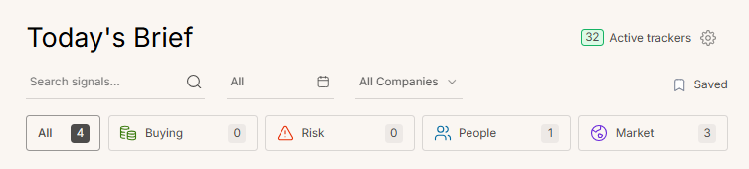
- Active Trackers: Set up accounts and stakeholders you want to track
- Signal Filters: Filter by Buying (intent), Risk, People, or Market
- Signal Card: AI-synthesized summary of the external event
- Confidence Indicator: Number of sources the signal was grounded in across the selected filters.

Header & Navigation
Your command bar for controlling the signal feed.
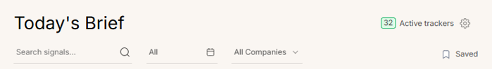
Active Trackers: Displays the total count of monitored entities (companies + stakeholders). Acts as a button to navigate directly to tracker settings.
Search Signals: Search your signals by keyword, entity, or topic to surface relevant intelligence instantly.
Date Filter: Filter signals by time horizon (e.g., Today, Last Week) to prioritize the most immediate intelligence.
Saved: Quick access to all insights you’ve bookmarked.

Signal Filters
Four intelligence categories — each with a distinct color for instant recognition.
■ All A consolidated feed of every signal across all categories.
▦ Buying: Signals indicating intent such as money, budget, active projects, or growth — events that open a door to a conversation.
△ Risk: Critical alerts regarding deal blockers — budget cuts, layoffs, legal constraints, or procurement freezes.
◉ People: Updates on stakeholder movement: hires, departures, promotions, and social posts that shift influence.
◎ Market: Strategic shifts, competitor moves, and product launches that change the selling landscape.

Signal Feed
Your real-time stream of synthesized intelligence displayed as individual signal cards.
Signal Card: A synthesized summary of the external event, translated into deal-relevant language by the AI agent.
Tag :The specific sub-category of the change (e.g., “Network Outage,” “Decision Centralization”) for rapid scanning.
Confidence Indicator: Shows the number of grounded sources used to generate the signal so you know how well-evidenced each insight is.

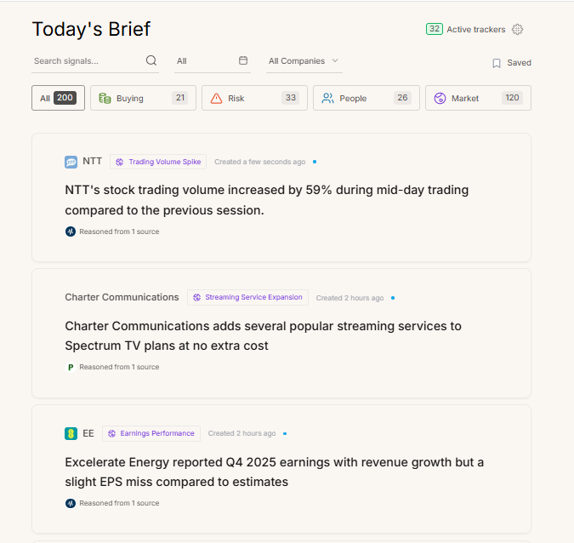
Signal Card
Tag
Confidence Indicator

Intelligence Panel
Click any signal card to open the Intelligence Panel. Five tabs take you from synthesized analysis to raw evidence, historical context, firmographic data, and agent configuration.
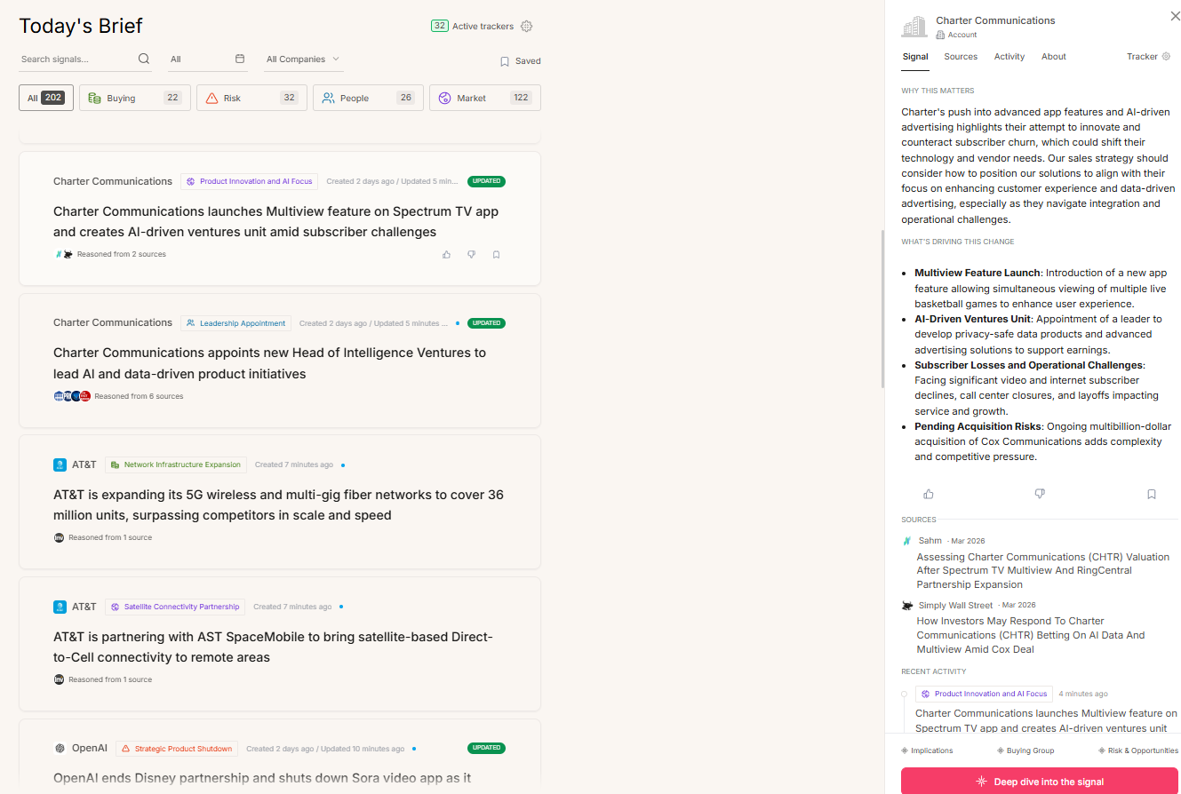


Signal | Sources | Activity | About | Tracker

Signal Tab
The default view shows synthesized intelligence with insight categories.
What It Means: The synthesized analysis section — distinguishes AI reasoning from raw news.
Insight Categories: CONSTRAINT, INFLUENCE, MOMENTUM, POSITIONING — scan for specific deal risks or opportunities.
Strategic Tags: A 1–2-word label (e.g., “Cost-Containment,” “Power Shift”) that summarizes the nature of the change.
Narrative Translation: Translates the external event into internal deal mechanics.
Rate: Thumbs up / down to train the agent on relevance for your specific deal.
Bookmark: Save this insight to the Saved filter for pre-call preparation.
Share Copy or export the insight for sharing in your messaging tools or email.
★ Pro Tip Rate signals regularly — even a few thumbs down per week meaningfully improves the agent’s relevance over time.

Sources Tab
Transparent access to the raw evidence behind every signal.
Evidence List: The specific documents, news articles, or reports the AI analyzed to form its conclusion.
Contextual Snippets: The exact quote or data point extracted from the source, allowing you to verify the AI’s reasoning.
Source Metadata: Date and origin of the information to establish freshness and credibility.

Activity Tab
A historical timeline of all signals for this account.
Chronological Feed: A timeline of every signal detected, showing whether the current event is an anomaly or part of a pattern.
Signal Tags: Visual badges (Buying, People, Market, Risk) to scan the timeline for specific types of momentum.
Narrative Threads: Connects related events to show cause-and-effect across time.
★ Pro Tip Use the Activity tab before renewal conversations — a pattern of Risk signals is a stronger negotiating data point than a single alert.

About Tab
Firmographic context to ground you before a call.
Firmographic Snapshot: Revenue, headcount, industry, and headquarters at a glance.
Stock Performance: A 12-month chart indicating macro-economic health and market sentiment.
Company Description: A brief summary of the entity’s core business operations.

Sales Workflows
Use Pulse to turn external changes into next actions. The workflows below show when to check Pulse, what to look for, and what to do next in your sales motion.
Workflow 1: Daily 10-minute routine (all roles)
- Open Today’s Brief: filter to your top accounts (or use Saved if you bookmark during the week).
- Scan for high-impact signals: prioritize Buying and People first, then check Risk for deal blockers.
- Open the Intelligence Panel: confirm “What it means” and quickly validate via Sources.
- Decide next action: outreach, internal alignment, meeting request, or deal plan update (use the Signal-to-Action Matrix below).
- Bookmark what matters: save signals you want to reference before calls, QBRs, or exec updates.
Workflow 2: Pre-call preparation (5 minutes)
- Set the feed to the specific company you’re meeting with (All Companies → select account).
- Review the last 7–30 days using the Date Filter to understand momentum and narrative.
- Open the top 1–3 signals and capture: What changed? Why now? What’s the implication for the customer’s priorities?
- Check People signals for stakeholder movement; adjust who you reference and who you ask to meet.
- Bring one insight + one question into the call (e.g., “I saw X—how is that impacting Y?”).
Workflow 3: Prospecting / first outreach (SDR/AE)
- Track the target account as Prospect and keep Signal Sensitivity on Balanced (or Everything for priority accounts).
- Filter for Buying signals to find a reason to reach out (budget, initiative, hiring, expansion, transformation).
- Open the signal → validate the key detail in Sources → capture a 1-line “why you, why now.”
- Track 2–5 stakeholders and assign buying roles (Champion/Decision Maker/Economic Buyer) to shape prioritization.
- Use the Signal-to-Action Matrix to choose: email, LinkedIn message, or call, and reference the signal in the first 2 lines.
Workflow 4: Active deal / renewal (AE/CSM)
- Switch the account-to-Account relationship type and ensure key stakeholders are tracked with roles.
- Check Risk signals weekly for early warnings (cuts, layoffs, procurement freeze, leadership changes).
- Use the Activity tab to identify patterns (one signal = noise; repeated signals = trend).
- When a key stakeholder changes roles/leaves, update your buying group map and re-confirm decision process.
- Bookmark signals you’ll use in QBRs, exec updates, and renewal planning.

Signal-to-Action Matrix
Use this matrix to translate common signals into concrete next steps. Always open the signal and validate the key detail in Sources before you reference it externally.
Signal type | Examples you may see | What it usually means | Next best action
Buying | Budget increase, transformation initiative, new program, hiring in a function you sell to | A funded priority and a reason to engage now | Outreach within 24–48h: reference the initiative and ask a discovery question; request the right stakeholder meeting.
People | New CIO/VP hire, champion promoted, decision-maker moved, influencer posting about your category | Power/influence shift; opportunity to reset messaging and mapping | Update buying group: track the person, assign role, and ask your internal team who owns the relationship; request an intro or send a tailored note.
Risk | Layoffs, budget freeze, procurement tightening, legal/regulatory change, outage or major incident | Deal friction likely; urgency to de-risk and revalidate process | Run a deal checkpoint: confirm budget, sponsor, and timeline; align with leadership; prepare options (scope, phased rollout) to protect momentum.
Market | Competitor partnership, new product launch, M&A, strategic shift, public roadmap changes | Competitive landscape changed; positioning needs adjustment | Arm your talk track: update competitive POV, add 1–2 discovery questions, and share an internal heads-up to the account team.
★ Operational Tip After you act on a signal, bookmark it and add a short note in your deal/account record (what changed, your hypothesis, and the next step). This keeps your team aligned and makes QBRs faster.

