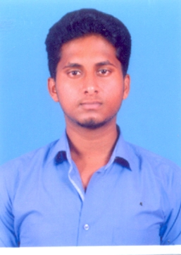Ilavarasan b

Address :Door no :243, Mariyamman street, pethanaikanpalayam (TK),Salem (DT).   
Pin Code :636104  
Mobile :9597705954  
Email : [livewithcoding@gmail.com](mailto:livewithcoding@gmail.com)

Linkedin : <https://www.linkedin.com/in/ilavarasan-dev-8ba480140>

Github : <https://github.com/ilavarasan-SWE>

|  |
| --- |
| **Objective** |
| A Computer Science professional seeking challenging opportunity to work for an organization to enhance my knowledge, skills and techniques which can benefit the organization. | |

|  |
| --- |
| **Educational Qualification** |
| **B. Tech (IT)**  (2016-2020) | **Muthayammal engineering college(Autonomous),rasipuram**  Marks: 8.4 CGPA |
| **H.S.C**  (2014-2016) | **Thiagarajar matric higher secondary school,Valapady**  Marks:80.01% |
| **S.S.LC**  (2013-2014) | **Thiagarajar matric higher secondary school,Valapady**  Marks:96.05% |

|  |
| --- |
| **Area of Interest** |
| Java  Datastructures | |

|  |
| --- |
| **Technical Skills** |
| **Languages** | C,java,python. |
| **Operating System** | Windows |
| **Databases** | MySQL |
| **Java Technologies** | Servlet.JDBC |
| **IDE** | Eclipse ,spyder(anaconda) |

|  |
| --- |
| **Personal skills** |
| Good communication & presentation skills.  Hardworking & eager to learn.  Ability to cope with the changing environment. | |

|  |
| --- |
| **Accolates** |
| * Completed “**Joy of computing using python” Nptel** certification coursewith an average score of **85%** . * Completed “**Internet of things” Nptel** certification coursewith an average score of **91%.** * Secured **first price** in **technical quiz** conducted in Tagore college of technology. * Participated in **chem quiz** and won **second price** in college campus. * Completed “**Business English communication (BEC)”** course. | |

|  |
| --- |
| **Extracurricular activities** |
| * Participated in Android App Development workshop * Participated in Software testing tools workshop. | |

|  |
| --- |
| **Personal particulars** |
| **Father’s Name** | Mr.S.Boopathi |
| **Mother’s Name** | Mrs.B.Valarmathi |
| **Date of Birth** | 05.11.1998 |
| **Marital Status** | Single |
| **Religion** | Hindu |
| **Nationality** | Indian |

**Declaration**

I hereby declare that the above information is correct to the best of my knowledge and belief.

**Date: 15.06.2019 Signature**

**Place: Rasipuram B.Ilavarasan**