**Week – 4**

**SUPER SET ID : 6389675**

**1.Create a Spring Web Project using Maven**

**// SpringLearnApplication.java:**

package com.cognizant.spring_learn;

import org.springframework.boot.SpringApplication;

import org.springframework.boot.autoconfigure.SpringBootApplication;

*@SpringBootApplication*

public class SpringLearnApplication {

public static void main(String[] args) {

SpringApplication.*run*(SpringLearnApplication.class, args);

}

}

**// SpringLearnApplicationTests.java:**

package com.cognizant.spring_learn;

import org.junit.jupiter.api.Test;

import org.springframework.boot.test.context.SpringBootTest;

*@SpringBootTest*

class SpringLearnApplicationTests {

*@Test*

void contextLoads() {

}

}

**// Pom.xml:**

<?xml version="1.0" encoding="UTF-8"?>

<project xmlns="http://maven.apache.org/POM/4.0.0" xmlns:xsi="http://www.w3.org/2001/XMLSchema-instance"

xsi:schemaLocation="http://maven.apache.org/POM/4.0.0 https://maven.apache.org/xsd/maven-4.0.0.xsd">

<modelVersion>4.0.0</modelVersion>

<parent>

<groupId>org.springframework.boot</groupId>

<artifactId>spring-boot-starter-parent</artifactId>

<version>3.5.3</version>

<relativePath/> <!-- lookup parent from repository -->

</parent>

<groupId>com.cognizant</groupId>

<artifactId>spring-learn</artifactId>

<version>0.0.1-SNAPSHOT</version>

<name>spring-learn</name>

<description>Demo project for Spring Boot</description>

<url/>

<licenses>

<license/>

</licenses>

<developers>

<developer/>

</developers>

<scm>

<connection/>

<developerConnection/>

<tag/>

<url/>

</scm>

<properties>

<java.version>24</java.version>

</properties>

<dependencies>

<dependency>

<groupId>org.springframework.boot</groupId>

<artifactId>spring-boot-starter-web</artifactId>

</dependency>

<dependency>

<groupId>org.springframework.boot</groupId>

<artifactId>spring-boot-devtools</artifactId>

<scope>runtime</scope>

<optional>true</optional>

</dependency>

<dependency>

<groupId>org.springframework.boot</groupId>

<artifactId>spring-boot-starter-test</artifactId>

<scope>test</scope>

</dependency>

</dependencies>

<build>

<plugins>

<plugin>

<groupId>org.springframework.boot</groupId>

<artifactId>spring-boot-maven-plugin</artifactId>

</plugin>

</plugins>

</build>

</project>

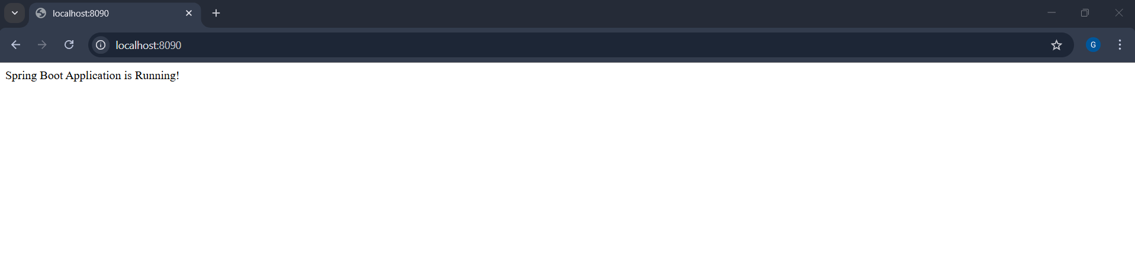**OUTPUT:**

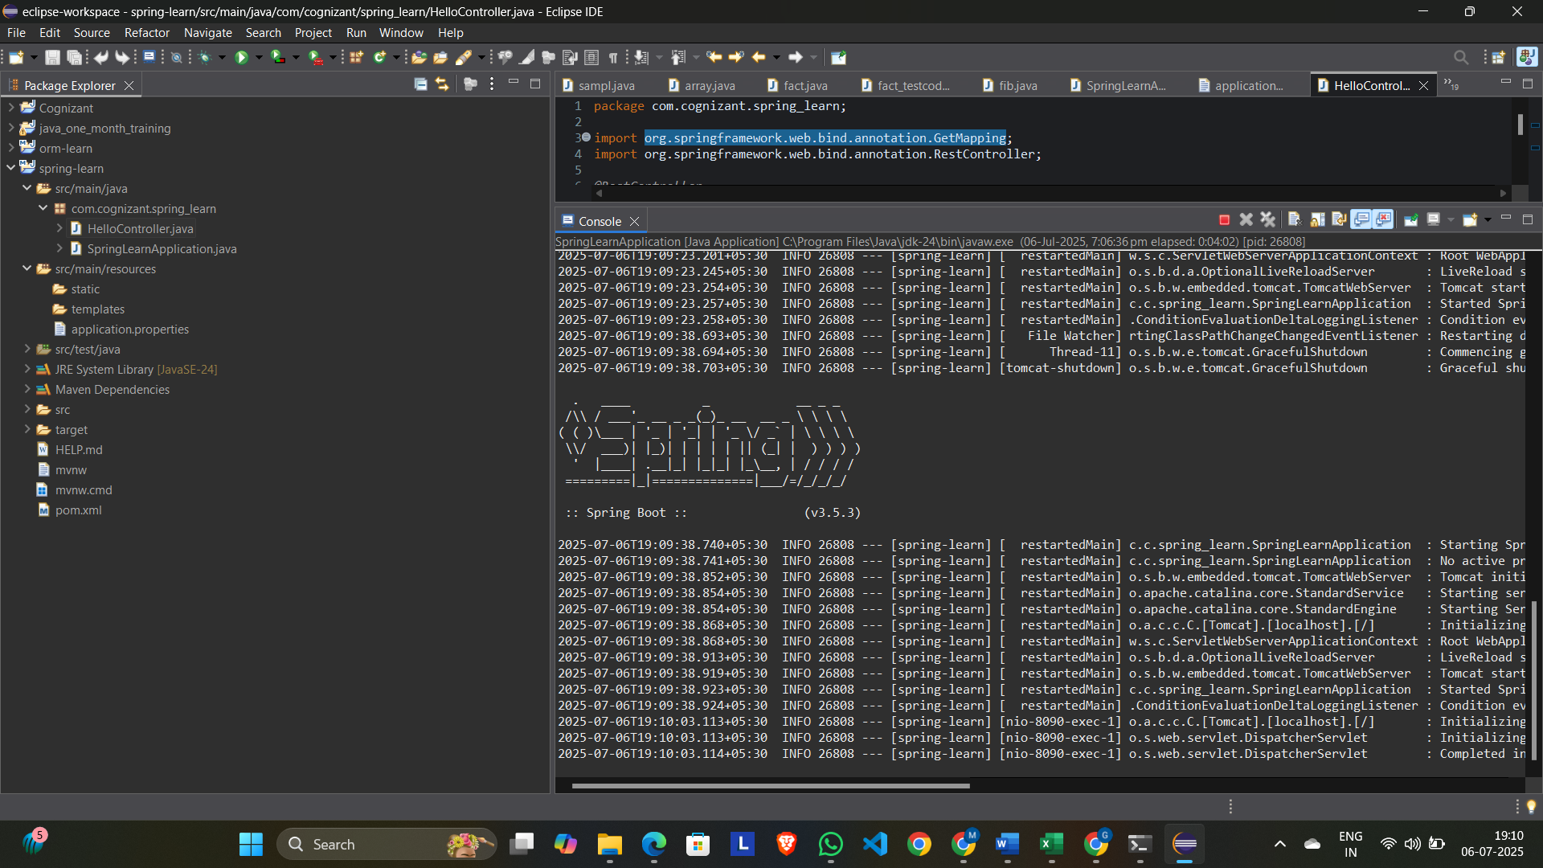

--------------------------------------------------------------------------------------------------------------------------------------

**2.Spring Core – Load Country from Spring Configuration XML**:

**// Country.java:**

package com.cognizant.spring_learn;

import org.slf4j.Logger;

import org.slf4j.LoggerFactory;

public class Country {

private static final Logger ***LOGGER*** = LoggerFactory.*getLogger*(Country.class);

private String code;

private String name;

public Country() {

***LOGGER***.debug("Inside Country Constructor.");

}

public String getCode() {

***LOGGER***.debug("Inside getCode()");

return code;

}

public void setCode(String code) {

***LOGGER***.debug("Inside setCode()");

this.code = code;

}

public String getName() {

***LOGGER***.debug("Inside getName()");

return name;

}

public void setName(String name) {

***LOGGER***.debug("Inside setName()");

this.name = name;

}

*@Override*

public String toString() {

return "Country [code=" + code + ", name=" + name + "]";

}

}

**// SpringLearnApplication.java:**

package com.cognizant.spring_learn;

import org.slf4j.Logger;

import org.slf4j.LoggerFactory;

import org.springframework.context.ApplicationContext;

import org.springframework.context.support.ClassPathXmlApplicationContext;

public class SpringLearnApplication {

private static final Logger ***LOGGER*** = LoggerFactory.*getLogger*(SpringLearnApplication.class);

public static void main(String[] args) {

***LOGGER***.info("START");

*displayCountry*();

***LOGGER***.info("END");

}

public static void displayCountry() {

ApplicationContext context = new ClassPathXmlApplicationContext("country.xml");

Country country = context.getBean("country", Country.class);

***LOGGER***.debug("Country : {}", country.toString());

}

}

**// Country.xml:**

<?xml version="1.0" encoding="UTF-8"?>

<beans xmlns="http://www.springframework.org/schema/beans"

xmlns:xsi="http://www.w3.org/2001/XMLSchema-instance"

xsi:schemaLocation="http://www.springframework.org/schema/beans

https://www.springframework.org/schema/beans/spring-beans.xsd">

<bean id="country" class="com.cognizant.spring_learn.Country">

<property name="code" value="IN" />

<property name="name" value="India" />

</bean>

</beans>

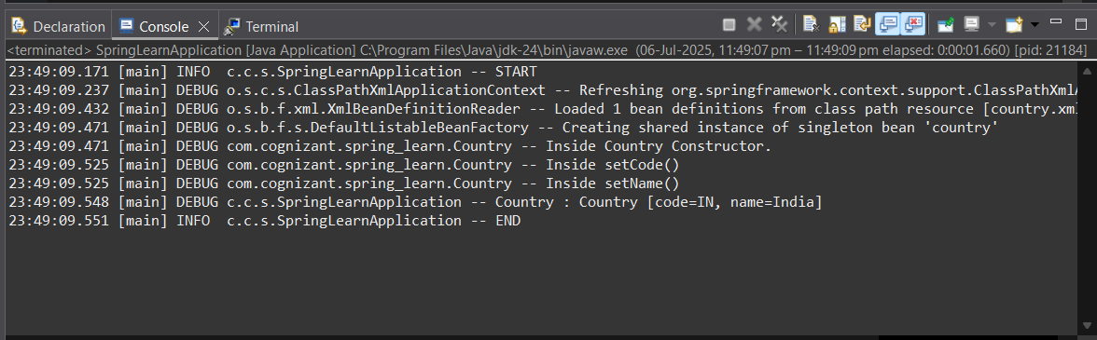**OUTPUT:**

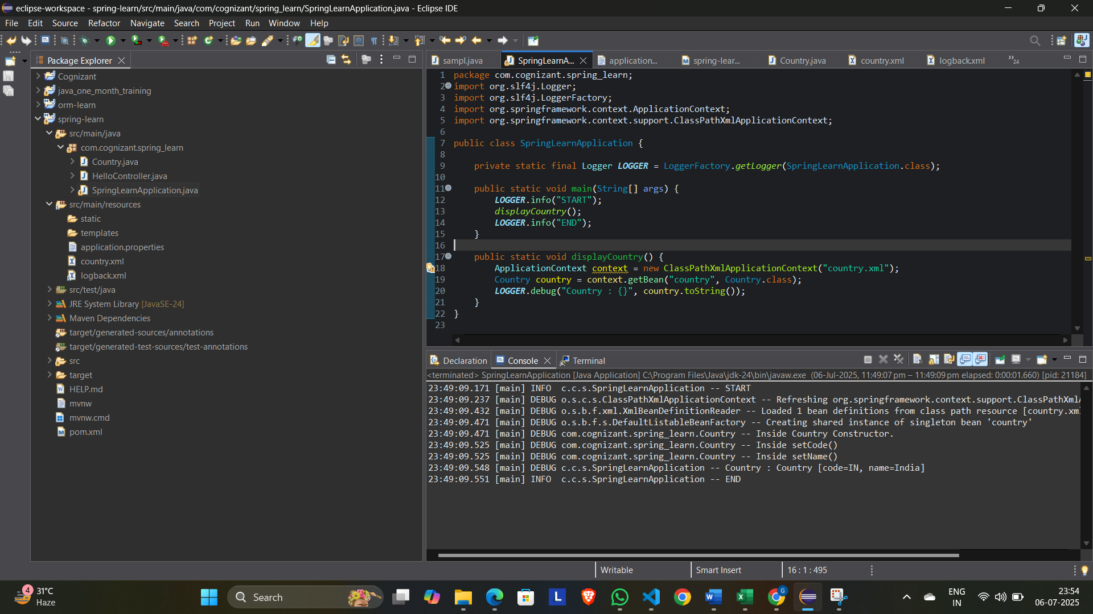--------------------------------------------------------------------------------------------------------------------------------------

**3.Hello World RESTful Web Service:**

**// Country.java:**

package com.cognizant.spring_learn;

import org.slf4j.Logger;

import org.slf4j.LoggerFactory;

public class Country {

private static final Logger ***LOGGER*** = LoggerFactory.*getLogger*(Country.class);

private String code;

private String name;

public Country() {

***LOGGER***.debug("Inside Country Constructor.");

}

public String getCode() {

***LOGGER***.debug("Inside getCode()");

return code;

}

public void setCode(String code) {

***LOGGER***.debug("Inside setCode()");

this.code = code;

}

public String getName() {

***LOGGER***.debug("Inside getName()");

return name;

}

public void setName(String name) {

***LOGGER***.debug("Inside setName()");

this.name = name;

}

*@Override*

public String toString() {

return "Country [code=" + code + ", name=" + name + "]";

}

}

**// SpringLearnApplication.java:**

package com.cognizant.spring_learn;

import com.cognizant.spring_learn.Country;

import org.slf4j.Logger;

import org.slf4j.LoggerFactory;

import org.springframework.boot.SpringApplication;

import org.springframework.boot.autoconfigure.SpringBootApplication;

import org.springframework.context.ApplicationContext;

import org.springframework.context.support.ClassPathXmlApplicationContext;

*@SpringBootApplication*

public class SpringLearnApplication {

private static final Logger ***LOGGER*** = LoggerFactory.*getLogger*(SpringLearnApplication.class);

public static void main(String[] args) {

***LOGGER***.info("START");

SpringApplication.*run*(SpringLearnApplication.class, args);

*displayCountry*();

***LOGGER***.info("END");

}

public static void displayCountry() {

ApplicationContext context = new ClassPathXmlApplicationContext("country.xml");

Country country = context.getBean("country", Country.class);

***LOGGER***.debug("Country : {}", country.toString());

}

}

**// HelloController.java:**

package com.cognizant.spring_learn.controller;

import org.slf4j.Logger;

import org.slf4j.LoggerFactory;

import org.springframework.web.bind.annotation.GetMapping;

import org.springframework.web.bind.annotation.RestController;

*@RestController*

public class HelloController {

private static final Logger ***LOGGER*** = LoggerFactory.*getLogger*(HelloController.class);

*@GetMapping*("/hello")

public String sayHello() {

***LOGGER***.info("START - sayHello()");

String message = "Hello World!!";

***LOGGER***.info("END - sayHello()");

return message;

}

}

**OUTPUT:**

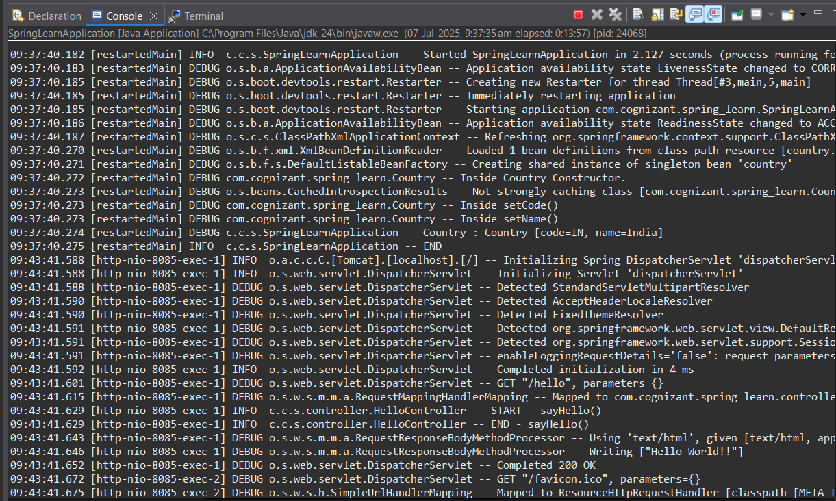

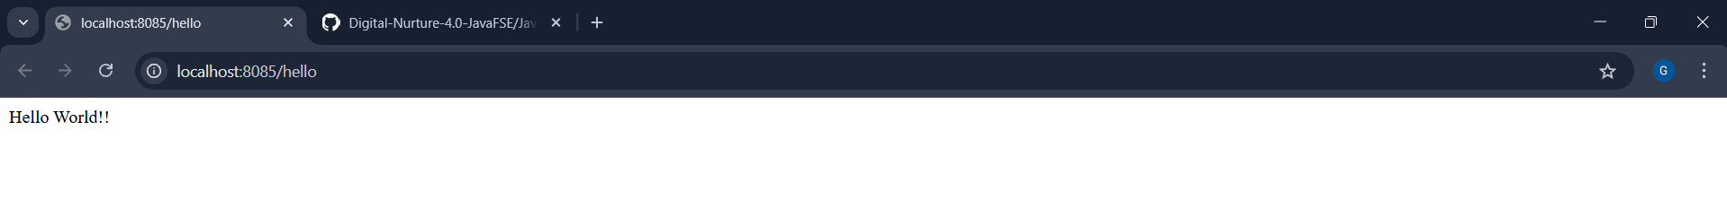

--------------------------------------------------------------------------------------------------------------------------------------

**4.REST - Country Web Service:**

**// SpringLearnApplication.java:**

package com.cognizant.spring_learn;

import com.cognizant.spring_learn.Country;

import org.slf4j.Logger;

import org.slf4j.LoggerFactory;

import org.springframework.boot.SpringApplication;

import org.springframework.boot.autoconfigure.SpringBootApplication;

import org.springframework.context.ApplicationContext;

import org.springframework.context.support.ClassPathXmlApplicationContext;

*@SpringBootApplication*

public class SpringLearnApplication {

private static final Logger ***LOGGER*** = LoggerFactory.*getLogger*(SpringLearnApplication.class);

public static void main(String[] args) {

***LOGGER***.info("START");

SpringApplication.*run*(SpringLearnApplication.class, args);

*displayCountry*();

***LOGGER***.info("END");

}

public static void displayCountry() {

ApplicationContext context = new ClassPathXmlApplicationContext("country.xml");

Country country = context.getBean("country", Country.class);

***LOGGER***.debug("Country : {}", country.toString());

}

}

**CountryController.java:**

package com.cognizant.spring_learn.controller;

import com.cognizant.spring_learn.Country;

import org.springframework.context.ApplicationContext;

import org.springframework.context.support.ClassPathXmlApplicationContext;

import org.springframework.web.bind.annotation.RequestMapping;

import org.springframework.web.bind.annotation.RestController;

*@RestController*

public class CountryController {

*@RequestMapping*("/country")

public Country getCountryIndia() {

ApplicationContext context = new ClassPathXmlApplicationContext("country.xml");

Country country = context.getBean("country", Country.class);

return country;

}

}

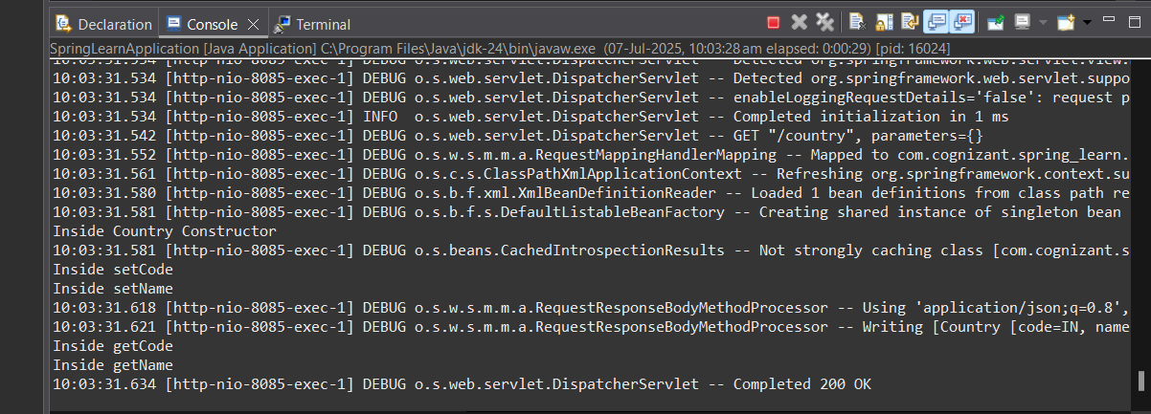**OUTPUT:**

--------------------------------------------------------------------------------------------------------------------------------------

**5.REST - Get country based on country code**

**// CountryService.java:**

package com.cognizant.spring_learn.service;

import com.cognizant.spring_learn.Country;

import org.springframework.context.ApplicationContext;

import org.springframework.context.support.ClassPathXmlApplicationContext;

import org.springframework.stereotype.Service;

import java.util.List;

*@Service*

public class CountryService {

public Country getCountry(String code) {

ApplicationContext context = new ClassPathXmlApplicationContext("country.xml");

List<Country> countries = context.getBean("countryList", List.class);

return countries.stream()

.filter(c -> c.getCode().equalsIgnoreCase(code))

.findFirst()

.orElse(null); // or throw custom exception

}

}

**// CountryController.java:**

package com.cognizant.spring_learn.controller;

import com.cognizant.spring_learn.Country;

import com.cognizant.spring_learn.service.CountryService;

import org.springframework.beans.factory.annotation.Autowired;

import org.springframework.web.bind.annotation.*;

*@RestController*

public class CountryController {

*@Autowired*

private CountryService countryService;

*@GetMapping*("/country/{code}")

public Country getCountry(*@PathVariable* String code) {

return countryService.getCountry(code);

}

}

**// SpringLearnApplication.java:**

package com.cognizant.spring_learn;

import com.cognizant.spring_learn.Country;

import org.slf4j.Logger;

import org.slf4j.LoggerFactory;

import org.springframework.boot.SpringApplication;

import org.springframework.boot.autoconfigure.SpringBootApplication;

import org.springframework.context.ApplicationContext;

import org.springframework.context.support.ClassPathXmlApplicationContext;

*@SpringBootApplication*

public class SpringLearnApplication {

private static final Logger ***LOGGER*** = LoggerFactory.*getLogger*(SpringLearnApplication.class);

public static void main(String[] args) {

***LOGGER***.info("START");

SpringApplication.*run*(SpringLearnApplication.class, args);

*displayCountry*();

***LOGGER***.info("END");

}

public static void displayCountry() {

ApplicationContext context = new ClassPathXmlApplicationContext("country.xml");

Country country = context.getBean("country", Country.class);

***LOGGER***.debug("Country : {}", country.toString());

}

}

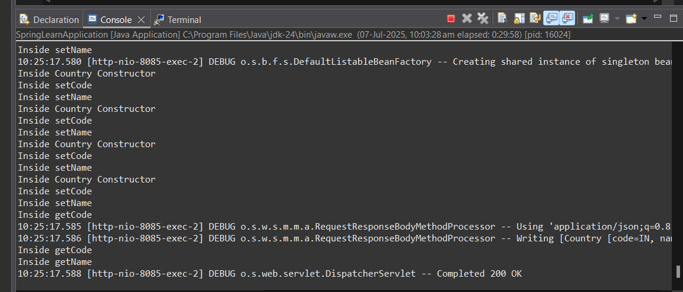**OUTPUT:**

--------------------------------------------------------------------------------------------------------------------------------------

**6.Create authentication service that returns JWT** 

**// SpringLearnApplication.java:**

package com.cognizant.spring_learn;

import com.cognizant.spring_learn.Country;

import org.slf4j.Logger;

import org.slf4j.LoggerFactory;

import org.springframework.boot.SpringApplication;

import org.springframework.boot.autoconfigure.SpringBootApplication;

import org.springframework.context.ApplicationContext;

import org.springframework.context.support.ClassPathXmlApplicationContext;

*@SpringBootApplication*

public class SpringLearnApplication {

private static final Logger ***LOGGER*** = LoggerFactory.*getLogger*(SpringLearnApplication.class);

public static void main(String[] args) {

***LOGGER***.info("START");

SpringApplication.*run*(SpringLearnApplication.class, args);

*displayCountry*();

***LOGGER***.info("END");

}

public static void displayCountry() {

ApplicationContext context = new ClassPathXmlApplicationContext("country.xml");

Country country = context.getBean("country", Country.class);

***LOGGER***.debug("Country : {}", country.toString());

}

}

**// SecurityConfig.java:**

package com.cognizant.spring_learn.config;

import org.springframework.context.annotation.Bean;

import org.springframework.context.annotation.Configuration;

import org.springframework.security.config.Customizer;

import org.springframework.security.config.annotation.web.builders.HttpSecurity;

import org.springframework.security.core.userdetails.User;

import org.springframework.security.core.userdetails.UserDetailsService;

import org.springframework.security.provisioning.InMemoryUserDetailsManager;

import org.springframework.security.web.SecurityFilterChain;

import org.springframework.security.crypto.bcrypt.BCryptPasswordEncoder;

import org.springframework.security.crypto.password.PasswordEncoder;

*@Configuration*

public class SecurityConfig {

*@Bean*

public SecurityFilterChain filterChain(HttpSecurity http) throws Exception {

http

.csrf(csrf -> csrf.disable())

.authorizeHttpRequests(auth -> auth

.requestMatchers("/authenticate").permitAll()

.anyRequest().authenticated()

)

.httpBasic(Customizer.*withDefaults*());

return http.build();

}

*@Bean*

public UserDetailsService users() {

return new InMemoryUserDetailsManager(

User.*withUsername*("user")

.password(passwordEncoder().encode("pwd"))

.roles("USER")

.build()

);

}

*@Bean*

public PasswordEncoder passwordEncoder() {

return new BCryptPasswordEncoder();

}

}

**// JwtUtil.java:**

package com.cognizant.spring_learn.util;

import io.jsonwebtoken.Jwts;

import io.jsonwebtoken.SignatureAlgorithm;

import io.jsonwebtoken.security.Keys;

import org.springframework.stereotype.Component;

import javax.crypto.SecretKey;

import java.util.Date;

*@Component*

public class JwtUtil {

private final SecretKey SECRET_KEY = Keys.*secretKeyFor*(*SignatureAlgorithm*.***HS256***);

private static final long ***EXPIRATION_TIME*** = 1000 * 60 * 60 * 10;

public String generateToken(String username) {

return Jwts.*builder*()

.setSubject(username)

.setIssuedAt(new Date(System.*currentTimeMillis*()))

.setExpiration(new Date(System.*currentTimeMillis*() + ***EXPIRATION_TIME***))

.signWith(SECRET_KEY)

.compact();

}

}

**OUTPUT:**

