**Week – 5**

**SUPER SET ID : 6389675**

**Creating Microservices for account and loan:**

**Account Microservice:**

**AccountApplication.java:**

package com.cognizant.account;

import org.springframework.boot.SpringApplication;

import org.springframework.boot.autoconfigure.SpringBootApplication;

*@SpringBootApplication*

public class AccountApplication {

public static void main(String[] args) {

SpringApplication.*run*(AccountApplication.class, args);

}

}

**// AccountController.java:**

package com.cognizant.account;

import org.springframework.web.bind.annotation.*;

import java.util.Map;

*@RestController*

*@RequestMapping*("/accounts")

public class AccountController {

*@GetMapping*("/{number}")

public Map<String, Object> getAccountDetails(*@PathVariable* String number) {

return Map.*of*(

"number", number,

"type", "savings",

"balance", 234343

);

}

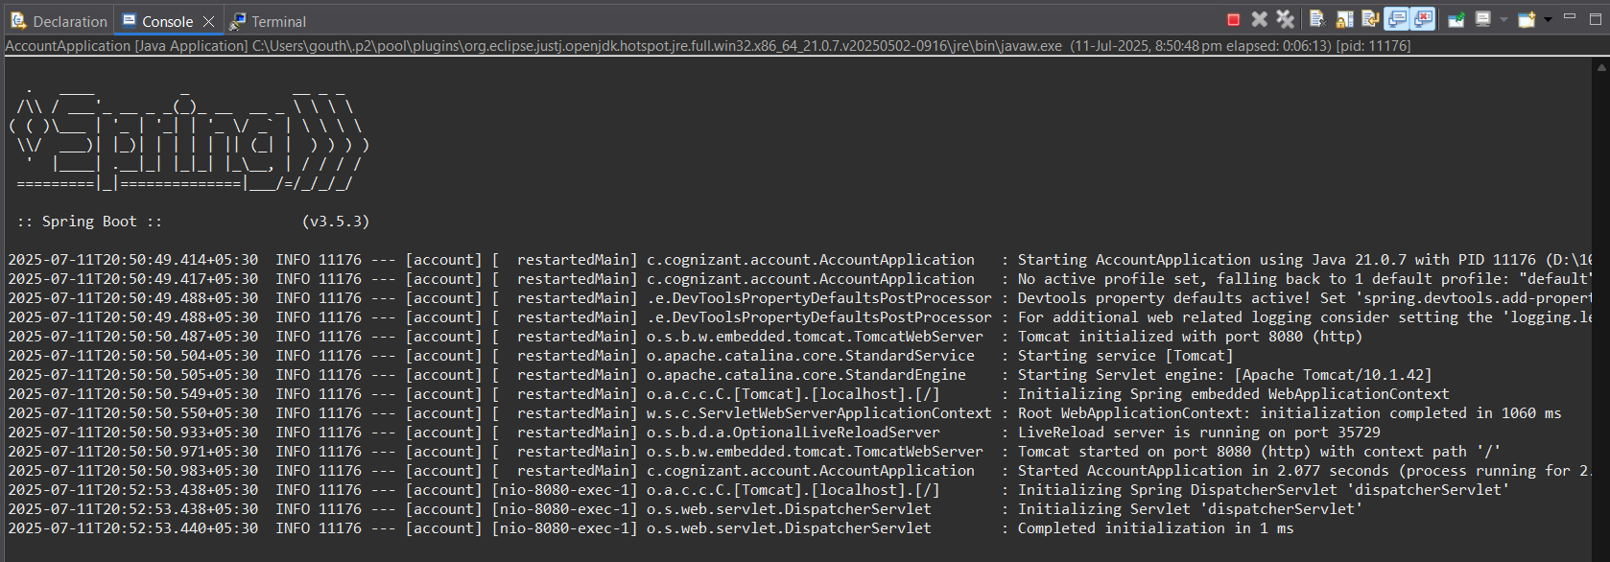**OUTPUT:**

**--------------------------------------------------------------------------------------------------------------------------------------**

**Loan Microservice:**

**LoanApplication.java:**

**package com.cognizant.loan;**

**import org.springframework.boot.SpringApplication;**

**import org.springframework.boot.autoconfigure.SpringBootApplication;**

***@SpringBootApplication***

**public class LoanApplication {**

**public static void main(String[] args) {**

**SpringApplication.*run*(LoanApplication.class, args);**

**}**

**}**

**LoanController.java:**

**package com.cognizant.loan;**

**import org.springframework.web.bind.annotation.*;**

**import java.util.Map;**

***@RestController***

***@RequestMapping*("/loans")**

**public class LoanController {**

***@GetMapping*("/{number}")**

**public Map<String, Object> getLoanDetails(*@PathVariable* String number) {**

**return Map.*of*(**

**"number", number,**

**"type", "car",**

**"loan", 400000,**

**"emi", 3258,**

**"tenure", 18**

**);**

**}**

**}**

**OUTPUT:**



