**Week – 7**

**SUPER SET ID : 6389675**

9. ReactJS-HOL.docx

1. **Set up your React app**

npx create-react-app crickerapp

cd crickerapp

npm start

**2. Create ListofPlayers.js component**

import React from 'react';

const ListofPlayers = () => {

const players = [

{ name: "Virat", score: 85 },

{ name: "Rohit", score: 40 },

{ name: "Rahul", score: 78 },

{ name: "Dhoni", score: 95 },

{ name: "Hardik", score: 68 },

{ name: "Pant", score: 88 },

{ name: "Shami", score: 56 },

{ name: "Bumrah", score: 35 },

{ name: "Ashwin", score: 80 },

{ name: "Jadeja", score: 60 },

{ name: "Gill", score: 70 }

];

// Arrow function to filter scores below 70

const filteredPlayers = players.filter(player => player.score < 70);

return (

<div style={{ padding: "20px", fontFamily: "sans-serif" }}>

<h1>🏏 List of Cricket Players</h1>

<h2>All Players</h2>

<table border="1" cellPadding="8" cellSpacing="0" style={{ borderCollapse: "collapse" }}>

<thead>

<tr>

<th>Name</th>

<th>Score</th>

</tr>

</thead>

<tbody>

{players.map((player, index) => (

<tr key={index}>

<td>{player.name}</td>

<td>{player.score}</td>

</tr>

))}

</tbody>

</table>

<h2 style={{ marginTop: "30px", color: "darkred" }}>Filtered Players (Score &lt; 70)</h2>

<table border="1" cellPadding="8" cellSpacing="0" style={{ borderCollapse: "collapse" }}>

<thead>

<tr>

<th>Name</th>

<th>Score</th>

</tr>

</thead>

<tbody>

{filteredPlayers.map((player, index) => (

<tr key={index}>

<td>{player.name}</td>

<td>{player.score}</td>

</tr>

))}

</tbody>

</table>

</div>

);

};

export default ListofPlayers;

3. **Create IndianPlayers.js component**

import React from 'react';

const IndianPlayers = () => {

// Define two arrays

const oddTeam = ['Virat', 'Rohit', 'Dhoni', 'Pant', 'Shami'];

const evenTeam = ['Rahul', 'Hardik', 'Gill', 'Ashwin', 'Jadeja'];

// Destructuring (optional but included for ES6)

const [odd1, odd2, odd3, odd4, odd5] = oddTeam;

const [even1, even2, even3, even4, even5] = evenTeam;

// Merge feature using spread operator

const T20players = ['Surya', 'Sanju'];

const RanjiPlayers = ['Iyer', 'Sarfaraz'];

const allPlayers = [...T20players, ...RanjiPlayers];

return (

<div style={{ padding: '20px', fontFamily: 'sans-serif' }}>

<h1>🏏 Indian Team Players</h1>

<h2>Odd Team Players</h2>

<ul>

{oddTeam.map((player, index) => (

<li key={index}>{player}</li>

))}

</ul>

<h2>Even Team Players</h2>

<ul>

{evenTeam.map((player, index) => (

<li key={index}>{player}</li>

))}

</ul>

<h2>All Players (Merged T20 + Ranji Trophy)</h2>

<ul>

{allPlayers.map((player, index) => (

<li key={index}>{player}</li>

))}

</ul>

</div>

);

};

export default IndianPlayers;Update App.js

import React from 'react';

import ListofPlayers from './ListofPlayers';

import IndianPlayers from './IndianPlayers';

function App() {

const flag = false; // change to true to show ListofPlayers

return (

<div>

{flag ? <ListofPlayers /> : <IndianPlayers />}

</div>

);

}

export default App;

export default App;

5. **Run the App**

npm start

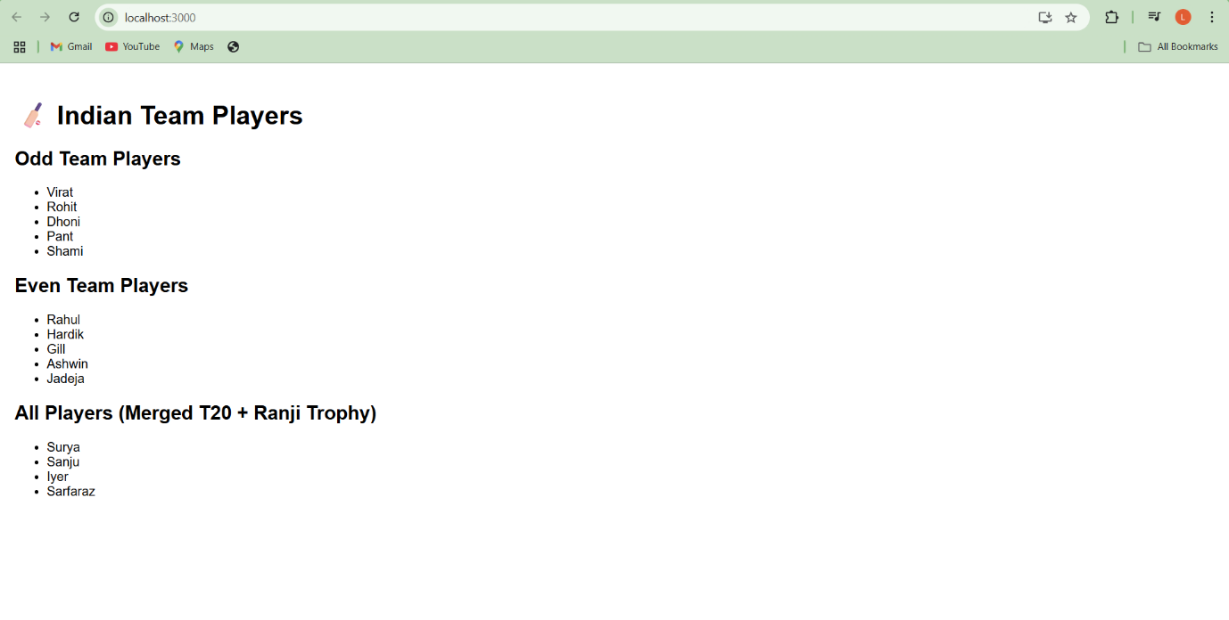**OUTPUT:**

**10. ReactJS-HOL.docx**

**Step 1: Create React App**

**npx create-react-app officespacerentalapp**

**cd officespacerentalapp**

**npm start**

**Step 2: Replace App.js with:**

**jsx**

**CopyEdit**

**import React from 'react';**

**const App = () => {**

**const offices = [**

**{**

**name: "Office A",**

**rent: 55000,**

**address: "Koramangala, Bangalore",**

**image: "https://via.placeholder.com/200x100.png?text=Office+A"**

**},**

**{**

**name: "Office B",**

**rent: 75000,**

**address: "MG Road, Bangalore",**

**image: "https://via.placeholder.com/200x100.png?text=Office+B"**

**},**

**{**

**name: "Office C",**

**rent: 60000,**

**address: "Indiranagar, Bangalore",**

**image: "https://via.placeholder.com/200x100.png?text=Office+C"**

**}**

**];**

**return (**

**<div style={{ padding: "20px", fontFamily: "Arial" }}>**

**<h1>Office Space Rental App</h1>**

**{offices.map((office, index) => (**

**<div key={index} style={{ border: "1px solid #ccc", marginBottom: "10px", padding: "10px" }}>**

**<img src={office.image} alt={office.name} style={{ width: "200px", height: "100px" }} />**

**<h2>{office.name}</h2>**

**<p><strong>Address:</strong> {office.address}</p>**

**<p>**

**<strong>Rent:</strong>{" "}**

**<span style={{ color: office.rent < 60000 ? "red" : "green" }}>**

**₹{office.rent}**

**</span>**

**</p>**

**</div>**

**))}**

**</div>**

**);**

**};**

**export default App;**

**Run the app**

**npm start**

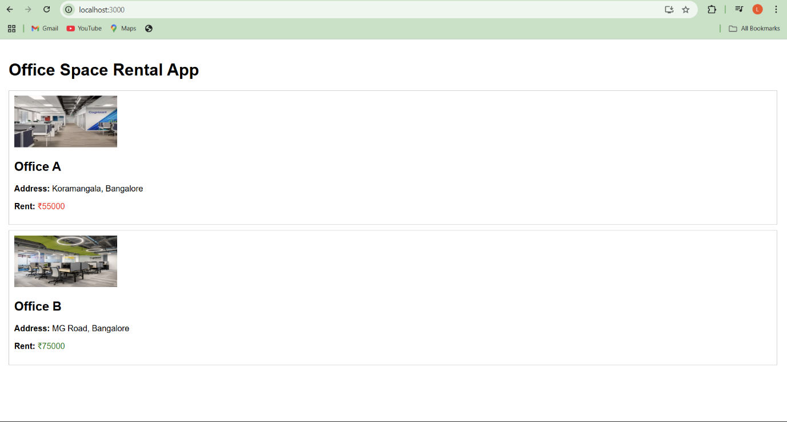**OUTPUT**:

-------------------------------------------------------------------------------------------------------------------------------------

11. ReactJS-HOL.docx

Folder Setup

npx create-react-app eventexamplesapp

cd eventexamplesapp

npm start

Replace App.js with:

import React, { useState } from "react";

import CurrencyConvertor from "./CurrencyConvertor";

function App() {

const [count, setCount] = useState(0);

const increment = () => {

setCount(prev => prev + 1);

};

const sayHello = () => {

alert("Hello! This is a static message.");

};

const handleIncrease = () => {

increment();

sayHello();

};

const decrement = () => {

setCount(prev => prev - 1);

};

const sayWelcome = (msg) => {

alert(msg);

};

const handleClickSynthetic = (e) => {

alert("I was clicked");

console.log("Synthetic Event Object:", e);

};

return (

<div style={{ padding: "20px", fontFamily: "Arial" }}>

<h1>React Event Handling Example</h1>

<h2>Counter: {count}</h2>

<button onClick={handleIncrease}>Increase</button>

<button onClick={decrement}>Decrease</button>

<hr />

<button onClick={() => sayWelcome("Welcome!")}>Say Welcome</button>

<hr />

<button onClick={handleClickSynthetic}>Synthetic Event Button</button>

<hr />

<CurrencyConvertor />

</div>

);

}

export default App;

**Create a new file: CurrencyConvertor.js**

import React, { useState } from "react";

function CurrencyConvertor() {

const [rupees, setRupees] = useState("");

const [euro, setEuro] = useState(null);

const handleChange = (e) => {

setRupees(e.target.value);

};

const handleSubmit = () => {

const inEuro = parseFloat(rupees) / 89; // Approx conversion rate

setEuro(inEuro.toFixed(2));

};

return (

<div>

<h2>Currency Convertor</h2>

<input

type="number"

value={rupees}

onChange={handleChange}

placeholder="Enter INR"

/>

<button onClick={handleSubmit}>Convert to Euro</button>

{euro && <p>Converted Amount: €{euro}</p>}

</div>

);

}

export default CurrencyConvertor;

Run the App

npm start

**OUTPUT:**

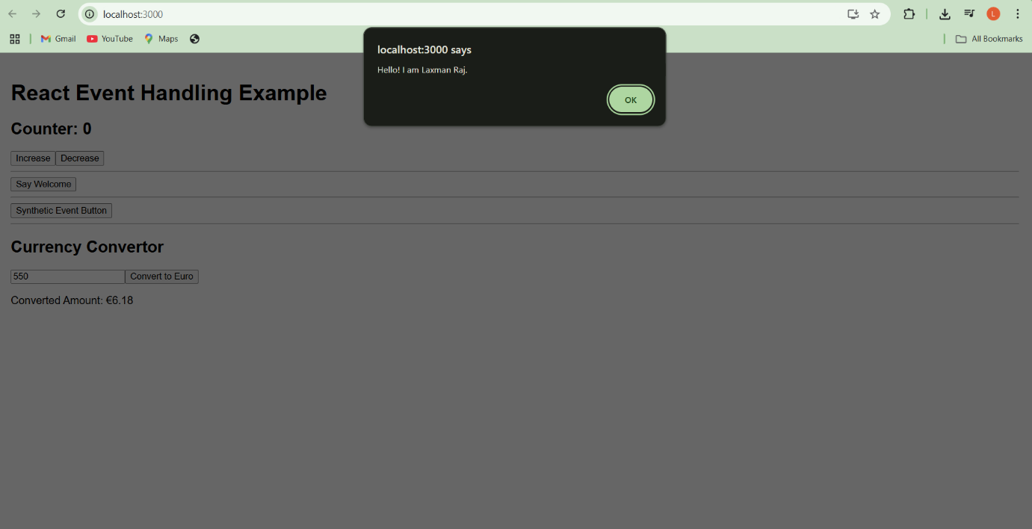

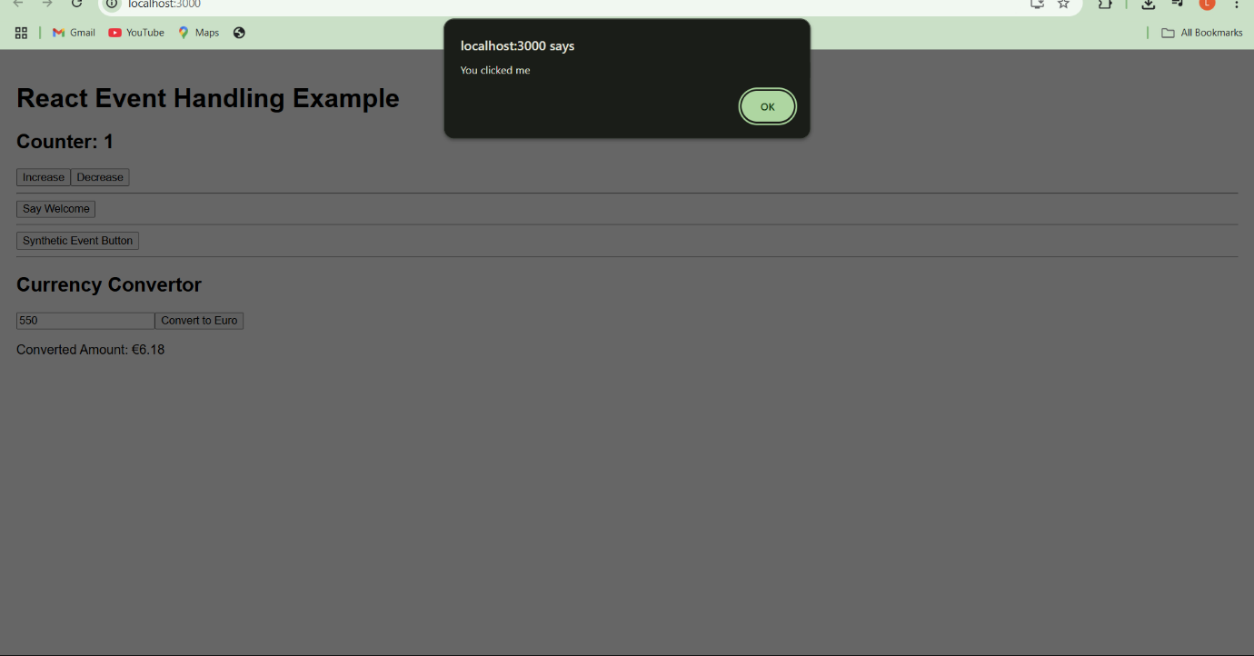

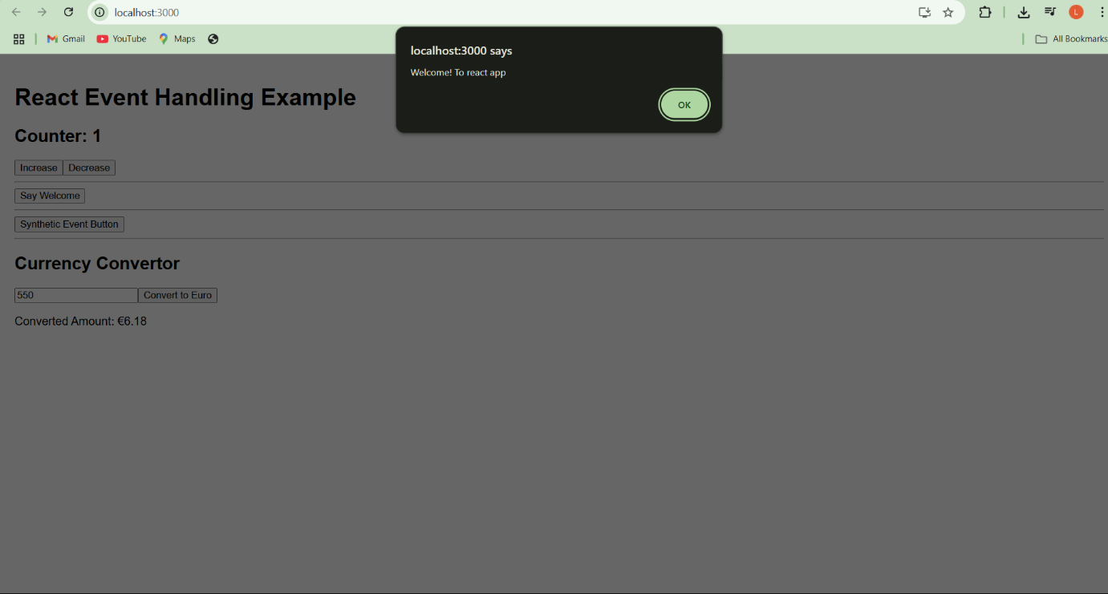

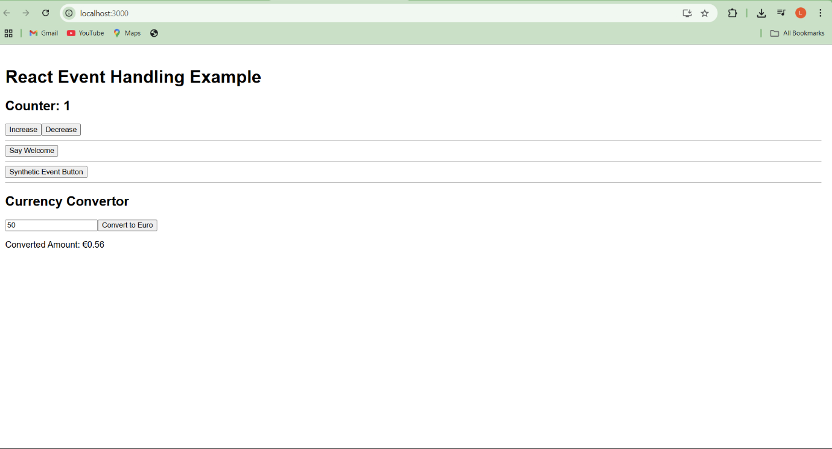

**12. ReactJS-HOL.docx**

Create your React app

npx create-react-app ticketbookingapp

cd ticketbookingapp

npm start

Replace src/App.js

import React, { useState } from "react";

function App() {

const [isLoggedIn, setIsLoggedIn] = useState(false);

const handleLogin = () => setIsLoggedIn(true);

const handleLogout = () => setIsLoggedIn(false);

let pageContent;

if (isLoggedIn) {

pageContent = (

<div>

<h2>Welcome User!</h2>

<p>You can now book your flight tickets here.</p>

<button onClick={handleLogout}>Logout</button>

</div>

);

} else {

pageContent = (

<div>

<h2>Welcome Guest</h2>

<p>Browse flights and check details. Please log in to book tickets.</p>

<button onClick={handleLogin}>Login</button>

</div>

);

}

return (

<div style={{ padding: "20px", fontFamily: "Arial" }}>

<h1>Ticket Booking App</h1>

<hr />

{pageContent}

</div>

);

}

export default App;

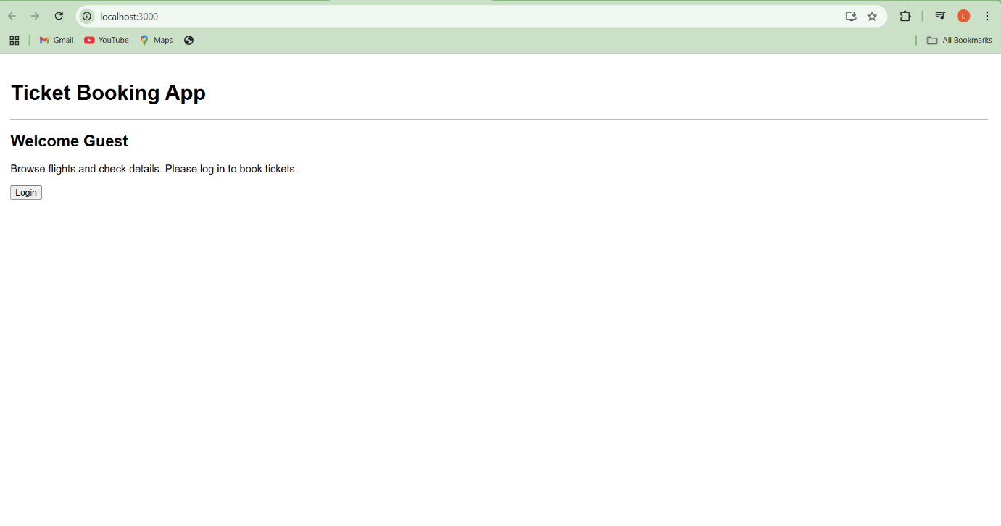

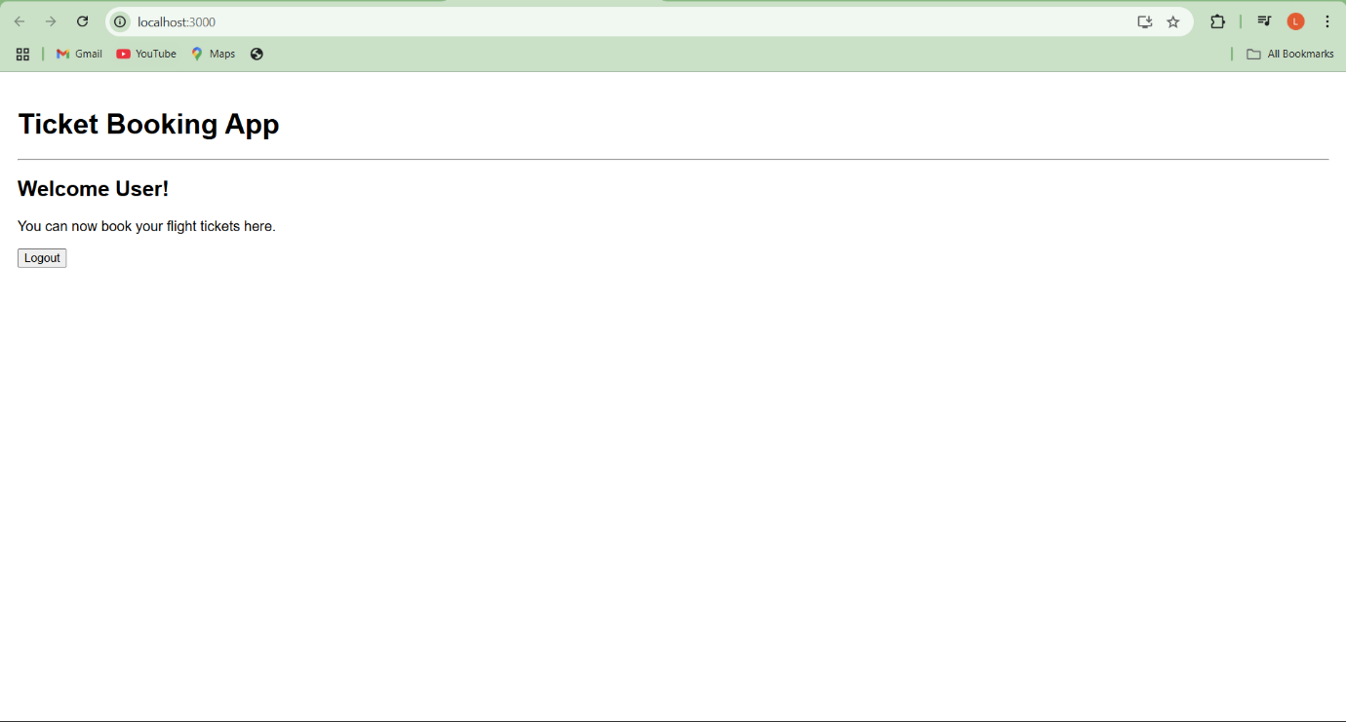

--------------------------------------------------------------------------------------------------------------------------------------

**13. ReactJS-HOL.docx**

Create React App

npx create-react-app bloggerapp

cd bloggerapp

npm start

Replace src/App.js with:

import React, { useState } from "react";

import BookDetails from "./BookDetails";

import BlogDetails from "./BlogDetails";

import CourseDetails from "./CourseDetails";

function App() {

const [section, setSection] = useState("book");

const renderComponent = () => {

// Conditional rendering using if-else

if (section === "book") {

return <BookDetails />;

} else if (section === "blog") {

return <BlogDetails />;

} else if (section === "course") {

return <CourseDetails />;

} else {

return <p>Please select a valid section.</p>;

}

};

return (

<div style={{ padding: "20px", fontFamily: "Arial" }}>

<h1>Blogger App</h1>

<div style={{ marginBottom: "10px" }}>

<button onClick={() => setSection("book")}>Book Details</button>

<button onClick={() => setSection("blog")}>Blog Details</button>

<button onClick={() => setSection("course")}>Course Details</button>

</div>

{/* Render based on current section */}

{renderComponent()}

</div>

);

}

export default App;

Create BookDetails.js

import React from "react";

const BookDetails = () => {

const books = [

{ id: 1, title: "React Made Easy", author: "Dan Abramov" },

{ id: 2, title: "Learn JS", author: "Kyle Simpson" },

];

return (

<div>

<h2>Book Details</h2>

<ul>

{books.map((book) => (

<li key={book.id}>

<strong>{book.title}</strong> by {book.author}

</li>

))}

</ul>

</div>

);

};

export default BookDetails;

BlogDetails.js

import React from "react";

const BlogDetails = () => {

const blogs = [

{ id: 101, title: "Why React Rocks", date: "2023-10-01" },

{ id: 102, title: "JSX Deep Dive", date: "2023-10-15" },

];

return (

<div>

<h2>Blog Details</h2>

{blogs.length > 0 ? (

<ul>

{blogs.map((blog) => (

<li key={blog.id}>

{blog.title} — <em>{blog.date}</em>

</li>

))}

</ul>

) : (

<p>No blogs available.</p>

)}

</div>

);

};

export default BlogDetails;

CourseDetails.js

import React from "react";

const CourseDetails = () => {

const showCourses = true; // toggle this to test conditional rendering

return (

<div>

<h2>Course Details</h2>

{/* Logical AND rendering */}

{showCourses && (

<ul>

<li>React for Beginners</li>

<li>Advanced JavaScript</li>

</ul>

)}

{!showCourses && <p>No courses available</p>}

</div>

);

};

export default CourseDetails;

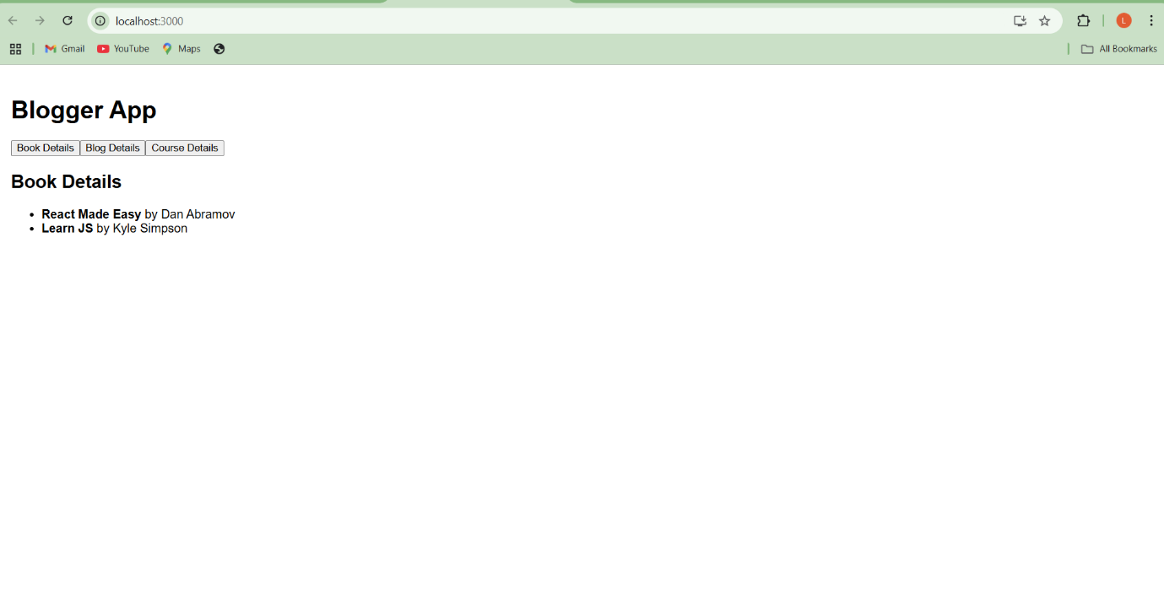**OUTPUT**:

