**E-Commerce Sales Analysis Project (2024)**

**Data Analysis Report**

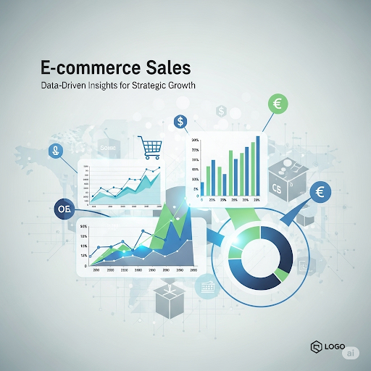

**Prepared For:** Portfolio Reviewers & Hiring Managers

**Project Summary:** This report provides a comprehensive analysis of a simulated e-commerce sales dataset for the year 2024, identifying key trends, customer demographics, and actionable business insights using Python and Excel.

**Prepared by:**

İlayda Başyiğit

ilayda_basyigit@icloud.com

https://www.linkedin.com/in/ilayda-ba%C5%9Fyi%C4%9Fit-2b0055282

**Project Repository:**

www.github.com/ilaydabasyigit

**Date:** August 3, 2025

**E-Commerce Sales Analysis Report - 2024**

**1. Executive Summary**

This report presents the analysis of e-commerce sales data for the year 2024. The project involved generating a synthetic dataset using Python, performing exploratory data analysis and visualization with Python libraries, and further in-depth analysis using Excel. Key findings include the identification of peak sales months, top-performing product categories, and customer demographics, providing valuable insights for strategic decision-making.

**2. Methodology**

The analysis was conducted in two primary phases:

* **Data Generation (Python):** A sales dataset was generated using Python's Pandas and Faker libraries. This synthetic data included details such as order ID, order date, product category, customer age, city, and total amount spent.
* **Google Colaboratory (Colab):** For running Python scripts and creating interactive visualizations directly in the cloud.
* **Data Analysis and Visualization (Python & Excel):** Python (with Matplotlib and Seaborn) was used for initial data exploration and the creation of key visualizations, including monthly sales trends, product category performance, and customer age distribution. Microsoft Excel was utilized for creating PivotTables to further analyze the data and generate a dynamic dashboard. Enhanced visualizations were also prepared using Canva for a more professional presentation.

**3. Key Findings**

**3.1. Monthly Sales Trend**

* The monthly sales analysis indicates fluctuations throughout the year. The highest sales volumes were observed in **March and November**, suggesting potential peaks around specific events or seasonal demands. A noticeable dip in sales occurred around **June**.

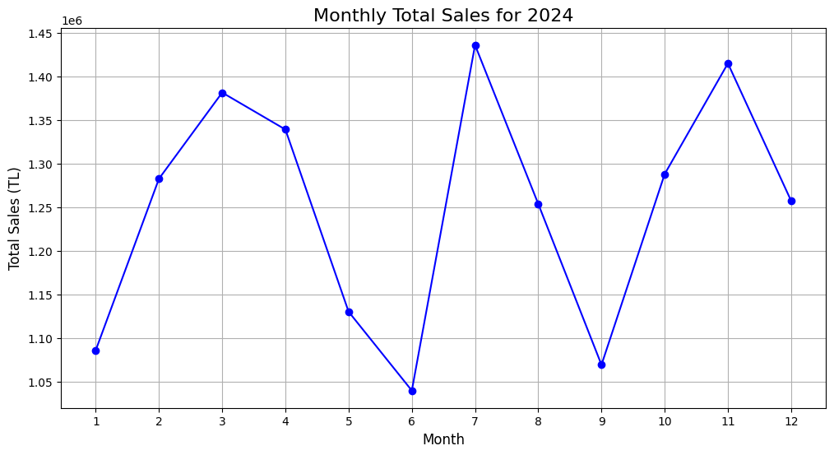

**3.2. Total Sales by Product Category**

* The analysis of sales by product category reveals that **Beauty** products generated the highest total revenue, closely followed by **Home & Garden**. **Books** and **Toys** also showed significant sales, while **Electronics** and **Clothing** had comparatively lower total sales in this dataset.

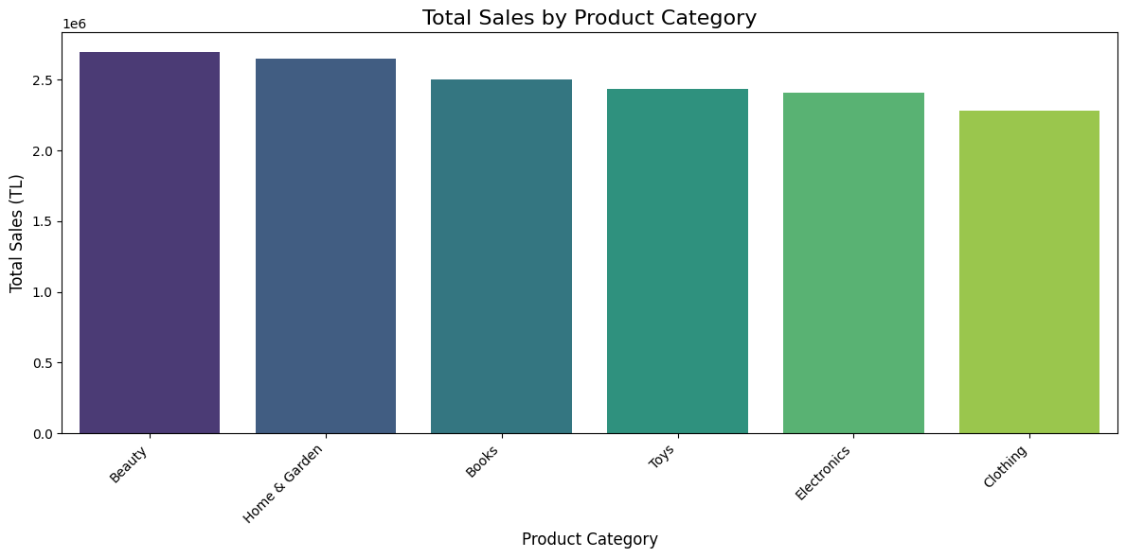

**3.3. Customer Age Distribution**

* The distribution of customer ages indicates that the majority of customers fall within the **20-35** age range, with a notable peak around the mid-20s. There is a relatively consistent presence of customers across a broader age spectrum from young adults to older individuals.

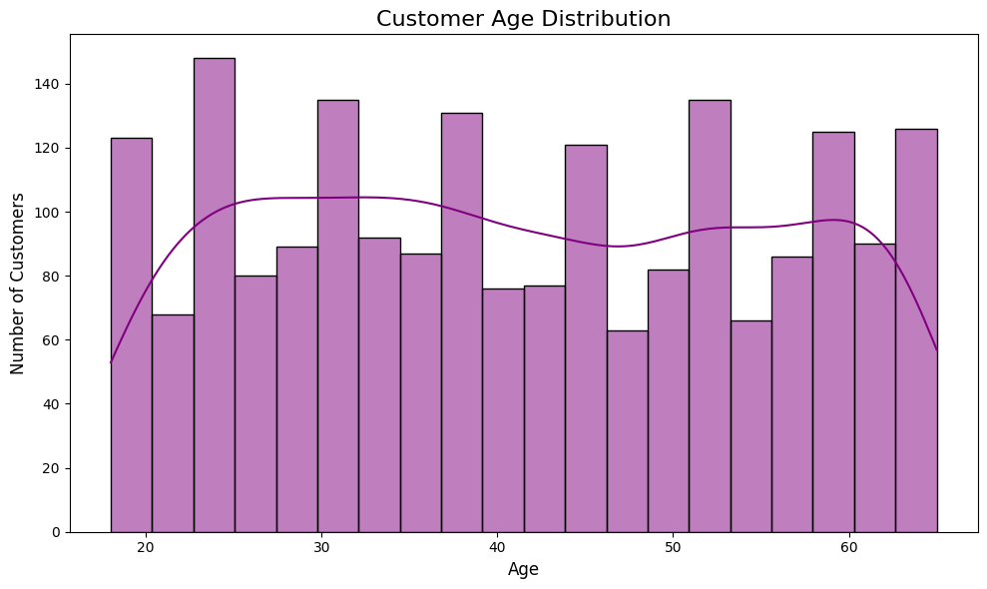

**4. Conclusion and Recommendations**

The analysis of the 2024 e-commerce sales data provides several actionable insights:

* **Focus on High-Performing Categories:** The **Beauty** and **Home & Garden** categories are significant revenue drivers and should continue to be prioritized in terms of product offerings and marketing efforts. Exploring the reasons behind the lower sales in **Electronics** and **Clothing** might reveal opportunities for improvement.
* **Capitalize on Peak Sales Months:** The high sales in **March and November** suggest potential for targeted campaigns and inventory management around these periods. Understanding the drivers behind the June dip could also inform strategies to mitigate similar occurrences in the future.
* **Engage the Core Customer Demographic:** With the majority of customers being in the 20-35 age range, marketing strategies should be tailored to resonate with this demographic's preferences and online behavior.
* **Further Geographic Analysis:** While the top cities were not explicitly provided in the immediate data, a deeper dive into geographic sales data could further refine marketing strategies and identify regional opportunities.

This project showcases a comprehensive data analysis process, starting from data generation and culminating in actionable business insights derived from both Python-based analytics and Excel-based exploration. The combination of technical coding skills and data interpretation abilities demonstrates a strong foundation in data analysis.