1. 5pts: What is the proportion of women in this society? Notice that we can go between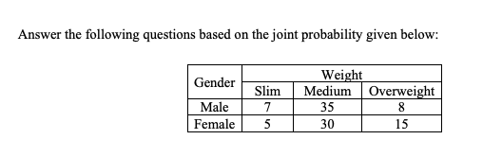 probability, proportion and numbers in an intuitive way. For example, you can look at the above probability or numbers among 100 people.

Answer : 50 / 100 = 1 / 2 = 0.5

2) 5pts: What is the probability of encountering an overweight male in this population?

Answer : 8 / 100 = 0.08

3) 10pts: What is the probability of the person being overweight, given that it is a woman?

Answer : 15 / 50 = 0.3

4) 15pts: If we pick a person m random from this population, what is the probability that s/he will be a slim-male or an overweight woman?

Answer : 7 / 100 + 15 / 100 = 22 / 100

5) 10pts: What is P(Weight)? Here, bold P indicates a vector.

Answer: <0.12 0.65 0.23>

6) 15pts: What is P(gender | overweight)?

Answer: 8/23 15/23