**Important Notes:**

1. There is only 1 question. You will update and **SUBMIT one *.java file**.
2. You are provided 2 different worlds. (**2 for each).** Your programs should **WORK CORRECTLY** for these given 2 worlds and all other similar worlds.
3. You’re expected to do **“Stepwise Refinement**” to decompose the main problem task into simpler subtasks and implement helper methods for these subtasks. You should **implement** the given **2 methods** and **WRITE at least 2 other helper methods**
4. DO NOT FORGET to **WRITE your name** at the top of your code.
5. DO NOT FORGET to **WRITE brief comments** to explain your code.
6. You should **NOT USE** variables, counters in your program. Code written using variables (other than the ones in the for loop) will be **penalized.**

Please read carefully the following requirements.

**Question 1**

1. (20 points)

* Karel start facing **EAST** somewhere before a mountain of stairs. She starts with **no beepers** present in her bag.
* First, Karel should climb up the stairs and pick the all beepers on its way.
* Then it should put all the collected beepers at **top of the stairs on the left hand side.**

1. (20 points)

* Karel should go down and pick all the beepers on the **right side of the mountain.**
* Karel should climb back to the top of the mountain again
* It should put all the collected beepers at the **top of the stairs on the right hand side.**

1. (60 points)

* Top of the mountain contains 3 corners. Karel should randomly decide and paint the middle corner either to RED or YELLOW (50/50 random distribution).
* **RED** color means **Addition** and **Yellow** color means **Subtraction.** If the middle color is painted to RED, then Karel should **ADD** the beepers on the left and right hand side of the painted corner and the result should be represented by dropping the number of beepers at the **NORTH** corner of the colored corner.
* Vice versa, if the middle color is painted to **YELLOW**, then Karel should **SUBTRACT** the beepers at right hand side from the beepers at the lefthand side. The result of the SUBTRACTION is represented by the number of beepers dropped at the **NORTH** of the colored corner.
* Karel should stop at the colored corner **facing EAST.**

**Sample Worlds**

Before and after screen shots of the program with the given 2 worlds are as such

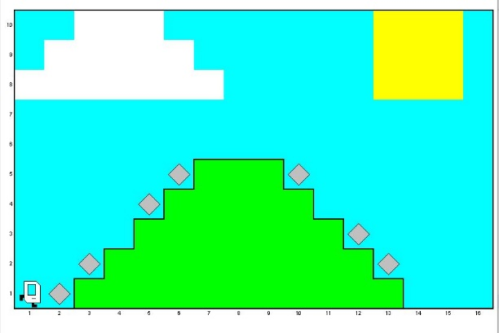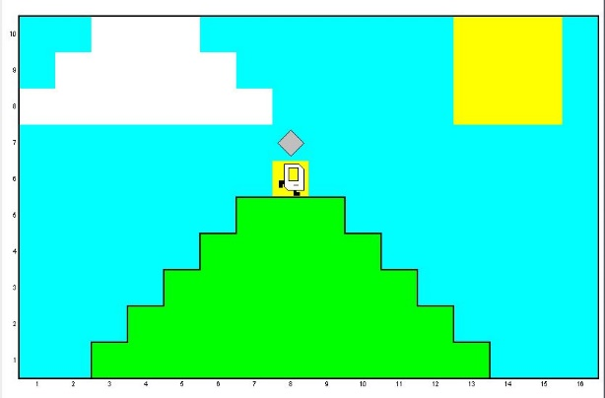

World1 Start World1 End of Program

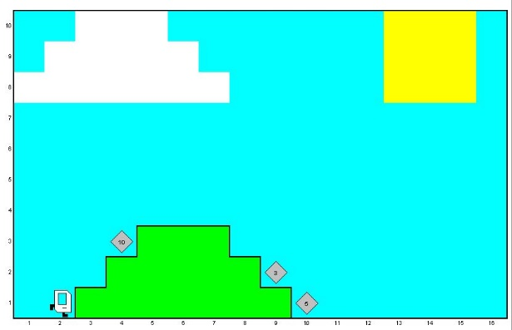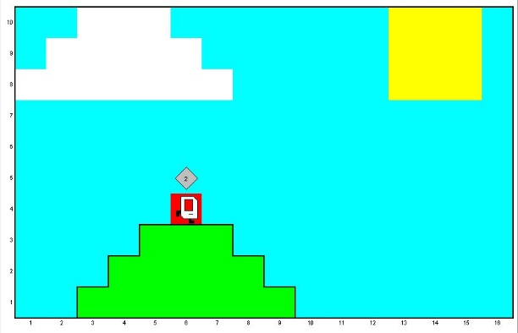

World2 Start World2 End of Program

**Video recording:**

* There is a video recording of the program in action in the package, please check it out.