**Important Notes:**

1. You are provided 2 different worlds. Each programs should **WORK CORRECTLY** for these given 2 worlds.
2. You should **WRITE helper methods** for **EACH** task. You’re expected to do **“Stepwise Refinement**” to decompose the main problem task into simpler subtasks and implement helper methods for these subtasks.
3. DO NOT FORGET to **WRITE your name** at the top of your code.
4. DO NOT FORGET to **WRITE comments** to explain your code.
5. You should **NOT USE** variables, counters in your program.

Please read carefully the following requirements.

Finally, time has come for Karel to start the university.

1. First day of school and Karel needs to **leave the dorm** in the morning. Note that Karel can be anywhere in the dorm **facing any direction**. Karel should exit the dorm from the door on the **East**.
2. After leaving the dorm, Karel wants to go to the campus. The entrance of the university is marked with **CYAN** color.
3. Upon entering the campus Karel needs to find its building by passing through a maze. Help Karel go through the maze and find the entrance of the building. Building entrance is mark with **RED** color. Karel should stop at the entrance of the building.

* Karel starts at anywhere in the dorm facing any direction(yellow rectangle)
* The size of the dorm (yellow rectangle) can be of any size.
* Karel should always finish at the red corner

**HINT:** Karel can travel the maze by following the walls on its RIGHT.

Sample worlds at start of Question 1 are:

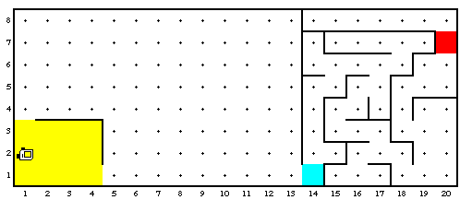 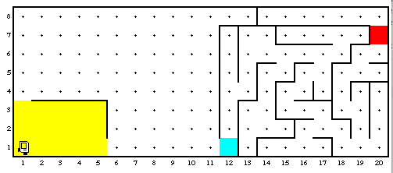

After completing all the tasks, Karel’s worlds should look like this:

