metin, küçük resim içeren bir resim

Açıklama otomatik olarak oluşturuldu What are the ways to get more followers on Twitch?

TEAM HARİYAMA

Talha Yusuf İnan Ahmet Kürşat İşken Nisa İlayda Karaduman Burcu Nur Kıvrak

181180040 181180041 181180044 181180050

**ABSTRACT**

Anyone who will start broadcasting on the Twitch platform, which is at the top of the video game viewing platforms, should definitely read this report. The main reason for this recommendation is; to create a roadmap for a new streamer who has no knowledge of the platform. Thanks to the data information used in this report, it is possible to reach information about how many followers the new streamer can gain under which conditions. Thanks to the visualizations made on different data, intelligibility was provided for the reader. It should not be forgotten that knowledge is power.

**1.INTRODUCTION**

There are multiple features to be a good streamer on Twitch. The main reason for this is that many features, from which games the streams play more to which games the viewers watch the most, affect the number of followers that a streamer can gain for a newcomer to the Twitch industry. Even people who grew up in the same house can watch different streamer and different games, and the accuracy rate was kept at a good level, although it is not easy to make a guess. Together with the predetermined dependent variables sent into the algorithm, the algorithm will tell the user its prediction of how many followers he will gain. However, during the selection phase of the algorithm in question, attempts were made for different algorithms. As a result of the trials, only one of the mentioned algorithms gave the highest result. Detailed information about the algorithms we tried for our data and why these algorithms were chosen will be given in the following sections. After the introductory explanations we made on the report, we can now move on to the more technical parts.

**Keywords**

# “Python, Data Science, Data Analysis, Pandas, Matplotlib, Seaborn, Machine Learning.”

# 2 . MOTIVATION

As it is known, the idea of getting rich on the internet quickly and with less effort has become very popular lately. One of the get-rich-quick ways is to stream on the Twitch video game platform. For this reason, it was our main motivation to prepare a report on what anyone with the idea of streaming should pay attention to in order to gain followers. So our main question is what should a twitch streamer pay attention to in order to gain more followers.

# 3.DATASETS

Three datasets were used to prepare this report. In these datasets, data is kept with watch time, peak viewers, average viewers, hours watched, game names, channel names, languages and many more features. Thanks to the features in the data, an algorithm has been developed that can answer our question about gaining the number of followers. The data used was obtained from Kaggle. In other words, any user can access these data if desired. The necessary links to reach the data we use are given below.

<https://www.kaggle.com/rankirsh/evolution-of-top-games-on-twitch> (Contains two datasets)

<https://www.kaggle.com/aayushmishra1512/twitchdata>

# METHODOLOGY

In this research, we used pandas, numpy, seaborn, matplotlib, sklearn libraries. It was used to read the Pandas library database. We used the Numpy library to convert the values ​​in the data set into a format suitable for linear regression. The heat map feature was used in the Seaborn library. The heat map allowed us to understand the level of relationship between the variables. With the matplotlib library, we provided a meaningful visualization of the values ​​in the dataset. For example barchart, pie chart, line chart, bar-line chart,bubble chart, scatter. visualizations were used. A bar chart is a way of summarizing a set of categorical data. You can easily see the change of data according to time in Barchart. This possibility is not available in the pie chart. Our purpose in using the scatter is to see the distribution of values ​​better. With the double y-axis in bar-linechar, we can visualize multiple variables on the same graph. In the Sklearn library, we used linear regression and metrics structures. Thanks to Metrics, there are structures where we can analyze how accurately the results obtained as a result of machine learning are predicted or whether they consist of a false prediction. We used it to analyze the amount of measurement errors in linear regression, which we use as machine learning. Linear regression was also used as machine learning. The reason for this is that we want to reach a numerical data rather than making a classification. Linear regression is a popular and uncomplicated algorithm used in data science and machine learning

# EXPERIMENTS & RESULTS

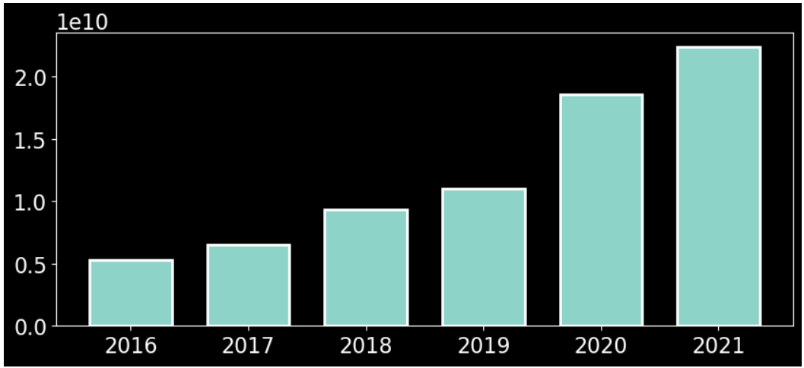

When we want to examine the changes in the total number of views on Twitch between 2016 and 2021, we see that this number is increasing unevenly with each passing year. Especially in 2020, which is the beginning of the pandemic process, we see a greater increase in viewership.

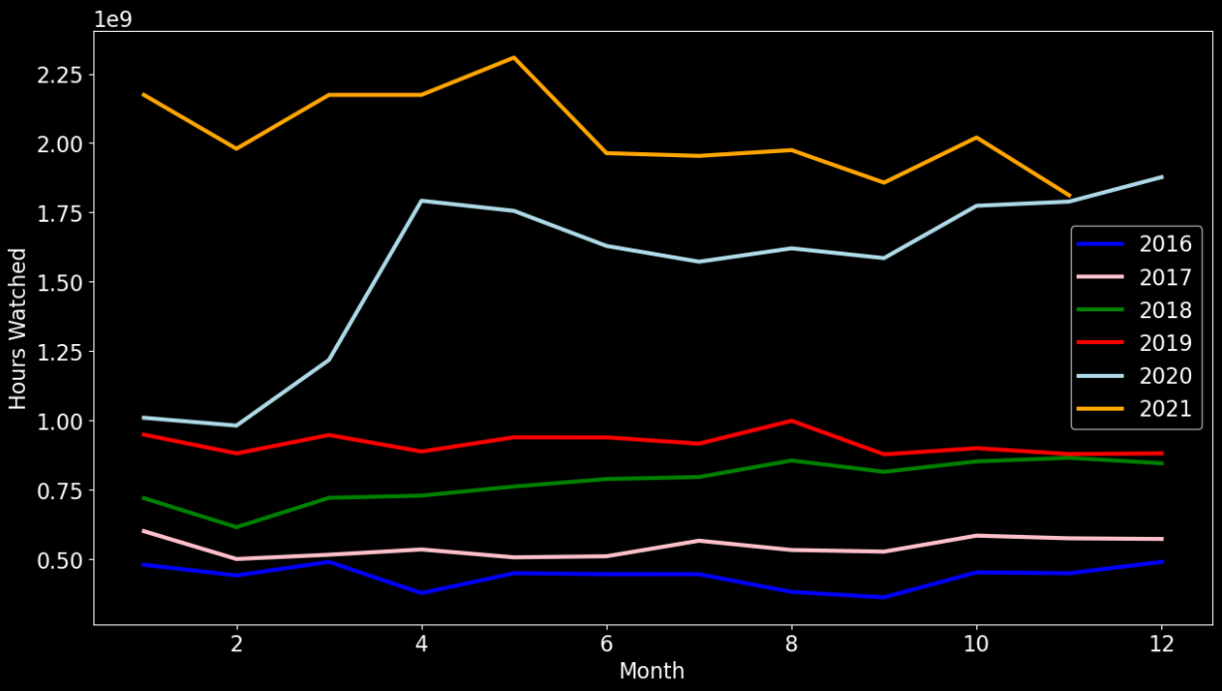

When we examine the changes in views by months for six years between 2016 and 2021, we see that the number of views increases every year. We see that the monthly viewing rates continue at almost the same level throughout 2016-2019. However, when we look at 2020, we see that the number of views increased exponentially throughout the year.

amount of

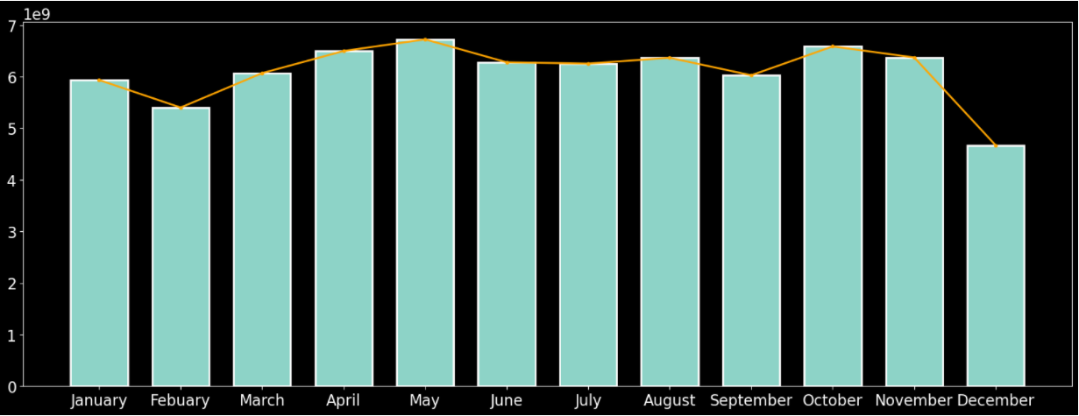

In this chart, we can see the average number of views per month. We noticed that there was no regular increase and decrease. By looking at this, we can say that there is a certain number of users and that there is an increase and decrease at certain intervals.

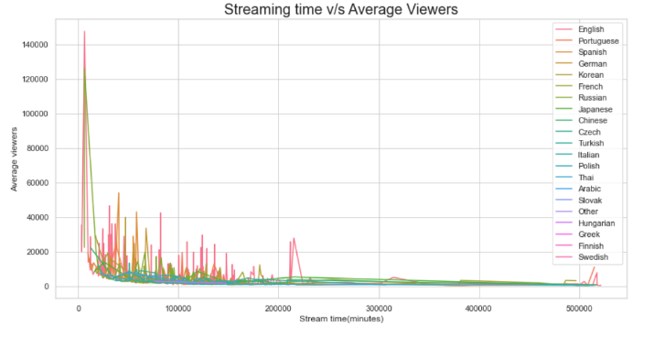

If we consider the average views of each streamer according to the stream times in their own language, we see that the average number of viewers decreases as the stream time increases, especially those stream in English and Russian.

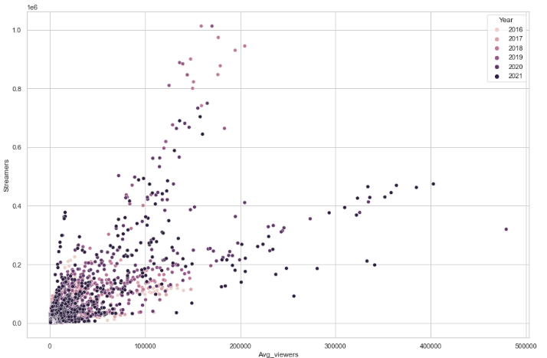

If we look at the average viewership of streamers between 2016-2021, we see that the number of broadcasters in 2017 and 2018 was high, but the average number of viewers was low. however, we see that the increase in the average number of viewers is higher in the years after 2019.

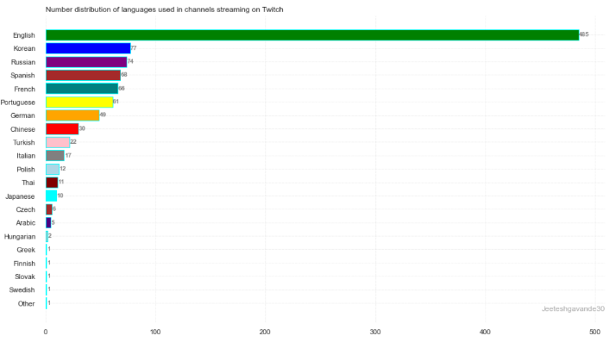

In the question here, we aimed to see the distribution and weight of the languages spoken by the streamers. We compared the number of languages on the streams.

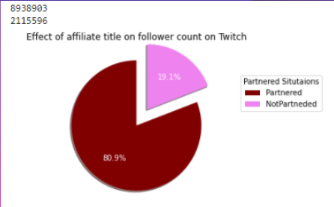

When we wanted to examine the effect of partnership status on twitch on the number of followers, we saw that the publisher's partnership with twitch almost quadrupled the number of followers. If a streamer becomes a partner with Twitch, the number of followers will increase and accordingly, we can predict that the number of views may increase.

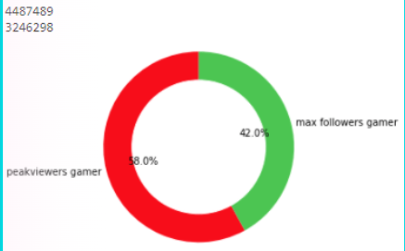

If we examine how the status of the peak viewers and watched time affect the number of followers, we have found that having the peak viewers gains more followers. We found that the watch time gained followers, to a lesser extent.

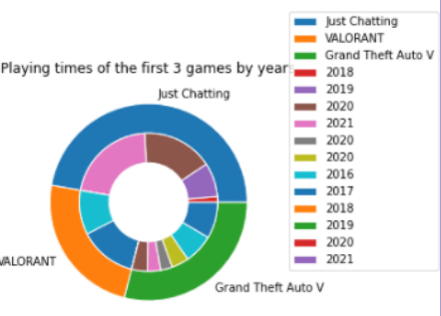**Effect o**

**f AWhen we list the most watched streams, the three game groups in the chart emerged as the most watched. Of these, valorant has the most views, while just chatting has been ranked as the most watched many times.**

**this graph, w**

**tablo içeren bir resim

Açıklama otomatik olarak oluşturuldue** In this graph, we see the number of views for the 3 most watched categories in the outer layer, compared to each other, and the number of views of these categories over the years in the inner layer. **other, and the number of views of these categories over the years in the inner layer.**

When we list the most watched streams, the three game groups in the chart emerged as the most watched. Of these, valorant has the most views, while just chatting has been ranked as the most watched many times.

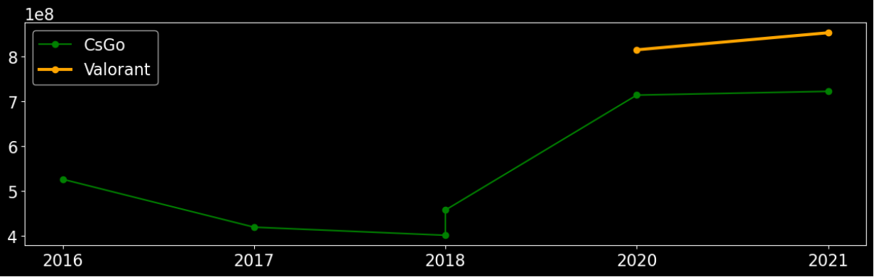

In this chart, we see the change in the number of views of the two most popular games in the fps category of the gaming industry. It is said that the popularity of the csgo game lost after the Valorant game was released. However, contrary to popular belief, there has been no decrease in the number of views of the csgo game. There is only a decrease in the amount of increase.

kare içeren bir resim

Açıklama otomatik olarak oluşturuldu

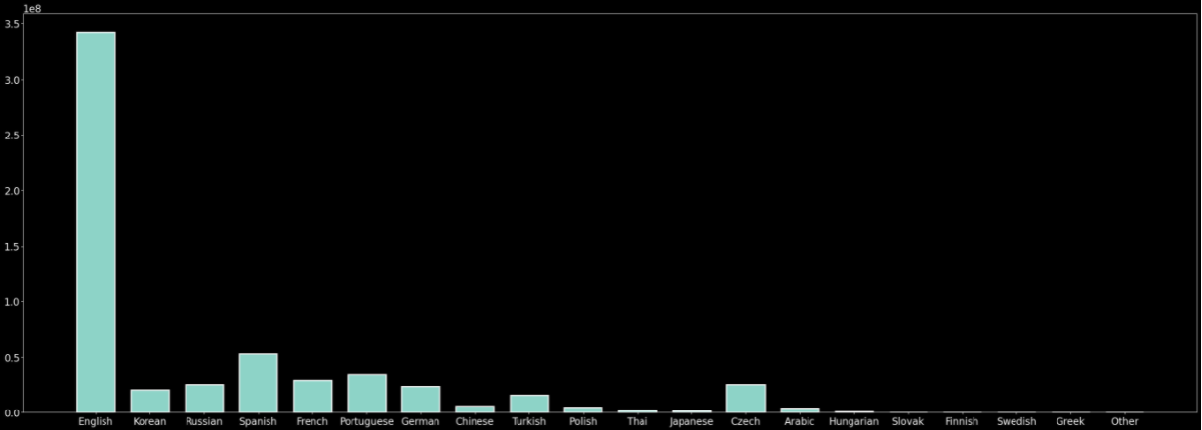

In the question here, we aimed to see the number of followers of the channels according to the languages used in the broadcasts. We have seen that English streams have more followers.

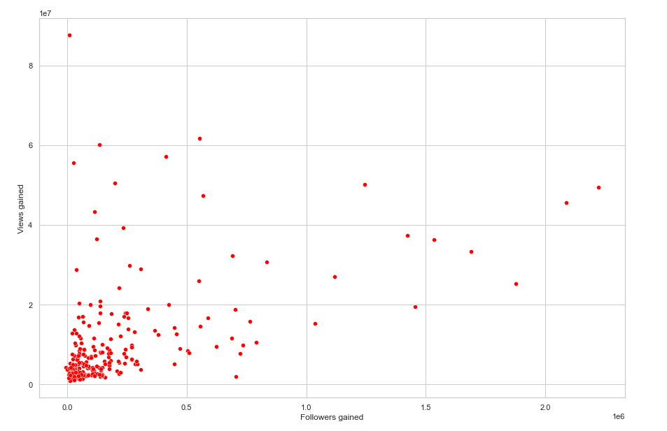

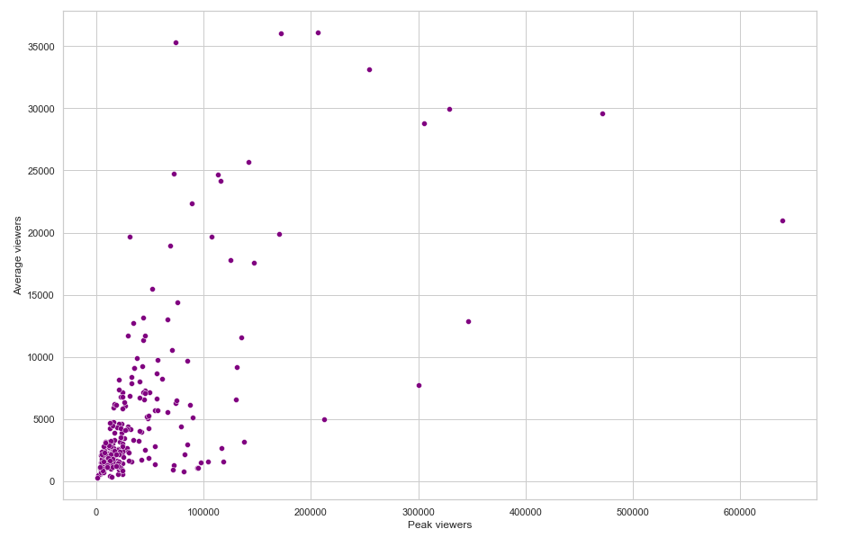

When we wanted to know what the average views of a channel with the highest number of views were, we were able to view the rates with this bar chart.

# CONCLUSION

In this project, we aimed to create a roadmap for a twitch streamer to gain more followers. As a result of our investigations in this direction, we have obtained the following results:

- We conclude that the streamer with the peak viewers does not have the most watched views.

-When we examined the happiness rate by region, we saw that the regions of the countries did not have a great effect on the happiness rate.

- We learned that the most used language in twitch streams is English.

- From 2016 to 2021, we observed a steady increase in interest in twitch.

- We have seen that the increase between the months between 2016 and 2021 is not a regular increase.

- As of the beginning of 2020, we observed that the increase in the number of viewers was higher than in other years.

- As a result of our research, we discussed the audience numbers of CsGo and Valorant, which are similar games and are said to be in competition.

- However, we found out that Valorant, which was released after CsGo, had a higher number of views.

- When we listed the 10 game groups with the most viewers, we observed that there was Just Chatting, Gta, Valorant.

# REFERENCES

1. <https://matplotlib.org/stable/gallery/style_sheets/style_sheets_reference.html>
2. <https://sullygnome.com/channels/watched>
3. <https://worldhappiness.report/ed/2021/>
4. <https://twitchtracker.com/statistics/viewers>

[5].<https://www.geeksforgeeks.org/python-seaborn-tutorial/>

[6] <https://www.geeksforgeeks.org/bar-plot-in-matplotlib/>

[7].<https://pythonspot.com/matplotlib-bar-chart/>