**Supplemental Material**

This file contains descriptive statistics and data about the Syrian rebel groups used in the analysis presented in the main text. It also contains a number of robustness tests to further validate our findings. Part I lists the 30 rebel groups we studied in depth; Part II is a description of the data collection and coding procedure; and Part III presents additional model specifications, MCMC descriptive plots, and other modeling approaches.

**Part I. Basic rebel group data and descriptive statistics**

Table I. Power, ideology, and state sponsors of Syria’s rebel factions

|  |  |  |  |  |  |  |
| --- | --- | --- | --- | --- | --- | --- |
| **Group** | **Group Code** | **Ideology** | **Location** | **State Sponsors** | **Group Size** | **Years of Existence** |
| 101st Infantry Division | 101st | Secular Nationalist | Idlib, Aleppo, Hama | US | 2,000 | 2013-Oct 2016 |
| 13th Division | 13th | Secular Nationalist | Idlib, Aleppo, Hama | US | 1,800 | Jun 2013-present |
| Ahfad al-Rasul Brigades | AARB | Secular Nationalist | National | Saudi Arabia, Qatar | 9,000 | Sept 2012-Jan 2014 |
| Ahrar al-Sham Islamic Movement | ASIM | Salafist Nationalist | National | Qatar, Saudi Arabia, Turkey | 15,000 | Feb 2012-present |
| Ahrar al-Shamal Brigade | AALS | Secular Nationalist | Aleppo | NA | 500 | 2012-2014 |
| Ajnad al-Sham Islamic Union | AASG | Salafist Nationalist | Damascus, Rif Dimashq | NA | 3,000 | Dec 2013-present |
| Al-Farouq Brigades | AF | Secular Nationalist | Homs, Aleppo | Saudi Arabia, Qatar, Turkey | 10,000 | Jun 2011 - Nov 2013 |
| Al-Fawj Al-Awal (1st Regiment) | 1st | Secular Nationalist | Aleppo, Hama | US | 900 | May 2015-Nov 2016 |
| Al-Furqan Brigades | AFB | Secular Nationalist | National | Qatar, US | 2,000 | Mar 2012-present |
| Al-Nusrah Front | ANF | Sectarian Jihadist | National | NA | 7,000 | Jan 2012-present |
| Al-Sham Legion (Faylaq al-Sham/Sham Corps) | ASL | Secular Nationalist | National | Turkey, Qatar, US | 4,500 | Mar 2014-Jan 2017 |
| Al-Tawhid Brigade (Liwa al-Tawhid) | ATB | Salafist Nationalist | Aleppo, Homs, Raqqa | Qatar, Turkey | 8,000 | Jul 2012-Dec 2014 |
| Ansar al-Din Front | ADF | Sectarian Jihadist | National | NA | 1,550 | Jul 2014-Jan 2017 |
| Ansar al-Sham Battalions | AASB | Salafist Nationalist | Latakia, Idlib, Aleppo | NA | 2,500 | Sept 2012-present |
| Authenticity and Development Front | AADF | Secular Nationalist | National | Saudi | 5,000 | Mar 2014 – present |
| Fastaqim Kama Umirta Gathering | FKUG | Secular Nationalist | Aleppo, Idlib | US | 1,100 | Sept 2013-Feb 2017 |
| Faylaq al-Rahman (Al-Rahman Corps; Al-Rahman Legion) | ARC | Secular Nationalist | Rif Dimashq, Damascus | US, Jordan | 6,000 | Dec 2013-present |
| Hazm Movement | Hazm | Secular Nationalist | National | US | 4,000 | Jan 2014-Mar 2015 |
| Islamic State | ISIL | Sectarian Jihadist | National | NA | 25,000 | Apr 2013-present |
| Jaish al-Islam (Army of Islam) | JAI | Salafist Nationalist | National | Saudi Arabia | 17,000 | Jul 2012-Jan 2017 |
| Jaish al-Muhajirin wal-Ansar | JMA | Sectarian Jihadist | Aleppo, Idlib, Latakia | NA | 750 | 2012-2017 |
| Jaish al-Mujahidin (Mujahidin Army) | JAM | Secular Nationalist | Aleppo | Turkey, Qatar, US | 8,500 | Jan 2014-Jan 2017 |
| Jund al-Aqsa | JAA | Sectarian Jihadist | Hama, Idlib, Aleppo | NA | 800 | Sept 2013-Feb 2017 |
| Levantine Front | LF | Salafist Nationalist | Aleppo, Homs, Raqqa | Qatar, Turkey | 8,000 | Dec 2014-Jan 2017 |
| Mujahidin Shura Council | MSC | Sectarian Jihadist | Deir al-Zour | NA | 500 | May 2014-July 2015 |
| Nur al-Din al-Zinki Movement | NADAZM | Secular Nationalist | Aleppo, Idlib | Saudi Arabia, Turkey, US | 5,000 | Nov 2012-Jan 2017 |
| People’s Protection Units | YPG | Kurdish Separatist | North Syria | US | 40,000 | 2011-present |
| Suqur al-Sham Brigades | SAS | Secular Nationalist | Idlib, Aleppo | NA | 9,000 | Sept 2011-Jan 2017 |
| Syrian Revolutionaries Front | SRF | Secular Nationalist | Idlib, Aleppo, Hama | Saudi Arabia, Turkey | 12,500 | Dec 2013-2017 |
| Southern Front | SF | Secular Nationalist | National | Saudi Arabia, Jordan, US | 38,000 | Feb 2014- Present |

Table II. Descriptive Statistics for 30 groups

|  |  |
| --- | --- |
| *Mean network degree* | 46.5 |
| *Top five groups by degree* | ISIL – 584  ANF – 193  ASIM – 109  JAI – 92  YPG – 89 |
| *Mean Group Size* | 7047 |
| *Standard deviation of group size* | 8453 |
| *Mean ideology* | Average of all three ideological components – 2.23  Nationalism-Revisionism– 1.93  Islamism-Salafism– 2.74  Sectarianism – 2.02 |
| *Standard deviation of ideology components* | Average – 1.34  Nationalism-Revisionism– 1.4  Islamism-Salafism– 1.58  Sectarianism – 1.5 |
| *Mean state sponsorship overlap degree* | 7.07 |
| *Top degree groups that overlap in state sponsorship* | NADAZM – 18  SF – 17  ASL – 15  JAM – 15  AFB – 14 |

**Part II. Data collection and coding rules**

This research project involved an extensive, multiyear data collection on 44 Syrian insurgent groups. The data covers the rebels’ infighting claims, ideological positions, estimates of group size, state sponsors, and other relevant information. The vast majority of the data were constructed from US Government translations of information derived from insurgent group’s social media cites, including content from Facebook, YouTube, and Twitter. We also drew upon secondary sources from organizations such as the International Crisis Group, Carnegie Middle East Center, Institute for the Study of War, and papers of record.

This online appendix describes the steps involved in the data generation process and data coding decisions. Due to the terms of use of the documents used to generate these data, we cannot provide direct links to the original text documents, nor can we cite the name of the translating organization. Replication data for this paper is fully available through the journal’s data repository. Researchers who are US citizens and who are already funded under US government grants may be able to access the primary source documents. Please contact us for more information.

**Data and coding rules for the dependent variable: infighting in the Network**

Infighting data was derived from daily US Government translations for the period of 1 January 2012 to 31 December 2015. Each infighting report had to have the following elements for each data point to be considered reliable:

1. DATE – A data point must have a specific date or date of report, which gave us roughly when the infighting took place.
2. DYAD – A data point must list the two groups that fought each other. (There are several reports of assassinations/bombings in which the targeted group is listed, but not the attacking group.) If multiple groups are listed, we duplicate the episode for each group to capture each infighting dyad.
3. LOCATION – A data point must list a location for infighting. At a minimum, it should include the governorate in which the infighting took place.
4. VALIDITY – A data point must be credible, or at least contain granular content that suggests it is credible and not mere propaganda. For example:

* Contains information on the city, district, neighborhood, or village in which the fighting took place.
* Specifies the names of the individuals killed or targets bombed.
* Image or video accompanies the report.
* Multiple sources corroborate the episode even if the details vary.
* Details about the source of the claim, including Twitter handle, Facebook page, or militant forum or website.

We used advanced search capabilities in the US government online portal to retrieve infighting reports. Here are the fields we used:

**Topic Country:** Syria

**With the phrase:** [Entered each group name and variations on the name]

**With at least one of the terms:** “infighting,” “internecine”

**Date Range:** 1-1-2012 to 1-1-2016

In addition to these targeted searches, we read daily reports from the U.S. Government source mentioned above with the titles:

**“Syria: Jihadist Infighting Highlights”**

**“Syria: ISIL, Armed Groups Infighting Update”**

These search methods resulted in over 3,000 reports. We went through all these reports and documented each infighting episode per our rules above in an excel sheet—i.e. our database. As we state in the paper, we collected data on 508 distinct fighting episodes in our four-year timeframe, yielding 697 infighting dyads.

*Coding for infighting over time*

Normally, if a group fights another group on a single day, that is entered as a data point. When we see the same two groups fight the following day, we code both events as a single data point. If the fighting continues for several days, it is still coded as a single data point. In some instances, the fighting continues on for weeks, which creates a challenge. If it is almost daily infighting for weeks that end in a single month (i.e. began January and ended January), then that month gets only one single data point for the infighting dyad. If the infighting is continuous for weeks that cut across months (i.e. began in January and ended in March), then each month gets a single data point for the infighting dyad. There are times when fighting breaks out, then it ceases for a few days while mutual recriminations are exchanged, and then fighting breaks out again. In those instances, we treat each infighting episode as a distinct data point even if they appear in the same month. In other words, if there is a sufficient break in the infighting, we treat the recurrence of infighting within a single month as a whole new episode.

*Constructing the infighting network*

Each infighting incident is assigned a value of one as an out-tie between the faction issuing the claim and those mentioned as involved in the infighting. If it is claimed via a joint statement or independently by two factions, it counts as one episode of infighting but appears as out-ties from both factions (or all the factions issuing the statement and engaged in the operation). If an infighting episode involved more than two groups, each group in the claim receives a tie with each other group. If an infighting episode occurred between members of a Front or Joint Operations Room (JOR) and another group, ties were distributed to all the Front/JOR members. However, if granular data suggested that only one group or a subset of groups within a broader coalition engaged in fighting other rebels, we distributed the infighting ties to that group or subset of groups.

**Data and coding rules for the independent variables**

*Power*

Power is measured in group size. We collected as many estimates of group size for each group as possible. The sources range from informed observers of the conflict to self-reported numbers by rebel groups. The Mapping Militant Organization data from Stanford University was particularly useful for collecting multiple estimates. We created a low-medium-high estimate for each group, when possible, and used the medium estimate in our analysis. We could not locate size estimates for two small groups. We assigned them a low estimate of 500 fighters. The table below lists the estimates collected and their sources.

We recognize that our study covers a three-year period of an extremely complex conflict, but we do not have time-varying data on the size of rebel groups. Unfortunately, collecting data on group size by year across 44 groups in an ongoing conflict is a challenging undertaking. Therefore, we chose the medium estimate of group size because we assumed that it probably reflected the actual group size during the critical period of 2014-2015, when most of the interrebel fighting took place (684 out of 697 dyads). The major shift in power (group sizes) took place in 2013 as ISIL emerged and as groups experienced consolidation through mergers. That year (2013) only had 13 infighting dyads.

*State sponsorship*

We collected data on state sponsors for each group, if any. We relied on the works of experts such as Charles Lister, Christopher Phillips, and Aron Lund, as well as papers of record and other evidence of direct state sponsorship in terms of funding and arming rebel groups at any time between 2012 and 2016. Groups that use TOW missiles were coded as U.S.-sponsored rebels, even though the missiles could have come from Qatar or Jordan. We assume that these countries did not share such vital weaponry without the consent of the United States. Table III below contains the references that we used to attribute state sponsorship across the rebel groups.

|  |  |  |  |  |
| --- | --- | --- | --- | --- |
| Table III. State sponsors and size estimates of Syrian rebel groups | | | | |
| **Group** | **Group Code** | **State Sponsor(s)** | **Group Size**  **Estimates** | **Sources for Group Size and State Sponsors** |
| 101st Infantry Division | 101st | US | 2,000 | * Asaad Hanna, “Don’t Underestimate Free Syrian Army,” *Al-Monitor*, October 1, 2015. * This group uses TOW missiles. |
| 13th Division | 13th | US | 1,800 | * John Beck, “Syria Rebel Recounts His Time in an ISIL Jail” *Al-Jazeera*, March 10, 2014. * This group uses TOW missiles. |
| Ahfad  al-Rasul Brigades | AARB | Saudi Arabia, Qatar | 7,000  9,000  10,000 | * BBC, *Guide to the Syrian Rebels*. December 13, 2013. http://www.bbc.com/news/world-middle-east-24403003 (accessed on December 23, 2016). * Ken Sofer and Juliana Shafroth, *The Structure and Organization of the Syrian Opposition*. May 14, 2013. https://www.americanprogress.org/issues/ security/report/2013/05/14/63221/thestructure-and-organization-of-the-syrian-opposition/ (accessed December 23, 2016). * Roula Khalaf and Abigail Fielding-Smith, “How Qatar Seized Control of the Syrian Revolution,” *Financial Times* May 17, 2003. |
| Ahrar  al-Sham Islamic Movement | ASIM | Qatar, Saudi Arabia, Turkey | 10,000  15,000  20,000 | * BBC, *Guide to the Syrian Rebels*. December 13, 2013. http://www.bbc.com/news/world-middle-east-24403003 (accessed on December 23, 2016). * David Ignatius, “A Nightmare Group in Syria Could Target the United States,” *Washington Post*, May 13, 2014. * Alastair Dawber, “Meeting of Syrian Rebel Groups in Saudi Arabia Ends in Chaos as Islamist Militia,” *The Independent*, December 10, 2015. * No author, *Ahrar al-Sham*. Mapping Militant Organizations. August 5, 2016. http://web.stanford.edu/group/mappingmilitants/cgi-bin/groups/view/523 (accessed on September 2, 2017). * No Author, *List of Armed Formations, Which Joined the Ceasefire in the Syrian Arab Republic on December 30, 2016*. Ministry of Defence of the Russian Federation. December 29, 2016. http://eng.mil.ru/en/news_page/country/more.htm?id=12107227 (accessed on June 2, 2017). * No Author. *If the Castle Falls: Ideology and Objectives of the Syrian Rebellion*. Centre on Religion and Geopolitics. http://tonyblairfaithfoundation.org/sites/default/files/If%20the%20Castle%20Falls.pdf (accessed on June 2, 2017). |
| Ahrar  al-Shamal Brigade | AALS | NA | 500 | * NA |
| Ajnad  al-Sham Islamic Union | AASG | NA | 3,000 | * Ryan O’Farrell, *Mapping Syria’s Armed Opposition: Rebel Groups by Theater*. February 20, 2015. https://medium.com/@ryanmofarrell/mapping-syria-s-armedopposition-rebel-groups-by-theater-1826ba6fd9f0#.f040rz7dv (accessed on December 23, 2016). * No Author. *If the Castle Falls: Ideology and Objectives of the Syrian Rebellion*. Centre on Religion and Geopolitics. http://tonyblairfaithfoundation.org/sites/default/files/If%20the%20Castle%20Falls.pdf (accessed on June 2, 2017). |
| Al-Farouq Brigades | AF | Saudi Arabia, Qatar, Turkey | 7,000  10,000  14,000 | * No Author: *Syria’s Armed Opposition: A Brief Overview*. Carnegie Middle East Center. February 7, 2013. http://carnegie-mec.org/diwan/50896?lang=en (accessed on December 23, 2016. * Aron Lund, “Freedom Fighters? Cannibals? The Truth About Syria’s Rebels,” *The Independent*. June 17, 2013. * Roula Khalaf and Abigail Fielding-Smith, “How Qatar Seized Control of the Syrian Revolution,” *Financial Times* May 17, 2003. * Christopher Phillips, *The Battle for Syria: International Rivalry in the New Middle East* (Yale University Press, 2016), p. 139. |
| Al-Fawj  al-Awal  (1st Regiment) | 1st | US | 500  900  1,500 | * Ryan O’Farrell, *Mapping Syria’s Armed Opposition: Rebel Groups by Theater*. February 20, 2015. https://medium.com/@ryanmofarrell/mapping-syria-s-armedopposition-rebel-groups-by-theater-1826ba6fd9f0#.f040rz7dv (accessed December 23, 2016). * Jennifer Cafarella and Genevieve Casagrande, *Syrian Armed Opposition Powerbrokers*. March 2016. www.understandingwar.org/sites/default/files/ Syrian\%20Armed\%20Opposition\%20Power brokers\_0.pdf (accessed December 23, 2016). * This group uses TOW missiles. |
| Al-Furqan Brigades | AFB | Qatar, US | 2,000 | * Ryan O’Farrell, *Mapping Syria’s Armed Opposition: Rebel Groups by Theater*. February 20, 2015. https://medium.com/@ryanmofarrell/mapping-syria-s-armedopposition-rebel-groups-by-theater-1826ba6fd9f0#.f040rz7dv (accessed December 23, 2016). * No author, *The Moderate Rebels*. October 20, 2015. http://defence.pk/threads/themoderate-rebels-a-growing-list-of-vetted-groups-fielding-bgm-71-tow-anti-tankguided-missiles.404107/#ixzz4MiDVRa5s (accessed December 23, 2016). * Brian Murphy and Zeina Karam, “Qatar Faces Backlash among Rebel Groups in Syria,” *The Times of Israel*. April 24, 2013. * Jeremy Bender, “There are a Lot of CIA-vetted Syrian Rebel Groups Taking it to Assad,” *Business Insider*. October 20, 2015. |
| Al-Nusrah Front | ANF | NA | 5,000  7,000  10,000 | * Noman Benotman and Roisin Blake, *Jabhat al-Nusrah*. No date. https://www.quilliamfoundation.org/wp/ wpcontent/uploads/publications/free/jabhat-al-nusra-a-strategic-briefing.pdf (accessed December 23, 2016). * BBC, *Guide to the Syrian Rebels*. December 13, 2013. http://www.bbc.com/news/world-middle-east-24403003 (accessed on December 23, 2016). * Charles Lister, *Profiling Jabhat al-Nusrah*. July 27, 2016. www.brookings.edu/wpcontent/uploads /2016/07/iwr\_20160728\_profiling\_nusra.pdf (accessed December 23, 2016). * Aymenn Jawad al-Tamimi and Joshua Landis, *Who’s Who in the Syrian Civil War*. No date. http://www.clarionproject.org/factsheet/whos-who-syrian-war (accessed on December 23, 2016). * No Author. *If the Castle Falls: Ideology and Objectives of the Syrian Rebellion*. Centre on Religion and Geopolitics. http://tonyblairfaithfoundation.org/sites/default/files/If%20the%20Castle%20Falls.pdf (accessed on June 2, 2017). |
| Al-Sham Legion (Faylaq al-Sham/Sham Corps) | ASL | Turkey, Qatar, US | 4,000  4,500  5,000 | * Ewen MacAskill, “Who are these 70,000 Syrian Fighters David Cameron is Relying On?” *The Guardian*. November 30, 2015. * Jennifer Cafarella and Genevieve Casagrande, *Syrian Armed Opposition Powerbrokers*. March 2016. www.understandingwar.org/sites/default/files/ Syrian\%20Armed\%20Opposition\%20Power brokers\_0.pdf (accessed December 23, 2016). * No Author. *If the Castle Falls: Ideology and Objectives of the Syrian Rebellion*. Centre on Religion and Geopolitics. http://tonyblairfaithfoundation.org/sites/default/files/If%20the%20Castle%20Falls.pdf (accessed on June 2, 2017). * Natasha Bertrand, “One of the Obama Administration’s Biggest Gambles in Syria is Completely Backfiring,” *Business Insider*. February 16, 2016. * No Author, *List of Armed Formations, Which Joined the Ceasefire in the Syrian Arab Republic on December 30, 2016*. Ministry of Defence of the Russian Federation. December 29, 2016. http://eng.mil.ru/en/news_page/country/more.htm?id=12107227 (accessed on June 2, 2017). |
| Al-Tawhid Brigade (Liwa al-Tawhid) | ATB | Qatar, Turkey | 7,000  8,000  11,000 | * No Author: *Syria’s Armed Opposition: A Brief Overview*. Carnegie Middle East Center. February 7, 2013. http://carnegie-mec.org/diwan/50896?lang=en (accessed on December 23, 2016. * Martin Chulov, “France Funding Syrian Rebels in New Push to Oust Assad,” *The Guardian*, December 7, 2012. * BBC, *Guide to the Syrian Rebels*. December 13, 2013. http://www.bbc.com/news/world-middle-east-24403003 (accessed on December 23, 2016). * Sahib Anjarini, “The Story of Al-Tawhid Brigade: Fighting for Sharia in Syria,” *Al-Monitor*, October 22, 2013. * Christopher Phillips, *The Battle for Syria: International Rivalry in the New Middle East* (Yale University Press, 2016), pp. 139-140. |
| Ansar  al-Din Front | ADF | NA | 1,400  1,550  1,800 | * Mark Boothroyd, *Who Are the Syrian Rebels?* December 19, 2015. http://www.syriauk.org/2015/12/who-are-syrian-rebels.html (accessed on December 23, 2016). * Size estimate based on estimation of the four component groups, which were all small: Harakat Sham al-Islam (Moroccan dominated), Jaysh al-Muhajirin wal-Ansar (Caucasus dominated), Harakat Fajr al-Sham al-Islamiyya (Syrian based in Aleppo), and Al-Katibatu al-Khadra (Saudi dominated). |
| Ansar  al-Sham Battalions | AASB | NA | 2,500 | * Tam Hussein. *The Ansar al-Sham Battalions*. Carnegie Middle East Center. March 24, 2014. http://carnegie-mec.org/diwan/55066?lang=en (accessed on June 3, 2017). |
| Authenticity and Develop-ment Front | AADF | Saudi Arabia | 2,000  5,000  13,000 | * Jennifer Cafarella and Genevieve Casagrande, *Syrian Armed Opposition Powerbrokers*. March 2016. www.understandingwar.org/sites/default/files/ Syrian\%20Armed\%20Opposition\%20Power brokers\_0.pdf (accessed December 23, 2016). * Ewen MacAskill, “Who are these 70,000 Syrian Fighters?” *The Guardian*. November 30, 2015. * BBC, *Guide to the Syrian Rebels*. December 13, 2013. http://www.bbc.com/news/world-middle-east-24403003 (accessed on December 23, 2016). * No Author. *If the Castle Falls: Ideology and Objectives of the Syrian Rebellion*. Centre on Religion and Geopolitics. http://tonyblairfaithfoundation.org/sites/default/files/If%20the%20Castle%20Falls.pdf (accessed on June 2, 2017). |
| Fastaqim Kama Umirta Gathering | FKUG | US | 900  1,100  1,300 | * Aaref Haj Yousef. *Map of Aleppo’s Armed Factions* (Arabic Source). http://aljumhuriya.net/33255 (accessed on June 2, 2017). * No Author. *If the Castle Falls: Ideology and Objectives of the Syrian Rebellion*. Centre on Religion and Geopolitics. http://tonyblairfaithfoundation.org/sites/default/files/If%20the%20Castle%20Falls.pdf (accessed on June 2, 2017). * This group uses TOW Missiles. |
| Faylaq al-Rahman (Al-Rahman Corps; Al-Rahman Legion) | ARC | US, Jordan | 2,000  6,000  7,000 | * Ewen MacAskill, “Who are these 70,000 Syrian Fighters?” *The Guardian*. November 30, 2015. * Ryan O’Farrell, *Mapping Syria’s Armed Opposition: Rebel Groups by Theater*. February 20, 2015. https://medium.com/@ryanmofarrell/mapping-syria-s-armedopposition-rebel-groups-by-theater-1826ba6fd9f0#.f040rz7dv (accessed on December 23, 2016). * Josko Baric, *Faylaq al-Rahman’s Decline in East Ghouta*. Syrian War Daily. https://syrianwardaily.wordpress.com/2017/04/30/faylaq-al-rahmans-decline-in-east-ghouta/ (accessed on June 2, 2017). * No Author. *If the Castle Falls: Ideology and Objectives of the Syrian Rebellion*. Centre on Religion and Geopolitics. http://tonyblairfaithfoundation.org/sites/default/files/If%20the%20Castle%20Falls.pdf (accessed on June 2, 2017). * Uses TOW missiles supplied through Jordan. |
| Hazm Movement | Hazm | US | 3,000  4,000  5,000 | * Liz Sly, “Syrian rebel group that got U.S. aid dissolves.” *Washington Post*, March 1, 2015. * Patrick J. McDonnell, “Fall of U.S.-backed Syrian Group Casts Doubt on Plan to Arm Moderates,” *Los Angeles Times*. March 10, 2015. |
| Islamic State | ISIL | NA | 20,000  25,000  31,500 | * No author, The Islamic State. Mapping Militant Organizations. April 14, 2017. <http://web>.stanford.edu/group/mappingmilitants/cgi-bin/groups/view/1 (accessed on September 2, 2017). * Jim Michaels, “New U.S. Intelligence Estimate Sees 20-25K ISIL Fighters,” *USA Today*, February 3, 2016. |
| Jaysh al-Islam (Army of Islam) | JAI | Saudi Arabia | 12,000  17,000  20,000 | * BBC, *Guide to the Syrian Rebels*. December 13, 2013. <http://www>.bbc.com/news/world-middle-east-24403003 (accessed on December 23, 2016). * Jennifer Cafarella and Genevieve Casagrande, *Syrian Armed Opposition Powerbrokers*. March 2016. <http://www>.understandingwar.org/sites/default /files/Syrian\%20Armed\%20Opposition\%20 Powerbrokers\_0.pdf (accessed December 23, 2016). * Khaled Yacoub Oweis, “Insight: Saudi Arabia Boosts Salafist Rivals to al-Qaeda in Syria,” *Reuters*. October 1, 2013. * No Author, *List of Armed Formations, Which Joined the Ceasefire in the Syrian Arab Republic on December 30, 2016*. Ministry of Defence of the Russian Federation. December 29, 2016. <http://eng>.mil.ru/en/news_page/country/more.htm?id=12107227 (accessed on June 2, 2017). |
| Jaysh  al-Muhajirin wal-Ansar | JMA | NA | 600  750  1,000 | * Bill Roggio, “Chechen Commander Forms ‘Army of Emigrants,’ Integrates Syrian Groups,” *Long War Journal*, March 28, 2013. * No Author, *Jaysh Al-Muhajirin Wal-Ansar*. The Mackenzie Institute. January 8, 2016. <http://mackenzieinstitute>.com/jaysh-al-muhajirin-wal-ansar-jma/ (accessed on June 2, 2017). |
| Jaysh al-Mujahidin (Mujahidin Army) | JAM | Turkey, Qatar, US | 5,000  8,500  12,000 | * Aron Lund, *Pushing Back Against the Islamic State of Iraq and the Levant: The Syria Revolutionaries’ Front and the Mujahideen Army*. Carnegie Middle East Center. January 7, 2014. <http://carnegie>-mec.org/diwan/54103?lang=en (accessed on May 15, 2017). * No Author, *List of Armed Formations, Which Joined the Ceasefire in the Syrian Arab Republic on December 30, 2016*. Ministry of Defence of the Russian Federation. December 29, 2016. <http://eng>.mil.ru/en/news_page/country/more.htm?id=12107227 (accessed on June 2, 2017). * Roy Gutman, “Al Qaida Rebels Leave Mass Grave Behind as They Desert Base in Syria,” *McClatchy*, January 6, 2014. * Tom Perry, “Facing Islamic State in Syria, U.S.-trained Rebels Await More Help,” *Reuters*, December 1, 2014. * Jennifer Cafarella and Genevieve Casagrande, *Syrian Armed Opposition Powerbrokers*. March 2016. <http://www>.understandingwar.org/sites/default /files/Syrian\%20Armed\%20Opposition\%20 Powerbrokers\_0.pdf (accessed December 23, 2016). |
| Jund  al-Aqsa | JAA | NA | 600  800  1,000 | * Thomas Joscelyn, “Jund al-Aqsa Leaders Join Al-Nusrah Front,” *Long War Journal*, February 17, 2016. * No author, Jund al-Aqsa. Mapping Militant Organizations. October 25, 2016. <http://web>.stanford.edu/group/mappingmilitants/cgi-bin/groups/view/669 (accessed on May 14, 2017). * No Author. *If the Castle Falls: Ideology and Objectives of the Syrian Rebellion*. Centre on Religion and Geopolitics. <http://tonyblairfaithfoundation>.org/sites/default/files/If%20the%20Castle%20Falls.pdf (accessed on June 2, 2017). |
| Levantine Front | LF | Qatar, Turkey | 7,000  8,000  11,000 | * Ryan O’Farrell, *Mapping Syria’s Armed Opposition: Rebel Groups by Theater*. February 20, 2015. <https://medium>.com/@ryanmofarrell/mapping-syria-s-armedopposition-rebel-groups-by-theater-1826ba6fd9f0#.f040rz7dv (accessed on December 23, 2016). * Jennifer Cafarella and Genevieve Casagrande, *Syrian Armed Opposition Powerbrokers*. March 2016. <http://www>.understandingwar.org/sites/default /files/Syrian\%20Armed\%20Opposition\%20 Powerbrokers\_0.pdf (accessed December 23, 2016). * No Author, *List of Armed Formations, Which Joined the Ceasefire in the Syrian Arab Republic on December 30, 2016*. Ministry of Defence of the Russian Federation. December 29, 2016. <http://eng>.mil.ru/en/news_page/country/more.htm?id=12107227 (accessed on June 2, 2017). * The median estimate of the Levantine Front is the same as its major group component, Al-Tawhid Brigade. |
| Mujahidin Shura Council | MSC | NA | 500 | * NA |
| Nur al-Din al-Zinki Movement | NADAZM | Saudi Arabia, Turkey, US | 1,500  5,000  7,000 | * No Author. *Harakat Nour al-Din al-Zenki*. The Syrian Civil War. October 17, 2016. <http://civilwaralsham>.com/home/harakat-nour-al-din-al-zenki (accessed on June 3, 2017). * Hosam Al-Jablawi, *Nour al-Din al-Zenki Movement: How a Once Moderate Group Joined Fateh al-Sham*. The Atlantic Council. Febraury 17, 2017. <http://www>.atlanticcouncil.org/blogs/syriasource/nour-al-din-al-zenki-movement-how-a-once-moderate-group-joined-fateh-al-sham (accessed on June 2, 2017). * No Author. *If the Castle Falls: Ideology and Objectives of the Syrian Rebellion*. Centre on Religion and Geopolitics. <http://tonyblairfaithfoundation>.org/sites/default/files/If%20the%20Castle%20Falls.pdf (accessed on June 2, 2017). |
| People’s Protection Units | YPG | US | 30,000  40,000  50,000 | * BBC, *Guide to the Syrian Rebels*. December 13, 2013. <http://www>.bbc.com/news/world-middle-east-24403003 (accessed on December 23, 2016). * Tom Perry, “Syrian Kurdish Militia Expands with its Territory,” *Reuters*, August 14, 2015. |
| Suqur  al-Sham Brigades | SAS | NA | 8,000  9,000  10,000 | * Charles Lister, “Syria’s Insurgency beyond Good Guys and Bad Guys,” *Foreign Policy*, September 9, 2013. * BBC, *Guide to the Syrian Rebels*. December 13, 2013. http://www.bbc.com/news/world-middle-east-24403003 (accessed on December 23, 2016). * No author, *Ahrar al-Sham*. Mapping Militant Organizations. August 5, 2016. http://web.stanford.edu/group/mappingmilitants/cgi-bin/groups/view/525 (accessed on September 2, 2017). |
| Syrian Revolution-aries Front | SRF | Saudi Arabia, Turkey | 10,000  12,500  15,000 | * Roy Gutman, “Al Qaida Rebels Leave Mass Grave Behind as They Desert Base in Syria,” *McClatchy*, January 6, 2014. * Aron Lund, *The Syria Revolutionaries’ Front*. Carnegie Middle East Center. December 13, 2013. http://carnegie-mec.org/diwan/53910?lang=en (accessed on July 1, 2017). * Charles Lister, *The Syrian Jihad* (Oxford University Press, 2015), p. 177. * Aaron Stein, *Turkey’s New Foreign Policy* (Royal United Services Institute for Defence and Security Studies, 2014), p. 70. |
| Southern Front | SF | Saudi Arabia, Jordan, US | 30,000  38,000  40,000 | * No author, *The Southern Front*. Mapping Militant Organizations. November 5, 2016. http://web.stanford.edu/group/mappingmilitants/cgi-bin/groups/view/645 (accessed on June 2, 2017). * Aron Lund, *Does the “Southern Front” Exist?* Carnegie Middle East Center. March 21, 2014. http://carnegie-mec.org/diwan/55054?lang=en (accessed on December 12, 2016). * This group uses TOW missiles provided through Jordan. |

*Ideology*

For each group, we reviewed hundreds of rebel communiqués detailing their operational claims against the Syria government and its supporters, including what they attacked, where they attacked, and how they described their targets. We made sure to use source documents separate from infighting reports to control for endogenous ideological framing of conflict episodes. We gave particular attention to major ideological manifestos and political programs that laid out the vision of the rebel groups, their core beliefs, and how they viewed the conflict. We considered how rebels framed the fight: for example, nationalists, including Islamic nationalists, often referred to the conflict as a “revolution” (*thawra*) to topple a dictatorship, while jihadists described the fight as a “jihad” against an impious regime. We also focused on the marker terms rebels used to describe themselves, other factions, the Syrian regime, the Syrian loyalist forces, Shiites and Alawites, Iran and Hezbollah, and the United States. For example, groups that consistently used the derogatory references to Shiites and Alawites as “rejectionists” (*rawafid*) and “nusayris,” respectively, were given high sectarianism scores. On a visual level, we analyzed group logos, which can serve as indicators of Syrian nationalism and Islamism. For example, groups that had the Syrian flag in their logo were coded as nationalists, while those who adopted the black standard with Islamic calligraphy were usually Salafists or sectarian jihadists. Lastly, we turned to secondary sources such as reports by the International Crisis Group, and the Carnegie Middle East Center; books (e.g. Lister 2015, Phillips 2016); or newspapers of record to validate our description of these groups.

*Ideological coding scheme for Syria – 1-5 scale*

Sectarianism

1. Completely non-sectarian: No evidence of sectarianism. Explicit statements against sectarianism
2. Trace sectarianism: Several or fewer instances of sectarian discourse, contradicted by other statements that explicitly reject sectarianism
3. Episodic sectarianism: Recurring use of sectarian discourse, but very low in volume in relation to overall rhetoric. Also, contradicted by other statements that explicitly reject sectarianism
4. Consistent sectarianism: Consistent use of sectarian discourse alongside non-sectarian discourse
5. Dominantly sectarianism: Sectarian discourse dominates non-sectarian discourse

Salafism

1. Essentially secularist that does not call for an Islamic state
2. Mix of secularist and Islamist symbolism (i.e. Syrian flag but Islamist calligraphy), but ambiguous about the nature of the desired future state
3. Exclusive Islamist symbolism, but does not specify the exact nature of the future state
4. Islamists that insist on an Islamic state
5. Islamists that insist on an Islamic state in accordance with the Salafist paradigm

Revisionism

1. Leadership insists on Syria’s territorial unity and integrity
2. No clear position regarding Syria’s future territorial integrity, and does not use Syrian flag
3. Leadership makes reference to broader pan-Islamic ideals, but no evidence of pursuing division of Syria as a conflict objective
4. Leadership rejects nationalism as a matter of principle, but does not pursue division of Syria as a conflict objective
5. Leadership seeks autonomy, separation, or redrawing of Syria’s border as a conflict objective

Table IV below captures the ideological scores for each of the 30 groups involved in infighting. (Note that some of the groups have decimal scores. These groups were the result of mergers of several brigades for which we had individual ideological scores. We averaged the scores of the groups after they merged, resulting in some groups having decimal scores.) Table V below provides the overall classification scheme we derived from the scoring procedure.



Table V. Ideological spectrum of Syria’s militant factions

|  |  |  |  |  |
| --- | --- | --- | --- | --- |
| **Dimensions of Ideology** | Secular nationalist | Kurdish  separatist | Salafist  nationalist | Sectarian  jihadist |
| **Conflict Frame** | Syrian Arabs vs. the Assad regime | Kurds vs. sectarian jihadists | Sunni Syrians vs. the Assad regime | Sunnis vs. Alawites/Shiites |
| **Ideal**  **Polity** | Inclusive secular Syria | Kurdish secular government | Islamic  state | Islamic  state |
| **Territorial Aspiration** | Unified  Syria | Separate republic or autonomy | Unified  Syria | Transnational Islamic Caliphate |

**Part III. Additional models, diagnostic plots and robustness tests**

*Additive and Multiplicative Effects (MCMC) Diagnostic Plots for AME models 1, 2, 4, and 5 in the main text:*

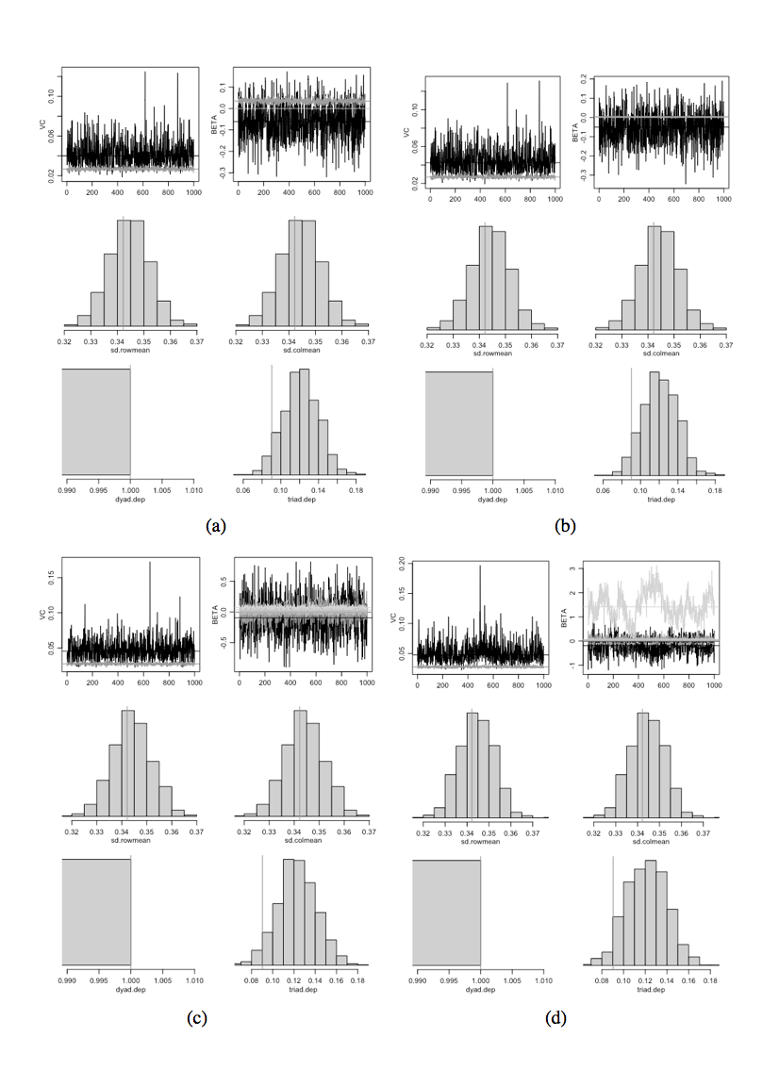

MCMC diagnostic plots from AME model in amen package (R) – Model 4 (d) and Model 5 (e). The light grey line in the diagnostic plot (b) for Model 5 is representative of the Beta value of “ISIL” at the node level, indicating that the Beta value for that variable is highly fluctuant in the MCMC simulation.Vertical lines represent observed values.

*AMEN Analysis using 30 Groups and Raw Count DV*

Irrespective of model used (binary outcome variable, count model, square root transformation of the DV or treating the model as an ordinal variable), ideological difference has a positive and statistically significant relationship with infighting. This is robust and matches both the ERGM analysis and assortativity findings. Power moves in and out of statistical significance across models, as does “ISIL” and “location”. State sponsorship never achieves statistical significance.

Table VI. AMEN analysis with 30 groups and alternative model formulations

|  |  |  |  |
| --- | --- | --- | --- |
|  | Model 1 (Count – OLS) | Model 2 (Ordinal) | Model 3  (Binary) |
| Intercept | 0.029  (0.399) |  | -6.348***  (1.486) |
| Average Ideology (Node) | - 0.041  (0.056) | -0.214  (0.176) | 0.289  (0.199) |
| Power (Node) | -0.006  (0.007) | -0.014  (0.052) | 0.051**  (0.023) |
| Sponsorship (Node) | -0.020  (0.153) | -1.054 (0.599) | -0.032  (0.550) |
| ISIL (Node) | -0.949  (02.04) | 3.592 *  (1.814) | 1.250  (0.988) |
| Ideological Difference (dyad) | 0.098***  (0.030) | 0.813*** (0.233) | 0.395***  (0.119) |
| Power Difference (dyad) | 0.006  (0.005) | 0.077 (0.045) | -0.017  (0.022) |
| Location Overlap (dyad) | 0.074  (0.005) | 0.326  (0.918) | 1.166  (1.006) |
| Sponsorship Overlap (dyad) | 0.028  (0.074) | 0.211  (0.535) | -0.293  (0.470) |
| VA: | 0.067  (0.021) | 2.42  (0.918) | 0.564  (0.278) |
| VE: | 0.246  (0.012) | 1.00  (0.00) | 1.00  (0.00) |
| Signif. codes: ‘***’ 0.001 ‘**’ 0.01 ‘*’ 0.05 ‘.’ 0.1 | | | |

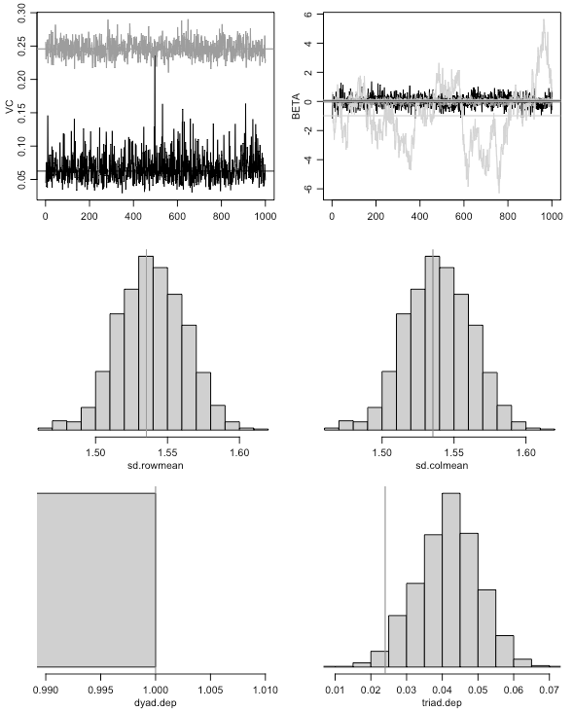 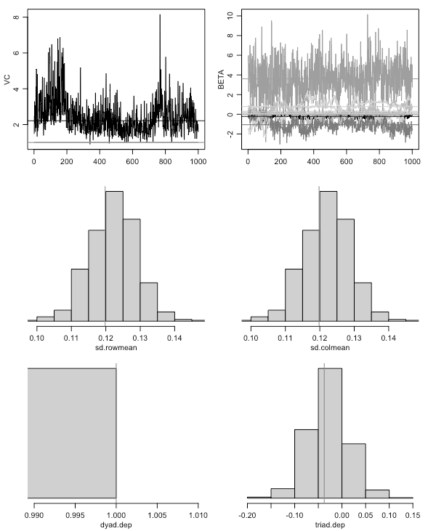 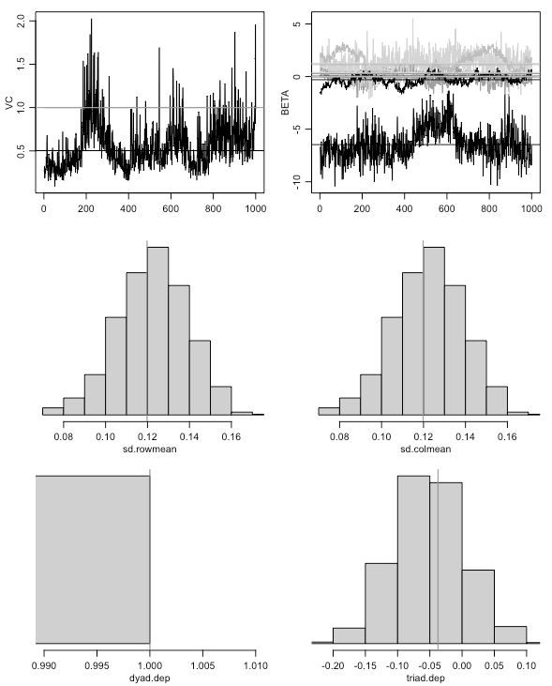

1. (b) (c)

MCMC diagnostic plots from AME model in amen package (R) – (a) is a raw count modeled with OLS; (b) is a count treated as an ordinal model; and (c) is a binary dependent variable.Vertical lines represent observed values.

In the main paper we referenced a number of robustness tests:

*ERGM Analysis using 30 Groups*

We run an ERGM analysis using the ERGM package in R for the 30 groups used in the AME model. Both models confirm the relationship between ideological difference and infighting found in the other analyses. However, the relationships between power asymmetry and infighting is less consistent: in the below models, power asymmetry achieves statistical significance, while in other models, power symmetry achieves statistical significance. Ideological difference is statistically significant regardless of the model used. Because ideological difference is significant in all three methodological approaches we’ve applied, we have quite a bit of confidence in this relationship. Power asymmetry was statistically significant in many models across all three approaches, though less consistent, and thus we have less confidence in this relationship. However, the models in which power symmetry is statistically significant demonstrate better goodness of fit in terms of this ERGM analysis.

Table VII. ERGM analysis with 30 groups

|  |  |  |
| --- | --- | --- |
|  | Model 1 | Model 2 |
| Edges | -5.55***  (0.64) | -17.82***  (3.84) |
| Average Ideology |  | 1.52***  (0.39) |
| Power |  | 0.15***  (0.03) |
| Ideological Difference | 1.07***  (0.18) | 1.59***  (0.40) |
| Power Difference | 0.05***  (0.01) | -0.10**  (0.04) |
| AIC: | 173 | 116 |
| BIC: | 185 | 136 |
| Signif. codes: 0 ‘***’ 0.001 ‘**’ 0.01 ‘*’ 0.05 ‘.’ 0.1 ‘ ’ 1 | | |

*AME Analysis with the 44 Groups. Data for this analysis is available in replication files.*

Table VIII. AMEN analysis with 44 groups

|  |  |  |
| --- | --- | --- |
|  | Model 1 (Count) | Model 2 (Square Root Transformed) |
| intercept | -0.176  (0.200) | -0.167  (0.131) |
| Average Ideology | 0.018  (0.038) | 0.022  (0.025 ) |
| Power | -0.007  (0.006) | -0.005  (0.004) |
| Ideological Difference | 0.060**  (0.023) | 0.027***  (0.007) |
| Power Difference | 0.009**  (0.005) | 0.004**  (0.002) |
| VA: | 0.066  (0.016) | 0.034  (0.008) |
| VE: | 0.387  (0.013) | 0.036  (0.001) |
| Signif. codes: ‘***’ 0.001 ‘**’ 0.01 ‘*’ 0.05 ‘.’ 0.1 | | |

MCMC Diagnostic Plots for AME models above (44 Groups)

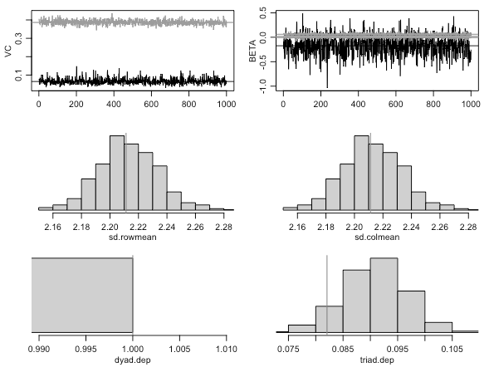 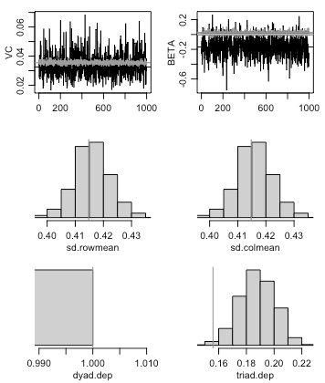

Model 1 (Count)Model 2 (square root transformed)

Vertical lines represent observed values.

*ERGM Analysis with the 44 Groups*

Table IX. ERGM analysis with 44 groups

|  |  |  |
| --- | --- | --- |
|  | Model 1 | Model 2 |
| Edges | -4.906***  (0.371) | -1.09e+01***  (1.09e+00) |
| Average Ideology |  | 8.07e-01***  (1.28e-01) |
| Power |  | 1.55e-04***  (2.26e-05) |
| Ideological Difference | 0.914***  (0.121) | 9.96e-01***  (1.54e-01) |
| Power Difference | 0.0538***  (0.0113) | -9.92e-05***  (2.75e-05) |
| AIC: | 413 | 297 |
| BIC: | 427 | 321 |
| Signif. codes: 0 ‘***’ 0.001 ‘**’ 0.01 ‘*’ 0.05 ‘.’ 0.1 ‘ ’ 1 | | |