Aim of the project: create a calculator like in google with MATLAB.

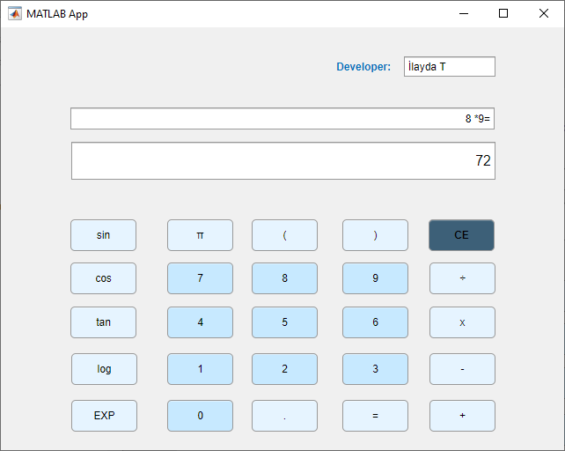

How to program calculator

First create global variables

