# 

**B. TECH (CSE) - V SEM**

**UE23CS341A - Software Engineering**

**PROJECT DOCUMENTATION ON**

**Software Requirements Specification for**

**Digital Asset and Cryptocurrency Portfolio Tracker**

**SEC: C**

**Team Members:**

|  |  |  |
| --- | --- | --- |
| **S.NO** | **SRN** | **Name** |
| 1 | PES1UG23CS154 | C Kaustubh |
| 2 | PES1UG23CS166 | Chinmay Shivanand Muragod |
| 3 | PES1UG23CS167 | Chirag K M |
| 4 | PES1UG23CS173 | Darshith M S |

**AUGUST – DECEMBER 2025**

**DEPARTMENT OF COMPUTER SCIENCE & ENGINEERING**

**RR CAMPUS (MAIN CAMPUS)**

**BENGALURU – 560085, KARNATAKA**

# **Software Requirements Specification (SRS) Template**

**Project:** Digital Asset and Cryptocurrency Portfolio Tracker  
**Version:** 1.0  
**Authors:** < Instructor / Student>  
**Date:** 02-09-2025  
**Status:** Model Answer / Approved

## **Revision History**

|  |  |  |  |  |
| --- | --- | --- | --- | --- |
| **Version** | **Date** | **Author** | **Change Summary** | **Approval** |
| 1.0 | 02-09-2025 | Instructor | SRS with diagrams embedded |  |

## **Approvals**

|  |  |  |  |
| --- | --- | --- | --- |
| **Role** | **Name** | **Signature / Email** | **Date** |
| Course Coordinator |  |  |  |

## 

## **Table of Contents**

1. Introduction
2. Overall description
3. External interfaces
4. System features (detailed)
5. Non-functional requirements (detailed)
6. Quality attributes & Acceptance tests
7. UML Use-Case Diagram
8. Requirements Traceability Matrix (RTM)

## **1. Introduction**

### **1.1 Purpose**

This document is a Software Requirements Specification (SRS) for a Digital Asset and Cryptocurrency Portfolio Tracker system. It defines functional and non-functional requirements, interfaces, and verification criteria intended for instructors and students to use as a reference for developing a comprehensive crypto portfolio management application.

### **1.2 Scope**

Covers user portfolio management, real-time market data integration, transaction tracking, performance analytics, security features for wallet integration, and portfolio reporting. Includes mobile and web interfaces, API integrations with cryptocurrency exchanges, and data synchronization across devices. Excludes actual cryptocurrency trading execution and custodial wallet services.

### **1.3 Audience**

Developers, QA Engineers, System Integrators, UI/UX Designers, Security Specialists, and Assessment Evaluators.

### **1.4 Definitions**

List of acronyms: API, DeFi, NFT, UI, UX, 2FA, KYC, GDPR, REST, JSON, SSL/TLS, OHLCV, P&L.

## **2. Overall Description**

### **2.1 Product Perspective**

The Digital Asset Portfolio Tracker is a comprehensive web and mobile application that integrates with multiple cryptocurrency exchanges and blockchain networks. It includes user authentication, portfolio management, real-time market data feeds, analytics engine, and reporting capabilities with secure API integrations for exchange connectivity and blockchain data retrieval.

### **2.2 Major Product Functions (Detailed)**

* User registration and authentication with 2FA
* Portfolio creation and asset management
* Real-time price tracking and market data integration
* Transaction import from exchanges and manual entry
* Performance analytics and P&L calculations
* Portfolio diversification analysis
* Price alerts and notifications
* Tax reporting and export capabilities
* Multi-currency support (fiat and crypto)
* DeFi protocol integration tracking
* NFT collection management

### **2.3 User Roles and Characteristics (Expanded)**

* **Individual Investor:** Basic to intermediate crypto knowledge, expects intuitive interface and accurate portfolio tracking.
* **Professional Trader:** Advanced knowledge, requires detailed analytics, multiple exchange integration, and real-time data.
* **Portfolio Manager:** Manages multiple client portfolios, needs advanced reporting and compliance features.
* **Administrator:** System maintenance, user management, and system monitoring capabilities.

### **2.4 Operating Environment**

Web browsers (Chrome, Firefox, Safari, Edge), iOS and Android mobile apps, cloud infrastructure (AWS/Azure), real-time WebSocket connections, RESTful APIs, and integration with cryptocurrency exchange APIs and blockchain networks.

### **2.5 Constraints**

Cryptocurrency exchange API rate limits, regulatory compliance requirements (KYC/AML), real-time data feed costs, blockchain network latency, mobile platform restrictions, and data privacy regulations (GDPR compliance).

## **3. External Interface Requirements**

### **3.1 User Interfaces**

**Primary UI:** Responsive web dashboard with portfolio overview, asset allocation charts, and transaction history. **Mobile UI:** Native iOS/Android apps with core portfolio tracking features. **Accessibility:** WCAG 2.1 AA compliance with screen reader support and high contrast modes.

### **3.2 Hardware Interfaces**

* Mobile device cameras for QR code scanning
* Biometric sensors for authentication (fingerprint, Face ID)
* Hardware security keys for 2FA
* Print interfaces for tax reporting

### **3.3 Software Interfaces**

* **Cryptocurrency Exchange APIs:** Binance, Coinbase Pro, Kraken, FTX (REST and WebSocket)
* **Blockchain APIs:** Ethereum, Bitcoin, Polygon networks via Infura/Alchemy
* **Market Data APIs:** CoinGecko, CoinMarketCap for pricing data
* **Payment Processing:** Stripe for premium subscriptions
* **Cloud Storage:** AWS S3 for data backup and file storage
* **Authentication Services:** Auth0 or Firebase Auth
* **Email Service:** SendGrid for notifications

### **3.4 Communications**

* HTTPS/TLS 1.3 enforced for all communications
* WebSocket connections for real-time price updates
* OAuth 2.0 for exchange API authentication
* JWT tokens for session management
* Rate limiting and retry mechanisms for API calls

## **4. System Features (Detailed)**

Each requirement below includes acceptance criteria and a reference test case. IDs follow CRYPTO-F-###.

### **4.1 User Authentication and Security**

**Description:** Secure user registration, authentication with multi-factor authentication, and session management.

|  |  |  |  |  |  |  |
| --- | --- | --- | --- | --- | --- | --- |
| **Req ID** | **Requirement** | **Type** | **Priority** | **Source/**  **Stakeholder** | **Acceptance Criteria / Test Case Ref** | **Comments / Dependencies** |
| CRYPTO-F-001 | The system shall require email verification during user registration with secure password requirements (min 8 chars, special chars, numbers). | Functional | High | Security/  User | AC-CRYPTO-F-001: Email verification link sent and account activated only after verification. Test: TC-Auth-01 | Email service integration required |
| CRYPTO-F-002 | The system shall enforce 2FA using TOTP authenticator apps or SMS for account access. | Functional | High | Security | AC-CRYPTO-F-002: Login requires both password and valid 2FA code. Test: TC-Auth-02 | TOTP library integration |
| CRYPTO-F-003 | The system shall automatically log out users after 30 minutes of inactivity and require re-authentication for sensitive operations. | Functional | Medium | Security | AC-CRYPTO-F-003: Session expires and redirects to login after inactivity timeout. Test: TC-Auth-03 | Session management |

### **4.2 Portfolio Management**

**Description:** Create, manage, and track cryptocurrency portfolios with multiple assets and allocation tracking.

|  |  |  |  |  |  |  |
| --- | --- | --- | --- | --- | --- | --- |
| **Req ID** | **Requirement** | **Type** | **Priority** | **Source/**  **Stakeholder** | **Acceptance Criteria / Test Case Ref** | **Comments / Dependencies** |
| CRYPTO-F-004 | The system shall allow users to create multiple portfolios with custom names and descriptions. | Functional | High | User/  Business | AC-CRYPTO-F-004: Users can create, edit, and delete portfolios with persistent storage. Test: TC-Portfolio-01 | Database schema design |
| CRYPTO-F-005 | The system shall support manual addition of cryptocurrency holdings with quantity, purchase price, and date. | Functional | High | User | AC-CRYPTO-F-005: Manual transactions recorded accurately with all required fields. Test: TC-Portfolio-02 | Input validation required |
| CRYPTO-F-006 | The system shall automatically import transactions from connected exchange accounts via API integration. | Functional | High | User/  Efficiency | AC-CRYPTO-F-006: Exchange transactions imported without duplicates and mapped to correct assets. Test: TC-Portfolio-03 | Exchange API credentials |

### **4.3 Real-time Market Data**

**Description:** Integrate with market data providers for real-time pricing and historical data.

|  |  |  |  |  |  |  |
| --- | --- | --- | --- | --- | --- | --- |
| **Req ID** | **Requirement** | **Type** | **Priority** | **Source/**  **Stakeholder** | **Acceptance Criteria / Test Case Ref** | **Comments / Dependencies** |
| CRYPTO-F-007 | The system shall display real-time prices for all tracked cryptocurrencies with updates every 10 seconds maximum. | Functional | High | User/  Market | AC-CRYPTO-F-007: Price updates visible within 10 seconds of market changes. Test: TC-Market-01 | WebSocket connections |
| CRYPTO-F-008 | The system shall provide historical price charts with multiple timeframes (1H, 1D, 1W, 1M, 1Y). | Functional | Medium | User/Analysis | AC-CRYPTO-F-008: Charts display accurate historical data for selected timeframes. Test: TC-Market-02 | Charting library integration |
| CRYPTO-F-009 | The system shall calculate and display percentage changes (24h, 7d, 30d) for each asset. | Functional | Medium | User/Analysis | AC-CRYPTO-F-009: Percentage calculations accurate within 0.01% tolerance. Test: TC-Market-03 | Mathematical precision |

### **4.4 Performance Analytics**

**Description:** Calculate portfolio performance metrics, profit/loss analysis, and investment insights.

|  |  |  |  |  |  |  |
| --- | --- | --- | --- | --- | --- | --- |
| **Req ID** | **Requirement** | **Type** | **Priority** | **Source/**  **Stakeholder** | **Acceptance Criteria / Test Case Ref** | **Comments / Dependencies** |
| CRYPTO-F-010 | The system shall calculate total portfolio value in multiple fiat currencies (USD, EUR, GBP, INR). | Functional | High | User/Business | AC-CRYPTO-F-010: Portfolio values accurate within 1% of market rates. Test: TC-Analytics-01 | Currency conversion API |
| CRYPTO-F-011 | The system shall display realized and unrealized gains/losses with tax implications clearly separated. | Functional | High | User/Tax | AC-CRYPTO-F-011: P&L calculations follow FIFO/LIFO methods accurately. Test: TC-Analytics-02 | Tax calculation engine |
| CRYPTO-F-012 | The system shall provide portfolio allocation analysis with asset percentage breakdowns and rebalancing suggestions. | Functional | Medium | User/Strategy | AC-CRYPTO-F-012: Allocation percentages sum to 100% and suggestions based on target allocations. Test: TC-Analytics-03 | Analytics algorithms |

### **4.5 Alerts and Notifications**

**Description:** Configurable price alerts, portfolio notifications, and market updates.

|  |  |  |  |  |  |  |
| --- | --- | --- | --- | --- | --- | --- |
| **Req ID** | **Requirement** | **Type** | **Priority** | **Source/**  **Stakeholder** | **Acceptance Criteria / Test Case Ref** | **Comments / Dependencies** |
| CRYPTO-F-013 | The system shall allow users to set price alerts for individual cryptocurrencies with customizable thresholds. | Functional | Medium | User/Monitoring | AC-CRYPTO-F-013: Alerts trigger within 1 minute of threshold breach. Test: TC-Alert-01 | Notification service |
| CRYPTO-F-014 | The system shall send portfolio performance summaries via email on configurable schedules (daily, weekly, monthly). | Functional | Medium | User/Reporting | AC-CRYPTO-F-014: Email reports contain accurate portfolio data and sent on schedule. Test: TC-Alert-02 | Email templates |
| CRYPTO-F-015 | The system shall provide push notifications on mobile apps for significant portfolio value changes (>5% by default). | Functional | Low | User/Mobile | AC-CRYPTO-F-015: Push notifications delivered within 5 minutes of significant changes. Test: TC-Alert-03 | Mobile push service |

**4.6 Exchange Integration**

**Description:** Integrate with multiple cryptocurrency exchanges for automatic transaction import and portfolio synchronization.

|  |  |  |  |  |  |  |
| --- | --- | --- | --- | --- | --- | --- |
| **Req ID** | **Requirement** | **Type** | **Priority** | **Source/ Stakeholder** | **Acceptance Criteria / Test Case Ref** | **Comments / Dependencies** |
| CRYPTO-F-016 | The system shall support read-only API integration with 10+ major exchanges (Binance, Coinbase, Kraken, Bitfinex, Huobi, KuCoin, etc.) for automatic transaction import. | Functional | High | User/  Business | AC-CRYPTO-F-016: Successfully imports transactions from all supported exchanges without data loss. Test: TC-Exchange-01 | Multiple API integrations |

**4.7 Advanced Analytics**

**Description:** Provide sophisticated portfolio analytics including risk metrics and performance indicators for professional users.

|  |  |  |  |  |  |  |
| --- | --- | --- | --- | --- | --- | --- |
| **Req ID** | **Requirement** | **Type** | **Priority** | **Source/ Stakeholder** | **Acceptance Criteria / Test Case Ref** | **Comments / Dependencies** |
| CRYPTO-F-017 | The system shall calculate and display portfolio volatility, Sharpe ratio, and maximum drawdown metrics. | Functional | Medium | Professional Trader | AC-CRYPTO-F-019: Financial metrics calculated using industry-standard formulas with 99.9% accuracy. Test: TC-Analytics-04 | Financial calculation library |

**4.8 NFT Management**

**Description:** Track and manage NFT (Non-Fungible Token) collections across multiple blockchain networks with automated detection and valuation.

|  |  |  |  |  |  |  |
| --- | --- | --- | --- | --- | --- | --- |
| **Req ID** | **Requirement** | **Type** | **Priority** | **Source/ Stakeholder** | **Acceptance Criteria / Test Case Ref** | **Comments / Dependencies** |
| CRYPTO-F-018 | The system shall automatically detect and import NFT holdings from connected wallets across multiple blockchains (Ethereum, Polygon, Solana). | Functional | Medium | NFT Collector | AC-CRYPTO-F-025: NFT detection accuracy >95% with metadata correctly imported. Test: TC-NFT-01 | NFT indexing services |

**4.9 Tax Reporting and Compliance**

**Description:** Generate comprehensive tax reports compliant with multiple jurisdictions and local tax regulations for cryptocurrency transactions.

|  |  |  |  |  |  |  |
| --- | --- | --- | --- | --- | --- | --- |
| **Req ID** | **Requirement** | **Type** | **Priority** | **Source/ Stakeholder** | **Acceptance Criteria / Test Case Ref** | **Comments / Dependencies** |
| CRYPTO-F-019 | The system shall generate tax reports compliant with multiple jurisdictions (US, EU, UK, Canada, Australia) with local tax rules. | Functional | High | User/Compliance | AC-CRYPTO-F-034: Tax reports accurate for supported jurisdictions and validated by tax professionals. Test: TC-Tax-01 | Tax regulation database |

**4.10 Data Management and Backup**

**Description:** Ensure secure data storage, backup, and recovery capabilities to protect user portfolio data and maintain business continuity.

|  |  |  |  |  |  |  |
| --- | --- | --- | --- | --- | --- | --- |
| **Req ID** | **Requirement** | **Type** | **Priority** | **Source/ Stakeholder** | **Acceptance Criteria / Test Case Ref** | **Comments / Dependencies** |
| CRYPTO-F-020 | The system shall provide automatic daily encrypted backups with point-in-time recovery capabilities up to 90 days. | Functional | High | Technical/  Business | AC-CRYPTO-F-037: Backups complete successfully daily and recovery tested monthly. Test: TC-Backup-01 | Backup infrastructure |

## **5. Non-functional Requirements (Detailed)**

NFRs below are measurable and tied to test plans. IDs CRYPTO-NF-###.

|  |  |  |  |  |
| --- | --- | --- | --- | --- |
| **Req ID** | **Requirement** | **Category** | **Priority** | **Acceptance Criteria / Measurement** |
| CRYPTO-NF-001 | Portfolio dashboard shall load within 3 seconds for users with up to 100 assets under normal network conditions. | Performance | High | 95th percentile load time ≤ 3s with simulated 100-asset portfolio. Test: TC-Perf-01 |
| CRYPTO-NF-002 | System shall maintain 99.5% uptime monthly excluding scheduled maintenance windows (max 4 hours monthly). | Reliability | High | Uptime monitoring shows ≥99.5% availability per month. Test: Continuous monitoring |
| CRYPTO-NF-003 | All user data must be encrypted at rest using AES-256 and in transit using TLS 1.3 with perfect forward secrecy. | Security/Compliance | High | Security audit confirms encryption standards met. Test: TC-Sec-01 |
| CRYPTO-NF-004 | System shall support concurrent access by 1000+ users without performance degradation exceeding 20%. | Scalability | High | Load testing with 1000+ concurrent users shows <20% performance impact. Test: TC-Scale-01 |
| CRYPTO-NF-005 | Mobile applications shall consume less than 50MB of device storage and 100MB RAM during normal operation. | Resource Usage | Medium | Mobile app resource monitoring confirms limits. Test: TC-Mobile-01 |

### **5.1 Security**

#### **5.1.1 Security Objectives**

1. **Data Protection:** Ensure all user portfolio data, API keys, and personal information are protected against unauthorized access and breaches.
2. **Transaction Integrity:** Maintain accuracy and prevent tampering of all portfolio transactions and calculations.

#### **5.1.2 Security Requirements**

|  |  |  |  |  |
| --- | --- | --- | --- | --- |
| **Req ID** | **Requirement (shall...)** | **Type** | **Priority** | **Acceptance Criteria / Test Case Ref** |
| CRYPTO-SR-001 | All API communications with exchanges shall use OAuth 2.0 with API keys encrypted using AES-256 and never logged in plaintext. | Security | High | Security audit confirms API key protection and no plaintext storage. Test: TC-Sec-02 |
| CRYPTO-SR-002 | System shall implement rate limiting (100 requests/minute per user) and DDoS protection mechanisms. | Security | High | Load testing confirms rate limits enforced and DDoS protection active. Test: TC-Sec-03 |
| CRYPTO-SR-003 | User sessions shall expire after 24 hours maximum and require re-authentication for API key management operations. | Security | High | Session timeout enforced and sensitive operations require re-auth. Test: TC-Sec-04 |
| CRYPTO-SR-004 | System shall log all user actions with timestamps and IP addresses for audit purposes without storing sensitive data. | Security | Medium | Audit logs complete and secure, sensitive data properly masked. Test: TC-Sec-05 |
| CRYPTO-SR-005 | All user inputs shall be validated and sanitized to prevent injection attacks and XSS vulnerabilities. | Security | High | Security testing confirms no successful injection attacks possible. Test: TC-Sec-06 |

## 

## **6. Quality Attributes & Acceptance Tests**

**Exit criteria for acceptance:** All high-priority functional requirements implemented and verified, no critical NFR failures, security requirements met, and RTM shows all test cases passed with 95% code coverage minimum.

**Acceptance test suites:** Authentication, Portfolio Management, Market Data Integration, Performance Analytics, Security, Mobile Functionality, and API Integration tests.

## **7. System Models and Diagrams**

### **7.1 UML Use-Case Diagrams**

**Use Case Diagram 1: User Portfolio Management**

* Actors: Individual Investor, Professional Trader, Portfolio Manager
* 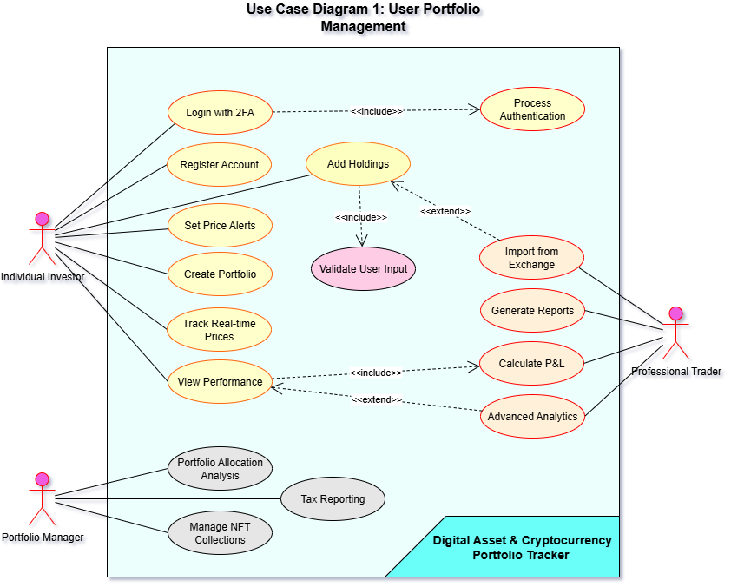Use Cases: Register Account, Login with 2FA, Create Portfolio, Add Holdings, View Performance, Set Alerts, Generate Reports

**Use Case Diagram 2: System Integration and Administration**

* Actors: System Administrator, External APIs (Exchange APIs, Market Data APIs), Mobile App
* Use Cases: Monitor System Health, Manage User Accounts, Sync Exchange Data, Update Market Prices, Send Notifications, Backup Data

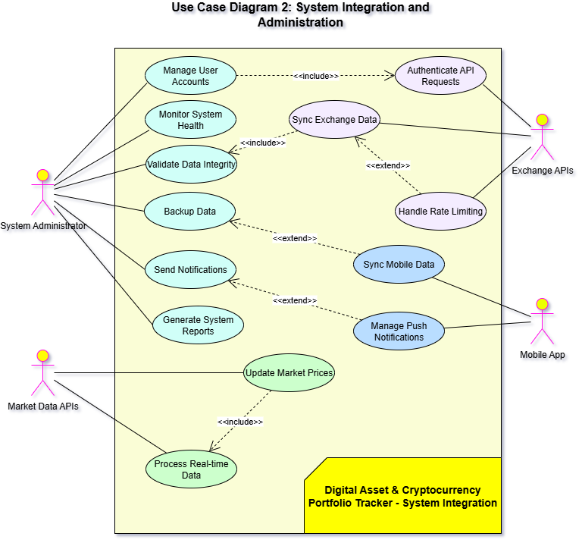

## **8. Requirements Traceability Matrix (RTM)**

|  |  |  |  |  |  |  |
| --- | --- | --- | --- | --- | --- | --- |
| **Req ID** | **Requirement Short** | **Section Ref / Design Spec** | **Module** | **Test Case(s)** | **Status (N/P/A)** | **Comments** |
| CRYPTO-F-001 | Email verification | 4.1 / DS-Auth-01 | AuthModule | TC-Auth-01 | N |  |
| CRYPTO-F-002 | 2FA enforcement | 4.1 / DS-Auth-02 | AuthModule | TC-Auth-02 | N |  |
| CRYPTO-F-003 | Session timeout | 4.1 / DS-Auth-03 | AuthModule | TC-Auth-03 | N |  |
| CRYPTO-F-004 | Multiple portfolios | 4.2 / DS-Portfolio-01 | Portfolio  Module | TC-Portfolio-01 | N |  |
| CRYPTO-F-005 | Manual holdings | 4.2 / DS-Portfolio-02 | Portfolio  Module | TC-Portfolio-02 | N |  |
| CRYPTO-F-006 | Exchange import | 4.2 / DS-Portfolio-03 | Integration  Module | TC-Portfolio-03 | N |  |
| CRYPTO-F-007 | Real-time prices | 4.3 / DS-Market-01 | MarketData  Module | TC-Market-01 | N |  |
| CRYPTO-F-008 | Historical charts | 4.3 / DS-Market-02 | Charting  Module | TC-Market-02 | N |  |
| CRYPTO-F-009 | Price changes | 4.3 / DS-Market-03 | CalculationModule | TC-Market-03 | N |  |
| CRYPTO-F-010 | Multi-currency value | 4.4 / DS-Analytics-01 | Analytics  Module | TC-Analytics-01 | N |  |
| CRYPTO-F-011 | P&L calculations | 4.4 / DS-Analytics-02 | Tax  Module | TC-Analytics-02 | N |  |
| CRYPTO-F-012 | Allocation analysis | 4.4 / DS-Analytics-03 | Analytics  Module | TC-Analytics-03 | N |  |
| CRYPTO-F-013 | Price alerts | 4.5 / DS-Alert-01 | Notification  Module | TC-Alert-01 | N |  |
| CRYPTO-F-014 | Email reports | 4.5 / DS-Alert-02 | Reporting  Module | TC-Alert-02 | N |  |
| CRYPTO-F-015 | Push notifications | 4.5 / DS-Alert-03 | Mobile  Module | TC-Alert-03 | N |  |
| CRYPTO-F-016 | Exchange Integration | 4.6 / DS-Exchange-01 | Integration Module | TC-Exchange-01 | N |  |
| CRYPTO-F-017 | Advanced analytics (volatility, Sharpe) | 4.7 / DS-Analytics-04 | Analytics Module | TC-Analytics-04 | N |  |
| CRYPTO-F-018 | NFT holdings import | 4.8 / DS-NFT-01 | NFT Module | TC-NFT-01 | N |  |
| CRYPTO-F-019 | Tax reports (multi-jurisdiction) | 4.9 / DS-Tax-01 | Tax Module | TC-Tax-01 | N |  |
| CRYPTO-F-020 | Encrypted backups | 4.10 / DS-Data-01 | Data Management Module | TC-Backup-01 | N |  |
| CRYPTO-NF-001 | Dashboard load time | 5 / DS-Perf-01 | WebUI/API | TC-Perf-01 | N |  |
| CRYPTO-NF-002 | System uptime | 5 / DS-Reliability-01 | Infrastructure | TC-Monitoring-01 | N |  |
| CRYPTO-NF-003 | Data encryption | 5.1 / DS-Security-01 | Security  Module | TC-Sec-01 | N |  |
| CRYPTO-NF-004 | Concurrent users | 5 / DS-Scale-01 | LoadBalancer/API | TC-Scale-01 | N |  |
| CRYPTO-NF-005 | Mobile resources | 5 / DS-Mobile-01 | MobileApp | TC-Mobile-01 | N |  |
| CRYPTO-SR-001 | Secure API communication with OAuth + AES-256 | 5.2 / DS-Sec-API-01 | APICommModule | TC-Sec-02 | N |  |
| CRYPTO-SR-002 | Rate limiting + DDoS protection | 5.1.2 / DS-Sec-Net-01 | NetSecModule | TC-Sec-03 | N |  |
| CRYPTO-SR-003 | Session expiry + re-authentication | 5.1.2 / DS-Auth-Session-01 | AuthModule | TC-Sec-04 | N |  |
| CRYPTO-SR-004 | Audit logging (no sensitive data) | 5.1.2 / DS-Log-01 | AuditLogModule | TC-Sec-05 | N |  |
| CRYPTO-SR-005 | Input validation and sanitization | 5.1.2 / DS-InputSanitize-01 | InputSanitizeModule | TC-Sec-06 | N |  |

**ROLES:**

|  |  |
| --- | --- |
| **Name** | **Contribution (section no.)** |
| C Kaustubh | Documented Overall Description, External Interfaces, and drafted the first half of System Features including Authentication, Portfolio Management, Real-time Market Data, Performance Analytics, and Alerts & Notifications.  ***{2,3, 4.1- 4.5}*** |
| Chinmay Shivanand Muragod | Prepared Non-functional Requirements, Quality Attributes & Acceptance Tests, and developed the Requirements Traceability Matrix (RTM).  ***{5,6,8}*** |
| Chirag K M | Template Design (structure, formatting, style consistency) and creation of UML diagrams.  ***{Pg:1-17, sec:7}*** |
| Darshith M S | Introduction, contributed to later System Features including Exchange Integration, Advanced Analytics, NFT Management, Tax Reporting, and Data Management, and detailed the Security requirements.  ***{1,4.5-4.10,5.1}*** |

***Thank You***