Deployment of WAR file into IMB WebSpere Studio Application Developer.

- Create your WAR file. Include resource reference to data source in web.xml descriptor. In EAGLS project datasource name is “jdbc/boa”. Then pack files to .war file.

web.xml
...
<web-app>
<servlet>...</servlet>
<servlet-mapping>...</servlet-mapping>
<welcome-file-list>...</welcome-file-list>
...
<resource-ref id="ResourceRef_1">
<description>Data Source</description>
<res-ref-name>jdbc/boa</res-ref-name>
<res-type>javax.sql.DataSource</res-type>
<res-auth>Container</res-auth>
</resource-ref>
...
</web-app>

- Import created file into IMB WebSpere Studio Application Developer by choosing File->Import menu item. When choose War file from dialog.
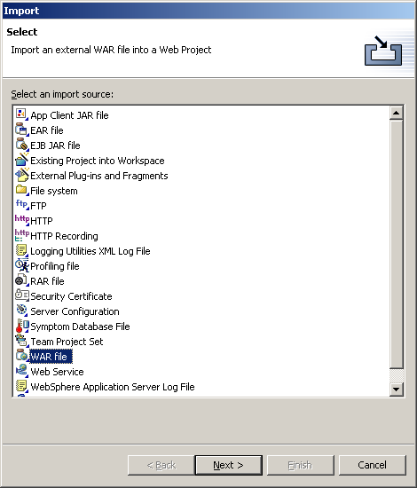

- Enter War file location, create new Web project and Enterprise Application project. During following deployments you can select existing Web project.
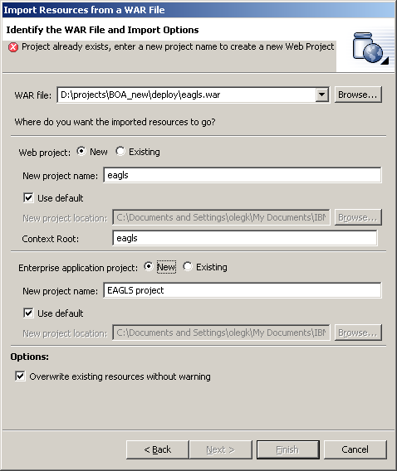

- Rebuild Web project. WebSphere Studio will add server-specific configuration information.
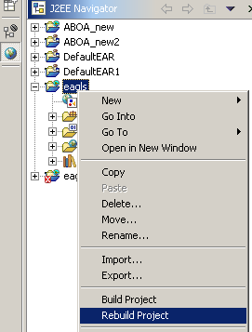

- In context menu of EAGLS Web project select item. Select “WebSphere v5.0 Test Enviroment”. Run server, then stop it. WebSphere Studio will create initial server configuration and put .ear and .war files into it.
- Go to Server Configuration in J2EE Navigator (bottom “Server Configuration” tab).
Select your Server and Server Configuration and double click on it.
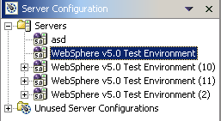
- Select Security tab.
- Add JAAS Authentication Entry. Alias=boa, User ID=gsa, Password=pigs.
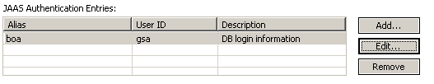
- Go to Data Source tab.
- Add Oracle JDBC Thin Driver. Name=jdbc/boa.
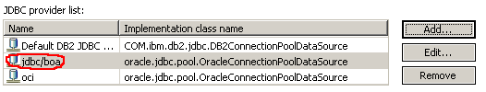
- Add Data source. Provider – Oracle JDBC Thin Driver, v.5.0. Connection URL is jdbc:oracle:thin:@romanso:1521:romanso. Fill creation dialog like this
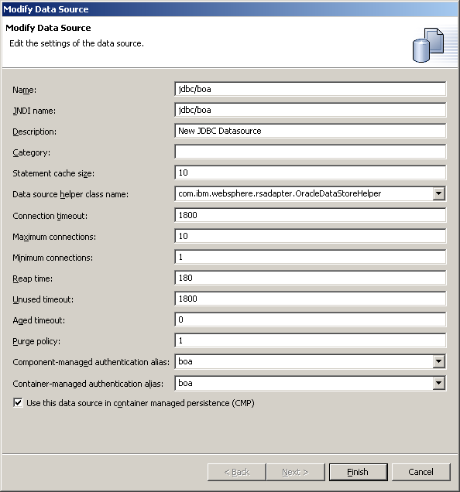

- Now you can select “Run on Server” from context menu of your Web project. After deployment Web project will be accessible via browser on 9080 port. Context name is the name of Web project.

