

System Document for
G-EAGLS Project



Statement of Confidentiality
This document contains information that is proprietary and confidential to Bank of America which shall not be disclosed outside Bank of America, transmitted, or duplicated, used in whole or in part for any purpose other than its intended purpose. Any use or disclosure in whole or in part of this information without express written permission of Bank of America is prohibited.

Any other company and product names mentioned are used for identification purposes only, and may be trademarks of their respective owners. The template and guidelines for preparing this document © Copyright 2002, TATA Consultancy Services (TCS)

Revision list

Document Name: System Document for G-EAGLS

Version | Author | Date | Changes done | Remarks
Draft 1.0 | TCS Team | 11/02/2002 | Initial Draft
Draft 1.1 | TCS Team | 11/15/2002 | Module descriptions added
1.0 | TCS Team | 11/26/2002 | Module descriptions were enhanced with finer details

Table of Contents
1 Introduction 6
2 Background 7
3 System Details 8
3.1 Business Overview 8
3.2 Surrounding Systems 8
4 Technical Overview 10
4.1 Software Details 10
4.2 Technical Architecture 11
4.2.1 High level design of the system 11
5 Modules or Components 13
5.1 Online 13
5.1.1 Basic Architecture 14
5.1.2 Overview of the System 15
5.1.3 Functionality of the System 18
5.1.4 Account Inquiry/Maintenance 23
5.1.5 Maintenance 26
5.1.6 Set Up 26
5.1.7 Transaction Data 27
5.1.8 Reporting Tool 30
5.1.9 Program Information 31
5.2 Reporting Module 32
5.2.1 System Overview – Reporting Module 32
5.3 53
5.3.2 Reports 58
5.3.3 Online Reports 59
5.3.4 Paper Reports 72
5.3.5 Summary Tables 73
5.3.6 Schemas and Tables 75
5.3.7 Build Process for Reports 75
5.3.8 L- Notes Databases in use 77
5.3.9 Code Base in PVCS: 77
5.4 DEF 79
5.4.1 Working of DEF Component 79
5.4.2 Reconciliation 80
5.4.3 DEFCUPS 80
5.4.4 DMDC 80
5.4.5 Valid values 80
5.4.6 Dependency 80
5.4.7 DEF Layout 81
5.5 Interfaces 82
5.5.1 Process 82
5.5.2 SQLJ Files 83
5.5.3 Perl Script 83
5.5.4 Support Files 83
5.5.5 Feeder File 84
5.5.6 Report Creation 85
5.6 Refunds 86
5.7 ISYS 88
5.7.1 Process 88
5.8 Replication 90
5.8.1 Process 90
5.9 Miscellaneous 92
5.9.1 Draft 256 92
5.9.2 Top 25 Options 92
6 Security 93
7 Appendices 94
8 References 95

Introduction

Bank of America has developed EAGLS (Electronic Account General Ledger System) to provide their Government Card contracts with an efficient means of managing credit card transactions at minimal cost.

G-EAGLS is an Electronic Account General Ledger System for Government Agencies. The features of G-EAGLS are on-line access for inquiry and maintenance, reporting data extract file from TSYS and electronic invoices via interface files.

The Government application (G-EAGLS) supports the Government Card program used for travel, purchase and fleet functions. There are approximately 350,000 log-ins of the Government EAGLS application today, with the portfolio continuing to grow. There are two main components to the Government application: Core EAGLS and a Reporting Tool, which is upgrading to Crystal Enterprise 8.5

The current Government EAGLS (GEAGLS) product utilizes a region within the Total Systems environment commonly called TS2.

The components are listed below:

Component
Online (Core)
Reports
External Interfaces
Data Exchange File (DEF) from Total Systems (TSYS)
Refunds
ISYS

Background

This document is being submitted to Bank of America in response to their request for the System Document for the Application testing Services for their Credit Systems Development applications.

The main objective of this project is to

- Understand the Environment, System Architecture, Existing maintenance processes
- Provide maintenance and enhancements for the Credit System Development Applications

System Details

EAGLS is a web-based application that provides a secure electronic commerce solution that eliminates the inefficiencies associated with manual, paper- based purchasing and accounting functions. There are different kinds of reports and each module either does the work of creation, movement or Source of report.

DEF forms the basic source of information for the other components. DEF is created everyday by Total Systems. The components like interfaces, online and refunds are used for reporting purpose, whereas ISYS is used for workflow management of the system. The individual components will be detailed in the succeeding chapters.

Business Overview

As one of the nations’ premier card providers, Bank of America is also one of the largest and fastest growing issuers of Visa and MasterCard card products worldwide. The Government Card Services group specifically offers business solutions designed to streamline processes and provide greater access to services and information by providing flexible end-to-end solutions, custom-tailored to meet the specific needs of a large corporation.

The a forementioned business solutions are based on these types of credit card programs, or product types:

Fleet Card | A charge card that is used solely for the purpose of Government fleet fueling and maintenance.
Travel Card | A charge card that is used solely for the purpose of purchasing government travel-related goods and services.
Purchase Card | A charge card used to make government-related purchases that are directly billed to and paid in full by agency or organization.
Integrate Card | A charge card designed to streamline all agency-purchasing processes, incorporating three business lines including purchase, travel and fleet.

Surrounding Systems

Total Systems

As a third-party card processor, most TSYS activities occur behind the scenes. As a result, Bank of America account holders are unaware of the many services TSYS provides. Through TSYS and their subsidiary, TSYS Total SolutionsSM, Inc., a complete account acquisition management program exists, including direct mail and inbound/outbound phone programs.

When an individual applies for a Bank of America credit card, TSYS goes into action. Application data is keyed into a terminal linked with THE TOTAL SYSTEM®. With a TSYS credit evaluation system and data from credit bureaus, it can be quickly determined if approval is warranted. If so, TSYS is electronically advised to open an account. .
The Card Services Department at TSYS is notified and, with sophisticated equipment, embosses a card with the consumer's name, account number and expiration date. The magnetic strip on the back is encoded, making the card readable by automated teller machines and point of sale terminals.

A mailer designed to hold the embossed plastic is prepared so the card can be sent to the consumer.
When the consumer makes a credit card purchase, TSYS also provides the system that authorizes the purchase as the merchant swipes the card through the point-of-sale terminal or otherwise enters the account number to gain approval for the transaction. Once approved, the purchase data is captured and transmitted each day to banks or Clearing houses.
Details about transactions are electronically received daily by TSYS and applied to individual accounts. Information is stored to be used later in reports to Bank of America and in monthly statements to individual cardholders.
In the Statement Production Department, TSYS uses advanced laser printers that receive computer data about cardholder accounts and print monthly statements. With this equipment, TSYS produces an average of 900,000 statements a day.
Once printed, the statements are sent to an in-house state-of-the-art mail operation where they are mechanically inserted into envelopes along with other printed materials Bank of America wishes to enclose.
When consumers pay their credit card bills, TSYS electronically receives payment data and credits the appropriate accounts.
The data that Total Systems warehouses for Bank of America is transferred nightly via the Data Exchange File (DEF) load. In summary, this file will include all account and transaction information for all accounts issued by Bank of America.

Technical Overview

Software Details

S.No | Module | Software Used
1 | Online | NES 3.6 sp 4  NAS 4  MQ Client  Netscape Extension for MQ Client  HTML  AppLogic  Windows NT  Visual Café
2 | Reports | Crystal Reports  Windows NT
3 | Interface | Perl  Oracle 8.1.7  Java  Development SunOS  Production Sun Solaris
4 | Refunds | Developer 2000  Oracle Queries  Development Sun OS  Production Sun Solaris
5 | DEF | C  Oracle Stored Procedure  Development Sun OS  Production Sun Solaris

Technical Architecture

High level design of the system
This section explains the High level design of the system.

User Interface

Web-Server - Netscape
SSL
Client
Browser

The above diagram illustrates the framework for graphical user interface services. The interface will be web-browser based and will be generated using HTML, JavaScript and Java. The primary use of JavaScript will be for input validation. Both Netscape Navigator 4.X and above and Internet Explorer 3.X and above are supported. Java will be supported at the browser when it is a component of a third party product that is to be incorporated into the system.

System Interface Services: Application Messaging

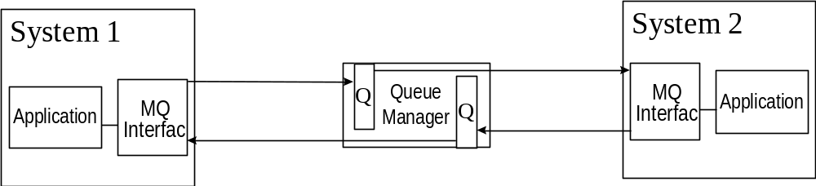

As shown in the above diagram, synchronous/asynchronous message-based interfaces between disparate systems will be supported by IBM’s MQSeries technology. To support this technology, each system must have a compliant MQ interface that has knowledge of its queue manager. Based on configurations set up in the MQ manager and each MQ interface, this can support synchronous/asynchronous messaging.

The primary responsibility of the system is to send updates to databases. For example, if a user changes his address on System 1, MQSeries will send an update to System 2. The process for doing so is that System 1 will send a message to the MQSeries Queue Manager, which can then send the information to System 2 or wait for System 2 to retrieve the information. The process is based on the configuration of the system.

MQSeries provides features that ensure message delivery. If the external system supports a compatible MQ interface to the Queue Manager and there is a requirement for scalable and reliable asynchronous or real time (synchronous) messaging, MQSeries will be used.

Modules or Components

Online

EAGLS is a web-based system, not a software program. The requests and changes are updated and maintained within EGALS, and then forwarded to the Bank of America mainframe system. This information is passed from the Bank of America mainframe system to Total Systems (TSYS), and TSYS in turn passes data back to EAGLS. TSYS is the company used to process all bankcard data for Bank of America.

EAGLS and TSYS communicate through interfaces. An interface is the point where independent systems interact. There are two interfaces to transfer information between EAGLS and TSYS; one is Message Query (MQ) and the other is the Data Exchange File (DEF).

G-EAGLS system features will help perform variety of administrative and accounting tasks such as online account setup and activation, account maintenance, reconciliation and cost allocation.

G-EAGLS Menu Option | Task
Account Inquiry/Maintenance | - Search for an account holder account by account number, last name/first name, SSN or hierarchy level.  - Activating and deactivating accounts  - Search for, change or update account information
Inquiry | - A read only function that allows to view information pertaining to agency, central account and vehicle accounts
Maintenance | - Perform routine card program tasks
Setup | - Setup an account and establish new accounting centers
Transaction Data | - View and work with detailed transaction data
User options | - Create and maintain User Profile information, which will affect the data and functions that are accessible to a user.
Reporting tool | - Access the online Reporting Tool that includes a customizable menu of report options can use to analyze EAGLS account data.
Log off | Signs completely out of EAGLS

Basic Architecture

Client Tier

The first tier is the client, or user interface, tier. End users interact with client software in order to use the application. The client software used in G-EAGLS module is the Web-browser and HTML.

Middle tier

The middle tier used is the Netscape Enterprise server. The Netscape Enterprise Server handles requests from clients by running the appropriate application code, and then returns the results to the clients. The means of communication between the client tier and Netscape Enterprise Server is the Internet or an Intranet. In the case of HTML clients, a Web server also stands between the client and Netscape Enterprise Server. The Web server passes requests and responses back and forth between HTML clients and Netscape Enterprise Server.

Database Tier

The third tier is the database tier. This tier consists of one or more database servers, which can be from different vendors. The database tier stores the information that forms the basis of the application

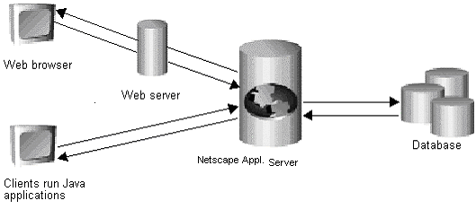

Overview of the System

From the initial screen (index.html) that enables the user to the system, the AppLogic takes the input parameters from the HTML source and then displays the logon screen after making validations for encryption and other security issues.

On click of the continue button in the index.html, the page passes a unique id GUID) to the Netscape server. The server then executes the AppLogic corresponding to that particular GUID. In this case it is LogonscreenAL.java. This java file on successful execution redirects to the SystemLogon.html.

The login screen or the SystemLogon.html is linked to the AppLogic (in the file LogonAL.java) defined which executes on click of the submit button. It validates the type of user, his access rights and the links that will be visible for that user by accessing the database. If the validations are successful, it redirects the browser to the HTML page eaglsSplash.html.

The initial splash screen appears after successful login. The Links in the right frame are initially collapsed. They can be expanded and collapsed as the users click on it.

The whole online module is built up on the three-tier architecture as described in section 1. The following are the software/languages used in the module.

MQ Connectivity

An exchange of information occurs between the EAGLS application database and the NGCC systems at Total Systems (TSYS), which supports all of the account information and transactions, which fall into the scope of the Government Card Programs.

It is necessary to verify that data is passed accurately between EAGLS and TSYS. This data is routed via MQ packets.

Reason for verification:

- New MQ packet introduced into EAGLS application
- Existing MQ packet change to current layout

Main Menu Items (Collapsed)

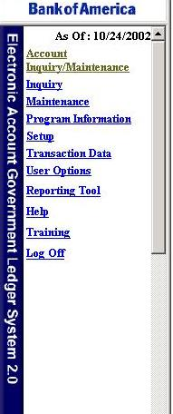
The figure below shows the Main Menu items that the user can access. Note that not all the menu items are accessible by all the users. The following Menu is a snapshot for the GCSU user.

List Of Menu (Expanded)

Account Inquiry/Maintenance | Setup
Inquiry | Account
Agency Profile | Accounting Center
Central Account | Agency
Vehicle Account | Central Account
 | Vehicle Account
Maintenance
Account Activation | Transaction Data
Account Status | Agency Invoice
Accounting Center | Cost Allocation
Agency Profile | Individual Statement
Bulk Activation | RapidRecon
Central Account
Change ATM PIN | User Options
Convenience Checks | Change Password
Credit Limit | Change Role
Queued Requests | Create Role
Request Card | Create User Profile
Transfer Account | Modify Role
Transfer Account Queue | Modify User Profile
Travelers Checks | Reset Password
Vehicle Account
 | Reporting Tool
Program Information
GSA Program Forms | Help
Newsletters
Log Off | Training

Functionality of the System

Logon and Logoff Functions

The Logon function gives an authorized user access to G-EAGLS. The user can perform functions within his/her span of control while using EAGLS. The Logoff function ensures that the user exits the system properly and maintains the security of the access.

Three invalid logon attempts will lock the user out of the system.

Password Expiration:

Every 84 days
The system prompts to change password seven days prior to expiration
Automatically directed to Change Password function if not changed by the 84th day

The password is a case-sensitive, ranging from seven to twenty characters, alphanumeric word which allows a registered user access to G-EAGLS. The user will be requested to change his/her password during initial logon to allow the user to set a unique password. The user-id is the identity of a registered G-EAGLS user. This is usually some combination of first and last name of the user and that may contain a number.

The Search Function

The Search function allows the user to navigate throughout G-EAGLS by selecting criteria specific to his/her needs. A search screen precedes almost every G-EAGLS function. A Search Result Screen will display a list of accounts when there are multiple search results. The desired account can be clicked to make a selection.

The search screen will display with the user’s default hierarchy. For most search screens, the user will have the ability to select several search criteria to perform a particular search. A wildcard search cannot be used in conjunction with any other wildcard search. Only one wildcard field per search is allowed in G-EAGLS.

Submit or Clear buttons at the top or at the bottom of the screen enables the user to submit or clear a bad query.

Account holders will not receive search screens except when searching for a statement.

Search By options are from the Account Inquiry/Maintenance function. Various search criteria can be used in G-EAGLS based on the information required.

Account Number – This field supercedes any other search criteria entered within the screen. The A/OPC may enter other fields within the screen; however, since this is a unique field all other criteria will not be used.

Last Name – This field will permit a wildcard search. The A/OPC must enter at least the first two characters in the field followed by an asterisk (*). (Only on Account Inquiry/Maintenance)

Optional Criteria / First Name – This field is optional. If used, it must be used in conjunction with a last name search. It allows a wildcard search by entering at least two characters followed by an asterisk (*) and by entering the entire last name.

Optional Criteria / Zip/Postal Code - This field is optional. If used, it must be used in conjunction with a last name search. It allows a wildcard search by entering at least two numeric characters followed by an asterisk (*) and by entering the entire last name.

Business Phone Number - This field allows the A/OPC to search by the account holder’s phone number. All fields must be populated. (Only on Account Inquiry/Maintenance)

Social Security # - This field allows the A/OPC to search by the account holder’s social security number. All fields must be populated. (Only on Account Inquiry/Maintenance).

Searching by Hierarchy - The Search function in EAGLS allows to browse through a list of agencies using a 40 character-length field for the agency name. The browse functionality pulls in the agency names associated with the hierarchy level within the user’s span of control and lists them in a pop-up window. As the user browse and selects an agency, he/she may continue moving to and through the next levels and make additional selections by continuing to drill down
through the hierarchy levels.

Other search options –

- Agency Name
- Vehicle Account
- Central Account Name
- Central Account ID

User Options

The User Options function allows creating user profiles and the criteria associated with them. The user profile defines the access to data and functions that a user can perform in EAGLS. The ability to change criteria associated with a profile allows greater access and functionality for the user.

Create User Profile

A/OPCs have access to the Create User Profile functionality. A User Profile defines the accessibility to screens, accounts and functions that can be performed in EAGLS. This can be utilized to allow an alternate A/OPC or account holder online access to his/her account.

A/OPCs have access to the Create User Profile functionality. A User Profile defines the accessibility to screens; accounts and functions can be performed in EAGLS. This function can be utilized to allow an alternate A/OPC or account holder online access to his/her account.

This function allows the A/OPC to establish a User Profile in EAGLS. It does not create a transaction account. This function is agency specific. Create User Profile can be accessed from the EAGLS Main Menu or from the User Profile Setup hyperlink in Account Setup.

The User Status Code defaults to “Active”. An inactive status will not allow the user to log on to EAGLS.Reports access is not available to the account holder role.

A “default role” must be assigned to the user profile when creating it. This is the role, such as A/OPC, that will be assigned to the user each time he/she logs onto the system. Multiple user roles can be assigned to each User Profile. For example, a user profile could have an A/OPC role and an account holder role.

Once a User Profile has been set up, it is submitted to GCSU for processing within 24 hours. The user can check the status of his/her request by accessing the Queued Requests function within Maintenance.

Modify User Profile

Certain criteria associated with a user profile may be modified. The user role may be modified by status, hierarchy level/program type and account number. For example the user can add the role of an account holder to an alternate A/OPC’s User Profile so that he/she will have access to account functions relative to that specific role.

Change Accounts

The session or default account number associated with a user profile can be set if there is more than one account associated with the specified user profile. The default account information displays when the user initially sign on to the system to perform maintenance, inquire on an account, or view a statement.

This functionality allows the user to gain access to all accounts associated with his/her profile. Only the users who have more than one account associated with their user profile can access this function.

The user can change the account number during his/her current session in EAGLS, or select to change the account number so that when the user does the next sign on to the system, a different account number defaults.

Change Hierarchies

The user may change hierarchies if there is more than one hierarchy associated with his/her profile in order to access accounts associated with the different hierarchies. This function is used when the user is assigned to more than one division or department within his/her agency, and when there is a need to change hierarchy so that the account information for a particular department displays. The user will have access to this function only if he/she has more than one hierarchy associated with User Profile. The user can have multiple roles within multiple hierarchies.

Change Password

The user is requested to change his/her password every 84 days. The change password screen is automatically displayed on password expiration

Favorites List

The user can create favorites lists of frequently used accounting codes. This process will enable the user to access frequently used accounting codes through a drop down box that appears when performing cost allocation. A maximum of 50 frequently used master accounting codes can be saved in Favorites List. Addition, deletion and modification of accounting codes in Favorites List can be performed.

The Favorites List is associated with a User ID. Account Holders and A/OPCs will have access to their own Favorites List; however, GSCU does not have access to any Favorites Lists.

Favorites List names do not need to be unique and can be used on more than one accounting code. But the accounting codes within a user’s favorites list must be unique. A user cannot assign multiple names to the same accounting code within a favorites list. If an account holder has more than one account, he/she must change accounts in the User Options function in order to modify or add a favorite code for a different account. Also if an account holder has more than one role, he/she must change to the role associated with an accounting code in order to modify or add a favourite code.

Inquiry

The Inquiry function allows quick access to central account and agency profile information. The Inquiry screens are "read-only," Account holders do not have access to this information.

Agency Profile

The Agency Profile Inquiry allows the user to review general information about the agency or hierarchy to which the user is assigned. This information includes the Hierarchy numbers and descriptions, the Agency Name, and the Agency ID.

Point of Contact

The Point of Contact (POC) screen gives contact information for various roles. The Agency Profile section lists contact information for all the Component Program Managers (CPM) as well as A/OPCs who have been assigned to that Agency Profile. The Central Account section lists contact information for all roles associated with a Central Account including the Transaction Dispute Officer (TDO), the Designated Billing Officer (DBO), Electronic Commerce/Electronic Data Interchange (EC/EDI) and the Agency/Organization Program Coordinator (A/OPC).

This information can be accessed via the link in the Agency profile/Central Account Search Screen

Central Account

The Central Account Information screen allows the user to view general Card Program information such as accounting, payment and balance, and transaction information by using the Central Account Inquiry function. The central account contains information that applies to all accounts within his/her hierarchy levels. Any account, whether an Individually Billed Account (IBA) or a Centrally Billed Account (CBA) rolls up to a Central Account for reporting purposes.

Account Inquiry/Maintenance

The Account Inquiry/Maintenance function allows the user to perform various tasks without having to choose other menu items. This function allows the user to maintain information like changing an account holder’s name and address, or transferring an account from one hierarchy to another.

A header box located at the top of the screen displays the Account Name, Account Number and Social Security number.

Account Holder Information

The Account Holder Information section of the Account Inquiry/Maintenance screen may be accessed by scrolling or by clicking on the "jump to link" located in the Header Box. It allows the user to maintain individual account holder personal information. The user can change other account holder information such as the Warrant Level Amount, Master Accounting Code and the Accounting Center ID.

This function is mainly used when an account holder:

• Adds middle initial or two characters of the name are misspelled
• Changes other personal information such as address, telephone, etc.
• Warrant Level amount authority changes
• Centrally billed account is being transferred from one hierarchy to another or transactions are being transferred from one account to another.

Account Information–

The Account Information section of the Account Inquiry/Maintenance screen is easily accessed by clicking on the "jump to link" in the Header Box. It contains general account information, which the user may conveniently change and update

This function is mainly used to –

Change account status:
1.Close an account
2.Review the status of an account
3.Account holder is no longer authorized to have a travel card
4.Account holder is no longer employed by the agency

Activate and Deactivate:
1.Activate or deactivate accounts on demand
2.Activate or deactivate accounts during a two-stage transfer account

Change Credit Limit:
1.The credit limit does not meet account holder travel expenses
2.The authorization controls n adjusted to meet account holder travel
expenses
3.Account holder has been transferred to a position that requires him/her to have
a higher credit limit

Order/reorder Convenience Checks and Traveler’s Checks:
1.A merchant or vendor does not accept credit cards for payment
2.Account holder has called to request convenience or traveler’s checks

For temporarily closing or opening an account, Deactivate On or Activate On function in the fields below the Account Status field is used. If a card is lost or stolen, it must be reported to GCSU and In these situations, GCSU will close the old account and a new card and account number will be issued to the account holder.

The Central Account ID and the account hierarchy level must match in order to maintain information. An error message will display advising no maintenance can be performed until the Central Account ID and hierarchy levels match.

Searching for an Individual Account

The Account Inquiry/Maintenance Search gives the user several "Search By" and "Search For" options to make it easy to search for individual accounts within his/her span of control. Note that a wildcard search cannot be used in conjunction with any other wildcard search.

Changing Authorization Controls

The Authorization Controls function can be accessed by clicking on the hyperlink located in the Account Information section of the Account Inquiry/Maintenance screen. The Authorization Control Maintenance screen allows the user to request a change or update to authorization controls for an individual account or Merchant Category Code Group (MCCG). Account-level controls are designed to limit account spending per cycle or during a designated time period, such as setting a single-purchase limit, a monthly spending limit, or cash advance limit.

When the user updates Authorization Controls in EAGLS for an individual account, they are queued to GCSU for processing.

• GCSU will process the Authorization Controls request within 24 to 48 hours.
• GCSU will not process Authorization Controls requests on weekends and holidays.
• The user can submit only one Authorization Control Maintenance request per account within a
24-hour period.
• Standard card authorization control limits may not be modified if the card was originally
issued as restricted.
• For any card which contains more than one MCCG, if it is necessary to increase the account holder’s authorization limits, the credit limit must be adjusted to cover twice the total authorization limit (agency dependent).

Transferring Accounts

The user can transfer an account from one hierarchy to another by completing a Simple Transfer Account or a Two-Stage Transfer Account. A Simple Transfer Account is done by simply changing the hierarchy number on the Hierarchy Information section of the Account Inquiry/Maintenance screen. By clicking on the hyperlink located at the bottom of the Hierarchy Information section the user can perform a Two-Stage Transfer Account. This hyperlink will not display if the account is closed. The Transfer Account functionality is available to Individual Accounts only.

Transfer an account from one hierarchy to another by completing a Simple
Transfer Account or by completing a Two-Stage Transfer Account. If a Central Account Number is given as input on either of the search screens, an error is returned. Transfer Account is only available for individual accounts.

SIMPLE TRANSFER ACCOUNT

When transferring an account that does not require a change in central account ID and it’s within the user’s span of control, Simple Transfer Account procedures are used. The user cannot submit a transfer if one is already pending. A flag message at the bottom of the Account Holder Information section that reads "A Hierarchy Transfer is pending on this account." is shown. This will cause the Hierarchy Display to be "read only."

Simple transfers are effective after the Data Exchange File (DEF) update.

TWO-STAGE TRANSFER ACCOUNT

Sending A/OPC – the A/OPC who submits the Transfer Account request. This A/OPC will be losing the account from their hierarchical span of control. When transferring an account that is outside the user’s span of control or requires a change in Central Account ID, two-stage transfer procedure is followed.

Stage one is completed by "Sending" A/OPC.

Stage two is completed by "Receiving" A/OPC.

Transfer Account hyperlink will not show on closed accounts and does not allows submitting a transfer. The user will not be able to submit a transfer if one is already pending.

A Sending A/OPC has the option to deactivate an account on the transfer date to prevent further transactions from accruing on the account that would bill to the old hierarchy.

The Receiving A/OPC can reactivate the transferred account once received into the new hierarchy.

For any transfer that involves a Central Account ID change, the changes are effective on the first day after the account cycles. However, if the account being transferred has no current transaction activity, including payments, credits, or purchases, the changes are effective after the Data Exchange File (DEF) update.

Maintenance

The Maintenance function allows the user to perform daily tasks like processing account holder requests for credit limit changes, ordering traveler’s and convenience checks, and replacing a card. Most of the Maintenance performed for Individual Accounts will be performed through the Account Inquiry/Maintenance function. However, there are additional functions for individual accounts as well as centrally billed accounts that can be performed through this Maintenance function.

The following are the list of functions that can be performed from the Maintenance screen.

Activating an Account
Activating Multiple Accounts
Increasing and decreasing Credit Limits
Requesting a Replacement Card
Ordering Convenience Checks on CBA accounts
Ordering Traveler’s Checks
Updating Accounting Center Information
Accessing and Processing Queued Requests
Accessing and Processing Queued Credit Limit Change Requests
Accessing and Processing Transfer Transaction Requests
Accessing and Processing Queued Transfer Account Requests

Set Up

The Setup function allows the user to establish accounts and/or issue cards for account holders via EAGLS. Only a designated A/OPC is authorized to establish an account holder transaction account for a Centrally Billed Account or to establish Accounting Center Information within their span of control. Depending on the user’s agency/organization’s policies and procedures, duties may vary. For Travel Card Program A/OPCs, a New User Profile may be set up at the same time as Account Setup if the new account holder will also be an EAGLS user. User Profiles are established on each EAGLS user and determine a user’s access to screens and functions.

Setup Account

The Setup Account function allows to input information into EAGLS to establish a transaction account for an account holder. This function enables the A/OPC to enter account information in order for the account holder to receive a card.

Accounting center Setup

The Accounting Center setup function allows the user to input accounting information for an agency into EAGLS. This information defines the unique criteria for performing cost allocation. Accounting centers are setup for CBAs only and maintain the accounting information that enables
Users to reallocate transactions to different accounting codes. When a transaction enters EAGLS, an accounting code is automatically assigned by the system based on one of the following priorities: individual account, central account, or MCC of the transaction. These priorities are determined by the agency based on their particular needs. The accounting code that defaults or is automatically assigned to the transaction may be changed to another accounting code, if necessary for reconciliation purposes. The definition and meaning of these accounting codes are
defined in the accounting center assigned to the account. A/OPCs may define accounting codes by establishing the default priorities, accounting code segments, and segment values.

Transaction Data

The Transaction Data function in EAGLS will assist the A/OPC and account holder in managing transactions for individually billed accounts or centrally billed accounts. The user can review transaction information through the agency invoice or individual statement as well as manage transaction information by transferring transactions to different accounts and allocating transactions to accounting codes. The user can also research transactions by matching them to a merchant credit, requesting a sales draft or disputing an incorrect transaction.

Transaction Details

The A/OPC may access the agency invoice in order to view transaction information. He may view central account activity or account holder activity on the agency invoice.

The A/OPC or account holder may access the individual statement in order to view transaction information. Within the individual statement the user may review individually billed and centrally billed charges at the transaction level, statement totals and statement messages.

Invoices for the previous 16 months can be viewed.
The A/OPC has unrestricted access to all contents of the Agency Invoice within his/her span of control.

For the Fleet card programs, details about tax information for rebate or recording purposes can be obtained from the Individual Statement Transaction Detail screen.

The A/OPC or account holder may allocate centrally billed transactions to another accounting code other than the default code assigned at the time of the transaction. The available allocation methods enable to allocate a transaction or transactions to one or more accounting codes.

When a transaction enters EAGLS, an accounting code is automatically assigned by the system based on the individual account default, the central account default, or the default based on the Merchant Category Code of the transaction. However, the accounting code may be changed through the Cost Allocation function that allows a transaction to be allocated across one or more accounting codes.

Cost Allocation

• Cost Allocation applies only to centrally billed transactions. While selecting the cost allocation function, only centrally billed transactions are displayed on the screen.
• Searches by first name and zip/postal code are optional with the Last Name Search.
• If invalid codes are detected, the summary screen is refreshed with an additional line beneath the accounting code, displaying the code with the incorrect segment bolded.
• An A/OPC can perform cost allocations on transactions for individual accounts within his/her hierarchy.
• A Designated Billing Officer (DBO) can perform cost allocations on transactions for central accounts within his/her hierarchy.
• An individual account holder can only perform cost allocation for CBA transactions on his/her own account.

There are three allocation methods available:

- Quick Allocation: A "quick allocation" is done by entering an accounting code from the Favorites List on the Cost Allocation Search Results screen. This method allocates the entire transaction amount to a single accounting code.

- Detailed Allocation: This link from the Cost Allocation screen, allows distributing a transaction across more than one accounting code. Using the detailed allocation method comments and percentage can be added. The Percentage feature allows cost allocation using percents instead of dollar amounts.

- Group Allocation: The link "group allocation" on the Cost Allocation screen, allows to distribute a group of transactions to one or many accounting codes. Only the Percentage feature is available through this function.

Transfer Transactions

For Integrated Card Programs, An A/OPC or account holder may transfer a transaction to another account through the transfer transaction function. This allows to re-assign a transaction charged to an individually billed account that should have been charged to a centrally billed account and vice-versa.

• This process cannot be reversed through EAGLS (there is no undo function) once the transaction has been queued.
• A transfer cannot occur on payments, fees, (except cash advance fees) or interagency trans
actions. In addition, a transfer cannot occur on a transaction that is in a dispute status.
• A transfer cannot occur on transactions for accounts that have been closed for the following
reasons: Deceased, Charged Off, Lost/Stolen, or Bankrupt.
• The DBO, A/OPC and account holder can initiate a transfer from an Individually Billed Account (IBA) to a Centrally Billed diversion account (CBA). Requests made by account holders will be queued to the DBO or A/OPC with DBO authority for approval.
• Transfers from Centrally Billed Accounts to Individually Billed Accounts can be initiated by the account holder, A/OPC or DBO. After the DBO or A/OPC approves a transfer, those requests are queued for automatic processing.
• A/OPC's and DBO's cannot initiate a transfer on their own IBA unless they change their role to account holder. Those requests are queued and are worked by another DBO or A/OPC at their level or above.
• Requests made by the DBO or A/OPC on account other than their personal account, will go directly into the queue as approved.
• Transfer Transaction is a batch process that is not posted until the nightly processing occurs.

Match Transaction

To ensure that the correct transaction amount was credited to account.

• The Match Transaction function is available only if a merchant has issued a credit transaction.
• The Possible Matching Debit Transactions screen will display the possible matches
by dollar amount and merchant name.

Requesting Sales Draft

•A sales draft may not be requested for an account that has been closed with a fraud or lost/stolen status.
• Sales drafts may not be requested for the following types of transactions: Fees, ATM Cash Advances, Convenience Checks, Traveler’s Checks, and Mail Order or Telephone Order Transactions.
• The Request Sales Draft functionality should not be used to verify that a charge is valid.
• Request Sales Draft function cannot be used if the transaction has previously been placed in a dispute status. Placing a transaction into dispute status starts the process of researching the transaction within the Government Claims Department, which may include ordering a sales draft.

Transaction Dispute

• The dispute function is for account holders.
• An A/OPC can dispute transactions on a vehicle account.
• Placing Voyager accounts into dispute through EAGLS is not available.
• An A/OPC can dispute transactions that are directly billed to a central account.

The dispute must be initiated within 60 days of the statement date on which the transaction posted.

Reporting Tool

The purpose of the Reporting Tool function is to allow the A/OPC to generate online reports to assist him/her in the management of the card program. In addition, certain reports are available in Raw Data. To further assist the A/OPC in the management of the card program, Info Analyzer 7.0, a third party software, is provided to enhance the reporting tool.

The EAGLS online reporting tool provides with:

• Regularly updated and time-sensitive information related to reports
• An easy-to-navigate, customizable interface to use for selecting, scheduling, and viewing reports
• Scheduling and sorting options for each report type that allow to specify the data to view and how it is presented
• Accurate tracking of expenditures by hierarchy
• Detailed individual account holder transaction data
• Summary information at hierarchy and agency levels, including subtotals, totals, and grand totals
• Flexible scheduling options

• Use the Reporting Tool function to access the Reports window. Through the Reports window the user can schedule and view all the reports within his/her span of control.
• A separate logon is not required to enter the Reporting tool.
• When Reporting Tool from the EAGLS Main Menu is selected, the user are automatically
logged out of G-EAGLS.
• The Reports section is structured in a tree format, similar to a directory tree. Reports are
listed by category. When expand the list is expanded for each report category, list of the available report types within that category can be seen. This format allows to view the entire menu of report options at a glance without scrolling, while providing an additional level of detail for each menu option that can be viewed with a single click of the mouse.

Scheduling Online Reports

Reports may be scheduled on demand or for a specific time. This flexibility gives the A/OPC the option of requesting a report anytime he/she wants a report. This eliminates the need for the A/OPC to wait for a report from Bank of America.

Viewing Online Reports

Reports are downloaded and viewed on the A/OPCs desktop in real time. There are several formats available that can be used to view a report. (Word, Excel, Info Analyzer, etc.)

Depending on data reporting needs, the user can select any one of the following formats
in which to view a report:

. Info Analyzer
.Microsoft Excel
.Microsoft Word
.HTML
.Text
.Rich Text Format (RTF)
.Comma-Separated-Values (CSV)
.Data Interchange (DIF)
.Lotus 1-2-3
.Raw Data

Delinquency Reporting

The Delinquency Report lists all accounts that have past due balances from 30 to 180+ days. Accounts are grouped by 30, 60, 90, 120, 150, and 180+ days past due. The benefit of this report is to identify and manage total delinquency. An account is in a state of delinquency any time the balance has not been paid by the due date.

Raw Data Reports

The Reporting Tool delivers certain reports in a Raw Data format. This feature allows downloading data into an ASCII CSV file on to the computer. The major benefit of Raw Data is to give the A/OPC the ability to manipulate the data within the file that was downloaded to create a
specialized report to meet his/her specific needs.

Exceptions Report

Exception Reports are used to help the A/OPC identify potential irregularities in card usage, trend analysis, and detailed review of specific MCC’s. The user may use the reports to do the following:

• Review detail cash usage in combination with retail spending
• Select cash usage with or without travel-related spending
• Isolate casino cash usage
• Identify mail and telephone order MCC’s (Merchant Category Code)

Program Information
The Program Information function connects directly to the GCSU THD Web site (www.gcsuthd.bankofamerica.com.). This Web site provides access to the GSA program forms and the GSA newsletter.

Reporting Module

System Overview – Reporting Module

Bank of America is providing electronic and paper reports to government agencies as a part of the overall EAGLS credit card maintenance and reporting system. The Reporting component of the EAGLS system will generate reports on all information that resides in the database. For each of the components in the application, Agency Setup, Account Setup, Maintenance, Inquiry, User Maintenance, Accounting, Statements & Invoices, and transactional information, users will be able to create instance of reports and view them in different formats.

EAGLS Reporting Interface (ERI)

The ERI is the interface used by end users to access, schedule and view the online reports.
The following is a description of the various functions and user selectable options provided by the ERI 5.0.

Entering the ERI application

By selecting the “Reporting Tool” option from the core EAGLS menu, the user enters the ERI application. Upon entering the ERI application, the screen that appears consists of two components, a navigation frame on the left and a response frame on the right. The navigation frame on the left, the response frame on the right is a convention that is consistent throughout this application. As the user selects various options from the navigation frame on the left, the display of the response frame on the right will vary

Upon entering the ERI application, the opening screen that appears has report options available to the user in the navigation frame on the left. The report options available in the navigation frame is consistent throughout the application. All navigation frame options consist of “What’s New”, “Options” and “Reports”. A more detailed description of the “What’s New” and “Options” displays are provided below.

The “Reports” heading in the navigation frame is further divided by a hierarchical listing of reports available to the user. As new reports are made available to the user, they are automatically added to the Reports heading upon re-entry into the application. The user has the option to remove any automatic additions to the Reports heading or otherwise modify the display of reports available at any time.

Session Timeout

The ERI application keeps track of a user’s activity during a user session. As long as the user is active, the ERI application will respond normally to commands. When a user has been inactive for a period of time the session is considered lost and the user will be denied access. This is analogous to the security methodology in place in the core EAGLS application.

The timeout period can be configured by Bank of America staff, but will default to 15 minutes.

After timing out, a user will be unable to schedule, view, or delete reports. They will be unable to view or set options. However, they will still be able to manipulate the navigation tree and activate the “What’s New” link.

Reporting Tool

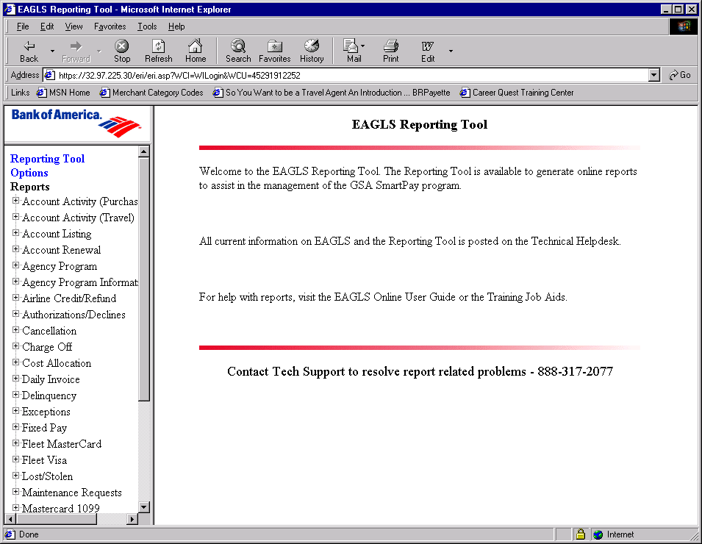

“Options” Display

The “Options” display, shown in the response frame on the right, is used to give the user the ability to customize certain parts of their interface by selecting a default viewer and customizing the list of visible reports. Each option available to the user is described in more detail below.
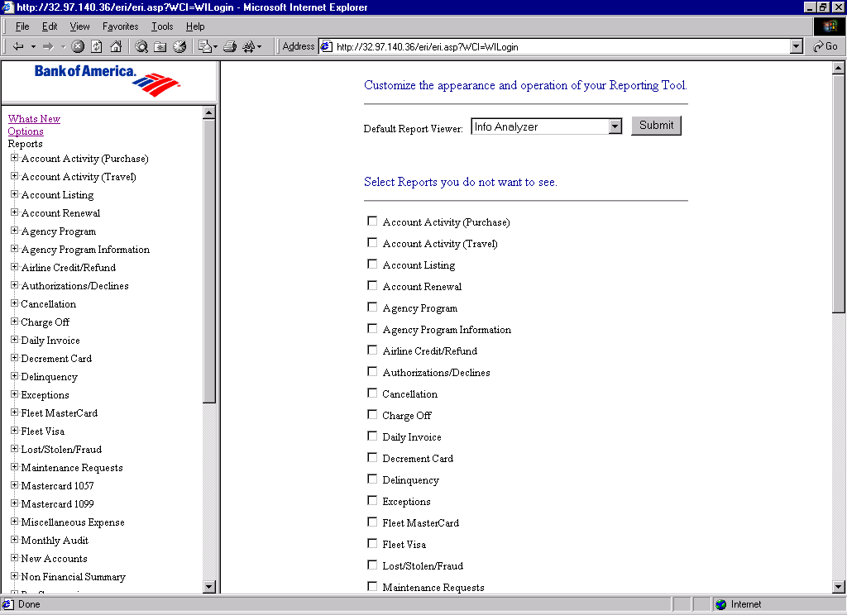

- “Default Report Viewer” – This gives the user the option to select the file viewer to use when viewing reports. The selected file viewer will remain the default for all reports available to the user until the user opts for a different file viewer. The file viewer options consist of: Info Analyzer, Microsoft Word, Microsoft Excel, HTML, text, rich text format, Comma Separated Values, Data Interchange Format, and Lotus 1,2,3.

- “Select Reports you do not want to see” – This gives the user the option to select and remove the reports that will be visible in the left frame tree view. All reports assigned to the user will be visible by default.

- To remove a report(s) from the tree view, the user ‘selects’ the check box in front of the report(s) the user does not wish to appear in the left frame and then clicks on the “Submit” button at the bottom of the screen. Once the user clicks “Submit”, the left frame tree view will instantly be refreshed, and the report(s) which were removed, (selected) will no longer be displayed in the reports tree in the left frame. The tree view in the left frame will be showing all reports assigned to the user, less those reports the user chooses not to see.

- To restore a report(s) to the tree view, the user ‘deselects” the check box in front of the report(s) the user does wish to appear in the left frame and then clicks on the “Submit” button at the bottom of the screen. Once the user clicks “Submit”, the left frame tree view will instantly be refreshed, and the report(s) which were restore, (deselected) will be added to the reports tree in the left frame. The tree view in the left frame will be showing all reports assigned to the user, less those reports the user chooses not to see.

Reports Display

The “Reports” listing in the navigation frame on the left, lists all reports that the user has access to, based on security permissions and the selections from the “Options” display described earlier. All reports assigned to the user will be visible by default. This listing is intended to be a listing of those reports routinely utilized by the user. To expand the list of visible reports available to include the Search Objects for a given report, the user must select the “+ “ next to the report name. By selecting the “+” next to the report, all available report search objects within each report are displayed.

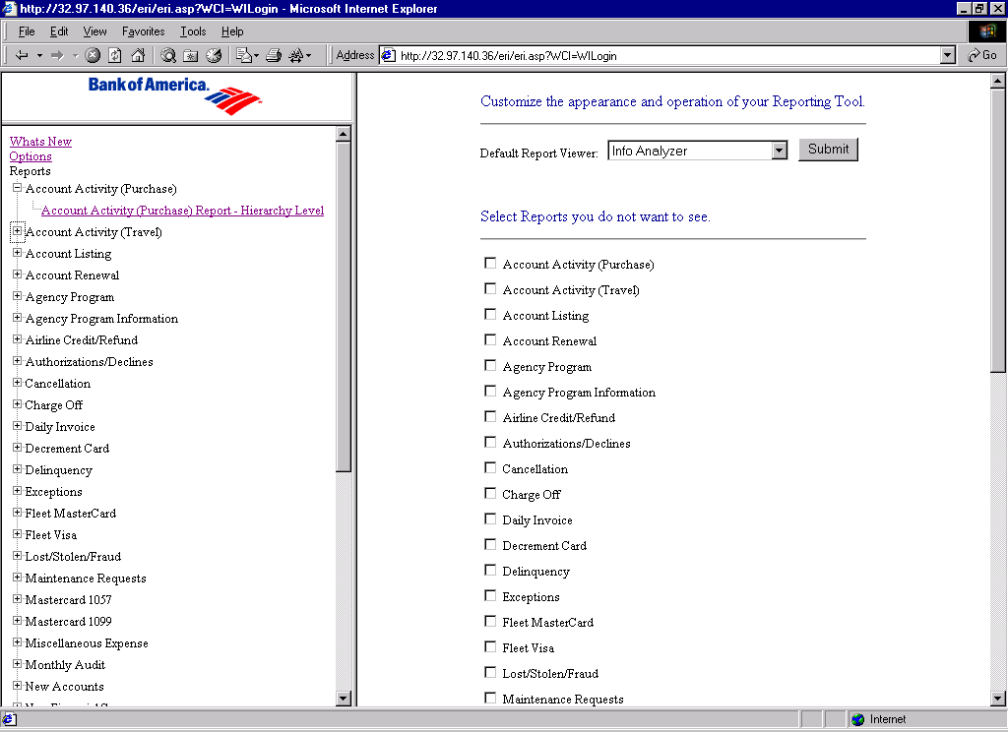
The Account listing, Transaction Activity, Delinquency HL and Delinquency HL/Delinquency reports will have an additional selection for Raw Data. All raw data reports will be delivered in Zipped Comma Separated Value format.

On selecting a search object from the navigation frame on the left, the appropriate Report instance Listing Screen is displayed in the response frame on the right.

Search Objects will have any redundancies removed from their names before being displayed in the navigation tree. For example, a Search Object called “Account Listing – Hierarchy Level” will be labeled simply “Hierarchy Level” underneath the “Account Listing” report. However, the complete name of the Search Object will be displayed in all other screens.

Report Listing Screen

The Report Listing Screen, displayed in the response frame on the right, has actions (via HTML links or buttons) that enable the user to refresh the display, schedule, view, fetch details, or delete instances. In addition, the user can view status, start time, end time and size of each instance for the chosen Search Object. Each of these described in more detail below.

The general concept of this screen is that users will use the “Schedule” link to schedule reports. When a report has been scheduled, the user will be returned to the Report Listing screen where they will see their scheduled instance. The back-end servers will take the “scheduled” instance and begin processing the report, turning the “scheduled” instance into a “processing” instance. When the “processing” instance is completed, this instance becomes either a “success” or “failed” instance. At all times, users can check the status of their instances using the “Refresh” link, which will update the Report Listing screen to include up-to-date information concerning the user’s instances for the chosen Search Object.

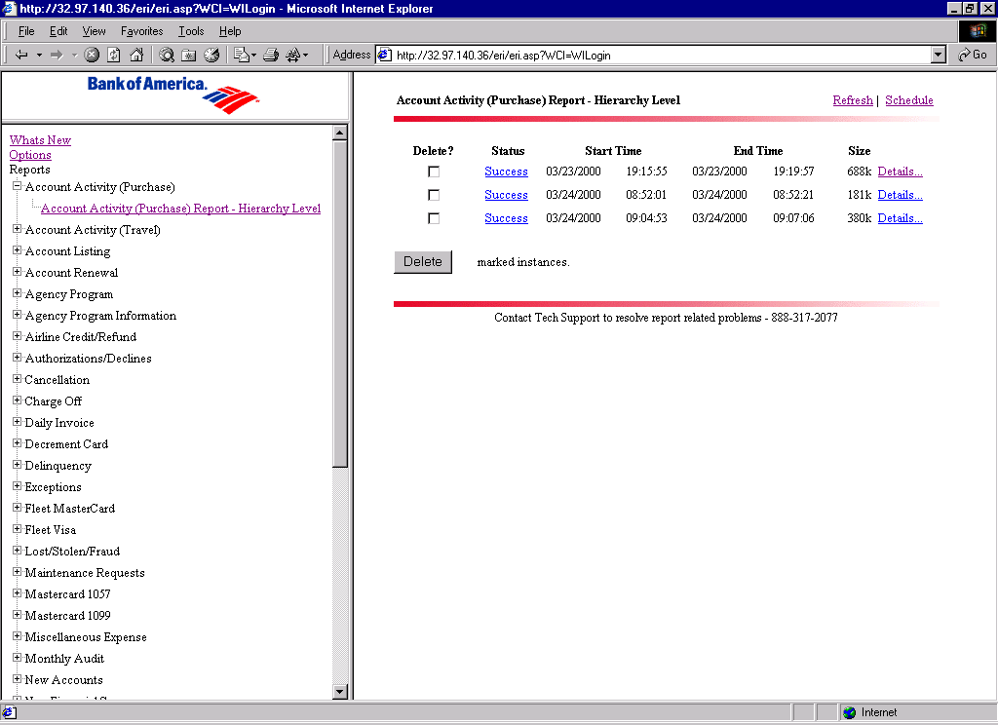
The following options are available to the user from the Report instance Listing Screen:

Refresh – This option is used to refresh the entries in the display to the most up to date information available.

- Schedule – This option is used to schedule reports, which creates a new instance.

- View – This option is displayed in the “Status” column as an HTML link with the label “Success”. It is available upon completion of a successful report instance and is used to navigate to the “View” screen, where the instance may be downloaded to the user’s machine in the default format (as chosen in the Options screen). This option is described in more detail in the “View Screen” section that follows.

- Details – This option is used to view details related to a report instance, which includes the scheduled time, start time, end time, file size and input prompts. The Details screen also provides the user with the capability to reschedule the report instance, delete the report instance and view the report instance using an alternate viewer.

- Delete – This option is used to delete all report instances that have been selected by their checkbox. The delete button will be located at the bottom of the screen beneath the report instance listing.

The instance listing section of the Report Listing screen shows a detailed display of the instances available to the user for the selected Search Object, detailing status, start time, end time and report size. Information is presented to the user in column form. From left to right, these columns are Delete, Status, Start Time, Stop Time, Size and Details. Each of these described in more detail below.
.
- Delete – This column provides the user with a selection checkbox to delete selected instances. The delete function does not occur on selection alone, see Delete option described above.

- Status – This column provides the user with the current status of the search object. Possible status conditions are Failed, Processing, Recurring, Scheduled, and Success. Instance with a status of “Success” will have their status displayed as an HTML link, providing a shortcut to the “View” screen.

- Start Time – This column indicates the date and time the selected report instance was scheduled for processing, or when processing began.

- End Times – This column indicates the date and time the selected report instance was scheduled for processing, or when processing was completed.

- Size – This column indicates the file size of the report instances that are successful. Failed report instances will not display a file size.

“Schedule” Screen

This option is used to schedule report instances.

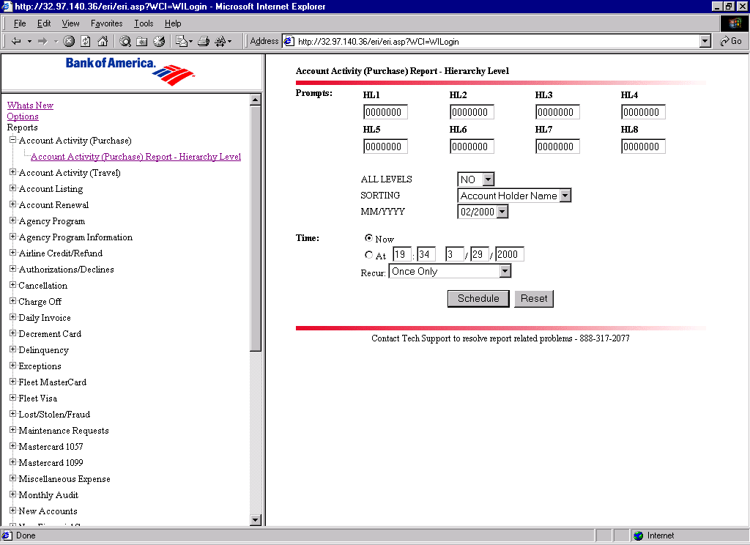
To schedule report instances, the user will click on the schedule link to display the schedule screen. The schedule screen contains the following:

- A section listing the user scheduling ”Prompts”, with which the user may modify the output of the report instance.

- A “Time” option allows the user to select the date, time and frequency of scheduling the report instance.

- A “Schedule” option submits the report instance scheduling prompts and a “Reset” option resets all fields to their original values.

The user has the option of changing any data on this screen by typing over the prompt values and/or selecting different entries from the drop down list boxes, though in some cases prompts may be filled with default values.

User Scheduling “Prompts”

In this section, available scheduling prompts are defined in detail. This section defines the behavior of individual report prompts, but does not specify which prompts are available for a given Search Object
The appearance, operation and validation of scheduling prompts will be in accordance with the following templates.
- Each prompt has its type specified as the first value in the template. There are two possible types: textbox and drop-down listbox.
- Prompts of type “textbox” will be displayed as a user-modifiable text entry box of the specified width. Note that this width specification only controls the display of the text entry box - it will not prevent a user from typing a greater number of characters.
- Drop-down listbox prompts will display the listed set of values.
- Refer to the “label text” entry in the prompt template to determine what text will be used to annotate the prompt for the user. In most cases, the label text will match the name of the prompt with all underscores replaced by spaces.
- The “help text” field is an optional template item that places helpful information to the right of the prompt. This is to be used to provide the user with guidance when entering information into a text box.

Account

Type: | Textbox
Width: | 16 characters
Validate: | - Accounts must be 16 numeric characters.  - Accounts must validate according to the checksum contained in the final digit (a standard method of validating credit card numbers).
Label Text: | Account
Help Text: | N/A
Error Text: | Invalid Account
Notes: | Used by Authorizations, Cost Allocation – Not Allocated, Daily Invoice, Delinquency, Exceptions, Maintenance Request, New Accounts, and Transfer Transaction reports.

Account_ID

Type: | Textbox
Width: | 7 characters
Validate: | No more than 7 digits.
Label Text: | Account ID
Help Text: | N/A
Error Text: | Invalid Account ID
Notes: | Used by Daily Invoice – Central Account ID report.

Agency
Type: | Textbox
Width: | 20 characters
Validate: | N/A
Label Text: | Agency
Help Text: | N/A
Notes: | Used by Miscellaneous Expense, Monthly Audit, Airline Credit/Refund, Summary ATM/Travel Checks, Summary Convenience Checks, Summary Purchase reports.

All_Levels
Type: | Drop-down listbox
Values: | Yes, No
Validate: | N/A
Label Text: | All Levels
Help Text: | N/A
Notes: | Used by all hierarchy driven reports.

Authtype
Type: | Drop-down listbox
Values: | Declines, Approvals
Validate: | N/A
Label Text: | AUTHTYPE
Help Text: | N/A
Notes: | Used by authorizations reports.

Billing
Type: | Drop-down listbox
Values: | Central, Individual, Both
Validate: | N/A
Label Text: | Billing
Help Text: | N/A
Notes: | Used by Delinquency Severity and Delinquency Severity Summary reports.

Certified
Type: | Drop-down listbox
Values: | Not Allocated Certified, Not Allocated Not Certified
Validate: | N/A
Label Text: | Certified
Help Text: | N/A
Notes: | Used by cost allocation – not allocated reports

Date_From
Type: | Textbox
Width: | 10 characters
Validate: | - Must be an actual date in MM/DD/YYYY format.  - Must specify a date prior to the value specified in “Date_To”.  - Must be a date equal to or greater (more current) than November 30, 1998.
Label Text: | Date From
Help Text: | MM/DD/YYYY
Error Text: | - Invalid dates will generate an “Invalid Date From” message. If attempt prior to 11/30/1998, then “Date From must be 11/30/1998 or later.”  - If Date_From does not specify a date prior to Date_To, then the message “Date From must be before Date To” will be displayed.
Notes: | Used in Charge-Off, Cost Allocation – Not Allocated, Exceptions, Lost/Stolen, Maintenance Request, Transaction Activity, Transfer Transaction reports.

Date_From_Ltd
Type: | Textbox
Width: | 10 characters
Validate: | - Must be an actual date in MM/DD/YYYY format.  - Must specify a date prior to the value specified in “Date_To_Ltd”.
Label Text: | Date From (mirrors Date_from)
Help Text: | MM/DD/YYYY
Error Text: | - Invalid dates will generate an “Invalid Date From” message.  - If Date_From_Ltd does not specify a date prior to Date_To_Ltd, then the message “Date From must be before Date To” will be displayed.
Notes: | Used in Convenience Check and Non-Travel Activity DOI Exception Reports. This prompt will be live in March 2001 when reports go into production. When the remainder of the prompt changes goes in to production for Data Retention (May 2001) this prompt should be removed and the Convenience Check and Non-Travel Activity should revert to use existing Date_From and Date_To.

Date_To
Type: | Textbox
Width: | 10 characters
Validate: | - Must be an actual date in MM/DD/YYYY format.  - Must specify a date after the value specified in “Date_From”  - Cannot be more than 3 calendar months greater than away “Date_From”.
Label Text: | Date To
Help Text: | MM/DD/YYYY
Error Text: | - Invalid dates will generate an “Invalid Date To” message. Or “End Date parameter cannot be more than three months from the start date.”  - If Date_From does not specify a date prior to Date_To, then the message “Date From must be before Date To” will be displayed.
Notes: | Used in Charge-Off, Cost Allocation – Not Allocated, Exceptions, Lost/Stolen, Maintenance Request, Transaction Activity, Transfer Transaction reports.

Date_To_Ltd
Type: | Textbox
Width: | 10 characters
Validate: | - Must be an actual date in MM/DD/YYYY format.  - Must specify a date after the value specified in “Date_From_Ltd”  - Cannot be more than 3 calendar months greater than away “Date_From_Ltd”.
Label Text: | Date To (mirrors Date_To)
Help Text: | MM/DD/YYYY
Error Text: | - Invalid dates will generate an “Invalid Date To” message. . Or “End Date parameter cannot be more than three months from the Start Date.”  - If Date_From_Ltd does not specify a date prior to Date_To_Ltd, then the message “Date From must be before Date To” will be displayed.
Notes: | Used in Convenience Check and Non-Travel Activity DOI Exception Reports. This prompt will be live in March 2001 when reports go into production. When the remainder of the prompt changes go in to production for Data Retention (May 2001) this prompt should be removed and the Convenience Check and Non-Travel Activity should revert to use existing Date_From and Date_To.

Delinquency
Type: | Drop-down listbox
Values: | Cycle 2, Cycle 3, Cycle 4, Cycle 5, Cycle 6
Validate: | N/A
Label Text: | Delinquency
Help Text: | N/A
Notes: | Used by Delinquency Severity and Delinquency Severity Summary Reports.

End_Date
Type: | Textbox
Width: | 10 characters
Validate: | - Must be an actual date in MM/DD/YYYY format.  - Must specify a date after the value specified in “Start_Date”  - Cannot be more than 3 calendar months greater than away “Date_From”.
Label Text: | End_Date
Help Text: | MM/DD/YYYY
Error Text: | - Invalid dates will generate an “Invalid End Date” message. Or “End date parameter cannot be more than three months from the start date.”  - If Start_Date does not specify a date prior to End_Date, then the message “Start Date must be before End Date” will be displayed.
Notes: | Used by Authorization Report.

HL1 through HL8
Type: | 8 parameters displayed as 8 separate textboxes.
Width: | 7 characters
Validate: | Query against AGENCY_HL. The hierarchy set specified must be an actual hierarchy set and it must match security criteria based on the user’s default hierarchy setting within EAGLS.
Label Text: | HL1, HL2,..,HL8
Help Text: | N/A
Error Text: | - If the specified hierarchy does not exist, the message returned will be: “Hierarchy set does not exist.”  - If the hierarchy set is invalid based on EAGLS security restrictions, the message returned will be: “Hierarchy set does not match user's current role/hierarchy setting.”
Notes: | - Values will be pre-filled based on the hierarchy set defined as the user’s default or current setting within EAGLS.  - All values less than 7 digits will automatically be left-padded with zeros.  - Used by all hierarchy driven reports.

Invoice_Date
Type: | Textbox
Width: | 10 characters
Validate: | Must be an actual date in MM/DD/YYYY format  Must be a date equal to or greater than (more current) November 30, 1998.
Label Text: | Invoice Date
Help Text: | MM/DD/YYYY
Error Text: | “Invalid Invoice Date” Error msg: Maximum data available is 16 months prior to current month. If data_access_level = 1, then “Maximum data available is 36 months prior to current month.”
Notes: | Daily Invoice Account Number and Central Account ID

MCC_Range_Start
Type: | Textbox
Width: | 4 characters
Validate: | - Must be less than MCC_Range_End.  - Numeric values only.  - No more than 4 digits.
Label Text: | MCC Range Start
Help Text: | N/A
Error Text: | - If the value cannot be validated, display “Invalid MCC Range Start”.  - If MCC_Range_Start is greater than the value specified for “MCC_Range_End,” display “MCC Range Start must be before MCC Range End”.
Notes: | MCC_String is not required if this and MCC_Range_End are entered.  Used by Authorizations and Exceptions reports (ATM/Cash, Returned Check Charges, Transactions over $2500, MCC-Account Number, MCC-HL)

MCC_Range_End

Type: | Textbox
Width: | 4 characters
Validate: | - Must be greater than MCC_Range_Start.  - Numeric values only.  - No more than 4 digits.
Label Text: | MCC Range End
Help Text: | N/A
Error Text: | - If the value cannot be validated, display “Invalid MCC Range End”.  - If the value of MCC_Range_Start is greater than the value specified for “MCC_Range_End,” display “MCC Range Start must be before MCC Range End”.
Notes: | MCC_String is not required if this and MCC_Range_Start are entered.  Used by Authorizations and Exceptions reports (ATM/Cash, Returned Check Charges, Transactions over $2500, MCC-Account Number, MCC-HL)

MCC_String

Type: | Textbox
Width: | 20 characters
Validate: | - Entry should consist of no more than 10 MCCs, separated by commas.  - No more than 59 characters
Label Text: | Multiple MCC
Help Text: | N/A
Error Text: | Invalid Multiple MCC
Notes: | If this is filled out, then MCC_Range_Start and MCC_Range_End may be left empty.  Used by Authorizations and Exceptions reports (ATM/Cash, Returned Check Charges, Transactions over $2500, MCC-Account Number, MCC-HL)

MONTHYEAR

Type: | Drop-down listbox
Values: | Previous sixteen or thirty-sixth months (if data_access_level = 1) in MM/YYYY format.  Month available cannot be prior to 11/1998.
Validate: | N/A
Label Text: | Month/Year
Help Text: | N/A
Notes: | Used by Account Activity Purchase and Travel reports, and all 8 Fleets

Open_Date

Type: | Textbox
Width: | 10 characters
Validate: | Must be an actual date in MM/DD/YYYY format  Must be a date equal to or greater than (more current) November 30, 1998.
Label Text: | Open Date
Help Text: | MM/DD/YYYY
Error Text: | “Invalid Open Date” Error msg: Maximum data available is 16 months prior to current month. If data_access_level = 1, then “Maximum data available is 36 months prior to current month.”
Notes: | New Accounts Date format

“Sorting”

Type: | Drop-down listbox
Values: | Miscellaneous title given to sorting options. Lists vary with report
Validate: | N/A
Label Text: | Sorting
Help Text: | N/A
Notes: | Used by Account Activity Purchase and Travel reports, Account Renewal, Airline Credit/Refund, Exceptions, Maintenance Request, New Accounts, Summary Quarterly Vendor Analysis, Transaction Activity

Start_Date

Type: | Textbox
Width: | 10 characters
Validate: | - Must be an actual date in MM/DD/YYYY format.  - Must specify a date prior to the value specified in “End_Date”.  - Must be a date equal to or greater than sixteen calendar months away from current system date.
Label Text: | Start Date
Help Text: | MM/DD/YYYY
Error Text: | - Invalid dates will generate an “Invalid Start Date” message. “Start Date Invalid. Maximum data available is 16 months prior to current month.”  - If Start_Date does not specify a date prior to End_Date, then the message “Start_Date must be before End_Date” will be displayed.
Notes: | Used by Authorization Report. This report data (authorizations table on CI1P) is only retained for 16 calendar months.

Status

Type: | Drop-down listbox
Values: | Open, Closed, Both
Validate: | N/A
Label Text: | Status
Help Text: | N/A
Notes: | Used by Account Listing reports.

Account Dollar Threshold
Type: | Text Box
Width | 7 digits.
Validation: | - Only whole dollar amounts.  - $0.00 will be the default value  - This is for both “Monthly” and “3 Moth Total”
Label Text: | - Account Dollar Threshold  - Two decimal places (cents) will be displayed as .00 at the end of the test box  - $ will be displayed in front of text box
Error Text: | Account Dollar Threshold Amount Must Be Numeric
Notes: | Used by the Frequent Repair Report (DOI Exception)

Prompts that do not have a template in the above section will be handled as follows.
- If the prompt includes a “picklist” in its definition, it will be displayed as a drop-down listbox. Picklists are defined using the Seagate Info Desktop when the report is added to the back-end reporting system.
- If no picklist is provided, it will be displayed as a textbox of 20 characters in width.
- Prompt labels will have all underscores replaced with spaces.
- No help text will be provided.
The only way the prompt will fail validation will be if no entry is made. In this case, the error text will be the word “Invalid” followed by the name of the prompt.

“Time” Options

Time selections are as follows:

- Time selection is by selection of the “Now” option or
- by selection of the “At” option, and entering time/date,
- and selection of the “Recur” option presented in the drop down list box of choices. The “Recur” options consist of: Once Only, Every Day, Every Week, Every Month and Last Day of Every Month.

Note that the user is allowed to select either “Now” or “At”. The “At” option is used to run the report at a given time, or to specify a given time of day and/or day of month to use in conjunction with the recurring option.

Reports that are scheduled to run with a recurring option other than “Once Only” will create a “Recurring” instance. This instance will serve as a marker in the Report Listing screen. Deleting the recurring instance will discontinue the recurring job.

The recurring options are handled in the following manner:
- Once Only – The report will be run immediately if the “Now” option is selected, or at the chosen time if the “At” option is selected.
- Every Day – The report will be run immediately and every day at the current time if the “Now” option is selected. If the “At” option is selected, the report will run on the current day at the chosen time and every following day at the chosen time.
- Every Week – The report will be run immediately and every week on the current day of the week (Monday, Tuesday, etc…) at the current time if the “Now” option is selected. If the “At” option is selected, the report will run at the chosen time and every following week on the chosen day of the week at the chosen time. Note that the day of the week is actually chosen by entering a day of the month if the “At” option is used (e.g. if the 15th is a Monday then specifying the 15th day of the current month will cause the report to run every Monday).
- Every Month – The report will be run immediately and every month on the current day of the month at the current time if the “Now” option is selected. If the “At” option is selected, the report will run at the chosen time and every following month at the chosen day of the month at the chosen time. Note that it is possible for the user to specify a day of the month that does not exist for a future month (e.g. the 31st). In this case, the logic will cause the report to be run the specified number of days after the first of the month. In other words, a report that should run on the 31st of each month will run on the 1st of any month following a 30-day month. To properly schedule a report to run on the last day of every month, the “Last Day of Every Month” option should be used.
- Last Day of Every Month – The report will be run on the last day of the month at the current time if the “Now” option is selected. If the “At” option is selected, the report will be run on the last day of every month at the chosen time.

After the user has entered or accepted the desired input parameters, the user clicks on the “Schedule” button. Clicking on the “Schedule” button sends the scheduling request to the server for validation. Any invalid prompt entries will cause the submission to be returned to the user with details as to why the validation failed. In all cases, an invalid parameter entry will produce an error message and a red asterisk will be displayed next to the invalid entry. The user will be prompted to re-enter any incorrect parameters.

If the user has chosen the “At” option the specified time is evaluated for errors. If the specified time does not represent a valid date/time entry, or if the specified time contains a past date, the message “Invalid Schedule Date/Time” will be presented to the user. In addition, the date/time entry area will be marked with a red asterisk. Note that if the time specified is a past time but within the current day, this is not considered an error condition - the application will schedule the report for immediate execution, as if the user had selected the “Now” option.

If there are no errors, the user will be brought to the report instance listing screen and the user should see a new instance with the status of “Scheduled” or “Recurring” depending on the scheduling action that was performed.

Note: The back-end servers will make every attempt to execute scheduled report instances at the requested time. In some cases the back-end servers will be forced to queue requests. This may occur when the database server is unavailable, or when there are too many requests to satisfy at a given moment.

“View” Screen

This screen performs a conversion of the report instance to the chosen viewer format (if necessary) and provides a means to download the output file, as well as approximate download time and the file size.

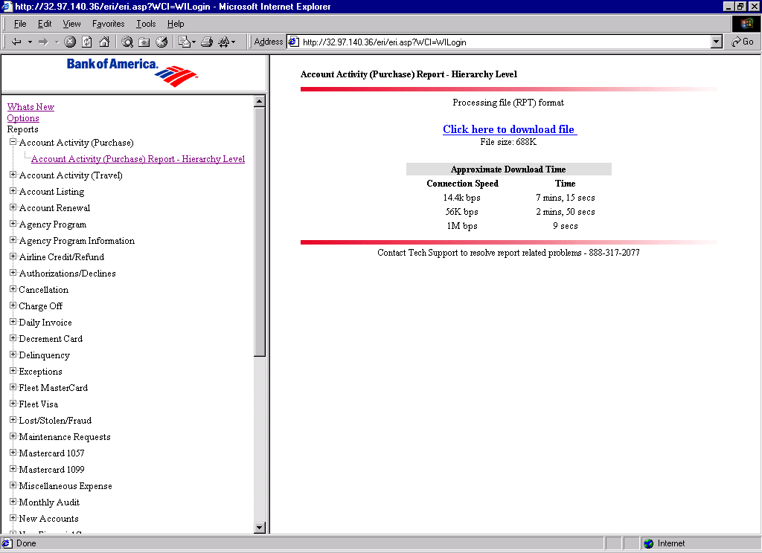
The user should select the HTML link labeled “Click here to download file” to initiate the download process. The behavior of the user’s browser is indeterminable by the ERI 5.0 application at this point, but most browsers will display a dialog box that allows the user to either:

- “Open this file from its current location”, which will open the report instance in the format the user has selected as the default viewer on the Options screen, or

- “Save this file to disk”, which will allow the user to specify a directory path that the user desires to download the file to.

If the user is using the Info Analyzer viewer, or the user is viewing a Raw Data instance, then the download should begin automatically on most browsers. This is accomplished using a Javascript method that should be available on all browsers supported by EAGLS. Users with browsers that do not support this feature will have to click the download link to receive their report.

Note: Formats other than Info Analyzer and Raw Data will require extra processing and may cause a significant delay before the View screen is displayed. This is an unavoidable limitation of the conversion process that is dependent on the choice of viewer and the size of the report file.

“Details” Screen

This option is used to view details related to a report instance, which includes the scheduled time, start time, end time, file size and input prompts. Reports with a status other than “Success” will display their status and any messages that may have been received from the back-end server, such as error messages. The Details screen also provides the user with the capability to reschedule the report instance, delete the report instance and view the report instance using an alternate viewer.

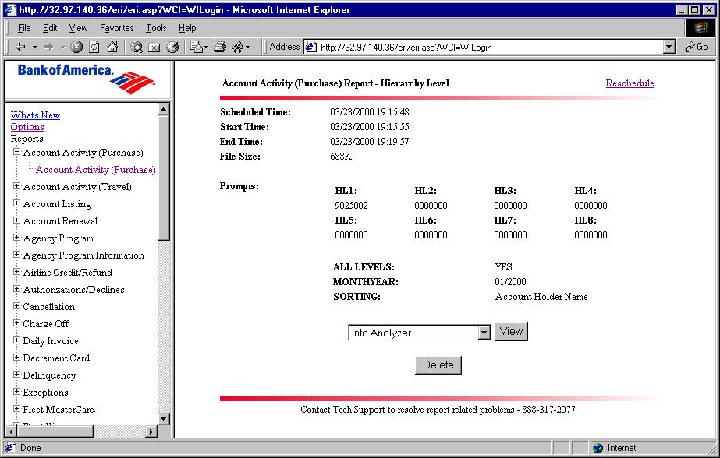
To examine the details related to a report instance, the user will click on the “Details” link to display scheduled time, start time, end time, file size and inputted prompts for the report instance. The display will present the user with the following options:

- “Reschedule”, which will take the user to the schedule screen. The schedule screen prompts will be pre-filled with the prompt information used from the report instance the user chose to reschedule from. The user will have the option to change any input parameters from the schedule screen as mentioned in the schedule section of this document.

- “View”, which will allow the user to change the viewer type by selecting the desired viewer type from the drop down list box and click “VIEW”. Note that Raw Data cannot be converted and will therefore show only the "view” button. This conversion option is report instance specific and will not change the user’s default viewer type selected from the Options menu. Viewer options will include those listed in the “Options” section of this document. The user’s currently selected default viewer will be the default choice in the drop-down list box. Once the user selects “VIEW” the user will be sent to the View screen.

- “Delete”, which allows the user to delete a report instance by clicking the “Delete” button. This will return the user to the Report Listing screen.

Technical Overview of ERI

The Front end of ERI is developed using Crystal Server Pages (CSP). The business logic resides in the CSP’s itself, but certain reusable components and database access components are moved to two DLLs, viz. the ERI Utility COM DLL and the File Access DLL.

Access to the APS database is done in the CSP itself. The ERI application is invoked when the
User clicks on the link Reports in the G-EAGLS Application. At this point, there is a check to validate whether the logged in user details are present in the APS database. If the user details are not present in the APS, the user is created in the APS database (The details of this user would already be available in the EAGLS tables). This user creation is a one-time process.

The online reports designed using Crystal Reports reside on the Crystal Enterprise APS. In the
Production environment, the APS database is Oracle, while in the development environment, it is MSSQL server that gets installed by default during Crystal Enterprise (CE) installation.

When the user logs into the Reporting Tool, an intersection of the Reports from the EAGLS database tables and the reports from APS is taken to show the list of Reports to the User on the left frame. The left frame appears the same irrespective of the logged in user’s rights to view reports. Only while scheduling a report, the user rights to schedule the report is checked and an error message is displayed if the user doesn’t have the right to schedule the report. Only 10 instances per user per report will be retained in the application. Instances beyond this will be removed from the database.

Components of ERI

Logonform.csp

- Two input boxes for user id and password
- Input value for authentication should be assumed to Enterprise
- The form should direct the user to the Logon.csp page when the submit button is pressed
- This is used by the development Team to access the ERI Application

Logon.csp

- This page processes the login information and authenticates the user. Can be called from Logonform.csp or URL from Online
- When called from URL from Online we will have to decrypt the user id using a special algorithm. Will be using Request.Querystring(“data”) to get the string containing user id.
- Create an enterprise session and log on to the APS. Coming from online the log on should not fail. If the user does not exist then we create a new user. If the log on fails for unknown reason then error message is displayed.
- Manage the Enterprise session by using a combination of session variables and logon tokens. The user would logon to the Enterprise system. In the Logon.csp page we will establish the enterprise session and store it in a session variable. A logon token is created that writes to a non-persistent cookie variable.

Checksession.csp

- This csp page will be created that handles checking the existence of a current enterprise session or reinstating the enterprise session by performing a logon utilizing the logon token. This generic page is included as a server-side include to all csp pages that the user will access.

LeftFolderTree.csp

- Get the As of date from the EAGLS database
- Get the list of valid folders from valid reports table and store it in an array.
- Get the list of folder from Crystal Enterprise and construct a new array with all common folders between the two sets.
- Using the java script available from previous ERI application to display the tree.

Instance.csp

- To query the instances from the Crystal Infostore for the selected report and the logged-in user, we will get the collection of reports in the folder and collection of instances for each report.
- Display the instances with status, start time, end time and size parameters and delete option. We can get these from instance properties.
- Get the default viewer and set the hyperlink to view in the default viewer.
- Hyperlinks to details page for displaying the details of that instance
- Hyperlink to schedule page
- Write the delete function to delete instances.

Detail.csp

- Query the Crystal Infostore for that instance.
- Using the Plugin interface we get all the parameters of that instance and display according to the screen layout. The HL prompts at the top and the rest below it.
- A delete instance button that has a hyperlink to the delete function in instance.csp page.
- A hyperlink to schedule.csp for rescheduling with same parameter values.

Schedule.csp

- Get the id of the object to be scheduled from the form or query string
- Perform prompt validation through the ERI Utility com dll
- Set the start time, parameter values and schedule the collection
- Redirect to instance page
- Month/Year picklist displayed in this CSP is based on the role of the user logged in.

Options.csp

- Default viewer setup
- List of reports in the tree view

ZipView.csp

- Call File Access dll to show file size

ERI Utility com dll

- Online and reports database access will be done through this com dll.
- Encryption and Decryption routines.
- INI file access functions.
- The validation code for the HL prompts in the report-scheduling screen is done in this dll itself. All validations are done together as a onetime process and the results are stored in a keyset.
- Zipping functions

File Access dll

- The File Access dll was developed, since while scheduling reports, the size of the report based on the file type needs to be shown.
- It accesses the Output File Server that resides on a different machine and provides the file size details for being displayed in the ERI.

All database queries are stored in text files under ERIUtil/config/queries.
The log file is under ERIUtil/temp/logs.txt.

Interaction of ERI Components

Logonform.csp
URL from Online
Logon.csp
Main.htm
Startpage.htm
LeftFolderTree.csp
Checksession.csp
Instances.csp
Detail.csp
Schedule.csp
Query
ERI Utility com dll
Options.csp
File Access com dll
ZipView.csp

Software Requirements for ERI:

Set up of ERI in the development environment would involve installation of the following Software:
- Crystal Enterprise 8.5 (Upgrade for Crystal Reports 8.5)
- Crystal Reports 8.5
- Microsoft Visual Studio 6.0 Enterprise Edition
- PVCS 6.8
- Oracle 8.1.6 Client

Details of Setup of ERI

1) Development in Windows 2000 environment would require Installation of IIS Server and Component Services for managing COM+ Applications.

2) WinNT would require installation of NT Option Pack 4.0 to cater to IIS and MTS functionality.

3) The ParentUserId in the eri.ini file is ParentUser. After set up of ERI in the development environment, this userid needs to be set up from the Crystal Management Console (CMC) using the Manage User’s option and created in the Crystal Infostore.

4) Whenever this user’s password is changed in the CMC, the eri.ini file should also be updated which has the password encrypted.

5) Do the following changes to the Eri.ini file in ERI/ERIUtil folder:

- APSO should point to the local machine name
- Change the code to connect to the development database (CI2D). Change database name, UserID and Password. The Password is stored in an encrypted format in the ini file.
- Change Optionsdir to point to the directory structure of ERI in the client m/c.
- Change the m/c name in RawDataDir.

6) Make a RAWDATA directory in the local m/c where ERI is to be installed.

7) Set up the system DSN for CI2D database using ODBC Oracle Driver

8) Register ERIUtil.dll using the command:
regsvr32 c:\eri\eruitil\eriutil1.dll.

9) Before registering, run the command regsvr32 /u c:\eriutil\eriutil1.dll to unregister.
10) Run the ERIUtil.dll from Visual Studio environment.

11) The ERI application can be now accessed by the url: IP Address of local machine/eri/logonform.csp

Reports

The following are the different phases of the Reporting Project

G-EAGLS New Reporting Tool - Phase 1

Phase I of this initiative establishes a stabilized Government EAGLS Reporting environment through the upgrade of the Crystal Enterprise software to Version 8.5.Phase I involved conversion of the Reports System from Crystal Reports 7.0 to Crystal Reports 8.5.

G-EAGLS New Reporting Tool Phase 2

Phase II is requesting utilization of enhancements provided by the upgrade Version 8.5 including Report Standardization, Smart Reporting capabilities, Statistical Reporting, and addition of a Large Result set edit to the report scheduling screen to accommodate business rules for large report requests.

Phase 2-Part A involved the Standardization of the design components for 20 reports.
The business purpose of report standardization is to provide consistency among the online reports. The standards included font size, font style, data type, justification, formatting and spacing for field names, header/footer information and data that will display beneath the columns. The field names that appear on the reports had to be consistent with the Core EAGLS on-line display.

The Reports Standardization document is available in the EAGLS 2000 database and latest versions of this document are uploaded to the Lotus Notes database.

The following Reports were standardized in Phase 2-A Project:
- Account Listing Report - HL Raw Data
- Delinquency Report - Hierarchy Level
- Transaction Activity Report - Hierarchy Level
- Exceptions Report - Transactions Over 2500
- Account Activity (Travel) Report - Hierarchy Level
- Infrequent Travel Expiration Report - Hierarchy Level
- Transfer Transaction Report - Hierarchy Level
- Account Renewal Report - Hierarchy Level
- Not Allocated Report - Hierarchy Level
- Statistical Summary (Purchase) Report - Hierarchy Level
- Suspension/Pre-Cancellation Report - Hierarchy Level Detail
- Aging Analysis Report - Hierarchy Level
- Budget Object Class Report - Hierarchy Level
- Cancellation DOI/SBA –Hierarch Level Detail
- Fleet MasterCard Report - Account Activity
- Fleet MasterCard Report - Fuel/Non-Fuel Summary
- Airline Exception Report - Hierarchy Level
- Airline Credit/Refund Report - Hierarchy Level
- Maintenance Requests Report - Hierarchy Level
- Monthly Audit Report - Hierarchy Level

G-EAGLS New Reporting Tool - Phase 2 Part B

This involves Standardization of the remaining 61 Online Reports

Each report is based on different functionality and the reports are generated for internal and external users. There are 81 online reports and paper reports as well. The end user schedules reports, generating instances of the individual reports. The Stored Procedures and Crystal Reports are checked into PVCS version control system in the Development environment. All reports are stored in the Automated Process Scheduler (APS) of the Development Server and a Build Script is used to load them from APS to the PVCS system.

There are two kinds of Reports
- Online Reports
- Paper Reports

Online Reports

The end users who schedule the online reports use the Eagls Reporting Interface (ERI) application for doing so. These reports are created using Crystal Reports and use stored procedures for access of data from the Reporting Database.

Components for the Online Reports:

There are two components for each report. One of them is the actual stored procedure and the other is the package spec that defines the cursor and record layout.

Package Spec

The package spec contains the fields that form part of the select clause inside the stored procedure. The fields in the select clause should match the sequence of the fields defined in the package spec.
The package spec name is composed of the package name followed by a period and the cursor reference name. This cursor reference name in the package spec should match the cursor reference name defined in the stored procedure.
The cursor name in the stored procedure that is part of the cursor reference definition should be the same as the cursor name specified after the TYPE statement in the package spec.
For e.g :
For the Maintenance Request Stored Procedure
The package spec name is REPORTS .REPORT_MAINT_REQ_HL.
where the package name is REPORTS
and the cursor reference name is PROC_CURSOR_MAINT_REQ_HL

Stored Procedure

The initial statement in the stored procedure is the declaration of the input parameters from ERI and the cursor reference definition.
The cursor reference definition is composed of the cursor reference name followed by a period and the cursor name.
The stored procedure can contain the declaration of certain fields called L- fields. These L fields could be parameters of ERI or calculated fields or fields that are fetched from database. Functions may be called from the stored procedure. Apparently there is a crystal limitation that prevents stored packages or more than one cursor from being used.
For e.g :
For the Maintenance Request Stored Procedure
The cursor reference definition is PROC_CURSOR_MAINT_REQ_HL . CUR_MAINREQH1
where the cursor reference name is is PROC_CURSOR_MAINT_REQ_HL
and the cursor name is CUR_MAINREQH1

It should be noted in the above example that the cursor reference name in the package spec matches the cursor reference name defined in the stored procedure and that is PROC_CURSOR_MAINT_REQ_HL

This stored procedure has an L-field named as l_asofdate that is mapped to the posting date in the gsa_batch_number table in the database

- Shared Objects in the Stored Procedures:.

REPORTS_STANDARD_OBJECTS.GET_USER_INFO is used by all online reports to determine the user role (primarily whether the user is gcsu or aopc). Access levels are limited for aopc users. Additionally, individual functions may be used by reports.

- Contents and Structure of Stored Procedures :.

Standard content for reports are posting_date for “As Of” date and Waterfall logic for the “All Levels” parameter. Posting date is selected from the gsa_batch_number table. Waterfall logic is included to limit access to hierarchy levels and differs for the two user roles, gcsu and aopc. Standard structure used within stored database code is primarily for legibility and uses indents and line spacing, such as:
IF l_user_role = 'GCSU' then
IF l_sorting = 'ACCOUNT HOLDER NAME' Then
OPEN data_out FOR
SELECT
a.agency_name agency_name,
TO_CHAR(b.account_nbr) account_nbr,
b.last_name last_name
FROM
Gsa_agency_hl a,
GSA_account b

Maintenance Requests Report

The Maintenance Requests Report gives the user information on maintenance conducted on his or her account(s) or within his or her agency. Searching only a range of days can narrow the list of maintenance work information. This report is user requested and will display information as of the prior business day. This information consists of any changes to the Agency/ Organization Program Coordinator specific information (A/OPC name, Agency/Organization identifying number, A/OPC address, etc.) when run for a hierarchy level. Also displayed for the hierarchy level and the account level are any changes to the Account/ Card Specific Information (Account cardholder name, Account number, Account Cardholder address, etc, or any DBO (Designated Billing Office), TDO (Transaction Dispute office), or EO (EC/EDI Office) information. A date range must be specified for all report requests, whether it is account number or hierarchy level report.
There are two search parameters for the report:

Hierarchy Level AND Date Range
The user can choose to run the report for node-specific data (default) or for all of the hierarchy levels that fall beneath the designated hierarchy level.

Account Number AND Date Range
This report will only display data that falls within the specified date range.
If no date range is specified, the report will return no data found.

The Maintenance Request Stored Procedure is named as REPORT_MAINT_REQ_HL.
The package name is REPORTS
The cursor reference name is PROC_CURSOR_MAINT_REQ_HL
The cursor reference definition is PROC_CURSOR_MAINT_REQ_HL . CUR_MAINREQHL
The cursor name is CUR_MAINREQHL

Delinquency Reports

These reports display accounts and their status that have past due balances from 30 to 180+ days (i.e. 30, 60, 90, 120 or more days). This report is generally used by the Designated Billing Office and the Chief Financial Officer to identify and manage delinquencies. NOTE: The Travel Card Program requires this information segregated by individually and centrally billed accounts. All account balances that are in a state of delinquency are reported here, including those in Mission Critical status. An account is in a state of delinquency any time that the balance has not been paid by the due date. The information listed is as of current point in time with statement information based on billing cycle.
The Delinquency Reports are of the following types

Detail Reports Summary Reports
Account Number
Hierarchy Level Hierarchy Level Summary
Hierarchy Level/Severity Hierarchy Level/Severity Summary
Hierarchy Level Raw Data
Hierarchy Level/Severity Raw Data

There is one FRD and three stored procedures for these reports
For the Delinquency Reports for Hierarchy Level, HL Summary and HL Raw Data
The Stored Procedure is named as REPORT_DELINQUENCY_HL.
The package name is REPORTS
The cursor reference name is PROC_CURSOR_DELINQUENCY_HL
The cursor reference definition is PROC_CURSOR_DELIQUENCY_HL . CUR_DELINQUENCY_HL
The cursor name is CUR_DELIQUENCY_HL

For the Delinquency Reports for Hierarchy Level/Severity, Hierachy Level /Severity Raw Data, HierarchyLevel/ Severity Summary
The Stored Procedure is named as REPORT_DELINQUENCY_HL_D
The package name is REPORTS
The cursor reference name is PROC_CURSOR_DELINQUENCY_HL_D
The cursor reference definition is PROC_CURSOR_DELIQUENCY_HL _D. CUR_DELINQUENCY_HL_D
The cursor name is CUR_DELIQUENCY_HL_D

For the Delinquency Reports for Account Number
The Stored Procedure is named as REPORT_DELINQUENCY_A
The package name is REPORTS
The cursor reference name is PROC_CURSOR_DELINQUENCY_A
The cursor reference definition is PROC_CURSOR_DELIQUENCY_A. CUR_DELINQUENCY_A
The cursor name is CUR_DELIQUENCY_A.

Account Listing Report

This report lists all accounts associated with the agency and includes all information necessary to identify and contact the account holder. The information is separated by centrally and individually billed accounts. Users have the option to request only open accounts, only closed accounts, or both.

Transaction Activity Report

The Transaction Activity Report provides the user with Level I information (i.e., total credits, total debits, etc.) about transactions at the individual account level. This report is user requested, and, as such, contains information up to the prior business day. A user can examine only individual accounts which are affiliated with the same hierarchy level specification and program type as the user’s profile. Search criteria allow the user to sort an agency’s individual accounts by account number or account name. The information listed is as of the user-selected dates

Exceptions Report

This report provides detailed transaction information at the individual or central level regarding purchase made at specific merchants, unusual spending activity based on specified MCC's, and amounts due. Agencies can use this report to track trends and monitor for potential card misuse. The information listed is as of user-selected dates.

Account Activity Report (Purchase Program)

The Account Activity Purchase Report includes account activity for both active and inactive Purchase program accounts. This report also includes purchase accounts without transaction activity during the fiscal year. It encompasses information on current and fiscal year account activity as well as convenience check transactions. The information listed is as of calendar month, however, the user selects which calendar month.

Account Activity Report (Travel Program)

The Account Activity Travel Report includes account activity for both active and inactive travel program accounts. This report also includes travel accounts without transaction activity during the fiscal year. It encompasses information on current and fiscal year account activity as well as ATM and travelers check transactions. The information listed is as of calendar month

Infrequent Travel Report

Provide a report to display all accounts that are greater than 45 days and less than 90 days of their expiration date or have not had specified activity.

Transfer Transaction Report

To track and report transactions that have been transferred between an individual and diversion, or a diversion and an individual account, in the Integrated Card Program. This report will display the transferred transactions that have been reconciled.

Account Renewal Report

The purpose of this report is to provide the user with detailed account information for accounts that are near automatic renewal. These are accounts that are within 90 days of their expiration date. 45 days prior to expiration, the accounts will no longer display on this report. Search criteria allows the user to select from one to eight hierarchy levels and the date to narrow the amount of information presented. The report can be sorted by account name, account number and expiration date. The report presents information as of a specific moment in time. This report will not be summarized.

Cost Allocation Report

To track and report all centrally billed transactions that have not yet been allocated. This report will also display the certification status of the transaction.

Statistical Summary Report - Purchase Card Program

This report lists dollar volume, convenience check volume, number of transactions, active account holders, total number of accounts, new accounts, miscellaneous fees and identification of fees on a current fiscal year basis. The information is monthly, with fiscal year to date totals.

Statistical Summary Report for the Travel Card Program

The Statistical Summary Report (Travel) provides dollar volume, ATM volume, travelers check volume, number of transactions, active account holders, total accounts, miscellaneous fees and identification of fees on a current and fiscal year basis. This reporting component is read-only and made available for viewing by FMS, GCSU, GSA and A/OPC users on a monthly basis. The information is reported monthly with fiscal year to date totals

Aging Analysis Report

The online Aging Analysis report is a monthly report, populated with data from the prior month. The summary data will be collected after each cycle and placed in the summary table until the end of each month when the report will be updated for online. At the end of the month, upon request for the report, the summary table data is used to produce the online report. The online report lists summary account status and ranking for the 30 to 180+ day time frame on a government-wide basis for each agency’s/organization’s individually and centrally billed accounts. All account balances; both current and those that are in a state of delinquency must be reported. An account is in a state of delinquency any time that the balance has not been paid by the due date. This report will be available with the prior month information after the 5th of each month. For agencies that have multiple cycle dates within their hierarchy, the summary table will roll up the different cycle dates to fairly represent the agency at hierarchy level one

Budget Object Class Report

Provide a report to display all transactions where the Budget Object Class (BOC) segment equals the BOC segment entered in the search criteria. This report is designed to point out BOCs used.

Cancellation and Suspension Reports

The online Cancellation and Suspension reports need to be offered to the SBA and DOI to meet their business requirements for delinquency reporting. DoI and SBA cancel their cards at 96 days past due. These reports are intended only for HL1 value for DoI=3 and SBA=27.The account will appear on the Cancellation report when it reaches 96-180 days delinquent from the billing date."

Airline Exceptions Report

Provide a report to display airline travel transactions where the passenger name does not equal the cardholder’s name or the travel is not a contract fare. This report will be identified as an exception report, designed to point out potential opportunities of account misuse.

Airline Credit / Refund Report

The purpose of this report is to list all airline transaction credits/refunds that have occurred during the month for both centrally and individually billed accounts. This is a temporal report that is scheduled to run every calendar month. Prior monthly historical issues of the report will be available for data up to 13 months old. This report can be sorted by individually billed and centrally billed accounts, and Merchant Category Codes with a credit transaction code. The report data can be searched by date. This report will be summarized by agency.

Monthly Audit Report

This report is a monthly listing of the common carrier transactions, including refunds and adjustments for the travel card program

Fixed Pay Report

To track and report accounts that have been setup with fixed pay. The Fixed Pay Program is an alternative payment option for Cardholders who cannot pay their balances. The program provides an opportunity to pay an account over a period of 12 to 24 months. The Cardholder will be offered Fixed Pay as an alternative Payment Option starting at 120 days past due. The reporting date is point in time.

Lost and Stolen Reports

To track and report the individual account information regarding a lost, stolen, or fraud card that has been reported and assigned a new account number. Search criteria allow the user to select by date range and hierarchy level. This report will display information that is current as of the day the user requests the report.

New Accounts Report

The purpose of this report is to provide the user with detailed information regarding each new account. An account will be included on this report after it has been setup as a new account on the system. Accounts that appear on this report are identified by the open date. It will remain on this report for 30 days. Search criteria allow the user to select new accounts by account number, open date or by hierarchy level. The report can be sorted by account number, open date, account name or hierarchy levels.

Agency Program Report

The Agency Program Report lists programs’ activity for selected agencies. All program transactions are identified and summarized here. Users apply a hierarchy level specification, hierarchy depth, and month in the search criteria to narrow down this report’s data presentation. If the user designates an ambiguous hierarchy level specification in the search criteria, resulting in multiple agency matches, information in the Agency Program Report is presented in ascending order by primary Agency Name. The report is temporal on a monthly and cumulative (fiscal year) basis, and it is sent by the 10th calendar day of each month to the GSA Contracting Officer.

Agency Program Information Report

The Agency Program Information Report lists all participating agencies/organizations, bureaus, divisions, offices, and other organizations for each agency. The A/OPC, DBO, TDO, and EC/EDI points of contact are segregated into different sections for each agency. The information listed is as of point in time.

Billing Cycle Summary Report

Provide a report to display a summary of transaction activity for all account holders within a specified time frame

Daily Invoice report

The Daily Invoice report provides the user with all the transactions associated to a Central Account or Central Account Id, on a daily basis. This report is used by agencies that have selected Daily Invoicing, as indicated in the billing agency table. The reports are balanced to the AAS interface file but they will include transactions that have been included in the Def catch up. It is understood by the customers that when this report runs off of CI1P, that the data will be one day behind GSAP and the actual interface file. The information listed is as of the user-selected invoice date.

Charge Off Report

This report lists the amount of the write-off and date written off. This report is generally used by the agency to identify problem areas to better manage delinquencies in the future, to analyze and project programmatic data for the future, and to verify and balance delinquent data in contract reports. Any balances that have been written off as non-collectable must be reported here. The information listed is as of user-selected dates.

Salary Offset Report

This report is used to track and report all DoD individually billed accounts that have been identified as salary offset (TSYS Status Code of DC and Reason Code of R4 ) and Credit Revoked (TSYS Status Code of CR and Reason Code of A2) or charge off (TSYS Status Code of ‘CO’).

Pre-Suspension and Pre-Suspension Report

This report lists accounts eligible for suspension. This includes accounts 45-60 days past due. Account will appear on the pre-suspension report when they reach the 45th day of delinquency. This report is generally used by the agency to flag cardholders and accounts for agency action and delinquency control. The Travel Card Program requires this information segregated by individually and centrally billed accounts. This report must identify accounts, on a daily basis, that are eligible for suspension. An account is eligible for suspension if it is between 30 and 61 days past due. This report will be summarized by agency. The report will include account name, account number, status, amount past due, days past due, and interest penalty for centrally billed accounts. The information listed is as of point in time with past due amounts based off of statement information.

Suspension/Pre-Cancellation and Suspension/Pre-Cancellation Summary Report

This report lists IBA accounts that have been suspended (at 61-120 days delinquent) and are eligible for pre-cancellation (at 121-125 days delinquent). This reports lists CBA accounts that are 91 plus days past due or CBAs with LG-LP status for not paying PPA interest. This report is generally used by the agency for delinquency control. The information listed is as of point in time with past due amounts based off of statement information

Fleet Statistical Summary Report (Visa & MasterCard)

This report presents a statistical summary of activity surrounding the fleet card program. Clerical, FMS, GCSU, Program Coordinator and GSA users may search by Month/Year and Hierarchy Level. This report component is read-only and is due by the 10th calendar day of each month.

Fleet Tax Summary Report (Visa & MasterCard)

The MasterCard Fleet Tax Summary Report includes a state by state tax summary of fleet transactions. It encompasses only summary information on current and fiscal year account activity. This temporal report is generated on a monthly basis. As such, users may access reports produced up to thirteen months in the past (extended to 16 months per data retention initiative). If the user designates an ambiguous hierarchy level specification in the search criteria, resulting in multiple agency matches, information in the Fleet Account Activity Report is presented in ascending order by Agency Name. Access to account activity information depends on the user’s role, hierarchy specification, hierarchy depth, and association with program type(s). The user cannot obtain an account activity report for a program with which he or she is not associated.

Fleet Account Activity Report (Visa & MasterCard)

The Fleet Account Activity Report includes complete account activity and a roll-up section for both active and inactive Visa fleet program accounts. It encompasses only summary information on current and fiscal year account activity. This temporal report is generated on a monthly basis. As such, users may access reports produced up to thirteen months in the past (extended to 16 months per data retention initiative). If the user designates an ambiguous hierarchy level specification in the search criteria, resulting in multiple agency matches, information in the Fleet Account Activity Report is presented in ascending order by Agency Name. Access to account activity information depends on the user’s role, hierarchy specification, hierarchy depth, and association with program type(s). The user cannot obtain an account activity report for a program with which he or she is not associated

Visa Fleet Fuel / Non-Fuel Summary Report

The Visa Fleet Fuel / Non-Fuel Summary Report includes a summary of Fuel/Non-Fuel spending. This report only shows Visa transactions. This temporal report is generated on a monthly basis. As such, users may access reports produced up to thirteen months in the past (extended to 16 months per data retention initiative). If the user designates an ambiguous hierarchy level specification in the search criteria, resulting in multiple agency matches, information in the Fleet Account Activity Report is presented in ascending order by Agency Name. Access to account activity information depends on the user’s role, hierarchy specification, hierarchy depth, and association with program type(s). The user cannot obtain an account activity report for a program with which he or she is not associated.

MasterCard Fleet Fuel / Non-Fuel Summary Report

The MasterCard Fleet Fuel / Non-Fuel Summary Report includes a summary of Fuel/Non-Fuel spending. It reports on the total of units per fuel type purchased in a reporting period. This report only shows MasterCard transactions. This temporal report is generated on a monthly basis. As such, users may access reports produced up to thirteen months in the past (extended to 16 months per data retention initiative). If the user designates an ambiguous hierarchy level specification in the search criteria, resulting in multiple agency matches, information in the Fleet Account Activity Report is presented in ascending order by Agency Name. Access to account activity information depends on the user’s role, hierarchy specification, hierarchy depth, and association with program type(s). The user cannot obtain an account activity report for a program with which he or she is not associated.

Summary ATM/Travelers Checks Report

This report provides a summary of total ATM/Travelers checks dollars and number of transactions by each participating agency. Monthly and cumulative amounts are provided. This report shall be sent by the end of the 10th calendar day of each month. This report will be used by the GSA Contracting Officer to track ATM/Travelers Checks for budgetary purposes.

Summary Convenience Checks Report

This report provides a summary of total convenience check dollars and number of transactions by each participating agency. Monthly and cumulative totals are provided.. This report shall be sent by the 10th calendar day of each month. This reporting component is read-only is viewable by the FMS, GCSU, Program Coordinator, CL and the GSA Contracting Officer.

Summary Purchase Report

The Summary Purchase Report provides, by agency, the summary of purchases under and over the $2,500 micro-purchase level. This report includes the number of transactions, dollar volume and comparative percentages for the current reporting period and the fiscal year activity. The Agency Name, Date Range and Central Account Number are the valid search criteria. This reporting component is read-only and accessible to Clerical, FMS, GCSU, GSA Contracting Officer and Program Coordinator users. Lastly, the report is required by the 15th calendar day of the end of each fiscal year quarter.

Summary Quarterly Merchant Report

This report provides agency summary spending information for each fiscal quarter by Merchant Category Code (MCC). This is a temporal report that is scheduled to run every fiscal quarter. This report will provide summary MCC spending data by agency only. Prior quarterly historical issues of the report will be available for data up to 13 months old. The report can be sorted by MCC and a date search can be used to find specific information. No additional detailed data will be available.

Summary Quarterly Vendor Analysis Report

This report provides, by fiscal year, a detailed quarterly and cumulative summary of the top 100 merchants/vendors for each program, by individual merchant/vendor, merchant city, state and service type, in total dollars and total number of transactions. Summary spending information on the top 100 merchants, by program is also reported. This is a temporal report covering fiscal quarter information. No detailed data will be available

Authorizations/Declines Report

This is an indicator type report to track and report declined and approved authorization trends to help identify potential card abuse. This report will pull all transactions, regardless of billing type, program type, or account type.

Convenience Check Report

This report provides detailed convenience check transaction information anywhere the accountholder's last name displays in the payee name field on the convenience check

Foreign Vendor Report

Provides a report to display all transactions, debits and credits, where the source currency code does not equal 0, 840, 998 or 997 (US dollars). This report is designed to point out card transactions made with foreign vendors.

Frequent Repair Report

Provides a report to show fleet transactions where the monthly transaction total exceeds $$ (variable) in a month or where the total transaction for three months exceeds $$ (variable). The variable will be in whole dollar amounts. This report will be identified as an “exception report”, designed to point out potential opportunities of account misuse

Fuel Frequency Report

Provides a report to show where there are 3 or more fuelings on an account in a rolling 7-day period. This report will be identified as an “exception report”, designed to point out potential opportunities of account misuse.

Master Card 1099 Report

The 1099 Report is a quarterly listing of a summary of payments made to merchants. Cumulative information from the calendar year is also presented. Transaction detail information is not available. Data is sorted in an ascending order according to the Merchant TIN field. 1099 reports are available only for the four previous quarters; prior reports are archived and not available through EAGLS. A user wishing to see the 1099 Report for a particular agency must have his or her user profile associated with the same hierarchy level and one or more program types as the agency. In conclusion, the purpose of the 1099 Report is to track an agency’s purchase spending patterns and to track sales taxes associated with the transactions.

Miscellaneous Expense Report

This report provides, by agency, summarized miscellaneous expenses such as customized services, value-added products/services, etc., on a quarterly basis.

Mixed Fuel Report

Provide a report to show when more than one fuel type is purchased for the same account, within date range specified. This report will be identified as an “exception report”, designed to point out use of accounts for multiple fuel types

Non Travel Activity Report

Provide a report to A/OPCs, Approving Officials, and Program Managers to identify travel cardholders using their government card while outside of official travel periods. This report will be identified as an “exception report”, designed to point out potential opportunities of account misuse

Transfer Transaction Report

This report is to track and report transactions that have been transferred between an individual and diversion, or a diversion and an individual account, in the Integrated Card Program. This will display the transferred transactions that have been reconciled

Weekend Holiday Activity Report

This report shows car rental and/or lodging activity that occurs over a weekend or during a federal holiday. This report will be identified as an exception report, designed to point out potential opportunities of account misuse. Specifically, data will appear on the report when a lodging or car rental transaction date falls on a Sunday or Monday, or a federal holiday.

The inputs for writing/modifying the Stored Procedures and Crystal Reports would be the Functional Requirements Documents (formerly called SDRs). Typically each FDR would map to about two reports. For e.g. for the Maintenance Requests – Account Number and Maintenance Requests – Hierarchy Level reports, there would a single FRD for Maintenance Requests.
The FRD lists the tables used for the report. The database fields will be mentioned in the Data Map section of the FRD. This section is used in forming the select clause and cursor definition for the stored procedure.

Unit Testing of the Reports in done by using the components on the Development Server(cedevaps_01) and connecting to the Testing Database (CI2D) using the Report Viewer (RPTViewer). Testing needs to be done by creating instances of the Report with data and no data as well.

For the Reports Standardization Project (Phase2), unit testing would involve testing from the ERI application using the three views:
DHTML View
PDF View
RPT Viewer

Paper Reports

Bank of America is required to provide paper reports to certain government agencies as part of the EAGLS credit card maintenance and reporting system. The GSA has required Bank of America to automatically produce and mail paper reports to government agencies that request them. This process involves extracting data from EAGLS, feeding it to the CCS mainframe for formatting, and then sending the reports to InfoPac (a mainframe based software system) for mailing and printing.

All data for the reporting period is loaded into the GSAP(online) database and there is a daily replication from the GSAP to CIIP(reporting) database.
The DBA generates the reports by running jobs on a daily basis on the Production Environment. The jobs would consist of KSH Files that are Korn Shell (UNIX shell language) files that we use for summary loads and other programs that run as a batch job. These korn shell script files call Oracle to execute a stored procedure or package. There are output files for each job. Log files are generated that identify start and end times as well as other variables coded within the database code, such as the number of records inserted. The Development Team works with the DBA group to create/modify ksh files for SIT.
A typical batch job would consist of four parts. The first two parts are for loading the summary tables and the second two parts for generating the paper reports (Delinquency Reports and the CBA Pre Suspension Reports). The output files for these reports are named as ER04 and ER06. The summary tables are populated by an automatic process once a month.
There are two jobs that run every mid months that generate paper reports in output files named ER00 and ER11.There are four jobs that run on the 4th day of every month. There are GSA extracts that run on the 5th day of the month. These extracts would generate CSV files. The Unix SAs would run automated scripts delivering files to the GSA FTP site. Transmission status emails are automatically generated which the MIS Team would review. At a preset time, GSA downloads the data files from the FTP site. The data files are run through systematic checks and the accepted data is loaded into the GSA warehouse.
The summary load job logs and extract creation job logs are reviewed by the DBA.
Notification emails are automatically generated for the end users.
All these jobs would involve use of these stored procedures/scripts that are maintained by the Development Team.
These reports are not limited to Crystal Reports requirements

Stored Procedures used in these Reports:

In PVCS under EAGLS/PVCS6/REPORTS /Stored Procedures folder, there is a stored procedure RPT_LD_MONTHLY.sql that is used to populate all the summary tables. This is the main stored procedure that in turn would trigger calls to other stored procedures: RPT_LD_SUMMARY_DELINQUENCY.LOAD_MONTHLY
RPT_LD_MNTHLY_PRCHS
RPT_LD_MNTHLY_TRVL
RPT_LD_MNTHLY_VNDR
LOAD_ATM_TRAV_PUR.rpt_ld_monthly
LOAD_MTHLY_FLEET.RPT_LD_MONTHLY_FLEET
RPT_LD_AGENCY_PROGRAM
It can be seen that some Stored Procedures that are triggered are under a package and some are not. All those stored Procedures that are under a package need to be called by referencing the package name followed by a dot and the procedure name.

Summary Tables

The summary tables were designed for reports that need to display summary information. These tables would allow these reports to have much better performance by simply pulling the summary values from a table instead of having to calculate the summary values each time a summary report is scheduled. In order for these tables to be loaded with the summary data, load procedures were developed that would calculate summary information for each hierarchy for each month.

The summary tables are located in the CI1P database and are owned by the reports user. This database is separate from the GSA database that houses the core tables and therefore will not impact core tables when the reports are scheduled. The summary tables are automatically loaded each month on the second of the month. This allows the database replication process to take place before the summary tables are loaded.

Summary Monthly Table Load Procedures

The summary table load procedure takes a date as an input parameter. It uses this date to determine which month to load the tables for. The procedure will load the tables for the month prior to the date entered. For example if the date passed to the procedure is 02-DEC-1999, the load procedures will load the tables for November 1999.

List of Summary tables

- Summary_Monthly_Purchase
- Summary_Monthly_Travel
- Summary_Monthly_Atm_Travel

Reports Affected by Summary Tables and The Summary Tables They Use

- Statistical Summary Travel Report
- Summary_Monthly_Travel
- Summary_Monthly_Atm_Travel

- Statistical Summary Purchase Report
- Summary_Monthly_Purchase

- Summary Purchase Report
- Summary_Monthly_Purchase

- Summary Convenience Check Report
- Summary_Monthly_Purchase

- Summary ATM/Traveler's Checks Report
- Summary_Monthly_Atm_Travel

Agency Program Summary Table Load Procedure

Summary tables

- Summary_Agency_Program

Reports Affected by Summary Tables

- Agency Program

Vendor Program Summary Table Load Procedure

The summary table load procedure takes a date as an input parameter. It uses this date to determine which quarter to load the tables for. The procedure will load the tables for the quarter prior to the date entered. For example if the date passed to the procedure is 02-JAN-2000, the load procedures will load the tables for the first fiscal quarter of 2000 (Calendar Oct-Dec 1999).
The load procedure will load prior quarter data only if the month specified as an input parameter is the month after quarter end. If any other month is specified as an input parameter, the procedure will exit and log a message to the log file.

Summary tables

- Summary_Monthly_Vendor

Reports Affected by Summary Tables

- Summary_Quarterly_Vendor_Analysis

Schemas and Tables

The development Database is CI2D. CI2D is replicated with the Online Database GS2D on a daily basis and the date of Replication is reflected in the “As of Date” field in the Reports, while the testing Database is CI2T. The reports schema within the reports database has synonyms that reference tables in the gsa schema (of the reports database). Non-replicated tables, such as summary and temp tables, exist in the reports schema. Examples of these tables are delinquency_temp, cba_suspended, and summary_monthly_purchase. New tables and changes to existing tables are developed in conjunction with the EAGLS Support Team.

Build Process for Reports

For fixing of discrepancy reports and report standardization, the following procedures are adopted in the development environment. There are two build scripts that need to be used in the two alternative procedures as discussed below:

The first alternative involves use of the EAGLSBoABuild.vbs script is used by the NT group to publish reports from PVCS to CE.
Check out the files from PVCS to the local machine.
Make the necessary changes to the components.
Invoke the build script that loads the changed components onto the CE of the Development Server APS(cedevaps_01).
After testing on cedevaps_01,the changed components can be checked into PVCS from the local machine.

The second alternative is as follows:

Check out all files from PVCS to the local machine.
Open the component (that needs to be modified) in Crystal Reports by using the Enterprise folders option. Connect to cedevaps_01 by providing the user id and password
The Extract report from CE for PVCS.vbs script is used for extraction of Reports from the cedevaps_01.Crystal APS names the reports in a cryptic format and the extract script is used to assign meaningful names to each report and extract these in the folder /scripts/Extracted Reports on the local machine. Check the log files for any errors during extraction and all 81 reports should have been extracted.
These extracted reports need to be copied into the machine folder that has the files from PVCS checked out. This happens when both cedevaps_01 and PVCS cannot be accessed from a single machine.
Any changes to the reports will be done in the local machine and checked into the APS once completed.
check the reports into the APS after modification and before running the script, Extract report from CE for PVCS.vbs.

Both these build scripts can be located in PVCS under EAGLS\PVCS Govt RPT/Reports-CE/Scripts. Either of these alternatives can be adopted

The Stored Procedures in PVCS would include the DDL scripts that are required for the Database Team for compilation purposes. These DDLs need to be extracted from the stored procedures after checking them out. This extraction can be done by using the extract option in SQL navigator or they can be manually added by cutting them from a prior PVCS version using any text editor. These need to be retained while checking the stored procedures into PVCS, since they are necessary for running the stored procedures in the migrating environments. These DDL scripts would not be seen when the stored procedures are viewed by connecting to the development Database.

For each Release, before the component is checked into PVCS, the properties of the component is modified to include the Release Number and the first letters of the first name and last name of the developer.

The EAGLS 2000 Lotus Notes Database is accessed by clicking on the BuildFiles/PVCS Proj view to create the Build and enter the component name that has been modified for the build. In case some other components have been checked into PVCS and are not part of the build,a note needs to be put in the Properties of the file mentioning that this component is not part of the Build.

The GSA SIT Lotus Notes Database is also accessed to change the status of the discrepancy to “Solved”. Search for the problem number in the ByID view and edit this document to change the status.
Email needs to be sent to EAGLS Technical Change Management informing that the Build is ready for Release.

L- Notes Databases in use

Build Process

EAGLS 2000 database in eagls/enhance1.nsf on NORNSE10/USASVR/BAC
under EAGLS 2000/ Build Files/PVCS Project

Discrepancy reports

GSA System Integration Testing Database for Discrepancy Reports in the SIT environment
eagls/gsasit.nsf on NORNSE10/USASVR/BAC

Change Management Database for Production Tickets in the Production Environment
gcsuthd/dispath.nsf on NORNSE10/USASVR/BAC

Functional Requirements Documents (FRDs)

EAGLS 2000 database in eagls/enhance1.nsf on NORNSE10/USASVR/BAC
1) The FRDs are stored under the Folders:
- Under EAGLS 2000/ Deliv: Team/ Reporting/ Online report SDRs

- Under EAGLS 2000/ Deliv: Team/ Not Categorized/ Online reports SDRs

- Under EAGLS 2000/ Deliv: Team/ Not Categorized/Crystal8.5 Report FRDs

2) The Report Standardization document is under the Crystal 8.5 link above.

Code Base in PVCS:

ERI

1) EAGLS/PVCS Govt RPT/ERI-CE

Online Reports

1) EAGLS/PVCS Govt RPT
a) The stored procedures changed for the Phase 1 upgrade project are in Reports-CE/Stored Procedures
b) All Crystal Reports are in Reports-CE/Crystal Reports

2) EAGLS/PVCS6/REPORTS
a) All stored procedures are in Reports/Stored_Procedures

Paper Scripts and Summary Tables

1) EAGLS/PVCS6/REPORTS
a) Under Reports/Paper_Scripts, the sqls listed in the Inventory.
b) Under Stored Procedures folder, the stored procedure, RPT_LD_MONTHLY.sql and all sqls triggered by it.

DEF

DEF, stands for Data Exchange File, component forms the basic source of information for all the other components like Online, Reports, Interfaces, Refunds and ISYS. The component is used 5 days a week from Tuesday to Saturday. This component is used for processing of previous day’s transaction except on Tuesday when transaction from Saturday to Monday is processed.

Working of DEF Component

Total Systems acts as a vendor where all the data of credit card operations is stored. They cater to other Banks also. The data from TSYS is forwarded to the client in the form of a DEF. The DEF is transmitted via NDM from TSYS to the database server residing at IGS (Shaumberg, IL) for production, and to the Bank’s Richmond data center for V-Region data. System administrator’s scripts place the file in the proper directory where the Shell script, defload.ksh performs the load functions. Processing starts after confirming the previous days processing is complete, along with the previous days replication run. Next, it is scanned for control characters, which are removed, and then it is broken down into various logical components by record type. Load tables are populated with the data, with the help of SQLloader. Data from load tables is then read using stored procedures, which massage the data, and load it into the EAGLS online tables.

TSYS
Information is passed to Database Server (DEF) via NDM

The System Administrator’s Script places the File in the Appropriate Directory
Check for Completeness of Previous Day’s Process
Scanning for Control Characters
Splitting into Logical Components Based on Record Type
Population of Load Tables using SQL Loader
Population of EAGLS Online Tables using Stored Procedures
Reconciliation of Oracle tables using TXA file

TXA Reconciliation process is also considered part of the DEF load.

Reconciliation

Total System sends an additional file along with the DEF, named TXA. The TXA file will contain details on all the transactions processed. This file is used for verification of the data (record 50s) loaded into EAGLS from the DEF. Oracle procedures are used for establishing this functionality.

DEFCUPS

DEFCUPS are files that contain additional transactions from TSYS. They are in the form of a DEF and are processed similarly with some additional preload checks. These files are requested by the Bank for specific companies / transactions when they fail to come in the regular DEF.

Additional functions handled by Norfolk Database Team:

- DMDC files
- Valid values

DMDC

This code is used for producing cardholder information extract files that are sent to our customers. The interface consists of Perl scripts and oracle procedures. Norfolk Team maintains the Oracle procedures. There are nine oracle procedures with parameters as log file name and hierarchy. Each of the eight files corresponds to the number of hierarchies being used on an account number whereas the remaining one is being used for sorting out records based on an agency,

Valid values

Valid Values interface is used to load accounting data provided by the agencies. It is an Oracle Procedure.

Dependency

DEF is the primary component for other modules and the only dependency being data retrieved from Total Systems. Changes to the format of output from Total Systems may happen two to four times in a year.

DEF Layout

The layout for DEF is present in the document master list.

Path
\utl\{sid}\def

{sid} is null in the case of production environment ie the path will be \utl\def

Interfaces

DEF file is created by a batch program and acts as input for the population of oracle tables used by the interface component. The data from the table is populated into an intermediate file of format AAS or EDI (intermediate 1). Intermediate 1 stores data grouped on Departments. The end user being agency, grouping on agency would be more meaningful rather than grouping on department. Thus the scope of interface module is to convert data stored in DEF format to an agency readable form.

Process
DEF Format
Population of Oracle Tables
Creation of flat file in AAS or EDI format
Creation of flat file customized for agencies
Stage 1
Stage 2
Stage 3

Stage 1

DEF, acts as the primary source information for reports sent to the agencies, is created as a result of EOD batch program DEFLoad.ksh. The download of files trigger run_interfaces.ksh, which is responsible for population of the tables in EAGLS database. The activity of creation of DEF and subsequent population of oracle database is not in the scope of the interface component.

Stage 2

The batch program, run_interfaces.ksh, is responsible not only for population of Oracle tables but also for calling other scripts that will create FEEDER files in the Agency Account System (AAS) and Electronic Data Interchange (EDI) formats. The activity of AAS or EDI format file creation is carried out with the help of batch files written in SQLJ.

Stage 3

AAS or EDI format typically contains information categorized on the department. For Instance, if there are 4 departments and 3 agencies linked to those departments, files are created based on the department and agency classification. The information contained in these files is regrouped or reorganized to suit the requirement of an agency. This regrouping of records based on the agency is carried out with the help of scripts written in PERL.

The scope of the interface component is to read agency information from the table and create a flat file that will suit the requirement of an agency.

SQLJ Files

SQLJ is used for creation of AAS or EDI format files from oracle tables. This is run as a batch program and as a part of script run_interfaces.ksh.
(Rest of the information on individual files and their activity will be updated later)

Perl Script

There are around 21 agencies and each agency report will have a PERL script of its own. These scripts are run as a part of run_interfaces.ksh. The logical grouping, customization to individual agencies, is carried out with the help of these scripts. AAS or Edi format flat files act as input for most of the case except in few where database is accessed directly from the PERL script with the help of support files namely control.cfg and respective mapping document.

Support Files

Support files used in the creation of customized reports are

Control.cfg
Map.cfg

Control.cfg

Control.cfg is used as a support document for identifying paths and other important information required for running the scripts and SQLJ class files like input document path, output document path, log path, database user id, database password, etc.

Map.cfg

A department may have one-many relationship with agency and vise versa an agency can have one-many relationship with agency. The relationship of agencies with the department is established with the help of a Mapping file. Whenever there is more than one department associated with an agency, the name of the agencies is linked with the help of this file. A separate MAP file is created whenever a perl script requires inputs about the files to be used for the creation of the agency customized flat file. .map file is rewritten whenever the batch program for creation of AAS program is run.

Path
\utl\{sid}\interfaces
{sid} is null in the case of production environment ie the path will be \utl\interfaces

Feeder File

Feeder file is of either AAS or EDI format. The creation of feeder file is takes place with the help of java and SQLJ. All the class files are packaged into a jar file and so formed file is deployed into oracle as a package. Class Cr_AAS_File is used for calling the files in the package. Flow for creation of feeder is the following

Cr_AAS_File
Cr_AAS_Main
RunInfoCheck
DBRetrieve2.sqlj
AccountRecords
RecordOutput

Feeder file format is as follows
Aas-date-format(AAS/EDI)-Agency Build Number

Report Creation

Perl scripts are used for grouping of account holders from a transaction file. The number of perl scripts depends on the number of reports. The typical flow in a perl script is as follows
Initialisation of variables and custom.inc file
Reading of MAP File
Connection to Database
Calling of query function in the perl script
Calling of Process Transaction function to write into a flat file

Refunds

In accordance with the General Services Administration (GSA) Solicitation, Bank of America (The Bank) pays agencies participating in its Government Card Program a refund for a portion of government card purchases.

The Bank provides a minimum refund of 6 basis points based on net charge volume (all purchases and charges, less credits and credit losses), 4 basis points of which will be remitted to GSA directly for the Industrial Funding Fee (IFF). For centrally billed accounts (CBA), a productivity refund is also paid based on payments – the faster payments are received, the higher the basis points used to calculate the refund. An electronic refund of 2 basis points is also provided to those agencies that receive invoices (not cardholder statements) and make payments electronically.

The EAGLS (Electronic Accounting General Ledger System) Refund System, an ORACLE application and database, calculates refunds for each agency and for GSA based on EAGLS transactions, statements, and payments. The application performs refund calculations at the hierarchy number level, further delineating by program (Purchase, Travel, Fleet, Integrated) and billing type (CBA, IBA).

At the end of each refund period, EAGLS Refund generates payment files, as well as external agency reports, internal management reports, and system exception reports. Two external reports are sent to each agency Disbursement Point each period: the Agency Refund Report and the Payment Performance Report.

Refund payments are remitted on the 10th calendar day of the month or quarter, depending upon the refund payment frequency selected by each agency. They will be disbursed based on the hierarchy level and payment method selected by each agency. Payment methods consist of check, ACH credit, or credit to account.

G/L West Accounting owns the operational activities that support the refund program, including the following functions:
- Validating refund calculations
- Booking entries to the General Ledger
- Researching and resolving refund issues
- Balancing the General Ledger, cash, and EAGLS Refund reports, and
- Handling adjustments, as required

Account Management will handle all communications with the agencies related to the refund program.

Development and infrastructure support for the refund application will reside in Charlotte.

The following, at a high level, depicts the overall refund process:
Collect & Input Agency Set-up Data
Run Refund Calculations
Validate Refund Calculations
Book Accounting Entries to G/L
Generate Refund Reports
Disburse Refund Payments
Identify and process any adjustments
Balance G/L, Cash, and Reports
Send
Agency Refund
Reports

ISYS

ISYS is, a separate application, used for tracking, verification and loading of files to appropriate locations used by agencies.

Dependent Component

All the components are dependent on DEF. The work of ISYS starts with the completion of def file creation.

Process

Table is checked for the completion of DEF creation process. Once the creation of DEF is complete, the scheduler of ISYS component comes into picture. The scheduler checks for creation mode of files. Most interfaces are processed with the help of def process. ISYS is also used for creation of some of the interfaces. The creation of interface is done with the help of the file creation option present in the ISYS executable. Based on the mode, a utility is used for triggering the sorting process. Utility triggers balancing process. In this process, file is checked for its existence in the specified path. There are two types of balancing process. First is summary balance where the record is checked in the log file and the second is transaction balance. In the transaction balancing process, the existence of the record is verified with the database table. Utility looks into research folder incase of files missing in the balancing process folder. The files are then transferred to a transmission folder. Files are transferred to the respective agency or banks through the NDM transmission or through mailbox transfer mechanism. Verification of transferred file is the last step in the transfer process.

Successful
Failure
Table
Scheduling of Files
Balancing Process
File is transmitted to appropriate folder
Research Folder
Agency
NDM Transmission or Mailbox Delivery

ISYS

Apart from transmission, ISYS also provides role-based security for the system. Users in online component need not be the users for the ISYS component. Role-based security is established with the help of separate user interfaces for users and role.

Replication

DEF component is responsible for the population of Online tables where as the population of Reports database takes place with the help of this process. This process takes place everyday around 9 o’clock in the night. The complexity of the process is increased because of partitions and transfer of data from online database to TSYS database. There are around 16 and 36 partitions in online and reports database respectively. Each partition in database corresponds to data processed during a month.

Process
The stages involved in the replication process are the following

  - Validation of Online Database
  - Refresh of reports database snapshot on Online database
  - Refresh of Current Partition
  - Refresh of Previous Partition
  - Validation of Reports Database

Validation of Online Database

Validation of online database is carried out with the help of shell script namely update_settlement.ksh. Shell script is used for verifying the inconsistencies present in the database.

Refresh of snapshot

Snapshot is nothing but the replica of a remote database on a local system. Snapshot of the reports database is maintained in online database. Refreshing of tables takes place with the execution of script Refresh_Snapshot.ksh.

Refresh of current partition

Data is export to a file in reports database. The exported database is read and the data is populated on to a temporary table. Population of data into reporting tables takes place with the help of an exchange process happening in the server. Temporary table is truncated after the exchange process.

Refresh of Previous Partition

Data is moved from Rep log table into the Export table present in the online database. The records in the log table is truncated after the export of data. The export table is similar to that online table excepting for the fields Tran sequence id and DML_Type. Data in Online database is passed on to the Export tables in Reports database. The export database is truncated after the population of export tables in reports database. Similar to the current partition exchange process, data is exchanged between temporary export table and report tables.

Validation of Reports Database

Validation of reports database is carried out with the help of shell script namely update_settlement.ksh. Shell script is used for verifying the inconsistencies present in the database. Same script as that of online validation is being used with the only difference being the parameter passed to the script.

Miscellaneous

Draft 256

The manipulation of data is carried out by agencies also. The changes made by the agencies must be passed on to the central repository, TSYS. The transfer of data takes place with the help of this process.

Script Name :- cr_draft_256.ksh

Path
\utl\{sid}\din

Top 25 Options

Records are grouped based on agencies and options to list out the preferred options available with the agency. The report is achieved with the help of a stored procedure.

Stored Procedure name :- Agency Default options

Security

Each user of G-EAGLS can have one or multiple roles. A Role decides the G-EAGLS system access level and system behavior for that user. It defines functional access (screens) and data access. A user is always associated with his default role unless he changes to another role in his role list. Once changed, a user is associated with his/her current role, which may or may not be the default role. This way security is attained.

Appendices

Appendix A – Inventory of files

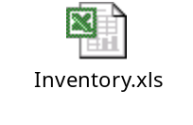

References

S.No | Name | Softcopy / hardcopy
1 | Rebates Documents | Softcopy
2 | Eagls Desktop reference | Softcopy
3 | Reports Standardization FDR’s | Softcopy
4 | Reports ERI app SDR | Softcopy
5 | Reports SDRs | Softcopy
6 | Interfaces SDR | Softcopy
7 | Interfaces – An overview | Hardcopy
8 | Solution Definition Reports EAGLS 2.0 | Hardcopy
9 | EAGLS Refunds Program reference guide | Hardcopy
10 | Draft 256 | Softcopy
11 | Custom Replication Steps.doc | Softcopy
12 | Replication-Ck_snapshots.vsd | Softcopy
13 | Replication-Daily_ref.vsd | Softcopy
14 | Replication-Main.vsd | Softcopy
15 | Replication-Refresh_curr_part.vsd | Softcopy
16 | Replication-Refresh_snapshot.vsd | Softcopy
17 | Replication-Refresh_snp.vsd | Softcopy
18 | Replication-summary_curr_part.vsd | Softcopy
19 | Replication-summary_prev_part.vsd | Softcopy
20 | Replication-summary_snap.vsd | Softcopy
21 | Replication-Update_settle.vsd | Softcopy

